ĐỀ VIP 8+ SỐ 11

Read the following article and mark the letter A, B, C, or D to indicate the correct option that best fits each of the numbered blanks from 1 to 6.

SUSTAINABLE LIVING: A PATH TO FULFILMENT GIASUTAIHUE
Sustainable living is a lifestyle choice that benefits both individuals and the planet. (1) the initiative to adopt eco-friendly habits, such as reducing waste and conserving energy, is a vital step towards a healthier future. This movement (2) collective efforts to protect the environment and ensure resources are preserved for future generations.
Embracing practices like reusing items and sharing a (3) of knowledge about sustainability with others fosters a sense of community. Individuals who make these changes often feel (4) , knowing they are contributing to a better world.
Sustainable living also involves (5) actions, such as choosing renewable energy sources and supporting local, organic products. Simple changes like these, (6) by environmentally conscious citizens, can create a significant impact. Together, we can build a world where sustainability is not just an option but a shared responsibility.
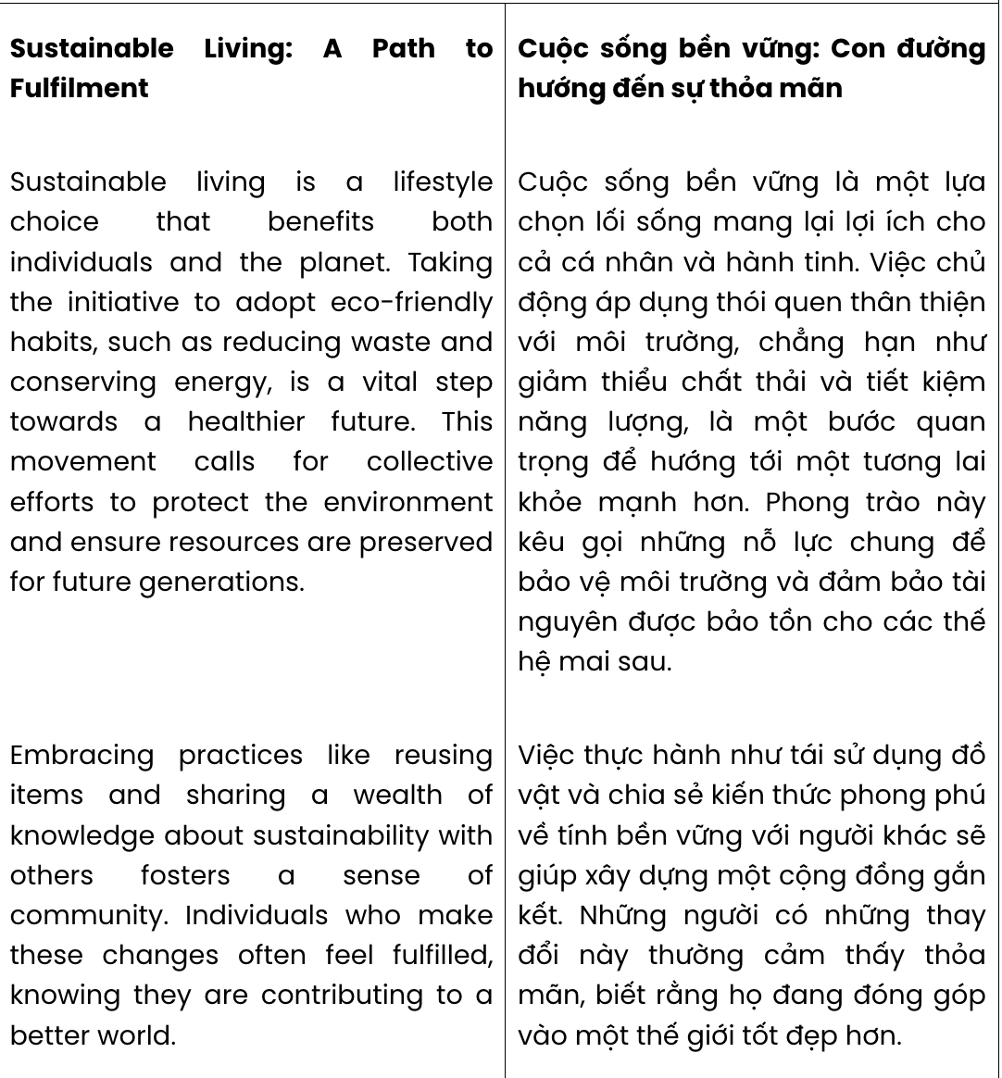
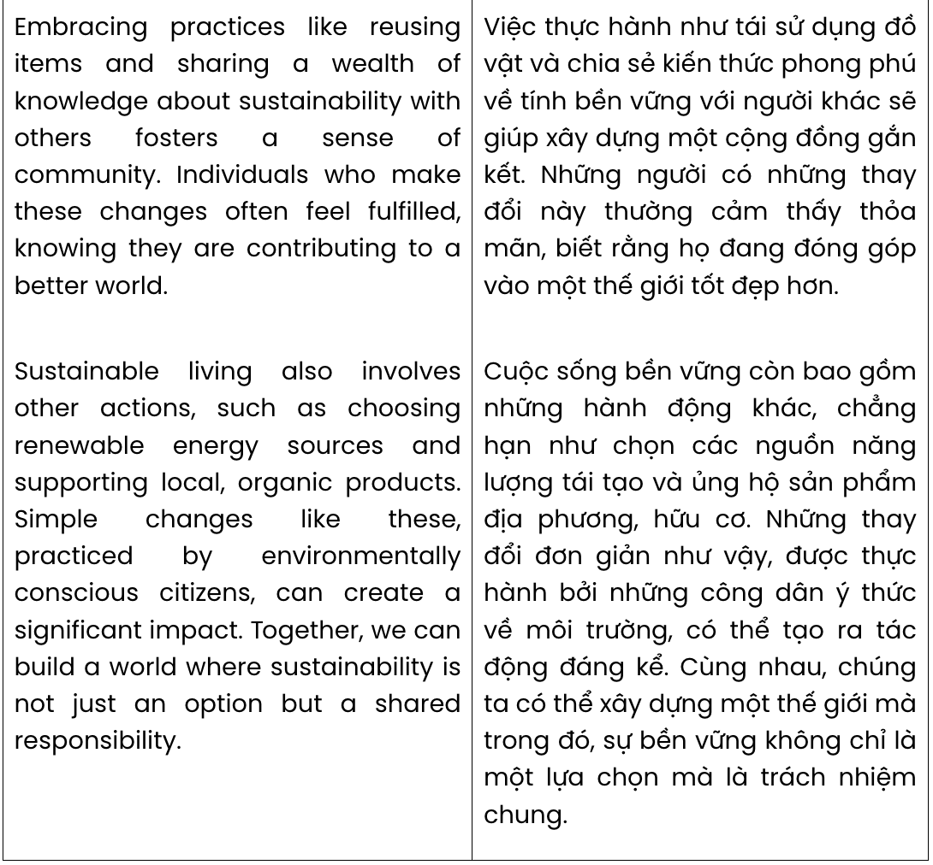
Question 1. A. Making B. Putting C. Taking D. Acting
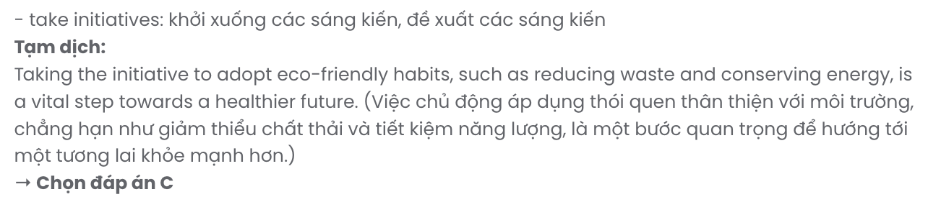
Question 2. A. gets over B. calls for C. puts off D. takes over
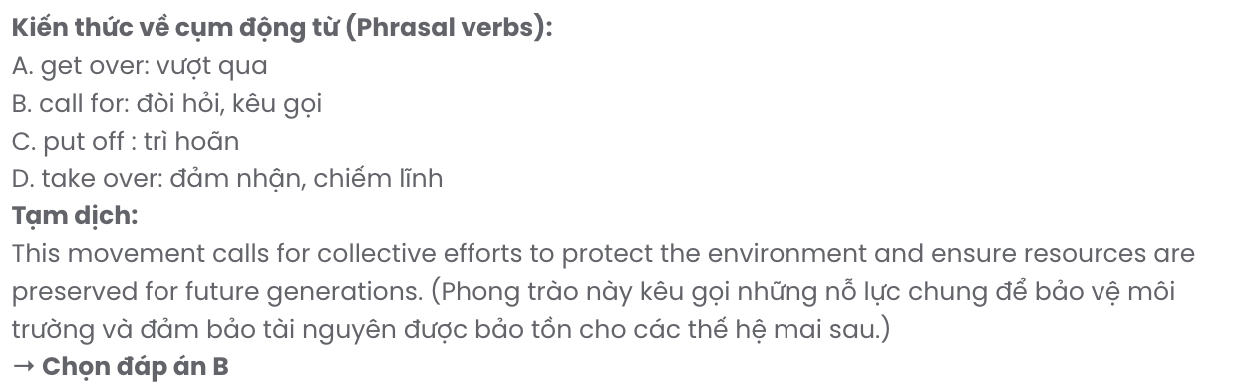
Question 3. A. number B. handful C. lack D. wealth
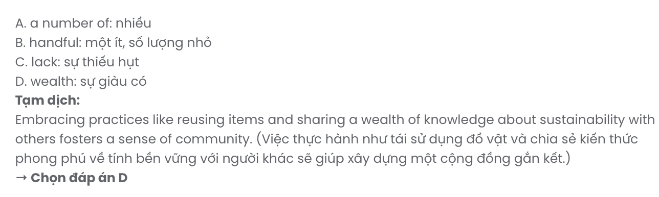
Question 4. A. fulfil B. fulfilling C. fulfilled D. fulfilment
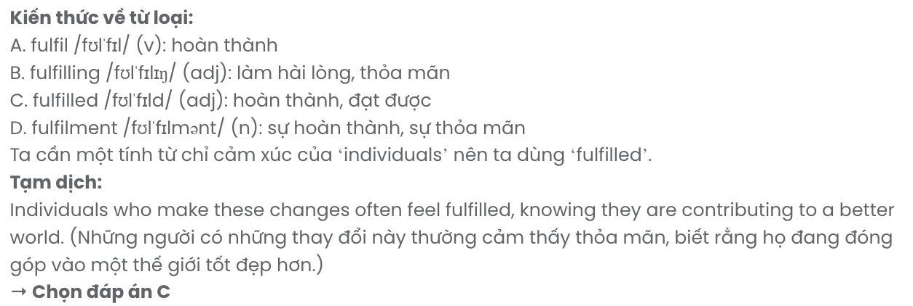
Question 5. A. another B. other C. each D. the others
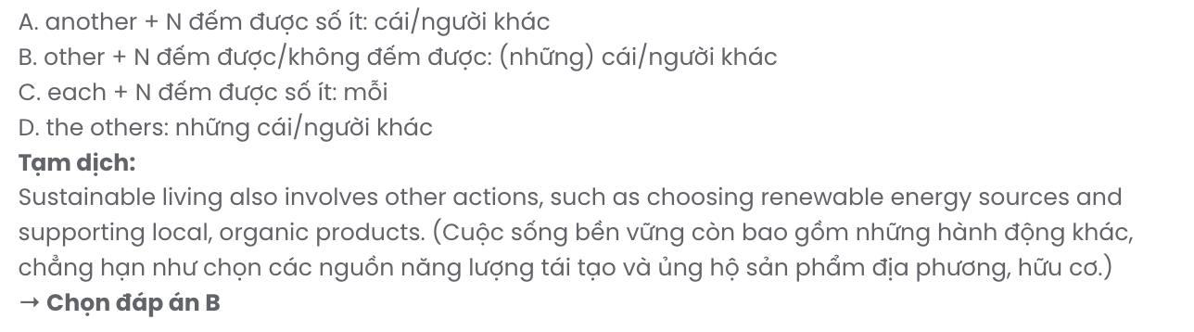
Question 6. A. are practiced B. that practice C. practicing D. practiced
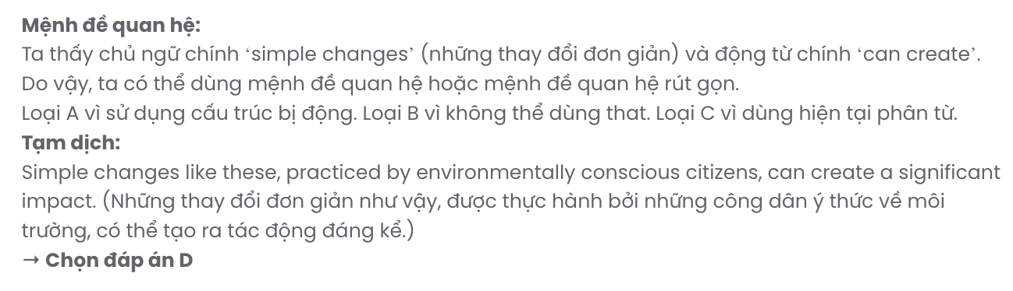

Read the following leaflet and mark the letter A, B, C, or D to indicate the correct option that best fits each of the numbered blanks from 7 to 12.
Are you ready to make a positive impact on your community? Participating in (7) allows you to connect with others while helping those (8) need. Whether it's providing food (9) to struggling families or offering support to the elderly, your efforts can bring hope to people’s lives.
- the dedication of our volunteers, we’ve built a supportive network that fosters care and
- for others. Together, we address critical needs through meaningful initiatives like clothing drives, educational programs, and health campaigns.
We hope (12) more individuals to take part in these activities, creating a stronger, more compassionate community. Your time and kindness can change lives-both theirs and yours.
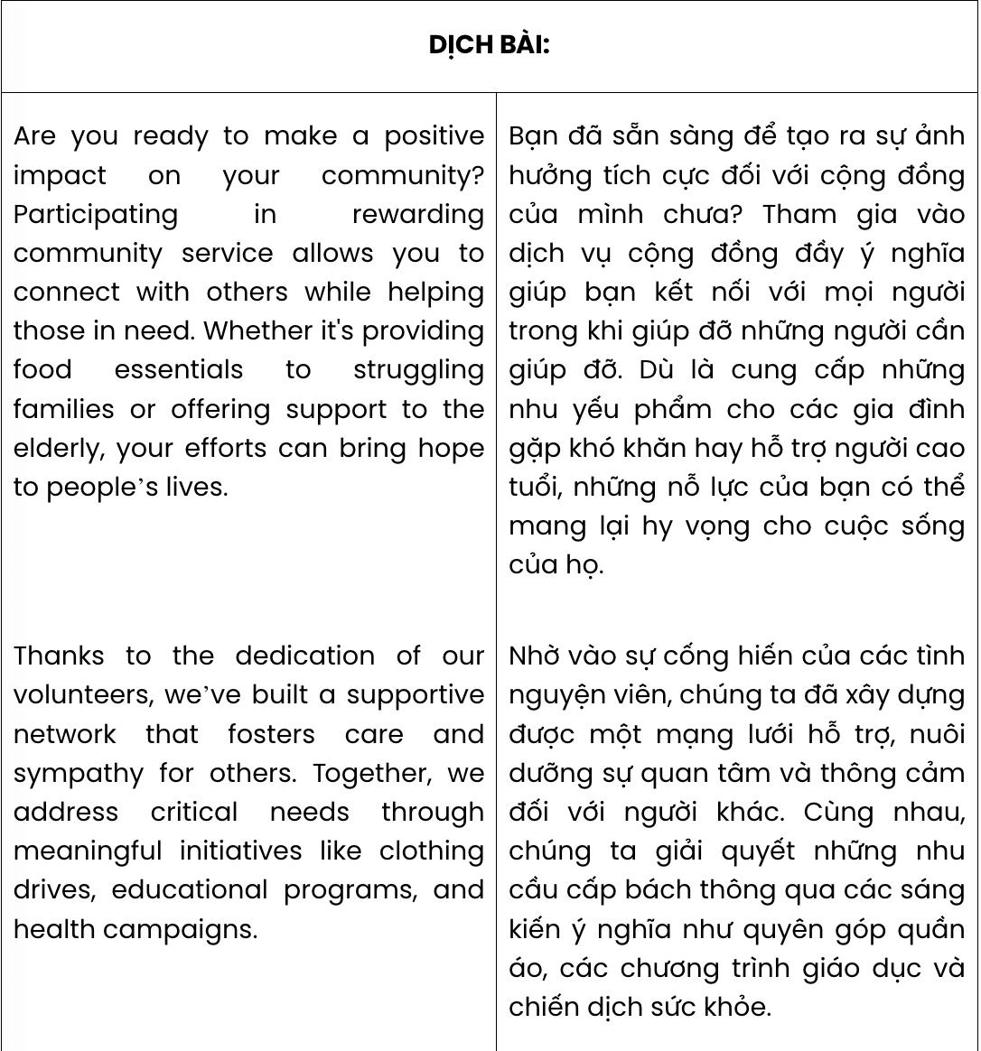

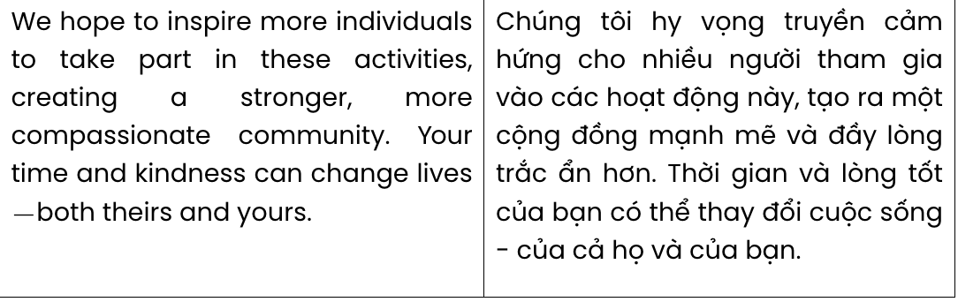

Question 7. A. rewarding service community B. rewarding community service
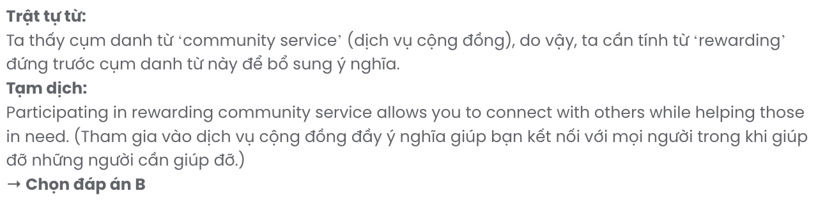
C. service rewarding community D. community rewarding service

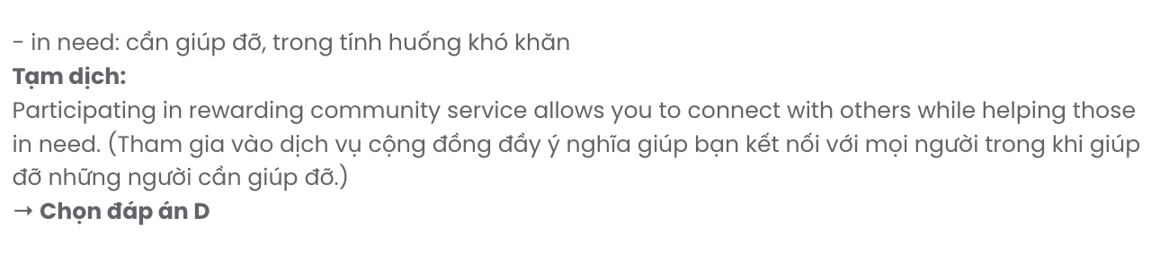
Question 8. A. for B. with C. on D. in

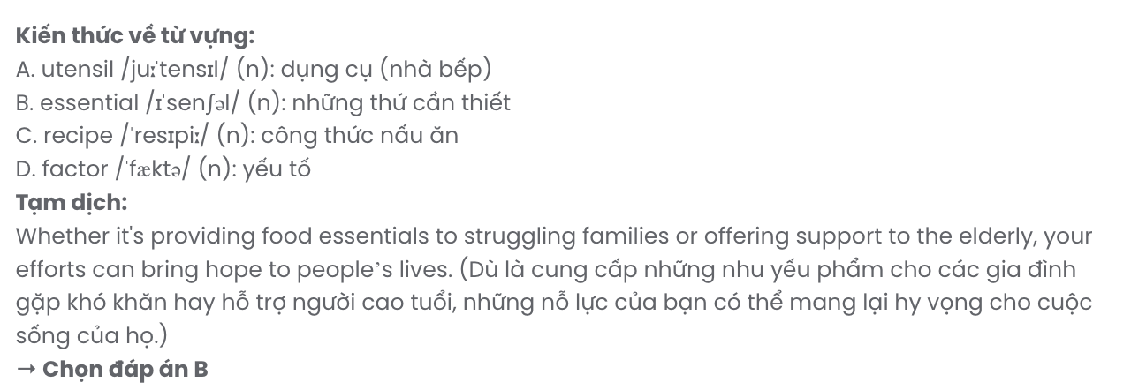
Question 9. A. utensils B. essentials C. recipes D. factors

Question 10. A. Thanks to B. In addition to C. But for D. In place of
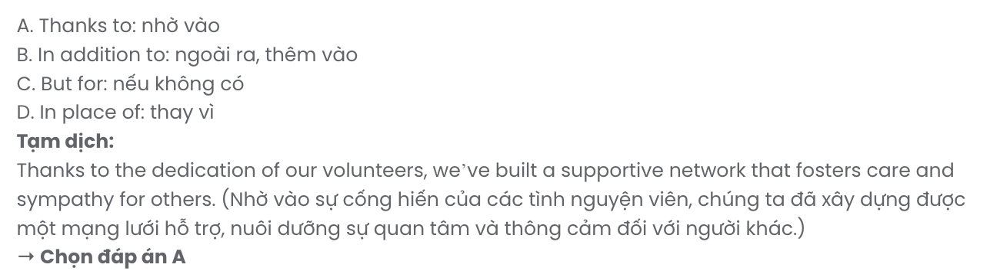
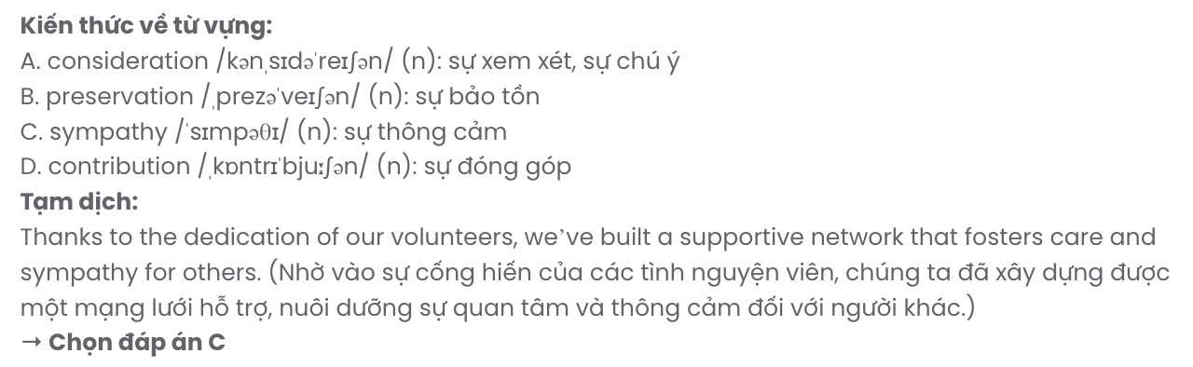
Question 11. A. consideration B. preservation C. sympathy D. contribution

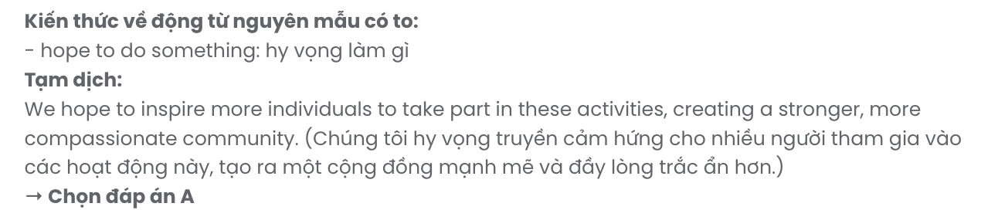
Question 12. A. to inspire B. to inspiring C. inspire D. inspiring

Mark the letter A, B, C or D to indicate the best arrangement of utterances or sentences to make a meaningful exchange or text in each of the following questions from 13 to 17.

Question 13.
  - As the tour progresses, the guide points out the library, known for its extensive collection and quiet study spaces.
  - In the student union, a bustling café and activity spaces reflect the campus's lively community spirit.
  - These features combine to create an environment that inspires both learning and connection, leaving a lasting impression on everyone who visits.
  - Nearby, a state-of-the-art science center showcases the university's commitment to innovation and research.
  - Walking through the vibrant college campus, visitors are greeted by lush gardens and historic buildings.
A. b – c – e – d – a B. e – a – d – b – c C. a – d – e – c – b D. c – a – d – b – e
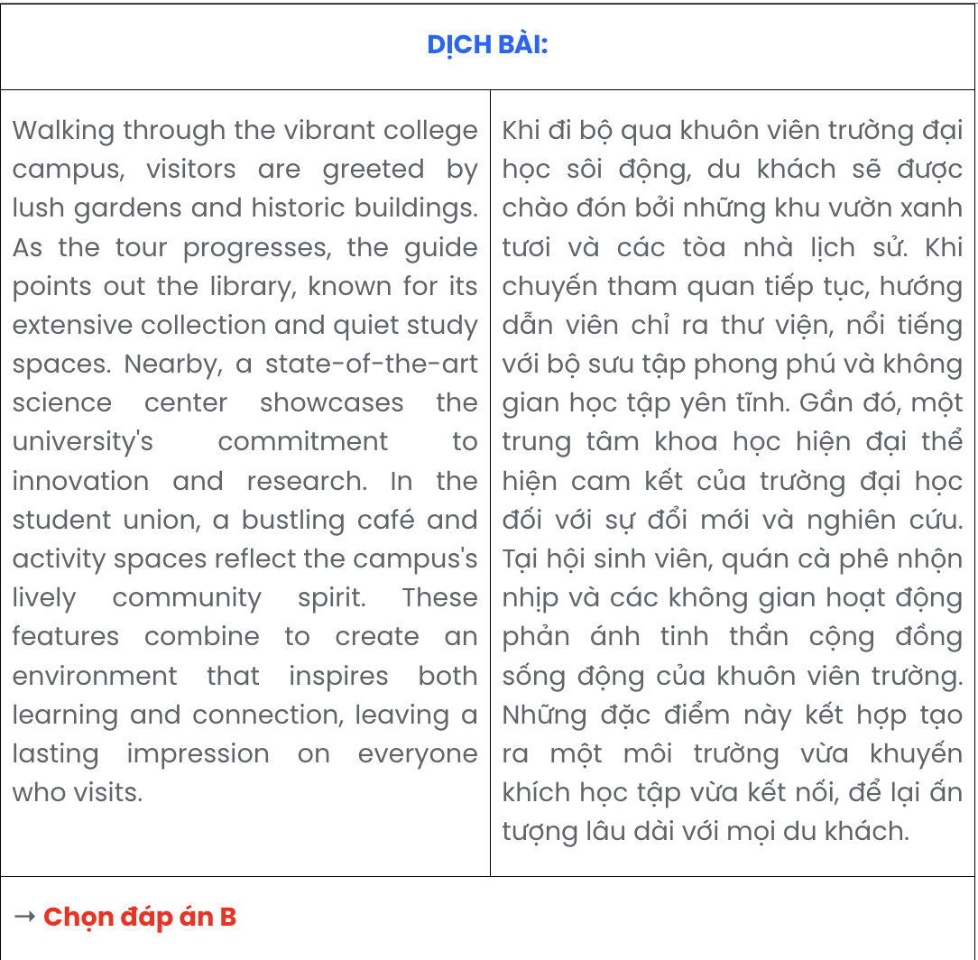

Question 14.
- Anna: Remember the last project? That idea you suggested really brought everything together.
- Ben: Definitely! I think being able to share ideas and listen to others makes a huge difference.
- Anna: True. I guess the more we practice it, the better we’ll get at working with others.
- Anna: Have you noticed how important teamwork skills are in group projects?
- Ben: Thanks, but it only worked because everyone pitched in. That kind of collaboration is what makes teamwork so effective. GIASƯTAIHUE (079.3833.272)
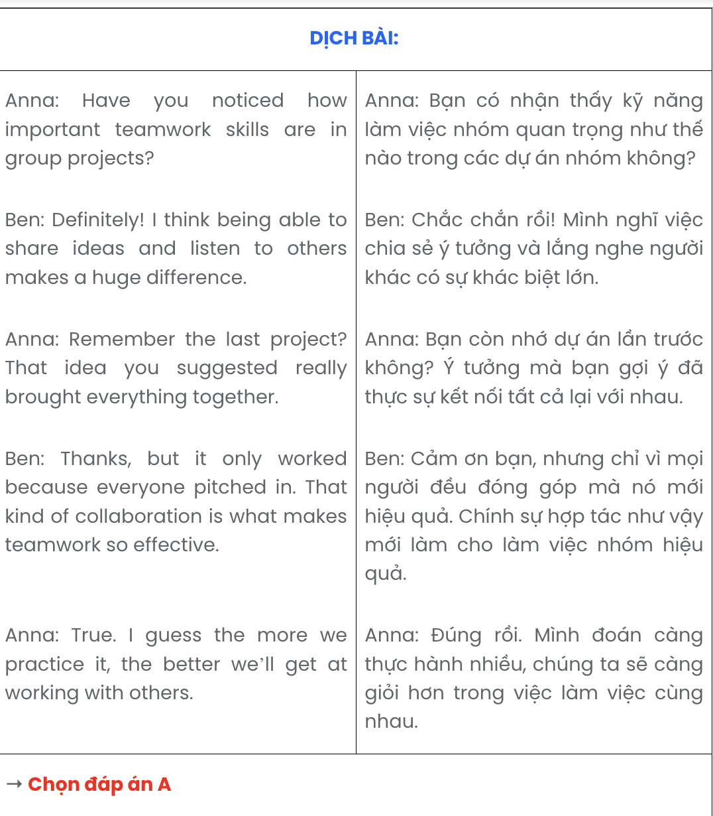
A. d – b – a – e – c B. a – e – c – b – d C. a – b – c – e – d D. d – e – a – b – c

Question 15.
- Without immediate action, however, these linguistic treasures could disappear forever, taking centuries of heritage with them.
- Efforts to preserve endangered languages, such as offering them in school curriculums, have shown promise in revitalising interest.
- Many minority languages are under threat due to the increasing dominance of global languages like English and Spanish.
- In some regions, younger generations are opting to speak more widely-used languages, leaving the traditional ones to fade.
- The loss of these languages also means losing unique cultural identities and traditional knowledge passed down through generations.
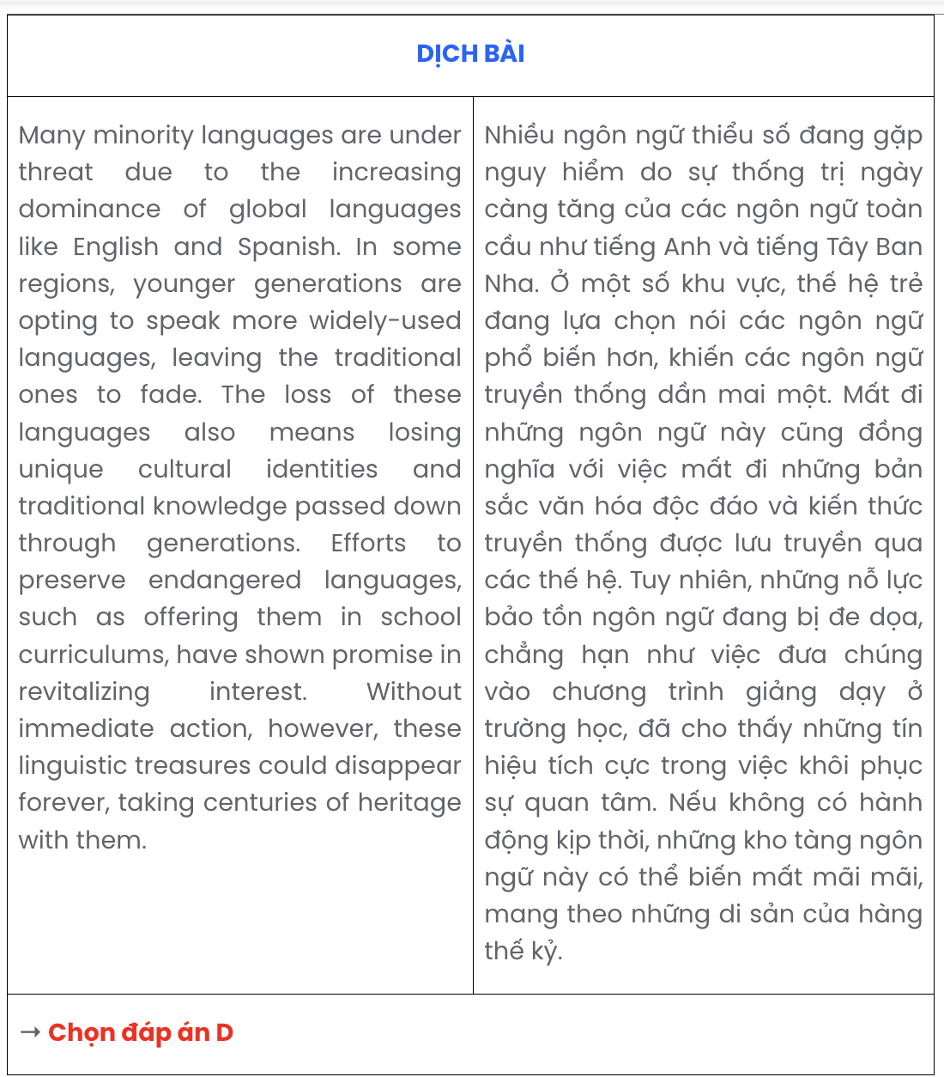
A. c – b – d – a – e B. c – e – a – d – b C. c – a – b – e – d D. c – d – e – b – a

Question 16.
- Sue: I’m thinking of joining a beach camp - sun, sand, and a lot of fun!
- Sue: Hi Mia, Do you have any plans for summer break?
- Mia: Hi Sue. I’m visiting my grandparents in the countryside. What about you?
A. a – c – b B. b – a – c C. c – b – a D. b – c – a
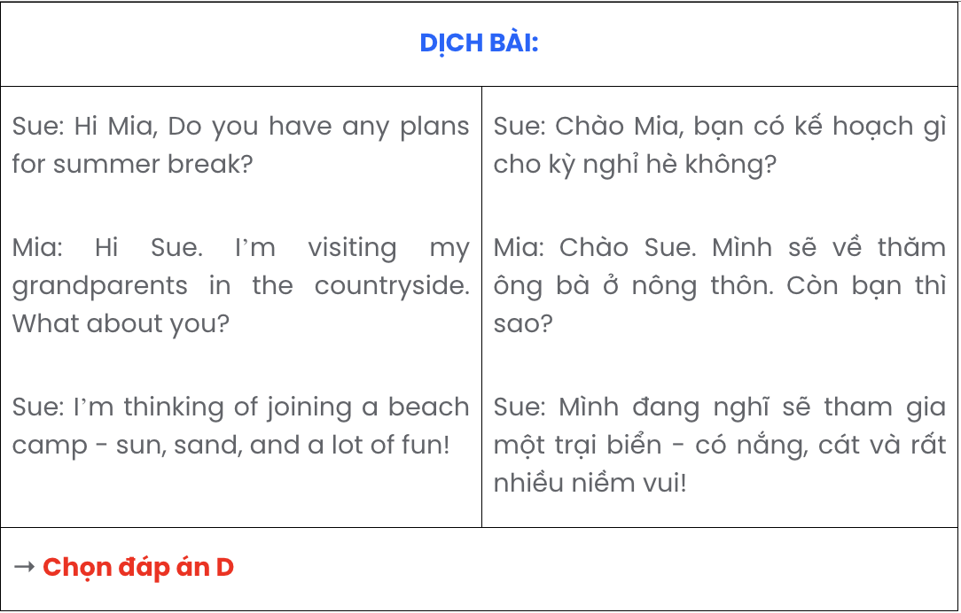

Question 17.
Hi Emma,
- The more I learned about the environmental impact of meat consumption, the harder it was to ignore.
- I’ve decided to switch to a vegetarian diet and thought I’d let you know.
- I’m excited to see how this new lifestyle benefits both my health and the planet!
- Cutting out meat has also given me a chance to explore so many delicious plant-based dishes.
- This change has been easier than I expected, thanks to the support of family and some great recipes. Take care,
Sophia
A. c – d – e – b – a B. a – e – b – c – d C. b – a – d – e – c D. d – a – e – c – b

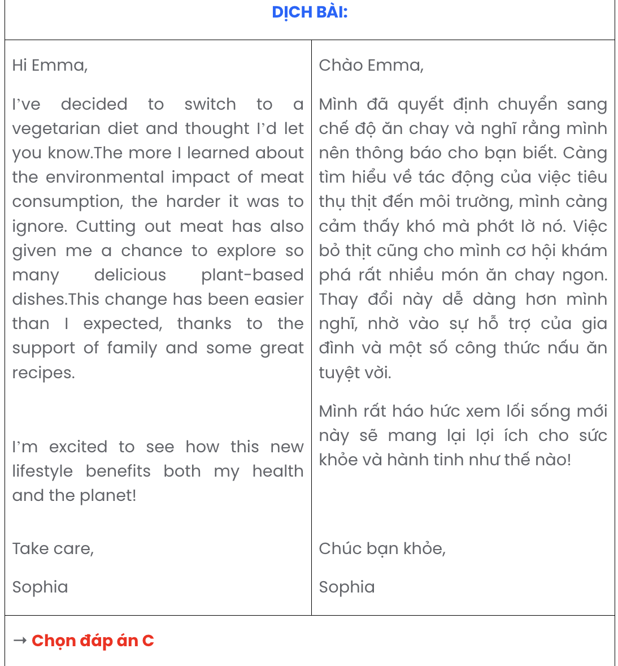

Read the following passage about dinner and mark the letter A, B, C, or D to indicate the correct option that best fits each of the numbered blanks from 18 to 22.
Dinner is more than just a meal; it is a time for families and friends to connect, unwind, and share experiences. Shared meals create a sense of togetherness, (18) .
(19) , leading to weaker bonds. Studies have shown that eating dinner together improves mental well-being and encourages healthier eating habits. These benefits, often overlooked, highlight the significance of prioritising dinner in our busy lives.
Gathering around the table, often practiced by many cultures, offers a chance to exchange ideas and discuss daily events. (20) . Moreover, preparing meals at home can be a rewarding experience, allowing people to explore creativity while promoting healthier lifestyles.
Discussing personal stories during dinner can lead to better understanding among family members, improving overall harmony. Having been influenced by such traditions, (21) .
By prioritising dinner, families can experience improved communication, strengthened bonds, and a sense of fulfillment. Sitting together and enjoying a meal, sharing laughter and meaningful conversations, contributes to emotional well-being. These moments, cherished by those who experience them, (22)
.
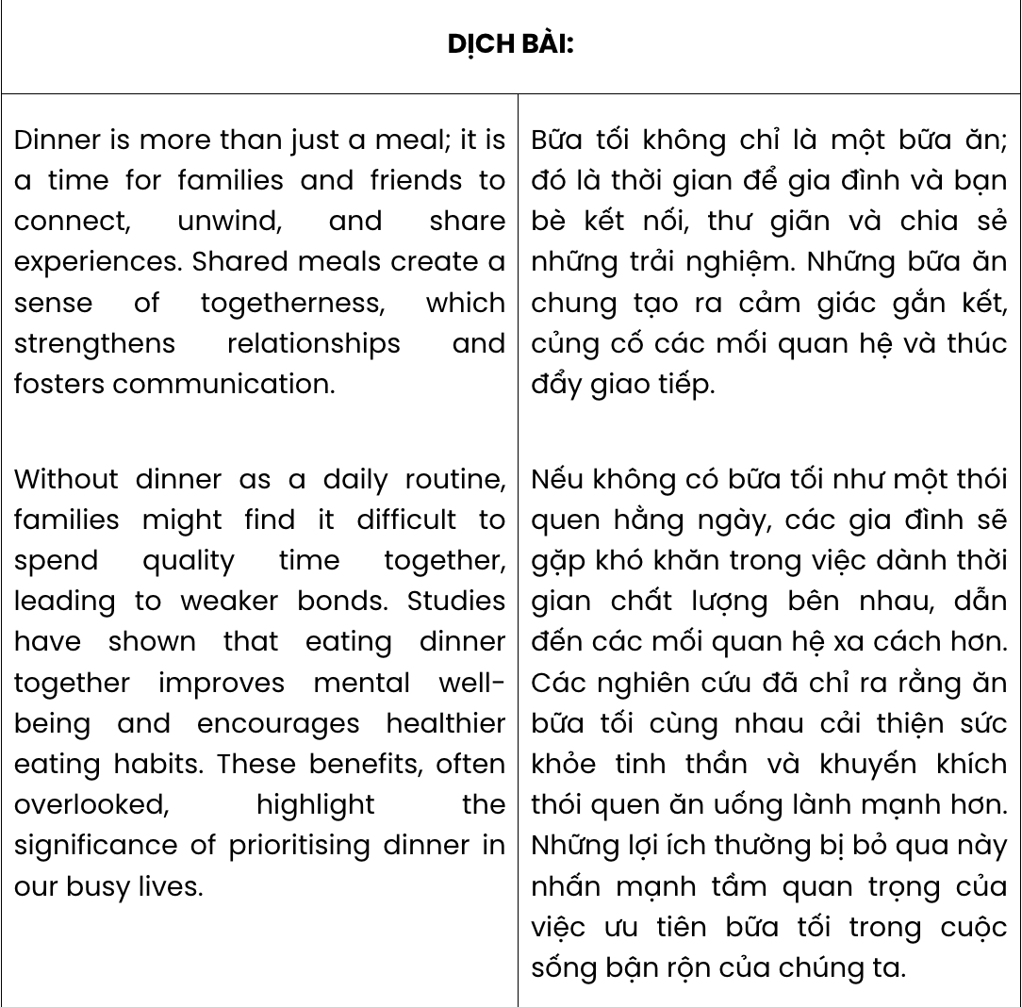
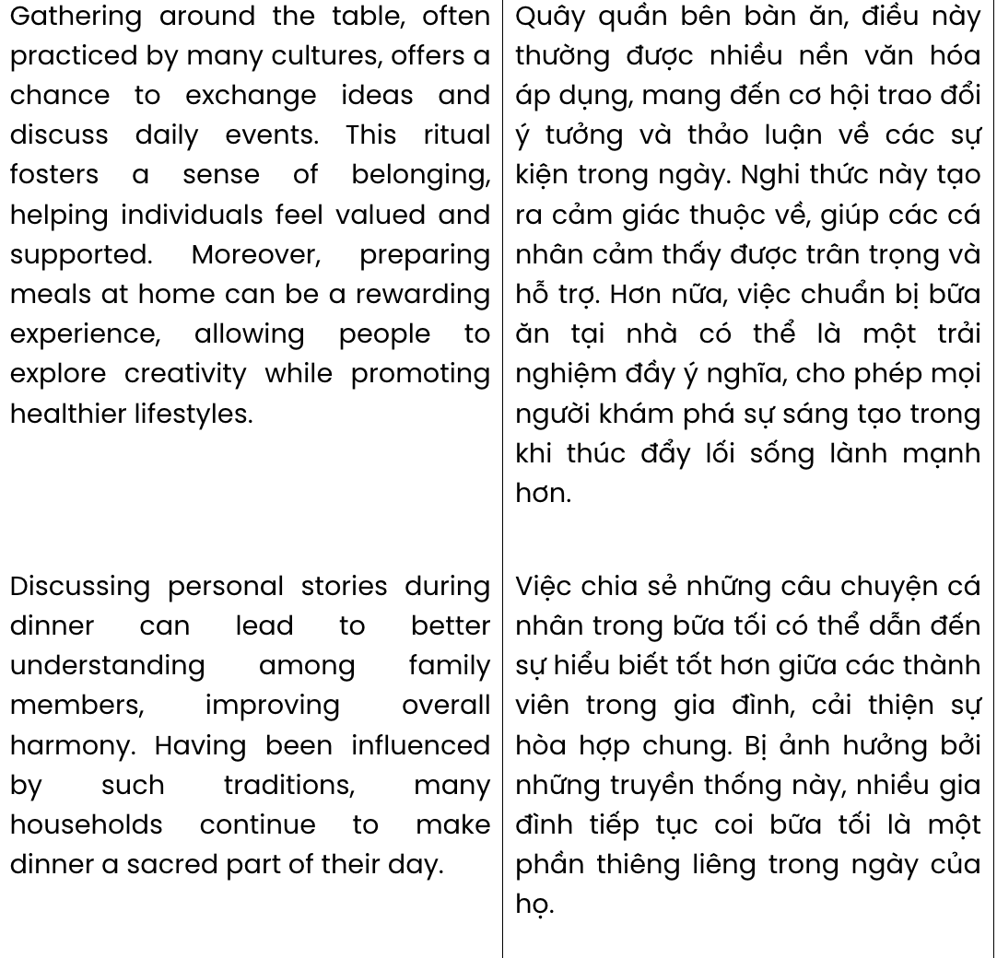
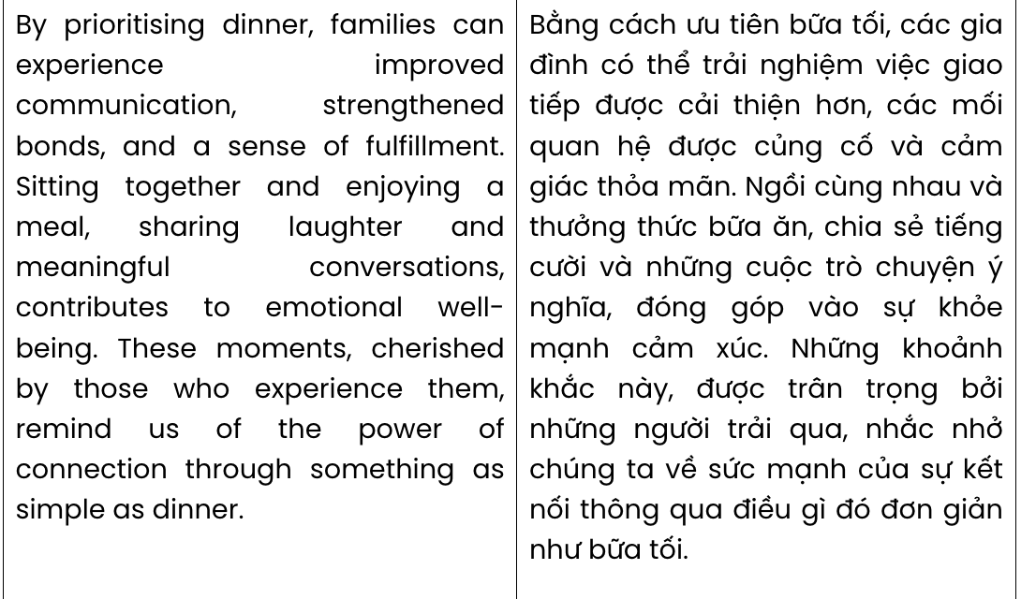

Question 18.
  - enabled closer relationships and better communication
  - which strengthens relationships and fosters communication
  - enhanced bonds and encouraged open communication
  - whose potential of forming bonds and fostering communication
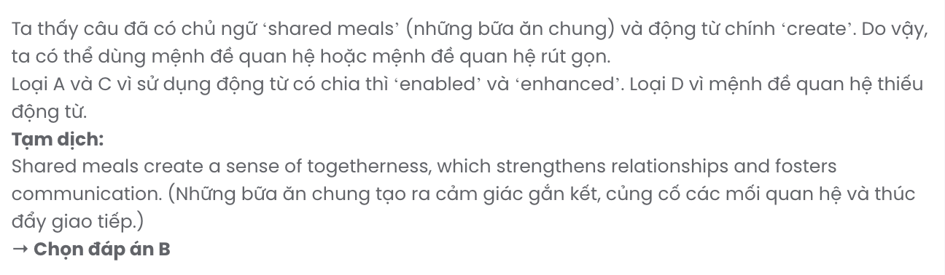

Question 19.
- Families should make an effort to spend quality time together so that dinner can be made as a daily routine
- Unlike other daily routines, dinner makes it more challenging for families to spend quality time together
- Struggling to spend quality time together, families should make dinner as a daily routine
- Without dinner as a daily routine, families might find it difficult to spend quality time together
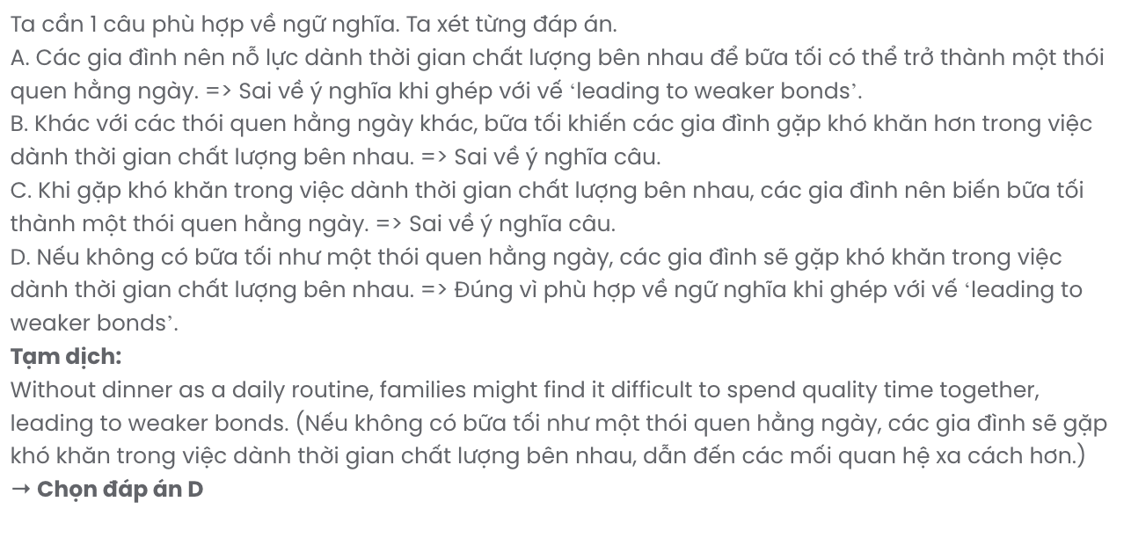

Question 20.
- This ritual fosters a sense of belonging, helping individuals feel valued and supported
- Fostering a sense of belonging, individuals make this ritual more valuable and supportive
- Individuals feel valued and supported as if this ritual fostered a sense of belonging
- A sense of belonging causes individuals to feel more valued and support this ritual
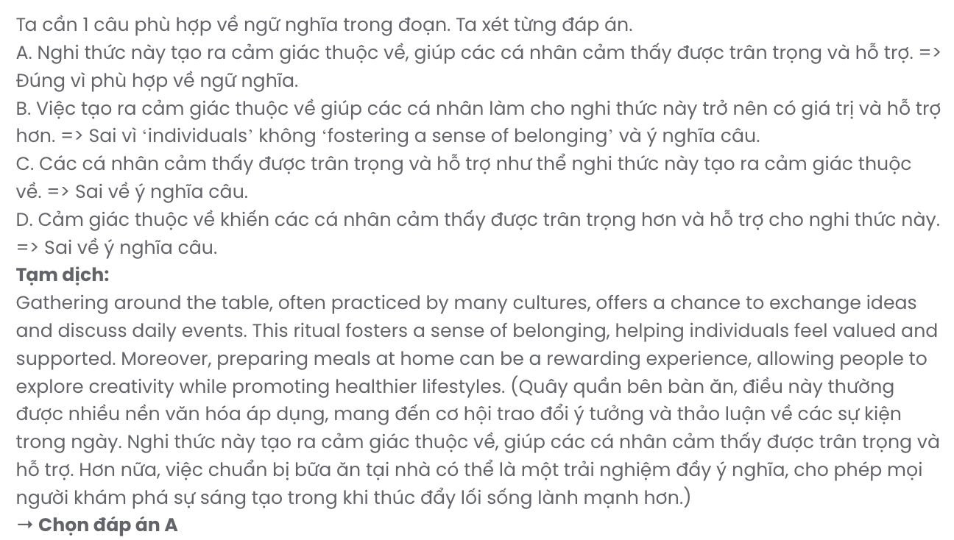

Question 21.
- many households continue to make dinner a sacred part of their day
- dinner has become an indispensable part of many families
- efforts to make dinner an important part have been made in many families
- making dinner a vital part of their day becomes a meaningful tradition
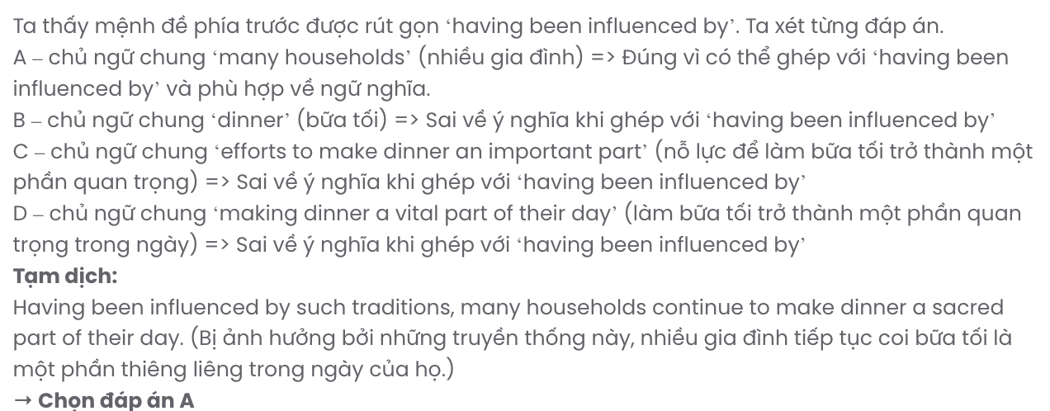

Question 22.
- that make us realise the importance of dinner as a way of connecting people
- having made us recognise the impact of dinner on the way we connect with others
- remind us of the power of connection through something as simple as dinner
- of which the power of connection when we have dinner together is evident

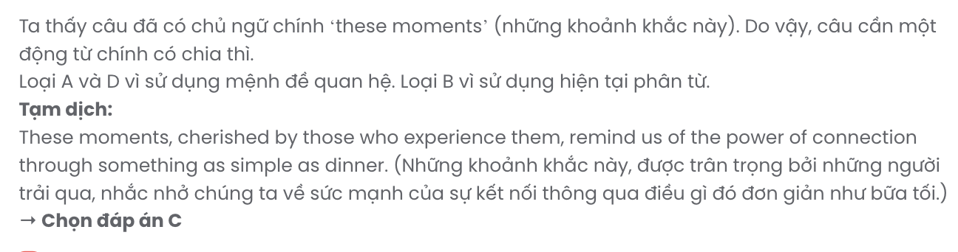

Read the following passage about a new tradition across cultures and mark the letter A, B, C, or to indicate the correct answer to each of the questions from 23 to 30.
Shantelle Davis is a nine-year-old girl in New York. On a cold night in December, her family is standing around the kitchen table while she lights a candle. The table is decorated with baskets of fruit and vegetables and ears of corn for Shantelle and her two brothers. Tonight is the first night of Kwanzaa, and Shantelle is spending the holiday with her family.
Kwanzaa is very unusual because it was started by one man. In 1966, an American named Maulana Karenga wanted a holiday for African-Americans to honour their culture and traditions. So he used words and customs from Africa to create a new celebration. At first, a few American families had small celebrations at home. Now, there are also Kwanzaa events in schools and public places, and it has spread to other countries like Canada and Jamaica.
The main symbol of Kwanzaa is a candle holder with seven candles, one for each of the principles of Kwanzaa. Each night, a family member lights one of the candles and talks about the idea it represents: being together, being yourself, helping each other, sharing, having a goal, creating, and believing. The parents also pour drinks to honour family members who have died. On the last night of Kwanzaa, there is a big dinner with African food, and children receive small presents.
Some people still don't believe that Kwanzaa is a real holiday because it's so new. But other people say that customs and celebrations are always changing and that Kwanzaa shows what is important in people's lives.
(Adapted from World English)
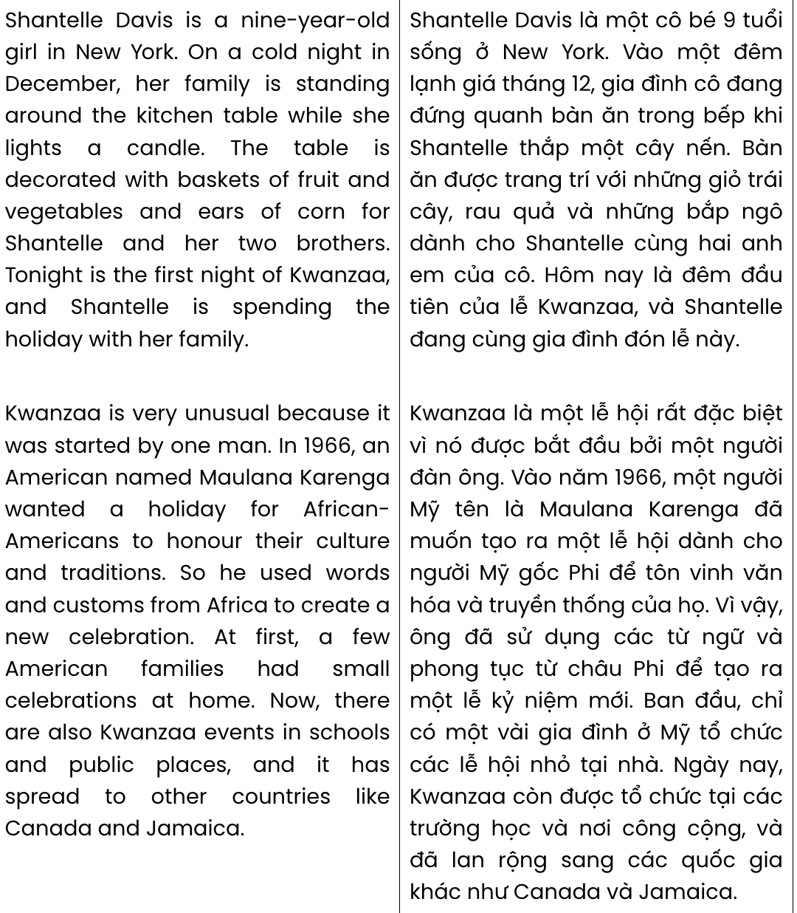
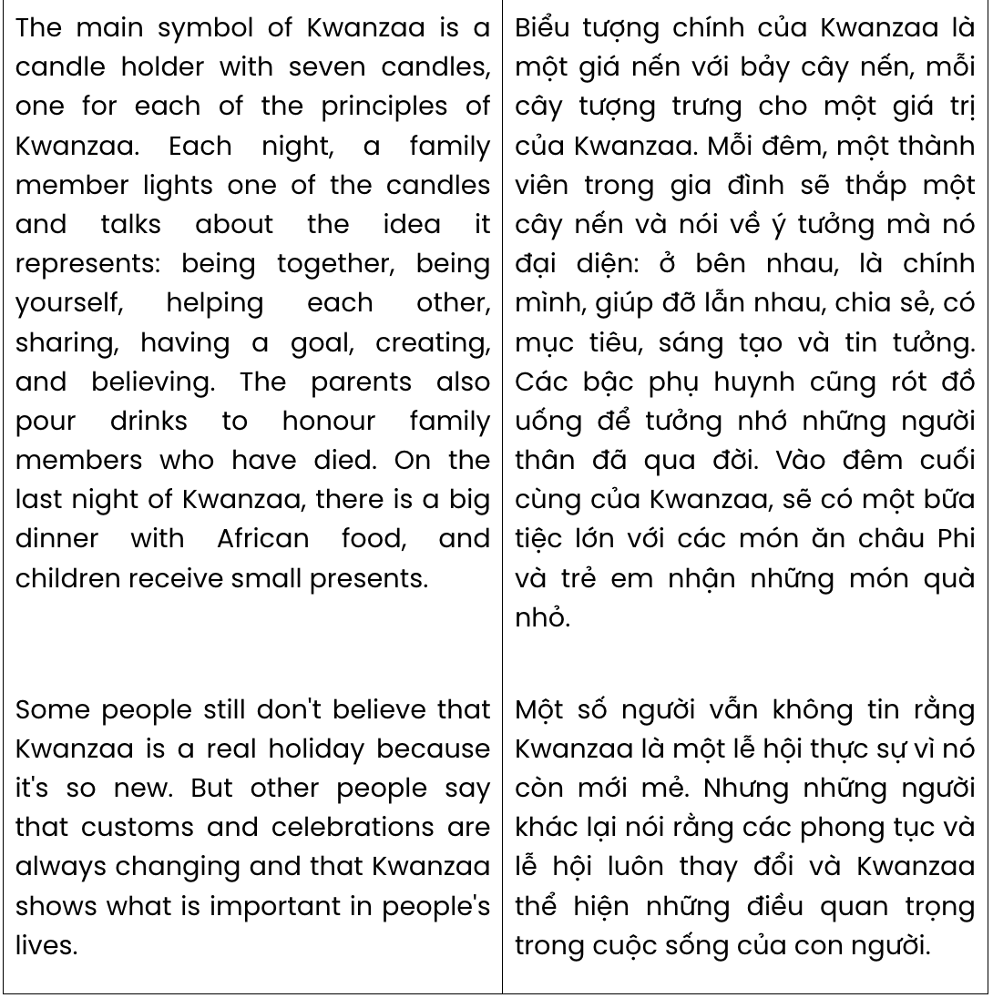
Question 23. The word unusual in paragraph 2 is OPPOSITE in meaning to .
A. uncommon B. hidden C. normal D. special
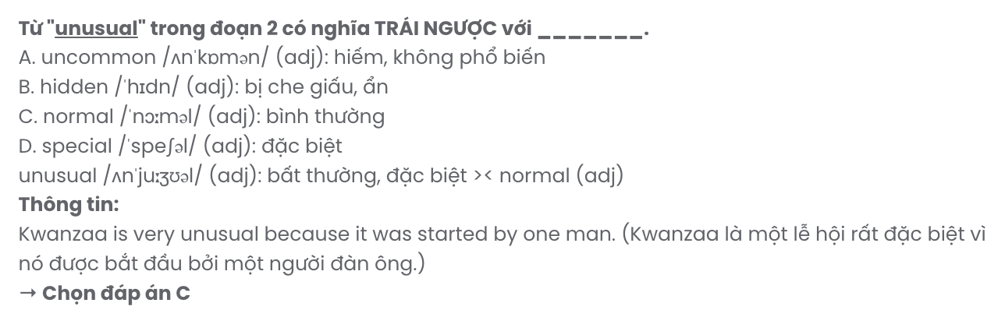
Question 24. Which of the following best paraphrases the underlined sentence in paragraph 2?

At first, a few American families had small celebrations at home.
- Initially, some American households organised modest gatherings within their homes.
- In the beginning, few American families hosted events at home.
- At first, American families celebrated with small parties outside.
- Initially, a few American families refrained from having any celebrations at home.
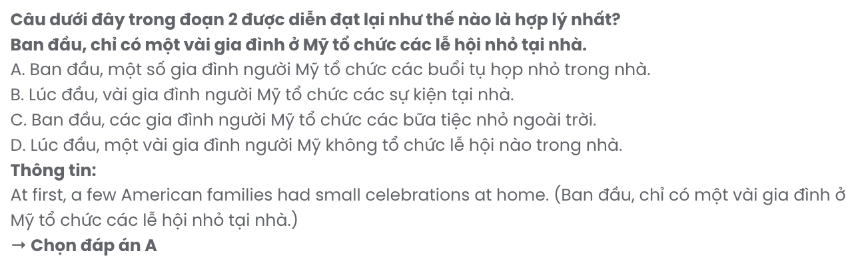
Question 25. The word it in paragraph 2 refers to .
A. Africa B. Canada C. Kwanzaa D. Jamaica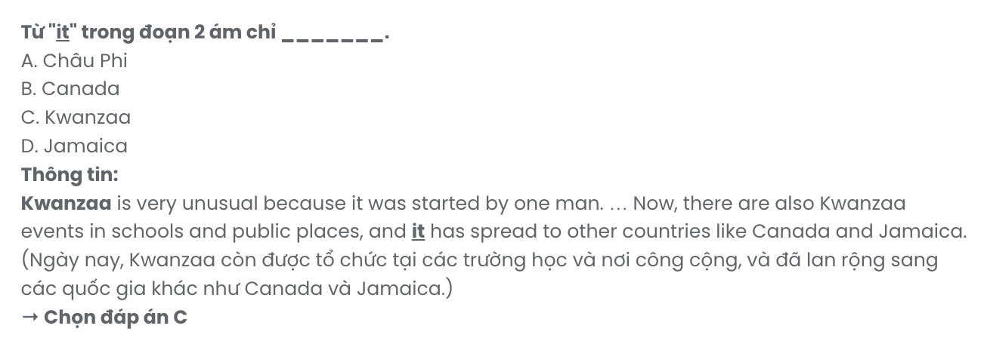

Question 26. The word principles in paragraph 3 is closest in meaning to .
A. standards B. values C. effects D. regulations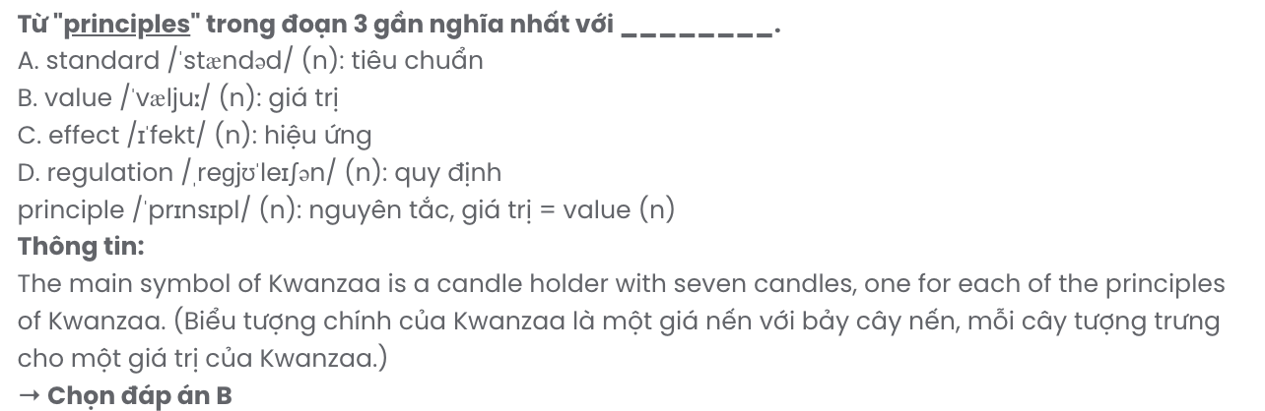

Question 27. All of the following are activities performed during the Kwanzaa holiday, EXCEPT .
A. lighting candles B. having a big meal C. pouring drinks D. unboxing presents
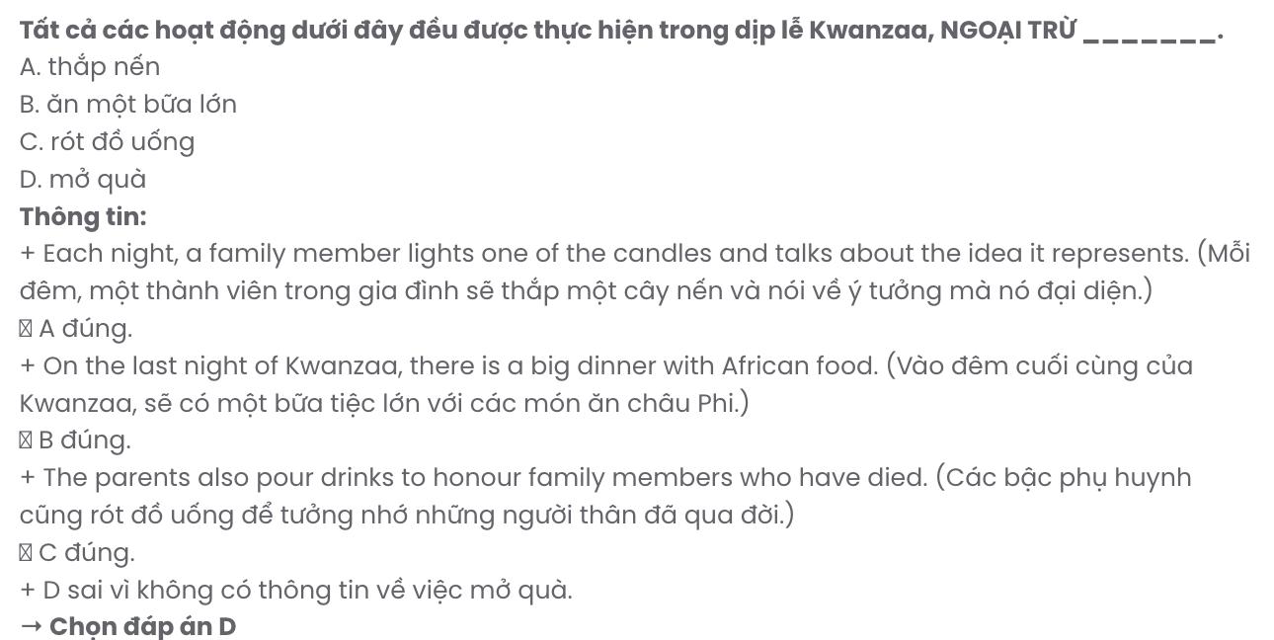
Question 28. Which of the following is TRUE according to the passage?
- Maulana Karenga introduced Kwanzaa to America to honour his ancestors.
- Every corner of the house will be decorated to celebrate Kwanzaa.
- Nowadays, Kwanzaa has not yet become an official holiday in America.
- Each of Kwanzaa's seven symbolic candles represents a different concept.
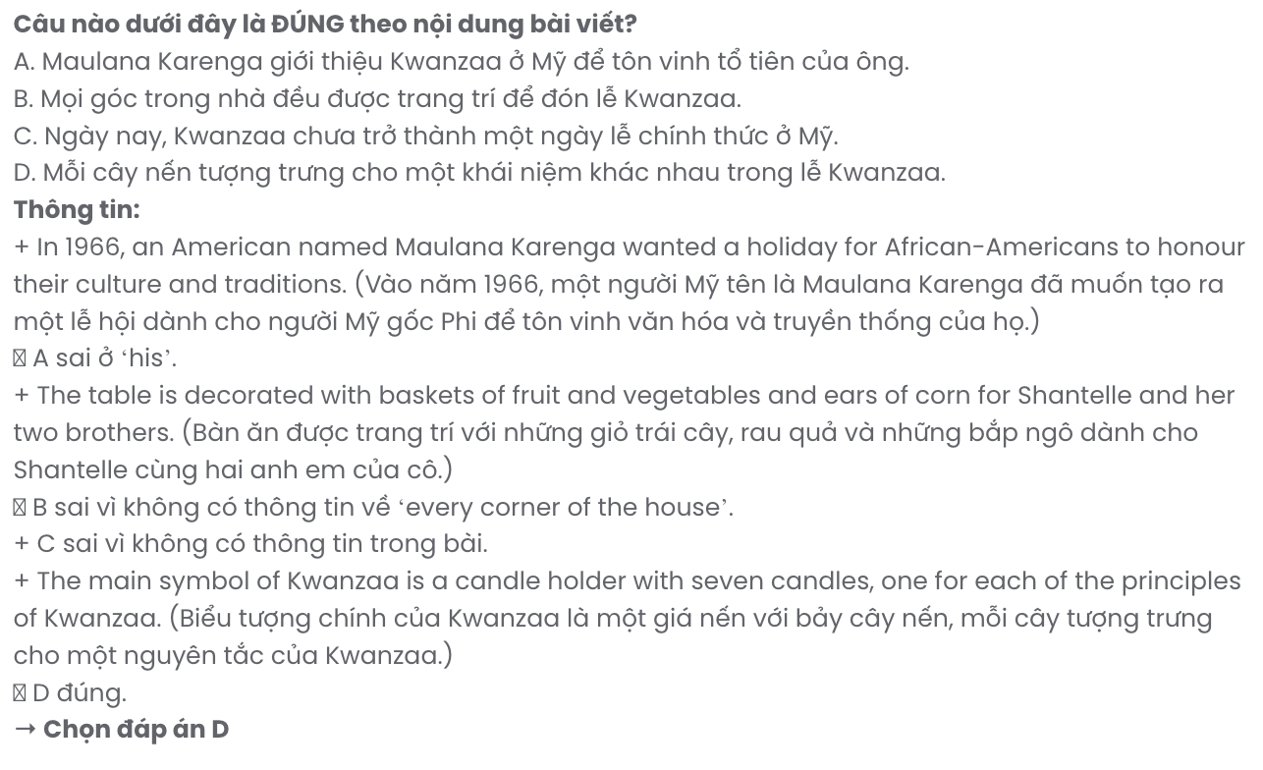
Question 29. In which paragraph does the writer discuss the origin of a holiday?
A. Paragraph 1 B. Paragraph 2 C. Paragraph 3 D. Paragraph 4
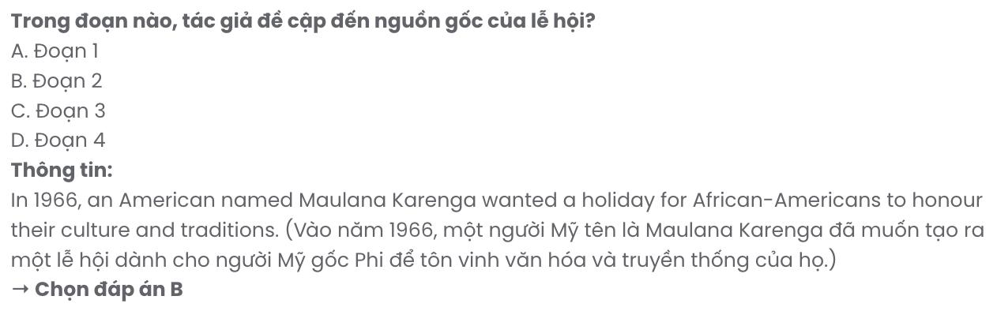
Question 30. In which paragraph does the writer mention a contrast relationship?
A. Paragraph 1 B. Paragraph 2 C. Paragraph 3 D. Paragraph 4

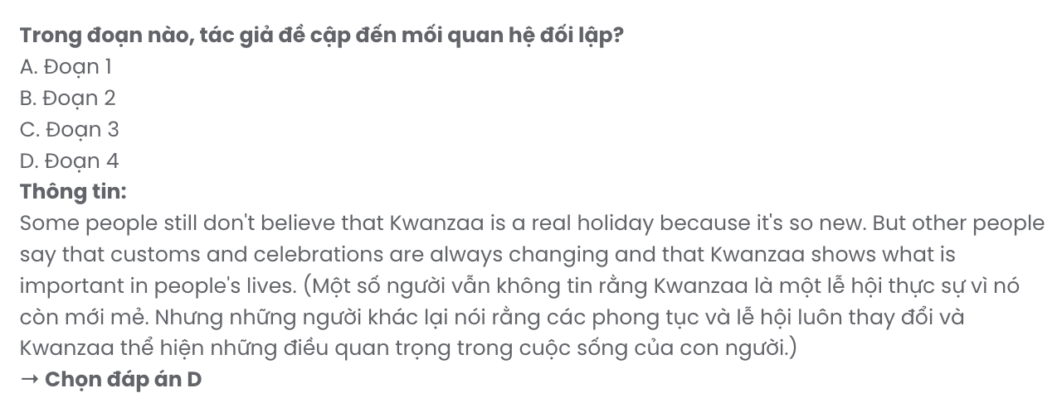

Read the following passage about a dancing man and mark the letter A, B, C, or D to indicate the correct answer to each of the questions from 31 to 40.
For Sean O'Brien, it was just an ordinary night out with friends. He knew that people sometimes mocked him for being overweight, and he was usually able to shrug it off. But this time, as well as laughing at him in person, someone decided to publicly fat-shame him by posting a video of him dancing online, with a hurtful comment. Sean was completely unaware of it, but the post about him was shared widely, and it prompted a wave of abuse from immature Internet trolls.
However, as well as the cyberbullies, other people were watching. A group of women in California, who were campaigning to encourage people to have a positive body image whatever their size, decided to take action. They put out a message on Twitter, inviting Sean on an all-expenses- paid trip from London to Los Angeles, to meet and dance with them. When Sean's friends first told him about the search for 'dancing man', he figured it was a bit of nonsense which would soon blow over, and decided not to bother doing anything about it.
[I] Sean rethought his decision, made contact, and the women - all 1,700 of them - started raising money to throw him an extra-special party in LA. [II] He went to the party in California. Sean had assumed that just a few people would turn up, but he realised his mistake as soon as he saw over 1,000 people queuing to get into the nightclub! Sean danced all night and the story of how he and the women's group in California took a stance against cyberbullying was reported around the world. [III] As a result of the event, some of the women set up Dance Free Movement, an online forum where anyone who felt they had been bullied or victimised could receive support. [IV] The 'dancing man' himself has become a fundraiser for several anti-bullying charities.
Sean commented in an interview at the time that he was amazed that something which started out so badly, had become such a positive movement. He said that he had actually never really thought about the people who posted the original images, concluding that they must have their own insecurities, to put the spotlight on someone else so maliciously. Sean certainly had the last laugh. We are often told that the best idea is not to give bullies any attention, but it may be that the best way to deal with cyberbullying is to act as these women did and be brave enough to make it clear that we are uncomfortable with this kind of behaviour, that we disagree with what is being said and that bullying is completely unacceptable.
(Adapted from High Note)

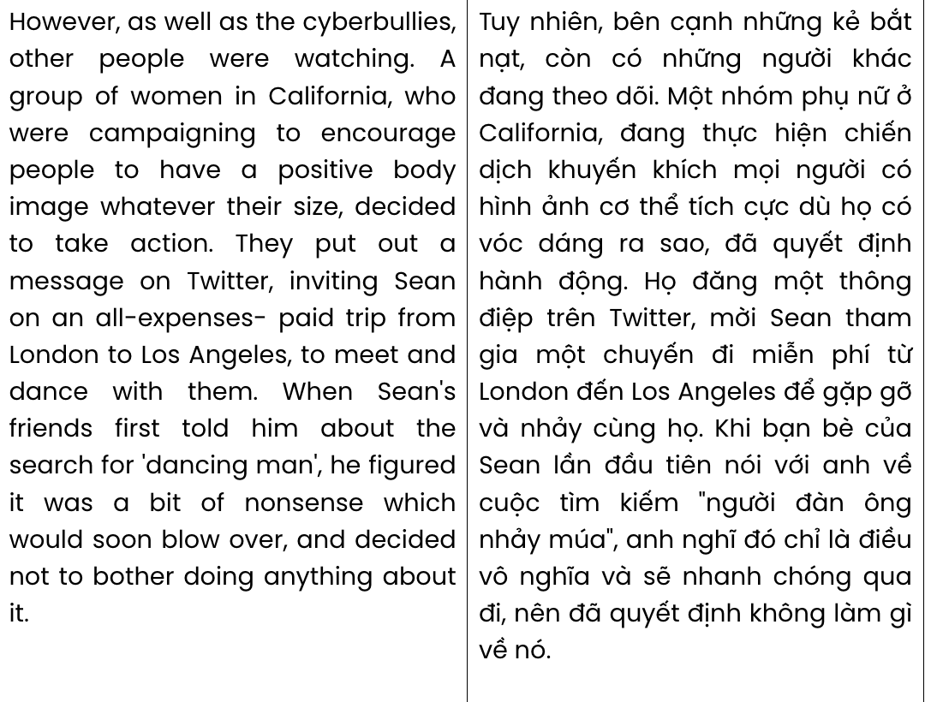
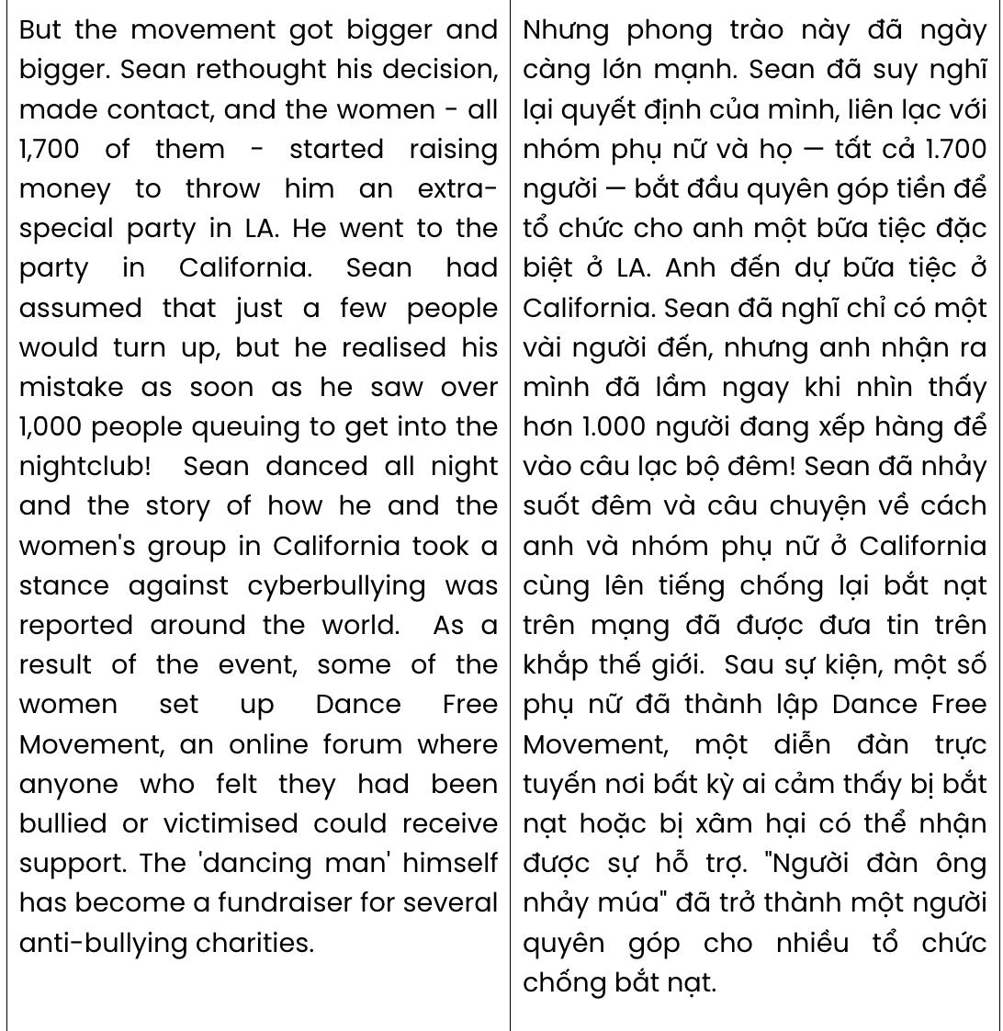
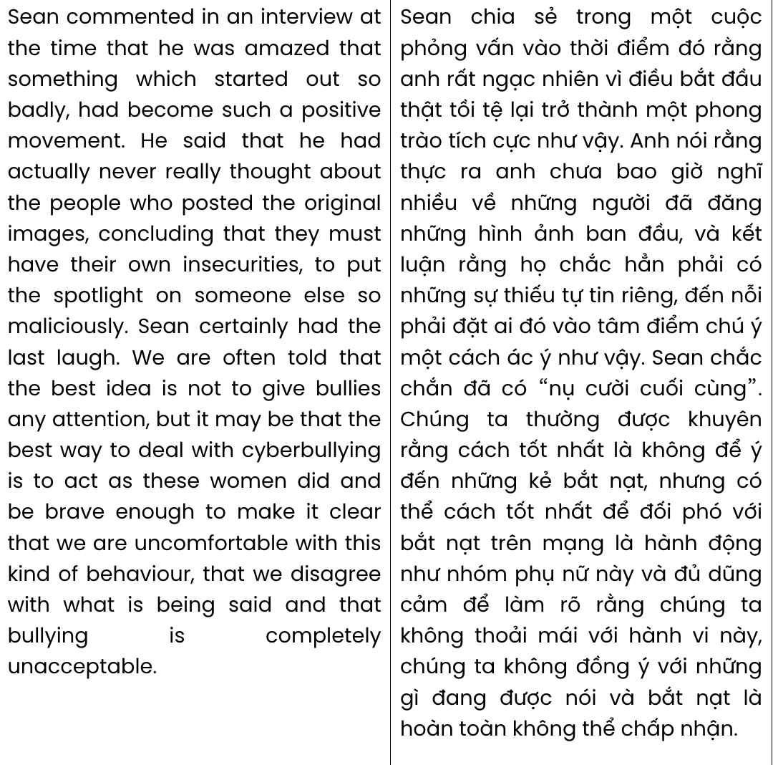
Question 31. The word prompted in paragraph 1 is OPPOSITE in meaning to .
A. triggered B. enacted C. compared D. discouraged GIASUTAI HUẾ
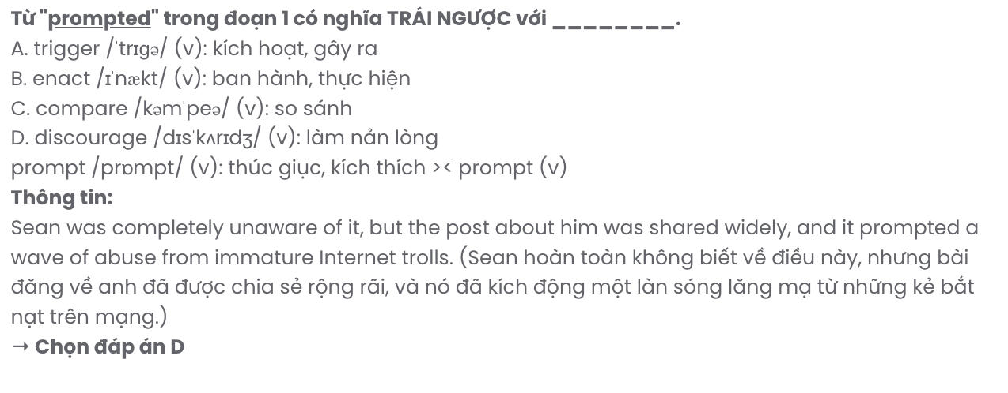
Question 32. According to paragraph 1, Sean O'Brien didn’t realise that .
A. he was teased by some of his acquaintances for being overweight
B. he was laughed by some Internet users for his awkward behaviour
C. he became a victim of body shaming on the Internet
D. his dance video was leaked by his casual friends
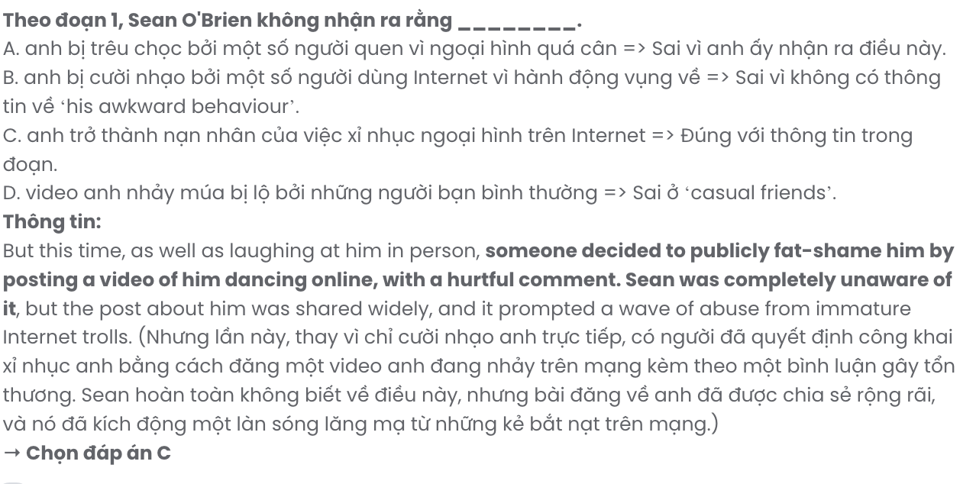
Question 33. The word them in paragraph 2 refers to .
A. Sean’s friends B. women C. expenses D. cyberbullies
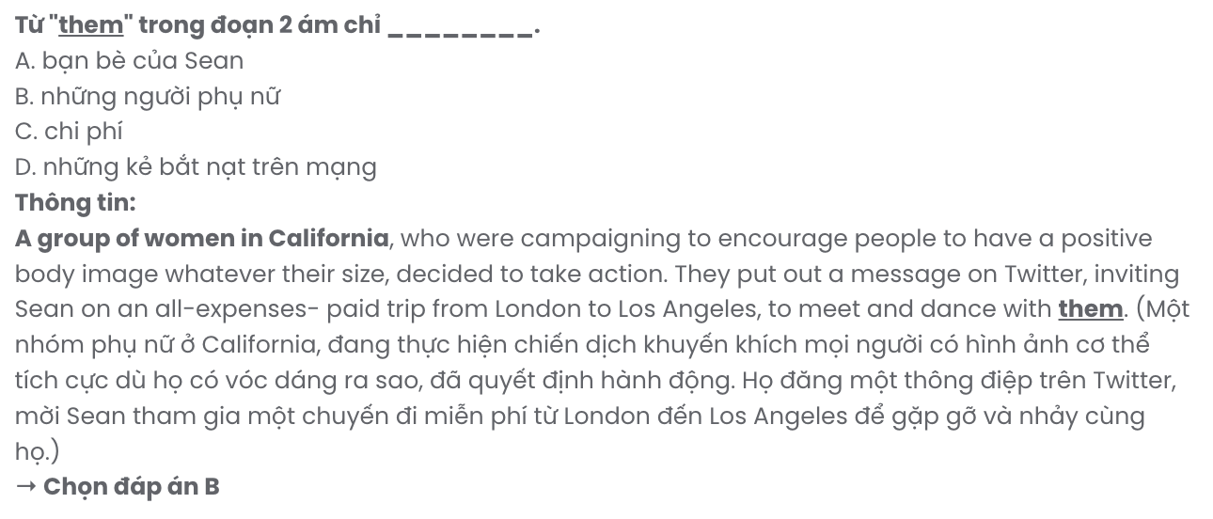
Question 34. The phrase blow over in paragraph 2 mostly means .
A. become a controversial topic B. incite intense hatred
C. gradually become less strong D. provide genuine pleasure

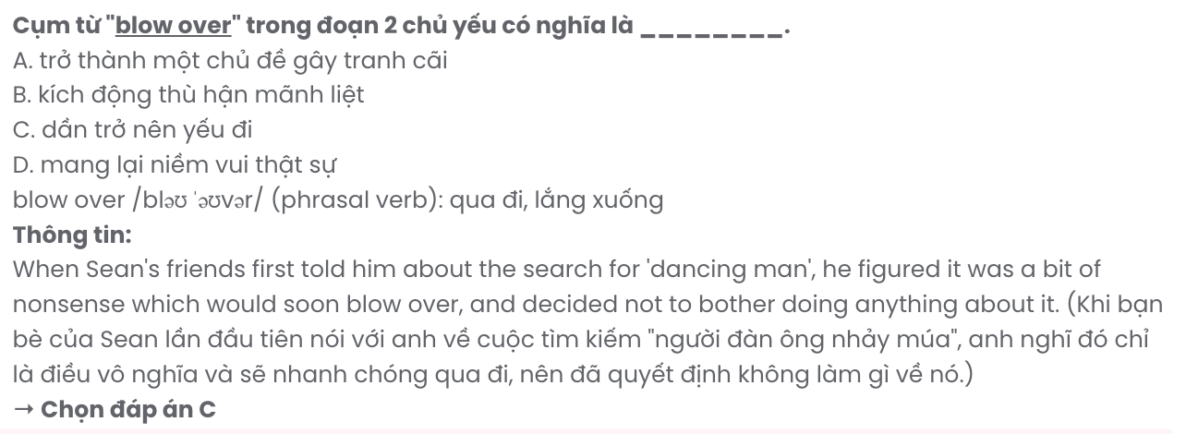
Question 35. Which of the following best summarises paragraph 2?
A. A group of women in California invited Sean to Los Angeles to meet and dance with them after seeing him mocked online, and he accepted their invitation.
B. Sean ignored his friends' comments about being mocked online, thinking it was unimportant, while a group in California promoted body positivity.
C. After Sean was mocked online, a California group promoting body positivity invited him to Los Angeles for an all-expenses-paid trip, but Sean dismissed it as nonsense at first.
D. A California group campaigning for body positivity invited Sean on an all-expenses-paid trip after his online ridicule.
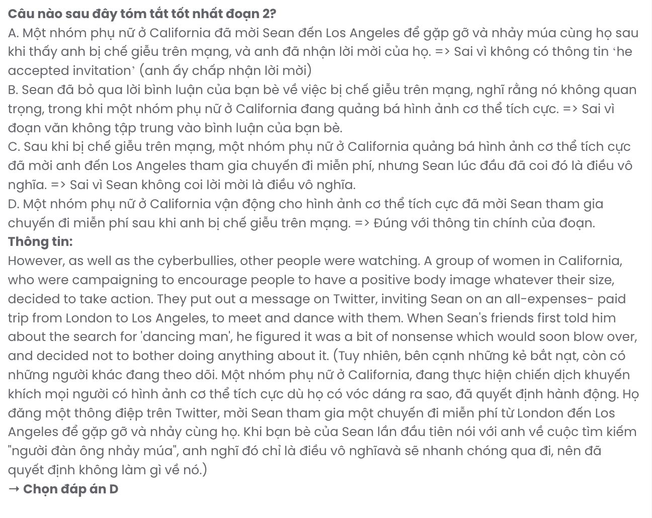
Question 36. Where in paragraph 3 does the following sentence best fit?

But the movement got bigger and bigger.
A. [I] B. [II] C. [III] D. [IV]
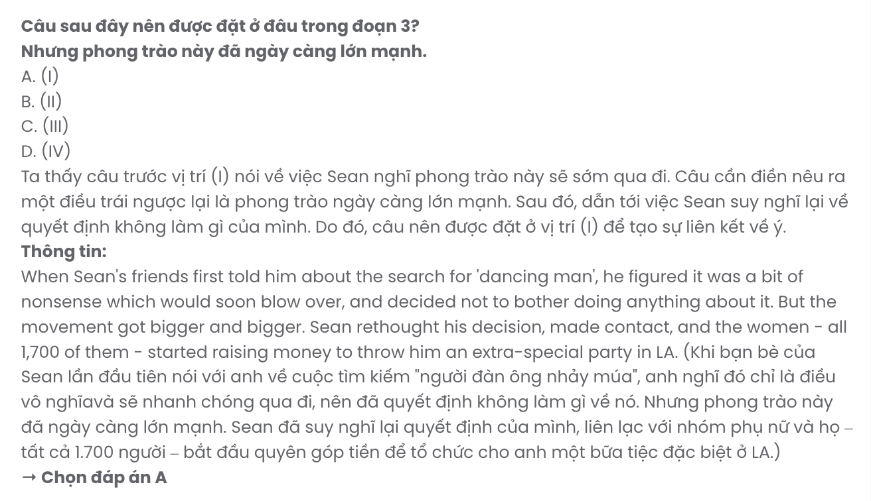
Question 37. Which of the following best paraphrases the underlined sentence in paragraph 3?

Sean had assumed that just a few people would turn up, but he realised his mistake as soon as he saw over 1,000 people queuing to get into the nightclub!
A. Sean believed only a handful of people would attend, but he quickly realised his error when he saw over 1,000 people lined up outside the nightclub.
B. Sean was confident that no one would show up, but he was shocked to see a nearly empty line at the nightclub entrance.
C. Sean thought the turnout would be massive, but he was surprised to find only a few people waiting to enter the nightclub.
D. Sean assumed a small crowd would appear, but he was stunned to discover more than 1,000 people eagerly dancing in the nightclub.
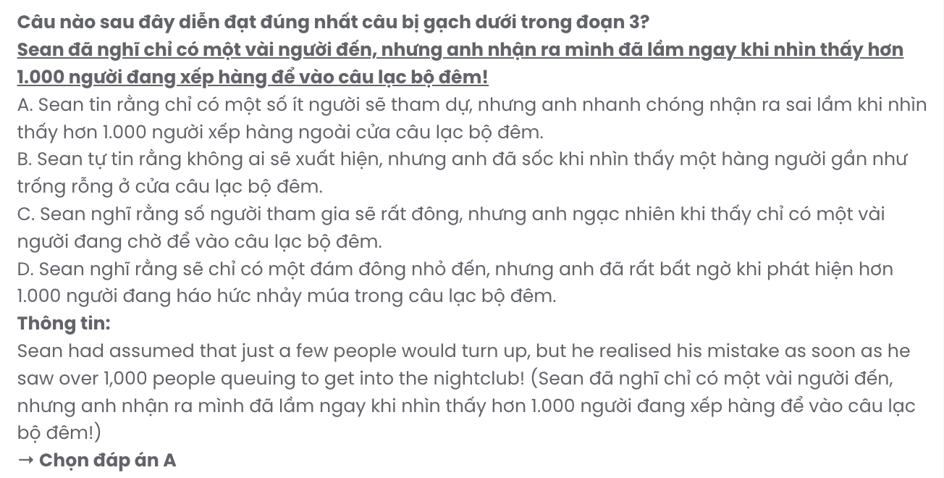
Question 38. Which of the following is true about Sean O'Brien according to the passage?
A. He wasn’t required to pay any costs to join the dance party in California.
B. He wasn’t taken aback by the number of people joining his dance party.
C. He accepted the offer by a group of women in California without hesitation.
D. He established an online forum for those who got cyberbullied like him.
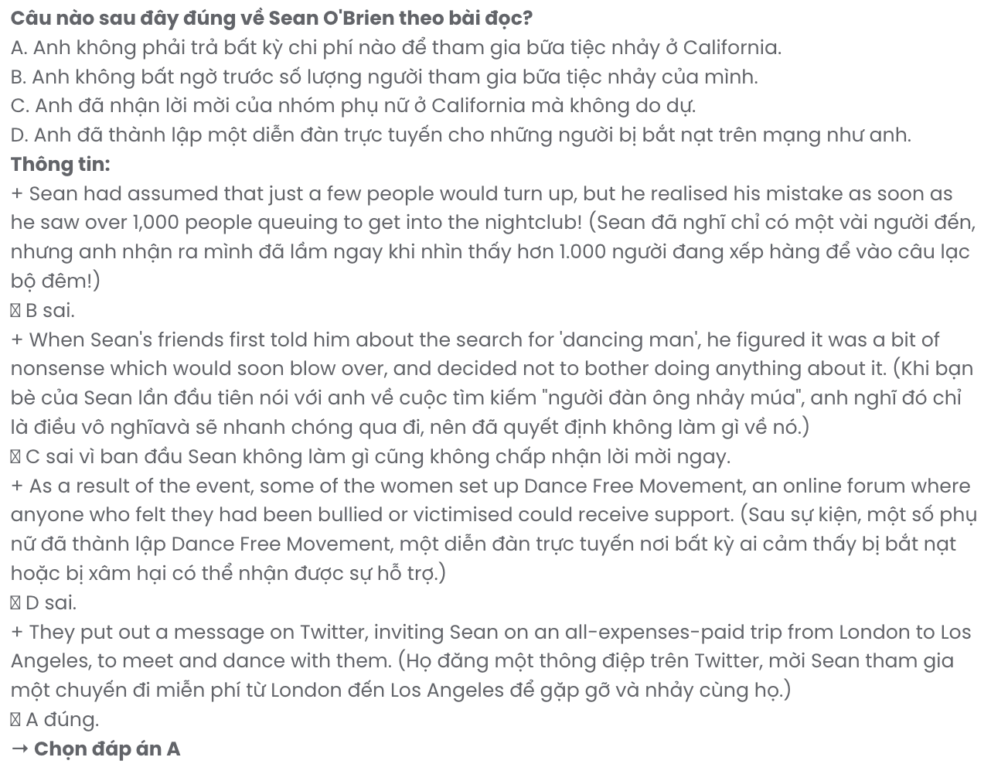
Question 39. Which of the following can be inferred from the passage?
A. Not feeding what online bullies want is the most sensible way to combat them.
B. Initially, Sean wasn’t bold enough to raise his voice against cyber bullies.
C. Online bullies who frequently mock others definitely suffer from mental health issues
D. The women’s initiative in California may reshape how we should deal with bullies.
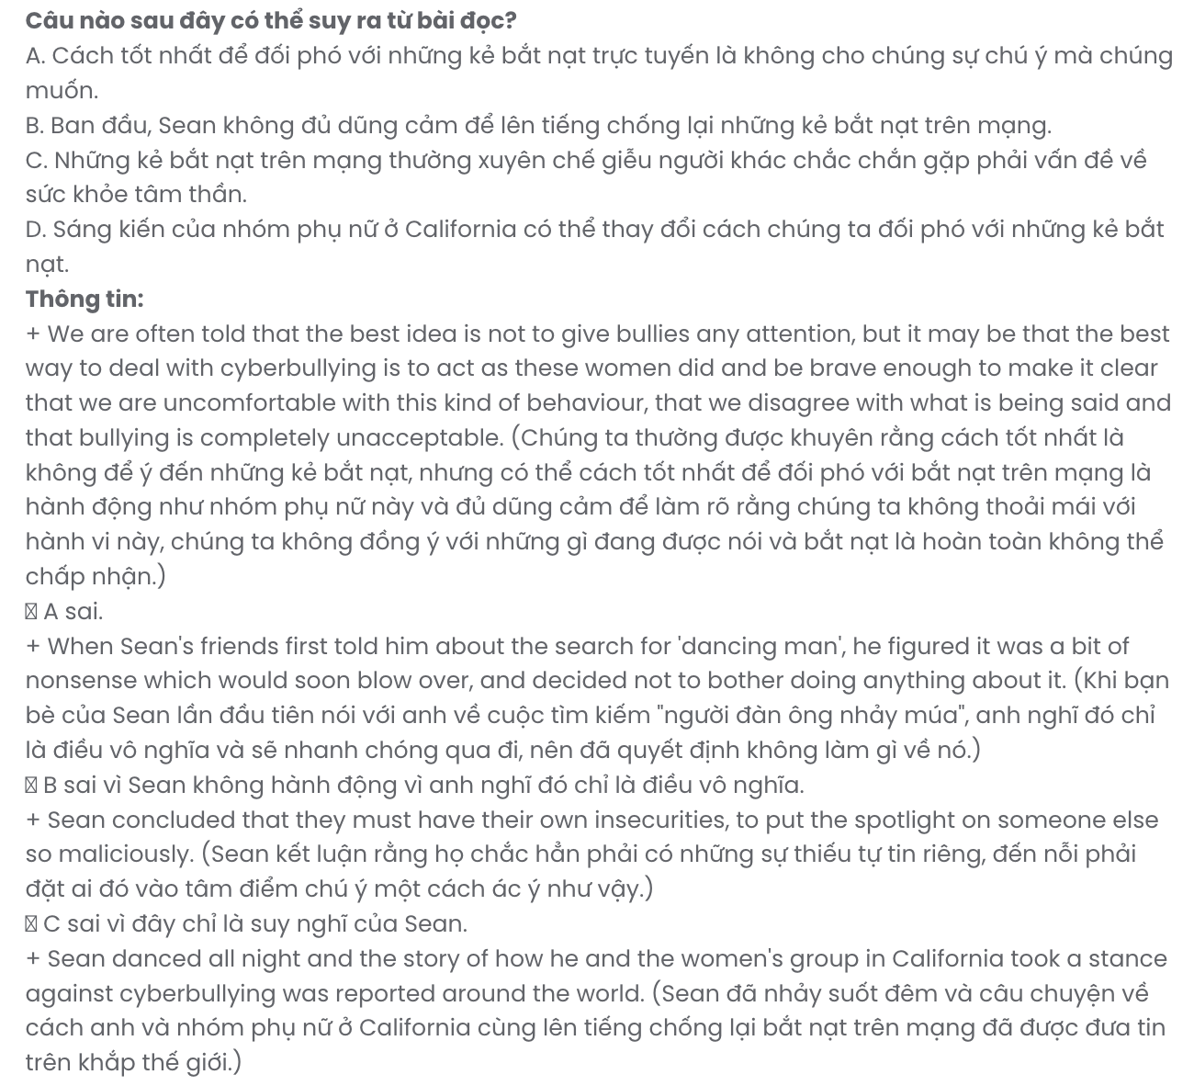

Question 40. Which of the following best summarises the passage?
A. Sean was mocked online for dancing, but Californian women organized a fundraiser to support him, which encouraged Sean to create the Dance Free Movement and several anti-bullying campaigns.
B. Mocked online for dancing, Sean received support from Californian women who invited him to a body positivity event, inspiring him to become a social media influencer.
C. After being fat-shamed online, Sean was invited by Californian women to a party promoting body positivity, sparking a global anti-cyberbullying movement and leading to the Dance Free Movement forum.
D. After cyberbullies targeted Sean, he ignored the incident, but Californian women were determined to turn it into a global anti-cyberbullying movement.

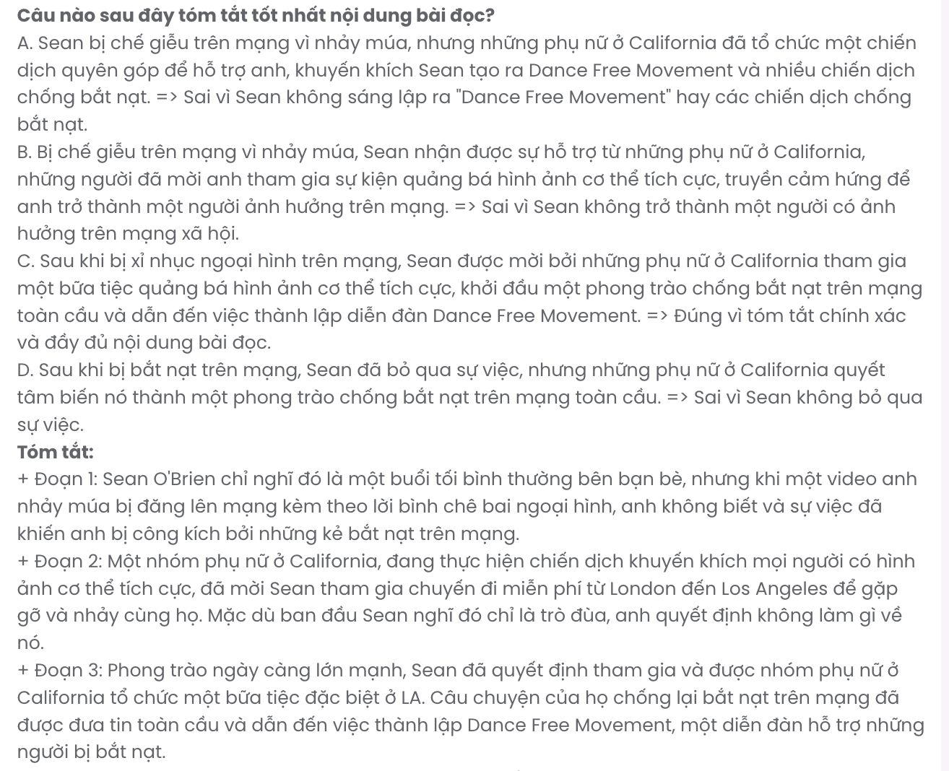
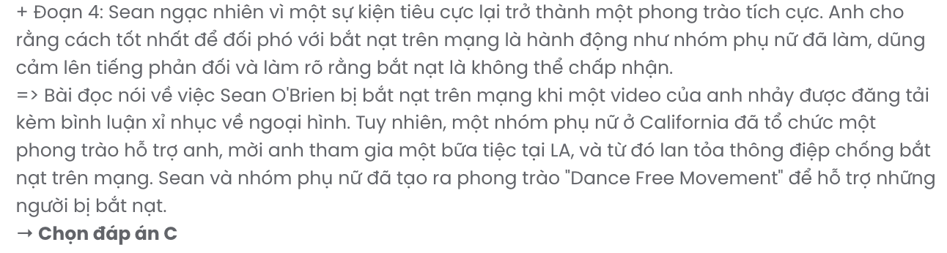

BẢNG TỪ VỰNG
STT | Từ vựng | Từ loại | Phiên âm | Nghĩa
1 | Sustainable | adj | /səˈsteɪnəbl/ | bền vững
2 | Fulfilment | n | /fʊlˈfɪlmənt/ | sự hoàn thành, sự thỏa mãn
3 | benefit | v | /ˈbenɪfɪt/ | đem lại lợi ích
4 | waste | n | /weɪst/ | rác thải
5 | collective | adj | /kəˈlektɪv/ | tập thể
6 | reuse | v | /ˌriːˈjuːz/ | tái sử dụng
7 | renewable | adj | /rɪˈnuːəbl/ | có thể tái tạo
8 | struggle | v | /ˈstrʌɡl/ | vật lộn
9 | dedication | n | /ˌdedɪˈkeɪʃən/ | sự cống hiến
10 | supportive | adj | /səˈpɔːtɪv/ | hỗ trợ
11 | compassionate | adj | /kəmˈpæʃənət/ | thương cảm
12 | essential | n | /ɪˈsenʃəl/ | điều cốt yếu, thứ thiết yếu
13 | sympathy | n | /ˈsɪmpəθɪ/ | lòng thông cảm
14 | utensil | n | /juːˈtensəl/ | dụng cụ
15 | recipe | n | /ˈresɪpi/ | công thức nấu ăn
16 | extensive | adj | /ɪkˈstensɪv/ | rộng lớn
17 | bustling | adj | /ˈbʌslɪŋ/ | nhộn nhịp
18 | state-of-the-art | adj | /ˈsteɪt əv ði ɑːt/ | hiện đại nhất
19 | innovation | n | /ˌɪnəˈveɪʃən/ | sự đổi mới
20 | vibrant | adj | /ˈvaɪbrənt/ | rực rỡ, sôi động
21 | lush | adj | /lʌʃ/ | xanh tươi, sum suê
22 | notice | v | /ˈnəʊtɪs/ | nhận thấy
23 | collaboration | n | /kəˌlæbəˈreɪʃən/ | sự hợp tác
24 | immediate | adj | /ɪˈmiːdiət/ | ngay lập tức
25 | linguistic | adj | /lɪŋˈɡwɪstɪk/ | thuộc ngôn ngữ
26 | revitalise | v | /ˌriːˈvaɪtəlaɪz/ | làm sống lại
27 | consumption | n | /kənˈsʌmpʃən/ | tiêu thụ
28 | unwind | v | /ʌnˈwaɪnd/ | thư giãn
29 | highlight | v | /ˈhaɪˌlaɪt/ | nổi bật, làm nổi bật
30 | well-being | n | /ˌwelˈbiːɪŋ/ | sức khỏe, hạnh phúc
31 | gather | v | /ˈɡæðər/ | tập hợp, quây quần
32 | harmony | n | /ˈhɑːməni/ | hài hòa
33 | rewarding | adj | /rɪˈwɔːdɪŋ/ | đáng giá, bổ ích
34 | promote | v | /prəˈməʊt/ | thúc đẩy
35 | strengthen | v | /ˈstreŋθən/ | tăng cường
36 | unusual | adj | /ʌnˈjuːʒʊəl/ | khác thường
37 | honour | v | /ˈɒnə/ | tôn vinh
38 | custom | n | /ˈkʌstəm/ | tập quán
39 | ordinary | adj | /ˈɔːdənəri/ | bình thường
40 | prompt | v | /prɒmpt/ | thúc giục
41 | abuse | v | /əˈbjuːz/ | lạm dụng
42 | immature | adj | /ˌɪməˈtjʊə/ | chưa trưởng thành
43 | rethink | v | /ˌriːˈθɪŋk/ | suy nghĩ lại
44 | queue | n | /kjuː/ | hàng đợi
45 | unacceptable | adj | /ˌʌnəkˈseptəbl/ | không thể chấp nhận
46 | insecurity | n | /ˌɪnsɪˈkjʊərɪti/ | sự bất an

BẢNG CẤU TRÚC
STT | Cấu trúc | Nghĩa
1 | Take initiatives | dẫn đầu, chủ động
2 | Call for | yêu cầu
3 | Make an impact on | ảnh hưởng đến
4 | Allow somebody to do something | cho phép ai làm gì
5 | Connect with | kết nối với
6 | Take part in | tham gia vào
7 | In place of | thay thế
8 | Point out | chỉ ra
9 | Impression on | ấn tượng với
10 | Commitment to | cam kết với
11 | Pass down | truyền lại
12 | Remind somebody of something | nhắc nhở ai về điều gì
13 | Take aback | ngạc nhiên
14 | Unaware of | không biết, không nhận thức được
15 | Blow over | qua đi (sự việc, khủng hoảng)

