|  |  |
| --- | --- |
| **SỞ GD&ĐT THỪA THIÊN HUẾ**  **TRƯỜNG THPT CHUYÊN QUỐC HỌC – HUẾ**  TRƯỜNG THPT CHUYÊN QUỐC HỌC HUẾLỊCH SỬ HÌNH THÀNH VÀ PHÁT ... | **KỲ THI CHỌN HỌC SINH GIỎI CÁC TRƯỜNG THPT CHUYÊN**  **KHU VỰC DUYÊN HẢI VÀ ĐỒNG BẰNG BẮC BỘ**  **LẦN THỨ …., NĂM 2023**  **ĐỀ THI MÔN: TIẾNG ANH - LỚP 10**  *Thời gian: 180 phút (Không kể thời gian giao đề)* |

**ĐÁP ÁN VÀ HƯỚNG DẪN CHẤM**

**SECTION A: LISTENING (50 points)**

***Part 1. You will hear a man phoning the owner of a holiday cottage. For questions 1-5, complete the notes by writing ONE WORD AND/OR A NUMBER for each answer. Write your answers in the corresponding numbered boxes provided on the answer sheet. (10 points)***

1.   £550

2.   Chervil

3.   garage

4.   garden

5.   parking

***Part 2. You will hear a man talking about insomnia. For questions 6-10, decide whether the following statements are true (T) or false (F). Write your answers in the corresponding numbered boxes provided on the answer sheet. (10 points)***

6. T

7. F

8. F

9. F

10. T

***Part 3. You will hear part of an interview with a woman called Barbara Darby, who works as a casting director in the film industry. For questions 11-15, choose the answer (A, B, C or D) that fits best according to what you hear. Write your answers in the corresponding numbered boxes provided on the answer sheet. (10 points)***

11. D

12. B

13. C

14. A

15. C

***Part 4. You will hear a man talking about depression. For questions 16-25, complete the summary by writing NO MORE THAN THREE WORDS******for each answer. Write your answers in the corresponding numbered boxes provided on the answer sheet. (20 points)***

16. brain chemicals 17. specific tasks

18. insurmountable 19. medical condition

20. personality trait 21. guilty for struggling

22. talking openly 23. suicide risk

24. erode stigma 25. seek treatment

**SECTION B: LEXICO- GRAMMAR (40 points)**

***Part 1. For questions 26-45, choose the best option A, B, C, or D to complete the following sentences and write your answers in the corresponding numbered boxes provided on the answer sheet. (20 points)***

26. A 27. B 28. B 29. C

30. B 31. C 32. C 33. B

34. B 35. A 36. A 37. B

38. D 39.C 40. A 41. D

42. C 43. A 44. A 45. B

***Part 2. For questions 46-55, fill each gap with the correct form of the words in brackets. Write your answer in the boxes provided on the answer sheet. (10 points)***

46. ferociously 47. estrangement

48. liquified 49. partition

50. surcharge 51. cleavage

52. transcendental 53. climactic

54. disarmament 55. benevolent

***Part 3. For questions 56-65, complete each of the following sentences with suitable preposition(s). Write your answer in the boxes provided on the answer sheet. (10 points)***

56. up 57. on

58. to 59. off

60. with 61. down

62. out 63. at

64. up 65. out

**SECTION C: READING (60 points)**

***Part 1. For questions 66-75, read the following passage and decide which option (A, B, C, or D) best fits each gap. Write your answers in corresponding numbered boxes on the answer sheet. (15 points)***

66. A 67. D

68. A 69. C

70. B 71. B

72. A 73. D

74. D 75. C

***Part 2. For questions 76-85, fill each of the following numbered blanks with ONE suitable word and write your answers in the corresponding numbered boxes on the answer sheet. (15 points)***

76. matter 77. into

78. might/ may/ can 79. Regardless/ Irrespective

80. state 81. bring

82. under 83. let

84. apply 85. how

***Part 3. For questions 86-95, read the following passage and circle the best answer to each of the following questions. Write your answers in corresponding numbered boxes provided on the answer sheet. (15 points)***

86. C 87. C

88. B 89. D

90. B 91. C

92. D 93. A

94. C 95. B

***Part 4. For questions 96-105, read the passage and do the following tasks. Write your answers in the corresponding numbered boxes on the answer sheet. (15 points)***

96. A – vi 97. B – v

98. C – viii 99. D – i

100. E – iv 101. F – vii

102. thousands of years 103. (tree) bark

104. overseas museums 105. school walls

**D. WRITING (50 points)**

***Part 1. (20 points)***

***The bar chart provides information about how often people in the USA spent ate fast food from 2003 to 2013. Summarize the information by selecting and reporting the main features and make comparisons where relevant. You should write about 150 words on the answer sheet provided.***

1. Introduction: The bar chart details fast food consumption in the United States in 2003, 2006, and 2013.

2. Overview: - Frequent consumption of fast food, defined as at least once a week, generally became less common.

- Having fast food once a week or once or twice a month remained the dominant trends.

- An exception to this pattern is not eating fast food, which declined.

3. Details: - Most pervasive habits, in 2003, 31% of individual ate fast food once a week compared to 30% eating it once or twice a month.

- The trends diverged with those eating once a week rising in 2006 and falling in 2013.

- Eating once or twice a month fell and surged in the final year.

- The figure for those eating fast food several times a week rose in 2006 and dipped in 2013.

- The number of individuals consumed fast food a few times a year stabilized for the final two years recorded.

- The numbers for every day and never were nearly identical.

***Part 2. Write an essay of about 250 words to express your opinion on the following topic. (30 points)***

**Many efforts have been made by countries to address challenges concerning the environment, but the situation has not improved. What are the possible reasons for environmental degradation? Are there any solutions to combat this problem?**

***Give reasons for your answer and include any relevant examples from your own knowledge or experience.***

The mark given to Part 2 is based on the following scheme:

1. Content: 35% of total mark

- Providing all main ideas and details as required

- Communicating intentions sufficiently and effectively

2. Organization and presentation: 30% of total mark

- Ideas are well organized and presented with coherence, cohesion and clarity.

- The essay is well-structured

3. Language: 30% of total mark

- Demonstration of a variety of vocabulary and structures appropriate to the level of English language gifted upper-secondary school students

- Good use and control of grammatical structures

4. Handwriting, punctuation and spelling: 5% of total mark

- Intelligible handwriting

- Good punctuation and no spelling mistakes

-----THE END-----

**AUDIOSCRIPT WITH ANSWERS UNDERLINED**

***Part 2.*** [Dan Kwartler: What causes insomnia? | TED Talk](https://www.ted.com/talks/dan_kwartler_what_causes_insomnia?language=en)

What keeps you up at night? Pondering deep questions? Excitement about a big trip? Or is it stress about unfinished work, an upcoming test, or a dreaded family gathering? For many people, this stress is temporary, as its cause is quickly resolved. But what if the very thing keeping you awake was stress about losing sleep? This seemingly unsolvable loop is at the heart of insomnia, the world’s most common sleep disorder.

00:36

Almost anything can cause the occasional restless night - a snoring partner, physical pain, or emotional distress. And **(6)** **extreme sleep deprivation like jetlag can throw off your biological clock**, wreaking havoc on your sleep schedule. But **(7) in most cases, sleep deprivation is short-term**. Eventually, exhaustion catches up with all of us.

00:59

However, **(8) some long-term conditions like respiratory disorders, gastrointestinal problems, and many others can overpower fatigue**. And as sleepless nights pile up, the bedroom can start to carry associations of restless nights wracked with anxiety. **(9) Come bedtime, insomniacs are stressed**. **(10) So stressed their brains hijack the stress response system, flooding the body with fight-flight-or-freeze chemicals. Cortisol and adrenocorticotropic hormones course through the bloodstream, increasing heart rate** and blood pressure, and jolting the body into hyperarousal. In this condition, the brain is hunting for potential threats, making it impossible to ignore any slight discomfort or nighttime noise.

01:46

And when insomniacs finally do fall asleep, the quality of their rest is compromised. Our brain’s primary source of energy is cerebral glucose, and in healthy sleep, our metabolism slows to conserve this glucose for waking hours. But PET studies show the adrenaline that prevents sleep for insomniacs also speeds up their metabolisms. While they sleep, their bodies are working overtime, burning through the brain’s supply of energy-giving glucose. This symptom of poor sleep leaves insomniacs waking in a state of exhaustion, confusion, and stress, which starts the process all over again.

***Part 3***

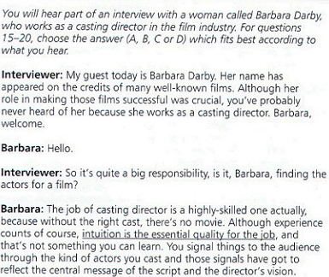

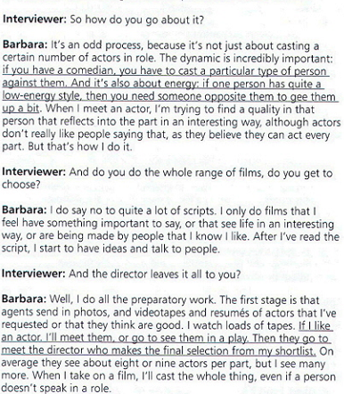

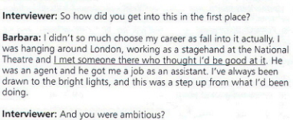

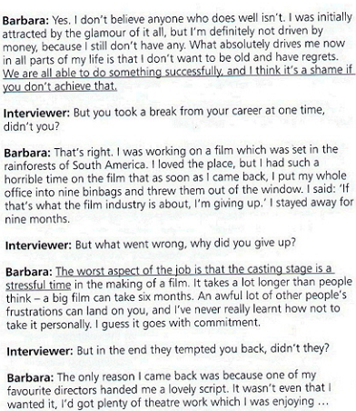

***Part 4.*** [Helen M. Farrell: What is depression? | TED Talk](https://www.ted.com/talks/helen_m_farrell_what_is_depression/transcript?language=en)

Depression is the leading cause of disability in the world. In the United States, close to 10% of adults struggle with depression. But because it's a mental illness, it can be a lot harder to understand than, say, high cholesterol.

According to the National Institute of Mental Health, it takes the average person suffering with a mental illness over ten years to ask for help. But there are very effective treatments. Medications and therapy complement each other to boost **(16)** **brain chemicals**. So, if you know someone struggling with depression, encourage them, gently, to seek out some of these options. You might even offer to help with **(17) specific tasks**, like looking up therapists in the area, or making a list of questions to ask a doctor. To someone with depression, these first steps can seem **(18) insurmountable**. If they feel guilty or ashamed, point out that depression is a **(19)** **medical condition**, just like asthma or diabetes. It's not a weakness or a **(20) personality trait**, and they shouldn't expect themselves to just get over it anymore than they could will themselves to get over a broken arm. If you haven't experienced depression yourself, avoid comparing it to times you've felt down. Comparing what they're experiencing to normal, temporary feelings of sadness can make them feel **(21)** **guilty for struggling**. Even just **(22) talking** about depression **(22)** **openly** can help. For example, research shows that asking someone about suicidal thoughts actually reduces their **(23) suicide risk**. Open conversations about mental illness help **(24) erode stigma** and make it easier for people to ask for help. And the more patients **(25) seek treatment**, the more scientists will learn about depression, and the better the treatments will get.