|  |
| --- |
| **TA7 i-Learn Smart World_Ss_Unit 2 Time allotted: 60** |

**PART 1**  **PRONUNCIATION (5 questions)**

**Choose the word that has the underlined part pronounced differently from the others.**

1. A. t**ea** B. s**ea** C. h**ea**t D. sw**ea**t

2. A. w**e** B. ch**e**st C. p**e**t D. l**e**g

3. A. p**ea** B. h**ea**d C. t**ea**m D. p**ea**ch

4. A. l**e**tter B. s**e**ntence C. tw**e**nty D. f**e**ver

5. A. k**e**y B. t**e**nt C. h**e**n D. p**e**n

**PART 2**  **VOCABULARY (10 questions)**

**Complete the text using the words in the box. (5 questions)**



6. ___________ a temperature  
 7. ___________ some aspirins  
 8. ___________ a headache  
 9. ___________ some rest  
10.___________ better

**Complete the conversation using the words or phrases in the box. (5 questions)**

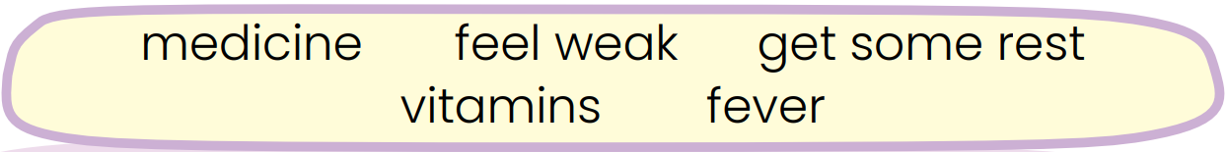

Mom: What’s the matter with you, Misa?  
Misa: I don’t know. But I (11)___________ and tired.  
Mom: Let me see. You have a (12)___________.  
Misa: What should I do? Should I take (13)___________?  
Mom: No, you shouldn’t. First, stay in bed, lie down and (14)___________. Then, I will help you reduce your body temperature.  
Misa: And may I drink orange juice, Mom?  
Mom: Sure. (15)___________ from fruit and vegetables are good for you.  
Misa: Thank you, Mom.

**PART 3**  **GRAMMAR (10 questions)**

**Complete the conversation using the indefinite quantifiers in the box. (5 questions)**



**Mom**: I’m making chocolate cakes today, Susie.   
**Susie**: That’s great, Mom. How can I help?   
**Mom**: First, I need (16) ___________ sugar for making cakes. Please pass me the jar on the table.  
**Susie**: Here you are. Anything else, Mom?   
**Mom**: Thanks, Susie. I need (17)___________ eggs, too.  
**Susie**: There aren’t (18)___________ eggs left in the fridge.   
**Mom**: How about the flour on the shelf?   
**Susie**: Yes, Mom. There is a (19) ___________ flour here.   
**Mom**: I also need salt.   
**Susie**: There isn’t (20) ___________ salt left.   
**Mom**: So we need to go to the market to get some.

**Choose the correct options. (5 questions)**

21. She doesn’t like to take ______________ medicine when she is sick.

A. any B. many C. a lot D. some

22. The baby drinks ______________ milk. He loves it.

A. many B. any C. a lot D. lots of

23. Would you like to have ______________ fried chicken?

A. any B. some C. a lot D. a little

24. I need ______________ eggs to make a birthday cake for my daughter.

A. any B. much C. lots of D. a little

25. You shouldn't add too ______________ salt to your dishes.

A. some B. a little C. many D. much

**PART 4**  **READING (10 questions)**

**Read the class survey report on healthy living. Choose the correct answers. (5 questions)**

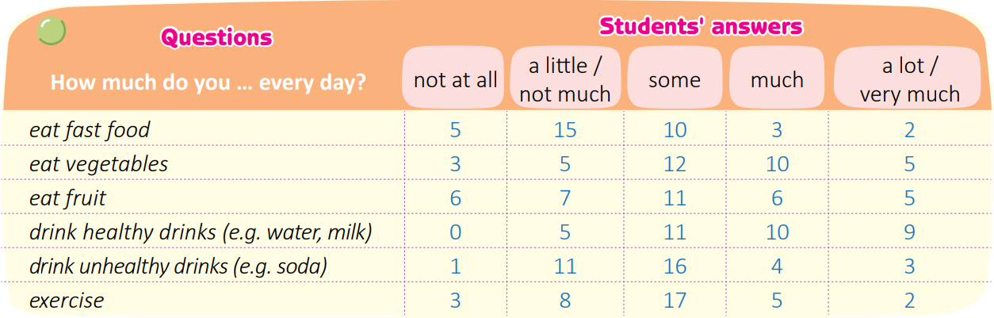

26. How many survey questions are there?

A. 5 B. 6 C. 7 D. 8

27. How many students do not exercise at all every day?

A. 0 B. 3 C. 17 D. 35

28. Which do most students do much every day?

A. eat fast food B. eat fruit C. exercise D. drink healthy drinks

29. What does the report show?

A. Most of the students eat vegetables every day.

B. All of the students eat a lot of fruit every day.

C. About half of the students drink healthy drinks every day.

D. Under half of the students exercise every day.

30. Which is NOT true according to the report?

A. Two of the students eat a lot of fast food.

B. Twelve of the students just eat some vegetables.

C. Nine of the students drink a lot of water.

D. Nobody in the survey exercises.

**Read the text about how to have a healthy eating habit. Complete each sentence with ONE WORD. (5 questions)**

|  |
| --- |
| HOW TO HAVE A HEALTHY EATING HABIT  **Do Not Eat Too Much Fast Food**   Fast food contains a lot of unhealthy fats and calories. When you eat fast food too often, it is easy for you to gain weight. Besides, your cholesterol level and your risk of cancer will be very high.  **Do Not Eat Too Much Red Meat**   It is OK to eat red meat, but eating too much red meat is unhealthy and may increase your health risks. Red meat is high in cholesterol, sodium, and saturated fat - a type of fat that is bad for your health.  **Do Not Drink Too Much Soda**   A can of soda is high in calories and sugar. Those who consume too much soda face health risks, such as diabetes and tooth decay. They may also gain weight and have high cholesterol levels.  **Eat More Fruit and Vegetables**   Fruit and vegetables contain a lot of nutrition and vitamins. They can protect you from many diseases. This type of food can lower cholesterol levels and help you lose weight.  **Drink Enough Water**   Water is essential for the proper functioning of all body parts and organs. A person should drink eight glasses of water per day on average. Your organs, particularly your brain, begin to shut down after three to five days of not drinking water. |

- Fast food contains (31) ___________ fats. They can be harmful to one’s health.   
- Eating too much red meat can raise your health (32) ___________.   
- Too much soda can cause (33) ___________ levels to increase.   
- Nutrition and (34) ___________ in fruit and vegetables help protect people from diseases.   
- Drinking (35) ___________ glasses of water per day is good for the human body.

**PART 5**  **LISTENING (10 questions)**

**Listen to an interview with David Chang. Choose the correct options. (5 questions)**

36. David Chang is ______________.

A. a chef B. a food expert C. a doctor D. a book publisher

37. David’s book is mainly about ______________.

A. a teenager B. teenagers’ food choice C. teenage lifestyles D. teenagers’ study

38. Teenagers tend to have ______________ fast food and soft drink.

A. a little B. some C. lots of D. too much

39. David says teenagers have to study more at learning centers ______________.

A. after school B. on weekends C. after relaxing time D. on weekdays

40. ______________ the problems can affect teenagers’ health.

A. None of B. One of C. Two of D. All of

**Listen again. Fill in each gap with ONE WORD. (5 questions)**

- Bad eating (41) ___________ make teenagers become overweight.   
- Too much study can cause bad eyesight, stress and lack of (42) ___________.   
- Teenagers should learn how to manage their time and spend more time on (43) ___________ activities.   
- Many teenagers choose to (44) ___________ in bed after studying rather than exercise.   
- Lack of exercise causes many health risks, so teenagers should do (45) ___________ such as yoga, aerobics or walking.

**PART 6**  **SPEAKING (5 questions)**

**Complete the conversation using the sentences in the boxes. (5 questions)**

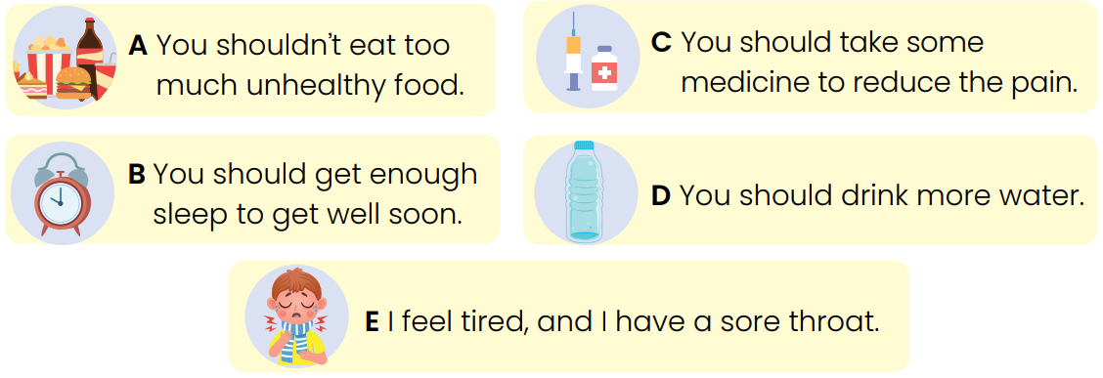

**Doctor**: Good morning. How can I help you?   
**Patient**: (46)___________   
**Doctor**: I see. Do you drink enough water every day?   
**Patient**: No. Sometimes, I drink too much coke.   
**Doctor**: (47)___________   
Do you eat fruit and vegetables?   
**Patient**: No, not really. I eat a lot of fast food such as French fries.   
**Doctor**: (48)___________   
**Patient**: OK.   
**Doctor**: Do you sleep eight hours a night?   
**Patient**: Actually, I don’t.   
**Doctor**: (49)___________   
**Patient**: Now, I can see that I have an unhealthy lifestyle.   
Should I take some medicine?   
**Doctor**: Yes. (50)___________   
**Patient**: Thank you, Doctor.   
**Doctor**: You’re welcome.

**PART 7**  **WRITING (5 questions)**

**Complete the request letter using the phrases or sentences in the box. (5 questions)**

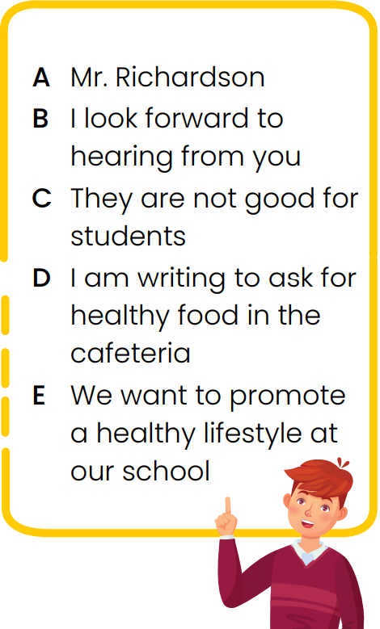

Andy Tran   
12 Oak Street   
Ryde NSW 2112   
Brian Richardson   
607 Dennis Ave   
Dear (51)___________ ,   
My name is Andy Tran, and I am in Class 7F. (52)___________. Our school’s cafeteria serves food such as fast food and soda. (53) ___________. As a principal, you should decide what food the cafeteria will serve and add healthier options to the menu. (54) ___________. Please listen to us and provide us with healthier food.   
 (55) ___________.   
Sincerely,   
Andy Tran

**---THE END---**