Date of preparing: ………………………………….
Date of teaching: ………………………………….

Period……
UNIT 2: SCHOOL
Lesson 3 - Part 2 (Page 21) – Reading, Speaking and Writing

I. OBJECTIVES
By the end of the lesson, Ss will be able to…
1. Knowledge
- read a book review about a Vietnamese book.
- talk about favorite book.
- write a book review.
2. Ability
- improve the reading, speaking and writing skills.
3. Quality
- have positive attitude in English language learning so that they actively participate in all classroom activities.
- love reading books.

II. TEACHING AIDS AND LEARNING MATERIALS
Lesson plan, PPT slides, student’s book, workbook, notebook, personal computer (if any), projector/TV, speakers, DCR &DHA on EDUHOME, handouts…
III. PROCEDURES
A. Warm up: (5’)
a) Objective: to introduce the new lesson and set the scene for Ss to learn the new language; to get students' attention at the beginning of the class by means of enjoyable and short activities as well as to engage them in the steps that follow.
b) Content: introduction of the film / the book “Yellow Flowers on the Green Grass”
c) Product: Ss have a general idea about the book they are going to read review in the lesson
d) Competence: Collaboration, synthesizing skill.
e) Organization of the activity:
Teacher’s Activities | Students’ Activities
- Give greetings  - Check attendance  - Option 1:  - Show the trailer of the film “Yellow Flowers on the Green Grass”, then introduce something about the film. (It was produced basing on the novel “Yellow Flowers on the Green Grass” by Nguyen Nhat Anh. The book is loved by many people, especially teenagers)  Link:  https://www.youtube.com/)watch?v=wmjiCP6R-7I  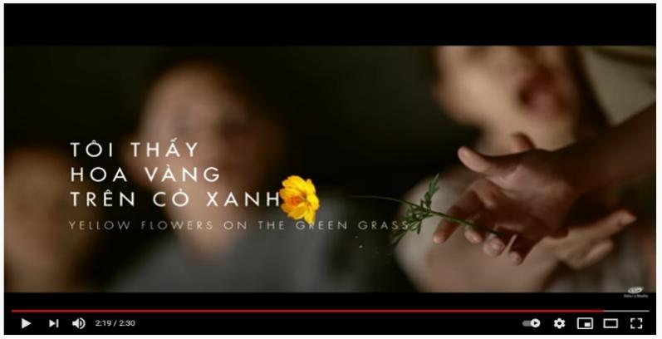  → Lead to the new lesson.  - Option 2:  - Ask Ss whether they’ve read about the book “Yellow Flowers on the Green Grass”  - Show the book on the screen or bring the book to class to introduce it to Ss  - Have Ss close books, give some multiple-choice questions to check how much Ss know about this book  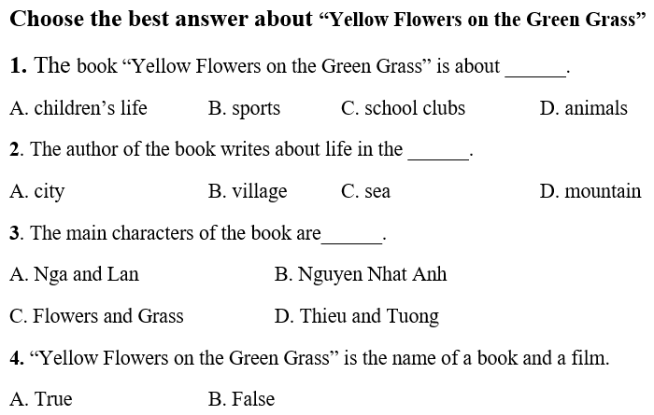  - Give a small gift or a big applause for Ss who can give the right answers  → Lead to the new lesson | - Greet T  - Watch  - Listen  - Look and listen  - Look and give answers  Answer keys  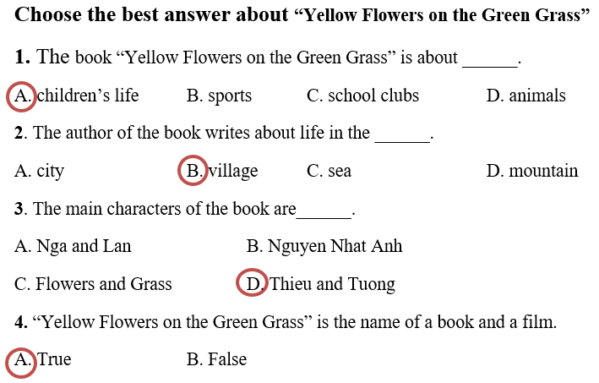  - Listen

B. New lesson (35’)
- Activities 1: Reading (10’)
a) Objective: Ss read and understand what a book review is.
b) Content:
- reading the book review “Yellow Flowers on the Green Grass” and circle True or False.
c) Products: Ss can recognize the correct and incorrect information in reading comprehension as well as some general ideas about a Vietnamese famous literature work.
d) Competence: Collaboration, communication, analytical and synthesizing skills.
e) Organization of the activity:
Teacher’s Activities | Students’ Activities
Read the book review “and circle “True” or “False”  - Option 1:  - Have Ss read the text individually  - Have some Ss read the text aloud  - Demonstrate the activity by using the example  - Have Ss read the sentences and circle “True” or “False”  - Check answers as a whole class  - Option 2:  - Have Ss read the sentences first, find and underline key words (important words that help Ss find answers quicky and correctly)  - Have Ss work in pairs to read and do the task  - Call Ss to give answers, show key words or explain how they can find the answers  - Have Ss correct the false one(s)  - Check answers as a whole class  - Give feedback | - Read in silence  - Read in front of the class  - Do the task  - Check and correct mistake  Answer keys  2.F 3.F 4.F 5.T 6.T  - Work individually  - Work in pairs  - Give answers, explain  Answer keys  2. F (The writer thinks the book is interesting.)  3. F (The story is about the boys as they grow up)  4. F (In the story, Tường lives in a village.  5. T  6. T
- Activity 2: Speaking: Book Lover (10’)
a) Objective: Ss can talk about their favorite book.
b) Content: role- playing a conversation about favorite book(s).
c) Products: Ss produce the language successfully, and they can talk about the book they like using the language learnt in the unit.
d) Competence: Collaboration, communication, creativity, public speaking
e) Organization of the activity:

Teacher’s Activities | Students’ Activities
a. Role play the conversation in the box, then swap roles and do the same with the other books  - Option 1:  - Demonstrate the activity by practicing the role play with a student  - Have Ss practice the conversation in pairs  - Have Ss swap the roles and continue with the other books  - Have some pairs act out the conversation in front of the class  - Give feedback and evaluation  - Option 2:  - Follow the same steps as option 1  - Give Ss more structures used in their conversation, show on the screen or use handouts  A: What’s your favorite book? / Which book do you like best?  B: I like … / I love … / My favorite book is …  A: What kind / type / sort of book is it?  B: It’s …  A: Who’s the author? / Who writes that book?  B: It’s by …  A: Why do you like it?  B: I think it’s … / Because it’s …  - Give Ss more adjectives to express why they like the book: interesting, funny, fantastic, adventurous, fascinating, thrilling, moving  b. Now try with books that you know  - Have Ss practice the role-play with other books they know  - Have some Ss share their ideas with the class  - Give feedback and evaluation | - Observe and listen  - Work in pairs  - Work in pairs  - Present  - Read  - Work in pairs  - Listen, write in notebooks  - Work in pairs  - Present
- Activity 3: Writing (15’)
a) Objective: Ss can write a book review.
b) Content: reading the writing tips, answering the questions, and writing.
c) Products: Ss can use what they have learnt to produce the language successfully.
d) Competence: Collaboration, communication, critical thinking, creativity.
e) Organization of the activity:

Teacher’s Activities | Students’ Activities
a. Read the writing tips and answer the questions  - Focus on the Writing Tip box  - Explain when to use capital letters  - Have Ss read the Writing Tip and the questions  - Have Ss answer the questions  - Have some Ss share their ideas with the class  b. Use your answers in Task a. to write a book review Use the Reading to help you. Write 40 to 50 words  - Option 1:  - Have Ss use their answers in Task a. and the Reading to write a book review in their notebooks  - Have some Ss write their paragraph on the board  - Check, correct Ss’ mistakes and give evaluation  - Option 2:  - Have Ss use their answers in Task a. and the Reading to write a book review  - Remind Ss the outline / content of a book review:  Name of the book  Type of the book  Author  Reasons for choosing the book  Recommendation  - Have Ss work in groups to choose a book and write in extra board  - Have groups hang their extra board on the big board  - Check, correct Ss’ mistakes and give evaluation  - Ask Ss to finish the writing in their notebooks | - Look  - Listen  - Work in pairs  - Give answers  - Present  - Work individually  - Write  - Work in groups  - Listen, write in notebooks

C. Consolidation (3’)
* Talk / write about a book review:
Name of the book
Type of the book
Author
Reasons for choosing the book
Recommendation
D. Homework (2’)
- Finish the writing part
- Read more books for children
- Do exercises in Workbook: Lesson 2 – Reading and Writing (page 13)
- Prepare: Unit 2 - Review (page 88 – SB)

