ĐỀ VIP 8+ SỐ 8
Read the following email and mark the letter A, B, C or D on your answer sheet to indicate the option that best fits each of the numbered blanks from 1 to 6.
Dear Customer Support Team,
I am writing this email to (1) a complaint regarding the delivery of my recent order (#12345) from your company, QuickShip Express. The delivery date initially (2) was December 1st, but I have yet to receive my package, and there has also been no update (3) its status.
I understand that delays can sometimes happen, but a(n) (4) of communication is even more frustrating. Could you please provide me with information about the whereabouts of my order and let me know when I can expect it (5) ?
I would appreciate your prompt attention to this matter. Thank you for your time and (6) . Best regards,
John Doe

Phone: 555-1234
Email: johndoe@email.com
Subject: Delayed Delivery
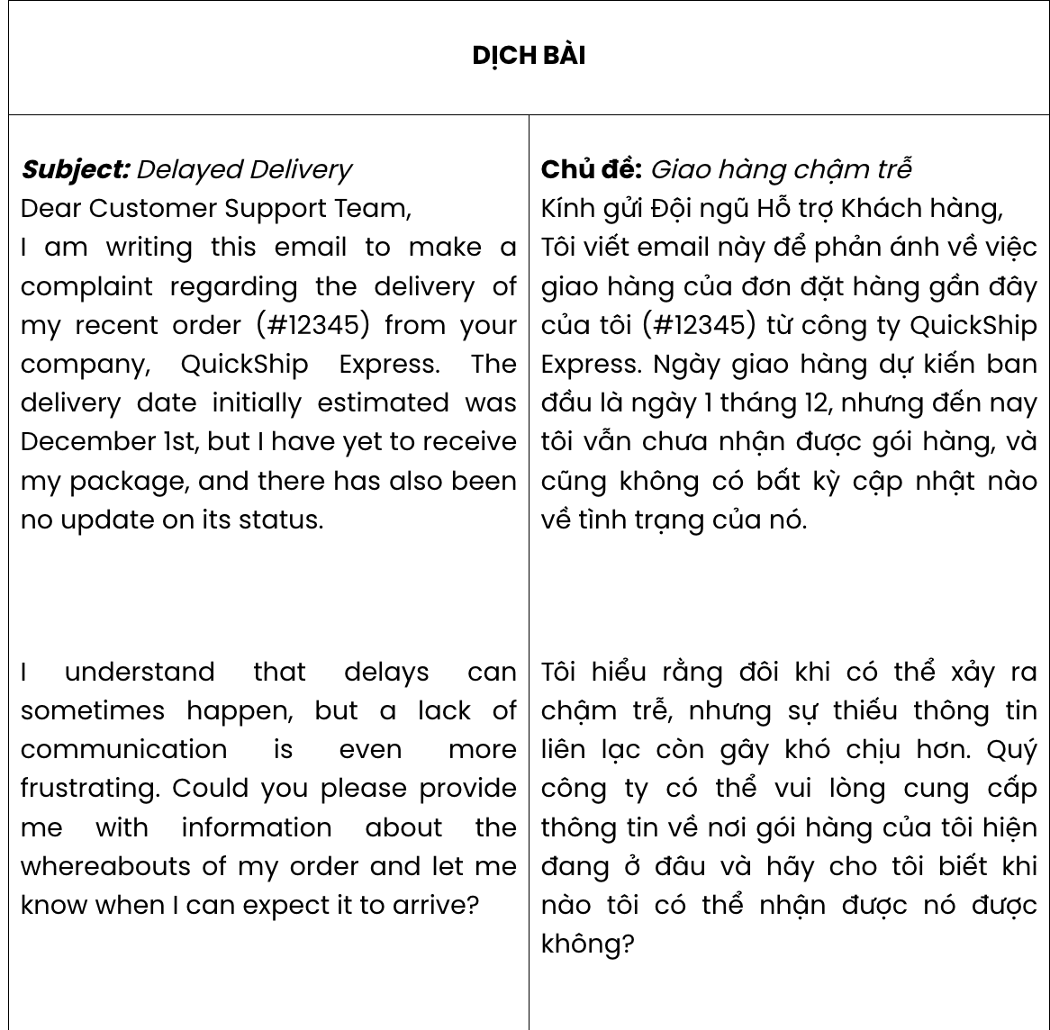
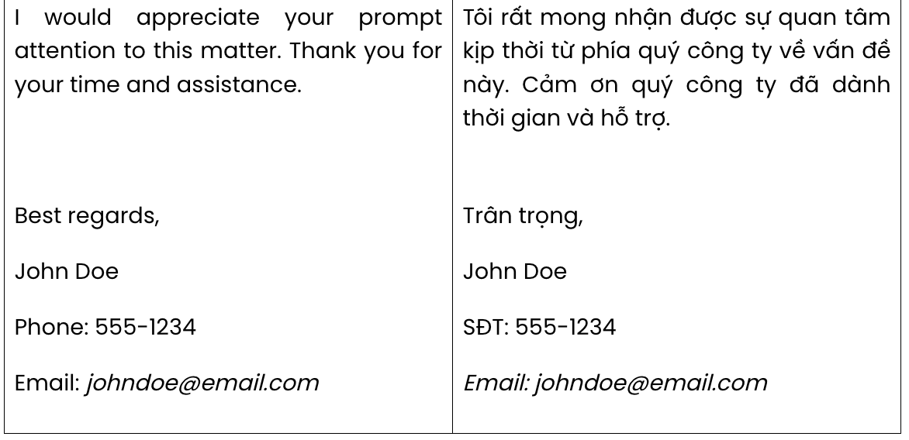
Question 1. A. set B. take C. make D. feed
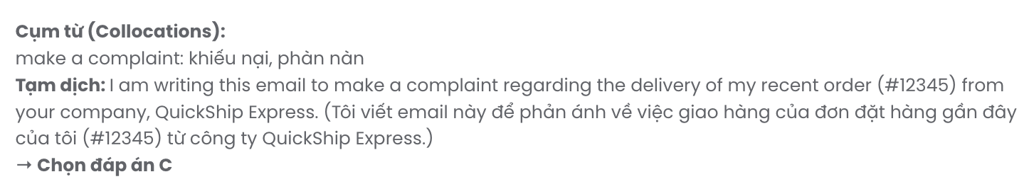
Question 2. A. estimated B. estimating C. to estimate D. estimates
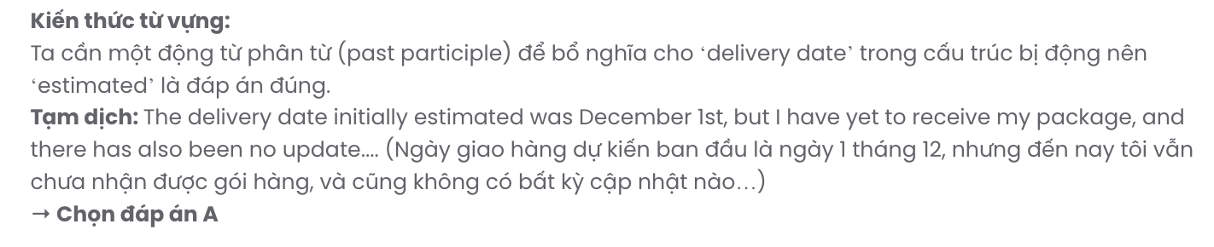
Question 3. A. by B. at C. on D. up
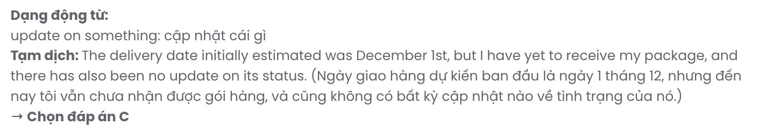
Question 4. A. variety B. proportion C. amount D. lack
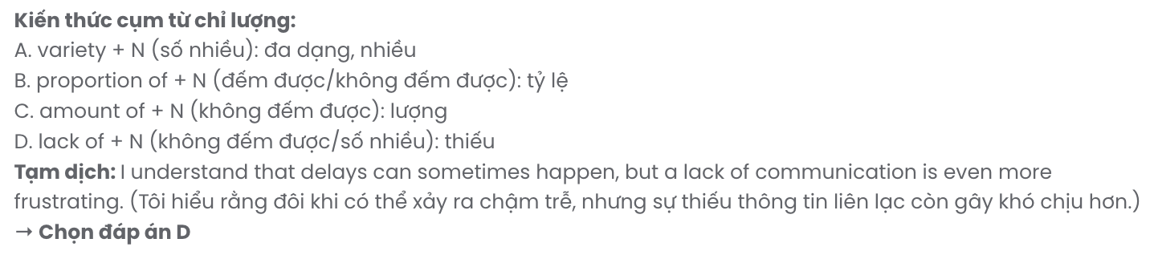
Question 5. A. to arrive B. arriving C. to arriving D. arrive
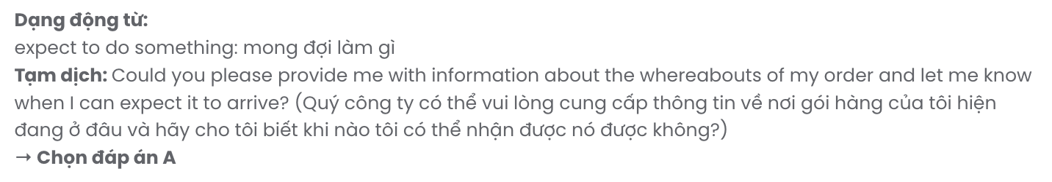
Question 6. A. assisted B. assist C. assistance D. assistants
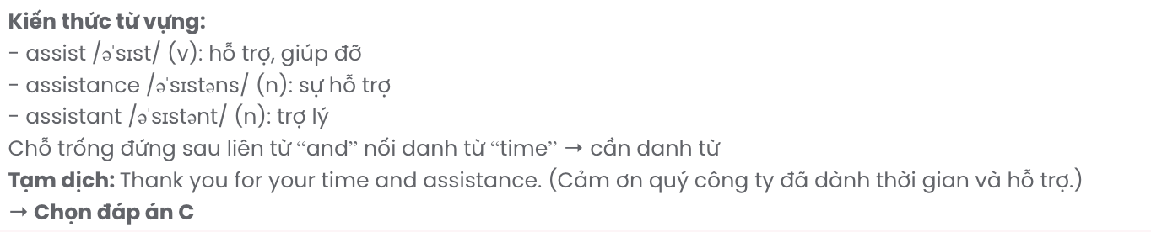
Read the following social media post and mark the letter A, B, C or D on your answer sheet to indicate the option that best fits each of the numbered blanks from 7 to 12.

🚨 Event Cancellation Notice 🚨
Unfortunately, the weather forecast predicts heavy storms tomorrow, so, (7) your safety, we have no choice but to (8) the event. We understand and sincerely apologise for any disappointment this may cause. However, there is a(n) (9) that will be notified to you as soon as possible. For those who’ve (10) tickets, please rest assured that there are two options available for you. You will receive a full refund if you claim it. (11) option is to transfer your ticket to the new date.
Please share this post to spread this information to everyone. We appreciate your understanding and support during this time. Thank you for your (12) , and we look forward to welcoming you again!
#EventUpdate #Cancellation #Reschedule #Refund #StaySafe

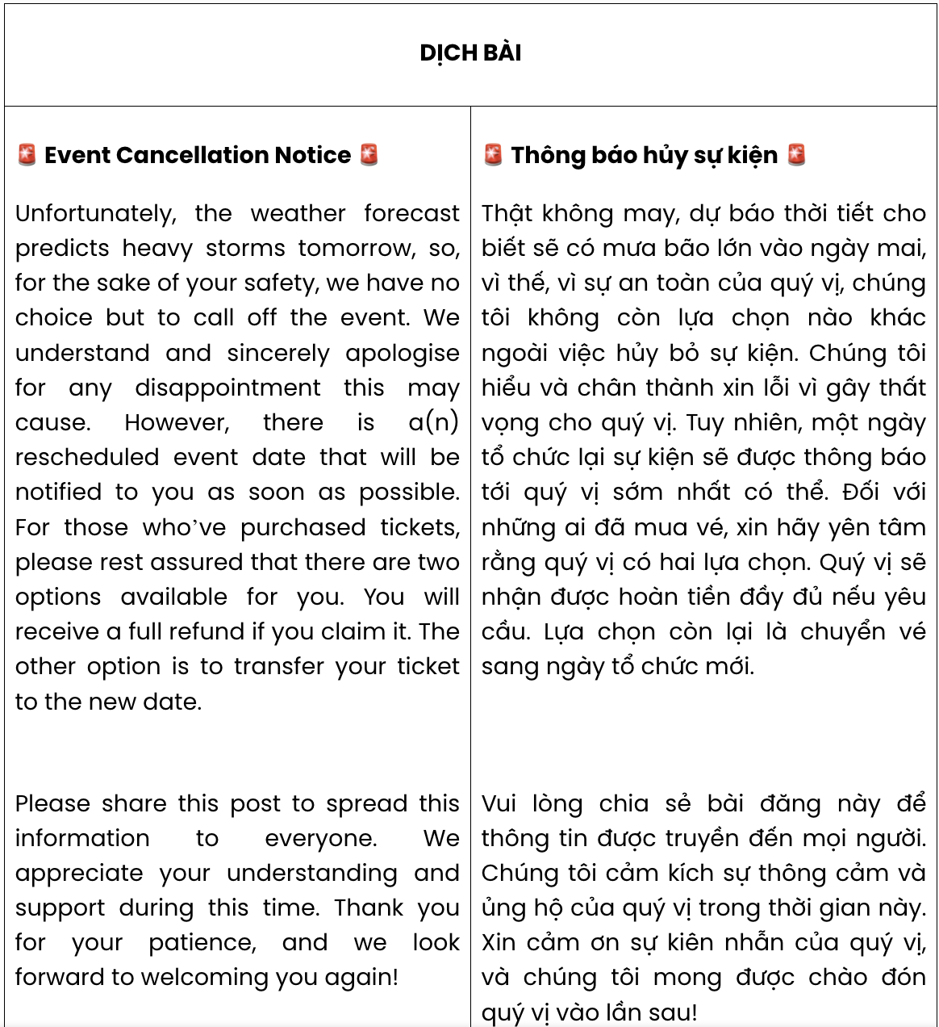

Question 7. A. for the sake of B. irrespective of C. prior to D. thanks to
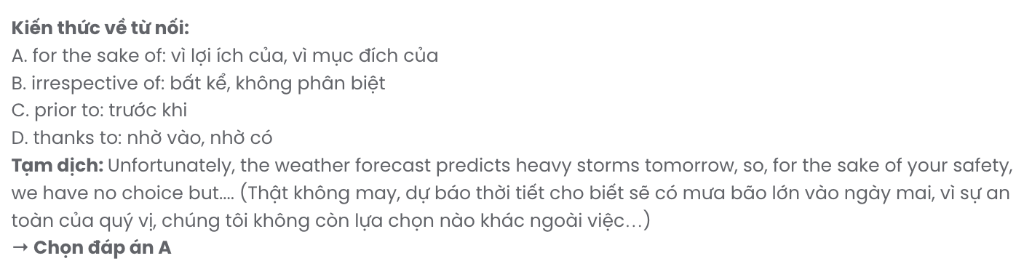
Question 8. A. go without B. figure out C. get by D. call off
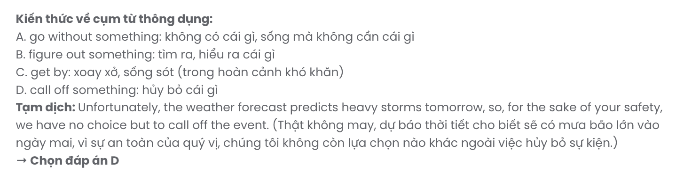
Question 9. A. rescheduled event date
C. event rescheduled date B. rescheduled date event
D. date rescheduled event
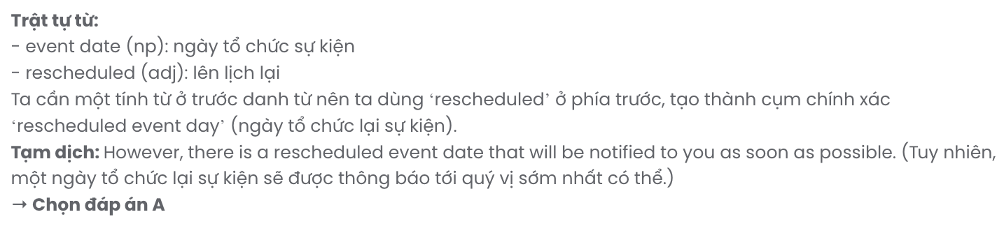
Question 10. A. repaid B. purchased C. preserved D. pursued
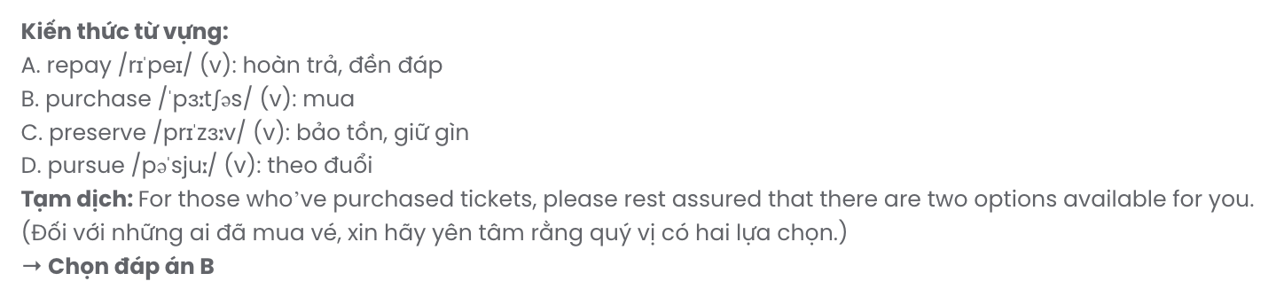
Question 11. A. Other B. The other C. Others D. Another
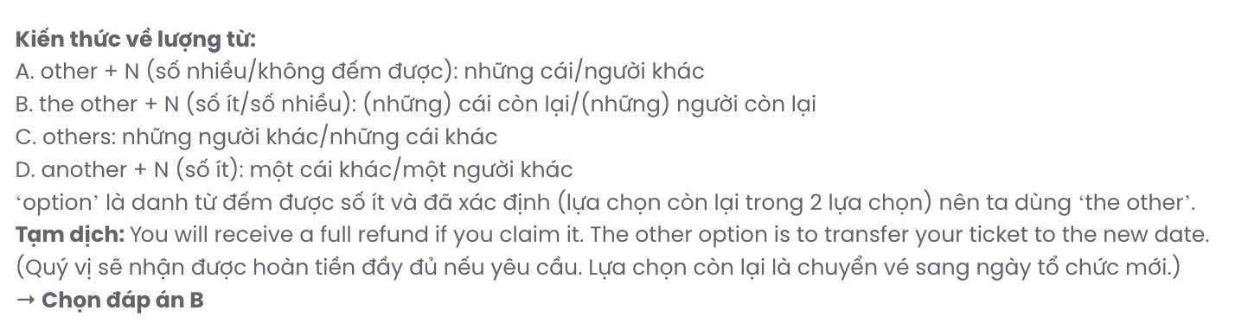
Question 12. A. leisure B. respect C. account D. patience
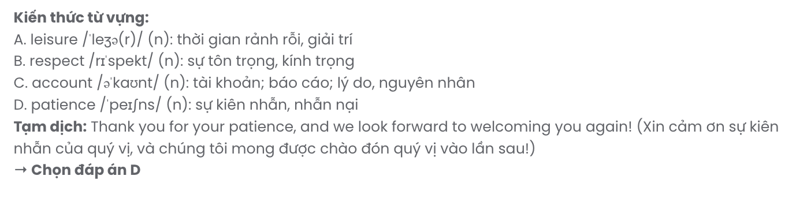
Mark the letter A, B, C or D on your answer sheet to indicate the best arrangement of utterances or sentences to make a meaningful exchange of text in each of the following questions from 13 to 17.

Question 13.
- Emma: That’s cool! Are you using a machine or just making it by hand?
- Kevin: I’ve been experimenting with making my own coffee at home recently.
- Kevin: I use a French press. It’s really easy and tastes great!
A. b – a – c B. a – c – b C. c – b – a D. c – a – b
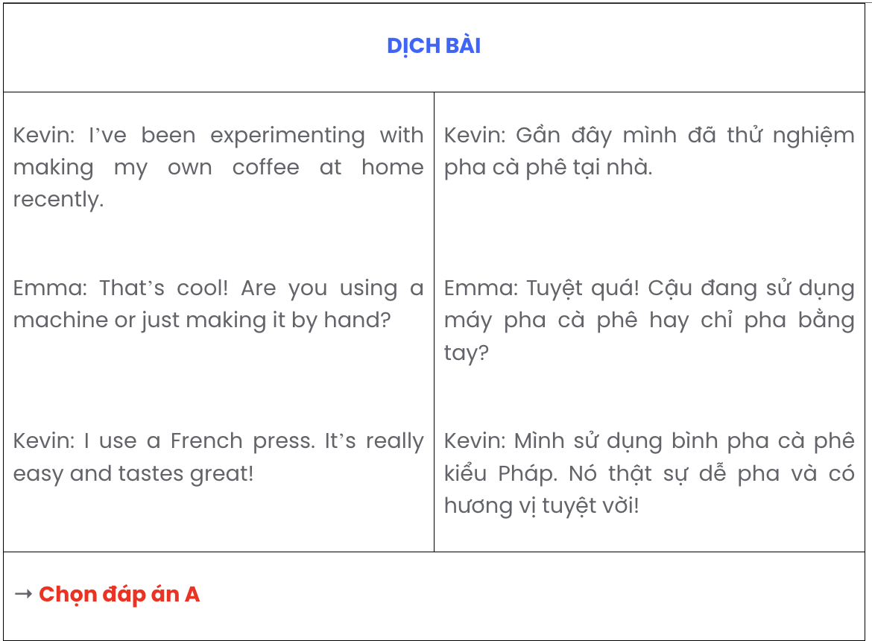

Question 14.
- Ben: That’s smart! I’ve heard a planner can make a big difference in productivity.
- Ben: What’s so special about using a planner?
- Sara: I’m going to use a planner to keep track of my assignments.
- Ben: How are you planning to manage your time better this semester?
- Sara: It helps me stay organized and prevents me from missing deadlines.
A. a – e – d – c – b B. b – e – a – c – d C. d – c – b – e – a D. d – c – a – e – b
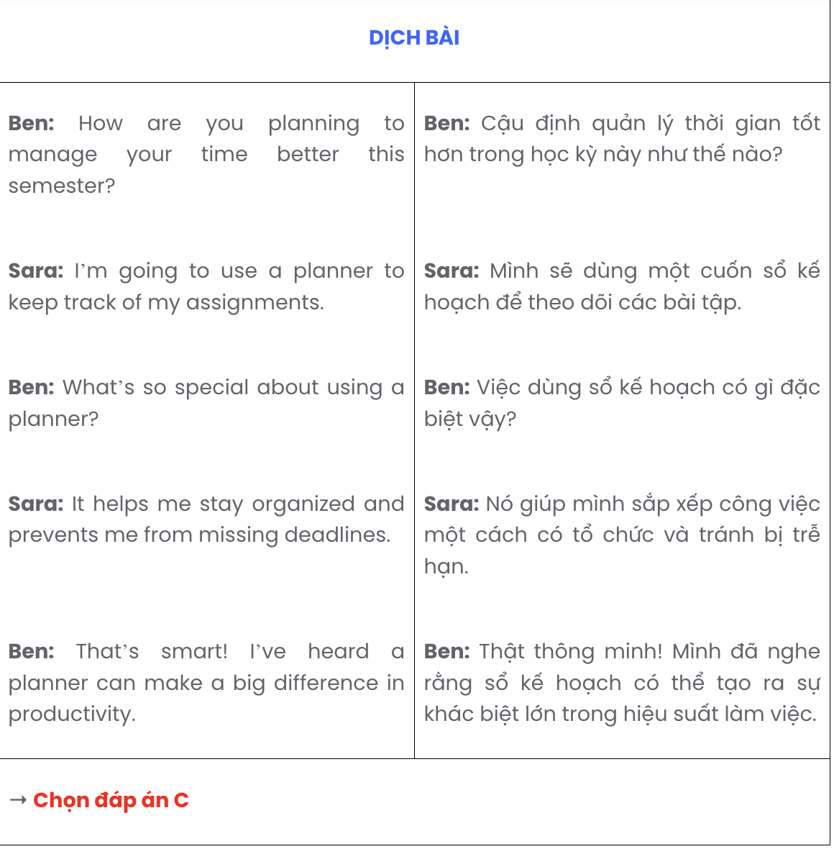

Question 15.
Hey Jack,
- I’m also trying to cut down on caffeine, so I’ve been drinking green tea instead of coffee.
- Let me know if you have any tips or ideas to make mornings even better!
- By the way, do you have any morning routines that help you start your day off right?
- At first, it was really tough, but I’ve gotten used to it, and I feel so much more energized.
- I’ve started waking up at 5 AM to do a morning workout before work. Cheers,
Sophie
A. d – c – a – b – e B. e – c – d – a – b C. e – c – a – b – c D. e – d – a – c – b
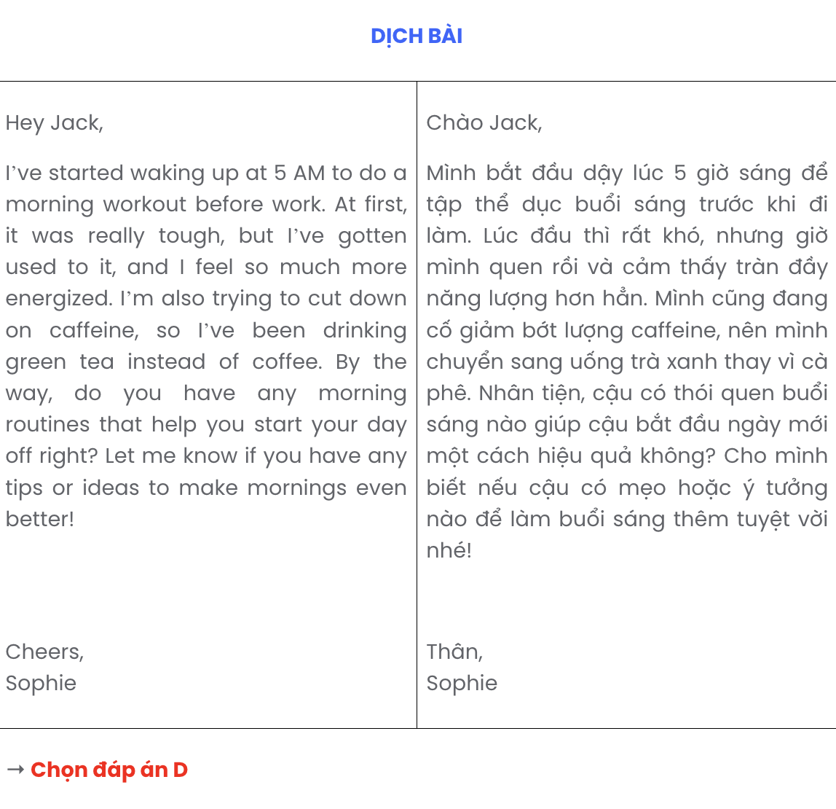
Question 16. GIA SƯ TẠI HUẾ ( 079.3833.272)
- He twisted his ankle badly and had to stop playing immediately because of the pain.
- He carefully followed the treatment plan, did physiotherapy exercises and took prescribed medications.
- Last month, Tom had a bad accident while playing football with his friends at the park.
- At first, he thought it was just a minor injury, but after visiting the doctor, he was told to rest and avoid walking for several days.
- After two weeks, he was able to walk again without any pain, and now he is fully recovered and back on the field.
A. c – a – d – b – e B. c – d – b – a – e C. c – a – e – d – b D. d – c – b – e – a

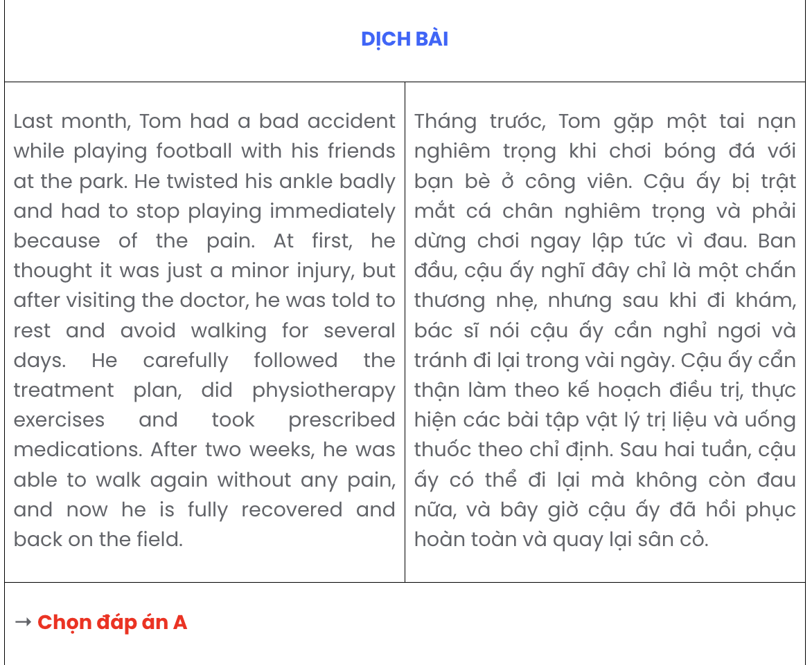

Question 17.
- Its consequences are devastating, with countless lives lost, economies destroyed, and entire populations left in dire conditions.
- Armed conflict has been a persistent issue throughout human history, causing immense suffering and displacement.
- The international community must work harder to find diplomatic solutions and promote peaceful coexistence, as the human cost of armed conflict is too high to ignore.
- Despite numerous peace efforts, many conflicts continue, leaving behind deep scars that last for generations.
- It often arises due to political, territorial, or belief-based disputes between nations or groups.
A. b – e – a – d – c B. c – b – e – d – a C. b – a – d – e – c D. b – e – d – c – a

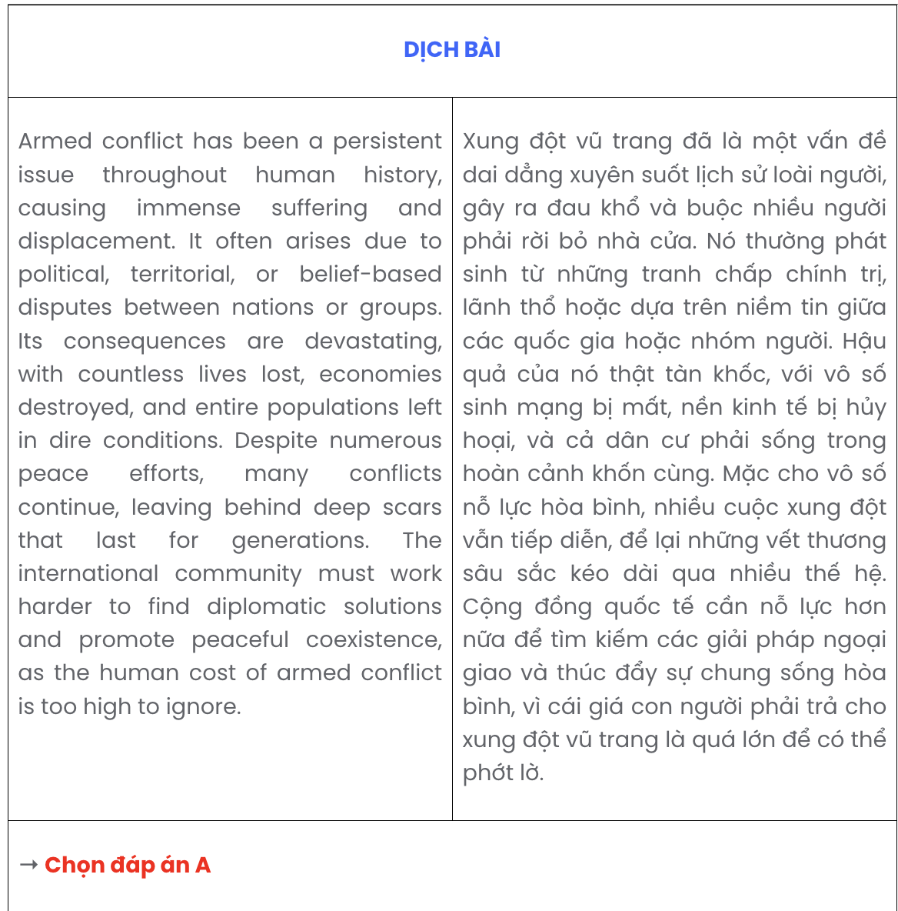
Read the following passage and mark the letter A, B, C, or D on your answer sheet to indicate the correct option that best fits each of the numbered blanks from 18 to 22.
The animation industry has become a global powerhouse in entertainment. Originating in the early 20th century, (18) . Gradually, it evolved into the sophisticated digital techniques we see today. Thanks to advances in technology, today’s animated films (19) can make the stories more immersive and engaging. For example, movies like Frozen and Toy Story have set new standards for visual effects, showcasing the potential of computer-generated imagery (CGI) and 3D modelling.
Moreover, (20) ; it extends to television shows, video games, and even advertising, all of which rely on animation to create appealing content. The growth of streaming platforms such as Netflix and Disney+, which has led to a surge in demand for animated series, (21) . These platforms have not only given rise to new animated series but have also enabled smaller studios to gain visibility.
In addition to technological advancements, (22) . Animated films often transcend language barriers, reaching international audiences and offering unique insights into different cultures. This universal appeal is one of the reasons why animation continues to thrive, drawing attention from all corners of the world. GIA SƯ TẠI HUẾ ( 079.3833.272)
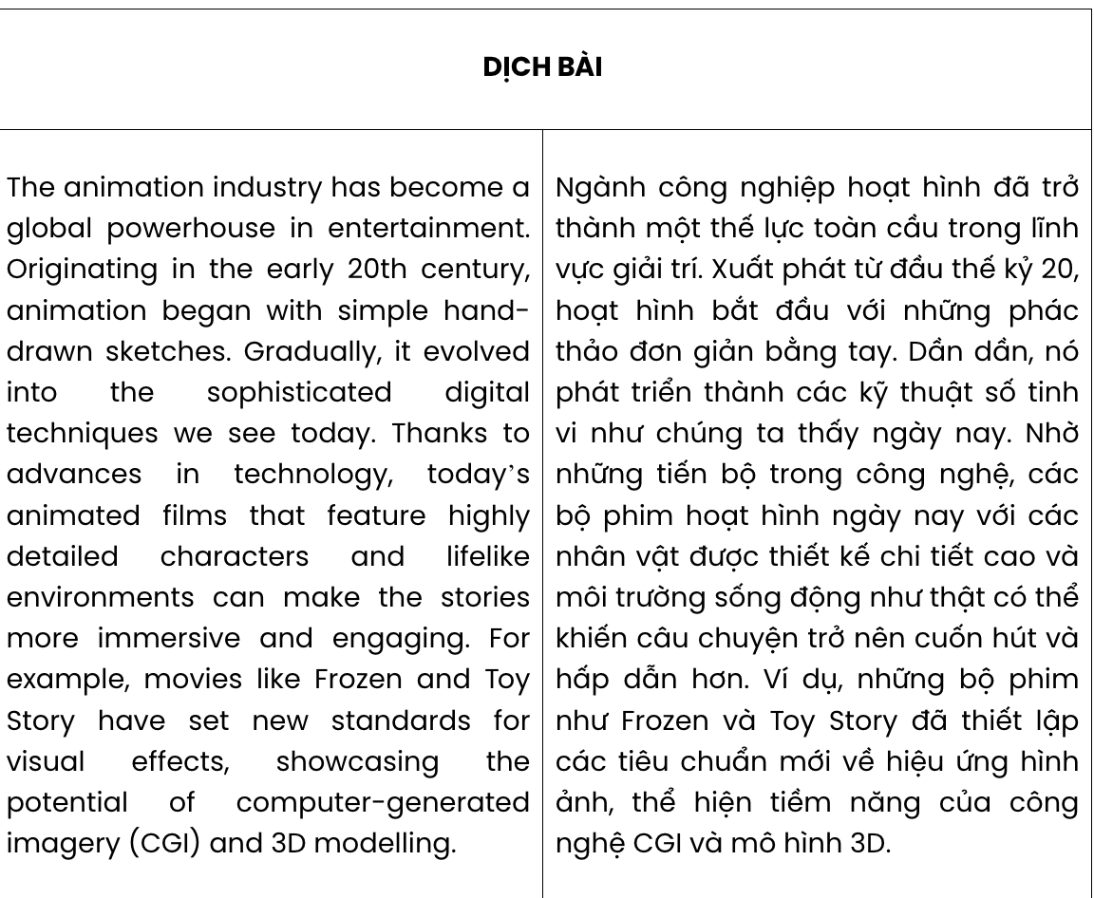
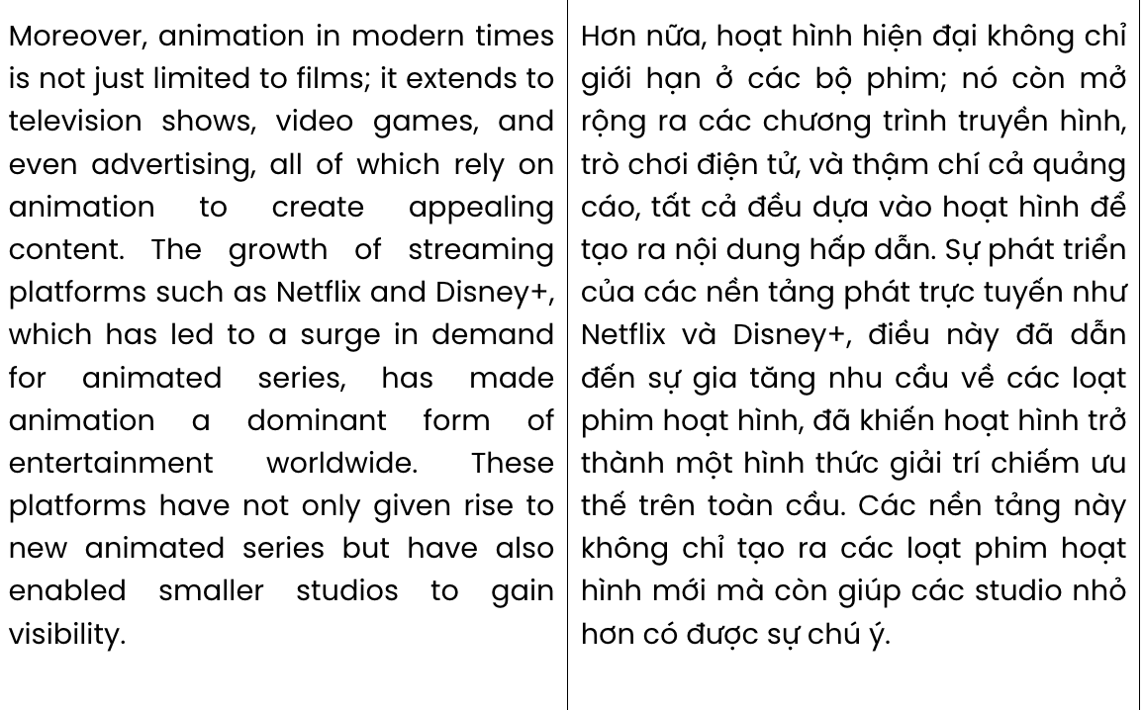
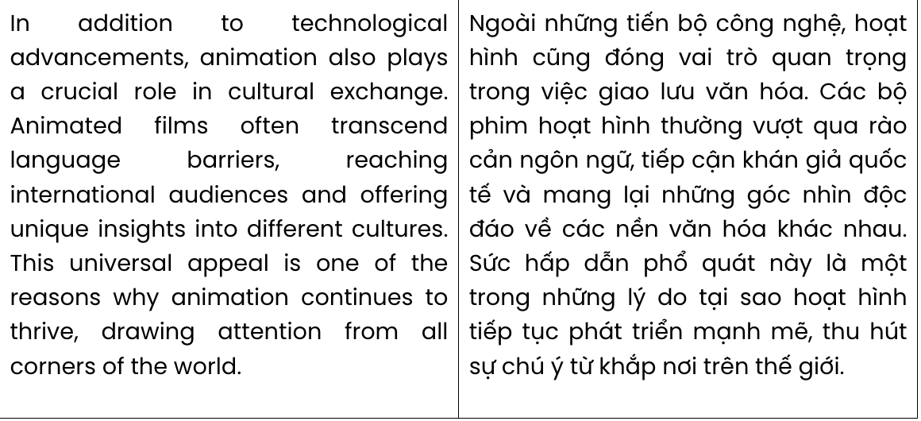

Question 18.
A. simple hand-drawn sketches were first used for animation
B. people originally used only hand-drawn sketches for animation
C. it's simple hand-drawn sketches that were used for animation
D. animation began with simple hand-drawn sketches
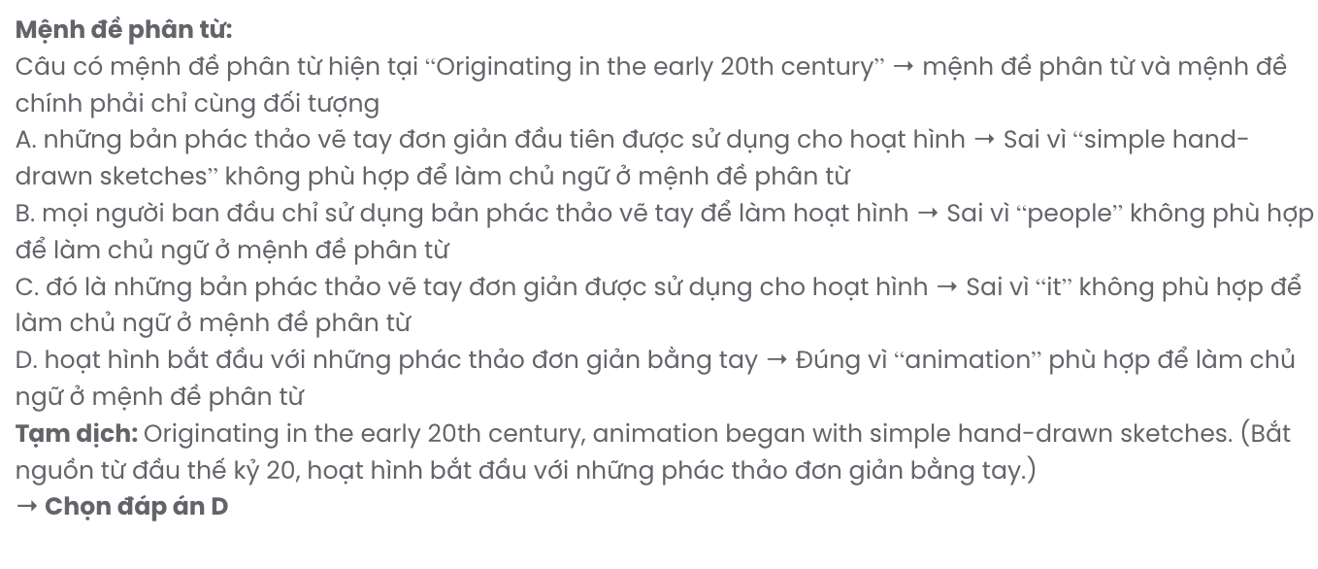

Question 19.
A. have various vivid characters and lifelike environments
B. that feature highly detailed characters and lifelike environments
C. to tell the story of real characters in real environments
D. bring the characters portrayed in the story to life in lifelike settings
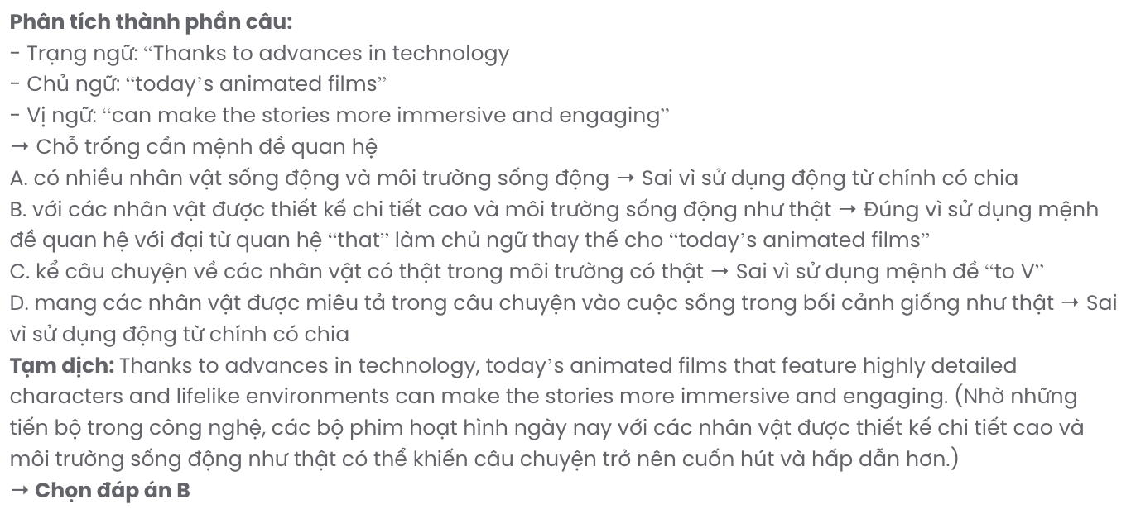

Question 20.
A. animation in modern times is not just limited to films
B. people are increasingly inclined to watch traditional animation
C. animation films convey human values in a friendly way
D. animation today covers both practical and pressing topics

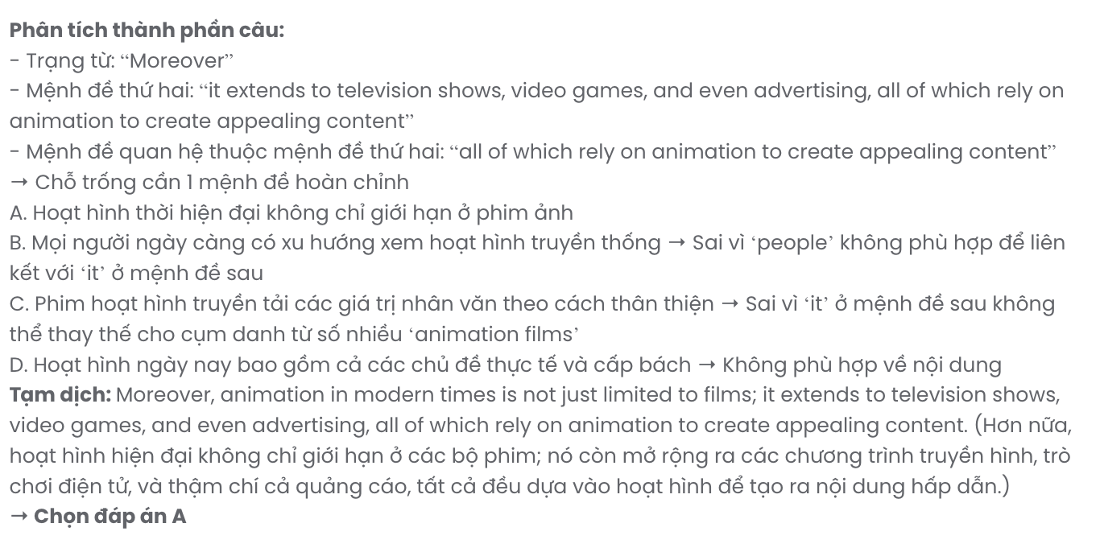

Question 21.
A. and animation has dominated as a global form of entertainment
B. when animation became dominant in entertainment worldwide
C. what made animation dominant as a form of entertainment
D. has made animation a dominant form of entertainment worldwide
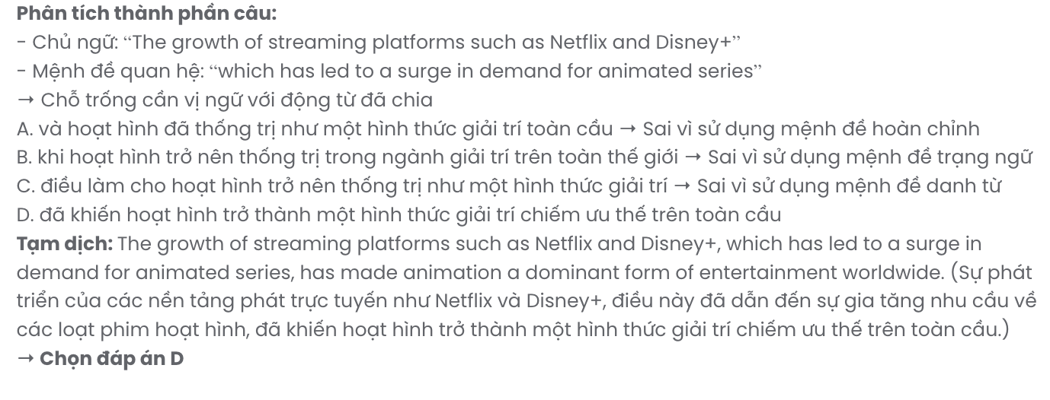

Question 22.
A. animation also plays a crucial role in cultural exchange
B. animation is often associated with national culture
C. you must understand the culture before watching animation
D. culture is sometimes reflected through animation

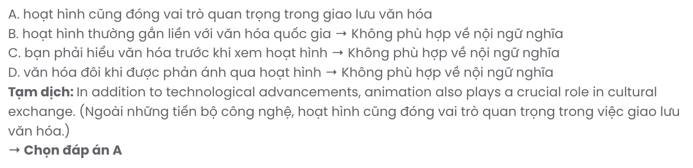
Read the following passage and mark the letter A, B, C, or D on your answer sheet to indicate the best answer to each of the following questions from 23 to 30.
The British Isles are not just a geographic entity; they are a collage of ecological and scenic variety that has evolved over millennia. In recent years, as eco-tourism continues to gain popularity, these natural havens have attracted a growing number of nature enthusiasts.
People from all walks of life are now more eager than ever to step away from the hustle of modern life and immerse themselves in the serene, majestic, and sometimes wild environments of the UK. One of the best ways to experience the beauty and diversity of the UK’s natural landscapes is by taking United Kingdom cruises. This journey through the UK’s coastlines and islands is not just a travelogue; it’s an exploration of the soul of Britain’s outdoors.
However, as the popularity of these natural sites increases, the importance of balancing tourism with environmental preservation becomes paramount. Various organizations across the UK are dedicated to conserving these landscapes while promoting sustainable tourism practices. These efforts are crucial in ensuring that these natural wonders remain unspoiled for future generations, maintaining both their beauty and ecological integrity.
There are various things that those planning to explore the natural wonders should keep in mind. First, responsible and sustainable travel is essential. Second, adhering to local guidelines, respecting wildlife, and practising ‘leave no trace’ principles are vital in preserving these areas. The most suitable times to visit vary, with each season offering its own unique experiences. Finally, accommodation options are plentiful, ranging from eco-friendly lodges to camping sites, allowing visitors to stay immersed in nature.
(Adapted from https://thebossmagazine.com/)
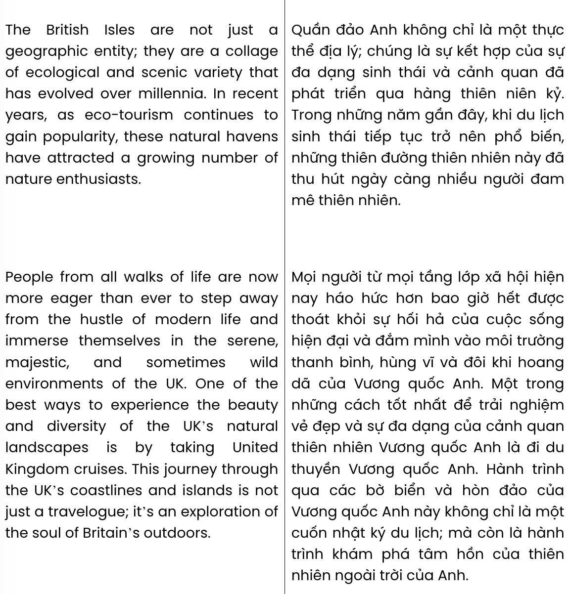
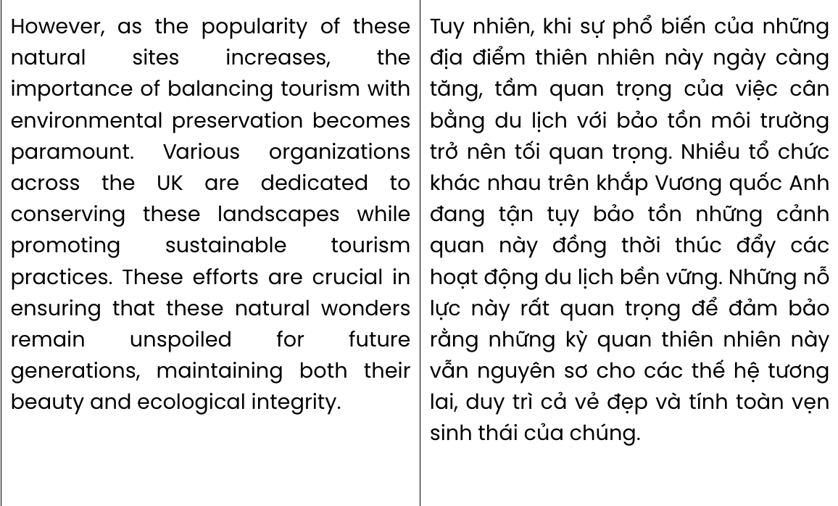
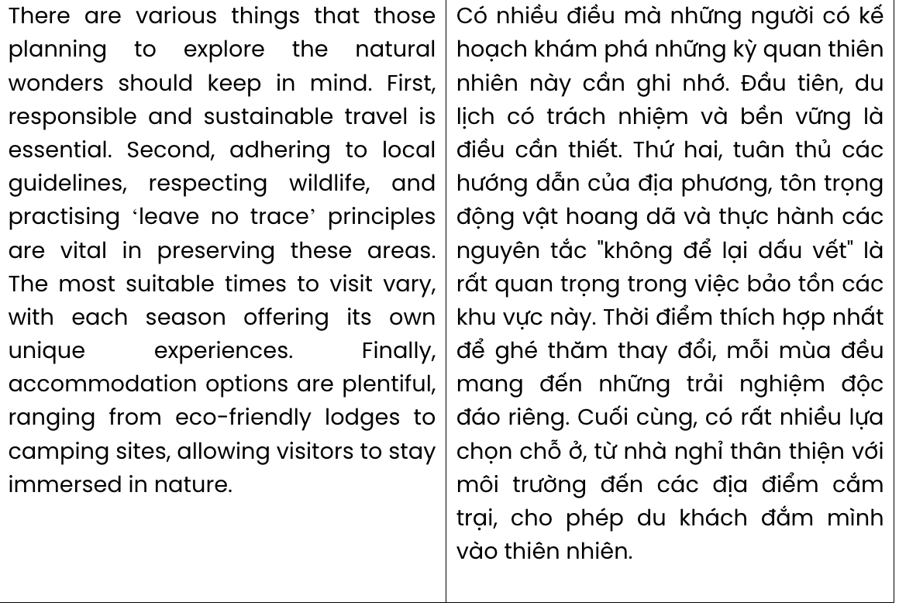
Question 23. The word evolved in paragraph 1 can be best replaced by .
A. developed B. operated C. transferred D. orbited
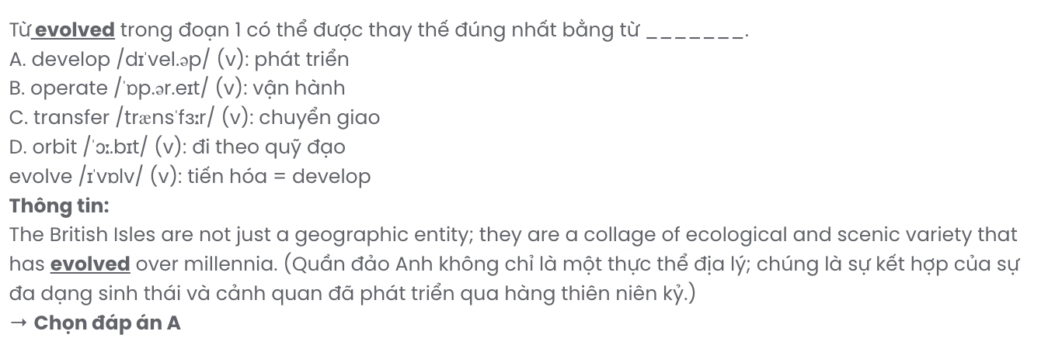
Question 24. The word themselves in paragraph 2 refers to . GIA SƯ TẠI HUẾ ( 079.3833.272)
A. walks B. havens C. people D. nature enthusiasts
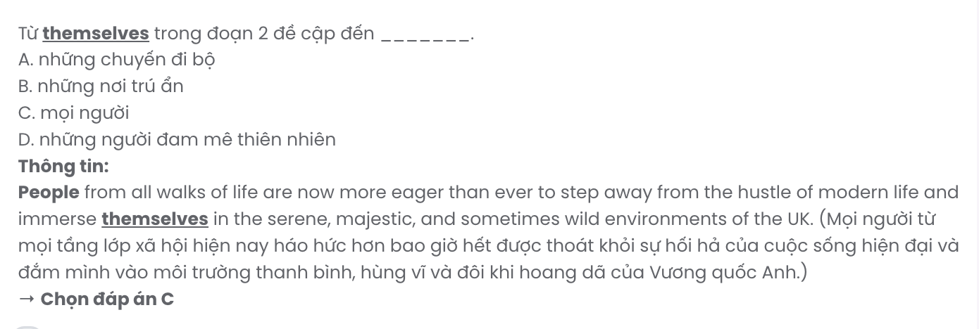
Question 25. The word unspoiled in paragraph 3 is OPPOSITE in meaning to .
A. amazed B. ruined C. crowded D. advanced
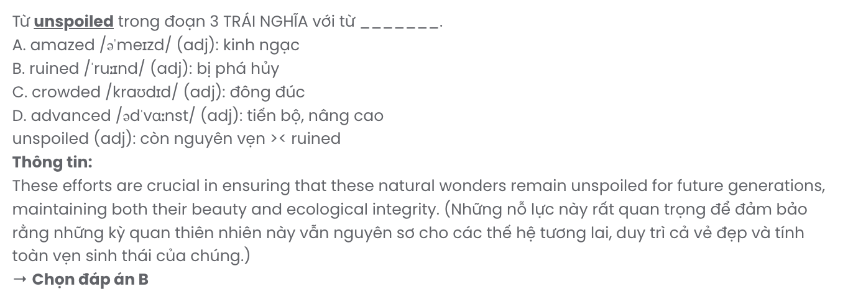
Question 26. Which of the following best paraphrases the underlined sentence in paragraph 4?

The most suitable times to visit vary, with each season offering its own unique experiences.
A. They can be visited in every season because all of them bring wonderful experiences.
B. All seasons are suitable for visitors although they can bring different experiences.
C. The best time to visit depends on each season which brings special experiences.
D. The best time to visit isn’t related to the season but to the experiences desired.

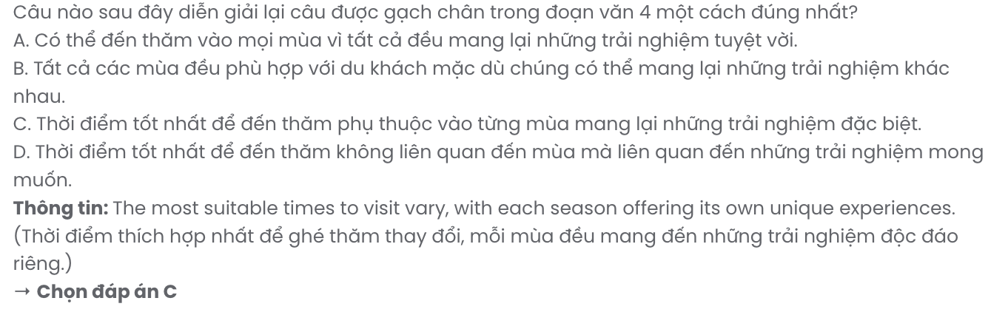
Question 27. Which of the following is NOT mentioned as one of the things to keep in mind for anyone wanting to visit natural wonders?
A. Respect wild species B. Travel responsibly and sustainably
C. Go on trails to stay safe D. There are various accommodation choices
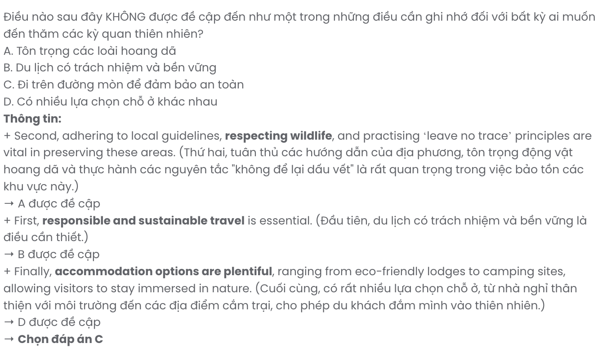
Question 28. Which of the following is TRUE according to the passage?
A. The British Isles are well known for their geographic features.
B. Eco-tourism has led to a decline in the popularity of mass tourism in the UK.
C. Various organizations are working to balance tourism and environmental preservation.
D. Visitors should avoid any interaction with wildlife to preserve the natural areas.
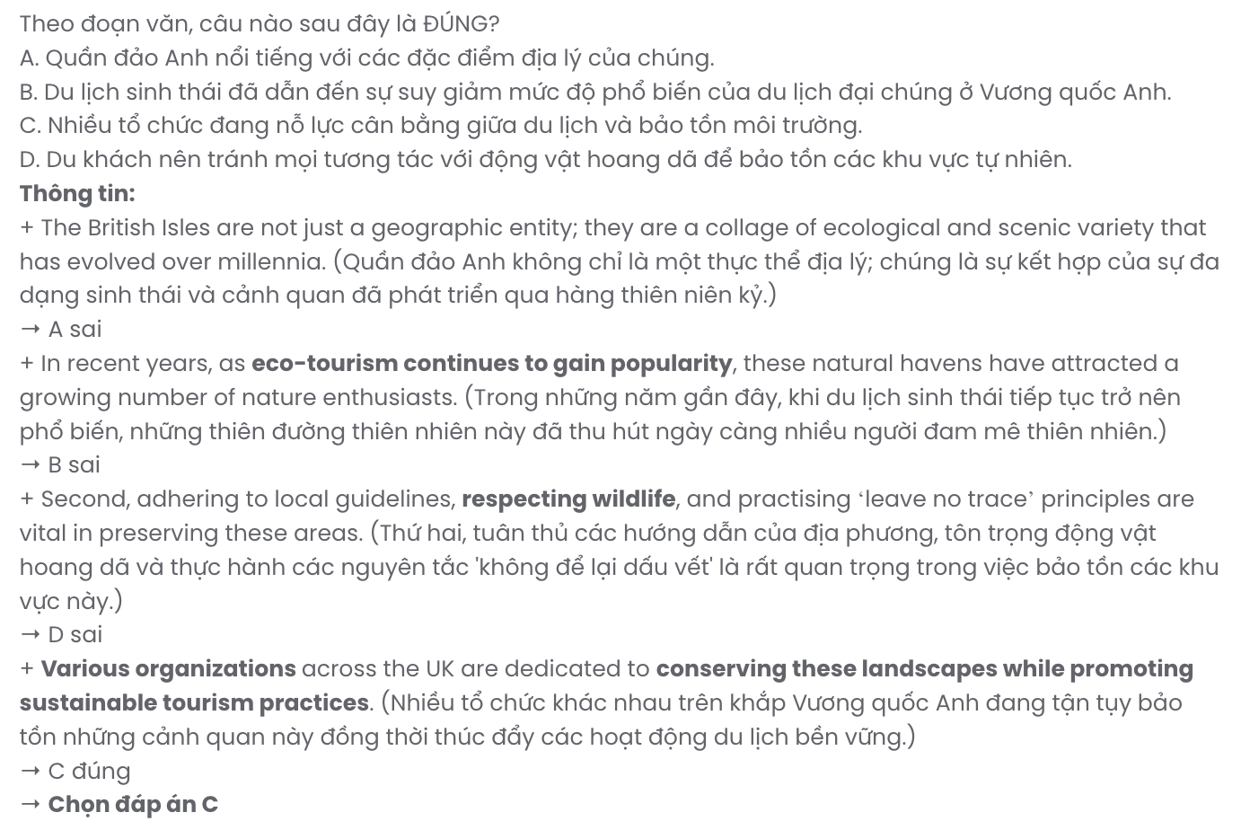
Question 29. In which paragraph does the author suggest a good way to explore the UK?
A. Paragraph 1 B. Paragraph 2 C. Paragraph 3 D. Paragraph 4
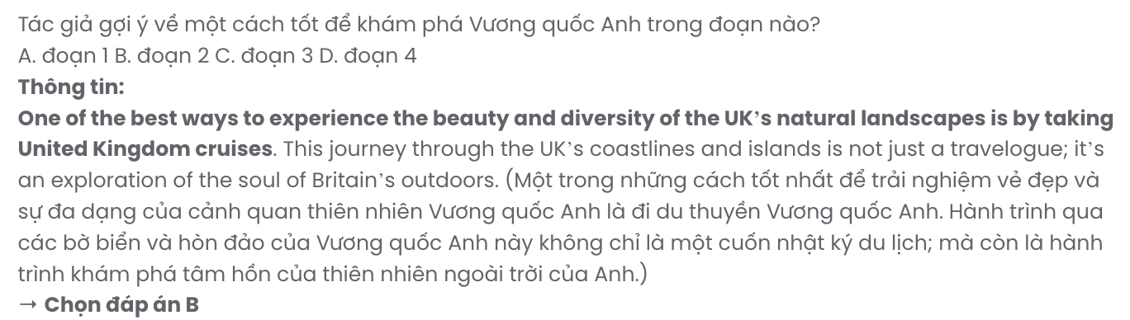
Question 30. In which paragraph does the author introduce a rise in a travelling style?
A. Paragraph 1 B. Paragraph 2 C. Paragraph 3 D. Paragraph 4
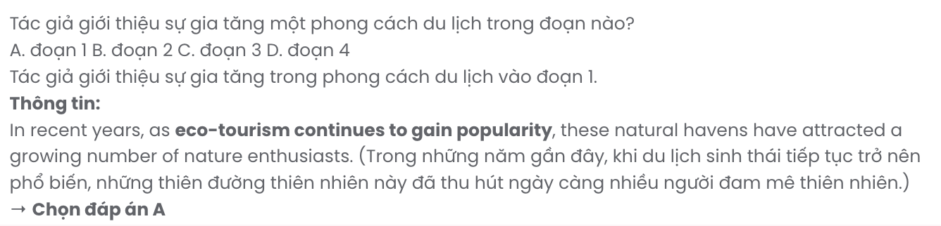
Read the following passage and mark the letter A, B, C, or D on your answer sheet to indicate the best answer to each of the following questions from 31 to 40.
Each year, over 700,000 emergency room visits involve children with asthma, according to the Journal of the American College of Emergency Room Physicians. While the exact cause of asthma remains unclear, and there is no cure, scientists know it runs in families and has linked the condition to over 30 genes. Children with parents who have asthma are more likely to develop the condition.
Factors such as prenatal antibiotic treatments, indoor pollutants, smoking, and being overweight can factor into the development of the disease in adults. Socioeconomic factors can also play a significant role. Researchers supported by the National Institute of Environmental Health Sciences have found that adults living in neighbourhoods with the most air pollution had the highest rates of asthma.
Fortunately, though, recent research suggests pregnant women may have some degree of control over whether their children develop asthma. [I] Women were once advised to avoid exercise during pregnancy to avoid the risk of premature labour or low birth weight. [II] However, physical activity is now seen as beneficial for the well-being of both the woman and the baby. [III] Moderate physical activity can help prevent excessive weight gain and gestational diabetes, according to the U.S. Centers for Disease Control and Prevention (CDC). [IV]
The agency also recommends healthy pregnant women get at least 150 minutes of moderate-intensity exercise per week, which can include brisk walking, bike riding, and yoga. Maternal exercise is associated with better outcomes for babies. Studies have shown that regular physical activities with increased blood flow during pregnancy can result in better lung, heart, and cognitive development in them.
(Adapted from https://www.nationalgeographic.com/)
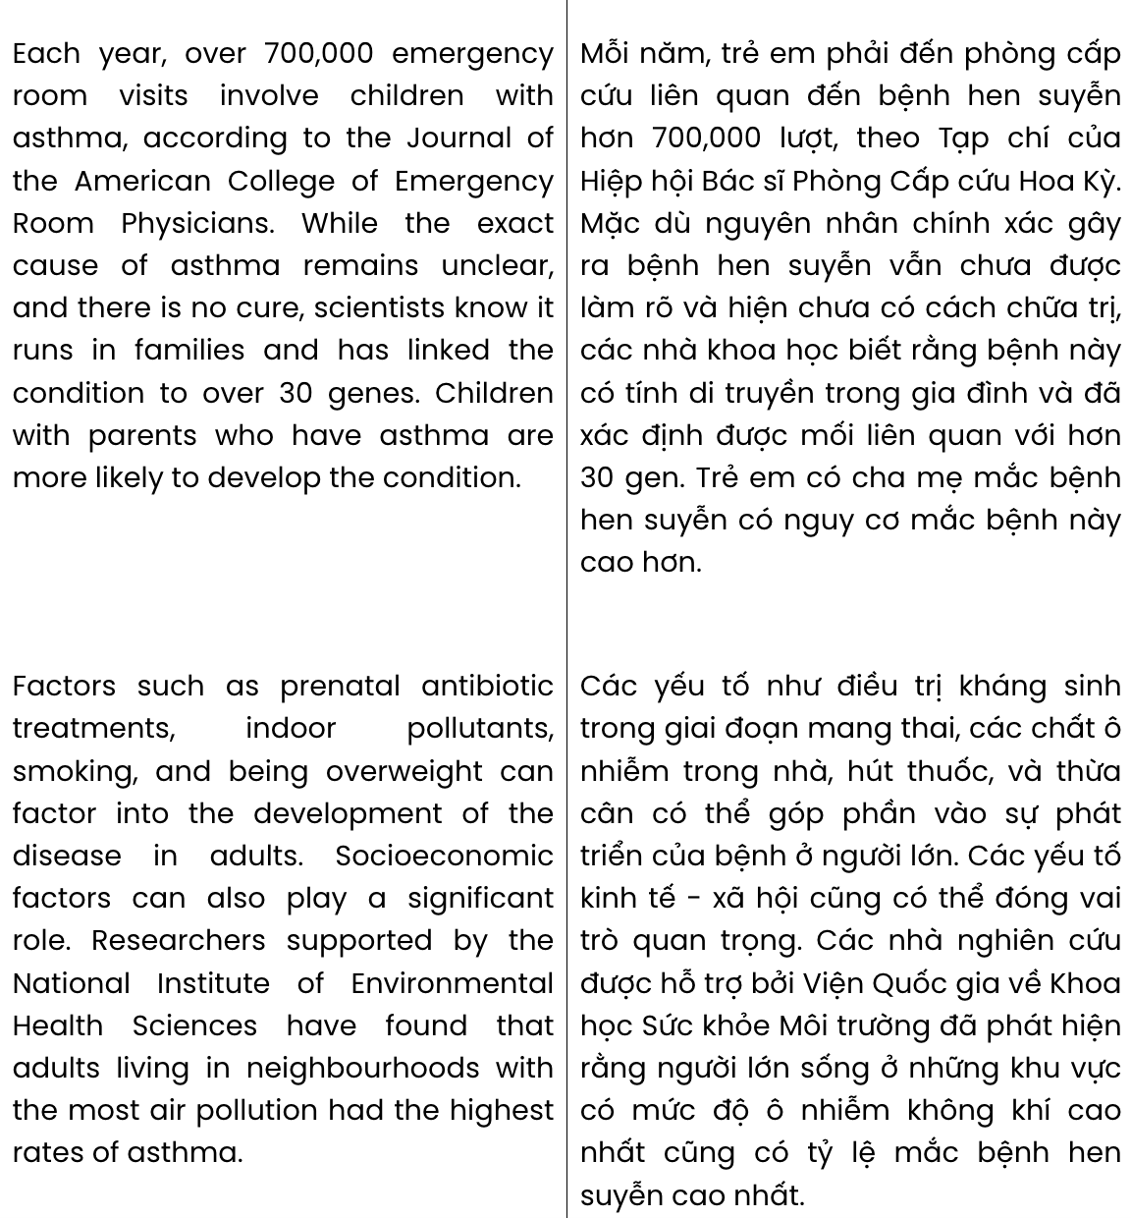
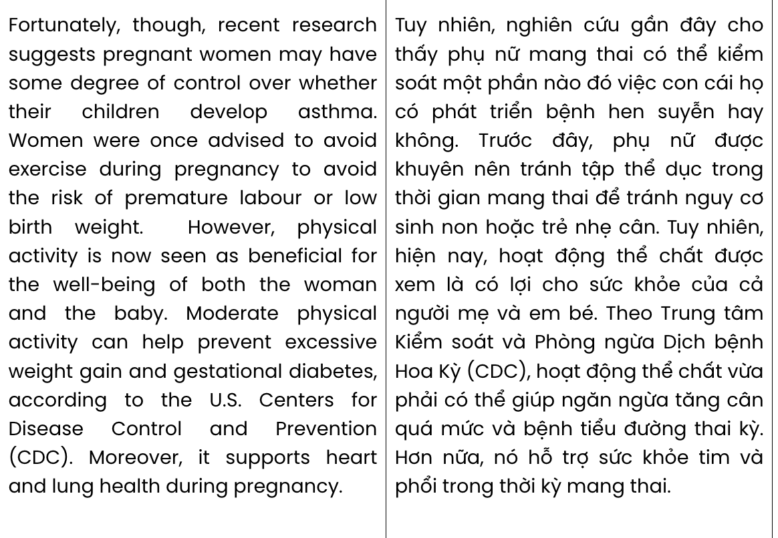
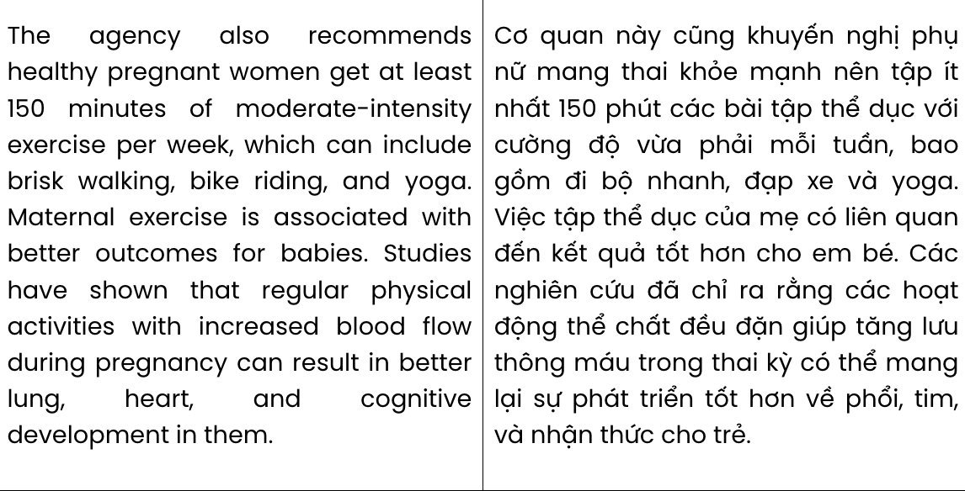
Question 31. The word them in paragraph 4 refers to .
A. outcomes B. babies C. studies D. activities
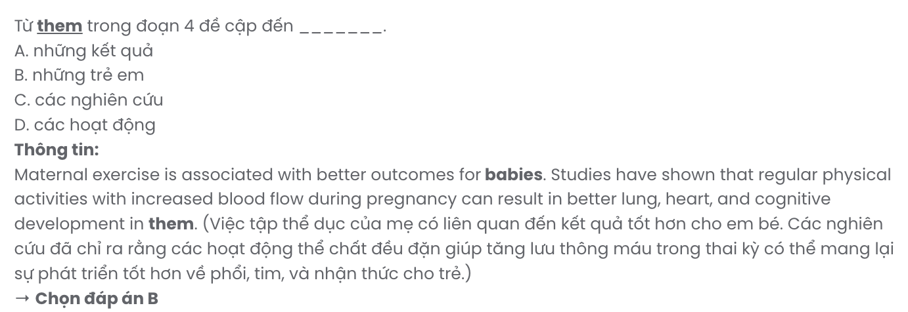
Question 32. Where in paragraph 3 does the following sentence best fit?

Moreover, it supports heart and lung health during pregnancy.
A. [I] B. [II] C. [III] D. [IV]

Question 33. The phrase it runs in families in paragraph 1 mostly means .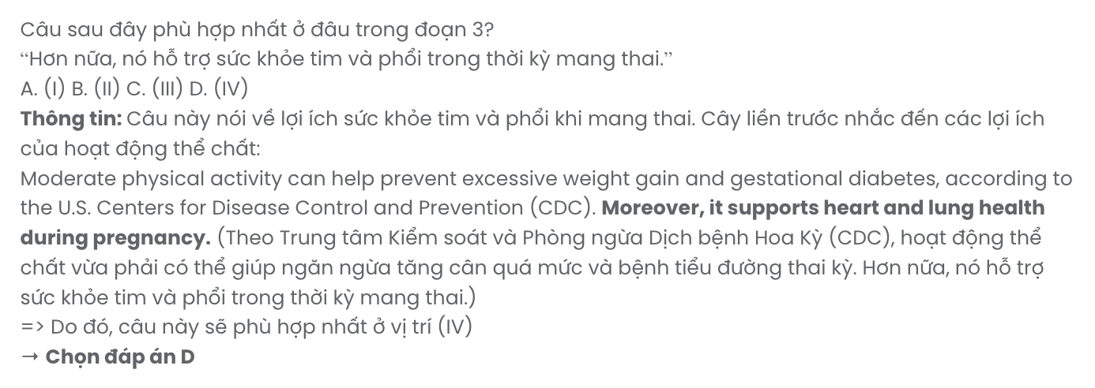
A. many family members have it B. it is a common issue among families
C. family members never ignore it D. families often consider it unimportant

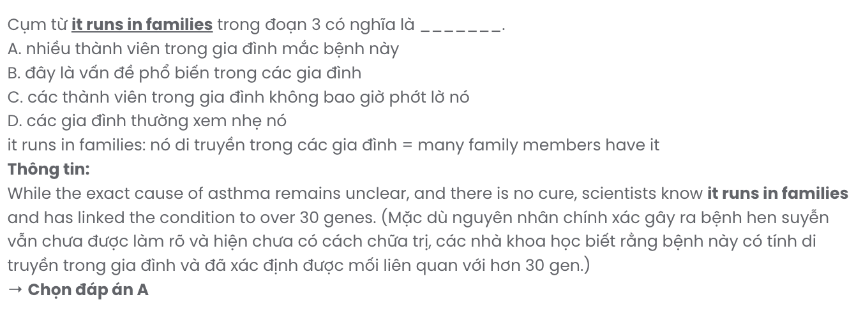
Question 34. Which of the following is NOT mentioned as one of the factors likely to cause asthma in adults?
A. indoor pollutants B. personal hygiene C. smoking D. air pollution
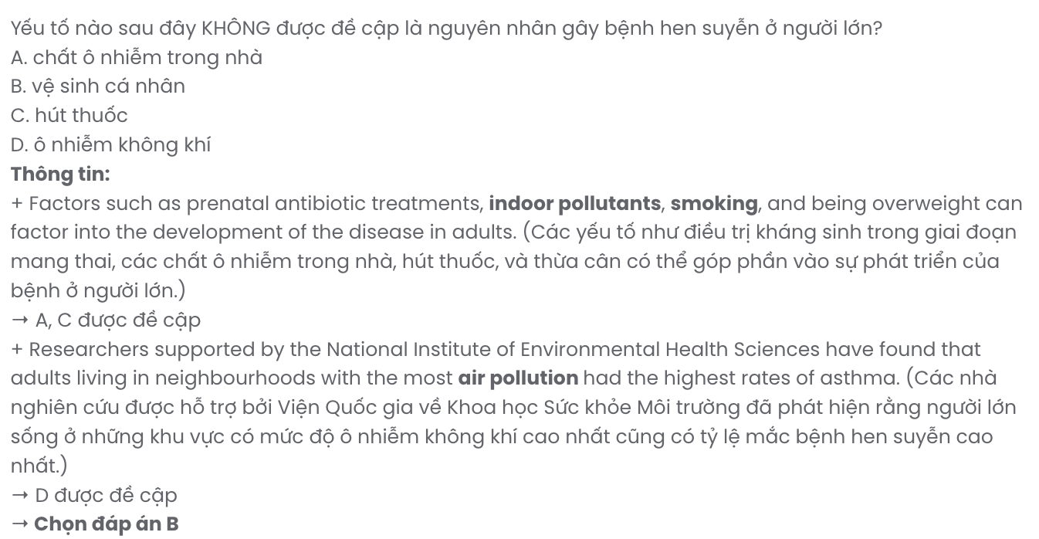
Question 35. The word beneficial in paragraph 3 is OPPOSITE in meaning to .
A. endangered B. vulnerable C. complimentary D. detrimental
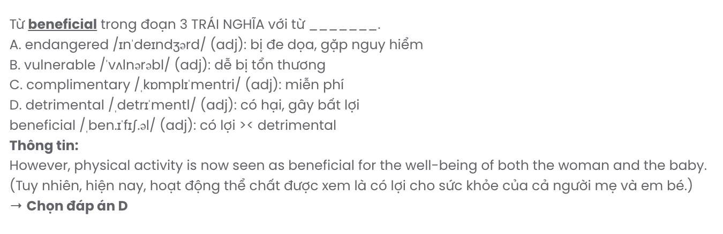
Question 36. Which of the following best summarises paragraph 4?
A. Regular physical activity during pregnancy can reduce the risk of developing asthma.
B. Babies will benefit mentally from active mothers once they are born.
C. Pregnant women should exercise properly to improve the health of their babies.
D. To maintain good health during pregnancy, women should exercise regularly.
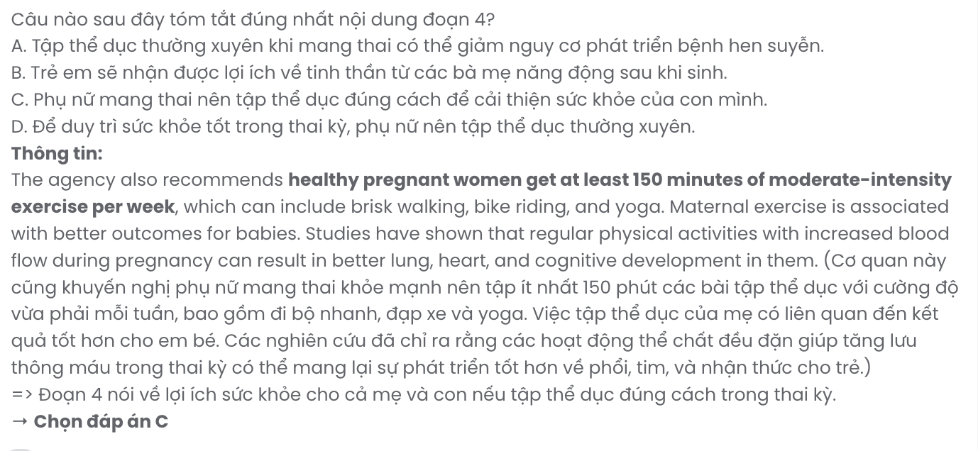
Question 37. Which of the following best paraphrases the underlined sentence in paragraph 1?

Children with parents who have asthma are more likely to develop the condition.
A. The likelihood of developing asthma is higher in children whose parents have it.
B. Children are less likely to develop asthma if their parents do not have the disease.
C. Having parents without asthma increases the chances of a child developing asthma.
D. Asthma is more likely to develop in children whose parents do not have the condition.
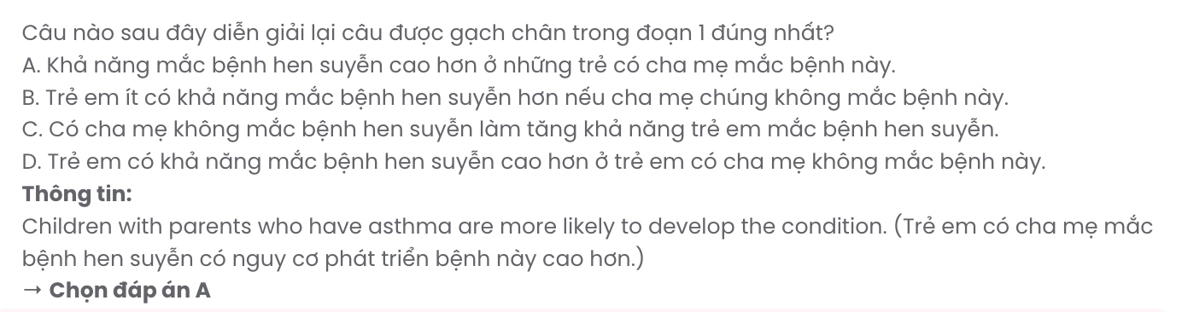
Question 38. Which of the following is TRUE according to the passage?
A. Asthma is primarily caused by prenatal antibiotic treatments.
B. Social and economic factors can influence the development of asthma.
C. Physical exercise during pregnancy is discouraged by health experts.
D. Babies whose mothers exercise during pregnancy are less likely to have lung issues.
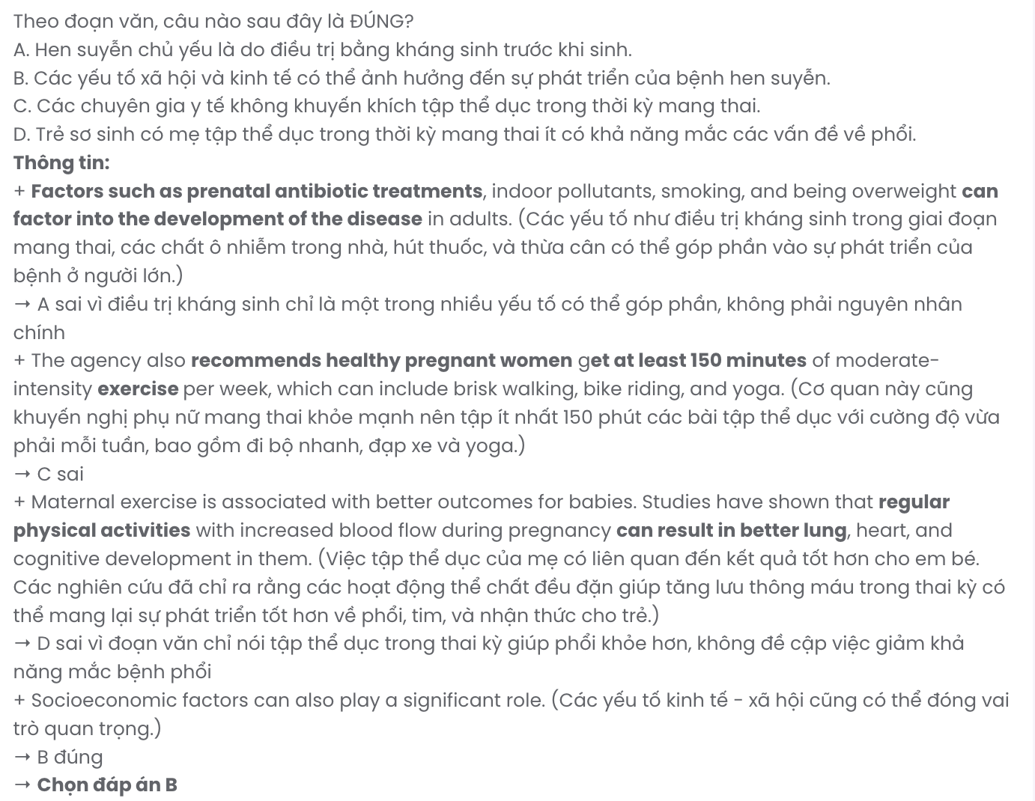
Question 39. Which of the following can be inferred from the passage?
A. Regular physical activity during pregnancy has long-term positive effects on the child’s cognitive development.
B. Although maternal exercise is beneficial, it does not guarantee that children will be free from asthma.
C. Physical exercise during pregnancy may contribute to better overall health for both mothers and babies.
D. Environmental factors are significant contributors to the increasing rates of asthma in both adults and children.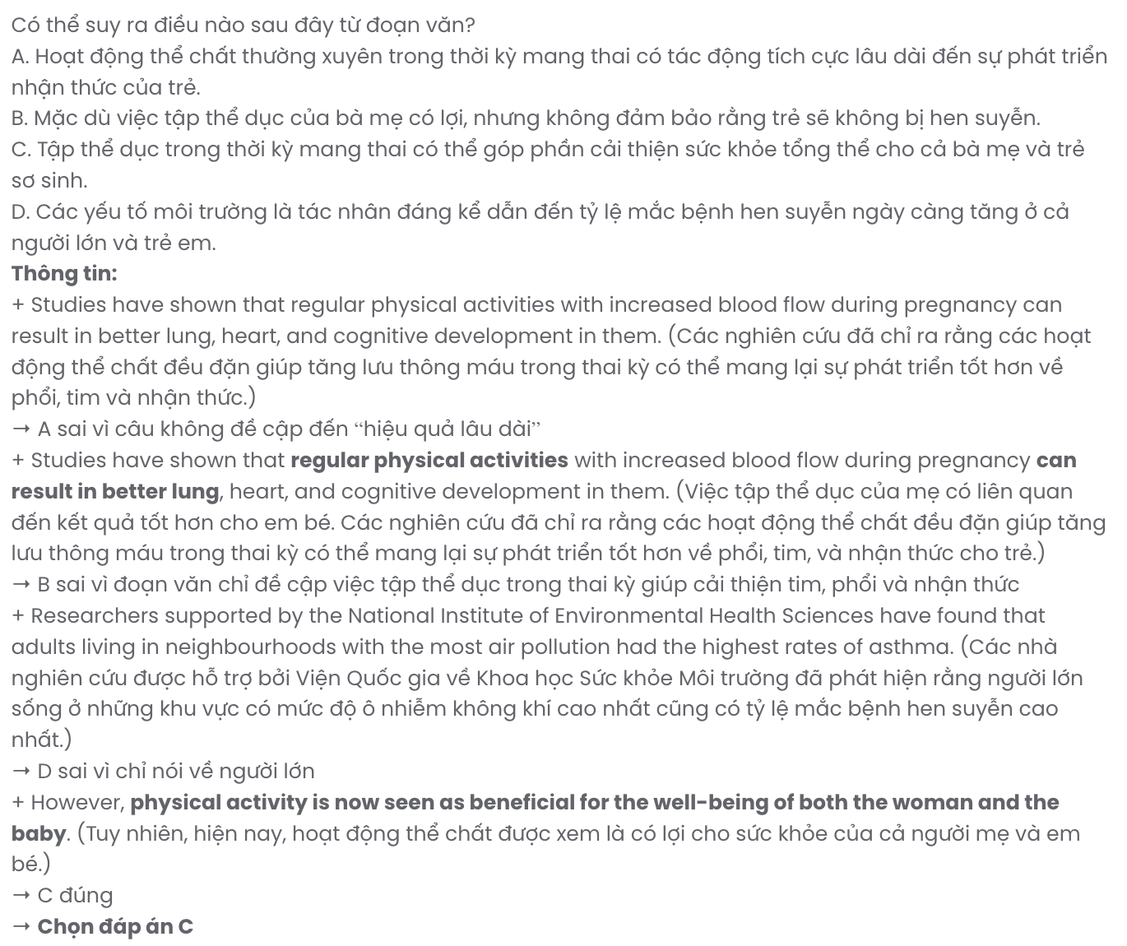

Question 40. Which of the following best summarises the passage?
A. Asthma remains largely unstudied, and exercise during pregnancy is proven to prevent this health condition in both mothers and babies.
B. Asthma is caused by many indoor and outdoor factors, and pregnant women should avoid polluted areas to maintain their babies’ future health.
C. Socioeconomic factors, air pollution, and family history contribute to the risk of asthma, while exercise is recommended for health improvements.
D. Asthma is caused by genetics, environmental factors, and lifestyle, and maternal exercise during pregnancy can reduce the risk of asthma in babies.

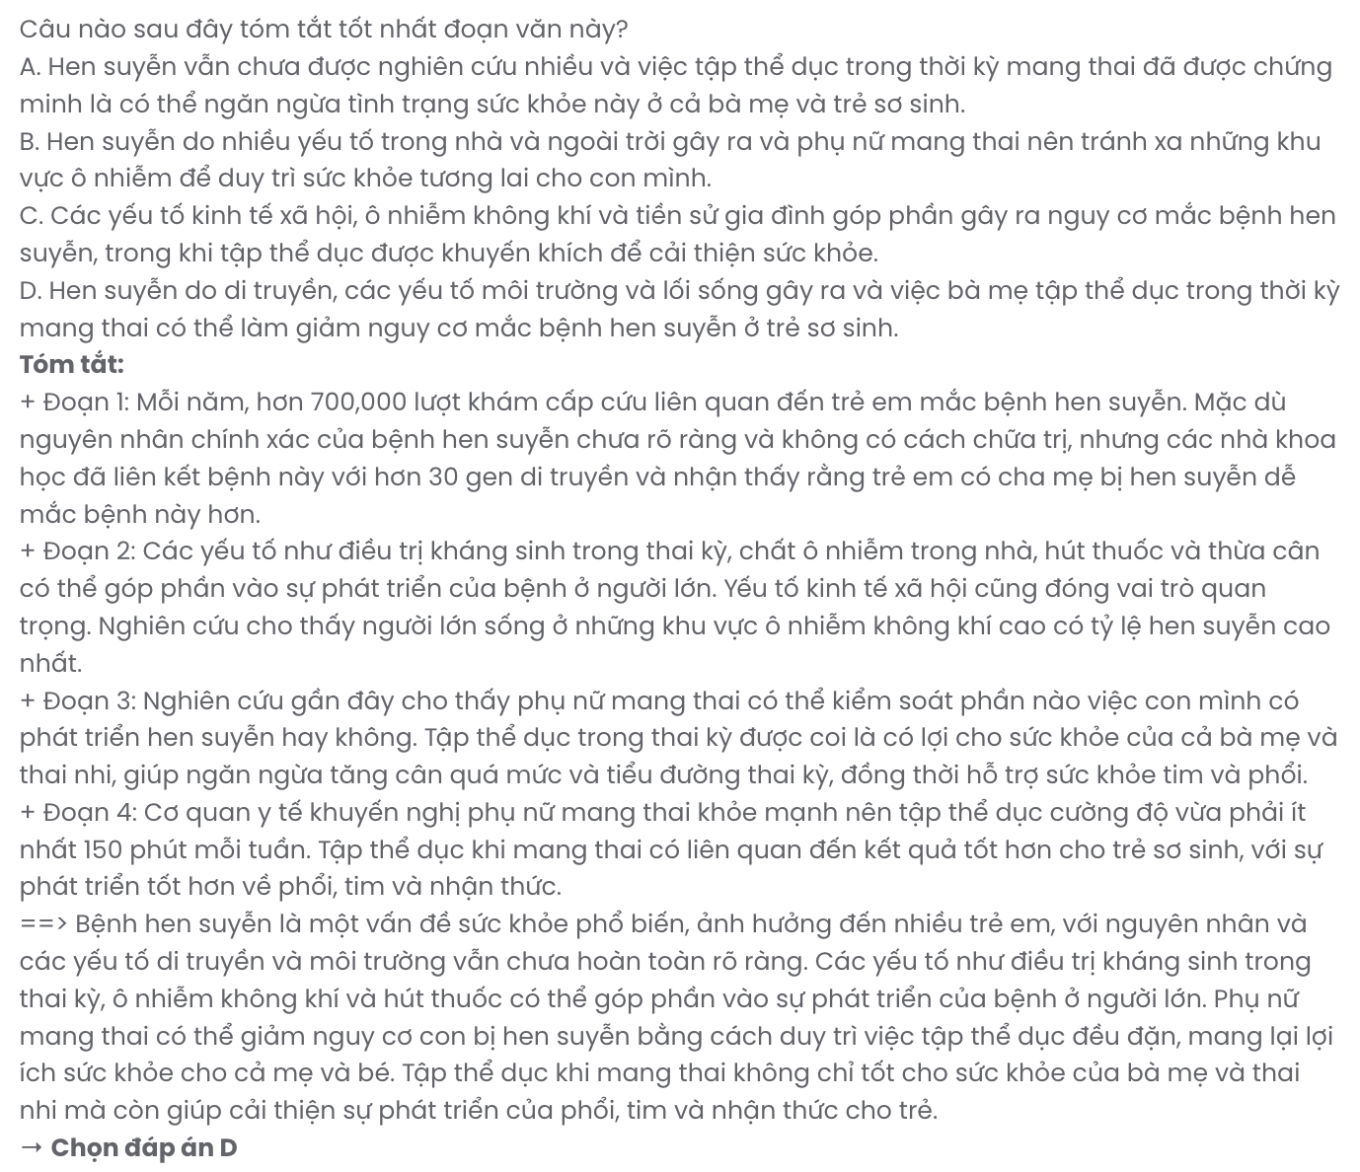

BẢNG TỪ VỰNG
STT | Từ vựng | Từ loại | Phiên âm | Nghĩa
1 | accommodation | n | /əˌkɒməˈdeɪʃn/ | chỗ ở
2 | amaze | v | /əˈmeɪz/ | làm kinh ngạc
3 | ankle | n | /ˈæŋkl/ | mắt cá chân
4 | assistance | n | /əˈsɪstəns/ | sự trợ giúp
5 | coexistence | n | /ˌkoʊɪɡˈzɪstəns/ | sự chung sống
6 | cognitive | adj | /ˈkɒɡnɪtɪv/ | liên quan đến nhận thức
7 | complaint | n | /kəmˈpleɪnt/ | lời phàn nàn
8 | conflict | n/v | /ˈkɒnflɪkt/ | sự xung đột; xung đột
9 | consequence | n | /ˈkɒnsɪkwəns/ | hậu quả
10 | conserve | v | /kənˈsɜːrv/ | bảo tồn
11 | countless | adj | /ˈkaʊntlɪs/ | vô số
12 | crowd | n | /kraʊd/ | đám đông
13 | cure | n/v | /kjʊr/ | phương pháp chữa trị; chữa bệnh
14 | delivery | n | /dɪˈlɪvəri/ | sự giao hàng, sự chuyển phát
15 | devastate | v | /ˈdevəsteɪt/ | tàn phá
16 | displacement | n | /dɪsˈpleɪsmənt/ | sự di dời
17 | eager | adj | /ˈiːɡər/ | háo hức
18 | eco-friendly | adj | /ˈiːkoʊˌfrendli/ | thân thiện với môi trường
19 | ecological | adj | /ˌiːkəˈlɒdʒɪkl/ | thuộc sinh thái
20 | energized | adj | /ˈenərdʒaɪzd/ | tràn đầy năng lượng
21 | entity | n | /ˈentəti/ | thực thể
22 | environmental | adj | /ɪnˌvaɪrənˈmentl/ | thuộc về môi trường
23 | estimated | adj | /ˈestɪmeɪtɪd/ | được ước tính
24 | evolve | v | /ɪˈvɒlv/ | tiến hóa, phát triển
25 | geographic | adj | /ˌdʒiːəˈɡræfɪk/ | thuộc địa lý
26 | immense | adj | /ɪˈmens/ | to lớn, bao la

27 | immerse | v | /ɪˈmɜːrs/ | đắm chìm
28 | initially | adv | /ɪˈnɪʃəli/ | ban đầu
29 | integrity | n | /ɪnˈteɡrɪti/ | sự toàn vẹn
30 | moderate | adj | /ˈmɒdərət/ | vừa phải, điều độ
31 | paramount | adj | /ˈpærəmaʊnt/ | tối quan trọng
32 | persistent | adj | /pərˈsɪstənt/ | kiên trì, dai dẳng
33 | plentiful | adj | /ˈplentɪfl/ | dồi dào, phong phú
34 | predict | v | /prɪˈdɪkt/ | dự đoán
35 | purchase | v | /ˈpɜːrtʃəs/ | mua
36 | recover | v | /rɪˈkʌvər/ | hồi phục
37 | reschedule | v | /ˌriːˈʃedʒuːl/ | lên lịch lại
38 | ruin | v | /ˈruːɪn/ | phá hủy, làm hỏng
39 | scenic | adj | /ˈsiːnɪk/ | đẹp, có cảnh quan
40 | serene | adj | /səˈriːn/ | yên bình, thanh thản
41 | spread | v | /spred/ | lan tỏa, lây lan
42 | sustainable | adj | /səˈsteɪnəbl/ | bền vững
43 | thrive | v | /θraɪv/ | phát triển mạnh
44 | transfer | v | /ˈtrænsfɜːr/ | chuyển đổi, chuyển giao
45 | treatment | n | /ˈtriːtmənt/ | sự điều trị
46 | unspoiled | adj | /ˌʌnˈspɔɪld/ | hoang sơ, chưa bị phá hủy
47 | visibility | n | /ˌvɪzəˈbɪləti/ | tầm nhìn
48 | whereabouts | n | /ˈweərəˌbaʊts/ | nơi ở, vị trí

BẢNG CẤU TRÚC
STT | Cấu trúc | Nghĩa
1 | make a complaint | phàn nàn, khiếu nại
2 | update on | cập nhật về
3 | the whereabouts of something | vị trí, nơi ở của cái gì
4 | variety of + N số nhiều | sự đa dạng của nhiều thứ
5 | proportion of + N đếm được/không đếm được | tỷ lệ của một thứ gì đó
6 | amount of + N không đếm được | lượng của một thứ không đếm được
7 | lack of + N không đếm được | sự thiếu hụt
8 | for the sake of | vì lợi ích của ai/cái gì
9 | irrespective of | bất chấp, không phụ thuộc
10 | prior to | trước khi
11 | thanks to | nhờ vào, nhờ có
12 | call off | hủy bỏ
13 | figure out | tìm ra, hiểu ra
14 | get by | xoay xở để sống
15 | plan to V | dự định làm gì
16 | prevent somebody from something | ngăn ai khỏi việc gì
17 | make a difference | tạo sự khác biệt
18 | avoid V-ing | tránh làm gì
19 | due to | bởi vì, do
20 | rely on | dựa vào, phụ thuộc vào
21 | result in | dẫn đến

