TEST 05

Listening
There are 25 questions
You will need coloured pens and pencils.

My name is…………………………….

PART 1
5 questions

This is an example. Now you listen and draw lines.
Mrs Black | Mr Green |  | May |  | John

Tim |  | Emily

PART 2
5 questions

Để một bức tranh biển
Listen and write. There is one example.
 | 
 | A FAMILY TRIP
0 | Where to go: | …beach …
1 | When to go: | ……a.m.
2 | Where to stay: | …….Hotel
3 | What to do: | ……
4 | What to eat: | ……
5 | What to buy: | ……

PART 3
5 questions

What did Tim buy for his family?
Listen and draw a line from the floor to the correct picture.
There is one example

 | A book  A pen  A T-shirt  A hat  Shoes  Bag  An umbrella | 
 |  | 
 |  | 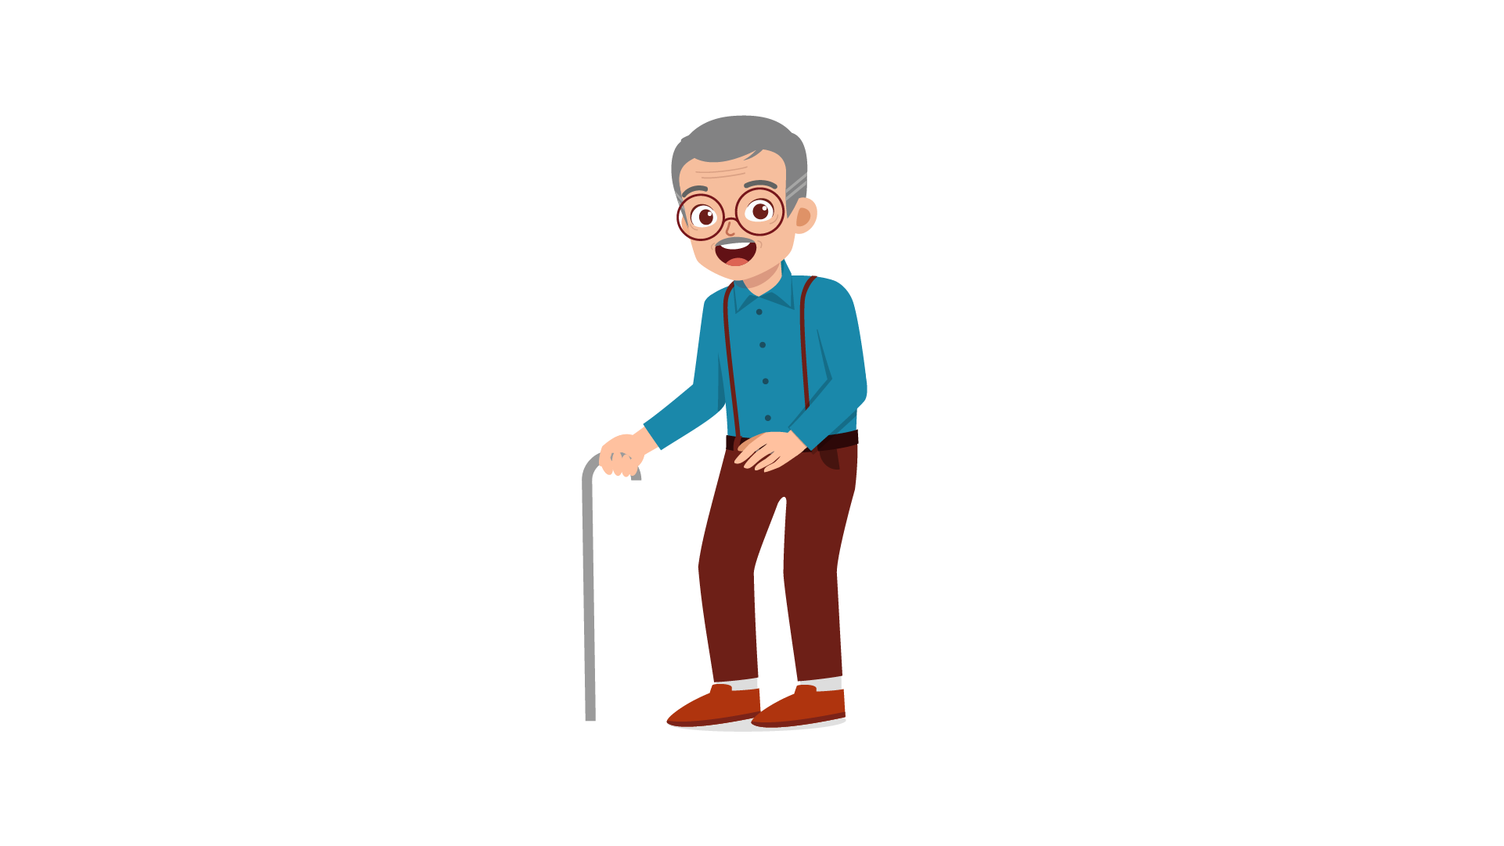

PART 4
5 questions

Listen and tick (✓) the box. There is one example.
Example : What time did Laura go to school?
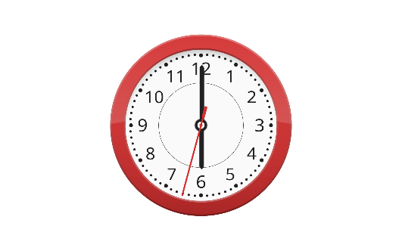 |  | 
A ⬜ | B ⬜ | C ⬜
- Where’s Emily’s scarf?
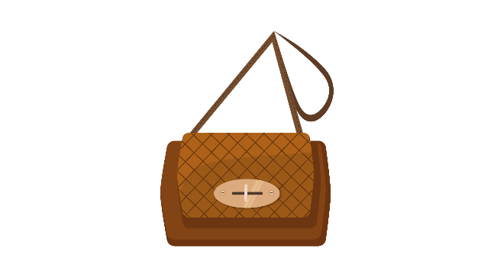 | 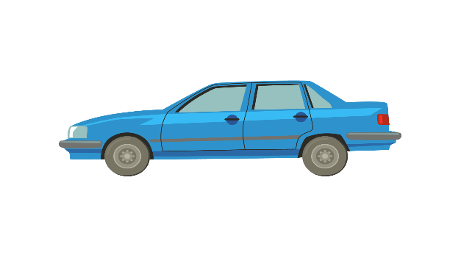 | 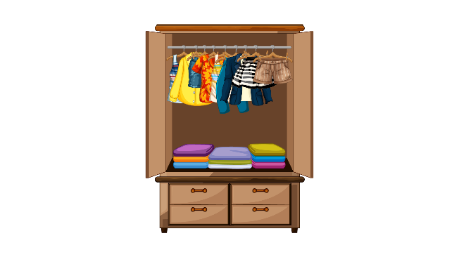
A ⬜ | B ⬜ | C ⬜
- What is Trang listening to?
 | 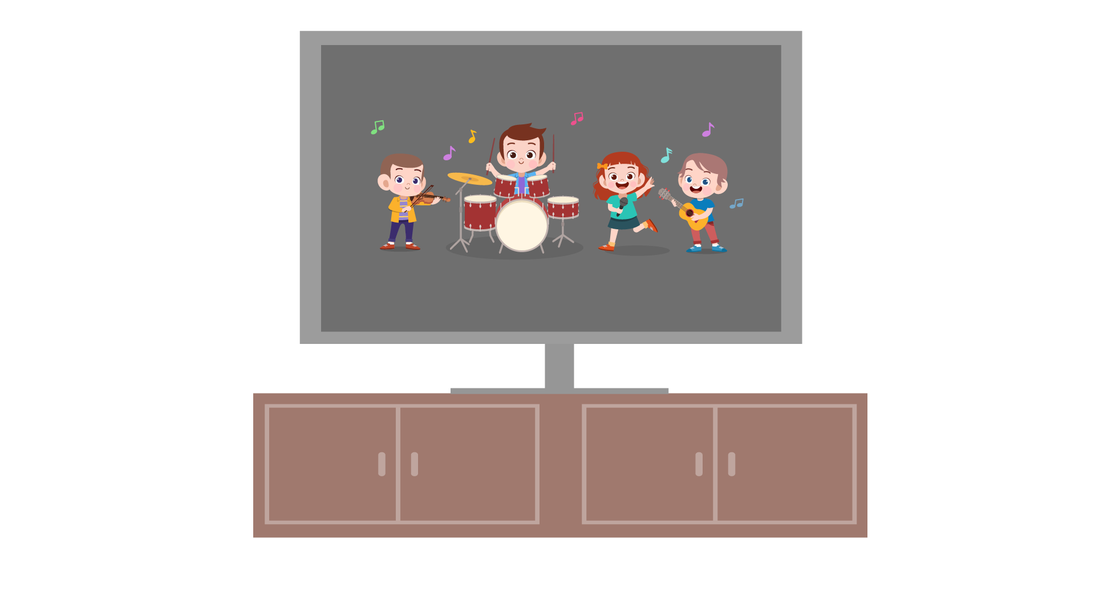 | 
A ⬜ | B ⬜ | C ⬜
- Which woman is Sue’s teacher?
 |  | 
A ⬜ | B ⬜ | C ⬜
- What does Minh want to do today?
 |  | 
A ⬜ | B ⬜ | C ⬜
- Why does Ben have a stomachache?
 | 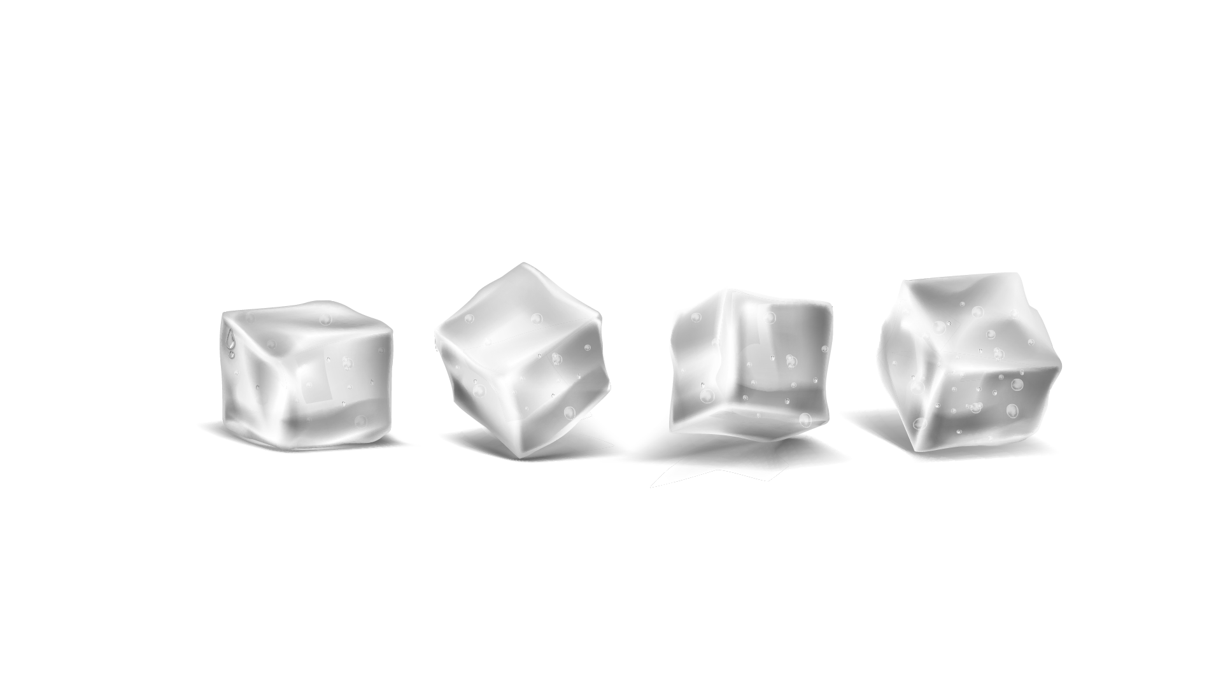 | 
A ⬜ | B ⬜ | C ⬜

PART 5
5 questions
Listen and colour and draw.
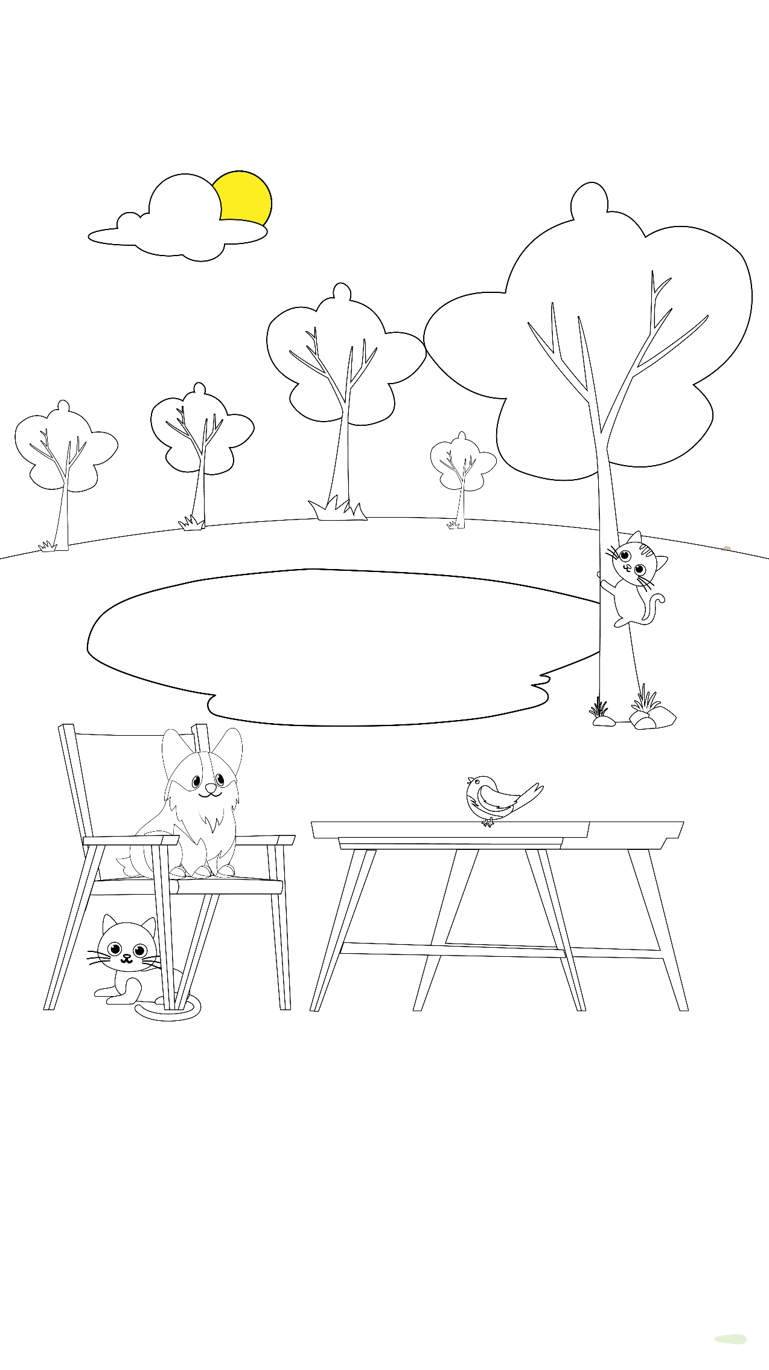

Reading and Writing
There are 35 questions
You have 30 minutes.
You will need a pen or pencil.
My name is…………………………….

PART 1
5 questions

Look and read. Choose the correct word and write them on the lines.

 | 
A hospital | Vegetable
 | 
Ground | A cinema
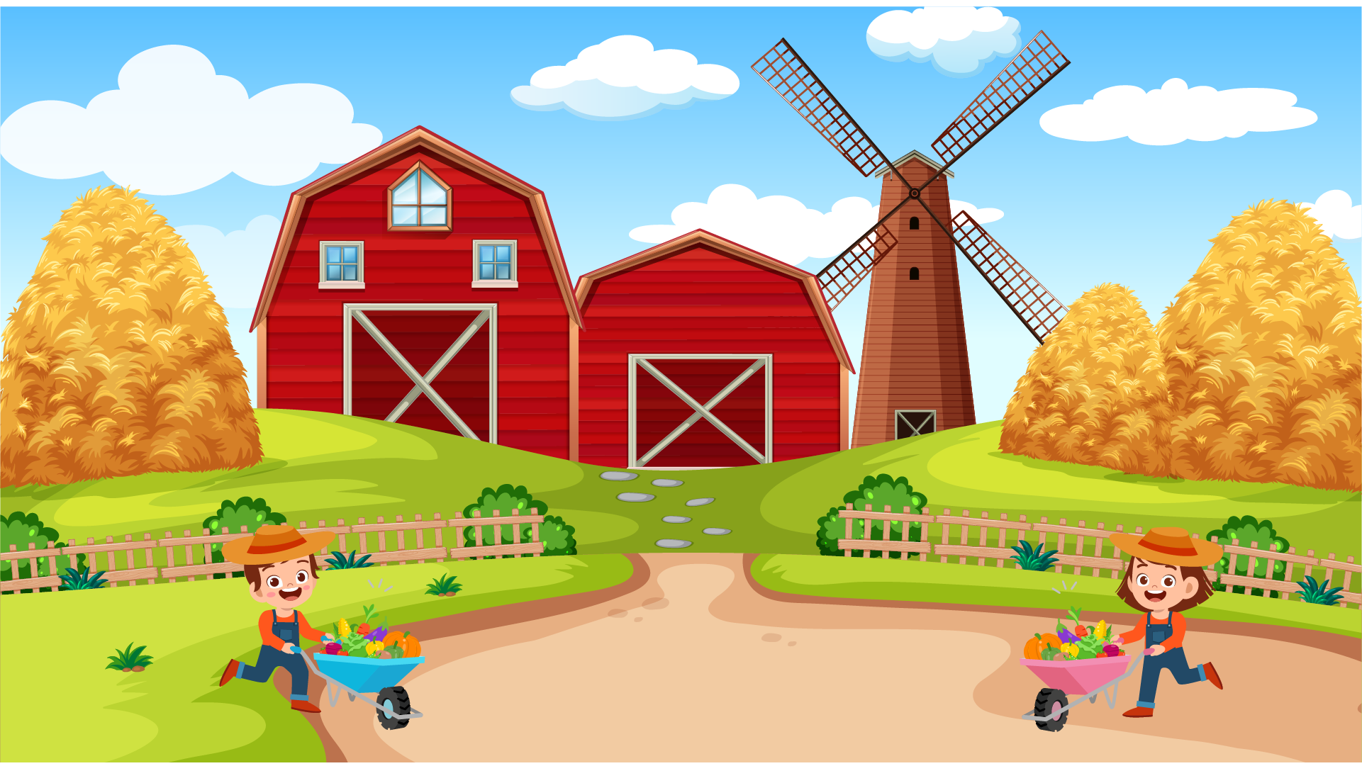 | 
A farm | An earache
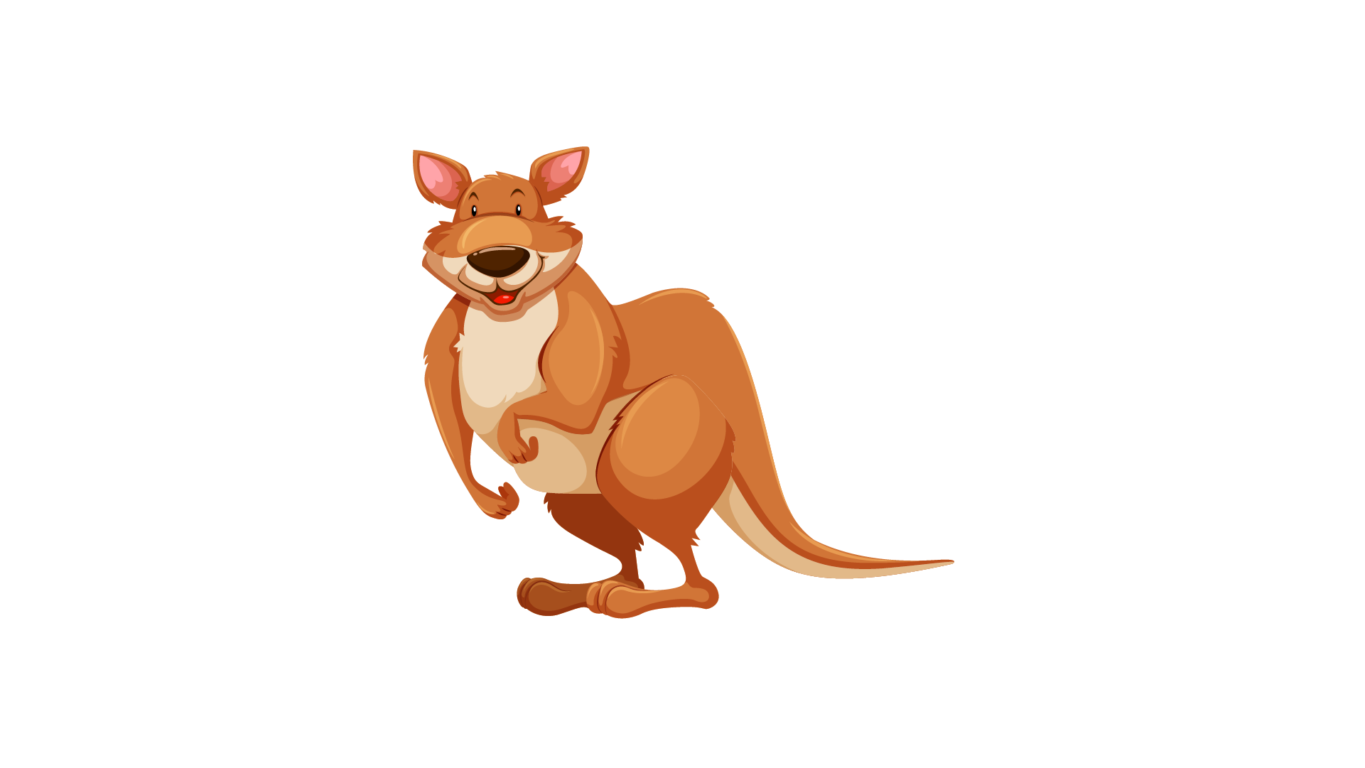 | 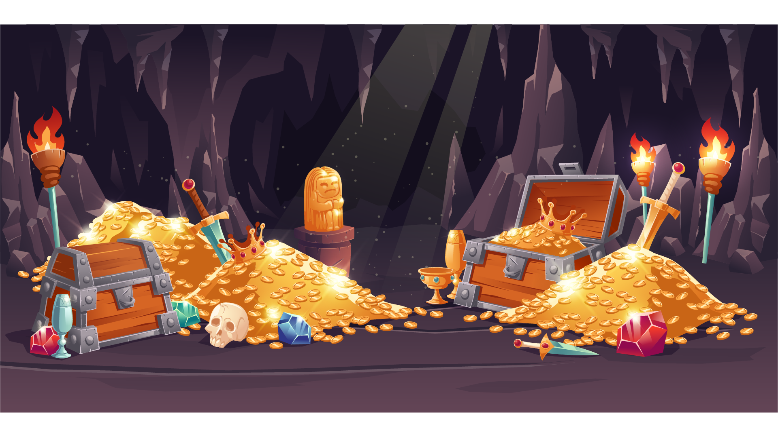
A kangaroo | A treasure

Example
(0) | It is a place. A doctor works there. | A hospital
Questions
1 | It’s a kind of food. It’s green and delicious. | ___________
2 | This can be gold, silver or diamond. People usually try to find it. | ___________
3 | You have this when your ear hurts. | ___________
4 | It’s an Australian animal. It has a pocket in front of its stomach. | ___________
5 | When you are standing, your feet are on this.

PART 2
6 questions

Read the text and choose the best answer.
Tony is talking to his grandfather, Susan, about his first day at school.


Example:
 | Susan: | Where are you now, Tony?
 | Tony : | A. I’m reading a book.
 |  | B. I have lessons at 8 a.m. at school.
 |  | C. I’m doing my homework at home.
Questions:
1 | Susan: | How was your first day at school, Tony?
 | Tony: | A. Yes, I enjoyed it.
 |  | B. Yes, it was very good.
 |  | C. Yes, I went to school today.

2 | Susan: | Where is your classroom?
 | Tony: | A. I study Physics in the lab.
 |  | B. My school is large and beautiful.
 |  | C. It’s on the second floor.

3 | Susan: | How many students are there in your class?
 | Tony: | A. The classroom is very big.
 |  | B. There are twelve classes in the school.
 |  | C. There are 22 girls and 20 boys.

4 | Susan: | How did you go to school?
 | Tony: | A. I rode my bike to the park every morning.
 |  | B. I travelled to school by bike.
 |  | C. I had a beautiful bike at home.

5 | Susan: | Who is your teacher?
 | Tony: | A. Mr. Alex is our school principal now.
 |  | B. Her name’s Mrs. Mina.
 |  | C. Mrs. Lisa drove me to school yesterday.

6 | Susan: | I have to go to school now, Grandmother.
 | Tony: | A. I do, too.
 |  | B. I’d love to.
 |  | C. Goodbye, dear!

PART 3
6 questions

Read the story. Choose a word from the box. Write the correct word next to the numbers 1-5. There is one example.
Last Saturday, Jack went to his uncle’s (0) …house.... in the country. It was a nice day with the (1) …. shining and the birds singing. Her parents drove Jack to his uncle’s house.
On the way to his uncle’s house, Jack could see large paddy fields long the (2) ….. Many people worked on the fields. He could see the (3) ….too. They helped the farmers with their work.
First, in the morning, he carried all the (4) …. They were very heavy but he could do it. Then, he gave food to the buffalos and the chicken. Sometimes, he played with them, too. In the afternoon, he went to the (5) …. to play with other kids. They went swimming together. After Jack had dinner with his uncle and aunt, he took a bus to go home.

Example
sun | house | road
carrots | buffalos | lake
mountains | hills | factory

(6) Choose the best name for the story.
Tick one box.
A day in the country | ⬜
A field trip at school | ⬜
A visit to uncle’s house | ⬜

PART 4
5 questions
Choose the right words and write them on the line.
 | Football
 | 
Example  1  2  3  4  5 | Football is called the King of sports  … people around the world play football.  The first people … played football is English. But now people in every nation play it. In America and Canada, some people call it soccer  because … have another football game. This American football is very different … soccer. Every four years, people hold World Cup. It’s the  … international football competition. Every country joins and tries to become the winner.

Example: | called | named | asked
1. | so | and | because
2. | which | who | whom
3. | they | them | their
4. | in | to | from
5. | large | largest | larger

PART 5
7 questions

Look at the picture and read the story. Write some words to complete the sentences about the story. You can use 1, 2 or 3 words.
A great lesson

Last Monday morning, Nick’s Science teacher, Mr Jack, was sick. Another teacher came in the class. It was Mrs Jones, the music teacher. Students were very surprised when they saw Mrs Jones in the class.
Examples:
Last Monday, Nick’s ……Science teacher…… was sick.
Students felt very …..surprised…..

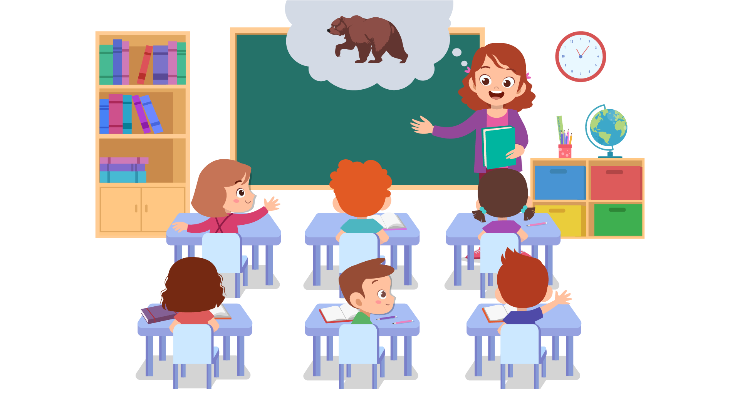
“Hello, I’ve got a message from Mr. Jack. He’d like you to answer the questions on page 66 and 67 for your homework. They are about the life of a bear.” Mrs Jones said to the whole class. “So what will we do today, teacher Jones?” Nick asked. Mrs Jones smiled and said : “Good question! Today we will have a special game.”
Questions:
1 | Mr Jack wanted students to do two pages in the book as …
2 | In this lesson, students would play a …


The rule of the game was very simple. There were 10 difficult questions. Students answered all the questions and they became the winners. Or Mrs Jones would be the winner. Mrs Jones gave students some orange books. “The informtion in these books can help you to find the answers. Or you can find them on the Internet.” Students became very excited because they all loved working on the computer.

Questions:
3 | In the game, students had to solve … to become the winners.
4 | Mrs Jones asked students to find the information in some orange ...
5 | Students liked working with the …


After an hour, students gave the question paper to Mrs Jones. She was really surprised when looking at our answers. “Many correct answers!” she said. “You’ve got lots of ticks and no crosses! You’re winners!”

Questions:
6 | Students finished all the questions in …
7 | Mr Jones was surprised because all of students’ answers were …

PART 6
6 questions

Look, read and write.


Examples:
The girl is turning …seven… today.
How many girls are there in the room? …two…

Complete the sentences.
1. The boy in a green … is sitting between a boy and a girl.
2. There are … children at the party.

Answer the questions.
3. What is the shape of the table?
4. What is the girl with short hair doing?

Now write two sentences about the picture.
5. …………………………………….
6. …………………………………….
Speaking
My name is…………………………….

Summary of Procedures
The usher introduces the child to the examiner. The examiner asks how old the child is.

- The examiner asks the child to describe several differences between the two Find the Differences pictures, e.g. ‘In picture 1, the window is on the left of the desk but in picture 2, the window is on the right.’
- The examiner tells the child the name of the story and describes the first picture, e.g. “Today is sunny. Emily and Lizzie play on the playground”. The examiner then asks the child to continue to tell the story.
- The examiner shows how to do the task with the first odd-one-out set of pictures. For example: ‘These are all places. But this is a room in a house’. Then the examiner asks the child to choose one picture in the other three sets and say which is different and why.
- The examiner asks questions about the child, e.g. ‘Who’s the oldest person in your family?’

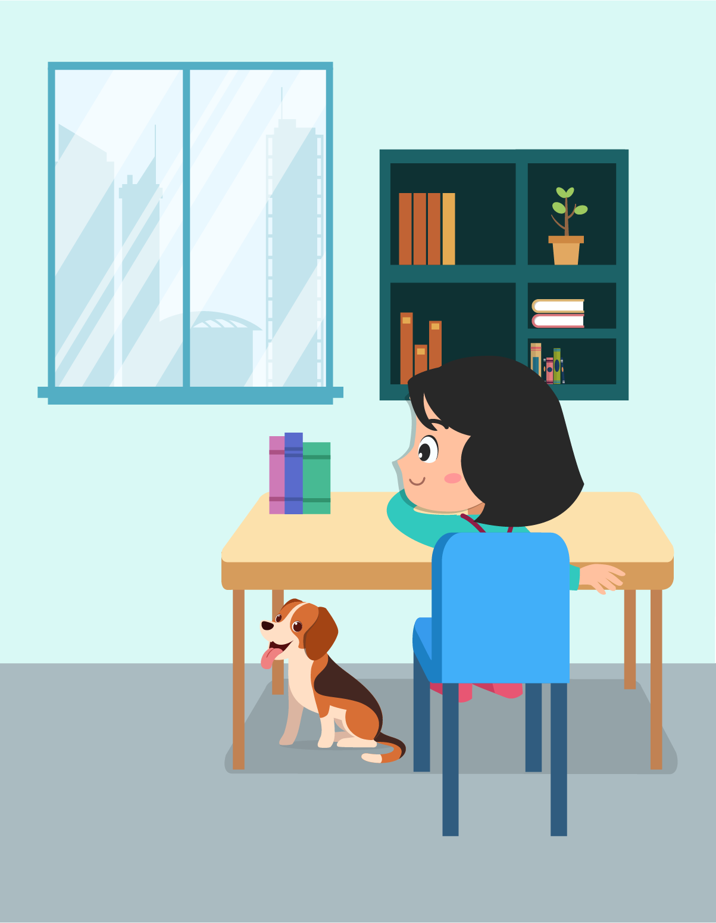 |  | 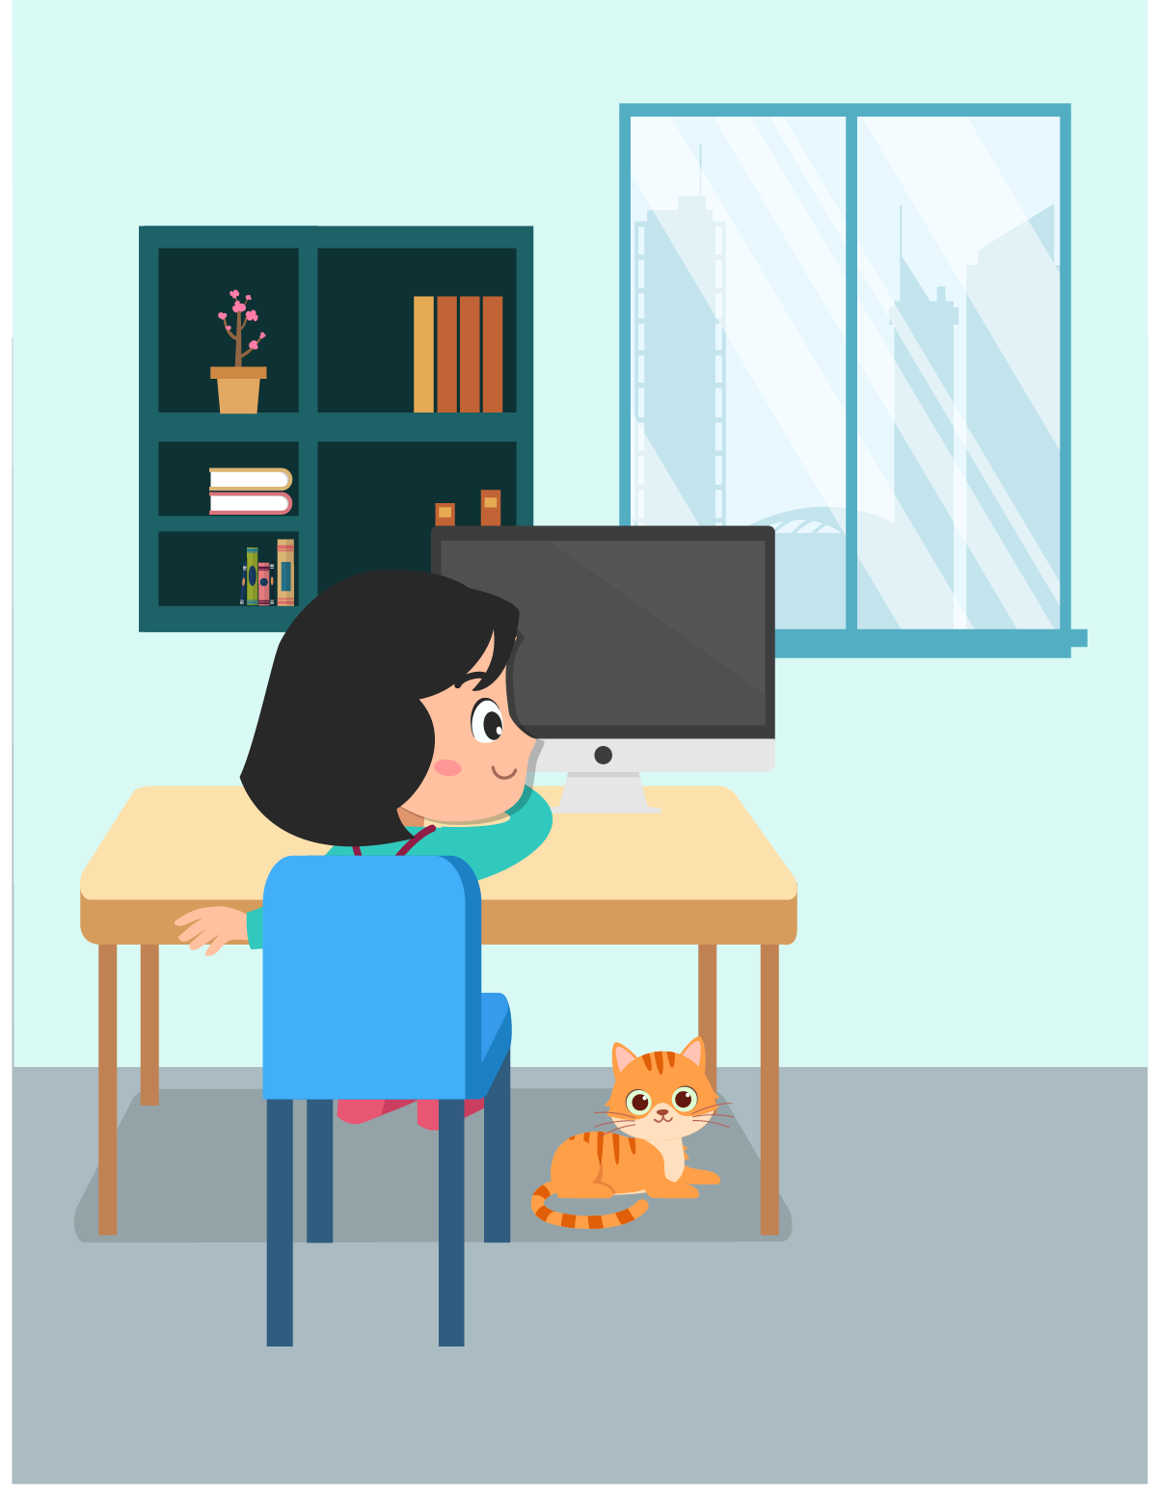

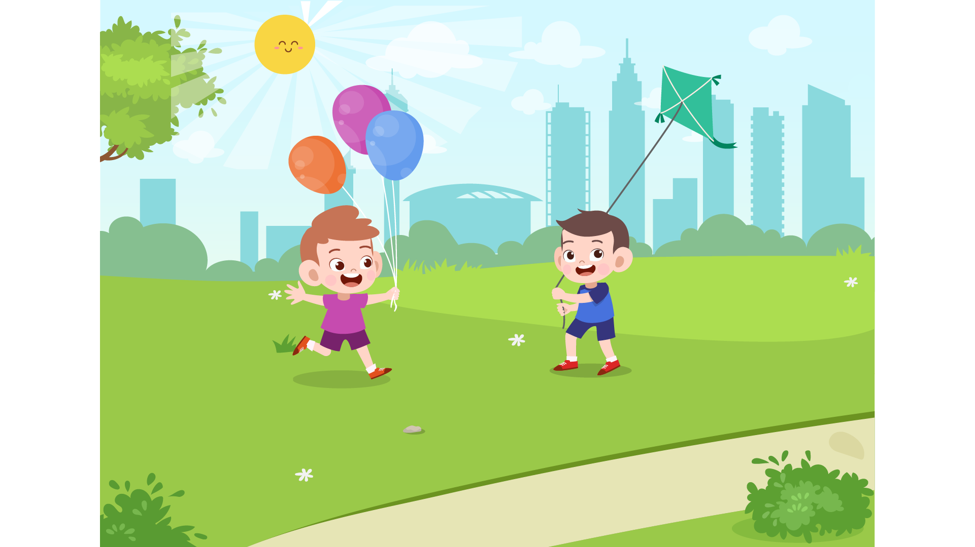
 | 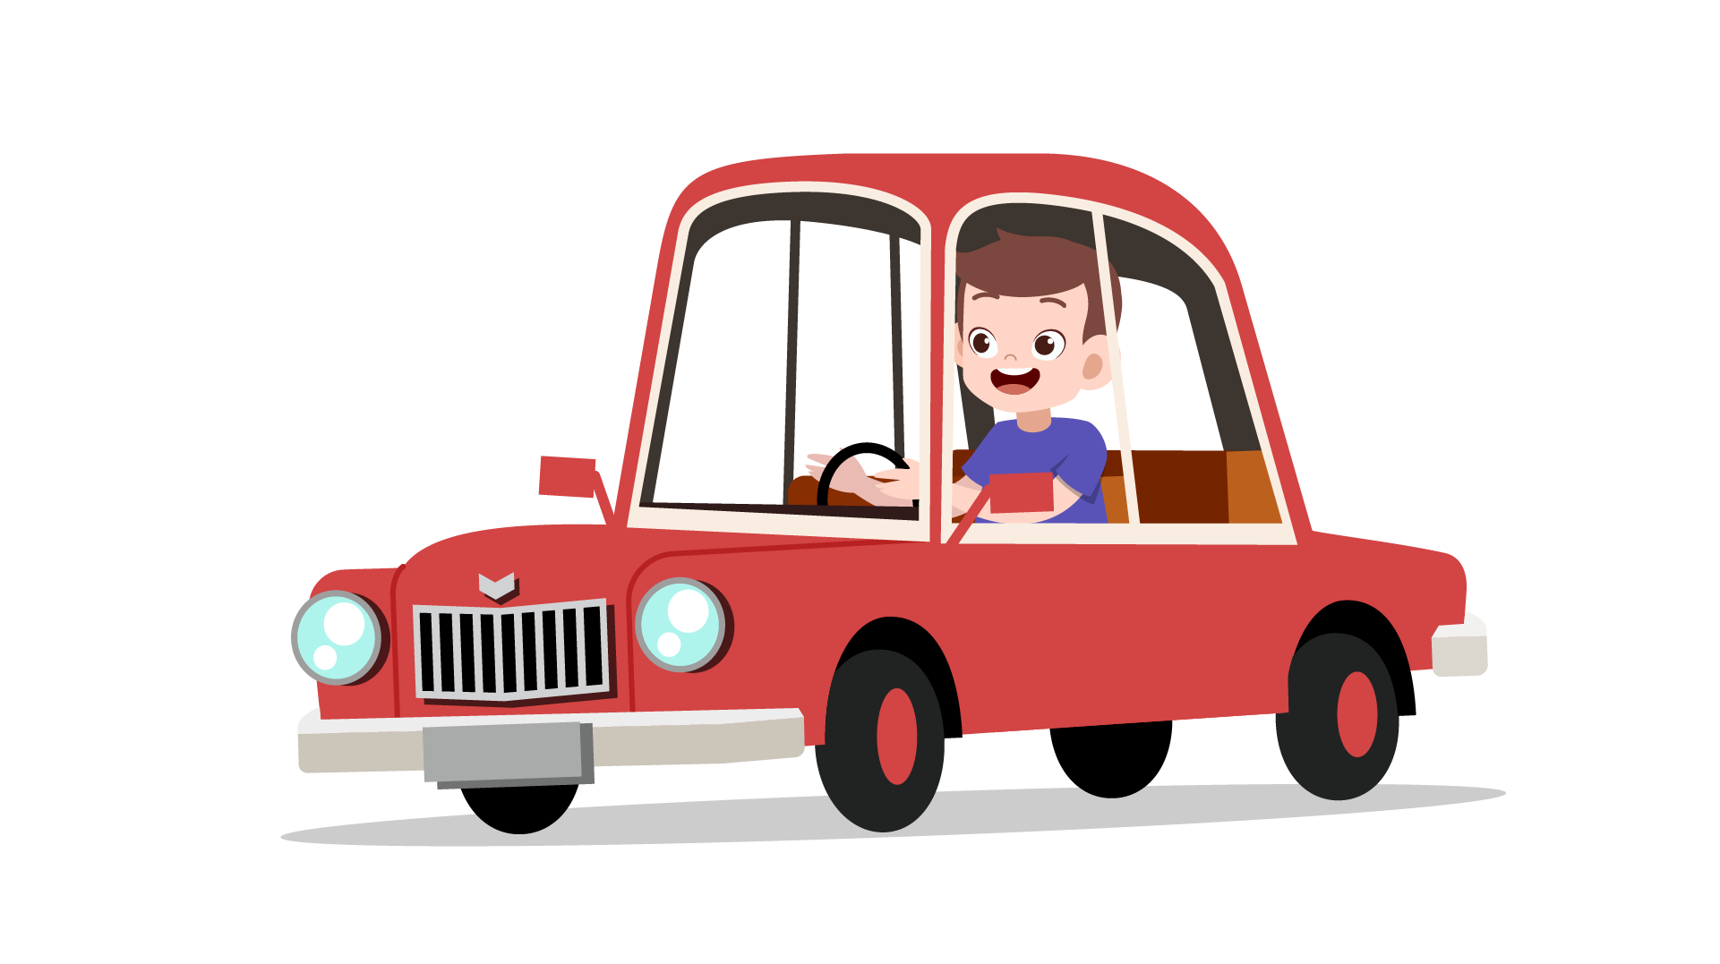 | 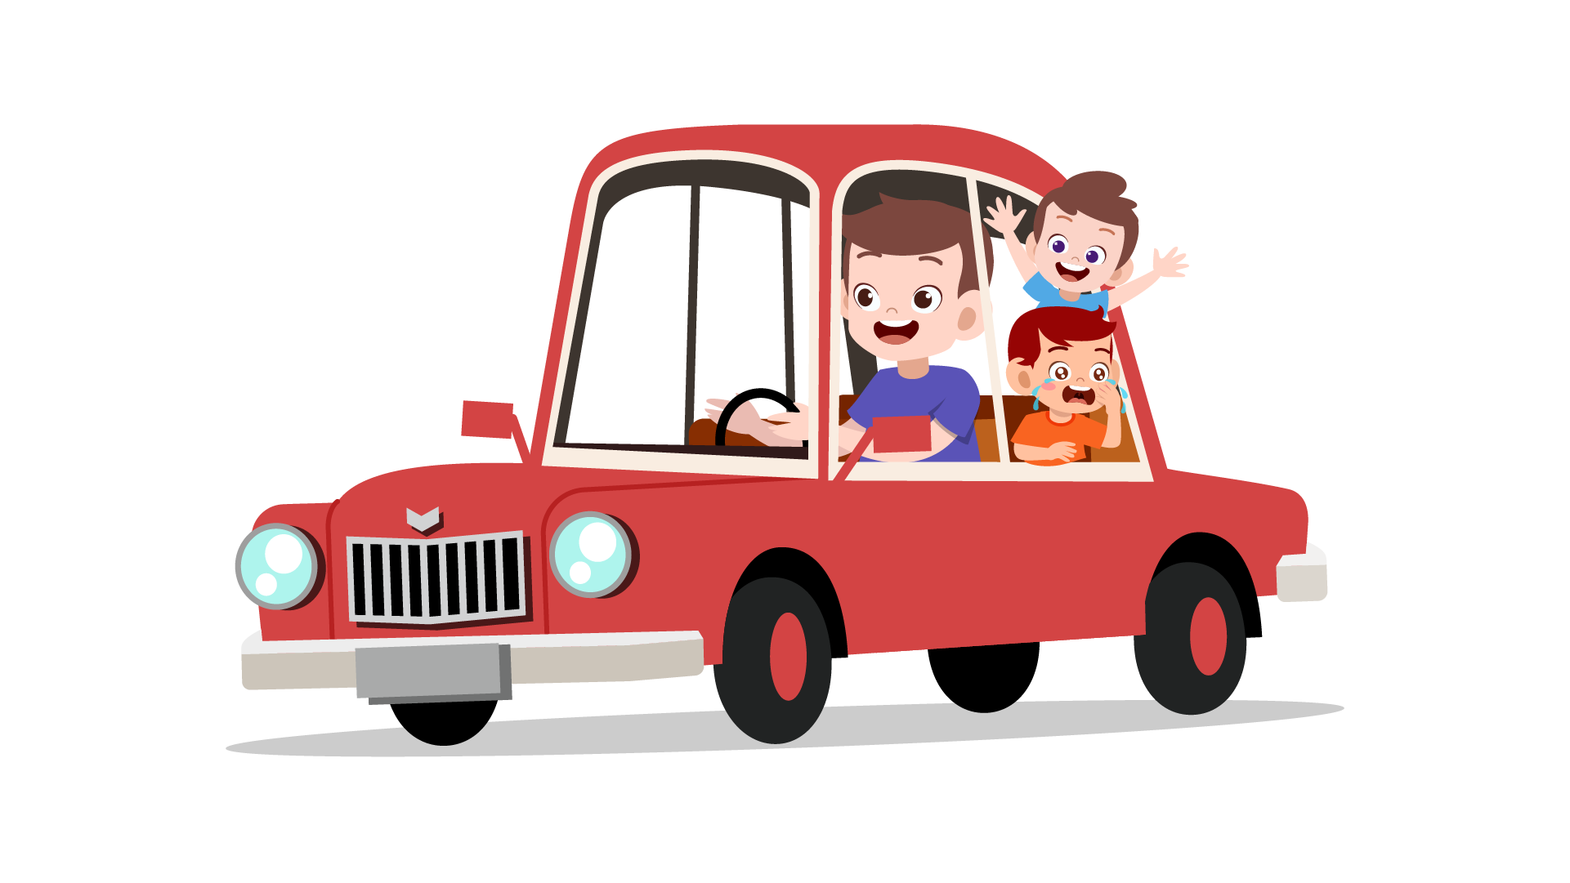

 |  | 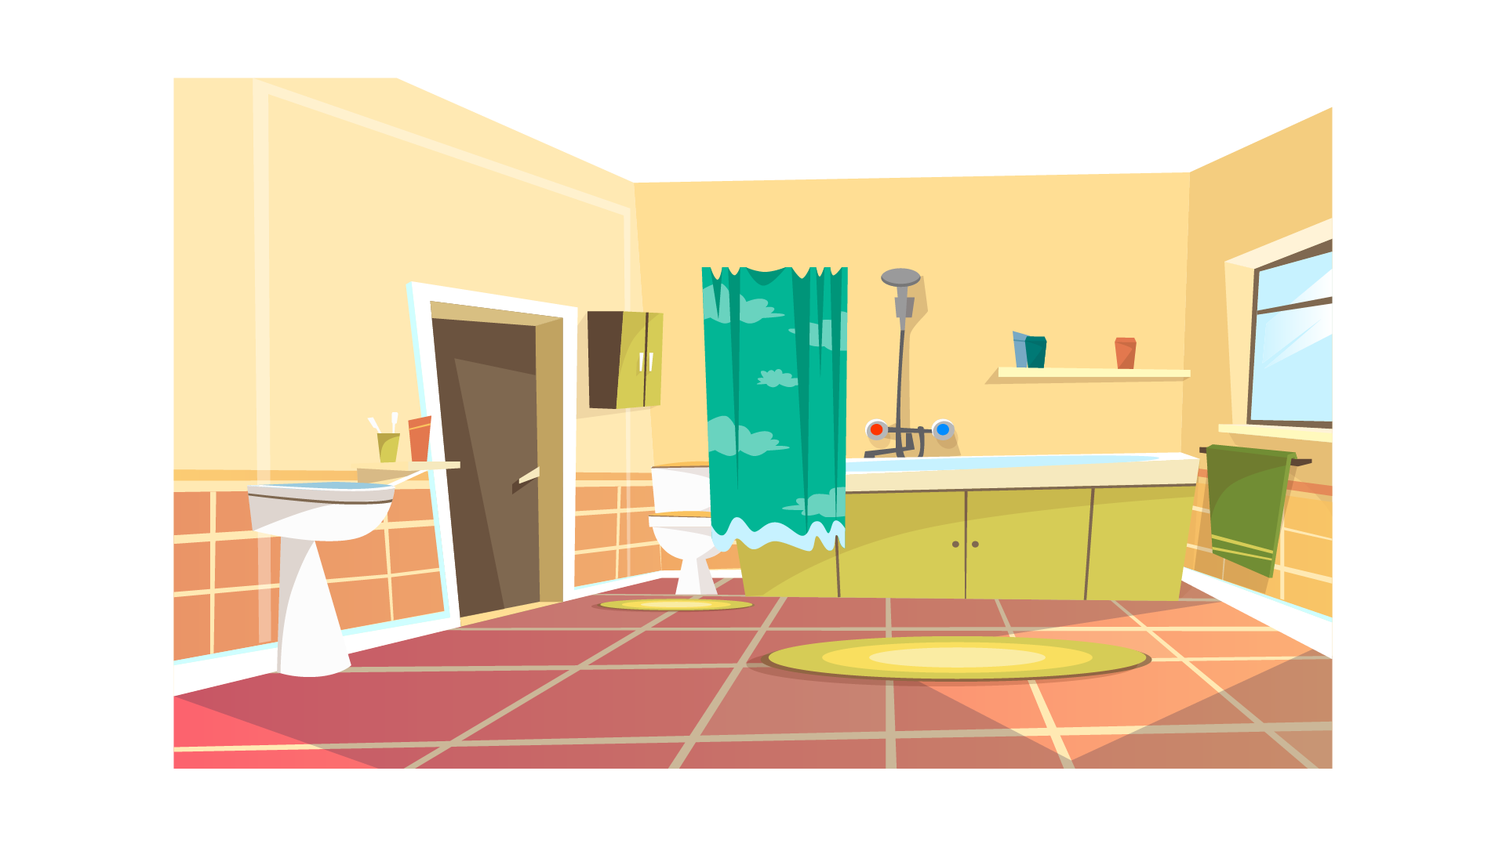 | 
 |  |  | 

 |  |  | 
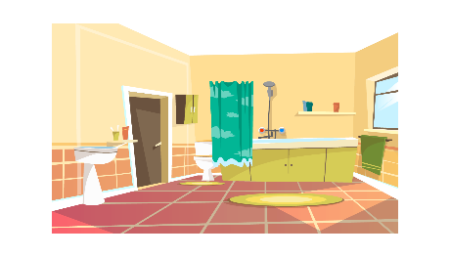 | 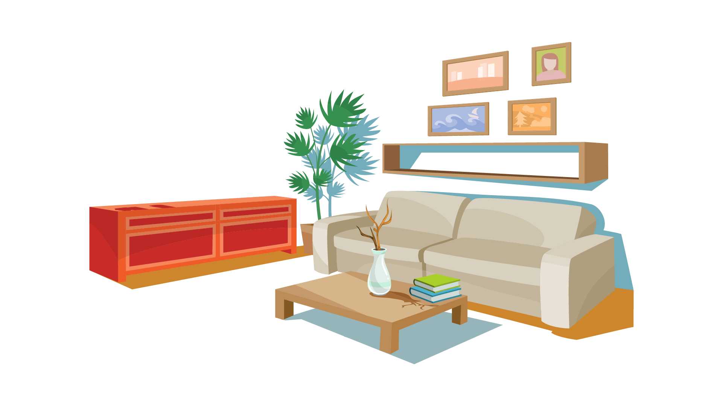 | 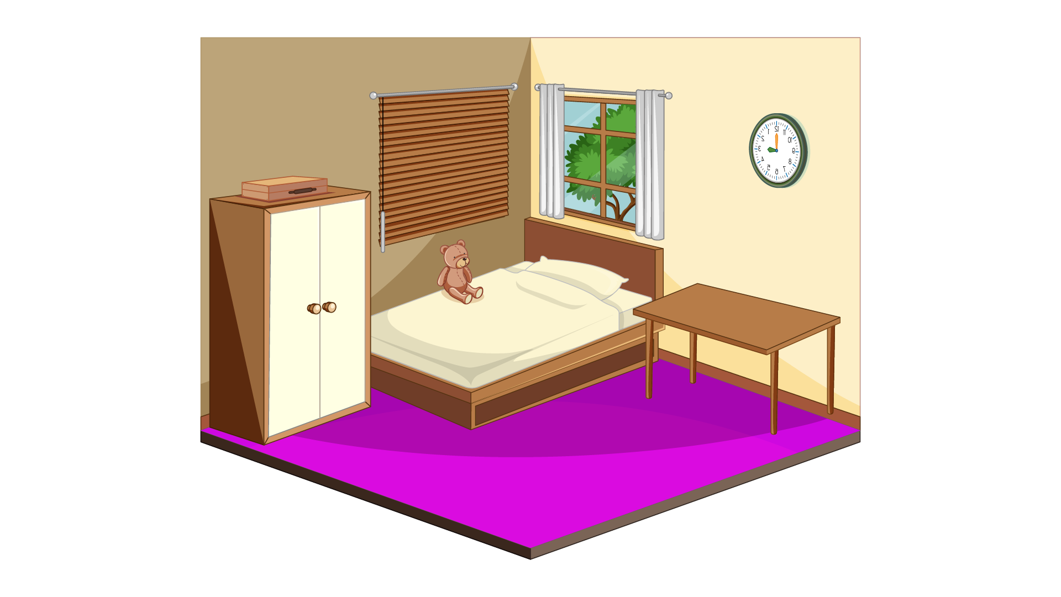 | 

