## **Tiếng Anh 8 i-Learn Smart World - Luyện tập - Unit 6 Time allotted: 45**

**PART 1. PRONUNCIATION (5 questions)**

**Choose the word whose underlined part differs from the other three in pronunciation in the following question.**

1. A. disappear B. planets C. Mars D. Venus

2. A. exciting B. living C. gravity D. billion

3. A. scientist B. life C. excited D. similar

**Choose the word whose primary stress is NOT placed on the second syllable.**

4. A. interesting B. polluting C. preventing D. protecting

**Choose the word whose primary stress is NOT placed on the first syllable.**

5. A. fascinating B. swimming C. exciting D. building

**PART 2. USE OF ENGLISH (12 questions)**

**Choose the option that best completes the following sentence.**

6. The farmer ______________ in the field when he saw a UFO.

A. is working B. was working C. worked D. works

7. A ______________ has a great view of the stars, so many scientists want to work on it.

A. gravity B. cloud C. temperature D. space station

8. Scientists float in a space station because there’s no ______________.

A. technology B. science C. gravity D. air

9. Jane’s mom: In 2100, there will be many space stations near Earth.   
Jane: ______________

A. Really? Why will you go there? B. What a good journey! C. I don’t know when they will come. D. Oh, it will be much easier to explore space.

10. The world’s ______________ is growing more quickly every year. Our planet is becoming more and more crowded.

A. pollution B. popularity C. population D. pollutant

11. NASA is now working hard to ______________ whether there is life on Mars.

A. discover B. collect C. experience D. accept

12. Humans can’t live unless they have enough ______________ to breathe.

A. water B. planets C. food D. oxygen

13. Scientists have spent years ______________ information about UFOs.

A. collecting B. to collect C. collected D. collect

14. Some scientists say that flying saucers might be people's ______________.

A. imagination B. imagine C. imaginative D. imaginary

15. When you are in orbit, you'll be out of the earth's ______________ and you're weightless.

A. outside B. gravity C. atmosphere D. outskirt

16. The gravity of Venus is very similar ______________ Earth’s.

A. to B. for C. with D. in

17. Jack: Where will people live in 100 years?   
Ben: ______________

A. Why not go there for some fresh air? B. On another planet, maybe! C. It’s a good place to live. D. It’s not suitable for people to live here.

**PART 3. WORD FORMATION (3 questions)**

**Write the correct form of the given word.**

18. I find her story about UFOs hardly ______________.***(BELIEVE)***

19. Environmental pollution has led to the ______________ of many species of plants and animals from our planet. ***(APPEAR)***

20. Many UFO ______________ have been recorded by the United States government. ***(SIGHT)***

**PART 4. ERROR RECOGNITION (2 questions)**

**Find the underlined part that needs correction in the following question.**

21. In my dream, I talked to an alien from another planet by a very strange language.

A. In B. to C. from D. by

22. We walked down that empty street when a UFO appeared in front of us.

A. walked B. that C. a D. front

**PART 5. READING (5 questions)**

**Read part of a short story. Choose the best word or phrase for each space. (5 questions)**

Zog checked all the information on the computer screens of his spaceship. He was making an approach to Venus after traveling more than 70 million miles from Mars. That planet was too cold, and he expected the (23) ___________ on this one to be too high. However, his job was to visit all the planets in the Sun’s system in the next 150 years.   
Zog’s spaceship was not like the UFOs which often visited the Earth – the Earth people called them flying saucers. Instead, it looked like an ice-cream cone – (24) ___________, with lights all around the bottom.   
Zog was ready to land on Venus. He found a flat area and stopped the spaceship. For a few minutes, he (25) ___________ over one spot, then he went down and touched the ground.   
His computer told him that there were aliens in the area, but it had no data on their size. Zog looked out of one of the windows and saw them for the first time. At first, he thought they were very small, but then he realized they were still a long way away. As they came closer, he saw that they were actually (26) ___________, and there were hundreds of them! He made a quick decision, pushed some buttons and rose from the ground, high above the crowd. He pushed some more buttons and set a course for his next planet, (27) ___________.

(23) A. temperature B. gravity C. oxygen D. water

(24) A. circular B. disk-shaped C. triangular D. square

(25) A. flew B. hovered C. drove D. rode

(26) A. huge B. tiny C. crowded D. terrified

(27) A. Mars B. Venus C. the Moon D. the Earth

**PART 6. LISTENING (5 questions)**

**Listen to five short texts. Choose the correct picture for each question. (5 questions)**

28. (1) Which planet is the speaker talking about?

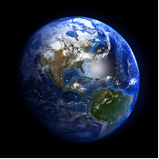 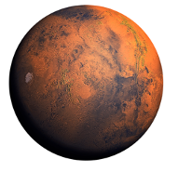 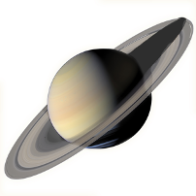

**A. ☐** **B. ☐** **C. ☐**

29. (2) What did the UFO look like?

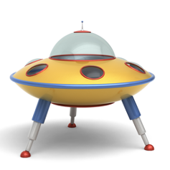 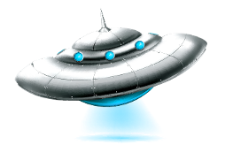 

**A. ☐** **B. ☐** **C. ☐**

30. (3) What did the alien look like?

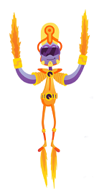  

**A. ☐** **B. ☐** **C. ☐**

31. (4) What problem is the astronaut talking about?

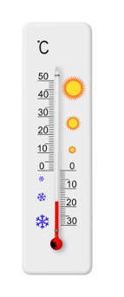  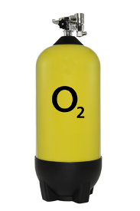

**A. ☐** **B. ☐** **C. ☐**

32. (5) What shape is the alien spaceship?

  

**A. ☐** **B. ☐** **C. ☐**

**PART 7. WRITING (8 questions)**

**Rewrite the following sentence without changing its meaning. Use the given word(s) if any.**

33. I will always remember the day the first man set foot on the moon.

→ NEVER___________

34. Venus and Earth are almost the same size.

→ BIG___________

35. Mars is called “the Red Planet”.

→ “The Red Planet”___________

36. An alien appeared during the time people were searching the spacecraft.

→ When people___________

**Use the given words or phrases to make a complete sentence.**

37. Astronaut Neil Armstrong / step down onto/ moon / July 20th, 1969 /.

→ ___________

38. there / intelligent beings / other planets / our solar system?

→ ___________

**Put the words in the correct order to make a correct sentence.**

39. Keywords: has records of/sightings/government/./thousands of/The United States/UFO

→ .......................................

40. Keywords: miles from Earth/the red planet,/140 million/./is about/Mars, which/is known as

→ .......................................

**---THE END---**