School: ……………………………………….. | Date:……………………………………..
Class: ……………………………..................... | Period: 5

UNIT 4: NATURAL DISASTERS
Lesson 2.1: Vocab & Listening, pages 38 & 39
1. Objectives
By the end of this lesson, students will be able to…
1.1. Language knowledge/ skills
- learn and use vocab. related to disasters
- practice listening for specific information
- practice functional English – Working through tasks in groups
1.2. Competences
- improve Ss’ communication, collaboration, analytical, critical thinking skills.
1.3. Attributes
- know how to keep safe in a disaster.
2. Teaching aids and materials
- Teacher’s aids: Student’s book and Teacher’s book, class CDs, DCR– Phần mềm tương tác trực quan, DHA – Ứng dụng trò chơi tương tác, projector / interactive whiteboard /TV (if any), PowerPoint slides.
- Students’ aids: Student’s book, Workbook, Notebook.
3. Assessment Evidence
Performance Tasks | Performance Products | Assessment Tools
- Match the bold words in the text with the pictures.  - Use the new words to talk about things your family has or does during a bad storm.  - Listen to two students talking about safety tips during disasters. Number the safety tips in the order you hear them  - Listen again and fill in the blanks to know why you should follow these safety tips.  - Listen to the conversation again and  count how many times you hear the sentences or phrases.  - In pairs: Which tip(s) did you know about? Which tip(s) would you tell your family about? | - Ss’ answers.  - Ss’ answers.  - Ss’ answers.  - Ss’ answers.  - Ss’ answers.  -Ss’ answers. | - Observation.  - Observation.  - Observation.  - Observation.  - Observation.  - Observation.
4. Procedures
A. Warm up: 5’
a. Objective: to introduce the topic of the new lesson.
b. Content: Let’s talk!
c. Expected outcomes: Ss can talk about what they see in the picture.
d. Organization
Teacher’s activities | Students’ activities
Let’s talk! In pairs: Look at the picture. What disaster happened? What should people do in this kind of disaster?    - Ask Ss to work in pairs to talk about what happened in the picture and what people should do in this kind of disaster.  - Pick some Ss to share their ideas.  - Give feedback. | - Talk with their partner about what happened in the picture and what people should do in this kind of disaster.  - Share their ideas.
B. New lesson (35’)
1. Vocabulary: 15’
a. Objective: to help Ss know more vocabulary related to disasters.
b. Content: tasks a & b.
c. Expected outcome: Ss can use new words to talk about what they should do when there is a bad storm.
d. Organization
Teacher’s activities | Students’ activities
Task a: Match the bold words in the text with the pictures. Listen and repeat.  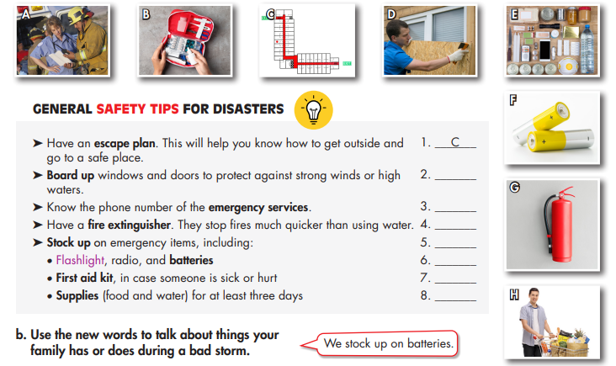  - Ask Ss to read the sentences, underline the key words, guess the meaning of the words in bold, then match them with the pictures.  - Get Ss to check with their partners.  - Pick some Ss to give their answers.  - Check their answers.  - Ask Ss to listen and repeat chorally.  - Pick some Ss to say the words and correct their pronunciation if necessary.  - Check their memory by playing a game in pairs: Student A say the definition; Student B say the word (with books closed).  Task b. In pairs: Use the new words to talk about things your family has or does during a bad storm.  -Ask Ss to work in pairs to use the new words to talk about things your family has or does during a bad storm.  - Pick some Ss to share their ideas.  - Give feedback. | - Read the sentences, underline the key words, guess the meaning of the words in bold, then match them with the pictures.  - Check with their partners.  - Give their answers.  Answer Keys:  1. C – escape plan  2. D – board up  3. A – emergency services  4. G – fire extinguisher.  5. H – Stock up  6. F – batteries  7. B – First aid kit  8. E - Supplies  - Listen and repeat chorally.  - Say the words individually.  -Play the game in pairs.  - Talk about things your family has or does during a bad storm, using new words.  - Share their ideas.  Sample answer:  We stock up on batteries.
2. Listening: 20 minutes
a. Objective: to help Ss practice listening for specific information and know how to talk when working through tasks in groups.
b. Content: tasks a, b, c, d, and e.
c. Expected outcomes: Ss can listen and get the safety tips during a disaster; use functional English while working in groups.
d. Organization:
Teacher’s activities | Students’ activities
Task a: Listen to two students talking about safety tips during disasters. Number the safety  tips in the order you hear them.  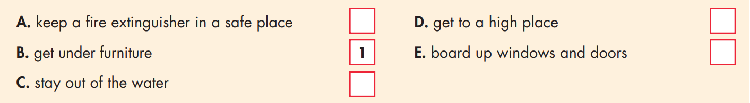 - Introduce the task, using DCR.  - Ask Ss to listen and number the safety tips in the order you hear them.  - Pick some students to give their answers.  - Check their answers. | - Listen and number the safety tips in the order you hear them.  - Check with their partner.  - Give their answers.  Answer Keys:  A. 2 B. 1 C. 4 D. 3 E. 5
Task b: Now, listen again and fill in the blanks to know why you should follow these safety tips.  1. …because something could __________ on your head.  2. …because the __________ may move to people's houses.  3. …because it's __________ to be on high ground.  4. …because it could carry you __________.  5. …because strong __________ can break  windows and doors.  - Ask Ss to guess the type of words in the gaps.  - Pick some Ss to share their ideas.  - Give feedback.  - Ask Ss to listen and fill in the gaps.  - Let Ss check with their partner.  - Pick some students to give their answers.  - Play the CD again and pause at the answers for Ss to check.  - Confirm the answers. | - Share their ideas.  Answer keys:  1. verb 2. noun 3. adjective  4. adverb 5. noun  - Listen and fill in the gaps.  - Check with their partner.  - Give their answers.  - Listen and check  Answer keys:  1. fall 2. Fire 3. Safer 4. Away 5. winds
Task c: . Read the Conversation Skill box. Then, listen and repeat.  - Ask Ss to read the Conversation Skill box and say the phrases that can be used when working through tasks in groups.  - Check their answers.  - Get Ss to listen and repeat.  Task d: Now, listen to the conversation again and count how many times you hear the sentences or phrases.  -Ask Ss to listen to the conversation again and count how many times you hear the sentences or phrases.  -Pick some students to give their answers.  -Check their answer. | -Read the Conversation Skill box and say the phrases that can be used when working through tasks in groups.  Answer keys:  What's next?  Next is (fires). What should we...?  -Listen and repeat.  - Listen to the conversation again and count how many times you hear the sentences or phrases.  - Give their answers.  Answer keys:  What's next? (3 times)  Next is (fires). What should we...? (3 times)
Task e: In pairs: Which tip(s) did you know about? Which tip(s) would you tell your family about?  - Ask Ss to work in pairs to answer the question: Which tip(s) did you know about? Which tip(s) would you tell your family about?  - Pick some Ss to share their ideas.  - Give feedback. | - Work in pairs, answering the question: Which tip(s) did you know about? Which tip(s) would you tell your family about?  - Share their ideas.
C. Consolidation and homework assignments: 5’
- Vocabulary: escape plan, board up, emergency services, fire extinguisher, stock up, batteries, first aid kit, supplies.
- Do exercises in workbook on page 22.
- Prepare the next lesson: Lesson 2.2 - Grammar, pages 39 & 40
- Do the exercises in Tiếng Anh 8 i-Learn Smart World notebook (pages 31 & 32).
5. Reflection

a. What I liked most about this lesson today:
…………………………………………………………………………………………
b. What I learned from this lesson today:
…………………………………………………………………………………………
c. What I should improve for this lesson next time:
…………………………………………………………………………………………

