School: ……………………………………….. | Date:………………………………..
Class: ……………………………..................... | Period: ……………………….........

UNIT 3: PROTECTING THE ENVIRONMENT
Lesson 2.2 - Grammar (Pages 29 & 30)

I. OBJECTIVES
By the end of the lesson, Ss will be able to:
1.1. Language knowledge and skills
- use “and” and “so” to make compound and complex sentences.
- improve speaking skills, using the grammar point.
1.2. Competences
- enhance communication, collaboration
1.3. Attributes
- know how to reduce pollution.
II. TEACHING AIDS AND LEARNING MATERIALS
1. Teacher’s aids: Student book and Teacher’s book, class CDs, Digital Book (DCR phần mềm tương tác SB, DHA (từ vựng/ cấu trúc) phần mềm trò chơi tương tác), projector/interactive whiteboard / TV (if any), PowerPoint slides, handouts.
2. Students’ aids: Student’s book, workbook, notebook.
III. ASSESSMENT EVIDENCE
Performance Tasks | Performance Products | Assessment Tools
- Read about compound and complex sentences and fill in the blanks  - Listen, check and repeat.  - Study the grammar box.  - Tick the correct sentences or cross and rewrite the incorrect sentences.  - Combine two sentences into one using “and” or “so (that)”  - Ask ways to reduce pollution in town (in pairs). | - Ss’ performance.  - Ss’ task.  - Ss’ answers /performance.  - Ss’ answers.  - Ss’ answers/ presentation. | - T’s feedback.  - T’s feedback/Peers’ feedback.  - T’s feedback/Peers’ feedback.  - T’s observation, T’s feedback/Peers’ feedback.

IV. PROCEDURES
A. Warm up: (5’)
a) Objective: Introduce the new lesson and set the scene for Ss to acquire new language; get students' attention at the beginning of the class by enjoyable and short activities as well as to engage them in the follow-up steps.
b) Content: Review vocabulary about ways to reduce pollution / Introduce “and” and “so”.
c) Expected outcomes: Ss review words about ways to reduce pollution and Ss have general ideas about the grammar point they are going to study in the new lesson.
d) Organization of the activity:
TEACHER’S ACTIVITIES | STUDENTS’ ACTIVITIES
- Option 1: Word chain  - Have Ss listen example from teacher.  - Call Ss to give next word.  - End game until ss cannot remember the previous words.  Suggested sentence:  I save electricity by turning of the light.  I save electricity by turning of the light and TV.  I save electricity by turning of the light, TV and fan.  …..  → Lead to the new lesson.  - Option 2: Game: Making sentences  - Have Ss close all books and notebooks.  - Show some words and have Ss work in groups of 4  - Have Ss make sentences as fast as they can on the board. The group with most correct sentences will be the winner.  - Give praise or a small present to the winner.  *Suggested words: recycle, reuse, reduce, save, waste, clean up.  - Tell Ss about the grammar point they are going to study in the new lesson: “and” and “so”.  →Lead to the new lesson. | - Listen  - Work in individually.  - Say the sentence.  - Close books and notebooks.  - Make sentences and write on the board.  *Suggested answers  1. My teacher recycles old clothes into pencil cases.  2. Tom’s father reuses his schoolbag.  3. The principle advices us to reduce trash by using banana leaves to wrap food.  4. The government suggests not wasting electricity to protect the planet.  5. My teacher requires us to clean up after class.

B. New lesson (35’)
- Activity 1: Presentation (10’)
a) Objective: Introduce compound and complex sentences with “and” and “so”.
b) Content:
- Listen and repeat.
- Introduce compound and complex sentences with “and” and “so”.
c) Expected outcomes: Ss know how to use “and” and “so” to do some following exercises.
d) Organization of the activity:
TEACHER’S ACTIVITIES | STUDENTS’ ACTIVITIES
Task a. Listen and repeat  - Have Ss look at the picture (using DCR).  - Read about compound and complex sentences and fill in the blanks.  - Play audio (CD1 – Track 34) and have Ss listen and read the speech bubbles.  - Play the audio again and have Ss listen and repeat.  Grammar box  - Option 1:  - Have Ss look at the grammar explanation (using DCR).  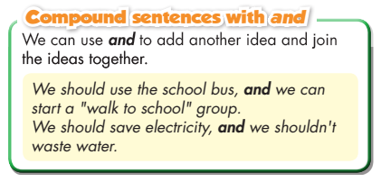  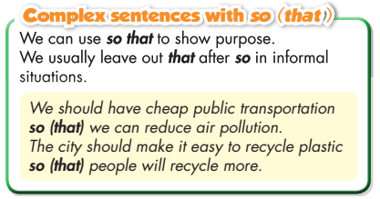  - Have some Ss read aloud the sentences in the Grammar Box.  - Ask Ss to give more examples using “and” and “so”.  - Option 2:  - Have Ss close books.  - Show sample sentences in the grammar box (using DCR).  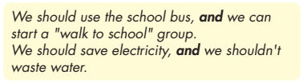  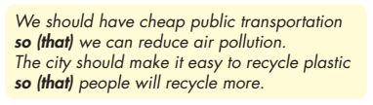  - Have Ss read the sentences aloud.  - Have Ss make comments on the way they use “and” and “so” by asking Ss some questions:  *Suggested questions:  1.What is the parts of speech of “and” and “so”?  2.When do we use “and”?  3. When do we use “so”  - Call Ss to give answers. Then have them open the books and read the grammar box.  - Have Ss give more examples of “and” and “so”, encourage them to make sentences with their own ideas.  - Give feedback and evaluation. | - Look.  - Read and fill in the blanks.  - Listen and repeat.  - Look and read.  - Read.  - Give examples.  - Close all books.  .  - Read.  - Answer the questions. Open the books and read the grammar box.  - Give examples.
- Activity 2: Practice (19’)
a) Objective: Students can distinguish the differences between compound and complex sentences and the use of “and” and “so”.
b) Content: Tick the correct sentences and cross the incorrect ones and combine two sentences into one using “and” or “so”
c) Expected outcomes: Students can apply “and” and “so” to give ways of reduce pollution in their speaking.
d) Organization of the activity:
TEACHER’S ACTIVITIES | STUDENTS’ ACTIVITIES
- Explain in details about compound and complex sentences with “and” and “so”.  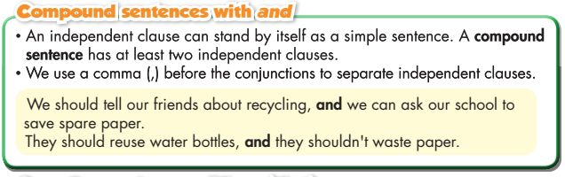  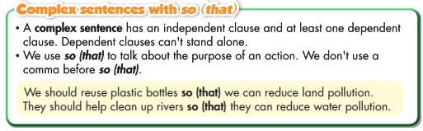  Task a. Read the examples and notes about, then tick () the correct sentences or cross () and rewrite the incorrect sentences.  - Demonstrate the activity, using the example (using DCR).  - Have Ss read and tick or cross, then rewrite (in individual).  - Have Ss work in pairs to check each other’s work.  - Have some Ss share their answers with the whole class.  - Give feedback, correct Ss’ answers if necessary.  Task b. Combine two sentences into one using and or so (that). Add a comma when necessary.  - Demonstrate the activity, using the example (using DCR).  - Have Ss combine two sentences with “and” or “so”.  - Have Ss check answers with their partners.  - Call Ss to read answers.  - Check Ss’ answers, give feedback. | - Listen.  - Look and listen.  - Work individually.  - Work in pairs.  - Write answers on the board.  Answer keys  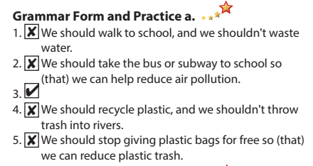  - Work individually.  - Work in pairs.  - Read answers.  Answer keys  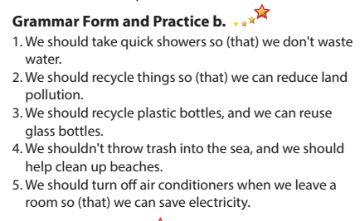

- Activity 3: Production (6’)
a) Objective: Students master the grammar point they study in the lesson.
b) Content: Speaking: give ways of reduce pollution.
c) Expected outcomes: Ss produce the new language successfully, and they can apply “and” and “so” in speaking and writing.
d) Organization of the activity:
TEACHER’S ACTIVITIES | STUDENTS’ ACTIVITIES
Task c. In pairs: What should people do to reduce pollution in your town?  - Explain the task. Divide class into pairs.  - Have Ss ask for and give their partner advice using the prompts.  - Encourage Ss to use more words about ways of reducing pollution with their own ideas.  - Have some pairs demonstrate the activity in front of the class.  - Give feedback and evaluation. | -Listen and take notes.  - Have conversation in pairs.  - Present.  - Listen.

C. Consolidation and homework assignments (5’)
*Consolidation
- the usage of “and” and “so”.
- the compound and complex sentences.
* Homework:
- Make 2 sentences, using “and” and “so.
- Do the exercises in WB: Grammar (page 17).
- Play consolidation games in Tiếng Anh 8 i-Learn Smart World DHA App on www.eduhome.com.vn
- Prepare: Lesson 2 – Pronunciation and Speaking (pages 30 & 31 – SB).
V. REFLECTION
a. What I liked most about this lesson today:
…………………………………………………………………………………………
- What I learned from this lesson today:
…………………………………………………………………………………………
c. What I should improve for this lesson next time:
…………………………………………………………………………………………

