School: ……………………………………….. | Date:……………………………..
Class: ……………………………..................... | Period: ………………………......

UNIT 6: EDUCATION
Lesson 1.1 – Vocabulary and Listening (page 44)

I. OBJECTIVES
By the end of the lesson, Ss will be able to:
1.1. Language knowledge and skills
- know more words relating to school tasks and school activities (essay, project, homework, book report, test, presentation).
- talk about things they have to do at school.
- listen to and understand a conversation of two students trying to make plans (for general and specific details).
- know how to decline an invitation.
1.2. Competences
- improve communication, collaboration, and critical thinking skills.
1.3. Attributes
- love school and schooling.
- have a balance between studying and relaxing.

II. TEACHING AIDS AND LEARNING MATERIALS
1. Teacher’s aids: Student book and Teacher’s book, class CDs, Digital Book (DCR phần mềm tương tác SB, DHA (từ vựng/ cấu trúc) phần mềm trò chơi tương tác), projector/interactive whiteboard / TV (if any), PowerPoint slides.
2. Students’ aids: Student’s book, workbook, notebook.

III. ASSESSMENT EVIDENCE
Performance Tasks | Performance Products | Assessment Tools
- Match the words with the descriptions. | - Ss’ answers. | - T’s feedback/Peers’ feedback.
- Listen and repeat. | - Ss’ presentation. | - T’s feedback/Peers’ feedback.
- Say which things you have to do at school. | - Ss’ presentation. | - T’s feedback/Peers’ feedback.
- Listen to two students trying to make plans. Who is busier? | - Ss’ answers. | - T’s feedback/Peers’ feedback.
- Listen and fill in the blanks. | - Ss’ answers. | - T’s feedback/Peers’ feedback.
- Speak: Does your life sound more like Alan's or Lucy's? Why? | - Ss’ answers/ presentation. | - T’s observation and feedback.

IV. PROCEDURES
A. Warm up: (5’)
a) Objective: Introduce the new lesson and set the scene for Ss to acquire new language; get students' attention at the beginning of the class by enjoyable and short activities as well as to engage them in the follow-up steps.
b) Content: Introduce words about school tasks / Introduce the new topic: Education.
c) Expected outcomes: Ss get to know some new words they are going to study in the lesson.
d) Organization of the activity:
TEACHER’S ACTIVITIES | STUDENTS’ ACTIVITIES
- Option 1: Match the words with the descriptions. Listen and repeat.  - Use the “New words” part a – page 44 for the warm-up activity.  - Show words and definitions using DCR, have Ss look and match the words with the descriptions (in pairs).  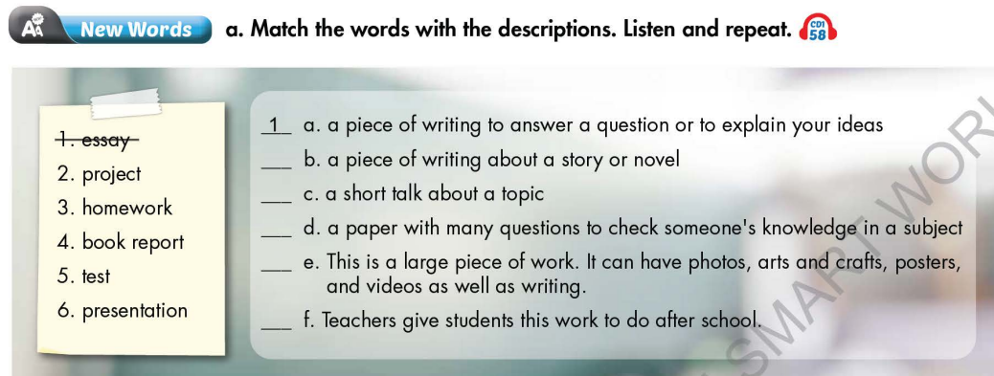  - Call Ss to give answers.  - Give feedback and show correct answers using DCR.  - Lead to the new lesson.  - Play the audio (CD1 – Track 58), have Ss listen and repeat.  - Correct Ss’ pronunciation if necessary.  - Option 2: Letter Lingo.  - Show 9 pictures.  - Have Ss give name of each picture (randomly) and use the red and underlined letter of each answer to form a new English word.  - The first S to give the right key word will be the winner.  - Lead to the new lesson.  *Illustration:  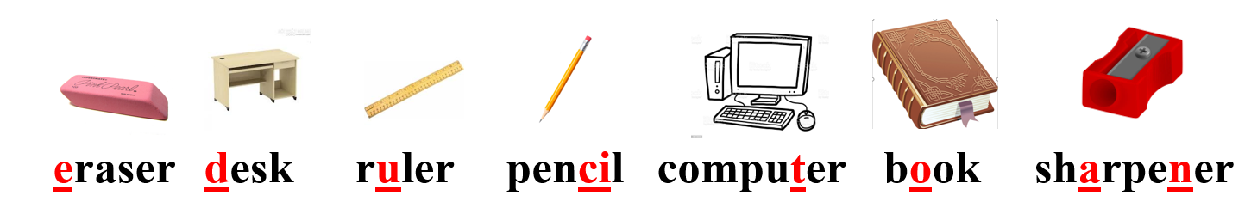 | - Work in pairs to match the words with the descriptions.  - Give answers.  - Listen.  - Listen and repeat.  Answer keys  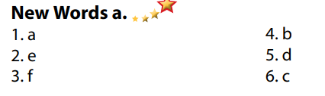  - Take part in the class’s activity.  - Give answers.  - Listen.  Answer key  Key word: Education

B. New lesson (35’)
- Activity 1: Pre-Listening (Vocabulary) (12’)
a) Objective: Ss get to know words about school tasks.
b) Content:
- Vocabulary study (essay, project, homework, book report, test, presentation).
- Speaking: Say which things you have to do at school.
c) Expected outcomes: Ss know how to pronounce the new words correctly and use them when talking about school tasks.
d) Organization of the activity:
TEACHER’S ACTIVITIES | STUDENTS’ ACTIVITIES
Task a. Match the words with the descriptions. Listen and repeat.  - Option 1 (If the teacher hasn’t used this part for the Warm-up activity)  - Demonstrate the activity on DCR, using the example.  - Have Ss match the words with the descriptions.  - Divide class into pairs and have them check their answers with their partners.  - Call Ss to give answers.  - Check answers as a whole class using DCR.  - Play audio (CD1 – Track 58). Have Ss listen and repeat.  - Correct Ss’ pronunciation.  - Option 2: (If the teacher has used part a. for the Warm-up activity.)  - Give some pictures, have Ss look and give names of the pictures, using new words in Task a. (T uses different pictures from those in Task a.)  - Have Ss give answers and tell the meaning of words / phrases again.  - Check answers as a whole class.  - Call some Ss to read the words again.  - Correct Ss’ pronunciation if necessary.  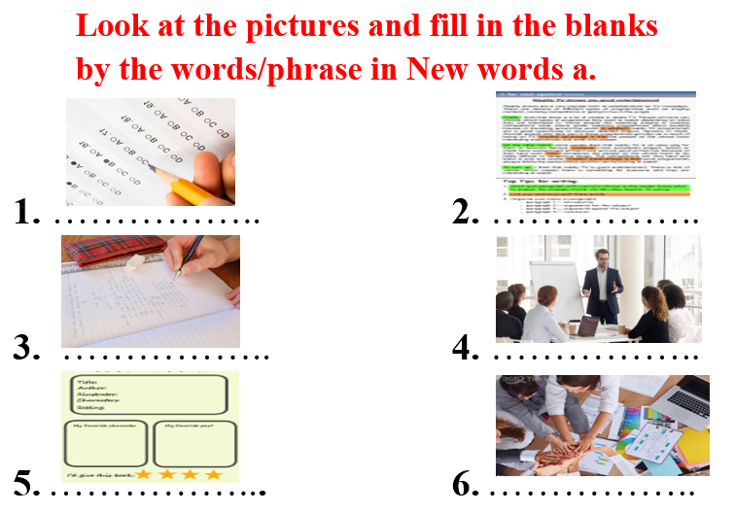  Task b. In pairs: Say which things you have to do at school.  - Have Ss work in pairs to say which things they have to do at school.  - Go round and give help if necessary.  - Have some pairs demonstrate the activity in front of the class.  - Give feedback and evaluation. | - Look and listen.  - Work individually.  - Work in pairs.  - Give answers.  - Listen and repeat.  Answer keys  - Work in pairs.  - Give answers, meaning.  - Read.  Answer keys  1 test  2 essay  3 homework  4 presentation  5 book report  6 project  - Work in pairs.  - Present.  Sample answers  
- Activity 2: While - Listening (17’)
a) Objective: Students can develop their listening skill.
b) Content:
- Listen to two students trying to make plans. Who is busier?
- Listen and fill in the blanks.
c) Expected outcomes: Students can listen and understand general and specific information about trying to make plans.
d) Organization of the activity:
TEACHER’S ACTIVITIES | STUDENTS’ ACTIVITIES
Task a. Listen to two students trying to make plans. Who is busier?  - Have Ss read the question, guess the answer.  - Play audio (CD1 - Track 59).  - Have Ss listen and circle the correct answer.  - Check answer as a whole class using DCR.  Task b. Now, listen and fill in the blanks.  - Have Ss read the through the content of Task b, underline the key words.  - Play the audio again (CD1 - Track 59).  - Have Ss listen and fill in the blanks.  - Have Ss check answers with their partners.  - Call Ss to give answers.  - Give feedback and show correct answers using DCR. | -Work individually.  - Listen.  - Circle the correct answers.  Answer keys  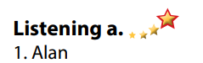  - Read, underline the key words.  - Do the task.  - Exchange answers.  Answer keys  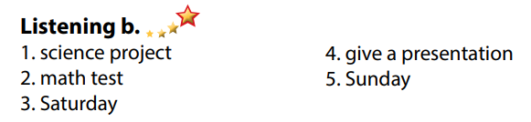

- Activity 3: Post - Listening (6’)
a) Objective: Students can use the vocabulary and the content in listening part to develop their speaking skill.
b) Content: Speaking: Does your life sound more like Alan's or Lucy's? Why?
c) Expected outcomes: Students can express their own ideas about school life and activities after school.
d) Organization of the activity:
TEACHER’S ACTIVITIES | STUDENTS’ ACTIVITIES
Conversation skill  - Have Ss look at the Conversation skill box and read.  - Play audio (CD 1 - Track 60) using DCR, have Ss listen and repeat.  - Ask Ss to find more ways to decline an invitation.  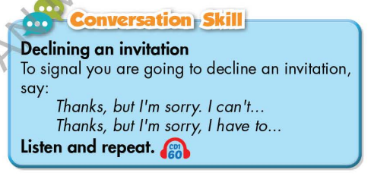  Task c. In pairs: Does your life sound more like Alan's or Lucy's? Why?  - Have Ss work in pairs to discuss.  - Observe and give help if necessary.  - Call some pairs to share their ideas with the class.  - Give feedback and evaluation. | - Look and read.  - Listen and repeat.  - Give answers.  - Work in pairs.  - Present.

C. Consolidation and homework assignments (5’)
* Consolidation:
- Words relating to school tasks and school activities. (essay, project, homework, book report, test, presentation).
- Language to ask for declining an invitation: Thanks, but I’m sorry I can’t / Thanks a lot, but I’m sorry, I have to …

* Homework
- Learn the new words by heart.
- Practice talking about things you have to do at school.
- Do the exercises in WB: New words and Listening (pages 32, 33).
- Do the vocabulary exercise in Tiếng Anh 7 i-Learn Smart World Notebook (page 36).
- Play consolation games in Tiếng Anh 7 i-Learn Smart World DHA App on www.eduhome.com.vn
- Prepare: Lesson 1.2 – Grammar (page 45 – SB).

D. Reflection
a. What I liked most about this lesson today:
…………………………………………………………………………………………
- What I learned from this lesson today:
…………………………………………………………………………………………
c. What I should improve for this lesson next time:
…………………………………………………………………………………………

