School: ……………………………………….. | Date: ………………………………..
Class: ……………………………..................... | Period: ………………………..........

UNIT 5: SCIENCE AND TECHNOLOGY
Lesson 4 – Review (page 96)

I. OBJECTIVES
By the end of the lesson, Ss will be able to
1.1. Language knowledge and skills
- review asking and answering about devices and comparing robots
- review the target language and language skills in unit 5.
Grammar: Wh-questions and Yes/No questions and comparative adverbs.
Vocabulary: Words of the topic “science and technology” (tablet, screen, inch, weight, gigabyte, storage, rescue, lift, complete, navigate, recognize, carefully, quietly, safely).
- practice test-taking skills.
1.2. Competences
- improve speaking, listening, reading and writing skills.
- improve the use of English.
1.3. Attributes
- have a good attitude toward learning English
- become more diligent.
- reread the previous lesson and be well-prepared for tests and the second mid-term examination.
II. TEACHING AIDS AND LEARNING MATERIALS
1. Teacher’s aids: Student book and Teacher’s book, class CDs, Digital Book (DCR phần mềm tương tác SB, DHA (từ vựng/ cấu trúc) phần mềm trò chơi tương tác), projector/interactive whiteboard / TV (if any), PowerPoint slides, handouts.
2. Students’ aids: Student’s book, workbook, notebook.
III. ASSESSMENT EVIDENCE
Performance Tasks | Performance Products | Assessment Tools
- Do the wordseach.  - Listening: You will hear five short conversations. You will hear each conversation twice. There is one question for each conversation. For each question, choose the correct answer (A, B, or C). | - Ss’ answers.  - Ss’ answers. | - T’s feedback/Peers’ feedback.  - T’s feedback/Peers’ feedback.
- Reading: Read the email about the phone Kenny wants. Choose the correct answer (A, B, or C). | - Ss’ answers. | - T’s feedback/Peers’ feedback.
- Listening: You will hear a teenager talking to a store assistant about a laptop. Listen and fill in the blanks. | - Ss’ answers. | - T’s feedback/Peers’ feedback.
- Reading: Read Ashley's email to tell Andy about a birthday gift. Circle the correct answers. | - Ss’ answers. | - T’s feedback/Peers’ feedback.

IV. PROCEDURES
A. Warm up: (5’)
a) Objective: Introduce the new lesson and set the scene for Ss to acquire new language; get students' attention at the beginning of the class by enjoyable and short activities as well as to engage them in the follow-up steps.
b) Content: Review: Science and technology
c) Expected outcomes: Ss are ready for the new lesson.
d) Organization of the activity:

TEACHER’S ACTIVITIES | STUDENTS’ ACTIVITIES
Wordsearch  - Have Ss work in pairs to find words of the topic ‘science and technology’ in this wordsearch.  - Call Ss to give answers.  - Lead to the new lesson.  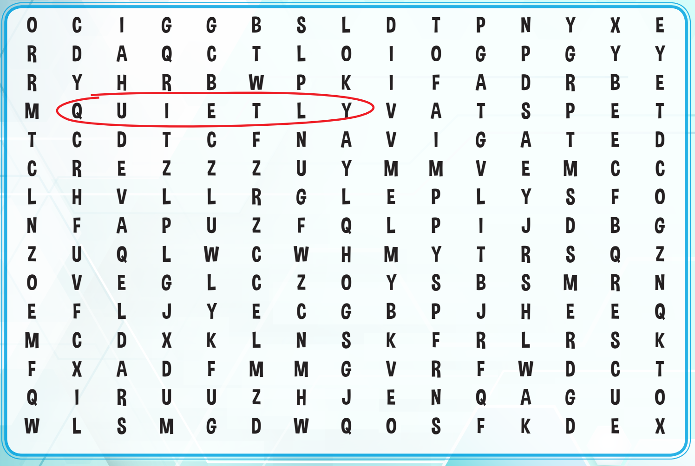 | - Work in pairs.  - Give answers.  Answer keys  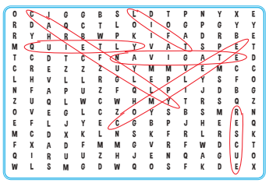

B. New lesson (35’)
- Activity 1: Listening (12’)
a) Objective: Help Ss improve their listening skill.
b) Content: Listening to five short conversations and choosing the correct answer (A, B, or C).
c) Expected outcomes: Ss listen in details and get familiar with the listening test format.
d) Organization of the activity:
TEACHER’S ACTIVITIES | STUDENTS’ ACTIVITIES
You will hear five short conversations. You will hear each conversation twice. There is one question for each conversation. For each question, choose the correct answer (A, B, or C).  - Have Ss read through the listening part, focusing on the pictures on each question.  - Demonstrate the activity, using the example.  - Play the audio (CD 2 – Track 42). Have Ss listen and choose the correct answer.  - Have Ss check answers in pairs, then read answers.  - Check answers as a whole class. | - Read the questions and look at the pictures.  - Listen and read answers.  Answer keys

- Activity 2: Reading (12’)
a) Objective: Students can improve their reading skill.
b) Content: Reading the email and choosing the correct answer (A, B, or C).
c) Expected outcomes: Ss read for comprehension and get familiar with the reading test format.
d) Organization of the activity:
TEACHER’S ACTIVITIES | STUDENTS’ ACTIVITIES
Read the email about the phone Kenny wants. Choose the correct answer (A, B, or C).  - Demonstrate the activity, using the example.  - Have Ss look and read, then choose the correct answer, underline the supporting ideas for their answers.  - Call Ss to give answers and explain.  - Give feedback. | - Observe and listen.  - Work individually.  - Give answers and explain.  Answer keys

- Activity 3: Listening (11’)
a) Objective: Help Ss improve their listening skill.
b) Content: Listening to a teenager talking to a store assistant about a laptop and filling in the blanks.
c) Expected outcomes: Ss listen in details and get familiar with the listening test format.
d) Organization of the activity:
TEACHER’S ACTIVITIES | STUDENTS’ ACTIVITIES
You will hear a teenager talking to a store assistant about a laptop. Listen and fill in the blanks. You will hear the conversation twice.  - Use the task in WB – page 54 for review.  - Give Ss handouts of the task.  - Have Ss read through the listening part, focusing on the blanks on each question.  - Demonstrate the activity, using the example.  - Play the audio (WB - Track 22). Have Ss listen and fill the blanks.  - Have Ss check answers in pairs, then read answers.  - Check answers as a whole class.  *Handout: | - Read the questions.  - Check answers in pairs.  - Listen and read answers.  Answer keys  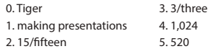
  You will hear a teenager talking to a store assistant about a laptop. Listen and fill in the blanks. You will hear the conversation twice.
  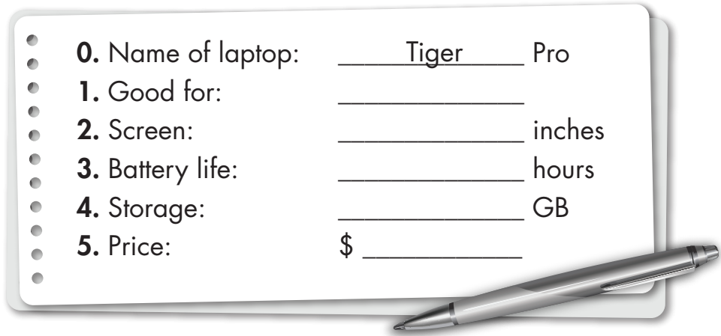

C. Consolidation and homework assignments (5’)
* Consolidation:
- Grammar of Unit 5: Wh-questions and Yes/No questions and comparative adverbs.
- Vocabulary of Unit 5: Words of the topic “science and technology” (tablet, screen, inch, weight, gigabyte, storage, rescue, lift, complete, navigate, recognize, carefully, quietly, safely).
The following reading task adapted from WB – page 30:
Read Ashley's email to tell Andy about a birthday gift. Circle the correct answers.
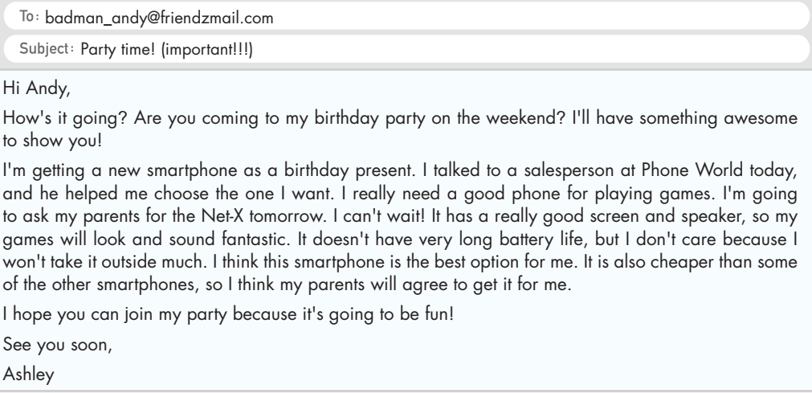
1. Ashley's birthday party is…
A. on the weekend. B. today. C. tomorrow.
2. Ashley wants to use her phone…
A. for school. B. to play games. C. outside.
3. The Net-X doesn't have a good…
A. speaker. B. screen. C. battery.
4. Ashley says the party is going to be…
A. awesome. B. long. C. fun
Answer keys:
1. A
2. B
3. C
4. C
* Homework:
- Review vocabulary, grammar and language skills of unit 5.
- Do the exercises in WB: Unit 5 Review - Part 1 (page 54).
- Prepare: Review – SB (page 97)
V. Reflection
a. What I liked most about this lesson today:
…………………………………………………………………………………………
- What I learned from this lesson today:
…………………………………………………………………………………………
c. What I should improve for this lesson next time:
…………………………………………………………………………………………

