Period
LESSON PLAN
TIẾNG ANH 10 FRIENDS GLOBAL
UNIT INTRODUCTION
LESSON A: VOCABULARY
LIKES AND DISLIKES?
I. OBJECTIVES:
By the end of the lesson, Ss will be able to:
1. Knowledge:
- Get some more knowledge to talk about school subjects, sports and hobbies
- Vocabulary: board games, drawing, drama, IT (information technology), basketball, chemistry, geography, gymnastics, chess, ice hockey, volleyball
2. Ability:
- main skills: listening and speaking skills
- sub skills: reading and listening for specific information
- Asking and answering about likes and dislikes
- Discussing about school subjects
3. Quality:
- have positive attitude in English language learning so that they can participate enthusiastically in all classroom activities, especially with the topic conducted by the teacher
- know how to talk about likes and dislikes, and discuss about school subjects
II. TEACHER AIDS AND LEARNING MATERIALS:
Lesson plan, PPT slides, student’s book, workbook, notebook, personal computer (if any), projector/ TV. Speakers, IWB software.
III. PROCEDURES:
A. Warm-up (5’)
a) Objective: Introduce the new lesson and set the scene for Ss to acquire new language; get students' attention at the beginning of the class by means of enjoyable and short activities as well as to engage them in the steps that followed.
b) Content: Warm-up game
c) Outcomes: Students can gain more confidence and interest in the lesson
d) Competence: guessing
e) Organisation of the activity:

TEACHER’S ACTIVITIES | STUDENT’S ACTIVITIES | CONTENTS
Warm-up T-Ss- T/ Ss – Ss  Game “CROSSWORD PUZZLE”  - Divides class into 4 groups  - There are 7 hobbies. Each group will choose a number to answer. With a correct answer, students will get one point. If any group can get the word in the vertical column fastest, that group can earn three points.  - Tells students which group has the most correct answers will be the winner.  - After revealing the words, teacher asks students a question: “What is the word in the vertical column?” | - Play game in groups.  - Each group will choose a number.  - With a correct answer, students will get one point.  - If one group can get the word in vertical column fastest, that group will get three points.  - Students answer, “HOBBIES” | 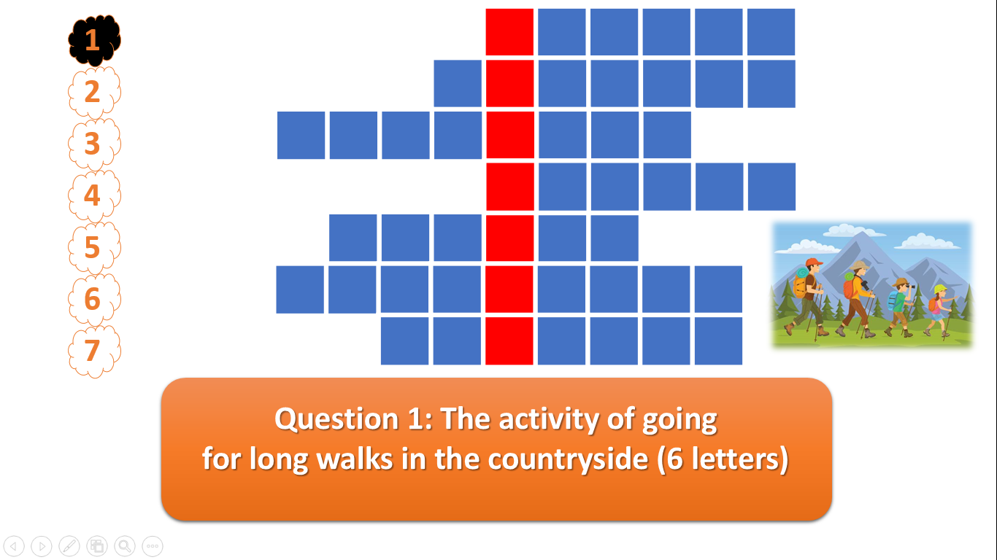  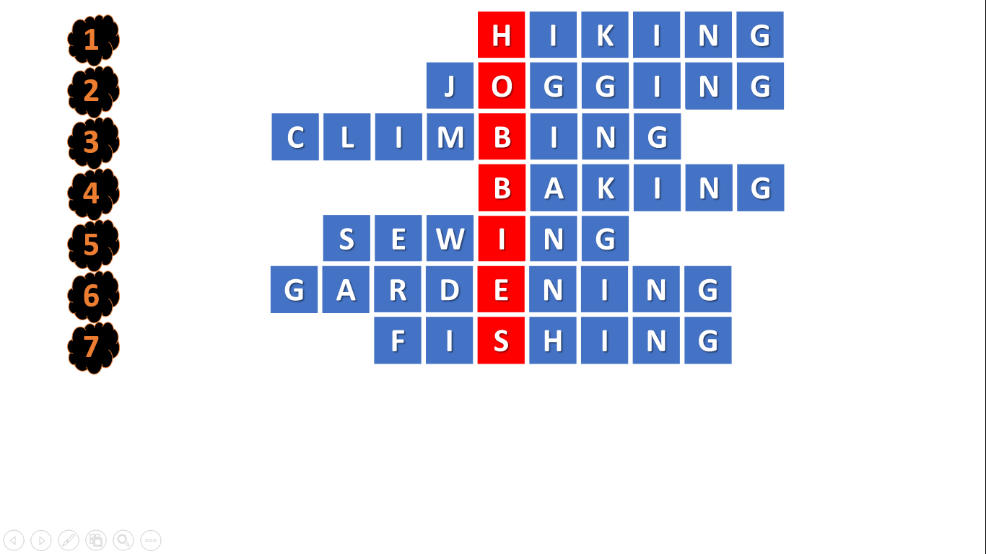

B. New lesson (35’)
- Activity 1: Vocabulary (8’)
a) Objective: Ss know more words about subjects, sports, and hobbies
b) Content:
Vocabulary: board games, drawing, drama, IT (information technology), basketball, chemistry, geography, gymnastics, chess, ice hockey, volleyball
Listening
c) Outcomes: Ss know how to pronounce the new words precisely and use them in appropriate contexts.
d) Competence: communication, collaboration, presentation
e) Organisation of the activity:

TEACHER’S ACTIVITIES | STUDENT’S ACTIVITIES | CONTENTS
PRESENTATION. T -Ss- T/ Ss- Ss/ Individual  Set context:  - Calls out some students to answer the questions: “What are your hobbies?  - Chooses one of the eight hobbies in the crossword puzzle, and ask them. For example: “Do you like gardening?” or “Do you like cycling?”, etc. “Why you like gardening” or “Why you dislike gardening?”, etc.  - Leads to the topic of the lesson – Likes and dislikes  Teach new vocabulary:  - Uses pictures and explanation to present new words.  - Have students practice their pronunciation drills.  New words:  1. Skateboarding (n)  2. Ice skating (n) picture +  3. Bowling (n) meaning  4. PE (n)  5. Board games (n)  6. Drawing (n) | - Some students will answer the questions.  - Listen to the teacher’s questions carefully, and have some time to think about the answers.  - Pay attention to the teacher  - Look, listen, and repeat in chorus and individuals  - Copy all the new words to the notebook. | Question: “What are your hobbies?”, “Do you like or dislike gardening/hiking/sewing/sculpting/cooking/jogging/dancing/fishing?”  New words:  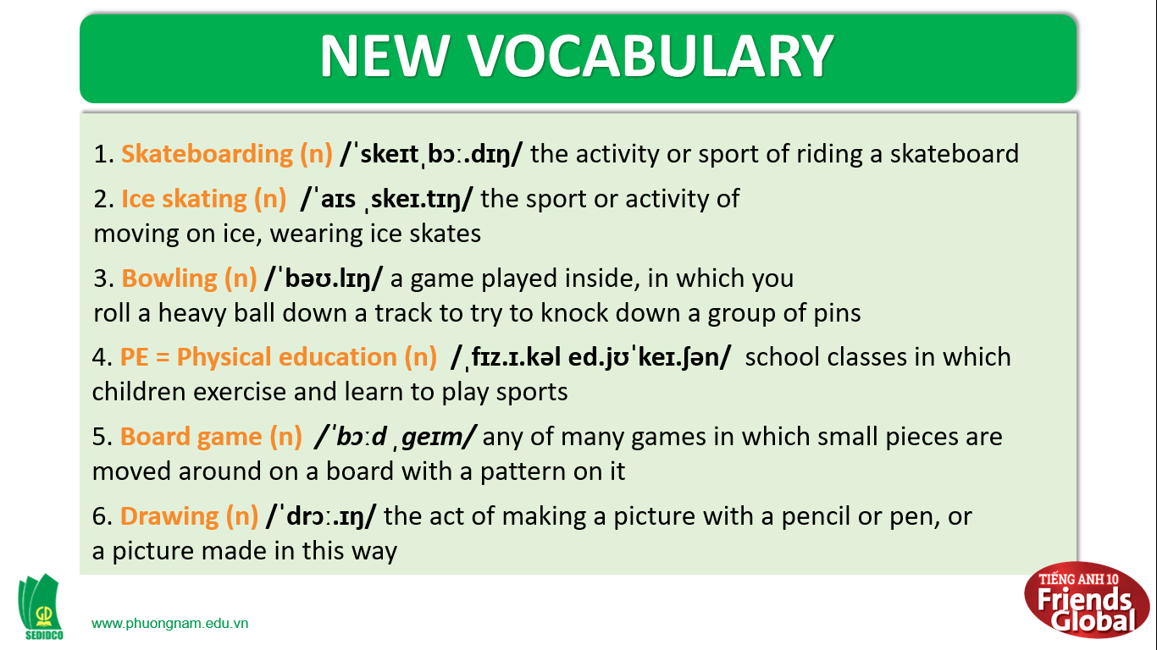
- Activity 2 Practice (23’)
a) Objective: Ss can answer the questions to critical thinking, and they can also finish the tasks in the textbook. Critical thinking skills (guessing/ reasoning) and communication can also be practiced.
b) Content: Students answer questions, classify words, choose the correct answer, read and complete, listen and match.
c) Outcomes: Ss read and listen, and they can apply the useful language in everyday listening and speaking.
d) Competence: collaboration, guessing, matching, communication
e) Organisation of the activity:
TEACHER’S ACTIVITIES | STUDENT’S ACTIVITIES | CONTENTS
PRACTICE. T-Ss- T/ S – S/ Individual  Activity 1 (2’) Describe the photo.  - Asks students to look at the photos and answer the questions.  - Gives some possible answers.  Activity 2 (4’) Read and listen to the dialogue. Find the names of the people in the photo.  - Plays the audio for students to listen to the words.  - Have the students to find out the names of the people in the photo.  - Shows the correct answers of the names of people in the photo  Activity 3 (5’) Are the sentences true or false? Write T or F.  - Divides class into 4 groups  - Asks students to work in groups and each group has 2 minutes to finish the task  - Checks students’ answers  - Plays the record again for the students to check the answers  Activity 4 (1’) Add three words from the dialogue in exercise 2 to each list  - Have students listen and repeat the words “board games” and “drawing”  - Shows the correct answers  Activity 5 (3’) Work in pairs. How many more words can you add to the lists in exercise 4 in three minutes  - Asks student to work in pairs and complete the task  - Checks students’ answers.  Activity 6 (2’) Label the phrases below A (like), B (OK), or C (don’t like). Which phrases are in the dialogue in exercise 2?  - Have students read and complete the task.  - Checks students’ answers.  Activity 7 (5’) Work in pairs. Give opinions of school subjects. Use the phrases in exercise 6.  - Ask students to work in pairs and take turns to give their opinions of school subjects  - Asks some pairs to stand up and say their opinions of school subjects | - Look at the photos and do the task.  - Listen and identify the names of people in the photo  - Find out the names of people in the photo  - Copy the correct answers to their books  - Sit with their teammates  - Work in groups and do the activity 3  - Write down the correct answers  - Listen carefully  - Listen and write the ending sound of each word.  - Listen and repeat after the teacher  - Copy the correct answers down  - Work in pairs.  - Check answers with teacher.  - Do the task.  - Check answers with the teacher  - Work in pairs  - Some pairs talk about their opinions of school subjects. | Suggested answers:  1. The people are in a canteen. They are having lunch  Answers:  Izzy, Becky, Ryan  Answers:  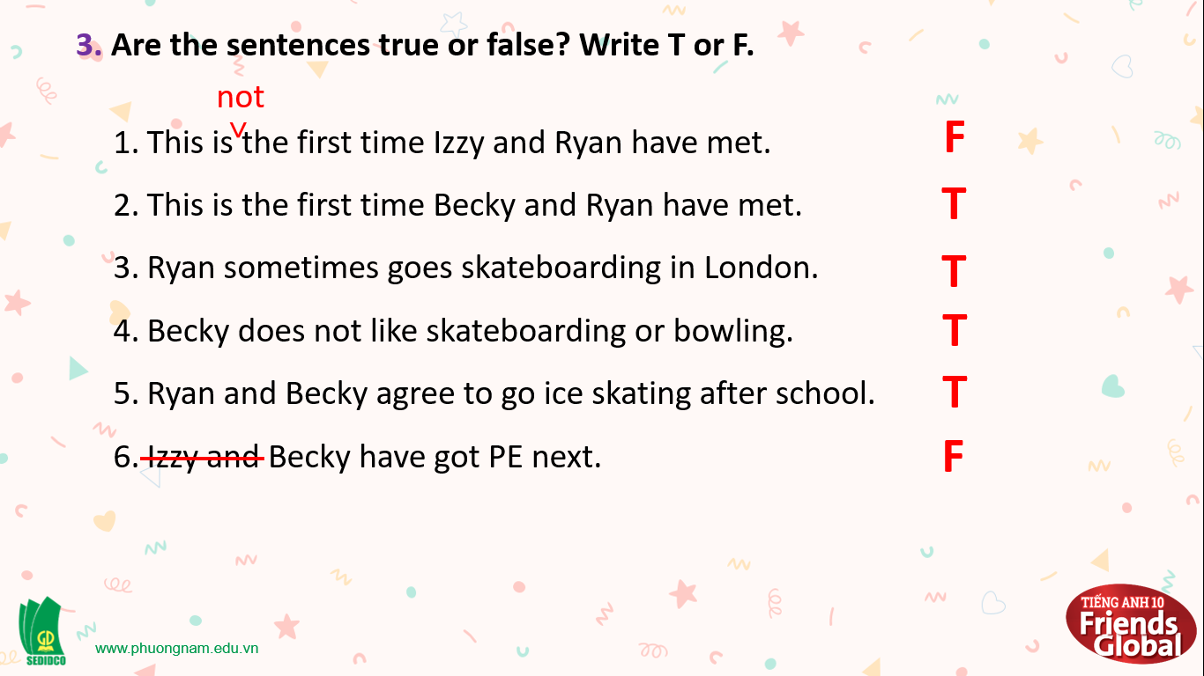  Answers:  Sport and hobbies: skateboarding, ice skating, bowling  School subjects: maths, history, PE  Suggested answer:  Subjects: chemistry, geography, music, Physics, English, Literature, etc  Hobbies: gymnastics, chess, dance / dancing, swimming, cycling, etc  Answer:  A (like): I love…; I’m really keen on…; … is great.  B (OK): I don’t mind…; I (quite) like…; …isn’t bad.  C (don’t like): I can’t stand…; I hate…; …is terrible.  Phrases in the dialogue: I love…; I hate…; I don’t mind…; I like…; I’m not very keen on…

- Activity 3: Outcomes (5’)
a) Objective: Ss can answer the question to describe feelings in some situations. Communication is also be practiced.
b) Content: Students work in pairs, speak and discuss
c) Outcomes: Ss speak and listen mutually, they can new words they have learnt in their conversation.
d) Competence: Collaboration, communication
e) Organisation of the activity:
TEACHER’S ACTIVITIES | STUDENT’S ACTIVITIES | CONTENTS
PRODUCT. S – S/ T – Ss  Activity 9 (5’) Play a game ‘Learn with Nobita’  - Have the students to work in group  - Asks them to choose 1 out of 4 given questions  - Asks them to answer the questions and discuss the subject if they like or dislike the school subject  - Invites 1 group to talk about their opinion | - Work in groups  - Choose 1 out of 4 questions  - Answer the questions and discuss the subject  - Talk about their own opinion about the school subject | Topic: Math, Geography, PE = Physical Education, Chemistry  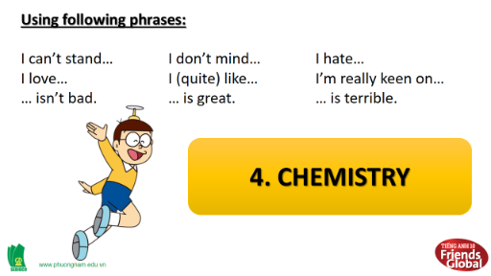
C. Consolidation (2’)
a) Vocabulary: skateboarding, ice skating, bowling, PE = Physical education, board game, drawing
b) Talking about likes and dislikes
D. Homework (3’)
- Learn by heart the new vocabulary about subject, sports, and hobbies
- Practice asking and answering about likes and dislikes
- Do exercise in the workbook
- Prepare: Unit 0: Introduction – B-Grammar (page 7 – SB)

