UNIT 3: COMMUNITY SERVICE
Lesson 3: A CLOSER LOOK 2
I. OBJECTIVES
By the end of this lesson, Ss will be able to gain:
1. Knowledge:
- Understand the use of the past simple tense
- Practice using the past simple to talk about past activities
2. Core competence:
- Develop communication skills and creativity
- Be collaborative and supportive in pair work and teamwork
- Actively join in class activities
3. Personal qualities
- Develop self-study skills
- Raise students’ awareness of the need to keep their neighbourhood green.

II. MATERIALS
- Grade 7 textbook, Unit 3, A closer look 2
- Computer connected to the Internet
- Projector/ TV/ pictures and cards
- sachmem.vn

Language analysis
Form | Explanation
Positive:  S + V-ed (played) | 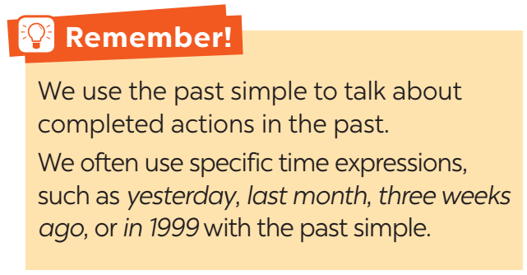
Negative:
S + did not / didn’t V (did not / didn’t play)
Questions and short answers:
Did + S + V (play)?
- Yes, S + did.
- No, S + didn’t.

III. PROCEDURE
TIME | T’S ANS SS’ ACTIVITIES | CONTENT
5’ | Write-it-up  - Ss work in two teams.  - They write past form of the verbs given on the board.  - T. confirms the answers. | I. WARM-UP  Past Form  - grow - had  - teach -  - make -  - take -  - send -  - read -  T: In which tense do we use past form of verbs?  Ss: Past simple (expected)  T: Great. Today I will help you review it
5’ | - T gives an example to review the simple past tense.  - Teacher asks students to study the Grammar box.  - Teacher draws students’ attention to the meaning and use of the past simple.  - Teacher then asks some more able students to give some more examples.  - Teacher and students discuss the answers.  - Teacher confirms the answers and gives feedback. | II. PRESENTATION  Examples.  1. Last year I went to Hoi An.  The past simple  Positive S + V-ed (played)  Negative S + did not / didn’t V (did not / didn’t play)  Interrogative Did + S + V (play)? - Yes, S + did. - No, S + didn’t.
5’  7’  7’  8’ | Multiple Choice  - Teacher has students work individually.  - Students work individually to to complete the sentences with the past simple form of the given verbs.  - Teacher lets students work in pairs and exchange the answers before checking with the whole class (explain each sentence if necessary).  - Teacher confirms the answers and gives feedback.  Gap – Fill  - Teacher has students work individually.  - Students work individually to complete the sentences.  - Teacher lets students work in pairs and exchange the answers before checking with the whole class (explain each sentence if necessary).  - Teacher confirms the answers and gives feedback.  Gap – Fill  - Teacher asks the whole class to read aloud the verbs in the box then has students work individually to complete the sentences with the correct forms of the verbs from the box.  -Students work individually to complete the task.  - Teacher then has them work in pairs, comparing their sentences. Teacher can go around to help students.  - Teacher confirms the answers and gives feedback.  Sentence Build  - Teacher has students work independently.  - Teacher asks students to do the exercise individually.  - Teacher lets students work in pairs and exchange the answers before checking with the whole class (explain each sentence if necessary).  - Teacher confirms the answers and gives feedback. | III. PRACTICE  * Task 1. Circle the correct answer A, B or C to complete each sentence. (Ex 1, p. 31)  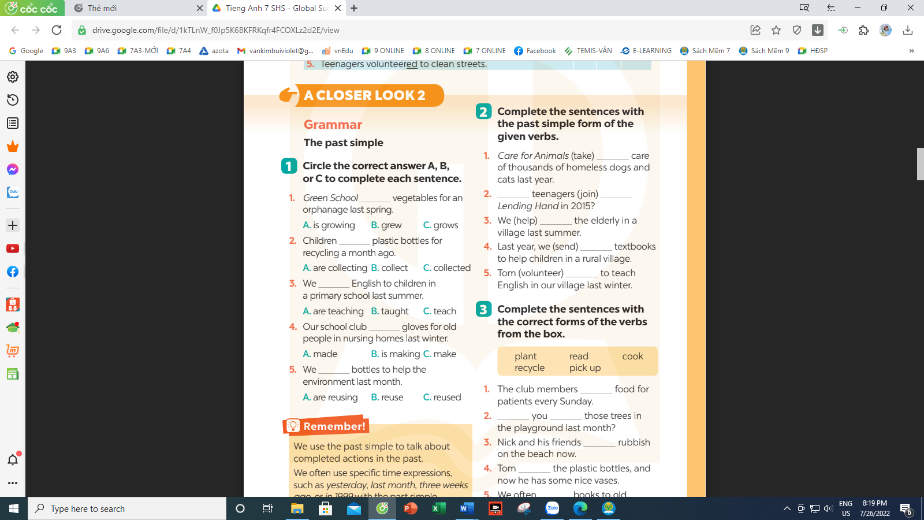  Answer key:  1. B 2. C 3. B 4. A 5. C  * Task 2. Complete the sentences with the past simple form with the given verbs. (Ex 2, p. 31)  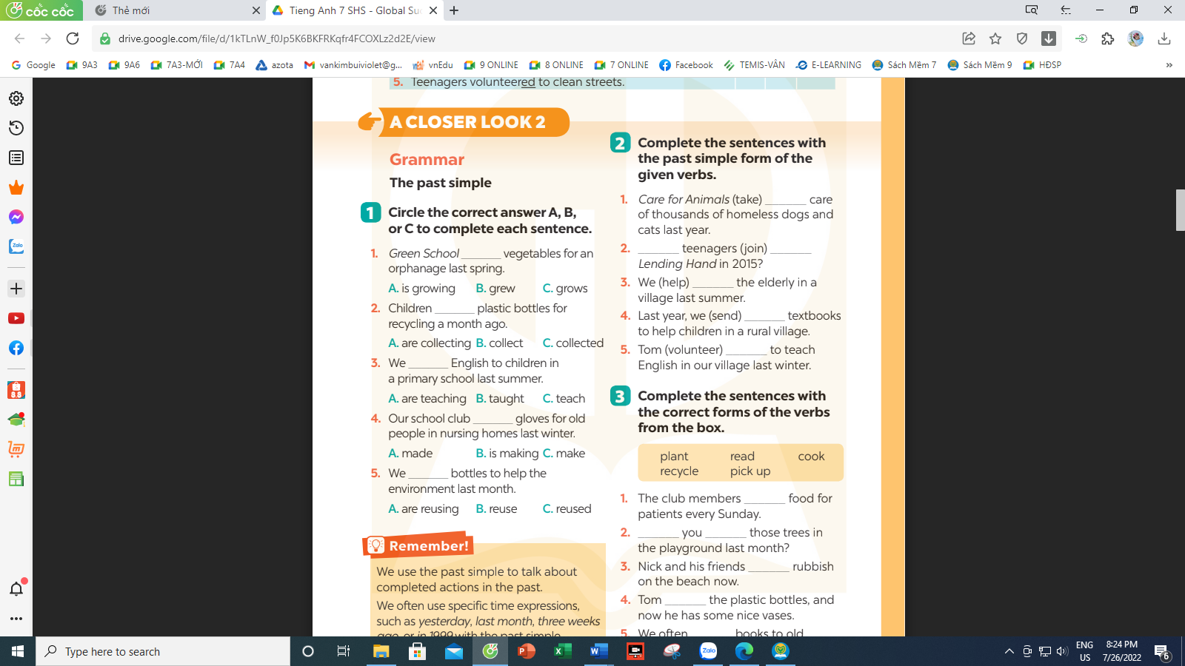  Answer key:  1. took 2. Did … join 3. helped  4. sent 5. volunteered  * Task 3. Complete the sentences with the verbs from the box. (Ex 3, p. 31)  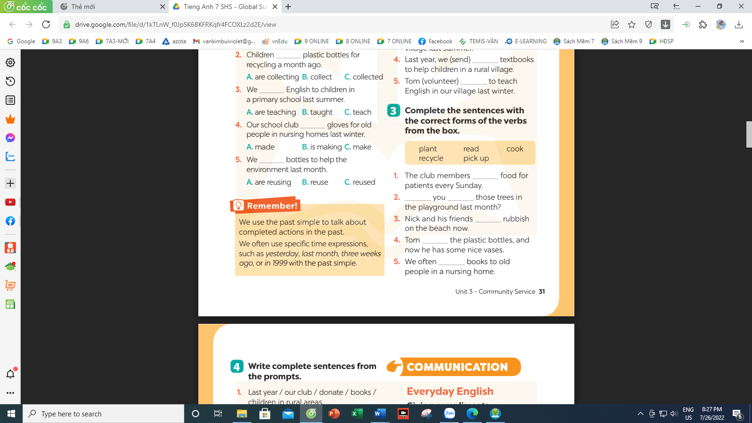  Answer key:  1. cook 2. Did … plant 3. are picking up  4. recycled 5. Read  * Task 4. Write comlete sentences from the prompts. (Ex 4, p. 32)  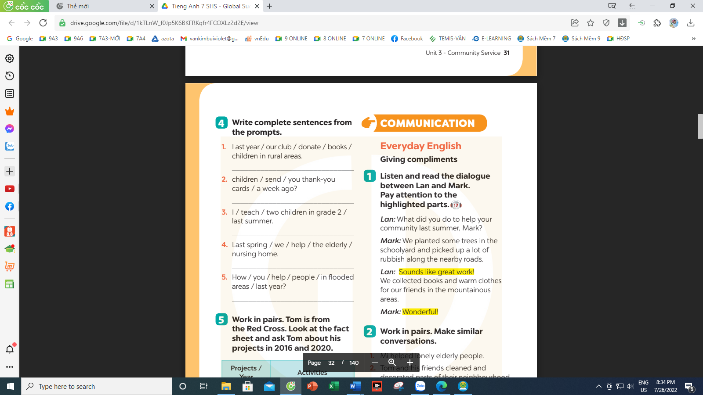  Answer key:  1. Last year, our club donated books to children in rural areas.  2. Children sent thank-you cards to us a week ago.  3. I taught two children in grade 2 last summer.  4. Last spring, we helped the elderly in a nursing home.  5. We helped people in flooded areas last year.
6’ | - Teacher introduces the Red Cross projects and activities in 2016 and 2020 and has students work in pairs for 5 minutes to practise asking and answering questions based on the fact sheet.  - Students use the past simple when they ask and answer questions about the past activities.  - Teacher invites some pairs to make short conversations as an example.  - Teacher corrects any grammar and pronunciation mistakes if necessary. | IV. PRODUCTION  * Task 5. Work in groups. Tom is from the Red Cross. Look at the fact sheet and ask Tom about his projects in 2016 and 2020.  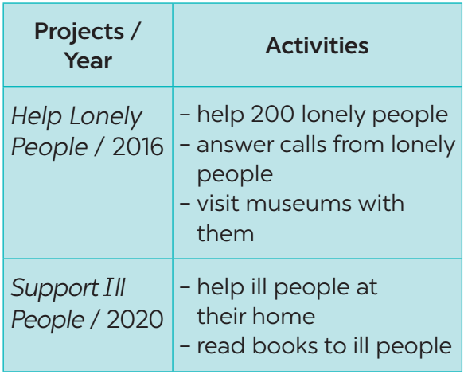  Example:  Tom: I’m from the Red Cross. I worked on the Help Lonely People project in 2016.  Lan: What did you do?  Tom: We helped 200 lonely people…
2’ | - Ss do at home. | V. HOMEWORK  - Review the simple past tense  - Do the exercises again.  - Prepare Unit 3 – Communication (Do task 1, 2, 3 first at home)

