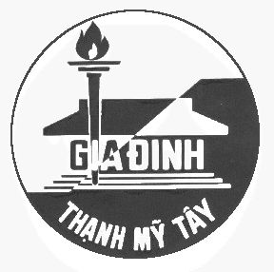 |  | ĐÁP ÁN CHÍNH THỨC KIỂM TRA HỌC KỲ 1-TOÁN 12. NK 2021-2022
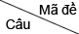 | 101 |  | 102 | 103 | 104
1 | D |  | D | A | A
2 | B |  | C | D | A
3 | B |  | C | C | B
4 | D |  | B | D | C
5 | B |  | D | D | C
6 | B |  | C | B | A
7 | C |  | D | C | A
8 | C |  | D | B | C
9 | B |  | A | B | C
10 | A |  | B | A | D
11 | D |  | B | B | D
12 | C |  | D | D | B
13 | C |  | A | D | D
14 | C |  | D | D | D
15 | D |  | B | A | C
16 | C |  | D | D | A
17 | C |  | A | B | A
18 | B |  | D | C | A
19 | C |  | B | B | C
20 | C |  | D | A | A
21 | A |  | B | D | A
22 | A |  | A | B | A
23 | B |  | C | C | A
24 | A |  | A | A | C
25 | C |  | C | B | A
26 | B |  | A | B | B
27 | A |  | B | C | D
28 | B |  | B | C | A
29 | A |  | C | A | B
30 | D |  | C | C | C
31 | D |  | B | A | D
32 | C |  | D | D | A
33 | D |  | B | C | C
34 | D |  | C | B | B
35 | A |  | A | B | C
36 | C |  | A | C | A
37 | C |  | D | A | D
38 | A |  | D | A | D
39 | B |  | D | C | A
40 | A |  | B | A | B
41 | C |  | D | B | A
42 | C |  | B | A | A
43 | D |  | D | C | A
44 | A |  | B | D | B
45 | C |  | D | C | C
46 | A |  | D | A | B
47 | C |  | B | A | B
48 | A |  | B | B | C
49 | C |  | A | B | C
50 | C |  | B | A | B

