Cambridge Young Learners English
MOVERS
TEST 10

Listening
There are 25 questions
You will need coloured pens and pencils.

My name is…………………………….

Part 1
5 questions

This is an example. Now you listen and draw lines.
Steve | Bill |  | Mary |  | Michael

Betty |  | Tony |  | Katy

Part 2
5 questions

Listen and write. There is one example.
 | 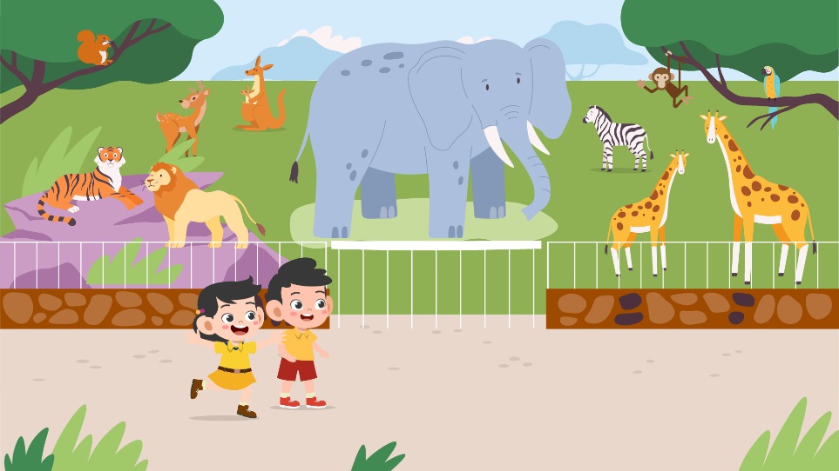
 | A VISIT TO THE ZOO
0 | Name of the zoo: | Green Star Zoo
1 | Where is it? | near the ……
2 | How much is the ticket? | $…….
3 | What time should he visit? | From 8 am until ……pm
4 | How does he get there? | By car or by ……
5 | Who will he go with? | Mrs. …… and classmates

PART 3
5 questions

What did Alex do last week?
Listen and draw a line from the floor to the correct picture.
There is one example

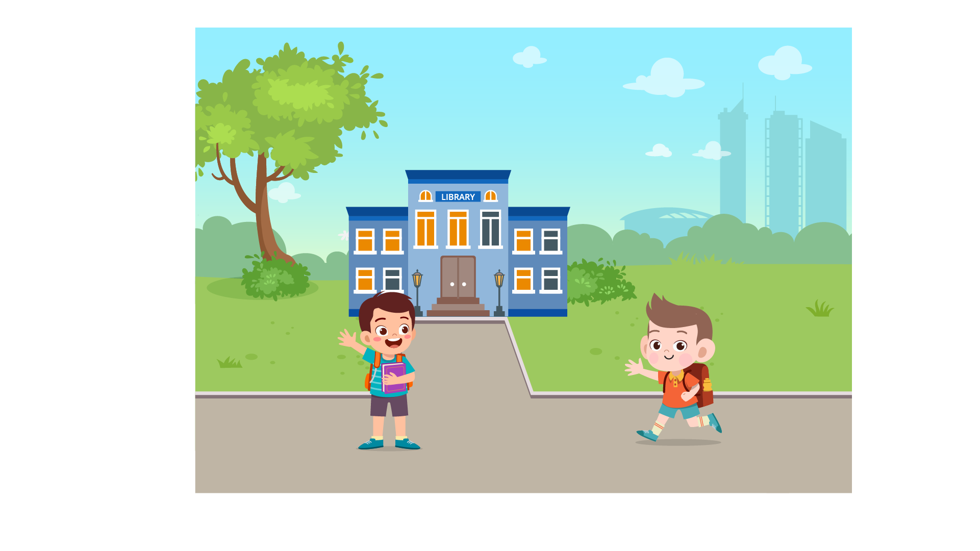 | Monday  Tuesday  Wednesday  Thursday  Friday  Saturday  Sunday | 
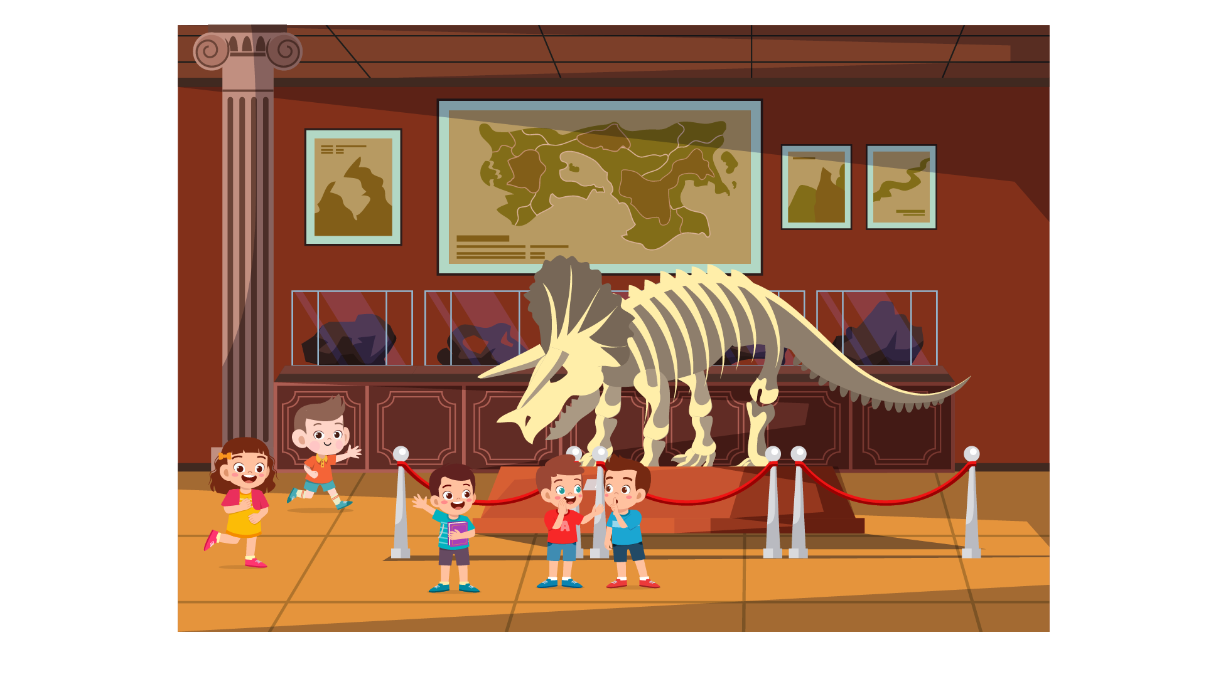 |  | 
 |  | 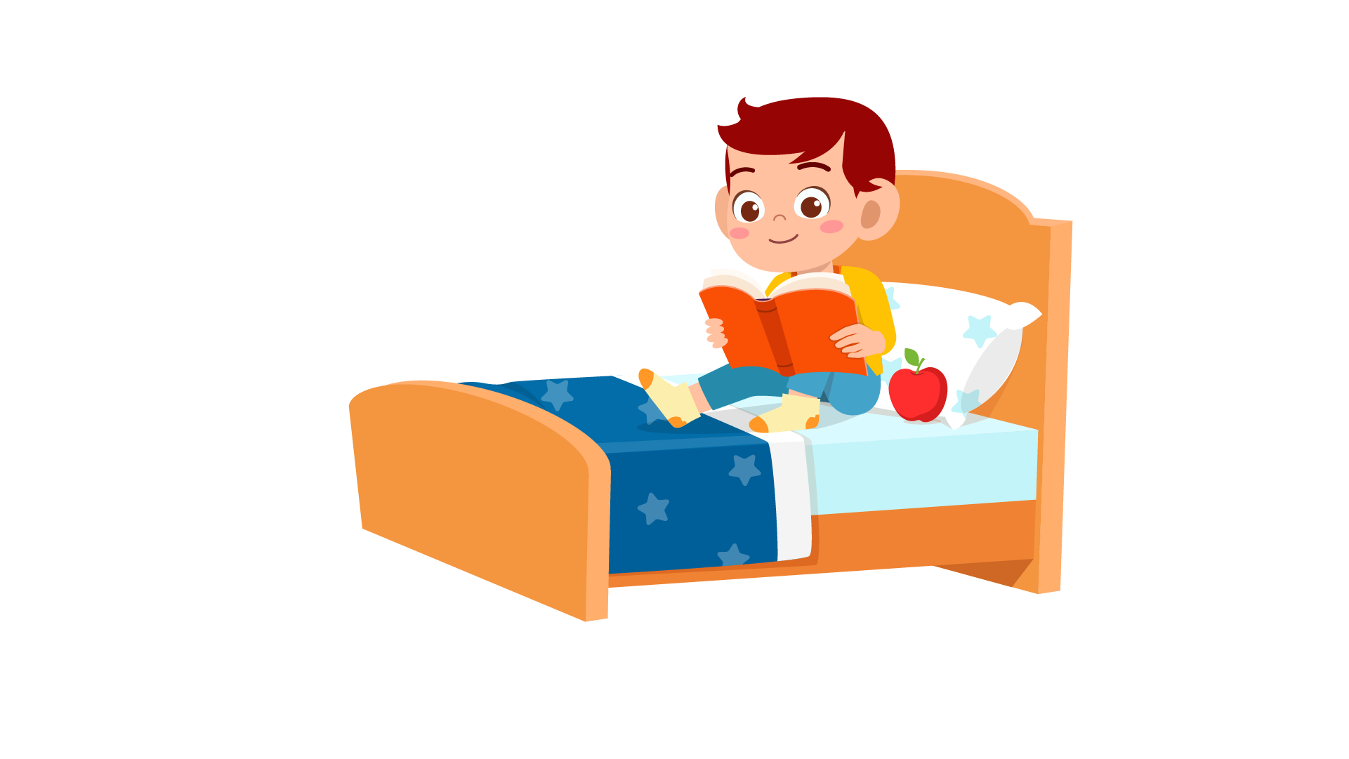
PART 4
5 questions

Listen and tick (✓) the box. There is one example.
What time did Laura go to school?
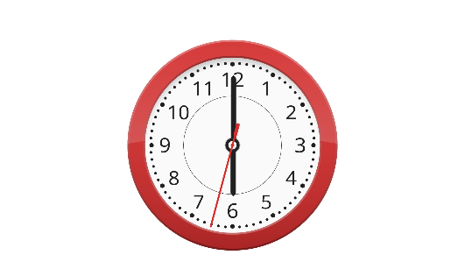 | 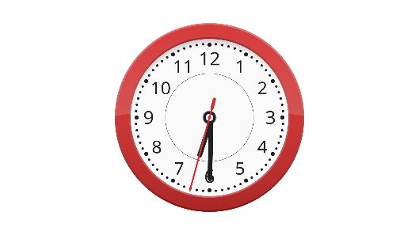 | 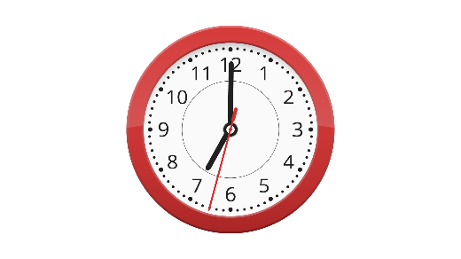
A ⬜ | B ⬜ | C ⬜
- Who did Mike go to the skate park with?
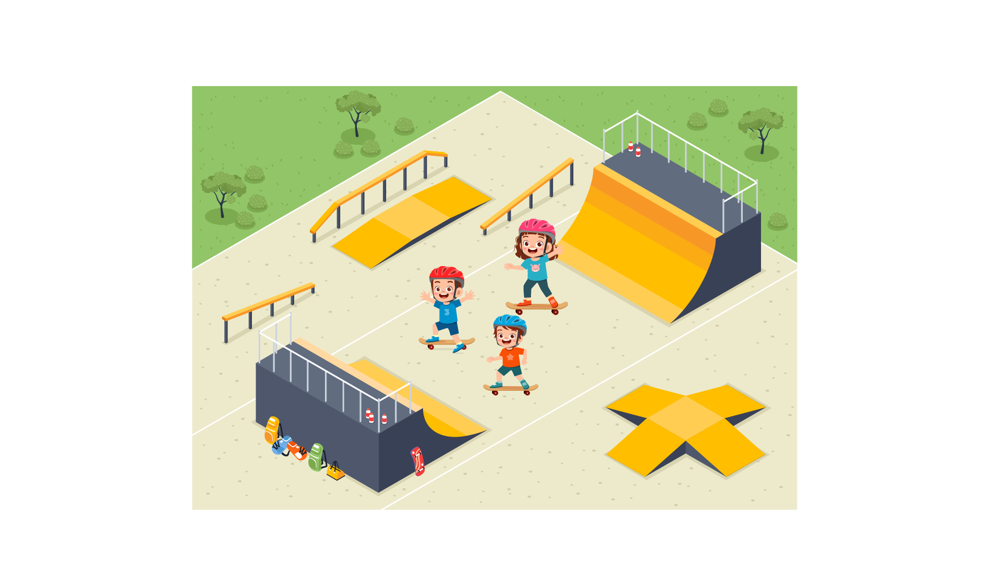 | 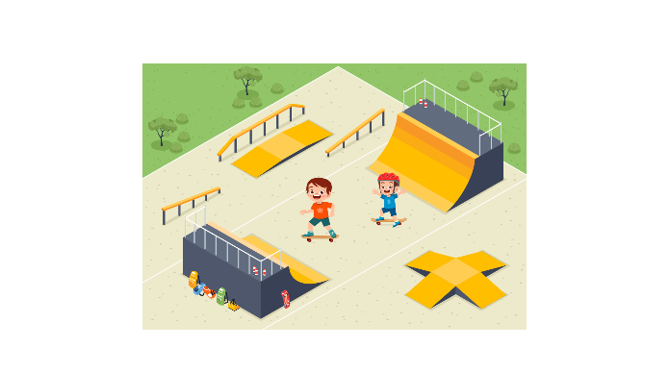 | 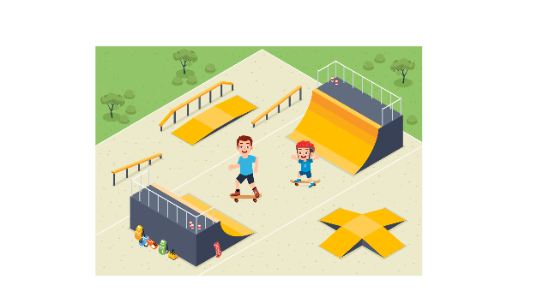
A ⬜ | B ⬜ | C ⬜
- Where was Betty at the weekend?
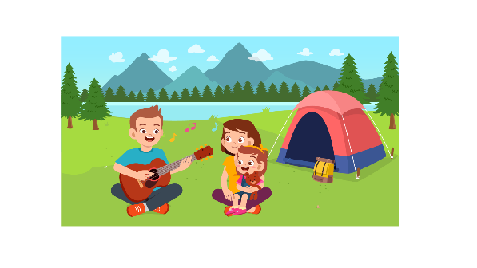 | 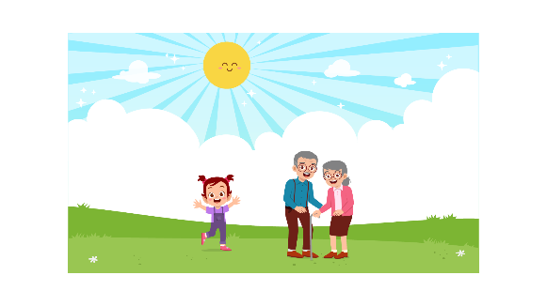 | 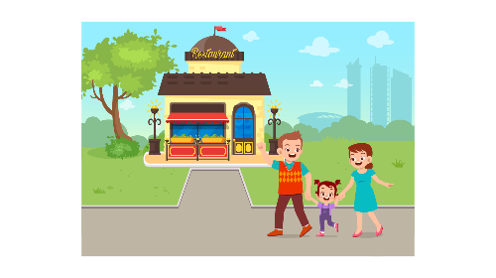
A ⬜ | B ⬜ | C ⬜
- When did Tony and Jake go to the park?
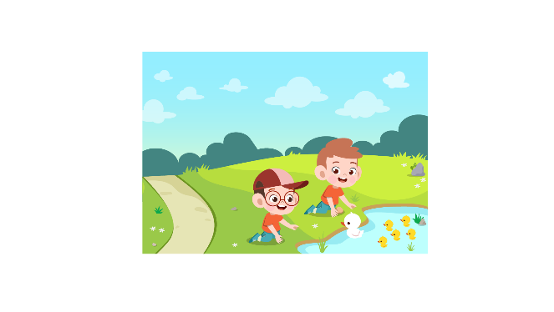 | 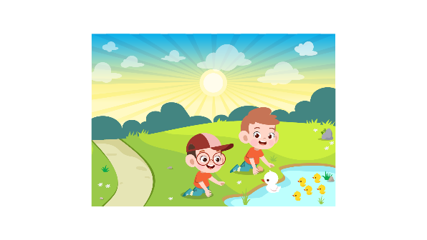 | 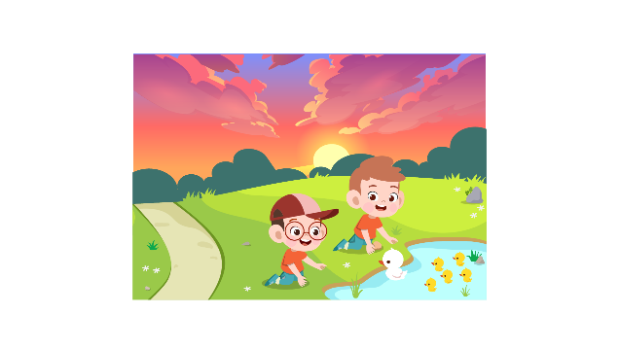
A ⬜ | B ⬜ | C ⬜
- Why is Mary tired?
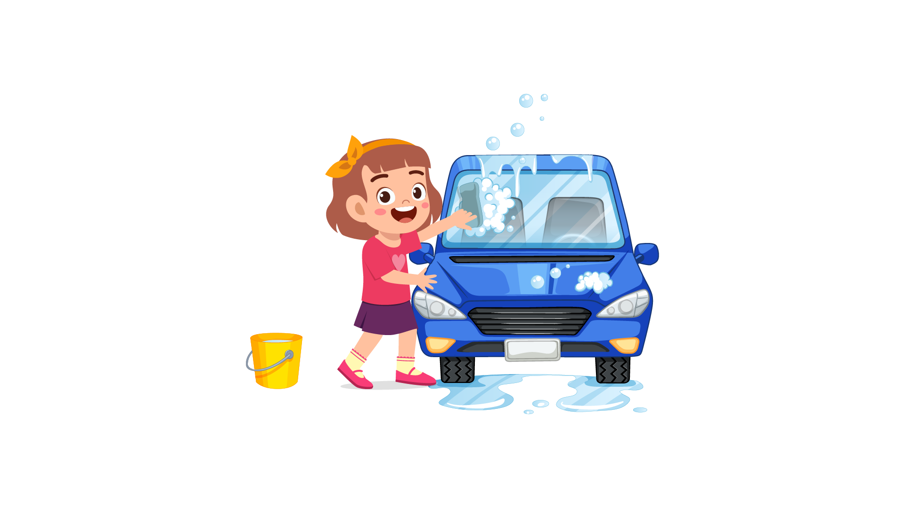 |  | 
A ⬜ | B ⬜ | C ⬜

- Where was the scarf?
 | 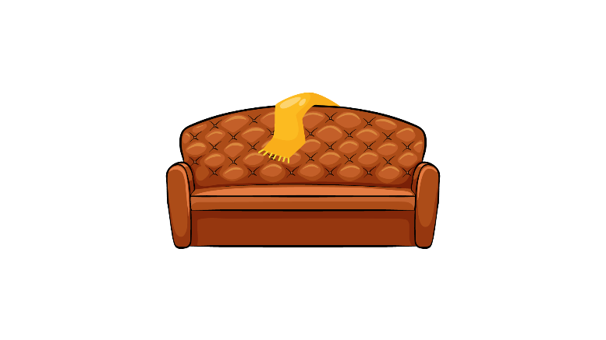 | 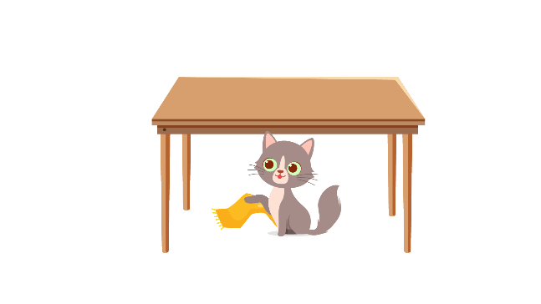
A ⬜ | B ⬜ | C ⬜

Part 5
5 questions

Listen and colour and draw.
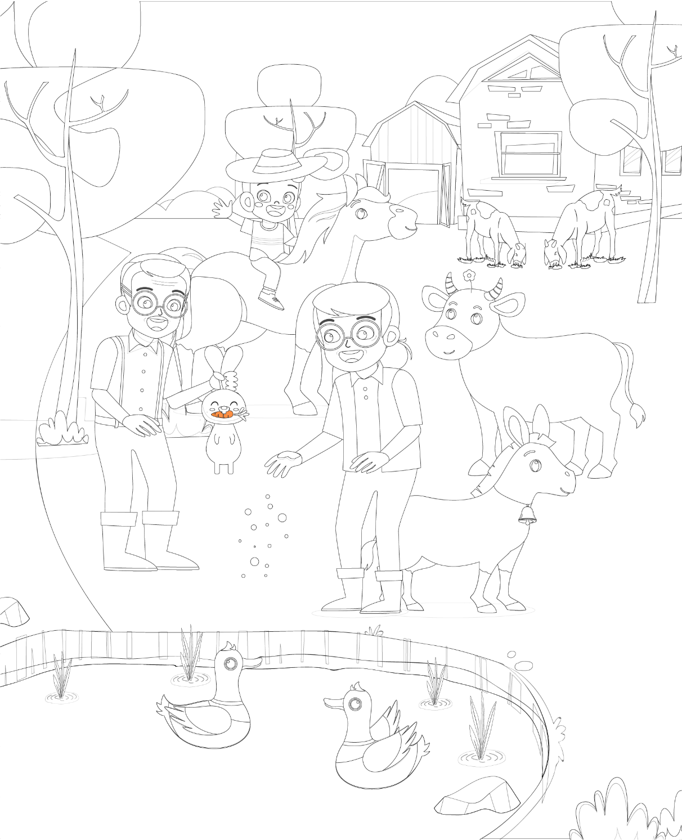

Reading and Writing
There are 35 questions
You have 30 minutes.
You will need a pen or pencil.
My name is…………………………….

Part 1
5 questions

Look and read. Choose the correct word and write them on the lines.

 | 
A hospital | A pilot
 | 
A storm | A towel
 | 
A dolphin | River
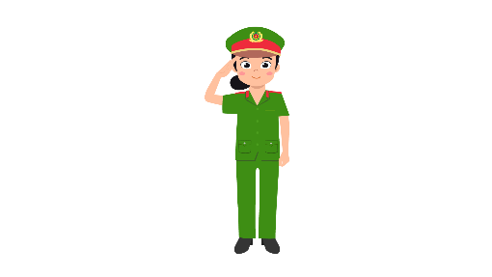 | 
A police officer | The moon

Example
(0) | It is a place. A doctor works there. | A hopital
Questions
1 | Water running on the ground, which goes into the sea. | ___________
2 | People use this when they come out of the swimming pool. | ___________
3 | This animal is a large fish. It’s very clever and friendly. | ___________
4 | This person can fly planes. | ___________
5 | This is very bad weather with strong winds and a lot of rain.

Part 2
6 questions

Read the text and choose the best answer.
Sarah is talking to her sister Emma.
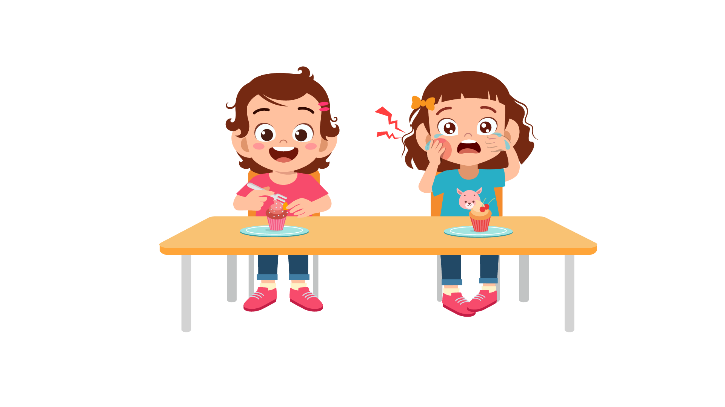

Example:
 | Sarah: | Hey, Emma. Are you OK?
 | Emma: | A. No, I don’t.
 |  | B. Not really. I’m not very well.
 |  | C. No, I wasn’t there.
Questions:
1 | Sarah: | What’s the matter?
 | Emma: | A. I’ve got terrible toothache.
 |  | B. I’ve got a cake.
 |  | C. Mum is downstairs.

2 | Sarah: | Why does your tooth hurt? Did you eat a lot of cake??
 | Emma: | A. I didn’t have breakfast.
 |  | B. I didn’t know that.
 |  | C. I did. You know I like it.

3 | Sarah: | I think you should go to the dentist’s?
 | Emma: | A. Yes, I’m good at it.
 |  | B It’s very boring.
 |  | C. No. I’m afraid of doctors.

4 | Sarah: | You must stop eating so much sugar. It’s not good for you
 | Emma: | A. Alright, I have to take a spoon.
 |  | B. OK, I’m going upstairs now.
 |  | C. I don’t want to go.

5 | Sarah: | Do you need me to bring you anything?
 | Emma: | A. Stop it, please.
 |  | B. Can you take off your shoes?
 |  | C. A cup of tea, please.

6 | Sarah: | Do you feel better now?
 | Emma: | A. Never.
 |  | B. You’re welcome.
 |  | C. Yes. Thank you!

Part 3
6 questions

Read the story. Choose a word from the box. Write the correct word next to the numbers 1-5. There is one example.
I love (0) …birds… I have a parrot. I like to teach it to talk. We keep it in a (1) ……….
Last Sunday, Mom and Dad took me to a (2) ………. We saw a (3) ………. making balloons for children. He gave me one shaped like a bird. I loved it very much.
We visited the pandas first. However, they were either sleeping or eating (4) ……….. They barely moved! I found it quite boring to look at them.
After that, we went to the (5) ……….. There were a lot of beautiful sea animals. I see a huge killer whale. It was amazing!

Example
birds | panda | pirate
clown | zoo | aquarium
cage | bamboos | parrot

(6) Choose the best name for the story.
Tick one box.
My weekend | ⬜
I love pets | ⬜
Going to the park | ⬜

Part 4
5 questions

Choose the right words and write them on the line.
 | Bears
 | 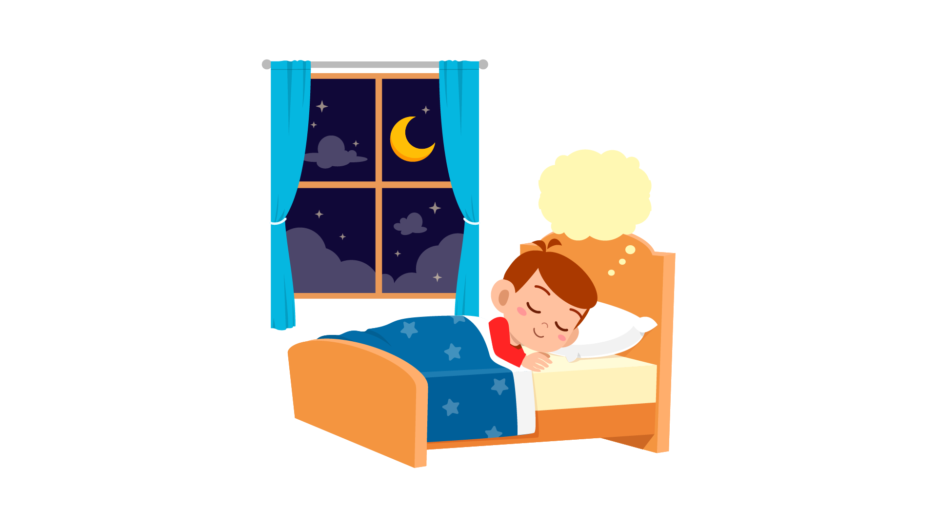
Example  1  2  3  4  5 | A dream is the pictures ....which…. we see in our sleep. Sometimes dreams are funny and exciting and some other times they are boring, or even bad. Every man, woman and child …………. dream. Some dreams are in black and white, but …………. of them are in colour. During the night, we never  …………. only one dream. People have from two to seven dreams every night. Not all dreams are …………. and sometimes you can have a dream  …………. is bad. You just have to try to think of something funny or nice.

Example: | what | which | where
1. | can’t | couldn’t | can
2. | most | more | few
3. | had | have | has
4. | good | better | best
5. | when | who | which

Part 5
7 questions

Look at the picture and read the story. Write some words to complete the sentences about the story. You can use 1, 2 or 3 words.
Going to grandparents’ house
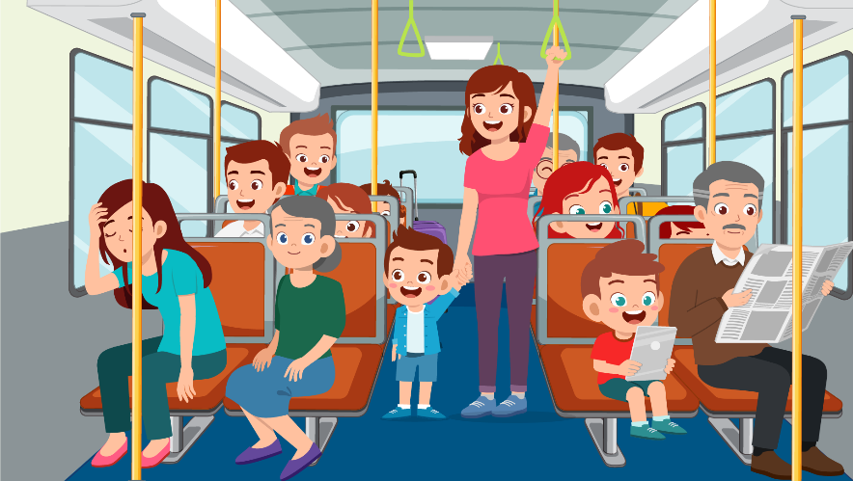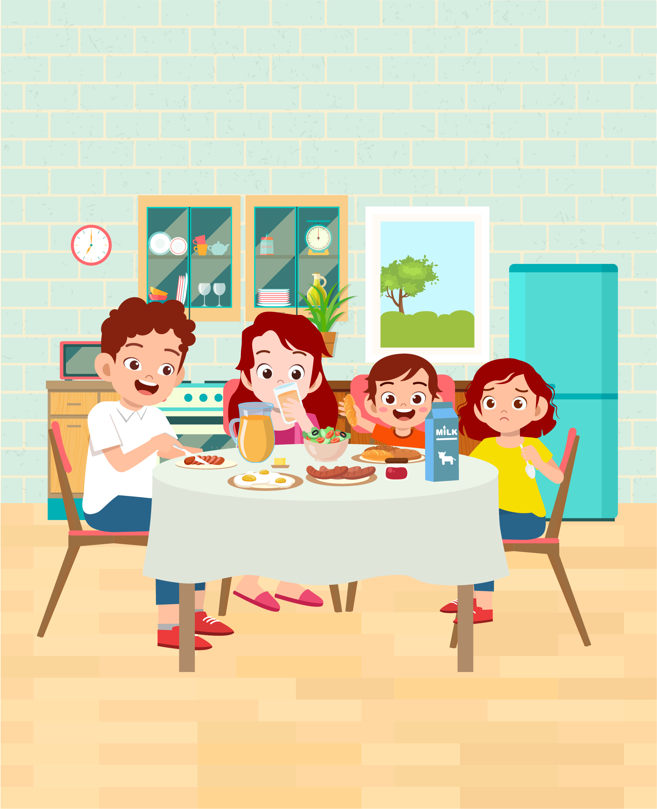
Yesterday Ben’s mum said, “Do you want to go and see Grandmother and Grandfather?” “Yes, please!” shouted Ben. He put on his favourite shirt and trousers. They caught a bus and went to the village. There were a lot of people on the bus, so they couldn’t sit down. But Ben was happy because he always liked going to see his grandparents.
Examples:
Ben and …Mum…. went to see his grandparents.
Ben put on his favourite shirt and … trousers …
Questions:
1. They …………. a bus to go to the village.
2. The bus was crowded so they couldn’t ………………
3. Ben was still ……………. because he liked going to his grandparents’ house.

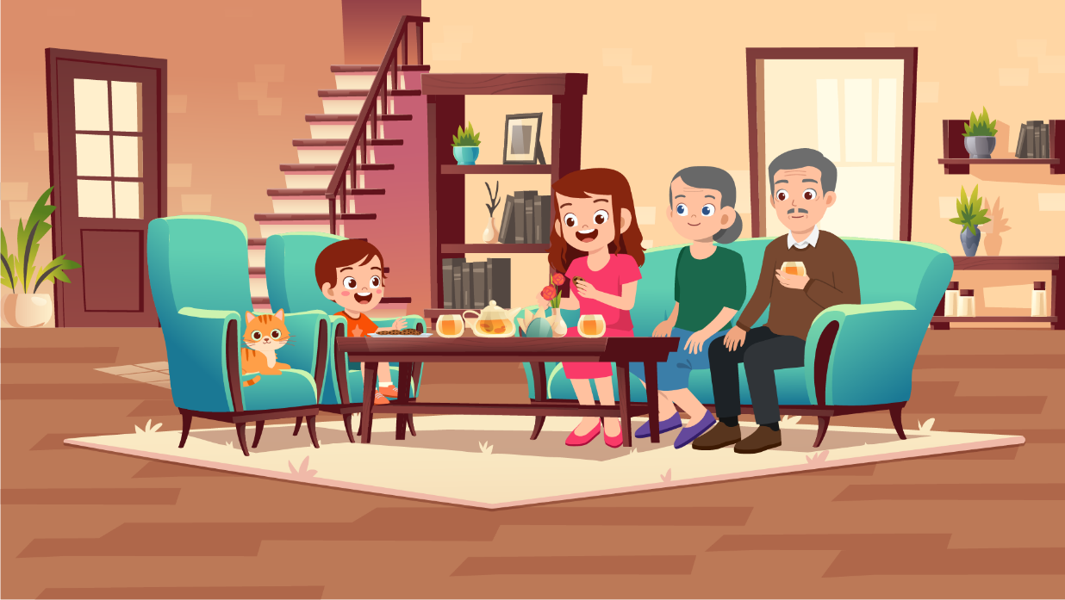

Ben said “Hello” to his grandmother and grandfather. His mum gave them some biscuits. In the afternoon, they all sat in the living room and had some tea. Grandmother’s cat was next to the sofa. Grandfather said, “It’s your birthday on Tuesday, Ben. What would you like?” Ben answered, “A new bike, please!”

Questions:
4 | Ben’s mum gave grandparents some ……………….
5 | In the afternoon, they had some tea in the ……………………….

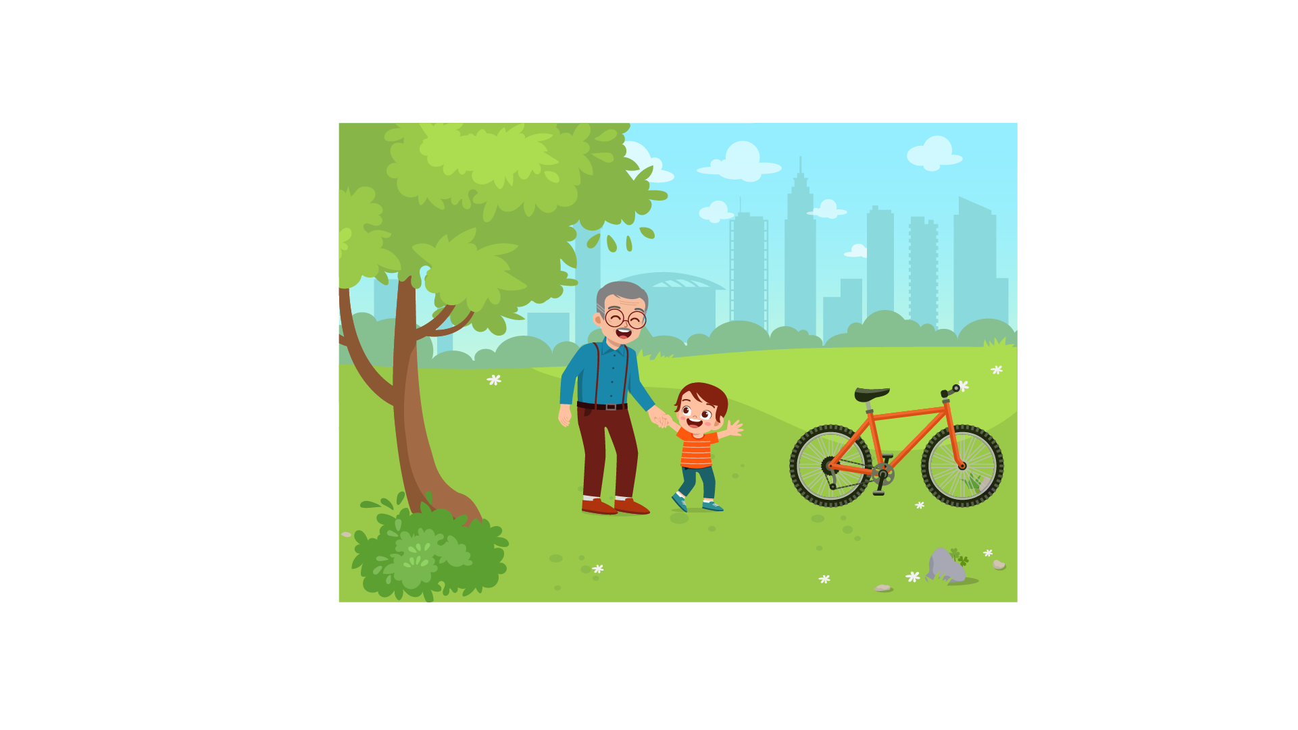

“Come outside with me,” said Grandfather. Ben and Grandfather went into the garden. There was a new red bike outside. “This is for you, Ben.” “Thanks, Grandfather. I love it!” said Ben. He went home on his new bike. He was excited.

Questions:
6 | Grandfather gave him a new …………………….
7 | Ben felt ………………. about his birthday present.

Part 6
6 questions

Look, read and write.
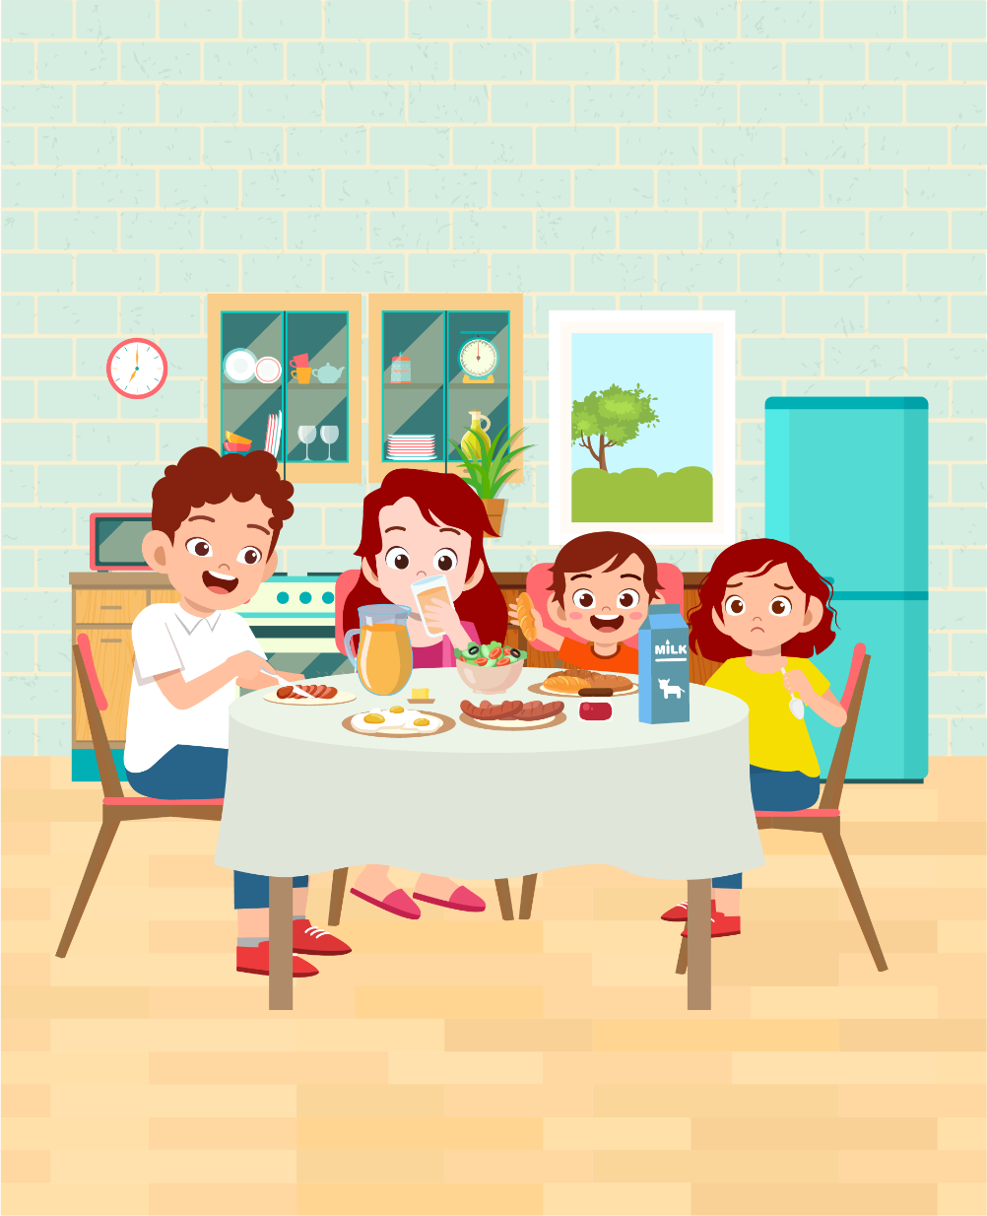

Examples:
How many people are there in the picture? …four…
They are …having a meal/ eating….

Complete the sentences.
1. The dad is cutting ….
2. The mom is drinking ….

Answer the questions.
3. Where is the butter?
4. What is the sister wearing?

Now write two sentences about the picture.
5. …………………………………….
6. …………………………………….
Speaking
My name is…………………………….

Summary of Procedures
The usher introduces the child to the examiner. The examiner asks how old the child is.

- The examiner asks the child to describe several differences between the two Find the Differences pictures, e.g. ‘This man has got orange hair but that man has got black hair.”
- The examiner tells the child the name of the story and describes the first picture, e.g. “Hugo is at the park with his friends.”. The examiner then asks the child to continue to tell the story.
- The examiner shows how to do the task with the first odd-one-out set of pictures. For example: ‘These are all places. But this is a room in a house’. Then the examiner asks the child to choose one picture in the other three sets and say which is different and why.
- The examiner asks questions about the child, e.g. ‘Where do you live?’

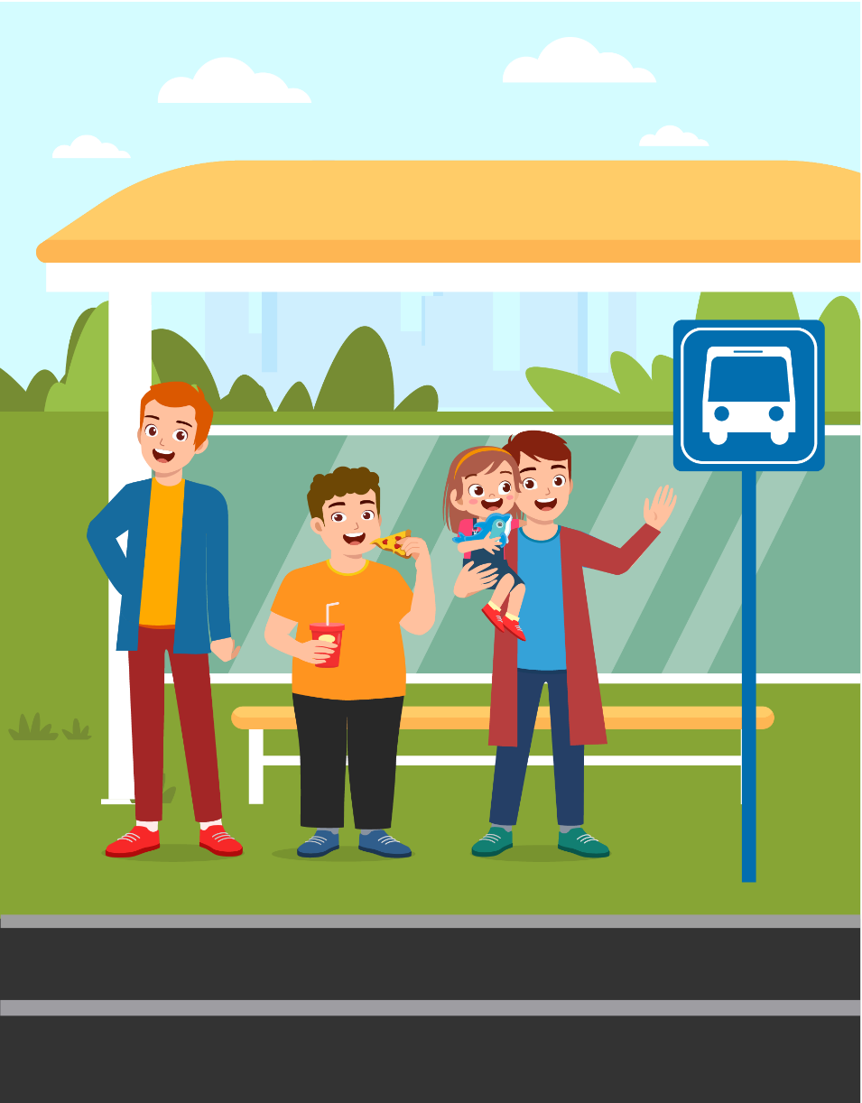 |  | 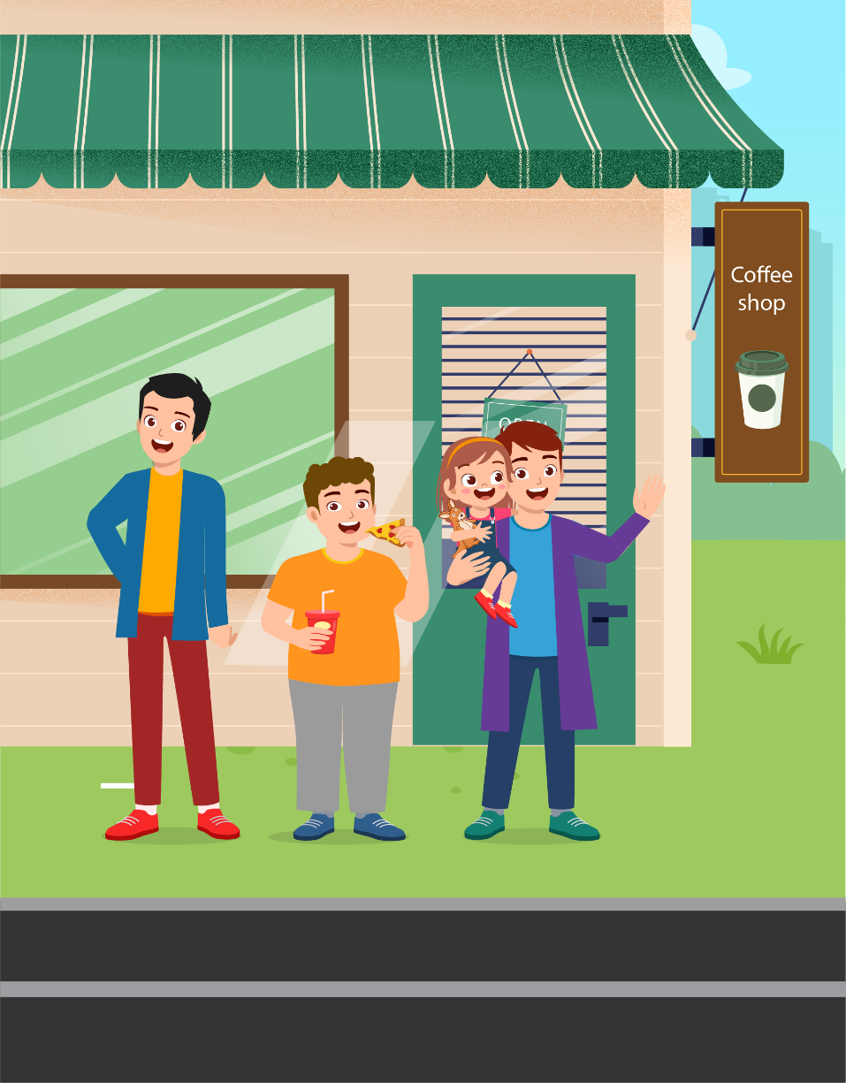

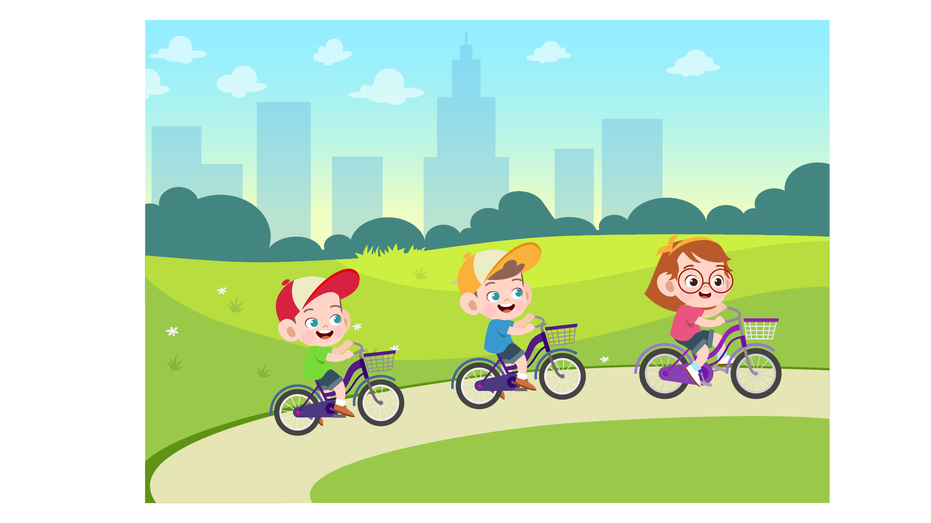
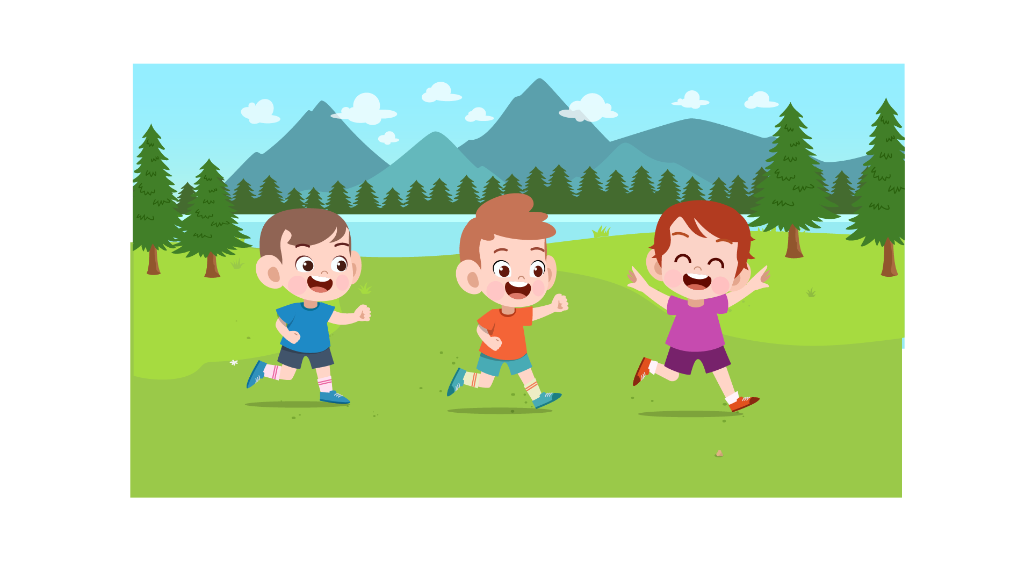 | 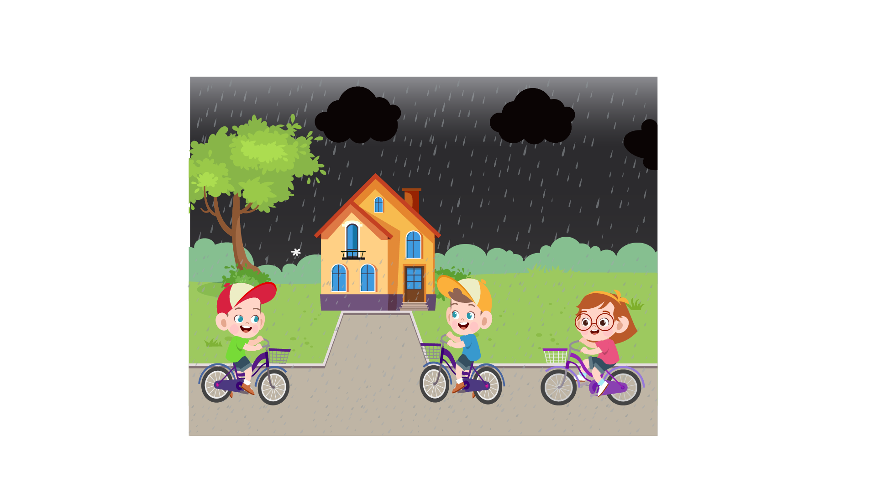 | 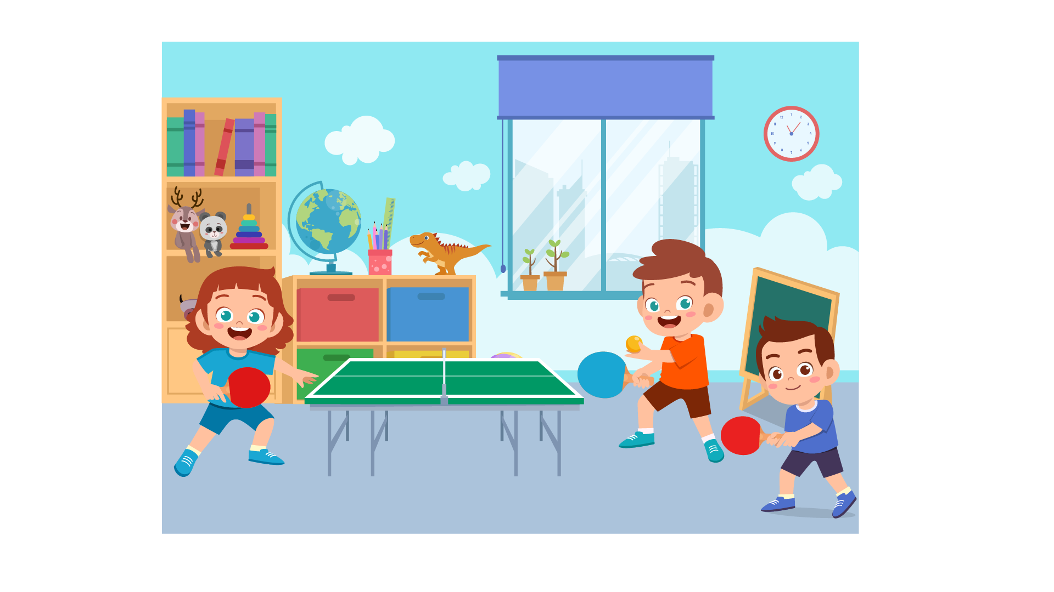

 |  | 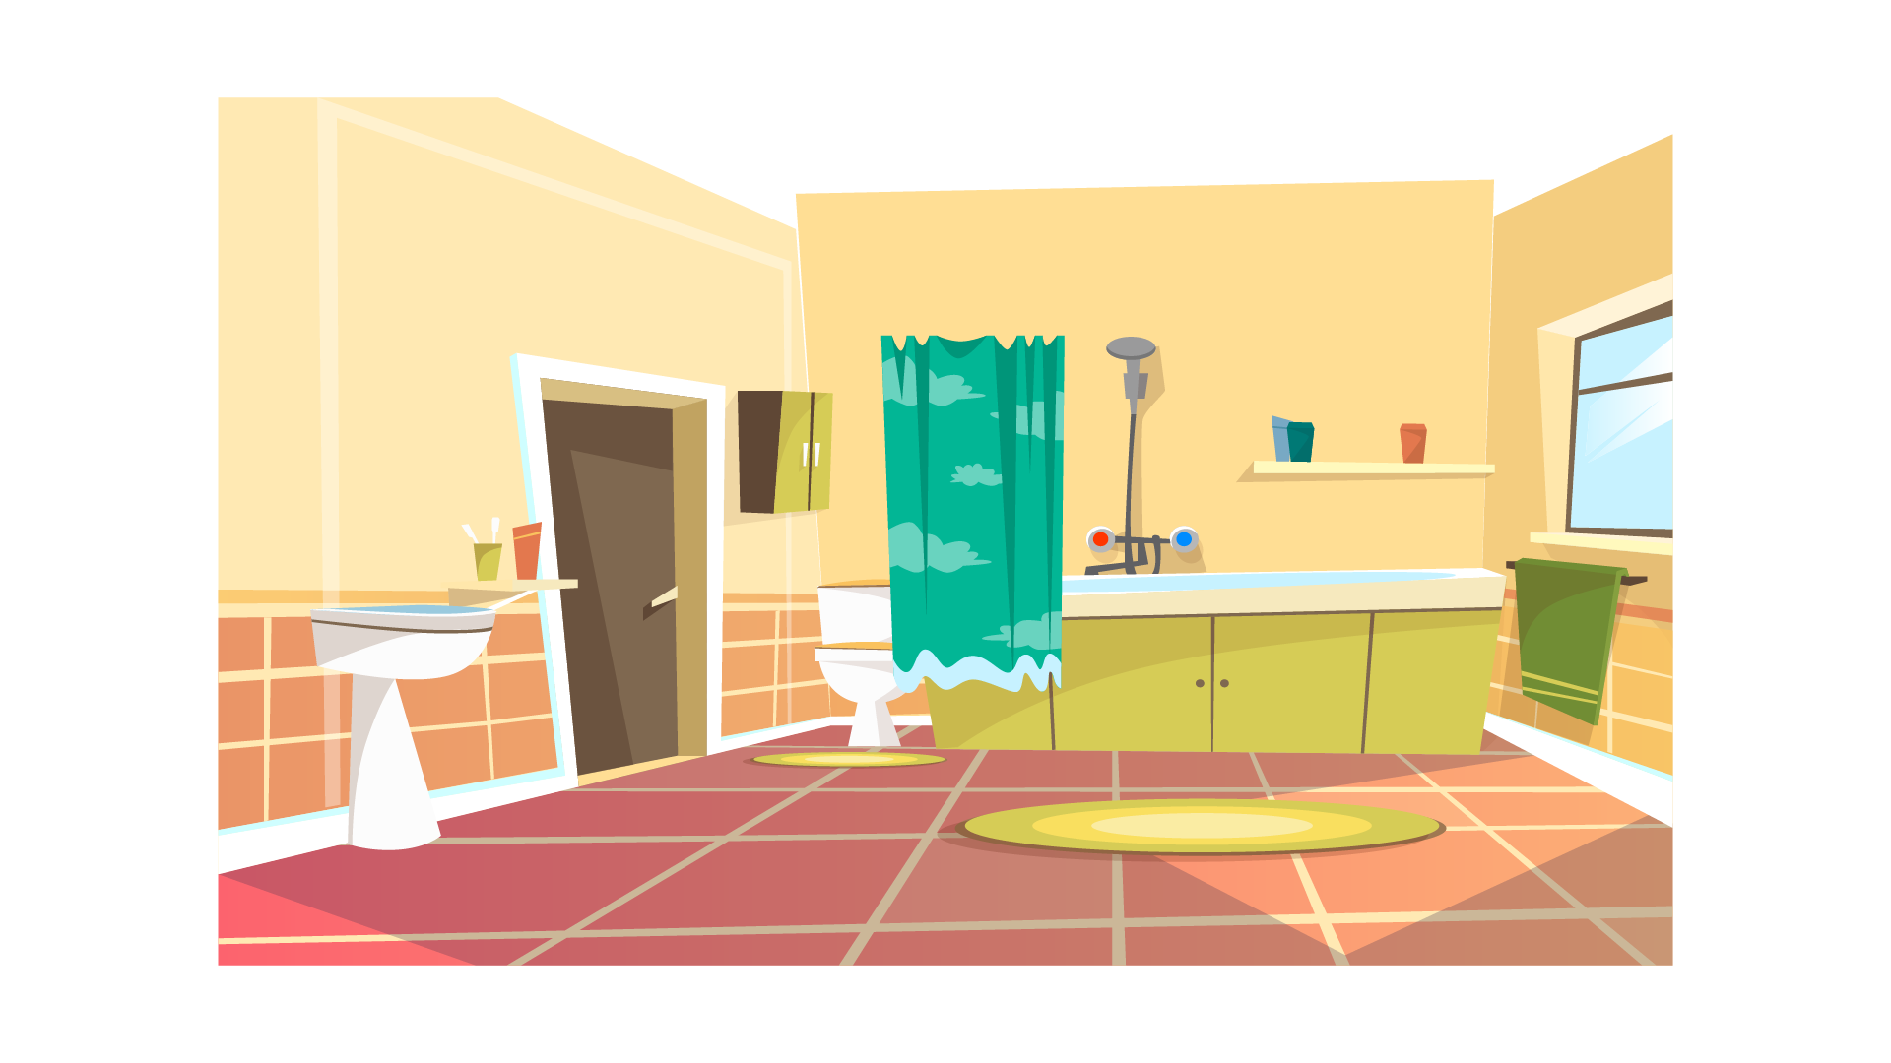 | 
 | 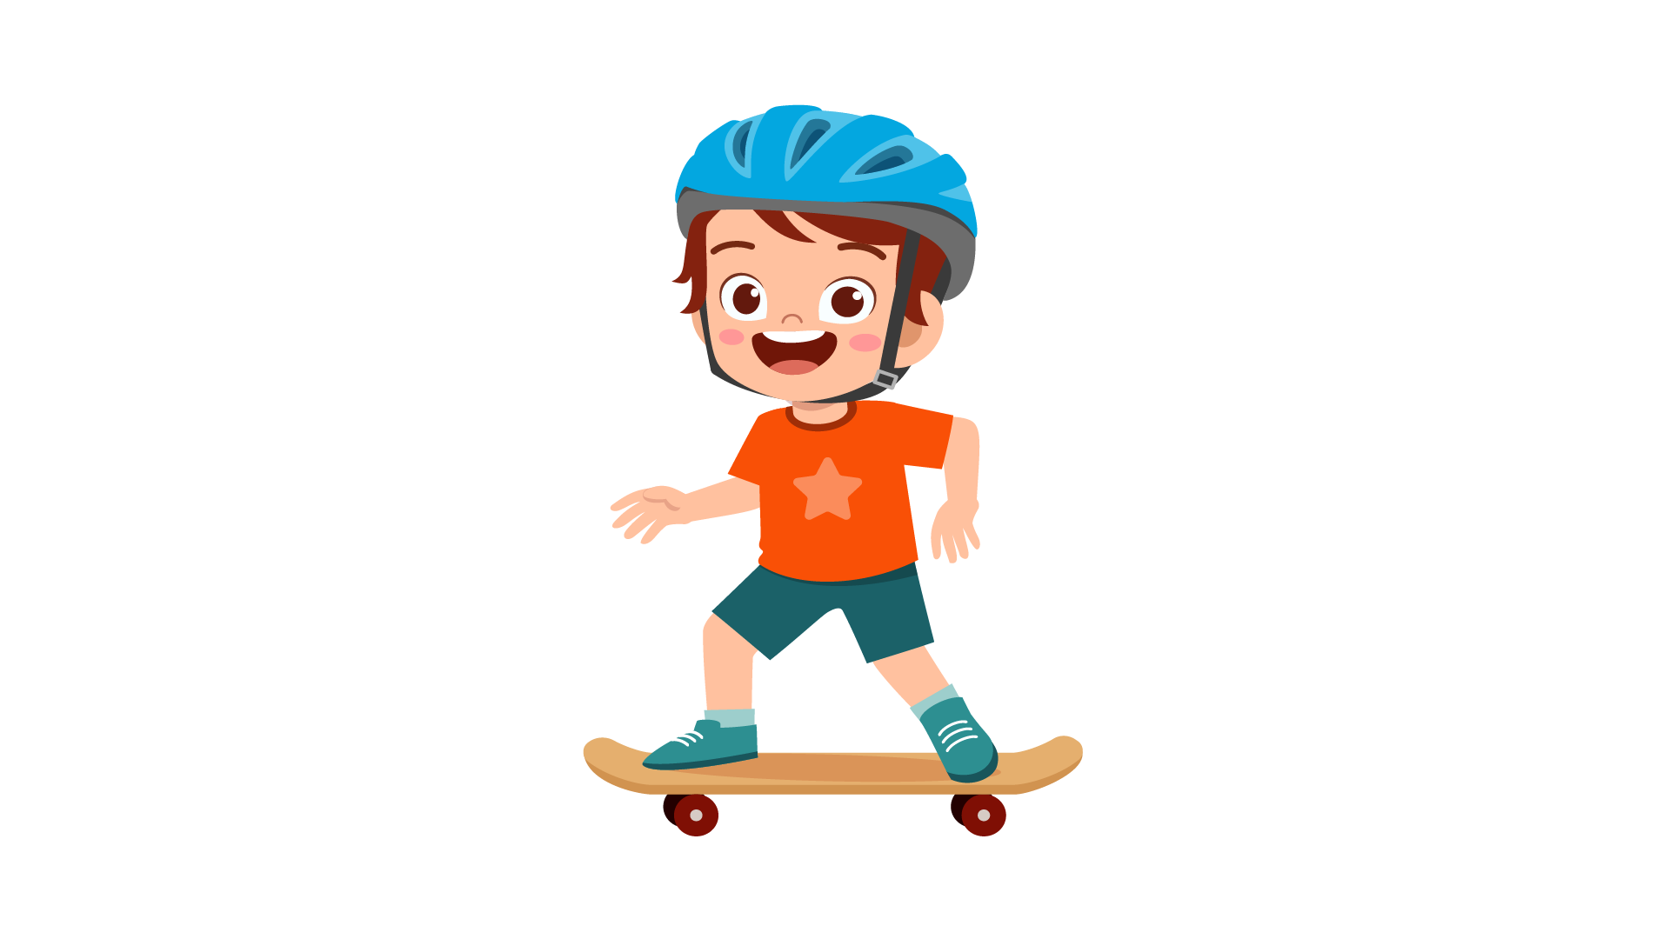 | 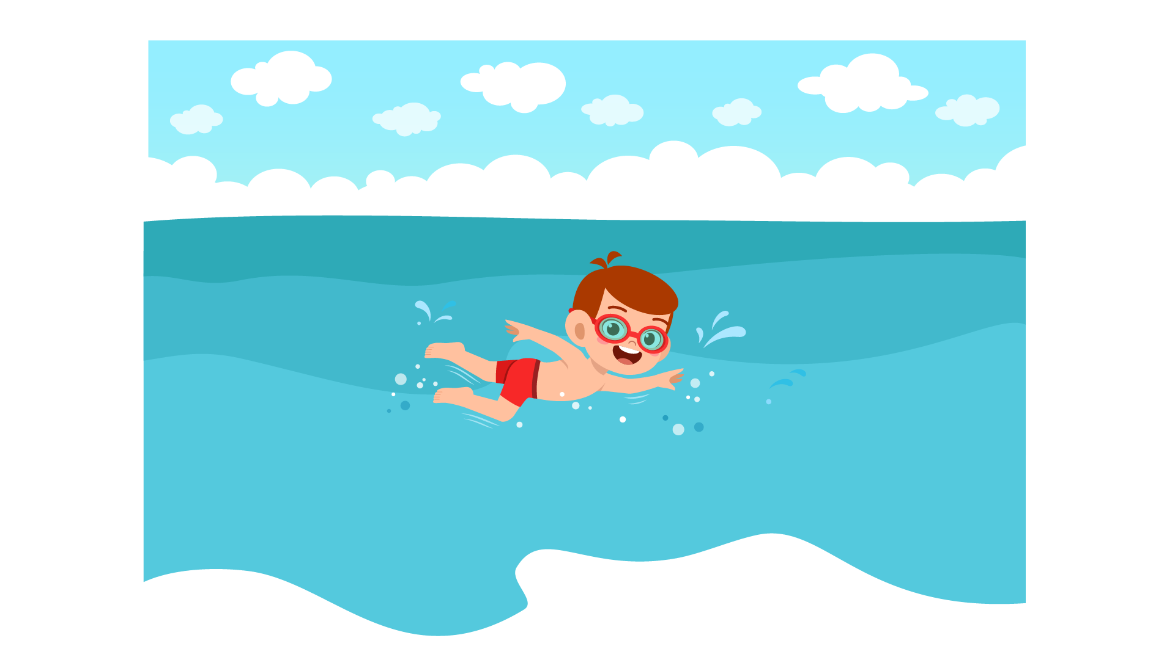 | 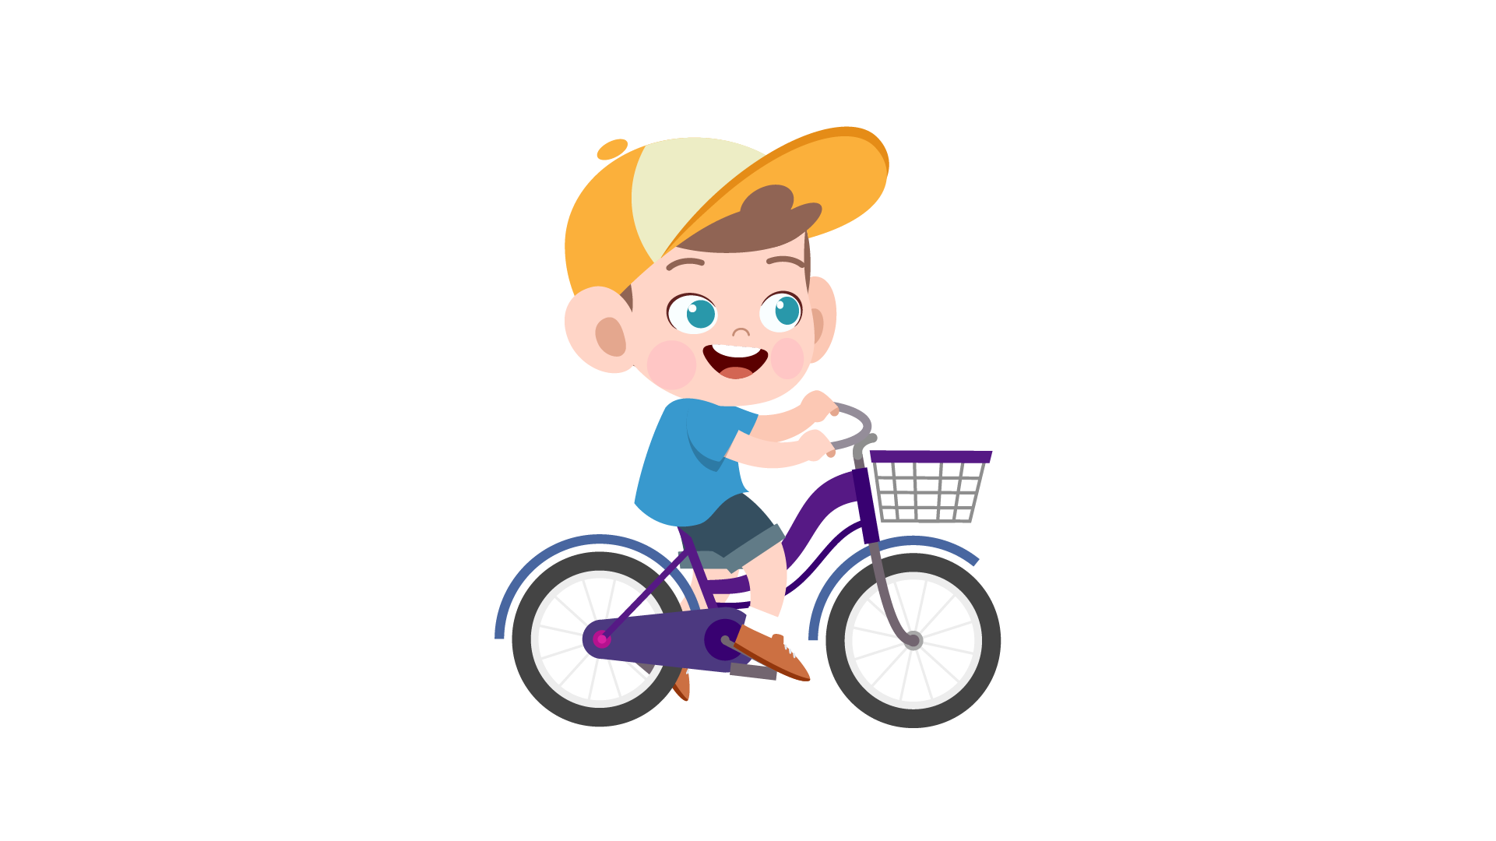

 | 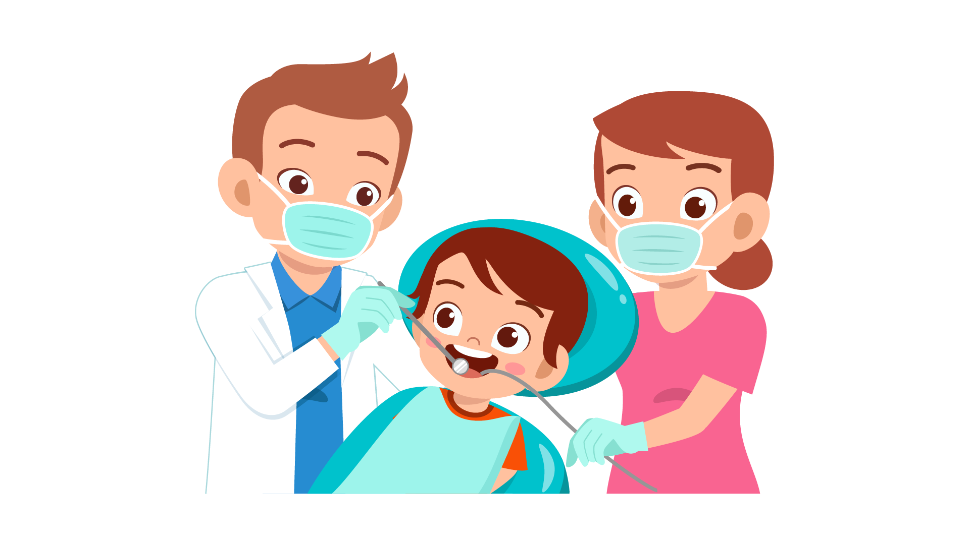 | 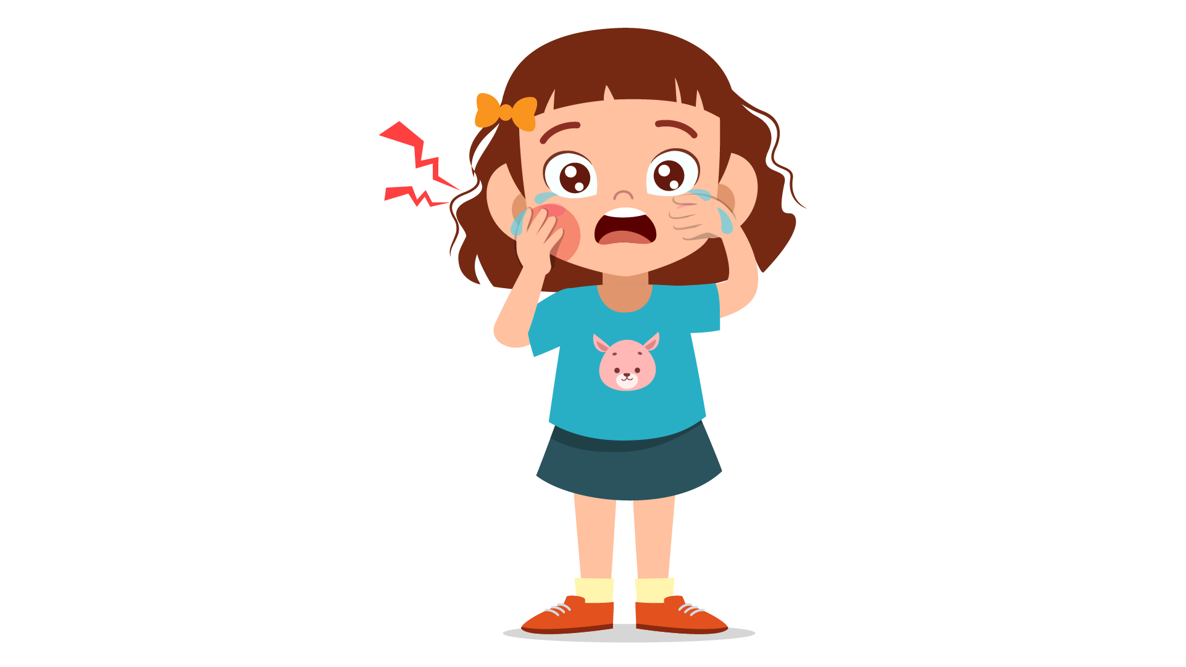 | 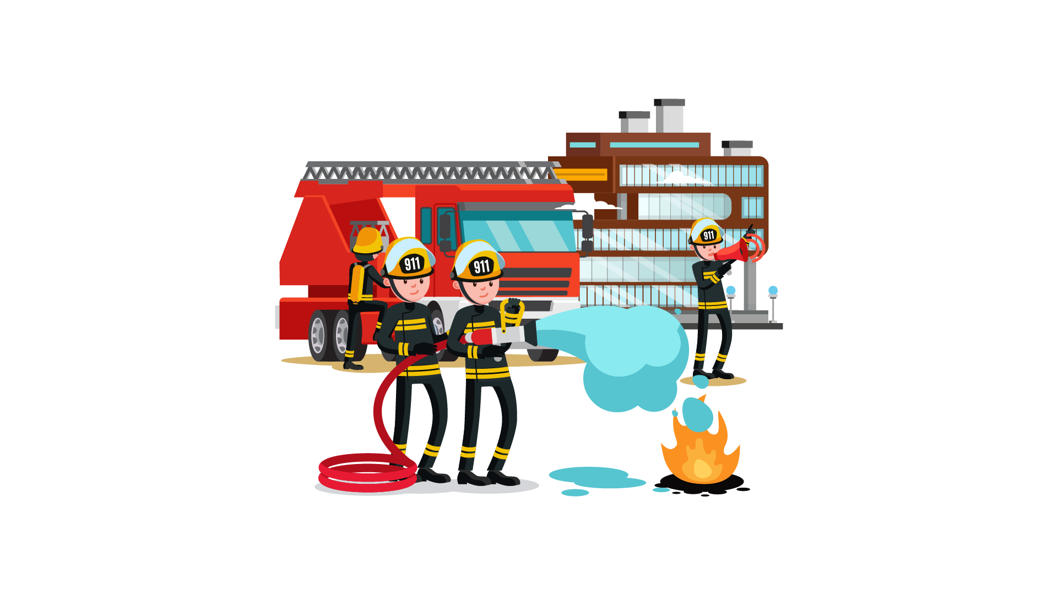
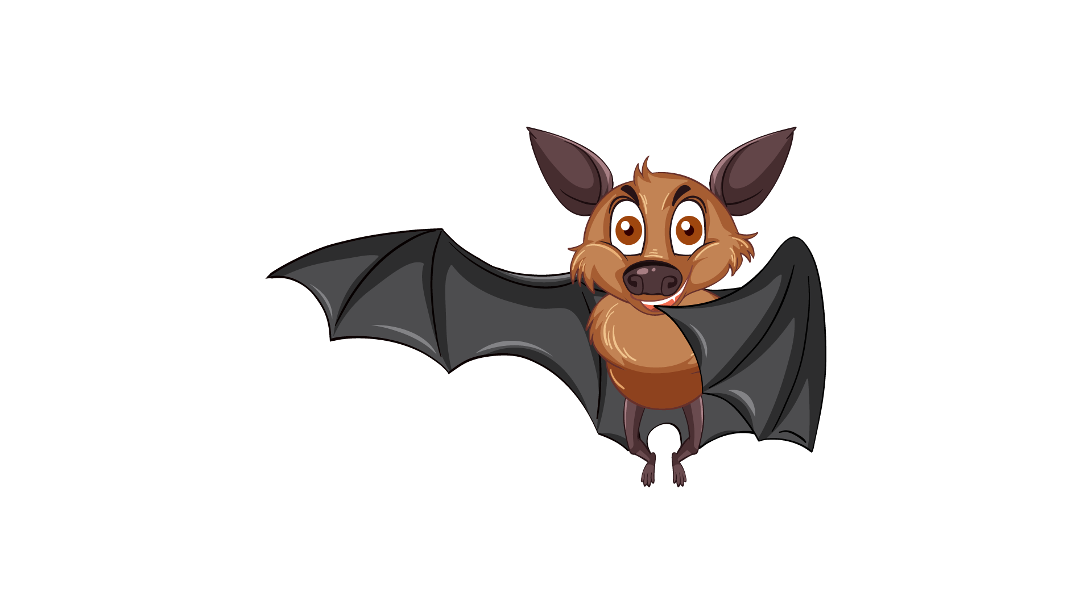 |  |  | 