Thời gian làm bài: 40 phút (Không kể thời gian giao đề)
-------------------------
Họ tên thí sinh: .................................................................
Số báo danh: ......................................................................
Mã Đề: 010.
Câu 1. Who should students contact if they have lost their phone?
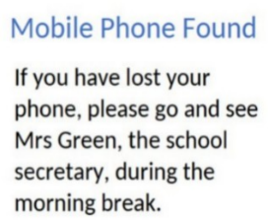
A. Mrs Green B. The janitor C. The principal D. Their teacher
Câu 2. What is the offer for the swim class?
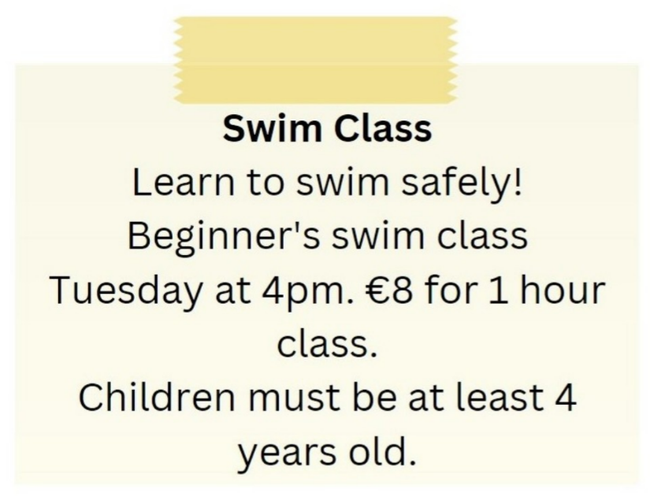
A. Beginner's swim class on Tuesday at 5pm for €10
B. Advanced swim class on Tuesday at 4pm for €8
C. Beginner's swim class on Tuesday at 4pm for €8
D. Beginner's swim class on Wednesday at 4pm for €8
Câu 3. Look at the signs. Choose the best answer for the question.
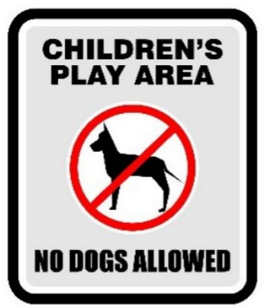
A. Dogs are not allowed to play with children in this area.
B. Dogs cannot be taken into this place as it is a children’s play area.
C. Dogs are not safe for children in this play area.
D. Don’t let your children play here because of the dogs.
Câu 4. Which day is the City Zoo closed?
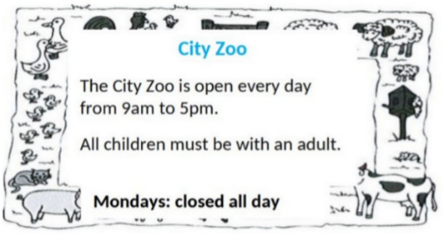
A. Sunday B. Friday C. Saturday D. Monday
Câu 5. What activities will be allowed when the pool reopens?
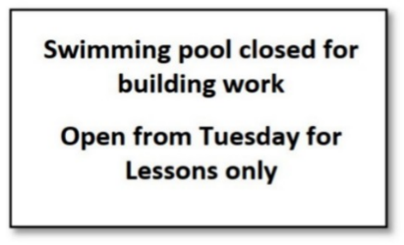
A. All regular activities B. Only swimming lessons
C. The notice doesn't specify allowed activities D. Building work and swimming lessons
Câu 6. Look at the signs. Choose the best answer for the question.

A. You must look after your cameras in this area. B. Cameras can be used in this area.
C. This area is supervised by camera. D. Cameras can only be used for security purposes.
Câu 7. Look at the signs. Choose the best answer for the question.
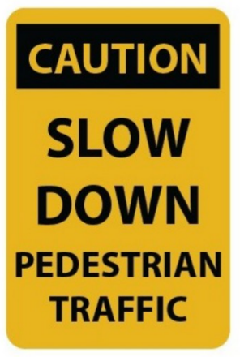
A. Pedestrians should walk slowly.
B. You should drive carefully because of slow pedestrians.
C. You should slow your speed and pay attention to pedestrians.
D. Pedestrians will slow down the traffic.
Câu 8. Look at the signs. Choose the best answer for the question.
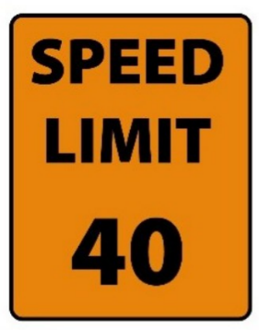
A. You can drive 40 miles per hour or more. B. You must drive at 40 miles per hour.
C. You cannot drive faster than 40 miles per hour. D. The minimum speed is 40 miles per hour.
Câu 9. What does this sign mean?
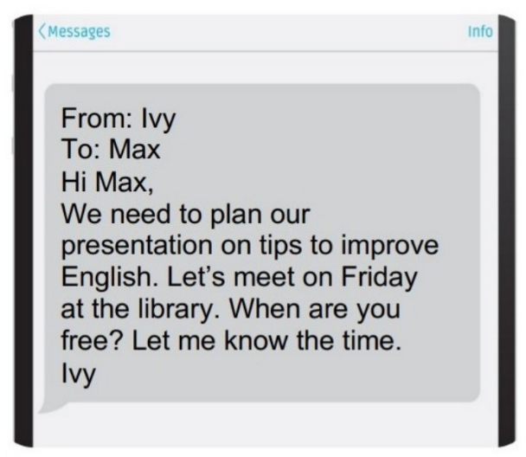
A. Ivy wants to remind Max of the project's deadline.
B. Ivy wants to thank Max for doing the presentation.
C. Ivy wants to find out more about the project from Max.
D. Ivy wants to know when they will meet to work on the project.
Câu 10. Look at the signs. Choose the best answer for the question.
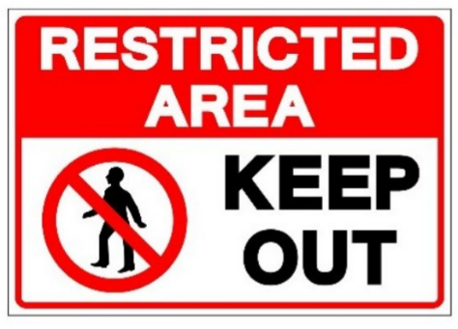
A. We should keep this area out. B. People aren’t allowed to enter this area.
C. This area is kept open. D. This area is open to everyone.
----HẾT---

