

TỐNG THỊ MINH HỒNG (Chủ biên)
NGUYỄN THỊ HỒNG HƯNG - VŨ THỊ LIỄU - PHẠM THỊ LAN PHẠM THỊ NƯƠNG - NGUYỄN TẤT MINH

H−íng dÉn «n tËp thi tuyÓn sinh vμo líp 10 trung häc phæ th«ng m«n tiÕng anh

N¨m häc 2021 – 2022

Giaoandethitienganh.info

Nhμ xuÊt b¶n ®¹i häc quèc gia hμ néi
Giaoandethitienganh.info

LỜI NÓI ĐẦU

Cuốn sách Hướng dẫn ôn tập thi tuyển sinh vào lớp 10 Trung học phổ thông môn tiếng Anh được biên soạn dựa trên nền tảng kiến thức ngữ pháp, từ vựng, kĩ năng theo chương trình sách giáo khoa Tiếng Anh 9 của Bộ Giáo dục và Đào tạo, nhằm chuẩn bị tốt cho các em học sinh ôn thi vào lớp 10 Trung học phổ thông.
Cuốn sách gồm 30 đề luyện tập tổng hợp được cập nhật theo xu hướng cấu trúc đề thi vào lớp 10 Trung học phổ thông trên cả nước, theo định hướng phát triển năng lực học sinh với việc bao quát các kĩ năng nói, đọc, viết và sử dụng ngôn ngữ trong những tình huống giao tiếp thực tế hoặc thông qua hiểu biết xã hội, kiến thức học thuật. Nhóm biên soạn hi vọng cuốn sách này không chỉ hỗ trợ các thầy, cô giáo trong quá trình giảng dạy và ôn tập cho học sinh, mà còn là một tài liệu hữu ích giúp học sinh phát triển kĩ năng tự học.
Do thời gian biên soạn gấp rút, cuốn sách khó tránh khỏi những thiếu sót, chúng tôi mong nhận được những ý kiến đóng góp, phản hồi từ các chuyên gia, các thầy, cô giáo, các bậc phụ huynh cùng các em học sinh để tiếp tục hoàn thiện cuốn sách trong những lần in sau.
Chúc các em thành công trong học tập và thi đạt kết quả cao.
NHÓM TÁC GIẢ
Giaoandethitienganh.info

Giaoandethitienganh.info

Phần 1. ĐỀ ÔN LUYỆN

PRACTICE TEST 1

Mark the letter A, B, C or D on your answer sheet to indicate the word whose underlined part differs from the other three in pronunciation in each of the following questions.
- A. districts B. problems C. regions D. wonders
- A. mobile B. wonder C. remote D. solar
- A. door B. school C. moon D. food
- A. visited B. prayed C. arrived D. followed
- A. pagoda B. grocery C. energy D. dialogue

Mark the letter A, B, C or D on your answer sheet to indicate the correct answer to each of the following questions.
- Hello, Tom! I you for a long time! How are you?
  - don’t see B. didn’t see C. haven’t seen D. am not seeing
Giaoandethitienganh.info

- Last week I the poor.
to the evening dinner organized to raise funds for

  - invite B. was invited C. invited D. inviting
- You usually take part in charity activities in your town, ?
  - do you B. are you C. aren’t you D. don’t you
- the ao dai encourages Vietnamese women to feel proud of the
traditions and customs of the country.
  - Wear B. To wear C. Wearing D. Worn
- I have breakfast at eight o’clock in the morning.
  - the B. a C. an D. no article
- Mrs. Lan needed some money, she took a part-time job at a local store.
  - because B. so C. but D. or
- Don’t forget to the light when you leave for work.
  - turn on B. turn up C. turn down D. turn off

- If Lan comes to England, it a good opportunity for her to improve her English.
  - will be B. would be C. is D. was
- Family spend more time talking instead of just watching TV or
surfing the Internet.
  - may B. should C. might D. needn’t
- Using solar energy is one of the that will save money as well as conserve the Earth’s resources.
  - invent B. inventions C. inventors D. inventing

- The man motorbike.
bicycle was stolen last week has decided to buy a

  - whom B. which C. who D. whose
- I wish I English as a native speaker.
  - can speak B. will be able to speak
C. could speak D. will have
Giaoandethitienganh.info

- Our children have no school Sunday.
  - at B. on C. in D. for
- I couldn’t finish the book because it was too .
  - boring B. bored C. bore D. boringly
- Summer is the season of the year.
  - hot B. hottest C. hotter D. most hot
- He is tired now he stayed up late last night.
  - because of B. because C. in spite of D. and
- The United States has a/an of around 250 million.
  - population B. separation C. addition D. nation
- Nguyen Du was a famous in Viet Nam.
  - musician B. poet C. designer D. singer
- Like Viet Nam, Malaysia tropical climate.
  - enjoys B. covers C. makes D. comprises

- My son English with his friends at the moment.
  - speaks B.is speaking C. spoke D. will speak
- My parents decided energy-saving bulbs to save electricity.
  - use B. used C. using D. to use

Mark the letter A, B, C or D on your answer sheet to indicate the word(s) CLOSEST in meaning to the underlined word(s) in each of the following questions.
- Many people use public transport minimize air pollution.
  - reduce B. increase C. save D. cause
- Last Sunday we went on a picnic and enjoyed the great feeling we had never had before.
  - general B. terrible C. bad D. wonderful

Mark the letter A, B, C or D on your answer sheet to indicate the word(s) OPPOSITE in meaning to the underlined word(s) in each of the following questions.
- The man opened the door and walked in.
  - closed B. knocked C. pulled D. pushed
- The foreigner spoke slowly enough for me to understand.
  - carefully B. badly C. fast D. hard

Mark the letter A, B, C or D on your answer sheet to indicate the most suitable response to complete each of the following exchanges.
- Mark and Jane are talking about Jane’s home village.
– Mark: “How lovely your home village is!” – Jane: “ ”
  - Really? It is. B. Thank you. It is nice of you to say so.
C. Can you say it again? D. I love it, too.
- Susan and Pitt are at the school canteen.
– Pitt: “Would you like some chocolate ice-cream?” – Susan: “ .”
  - Yes, let’s B. Yes, please
C. I think so D. Here you are

Read the following passage and mark the letter A, B, C or D on your answer sheet to indicate the correct answer to each of the questions from 33 to 37.
The search for alternative sources of energy has led in various directions. Many communities are burning garbage and other biological waste products to produce electricity. Converting waste products to gases or oil is also an efficient way to dispose of waste.
Experimental work is being done to derive synthetic fuels from coal, oil shale, and coal tars. But today, that process has proven expensive. Other experiments are underway to harness power with giant windmills. Geothermal power, heat from the earth, is also being tested.
Some experts expect electrical companies to revive hydroelectric power derived from streams and rivers. Fifty years ago hydroelectric power provided one-third of the electricity used in the United States, but to day it supplies only 4 percent. The oceans are another potential source of energy. Scientists are studying ways to convert the energy of ocean currents, tides, and waves to electricity. Experiments are also underway to make use of temperature differences in ocean water to produce energy.
- What is the passage mainly about?
  - The use of biological waste products to produce electricity.
  - The search for alternative sources of energy.
  - Efficient ways of disposing of waste.
  - Geothermal power-a main source of energy in the future.
- The word “expensive” in the second paragraph is closest in meaning to .
  - cheap B. new C. old D. costly
- Fifty years ago, one-third of the electricity in the United States was provided by .
  - wind B. waste products C. water D. oil
- The word “it” in the last paragraph refers to .
  - alternative source B. hydroelectric power
C. electricity D. the United States

- Which of the following energy is NOT mentioned in the passage as ways scientists are studying to change to electricity?
Giaoandethitienganh.info

  - ocean currents B. fossil fuels C. tides D. waves

Read the following passage and mark the letter A, B, C or D on your answer sheet to indicate the correct word or phrases that best fits each of the numbered blanks from 38 to 42.
Christmas is my favorite holiday. I enjoy (38) Christmas cookies and planning parties. I like sending cards and hearing from old friends. I love seeing children open their gifts on Christmas morning. Most of all, I love one special custom (39) we have in our family. On the night before Christmas we wear warm clothes and go from house (40) house in our neighborhood. At each house, we (41) Christmas songs. Then we go to a hospital or a home for elderly people and we sing there. We want to let people know that we care about them. (42) , we come home and drink hot chocolate by the fireplace. I love this!
- A. bake B. baking C. to bake D. baked
- A. who B. when C. which D. whom
- A. to B. with C. in D. at
- A. hear B. listen to C. write D. sing
- A. Afterward B. Lately C. Recently D. Now

Mark the letter A, B, C or D on your answer sheet to indicate the underlined part that needs correction in each of the following questions.
- My friends is eager to take part in after-school activities. A B C D
- Mr. Ba walks always to work because his office is not far from his house. A B C D
- You had better get up early and to revise your lessons in the morning. A B C D

Mark the letter A, B, C or D on your answer sheet to indicate the correct sentence that is closest in meaning to each of the following questions.
- Mai said: “English is my favorite subject at school.”
  - Mai said English was her favorite subject at school.

  - Mai said English is her favorite subject at school.
  - Mai said English was my favorite subject at school.
  - Mai talked English was her favorite subject at school.
- They keep this room tidy all the time.
  - This room is kept tidy all the time.
  - This room is keeping tidy all the time.
  - This room are kept tidy all the time.
Giaoandethitienganh.info

  - This room all the time is kept tidy.

Mark the letter A, B, C or D on your answer sheet to indicate the sentence that best combines each pair of sentences in the following questions.
- He is an architect. He designed the new city library.
  - He is the architect who designed the new city library.
  - He is the architect which designed the new city library.
  - He is the architect whose designed the new city library.
  - He is the architect who he designed the new city library.
- She can’t answer the question. It is too difficult.
  - If the question were not so difficult, she couldn’t answer it.
  - If the question were difficult, she couldn’t answer it.
  - If the question is not so difficult, she can answer it.
  - If the question were not so difficult, she could answer it.
- It is raining hard. They have to go to school.
  - In spite of it is raining hard, they have to go to school.
  - Despite of the hard rain, they have to go to school.
  - Although it is raining hard, they have to go to school.
  - Although the rain, they have to go to school.

PRACTICE TEST 2

Mark the letter A, B, C or D on your answer sheet to indicate the word whose underlined part differs from the other three in pronunciation in each of the following questions.

1. A. address | B. plastic | C. channel | D. program
2. A. captured | B. designed | C. conserved | D. erupted
3. A. disasters | B. thunderstorms | C. scientists | D. expressions
4. A. country | B. council | C. mountain | D. playground
5. A. develop | B. consider | C. introduce | D. educate
Mark the letter A, B, C or D on your answer sheet to indicate the correct answer to each of the following questions.
- Lan Kuala Lumpur two years ago.
  - visits B. has visited C. visited D. is visiting
- Computers to design new models.
  - are using B. are used C. use D. used
- You are alert while enjoying surfing, ?
  - are you B. aren’t you C. do you D. don’t you
- I suggest different kinds of waste in separate dustbins.
  - putting B. being put C. put D. to put
- the weather forecast said it would rain, it turned out to be a beautiful day.
  - In spite of B. Although C. Because D. However
- Don’t wait for me! I be late. It depends on the traffic.
  - might B. ought to C. must D. should
- Tet holiday is one of the most important for Vietnamese people.
  - celebrate B. celebrations C. celebrated D. celebrating
- Nha Trang is a place you can find many beautiful beaches.
  - which B. that C. whom D. where
- I wish I a space trip some day in the future.
  - take B. took C. would take D. will take

- Paola has her English classes Monday morning.
  - on B. in C. at D. for
- Father’s Day a national holiday in America since 1972.
  - has been B. was C. is D. will be
- What’s the going to be like tomorrow? Will it rain?
  - climate B. weather C. condition D. temperature
- Buddhism is a/an in many countries in the world.
  - group B. religion C. association D. imagination
- Would you like to our house next Sunday night?
  - coming B. come C. came D. to come
- An energy-saving bulb is than an ordinary 100-watt bulb.
  - good B. best C. better D. gooder
- I am about going on an excursion to Cuc Phuong National park.
  - excited B. exciting C. excitedly D. excitement
- I don’t really like reading novels. , I enjoyed his latest novel.
  - But B. So C. However D. Although
- Many students have become dependent on Internet for information.
  - no article B. a C. the D. an
- If we wasting water, there will be a shortage of fresh water in a few decades.
  - go on B. go up C. go off D. go away
- If people drove more carefully, there so many accidents on the road.
  - would not be B. will not be
C. wouldn’t have been D. aren’t
- I think the government should heavily anyone using dynamite to catch fish.
  - allow B. fine C. advise D. encourage

Mark the letter A, B, C or D on your answer sheet to indicate the word(s) CLOSEST in meaning to the underlined word(s) in each of the following questions.
- A fierce storm hit the west coast of Florida last week.
  - struck B. flew C. erupted D. lifted
- As volunteers, we help elderly people and war invalids in our neighborhood with their chores.
  - young B. sick C. poor D. old

Mark the letter A, B, C or D on your answer sheet to indicate the word(s) OPPOSITE in meaning to the underlined word(s) in each of the following questions.
- Their long train journey across India made them very tired.
  - deep B. short C. wide D. high
- She shook her head sadly, saying that she missed the flight.
  - worriedly B. angrily C. happily D. politely

Mark the letter A, B, C or D on your answer sheet to indicate the most suitable response to complete each of the following exchanges.
- Tom and Sue are talking about Sue’s new dress.
– Tom: “What a beautiful dress you are wearing!” – Sue: “ ”
  - Can I have it? B. It’s in the wash.
C. I’m glad you like it. D. Oh, no, not really.
- Lien and Trung are talking about their hobbies.
- Lien: “I really like watching documentaries.”
- Trung: “ . I find them quite boring.”
  - I’m the opposite B. I love watching them, too
C. They are my favorites D. So do I

Read the following passage and mark the letter A, B, C or D on your answer sheet to indicate the correct answer to each of the questions from 33 to 37.
Jeans are the most popular kind of clothing in the world. They are popular almost everywhere and with everybody. They are considered not just practical
Giaoandethitienganh.info

but very fashionable as well. But what do you know about the history of jeans? Who made the first jeans?
In 1850 Levi Strauss, a young immigrant from Germany, arrived in San Francisco. He came to sell canvas, a heavy fabric used for tents, to gold miners. One day Strauss saw that the miners needed strong clothes for work. He quickly took some of his canvas and made it into pants. These pants were very strong and lasted a long time. The pants became very popular immediately. Later Strauss wanted to make his pants even better, so he started making his pants from cotton cloth that was softer than canvas but just as strong. This fabric came from Nimes, a city in France, and was called “denim” (from de Nimes). Denim was popular in the fifteenth century. Christopher Columbus used denim for the sails of his ships. Sailors in Genoa, Italy, wore denim pants. The word “jeans” comes from the word “Genoa”. Mr. Strauss made the first jeans in the United States, but their name and their kind of cloth came from Italy and France.
- What does the passage mainly discuss?
  - The reasons why jeans are the most popular kind of clothing in the world.
  - The history of jeans.
Giaoandethitienganh.info

  - Some different styles of jeans.
  - Jeans in the future.
- Where were the first jeans made?
  - In Italy B. In Germany C. In the United States D. In France
- Who does the word “he” in the second paragraph refers to ?
  - a miner B. Levi Strauss C. Christopher Columbus D. a sailor
- The word “pants” in the second paragraph is closest in meaning to .
  - shirts B. trousers C. skirts D. shorts
- According to the passage, what did the gold miners in San Francisco buy?
  - tents B. gold C. pants D. canvas

Read the following passage and mark the letter A, B, C or D on your answer sheet to indicate the correct word or phrases that best fits each of the numbered blanks from 38 to 42.
The second Sunday in May is Mother’s Day. It is a (38) holiday in
both Britain (39) America. On that day, children send Mother’s Day

cards to their mothers. They give their mothers flowers or sweets as presents. Fathers and children do the cooking so that mothers can have a rest.
In the USA, Mother’s Day started in the 1860s. There was a small town
(40) was called Prunty town in the middle of the USA. People in the
town fought against each other during a war. After the war, they hated each other. Mrs. Ann Reeves Janis wanted the people (41) friends with each other again. So she started “Mother’s Friendship Day”. On that day, she visited (42) the other mothers in the town and said, “Let us be friends with each other again”.
Her idea succeeded. The same thing happened in other parts of the country. After she died, her daughter carried on her idea. In 1908, “Mother’s Friendship Day” became “Mother’s Day”.

38. | A. public | B. publicity | C. publicize | D. publicly
39. | A. but | B. and | C. so | D. as
40. | A. who | B. where | C. which | D. whom
41. | A. made | B. making | C. make | D. to make
42. | A. each | B. all | C. every | D. one

Mark the letter A, B, C or D on your answer sheet to indicate the underlined part that needs correction in each of the following questions.
- There is many rivers and lakes in their hometown, which makes it so beautiful. A B C D
- She is a kind woman. She thinks always of other people’s feelings. A B C D
- At weekends, we often do some outdoor activities such as going jogging,
A B C
camping and cycle.
D

Mark the letter A, B, C or D on your answer sheet to indicate the correct sentence that is closest in meaning to the given one.
- “Let’s use fewer plastic bags,” our headmaster said.
  - Our headmaster suggested using fewer plastic bags.

  - Our headmaster asked to use fewer plastic bags.
  - Our headmaster advised using fewer plastic bags.
  - Our headmaster required to use fewer plastic bag.
- They used to drink beer for breakfast in England years ago.
  - Beer used to drink for breakfast in England years ago.
  - Beer used to be drunk for breakfast in England years ago.
  - Beer used to be drinking for breakfast in England years ago.
  - Beer used to be drank for breakfast in England years ago.
Giaoandethitienganh.info

Mark the letter A, B, C or D on your answer sheet to indicate the sentence that best combines each pair of sentences in the following questions.
- The weather was bad. We enjoyed our trip.
  - The weather was bad, but we enjoyed our trip.
  - The weather was bad, and we enjoyed our trip.
  - The weather was bad, so we enjoyed our trip.
  - The weather was bad, as we enjoyed our trip.
- The people were very friendly. We met them at the party last night.
  - The people whom we met at the party last night were very friendly.
  - The people which we met at the party last night were very friendly.
  - The people whose we met at the party last night were very friendly.
  - The people whom we met them at the party last night were very friendly.
- You can’t look the word up. You don’t have a dictionary.
  - If you don’t have a dictionary, you can’t look the word up.
  - If you had a dictionary, you could look the word up.
  - If you had a dictionary, you couldn’t look the word up.
  - If you didn’t a dictionary, you could look the word up.

PRACTICE TEST 3

Mark the letter A, B, C or D on your answer sheet to indicate the word whose underlined part differs from the other three in pronunciation in each of the following questions
- A. school B. church C. chance D. change
- A. humor B. puppet C. funnel D. thunder
- A. shops B. towns C. works D. lifts
- A. jumped B. washed C. checked D. stayed
- A. dear B. clear C. hear D. learn

Mark the letter A, B, C or D on your answer sheet to indicate the correct answer to each of the following questions.
Giaoandethitienganh.info

- We don’t forget the typhoon which through our village five years ago.
  - sweeps B. was sweeping C. swept D. has swept
- Our class into four groups when we have English lessons.
  - usually divides B. is usually divided
C. is usually dividing D. divides usually
- You have been here before, ?
  - have you B. do you C. don’t you D. haven’t you
- Would you mind me how to make Banh Chung?
  - showing B. to show C. show D. showed
- Rainforests are very important to Earth’s climate.
  - no article B. a C. the D. an
- I like living in the country I want to be close to nature.
  - because B. so C. or D. however
- You can a word in a dictionary if you don’t know its meaning.
  - look for B. look at C. look after D. look up
- If the sea water continues to be polluted, many fish species extinct.
  - will become B. would become C. become D. became
- Mr. Ba hasn’t decided yet where to spend his holidays. He go to Da Nang.
  - might B. has to C. must D. should

- Typhoon, hurricane and tropical storm are different words for the same disaster.
  - nature B. natural C. naturally D. naturalize
- The girl has been selected for the race is the fastest runner in the school.
  - who B. that C. whom D. which
Giaoandethitienganh.info

- Children sometimes wish they sisters do.
do things their older brothers and

  - can B. could C. will D. may
- Vietnamese people often go to pagodas New Year’s Eve.
  - on B. in C. at D. for
- he was in a hurry, he stopped to help the old man who fell down.
  - Although B. But C. However D. Because
- I am very that we will meet again soon.
  - please B. pleased C. pleasant D. pleasure
- I my homework when the light went out last night.
  - did B. do C. was doing D. done
- Nam is than his brother.
  - tall B. more tall C. tallest D. taller
- The teacher asked me this passage into Vietnamese.
  - translate B. to translate C. translating D. translated
- We should a shower instead of a bath to save water.
  - do B. take C. put D. fix
- We must learn English at school. It’s a (n) subject.
  - primary B. compulsory C. national D. optional
- The newspaper is published every day. It’s a newspaper.
  - monthly B. weekly C. daily D. yearly

Mark the letter A, B, C or D on your answer sheet to indicate the word(s) CLOSEST in meaning to the underlined word(s) in each of the following questions.
- Tet is a festival which occurs in late January or early February.
  - happens B. begins C. causes D. ends
- The farm and surrounding area were seriously flooded.
  - place B. space C. region D. country

Mark the letter A, B, C or D on your answer sheet to indicate the word(s) OPPOSITE in meaning to the underlined word(s) in each of the following questions.
- I don’t like rainy weather. It’s so wet.
  - foggy B. cloudy C. windy D. sunny
- My little daughter hates having to getting up early in the morning.
  - late B. quickly C. quietly D. lazily

Mark the letter A, B, C or D on your answer sheet to indicate the most suitable response to complete each of the following exchanges.
- Mary brings to class a new picture she has painted.
Giaoandethitienganh.info

– Tom: “What a wonderful picture!” – Mary: “ ”
  - I’m very proud of it. B. It’s nice of you to say so.
C. You don’t need to say so. D. Of course, I think so.
- Nam and Lan are meeting on the second day of Tet.
– Nam: “Happy New Year!” – Lan: “ ”
  - The same to you! B. You’re happy, too.
C. All right. D. It’s my pleasure.

Read the following passage and mark the letter A, B, C or D on your answer sheet to indicate the correct answer to each of the questions from 33 to 37.
Every year people in many countries learn English. Some of them are young children. Others are teenagers. Many are adults. Some learn at school. Others study by themselves. A few learn English just by hearing the language in films,

on television, in the office or among their friends. Most people must work hard to learn English.
Why do all these people learn English? It's not difficult to answer this question. Many boys and girls learn English at school because it is one of their subjects. Many adults learn English because it is useful for their work. Teenagers often learn English for their higher studies because some of their books are in English at the college or university. Other people learn English because they want to read newspapers or magazines in English.
- What is the passage mainly about?
  - The reasons why people in many countries learn English.
  - The advantages of learning English.
  - Many newspapers and magazines worldwide in English.
  - The way of learning English of teenagers.
- What does the word “it” in the second paragraph refers to ?
  - school B. country C. English D. question
- Why do many adults learn English?
  - In order to be able to read newspapers in English.
  - Because it helps them in their work.
  - Because they are forced to learn it.
  - Because of their higher studies.
- The word “useful” in the second paragraph is closest in meaning to .
  - interesting B. helpful C. careful D. dangerous
- Which of the following is NOT mentioned in the passage?
  - All people learn English so that they can find better work.
  - Hearing English in films or on television is also a good way of learning English.
  - English is a compulsory subject at school.
  - English is an international language.

Read the following passage and mark the letter A, B, C or D on your answer sheet to indicate the correct word or phrases that best fits each of the numbered blanks from 38 to 42.
The use of computer and the Internet allows people to work at home instead of traveling to work. For example, a journalist (38) lives in a remote part

of the world still gets in his articles on time for the next day’s newspapers. The internet allows businesses to communicate (39) customers and workers in any part of the world for the cost of a local telephone call. Email allows users to send documents, pictures and other data from (40) part of the world to another in at least five minutes. The Internet is providing a lot of new business opportunities. Some businesses are advertising their products on the Internet. People can use the Internet to do shopping. This saves a lot of time. It is possible to use the Internet for (41) - students may connect with their teachers from home to send (42) receive email or talk their problems through “online” rather than attend a class.

38. A. which | B. who | C. when | D. where
39. A. with | B. to | C. for | D. of
40. A. some | B. one | C. many | D. lots
41. A. educative | B. educational | C. educate | D. education
42. A. or | B. and | C. but | D. so

Mark the letter A, B, C or D on your answer sheet to indicate the underlined part that needs correction in each of the following questions.
- Mrs. Lan are saving money for her trip to Singapore next year. A B C D
- Mr. Thanh drinks never coffee at night because it keeps him awake. A B C D
- I suggested having dinner early and go to see a film for a change. A B C D

Mark the letter A, B, C or D on your answer sheet to indicate the correct sentence that is closest in meaning to the given one.
- “You had better check the water pipes in your house,” Mr. Ba said to Mrs. Ha.
  - Mr. Ba advised Mrs. Ha to check the water pipes in her house.
  - Mr. Ba advised Mrs. Ha to check the water pipes in your house.
  - Mr. Ba advised Mrs. Ha not to check the water pipes in her house.
  - Mrs. Ha advised Mr. Ba to check the water pipes in his house.

- They make these artificial flowers of silk.
  - These artificial flowers are making of silk.
  - These artificial flowers are made of silk.
  - These artificial flowers were made of silk.
  - These artificial flowers were making of silk.

Mark the letter A, B, C or D on your answer sheet to indicate the sentence that best combines each pair of sentences in the following questions.
- She showed me a photograph of her son. He is a policeman.
  - She showed me a photograph of her son, whom is a policeman.
  - She showed me a photograph of her son, who is a policeman.
  - She showed me a photograph of her son, which is a policeman.
  - She showed me a photograph of her son, that is a policeman.
- The fridge is very heavy. They can’t move it.
  - If the fridge were not so heavy, they could move it.
  - If the fridge is not so heavy, they can move it.
  - If the fridge were heavy, they couldn’t move it.
  - If the fridge is heavy, they can’t move it.
- Despite the heavy snow, we arrived at school on time.
  - It snowed heavily. Therefore, we arrived at school on time.
  - It snowed heavily. However, we arrived at school on time.
  - We arrived at school on time because it snowed heavily.
  - It snowed heavily, so we arrived at school on time.

PRATICE TEST 4

Mark the letter A, B, C or D on your answer sheet to indicate the word whose underlined part differs from the other three in pronunciation in each of the following questions.
- A. impress  - A. addition | B. separate  B. together | C. predict  C. interest | D. prevent  D. student
3. A. models | B. feelings | C. planets | D. letters
4. A. complain | B. explain | C. captain | D. contain
5. A. encouraged | B. organized | C. remembered | D. distinguished
Mark the letter A, B, C or D on your answer sheet to indicate the correct answer to each of the following questions.
- Nga a letter to her pen pal in the USA at the moment.
  - writes B. wrote C. is writing D. will write
- Mr. Ba enjoys his children to the countryside at weekends.
  - to take B. taken C. taking D. take
- She is going to finish her work tonight, ?
  - will she B. is she C. doesn’t she D. isn’t she
- When I was a child, I used of becoming an astronaut.
  - to dream B. dream C. dreaming D. dreamt
- Nam is a student. He goes to school six days a week.
  - no article B. a C. the D. an
- Do you like reading the Kien thuc ngay nay Hoa hoc tro?
  - as B. but C. or D. so
- I saw Mark the bus and go straight home.
  - get on B. get away C. get up D. get off
- If Nam younger, he would take part in the project to be trained to become an astronaut.
  - were B. is C. will be D. would be
- I suggest that we take a trip to Cu Chi Tunnels next Sunday.
  - may B. can C. must D. should

- Wearing uniforms makes students feel in many ways.
  - equality B. equal C. equally D. equalize
- Passover is a festival is celebrated by all Jewish people.
  - where B. when C. who D. which
- It rains a lot here. I wish it so often.
  - doesn’t rain B. didn’t rain C. won’t rain D. wasn’t raining
- Easter happens around the same time as Passover.
Giaoandethitienganh.info

  - on B. in C. at D. for

- The weather forecast Thanh Hoa tomorrow.
that it will be sunnyalong the coast of

  - says B. tells C. speaks D. talks
- The animals twice a day by the zoo keepers.
  - feed B. are feeding C. are fed D. fed
- Our trip to Napa Valley was very .
  - excite B. exciting C. excited D. excitement
- According to the weather it will be raining tonight.
  - forecast B.telling C. announcement D. information
- Mary for the same company since she left university.
  - works B. is working C. has worked D. worked
- Ha failed her math test. , she has to do the test again.
  - And B. But C. However D. Therefore
- No one in the volunteer group is he is.
  - more active as B. as active than C. more active D. so active as
- If you want to save money, you should the amount of water your family uses.
  - increase B. repair C. adapt D. reduce

Mark the letter A, B, C or D on your answer sheet to indicate the word(s) CLOSEST in meaning to the underlined word(s) in each of the following questions.
- Who will take care of your children when you are away?
  - look after B. take off C. put on D. give up

- The weather last summer was awful. I didn’t like it at all.
  - fine B. beautiful C. terrible D. good

Mark the letter A, B, C or D on your answer sheet to indicate the word(s) OPPOSITE in meaning to the underlined word(s) in each of the following questions.
- Look! That man over there is driving so dangerously! There’s going to be an accident.
  - fast B. safely C. carelessly D. well
- I couldn’t sleep last night because the street was very noisy.
Giaoandethitienganh.info

  - crowded B. busy C. empty D. quiet

Mark the letter A, B, C or D on your answer sheet to indicate the most suitable response to complete each of the following exchanges.
- Nga and Lien are talking about saving trees.
- Nga: “I think we should use less paper so that we can save trees in the forests.”
- Lien: “ That way we can protect the forests as well. ”
  - Congratulations! B. Yes, I’d love to.
C. That’s a good idea! D. It’s nice of you to say so.
- Mai has just won the first prize in the English speaking contest.
– Nam: “Well done, Mai.” – Mai: “ .”
  - I am sorry B. Thanks C. No problem D. Not at all

Read the following passage and mark the letter A, B, C or D on your answer sheet to indicate the correct answer to each of the questions from 33 to 37.
Environmental pollution is a term that refers to all the ways by which man pollutes his surroundings. Man dirties the air with gases and smokes, poisons the water with chemicals and other substances, and damages the soil with too many fertilizers and pesticides. Man also pollutes his surroundings in various other ways. For example, people ruin the natural beauty by scattering junk and litter on the land and in the water. They operate machines and motor vehicles that fill the air with disturbing noise.

Environmental pollution is one of the most serious problems facing mankind today. Air, water, and soil are necessary to the survival of all living things. Badly polluted air can cause illness, and even death. Polluted water kills fish and other marine life. Pollution of the soil reduces the amount of land that is available for growing food. Environmental pollution also brings ugliness to man's naturally beautiful world.
- What is the passage mainly about?
  - Environmental pollution. B. Air pollution
C. Water pollution D. Land pollution
- The word “pollution” in the first paragraph is closest in meaning to .
  - comfort B. contamination C. nature D. danger
- How does man damage the soil?
  - By using too many fertilizers and pesticides.
  - By dirtying it with gases and smokes.
  - By making much noise.
  - By killing fish and other marine life.
- The word “They” in the first paragraph refers to .
  - people B. surroundings
C. gases and smokes D. chemicals
- Which of the following is NOT mentioned in the passage?
  - Air pollution can cause illness and even death for people.
  - Environmental pollution makes man's naturally beautiful world ugly.
  - Many living things don’t need water to live.
  - Machines and motor vehicles fill the air with disturbing noise.

Read the following passage and mark the letter A, B, C or D on your answer sheet to indicate the correct word or phrases that best fits each of the numbered blanks from 38 to 42.
Giaoandethitienganh.info

It is not easy for adult students of English to improve their accents. Unlike children, who are flexible, adults often find it hard to change the way they speak. This is why even the top or smartest adult students have difficulty with

pronunciation. There are several things (38) an international student can do to improve his or her pronunciation.
One method is to sign up for a pronunciation class. Studying pronunciation
can help students to understand the rules of English, (39) in order to
practice speaking, students often need to be exposed to English outside the
classroom as well. This is why (40) students say that studying in an
English- speaking country greatly affects their English. Living (41) native speakers can help students to learn new vocabulary as well as improve
their accents. International can also learn important (42) information.
This can help to prevent misunderstandings that can occur when people from different cultures live together.

38. | A. that | B. who | C. whom | D. whose
39. | A. but | B. and | C. so | D. as
40. | A. much | B. a lot | C. many | D. lots
41. | A. to | B. for | C. in | D. with
42. | A. culturally | B. cultural | C. culture | D. cultured

Mark the letter A, B, C or D on your answer sheet to indicate the correct sentence that is closest in meaning to the given one.
- “Why are you learning English, Hoa?” Tom said.
  - Tom asked Hoa why she was learning English.
  - Tom said to Hoa why she was learning English.
  - Tom wondered why Hoa was learning English.
  - Tom asked Hoa why was she learning English.
- They will translate this book into Vietnamese.
  - This book will be translate into Vietnamese.
  - This book will be translated into Vietnamese.
  - This book will be translating into Vietnamese.
Giaoandethitienganh.info

  - This book will translate into Vietnamese.

Mark the letter A, B, C or D on your answer sheet to indicate the sentence that best combines each pair of sentences in the following questions.
- The man is a famous weather forecaster. You met him at the party last night.
  - The man which you met him at the party last night is a famous weather forecaster.

  - The man whom met him at the party last night is a famous weather forecaster.
  - The man whom you met at the party last night is a famous weather forecaster.
  - The man whose you met at the party last night is a famous weather forecaster.
- Try to recycle things. That way we will save natural resources.
  - If we try recycle things, we will save natural resources.
  - Unless we try recycle things, we will save natural resources.
  - If we try recycle things, we will not save natural resources.
  - We try recycle things or we will save natural resources.
- I was very tired. I didn’t stop working.
  - In spite of being very tired. I didn’t stop working.
  - Although I was very tired, but I didn’t stop working.
  - Despite I was very tired. I didn’t stop working.
  - Although I didn’t stop working, I was very tired.

Mark the letter A, B, C or D on your answer sheet to indicate the underlined part that needs correction in each of the following questions.
- My mother remember always to turn off the stove every time she finishes cooking. A B C D
- There has been a lot of changes in our village in the last ten years. A B C D
- We can reduce garbage by reusing and recycle bottles and cans. A B C D

PRACTICE TEST 5

Mark the letter A, B, C or D on your answer sheet to indicate the word whose underlined part differs from the other three in pronunciation in each of the following questions.

- A. hamburger  - A. design | B. highlands  B. picture | C. honesty  C. writer | D. household  D. website
3. A. consumed | B. published | C. explored | D. enjoyed
4. A. roofs | B. cooks | C. streets | D. bells
5. A. near | B. hear | C. wear | D. dear
Mark the letter A, B, C or D on your answer sheet to indicate the correct answer to each of the following questions.
- My father watching sports and documentaries and he watches them every day.
  - is loving B. loves C. loved D. has loved
- Many accidents by careless driving.
  - cause B. are caused C. is caused D. are causing
- They are as astronauts, ?
  - aren’t they B. are they C. were they D. have they
- The boy hates get up early in the morning.
  - have to B. had to C. having to D. to have
- I was born on the bank of Red river.
  - no article B. a C. an D. the
- The air in our city is seriously polluted there’s too much traffic.
  - and B. because C. so D. but
- Do you want to by yourself, or would you like me to wake you up?
  - get up B. stay up C. set up D. look up
- If I a wing, I wouldn’t have to take an airplane to fly home.
  - had B. have C. would have D. will have
- I need some help with this table. you lift the other end, please?
  - Could B. Should C. Shall D. May

- People sing Auld Lang Syne on New Year’s Eve.
  - joy B. joyfully C. joyful D. joyfulness
- Martin is a kind of person to one can talk about anything.
  - which B. who C. that D. whom
- My grandparents don’t like living in the city. They wish they in the countryside.
  - lived B. live C. will live D. had lived
- Liz is very interested mathematics.
  - for B. on C. at D. in
- My parents a new house next month.
  - buy B. are going to buy C. bought D. have bought
- We are that people have spoiled this beautiful beach.
  - disappoint B. disappointed C. disappointment D.disappointing
Giaoandethitienganh.info

- Tom a lot of photos during his trip to the countryside last Sunday.
  - put B. did C. took D. drew
- No one can the advantages of using computers. They help us do our work quickly and efficiently.
  - deny B. refuse C. agree D. accept
- My brother has a guitar he can play the guitar very well.
  - but B. so C. and D. therefore
- The teachers advises us our friends’ papers.
  - not copy B. not copying C. to not copy D. not to copy
- Nam is of the three boys.
  - more intelligent B. as intelligent as
C. the most intelligent D. intelligent
- They me if I could speak English.
  - told B. said C. talked D. asked

Mark the letter A, B, C or D on your answer sheet to indicate the word(s) CLOSEST in meaning to the underlined word(s) in each of the following questions.
- Mr. Black gave up smoking because he had a bad cough.
  - stopped B. encouraged C. advised D. continued

- She won the school singing contest, which made her parents very proud.
  - lesson B. course C. career D. competition

Mark the letter A, B, C or D on your answer sheet to indicate the word(s) OPPOSITE in meaning to the underlined word(s) in each of the following questions.
- Rio de Janerio is a/an exciting city. It’s really an ideal place to visit.
  - interesting B. dangerous C. boring D. expensive
- Unfortunately, he failed the exam and had to retake it.
  - Unluckily B. Luckily C. Unhappily D. Happily

Mark the letter A, B, C or D on your answer sheet to indicate the most suitable response to complete each of the following exchanges.
- Andrew and Linda are talking about what to buy to prepare for a typhoon.
Giaoandethitienganh.info

- Andrew: “I think we should buy some canned food before a typhoon.”
- Linda: “ The market will be closed and no food will be available.”
  - I agree with you. B. I don’t think so.
C. What is canned food? D. What for?
- Mike is inviting Laura to a concert.
- Mike: “Would you like to go to a concert tonight?”
- Laura: “ . I have a lot of homework to do.”
  - All right. Let me see B. I’d love to, but I can’t
C. No, not at all D. That’s a good idea

Read the following passage and mark the letter A, B, C or D on your answer sheet to indicate the correct answer to each of the questions from 33 to 37.
Singapore is an island country and was the smallest country in South East Asia till 2002. Singapore consists of 63 islands, including the main islands itself. The area of Singapore is about 697.2 sq. km, about 23% of Singapore land area comprises forests and natural reserves. The capital and the largest city is Singapore city and the population in June 2006 was about 4 million. Singapore has a tropical rainforest climate, its temperatures range from 22 degrees Celsius to 34 degrees Celsius. Singapore is also a multi-religious country with Buddhism,

Christianity, Muslims, Taoism, Sikhism, Hinduism and others. The national language is Malay. English, Chinese and Tamil are also official languages. Today, it has the highest standards of living in Asia with its economy centered on the production of electronic items, ship building, petroleum refining, tourism and international trade.
- What percentage of Singapore’s land area is used for forests and natural reserves?
  - About 77 % B. About 63% C. About 23% D. About 34%
- How many languages are spoken in Singapore?
A. 3 B. 4 C. 5 D. 6
- The word “about” in line 5 is closest in meaning to .
  - over B. approximately C. under D. below
- The word “it” in line 10 refers to .
A. Singapore B. South East Asia C. Asia D. Singapore city
- Which of the following is NOT mentioned in the passage as main industrial productions of Singapore?
A. electronic items B. ship building
C. petroleum refining D. coal mining

Read the following passage and mark the letter A, B, C or D on your answer sheet to indicate the correct word or phrases that best fits each of the numbered blanks from 38 to 42.
Giaoandethitienganh.info

Every day on radio, on TV, and in the newspaper, we hear, see or read about
many problems (38) the world, for example, pollution problems. Air
pollution is the first kind. It mostly comes from fumes released from motorbikes, cars, airplanes, trains and (39) gases emitted from factories. Also, waste is
dumped anywhere, even in the city (40) many people are living. The
second pollution problem is sea pollution. Many people earn their living from fishing in the sea, (41) the fish they catch feed many people. But the sea has become so polluted from oil spills and factory wastes that the fish are dying. This pollution is not only killing the fish, but is also affecting those people who eat fish.

Seldom do you find a place nowadays that is not polluted. This problem is growing more difficult every day. We must find a good solution that makes the world a (42) place to live.

38. | A. in | B. on | C. at | D. from
39. | A. poison | B. poisoning | C. poisonous | D. poisoner
40. | A. which | B. that | C. when | D. where
41. | A. but | B. and | C. since | D. with
42. | A. better | B. best | C. worse | D. worst

Mark the letter A, B, C or D on your answer sheet to indicate the correct sentence that is closest in meaning to the given one.
- “We will take a trip to the countryside next Sunday,” Ba said.
  - Ba said they would take a trip to the countryside next Sunday.
  - Ba said they would take a trip to the countryside the next Sunday.
  - Ba said they will take a trip to the countryside the next Sunday.
  - Ba said we would take a trip to the countryside the following Sunday.
- People should use bicycles for short journeys.
  - Bicycles should be using for short journeys.
Giaoandethitienganh.info

  - Bicycles should use for short journeys.
  - Bicycles should be used for short journeys.
  - Bicycles should have used for short journeys.

Mark the letter A, B, C or D on your answer sheet to indicate the sentence that best combines each pair of sentences in the following questions.
- I don’t have his number. I don’t phone him.
  - If I had his number, I wouldn’t phone him.
  - If I have his number, I will phone him.
  - If I had his number, I would phone him.
  - If I didn’t have his number, I wouldn’t phone him.
- Mrs. Nga is generous to the poor. She is not rich.
  - Although Mrs. Nga is not rich, but she is generous to the poor.
  - Although Mrs. Nga is not rich, she is generous to the poor.

  - In spite of Mrs. Nga is not rich, she is generous to the poor.
  - In spite of being poor, but Mrs. Nga is generous to the poor.
- We are looking forward to a concert. It’s on Saturday night next week.
  - We are looking forward to a concert which is on Saturday night next week.
  - We are looking forward to a concert who is on Saturday night next week.
  - We are looking forward to a concert when is on Saturday night next week.
  - We are looking forward to a concert where is on Saturday night next week.

Mark the letter A, B, C or D on your answer sheet to indicate the underlined part that needs correction in each of the following questions.
- Vietnamese women today wear often modern clothing at work, but wear
A B C
ao dai on special occasions.
D
- Mr. Pike haven’t finished decorating the Christmas tree yet.
A B C D
- We all admire Mary for her honesty, loyalty, constancy and she is sincere. A B C D
Giaoandethitienganh.info

PRACTICE TEST 6

Mark the letter A, B, C or D on your answer sheet to indicate the word whose underlined part differs from the other three in pronunciation in each of the following questions.
- A. enter B. refer C. border D. better
- A. drive B. slice C. split D. hide
- A. laugh B. rough C. cough D. weigh
- A. wakes B. files C. gives D. clothes
- A. looked B. missed D. laughed D. cried

Mark the letter A, B, C or D on your answer sheet to indicate the correct answer to each of the following questions.
- She has never been here before, ?
  - does she B. does her C. doesn’t she D. doesn’t her
- This is first time I have joined the volunteer program.
  - a B. an C. the D. no article
- Many foreigners coming Ha Noi are impressed by its unique beauty.
  - on B. in C. at D. to
- Nothing can prevent him the truth.
  - telling B. to tell C. tell D. to be told
- When I home, my son was sleeping.
  - arrive B. am arriving C. arrived D. had arrived
- My father watching the news every evening.
  - enjoys B. had enjoyed C. is enjoying D. was enjoying
- If endangered species in zoos, their future survival would be ensured.
  - were kept B. are being kept C. are kept D. would be kept
- The children are about the coming holiday.
  - exciting B. excited C. excitement D. excite
- Stay up late you'll find yourself tired the next morning.
  - and B. but C. or D. nor

- She decided to walk home by herself, she knew that it was dangerous.
  - because B. therefore C. although D. however
- I wish I to rewrite my essay yesterday as I only made it worse.
  - am trying B. hadn’t tried C. try D. will try
- Parents leave small objects lying around when they have small
children in the house.
  - mightn’t B. wouldn’t C. needn’t D. shouldn’t
- Olive oil from olives.
  - makes B. is made C. is to be made D. is making
- Someone knocked at the door and entered before I could all the living room lights.
  - turn on B. turn up C. turn to D. turn off
- My sister plans a new flat next year.
  - buying B. buys C. to buy D. being bought
- This is city that I have ever been to.
  - the busiest B. the most busy
C. the busier D. the more busy
- It is clear that affects every aspect of our lives.
  - imagination B. imaginative
C. imaginatively D. imagine
- I have just an appointment with my dentist.
  - made B. taken C. given D. done
- If you want to have a trip to space, you must shows you’re in health.
  - bad B. poor C. correct D. perfect
- Becoming a father was the most wonderful of my life.
  - way B. experience C. sight D. advice
- I would like to live in a house is surrounded with flowers.
  - whose B. which C. who D. where

Mark the letter A, B, C or D on your answer sheet to indicate the word(s) CLOSEST in meaning to the underlined word(s) in each of the following questions.
- The robot I have just bought is very simple to use. I just need to push this button and it will operate.
  - boring B. interesting C. easy D. difficult
- Of all these verbs, this one is the most extensively used. You can use it in all written and spoken contexts.
  - actively B. widely C. happily D. rarely

Mark the letter A, B, C or D on your answer sheet to indicate the word(s) OPPOSITE in meaning to the underlined word(s) in each of the following questions.
- We had a fantastic meal at that famous restaurant.
  - extremely bad B. very interesting
C. very expensive D. extremely good
- She spoke in a quiet voice so as not to wake her child.
  - small B. loud C. happy D. sad

Mark the letter A, B, C or D on your answer sheet to indicate the most suitable response to complete each of the following exchanges.
- Two students are talking to each other about how they get to school.
– Nam: “How do you usually get to school?”
– Viet: “ .”
Giaoandethitienganh.info

  - Well, only one kilometer B. On foot
C. Half an hour D. 7 days a week
- Two close friends are talking about the birthday gift.
- Anna: “This is a really nice hat. Thanks, Mary.”
- Mary: “ ”
  - Not at all. I’m glad you like it. B. I apologize for this hat.
C. Thanks for wearing it. D. Thanks anyway.

Read the following passage and mark the letter A, B, C or D on your answer sheet to indicate the correct answer to each of the questions.
Some people say that laughter is the best medicine. Scientists are beginning to agree with this. They are studying laughter seriously and are finding that it is really good for us.
So what happens when we laugh? We use 15 different muscles in our face, and laughing is good for every organ in our body. When we laugh, we breathe quickly and exercise the face, shoulders, and chest. Our blood pressure decreases, and our circulation gets better. Our heartbeat is lower, and our brain makes a natural painkiller called a beta-endorphin.
Every minute we laugh is the same as 45 minutes of relaxation. Many doctors around the world believe that laughter helps us get better when we are sick.
Of course, there are many kinds of laughter. We may laugh in different ways when we are in different situations. But we all have a laugh that is special to us.
- What should be the best title of the passage?
  - Benefits of Laughter B. Reasons for Laughing
C. Kinds of Laughter D. Ways of Laughing
- What does the word “They” in paragraph 1 refer to?
  - people B. scientists C. muscles D. organs
- According to the passage, what is laughing good for?
  - the face B. our muscles
C. body organs D. blood circulation
- The word “decreases” in the paragraph 2 can be best replaced by .
  - goes up B. goes down C. goes faster D. goes further
- Which statement is NOT true according to the passage?
  - We use 15 different muscles in our face when we laugh.
Giaoandethitienganh.info

  - Laughter is believed to be the best medicine.
  - Laughter can help people recover from all illnesses.
  - People laugh in different ways in different situations.

Read the following passage and mark the letter A, B, C or D on your answer sheet to indicate the correct answer to each of the questions.
Learning a language is, in some way, like learning how to fly or play the piano. There are important differences, (38) there is a very important similarity. It is this: learning how to do such things needs lots of practice. It is never simply to “know” something. You must be able to “do” things (39) you know. For example, it is not enough (40) to read a book on how to fly an aeroplane. A book can give you lots of information (41) how to fly, but if only read a book and then try to fly without a great deal of practice first, you will crash and kill yourself. The same is true of playing the piano. So you think it is enough simply to read about it? Can you play the piano without
(42) lots of practice first?

38. | A. but | B. and | C. so | D. for
39. | A. whose | B. that | C. who | D. why
40. | A. simplify | B. simple | C. simply | D. simplicity
41. | A. about | B. with | C. on | D. at
42. | A. having | B. to have | C. have | D. had

Mark the letter A, B, C or D on your answer sheet to indicate the underlined part that needs correction in each of the following questions.
- A large numbers of farmers expects their products will be to many different
A B C
Giaoandethitienganh.info

countries.
D
- All kinds of feelings, including anger, joy, and anxious, can be the topic of A B C D
our talk.
- They will show the machine time to the public when they finish it. A B C D

Mark the letter A, B, C or D on your answer sheet to indicate the correct sentence that is closest in meaning to the given one.
- The teacher said to the students: “Don’t make so much noise”.
  - The teacher told the students that we didn’t make so much noise.

  - The teacher asked the students not to make so much noise.
  - The teacher said the students didn’t make so much noise.
  - The teacher ordered the students if we didn’t make so much noise.
- They built the hospital from 2000 to 2004.
  - The hospital was built in 4 years starting from 2000.
  - It will take them 4 years to build the hospital.
  - It is in for years that they will build the hospital.
  - They have been building the hospital since 2000.

Mark the letter A, B, C or D on your answer sheet to indicate the sentence that best combines each pair of sentences in the following questions.
- I went to see a doctor. She had helped my father.
  - I went to see the doctor who had helped my father.
  - I went to the doctor to help the girl who saw my father.
  - The girl who had helped my father went to see a doctor.
  - The doctor who had helped the girl saw my father.
- You should listen carefully. Otherwise, you won’t follow the teacher’s lecture.
  - If you listen, you won’t follow the teacher’s lecture.
  - If you don’t listen, you won’t follow the teacher’s lecture.
  - If you don’t listen, you will follow the teacher’s lecture.
  - If you follow the teacher’s lecture you will listen.
- He had a good salary. However, he was unhappy in his job.
  - He had a good salary because he was unhappy in his job.
  - In spite of having a good salary, he was unhappy in his job.
  - Because he had a good salary, he was unhappy in his job.
  - He was unhappy as he had a good salary.

PRACTICE TEST 7

Mark the letter A, B, C or D on your answer sheet to indicate the word whose underlined part differs from the other three in pronunciation in each of the following questions.

1. A. relate | B. relax | C. reply | D. relic
2. A. wall | B. tap | C. hat | D. bag
3. A. design | B. visit | C. ensure | D. husband
4. A. parks | B. spills | C. cloths | D. maps
5. A. combed | B. pilled | D. moved | D. wished
Mark the letter A, B, C or D on your answer sheet to indicate the correct answer to each of the following questions.
- The final exam is coming, ?
  - does it B. doesn’t it C. is it D. isn’t it
- My mother often works late at night.
  - a B. an C. the D. no article
- Her red shirt does not go her trousers.
  - on B. in C. with D. for
- He is overweight so he dislikes .
  - walking B. to walking
C. to be walked D. to be walking
- My father often my mother with housework every day.
  - helped B. is helping
C. helps D. has helped
- This is the first time I such delicious food.
  - taste B. had tasted
C. am tasting D. have tasted
- If you try your best, you accepted to a good school.
  - would be B. will be
C. would have been D. will have been

- I was absolutely when I heard I got the highest scores.
  - amazing B. amaze C. amazed D. to be amazed
- Our natural resources are limited we should recycle all used things.
  - and B. but C. so D. nor
- You will live happily you think optimistically.
  - so that B. as long as C. even if D. as well as
- I wish that I work today so that I can hang out with my friends.
  - didn’t have to B. don’t have to
C. won’t have had to D. hadn’t had to
- You finish your homework now as you have a lot of time to do it after dinner.
Giaoandethitienganh.info

  - mightn’t B. can’t C. won’t D. needn’t
- I hope that the work by this weekend.
  - is finished B. will be finished
C. finishes D. is finishing
- In Viet Nam, it is a tradition that the young the old in their family.
  - go after B. name after
C. take after D. look after
- The doctor decided on the patient immediately.
  - operate B. operating
C. to operate D. being operated
- My brother can swim than I can.
  - more fast B. the most fast
C. the faster D. faster
- Vietnamese fashion designers have taken from ethnic minorities.
  - inspire B. inspiration
C. inspiring D. inspirational
- He sure of his place on the team with three great goals.
  - made B. took C. did D. got
- It is a fact that doing regular is good for health.
  - job B. task C. exercise D. chore

- We want clean rivers and lakes, where we can swim without to our health.
  - action B. risk C. warning D. hurt
- I love listening to fairy tales are told by my mom every night.
  - who B. when C. which D. whom

Mark the letter A, B, C or D on your answer sheet to indicate the word(s) CLOSEST in meaning to the underlined word(s) in each of the following questions.
- The secretary will be expected to assist the director with the working schedule.
  - impress B. help C. fool D. cure
- This speedy and secure service of transferring money can be useful.
  - rapid B. slow C. crazy D. hurried

Mark the letter A, B, C or D on your answer sheet to indicate the word(s) OPPOSITE in meaning to the underlined word(s) in each of the following questions.
- Only a small number of applicants are successful.
  - tiny B. large C. exact D. low
- Thankfully, nobody injured in the accident.
  - Happily B. Strangely C. Unluckily D. Generally

Mark the letter A, B, C or D on your answer sheet to indicate the most suitable response to complete each of the following exchanges.
- Two classmates are talking about weather.
– Bi: “Can you check what the weather is like tomorrow?”
– Rain: “ .”
  - I don’t care B. It’s going to rain
C. It is not fair D. I don’t like it
- The teacher is talking to her student.
- Teacher: “Your presentation was beyond my expectations.”
- Student: “ ”
  - Are you kidding? B: It’s OK.
C. Not at all. It’s my pleasure. D. Thank you for your encouragement.

Read the following passage and mark the letter A, B, C or D on your answer sheet to indicate the correct answer to each of the questions.
Sleep is very important. Did you know that sleep is more important than food? How much sleep do we need? We are all different. A baby needs 16 hours of sleep every day. Children 6 to 12 years old need an average of 10 to 12 hours of sleep. A teenager needs 9 to 10 hours of sleep. An adult needs an average of 7 to 8 hours a night. There are some people who need only 3 hours of sleep. Others need 10 hours of sleep. After the age of 50, the average sleep time goes down to
6.5 hours a night. We need less sleep as we get older. Most people have some nights when they cannot sleep. About one in three Americans has a problem with sleep. Many of these people cannot fall asleep or stay asleep. The name of this problem is insomnia. The word insomnia means “no sleep.” Some people say, “I didn’t sleep all night.” They may sleep lightly and wake up several times. In the morning, they only remember the times they were awake, so they think they were awake all night. This is not a novel problem as many people in history had insomnia.
- What is the main idea of the passage?
  - Sleep plays an important part in our lives.
  - People need to know how to have a good sleep.
  - Some people around the world have a problem with sleep.
  - We need sleep in order to be different.
- What does the word “they” in the passage refer to?
  - nights B. people C. hours D. Americans
- What is the name of the problem for people who cannot sleep?
  - sleep time B. insomnia
C. sleepless nights D. important sleep
- The word “novel” in the passage can be best replaced by .
  - easy B. difficult C. new D. sad
- Which statement is TRUE according to the passage?
  - Everyone needs to have an equal amount of sleep time.
  - People have different amount of sleep time.
  - When young, people often need fewer hours of sleep.
  - Only today’s people have to suffer from insomnia.

Read the following passage and mark the letter A, B, C or D on your answer sheet to indicate the correct answer to each of the questions.
It is a custom in Britain and in most European countries to celebrate a person’s day. Members of the family and close friends are supposed (38) present at the party. If they can’t come, they may send a gift by post. At the birthday party, the person (39) gives birthday party opens all the gifts in front of all the people present and (40) them for the gifts.
The mother usually makes a birthday cake, (41) if she can’t, she may order one from a cake-shop. A number of candles are placed on the top of the cake and will be lighted when the party starts. The number of candles is also the age of that person. After the light is (42) they all sing a song “Happy birthday to you…”. Then they play some games or sing or dance together.

38. A. to be | B. being | C. be | D. been
- A. whose  - A. thankfulness  C. thankful  - A. nor | B. which  B. or | C. who  B. thankfully  D. thanks  C. so | D. why  D. and
42. A. up | B. on | C. out | D. in

Mark the letter A, B, C or D on your answer sheet to indicate the underlined part that needs correction in each of the following questions.
- The boy, as well as his siblings, are playing happily in the sand. A B C D
- Many people like travelling by air because it is fast, safe, and conveniently.
A B C D
- They didn’t find it easy to live in a country foreign.
A B C D

Mark the letter A, B, C or D on your answer sheet to indicate the correct sentence that is closest in meaning to the given one.
- “If I were you, I would read different types of books in different ways” Alex said to me.
  - Alex ordered me to read different types of books in different ways.
  - Alex urged me to read different types of books in different ways.

  - Alex insisted that I read different types of books in different ways.
  - Alex advised me to read different types of books in different ways.
- They say that the worker has made a serious mistake.
  - The worker is said to have made a serious mistake.
  - It is saying that the worker has made a serious mistake.
  - The worker says he has made a serious mistake.
  - The worker says that a serious mistake has been made by them.

Mark the letter A, B, C or D on your answer sheet to indicate the sentence that best combines each pair of sentences in the following questions.
- Mary was wearing the red dress. It was made in France.
  - Mary was wearing the red dress that they made it in France.
  - Mary was wearing the red dress made in France.
  - Mary was wearing the red dress making in France.
  - Mary was wearing the red dress which made in France.
- Linh ate four cream cakes. Therefore, she felt sick.
  - If Linh felt sick, she didn’t eat four cream cakes.
  - If Linh ate four cream cakes, she would feel sick.
  - If Linh hadn’t eaten four cream cakes, she wouldn’t have felt sick.
  - If Linh had felt sick, she wouldn’t have eaten four cream cakes.
Giaoandethitienganh.info

- She was not certain of the way. So she asked the policeman.
  - In spite of not being certain of the way, she asked the policeman.
  - Because she was certain of the way, she asked the policeman.
  - She was not certain of the way as she asked the policeman.
  - Since she was not certain of the way, she asked the policeman.

PRACTICE TEST 8

Mark the letter A, B, C or D on your answer sheet to indicate the word whose underlined part differs from the other three in pronunciation in each of the following questions.
- A. room  - A. pipe | B. soon  B. tide | C. good  C. file | D. tooth  D. split
3. A. heir | B. hair | C. heat | D. hope
4. A. needs | B. meets | C. knows | D. hears
5. A. cured | B. ruined | C. shaped | D. piled
Mark the letter A, B, C or D on your answer sheet to indicate the correct answer to each of the following questions.
- He had to leave early, ?
  - didn’t he B. did he C. had he D. hadn’t he
- The best way to see how many stars we can all see in sky is to count them.
  - a B. an C. the D. no article
- American English is different British English in many ways.
Giaoandethitienganh.info

  - with B. from C. to D. by
- The boy denied the neighbor’s window.
  - to break B. having broken
C. to be breaking D. being broken
- The students left the room after they their exam.
  - completed B. have completed
C. were completed D. had completed
- She always that he is just a silly old man.
  - thinks B. is thinking
C. thought D. has thought
- Don’t blame him. What if you were him?
  - would you do B. will you do
C. do you do D. did you do

- It is always to learn from other people's experience.
  - interest B. interesting C. interested D. interests
- I thought the figures were accurate; , I have now discovered some errors.
  - therefore B. however C. because D. otherwise
- I can’t go to your party I’m going away at that time.
  - because B. so C. and D. but
- I wish that I work today so that I could play with my friends.
  - didn't have to B. don’t have to
C. won’t have had to D. am not going to have to
- By the time I come back home, I hope all housework .
  - will have been finished B. are going to be finished
C. is to be finished D. was finished
- My son hopes that he be a pilot in the future.
  - must B. needs C. will D. should
- The Essay Competition is held to students with good writing skills.
  - look after B. look at C. look for D. look up
- We intend a holiday abroad next year.
  - having B. to have C. have D. to be have
- I thought she was woman I’d ever seen.
  - the most beautiful B. the more beautiful
C. most beautiful D. more beautiful
- The ao dai is considered as the dress of Vietnamese women.
  - tradition B. traditionalized
C. traditional D. traditionally
- By tradition, Vietnamese children care of their old parents.
  - make B. take C. do D. get
- That student never talks to teachers, never makes friends, never plays at .
  - recess B. work C. task D. class

- Autumn is my favorite .
  - season B. month C. week D. year
- My brother, lives in Ha Noi, came to see me last month.
  - which B. that C. when D. who

Mark the letter A, B, C or D on your answer sheet to indicate the word(s) CLOSEST in meaning to the underlined word(s) in each of the following questions.
- Vegetable prices in cities often fluctuate according to the season.
  - change B. move C. break D. repair
- Cheetahs are the world's swiftest land animals, capable of reaching speeds of up to 70 mph.
  - slowest B. fastest C. laziest D. happiest

Mark the letter A, B, C or D on your answer sheet to indicate the word(s) OPPOSITE in meaning to the underlined word(s) in each of the following questions.
- We didn’t expect such a large number of people to attend the concert.
  - huge B. small C. big D. lucky
- She looks happy with bright smiles on her face.
  - sad B. joyful C. strange D. beautiful

Mark the letter A, B, C or D on your answer sheet to indicate the most suitable response to complete each of the following exchanges.
- A student is talking to the teacher.
- Student: “Sorry for my being late. I was stuck in a traffic jam.”
- Teacher: “ ”
  - Did you stay up late last night?
  - What time is it?
  - It’s OK. We’ve just started.
  - Never mind. Thanks.
- Two friends are talking to each other.
- Thai: “Do you know where Viet is? I haven’t seen him for hours.”
- Binh: “ ”
  - He’s in the library studying for exam.

  - Sorry. I don’t have a watch.
  - Oh. Have you seen him before?
  - Well. I don’t know him.

Read the following passage and mark the letter A, B, C or D on your answer sheet to indicate the correct answer to each of the questions.
Social media can influence our lives in many ways. It can influence what we buy, what we eat and even what we desire to look like. Social media affects the relationships between people in both positive and negative ways. Due to social media, it’s hard to have privacy. Someone can find out a lot of information about you with just the click of a button. Social media is a huge distraction for teens who are trying to get school work done. However, social media has its positive side. It makes meeting and connecting with people a lot simpler and it makes planning events a way easier task than it would be without the help of social media. People also use social media to keep up with their friends and family who are far away. It can even help with businesses that need people’s opinions because they can get feedback on what people think of their product or service they want to sell. We all know that social media affects the relationships we have with each other and whether the effects are positive or negative, it's important to have in our society.
- What is the main idea of the passage?
  - Social media can have both negative and positive impacts.
  - Social media have no advantages.
  - People will have no privacy when using social media.
  - Social media is an important part of relationships.
Giaoandethitienganh.info

- What does the word “they” refer to?
  - businesses B. opinions C. people D. friends
- According to the passage, what is one of the problems caused by social media?
  - mental breakdown B. study distraction
C. simple connection D. Strong relationships
- The word “huge” in the passage can be best replaced by .
  - small B. big C. medium D. normal

- Which statement is NOT true according to the passage?
  - Social media affect people’s lives in different ways.
  - People’s privacy may be violated on social media.
  - Social media help people connect in a simpler way.
  - Social media destroy people’s businesses.

Read the following passage and mark the letter A, B, C or D on your answer sheet to indicate the correct answer to each of the questions.
Air pollution is a cause of ill-health in human beings. In a lot of countries there are laws limiting the amount of smoke (38) factories can produce. There isn’t enough information on the effects of smoke in the atmosphere; (39)
, scientists have proved that air pollution causes lung diseases.
The gases from the exhausts of cars have also increased air pollution in most cities. The lead in petrol (40) a poisonous gas which often collects in busy streets surrounded by high buildings. Children who live in areas where there is a lot of lead in the atmosphere can’t think (41) other children and are clumsy when they use their hands.
There are other long-term effects of pollution. If the gases in the atmosphere continue to increase, the earth’s climate may become warmer. A lot of the ice near the Poles may melt and may cause serious floods.
- A. which B. when C. where D. who
- A. because B. however C. therefore D. otherwise
- A. product B. productively C. produces D. productive
- A. as quickly as B. the quickest
Giaoandethitienganh.info

C. the quicklier D. more and more quickly
- A. on B. of C. at D. in

Mark the letter A, B, C or D on your answer sheet to indicate the underlined part that needs correction in each of the following questions.
- News on the Internet are not always reliable. A B C D
- You should stop wasting your time and doing something useful instead. A B C D
- My father asked me to borrow not from friends.
A B C D

Mark the letter A, B, C or D on your answer sheet to indicate the correct sentence that is closest in meaning to the given one.
- “Why don’t you ask the teacher for help?” my friend said.
  - My friend wants to know why I don’t ask the teacher for help.
  - My friend advised me to ask the teacher for help.
  - My friend recommended asking the teacher for help.
  - My friend told me not to ask the teacher for help.
- The report says that many people are homeless after the tsunami.
  - Many people are reported to be homeless after the tsunami.
  - Many people report that they are homeless after the tsunami.
  - The tsunami reports many people are homeless.
  - Homeless people are reported by the tsunami.

Mark the letter A, B, C or D on your answer sheet to indicate the sentence that best combines each pair of sentences in the following questions.
- Tom is my closest friend. I have known him for three years.
  - Tom is my closest friend knowing me for years.
  - Tom being my closest friends has known me for three years.
  - Tom is my closest friend who I have known for three years.
  - I have known Tom’s closest friends for three years.
- He should phone her immediately. Otherwise, he won’t get any information.
  - If he didn’t phone me immediately, he won’t get any information.
  - If he phones me immediately, he won’t get any information.
  - If he phoned me, he would have got information.
  - If he doesn’t phone me immediately, he won’t get any information.
- I have tried hard. However, I cannot make her understand.
  - Although I have tried hard, I cannot make her understand.
  - I have tried hard and so I can make her understand.
  - I have tried hard so that I can make her understand.
  - As I have tried hard, I can make her understand.

PRACTICE TEST 9

Mark the letter A, B, C or D on your answer sheet to indicate the word whose underlined part differs from the other three in pronunciation in each of the following questions.

1. A. elect | B. delete | C. repeat | D. lengthen
2. A. rode | B. role | C. done | D. hole
3. A. danger | B. giant | C. region | D. google
4. A. books | B. helps | C. pools | D. roofs
5. A. locked | B. curved | C. sneezed | D. cleaned
Mark the letter A, B, C or D on your answer sheet to indicate the correct answer to each of the following questions.
- This is your house, ?
  - is it B. isn’t it C. is this D. isn’t this
- People are used to shopping in supermarket.
  - a B. an C. the D. no article
- The quality of learning and teaching can depend class size.
  - on B. in C. at D. to
- Summer has come, I feel like swimming immediately.
  - to go B. go C. to be going D. going
- While I the flowers in the garden, I saw a giant butterfly.
  - watered B. was watering
C. had watered D. am watering
- They with any stranger recently.
  - haven’t contacted B. contact
C. are contacting D. are contacted

- If I contest.
good at English, I would participate in the English speaking

  - were B. will be C. would be D. had been
- I can’t answer this question.
  - confusing B. confuses C. confusing D. confuse

- My friend wants to be a model, she has trouble with her height.
  - and B. but C. or D. so
- We were unable to get funding and had to abandon the project.
  - therefore B. however
C. although D. nevertheless
- My sister wishes that she a new bicycle on her birthday next week.
  - had had B. could have
C. has D. will have had
- What you say be true but I am very much doubt it.
  - will B. need C. must D. may
- English in almost every corner of the world.
  - spoken B. is spoken
C. speaks D. is speaking
- If people wasting water, there will be a shortage of fresh water.
  - go on B. go off C. go up D. go over
- I don't want this subject anymore - let's drop it.
  - discussing B. discuss
C. to discuss D. to be discussed
- He looks in his new suit.
  - the most smart B. the smarter C. more smart D. smarter
- Men’s clothing is often from women’s.
  - different B. differ C. difference D. differently
- Students the chance to sleep at weekends.
  - grow B. move C. do D. get
- Teachers often give students on taking tests.
Giaoandethitienganh.info

  - advice B. intelligence C. brain D. job
- Parents don’t usually let the children eat sweet .
  - drinks B. food C. dish D. water
- Tet is a festival is the most important festivals in Vietnam.
  - which B. why C. when D. who

Mark the letter A, B, C or D on your answer sheet to indicate the word(s) CLOSEST in meaning to the underlined word(s) in each of the following questions.
- Many things make it difficult for women to reach the top in society.
  - easy B. hard C. studious D. simple
- In remote areas, it’s important for people to replenish stocks in winter.
  - refill B. remake C. repeat D. redo

Mark the letter A, B, C or D on your answer sheet to indicate the word(s) OPPOSITE in meaning to the underlined word(s) in each of the following questions.
- The water level in the flooded region has finally begun to drop after three days.
  - stop B. flow C. increase D. decrease
- Although my desk mate often disagrees with me, he is always polite.
  - ugly B. rude C. angry D. happy

Mark the letter A, B, C or D on your answer sheet to indicate the most suitable response to complete each of the following exchanges.
- Two friends are talking to each other.
– Hoang: I won the first prize in the singing contest.
– Lan: “ ”
  - Congratulations! B. I don’t believe you.
C. Have a good day! D. See you then.
- Two friends are talking to each other.
- Steven: “Thank you for helping me, Jack.”
- Jack: “ ”
  - No worries. B. I didn’t mean that.
C. My pleasure. D. Do you need help?

Read the following passage and mark the letter A, B, C or D on your answer sheet to indicate the correct answer to each of the questions.
Every year people in many countries learn English. Some of them are young children. Others are teenagers. Many are adults. Some learn at school. Others

study by themselves. A few learn English just by hearing the language in film, on television, in the office or among their friends. Most people must work hard to learn English.
Why do these all people learn English? It is not difficult to answer this question.
Many boys and girls learn English at school because it is one of their subjects. Many adults learn English because it is useful for their work. Teenagers often learn English for their tertiary education because some of their books are in English at the college or university. Other people learn English because they want to read newspapers or magazines in English.
- What is the main idea of the passage?
  - English learners and reasons why people learn English.
  - People have different methods of learning English.
  - There are many places to learn English.
  - English for future life.
- Where do many boys and girls learn English?
  - at home B. in the office
C. in evening class D. at school
- What does the word “it” in the paragraph 3 refer to?
  - school B. English C. subject D. work
- The word “tertiary” in the passage can be best replaced by .
  - higher B. upper C. smaller D. bigger
- Why do many adults learn English?
  - Because they want to see movies in English.
  - Because they need it for their job.
  - Because they are forced to learn.
  - Because it’s not difficult to learn.

Read the following passage and mark the letter A, B, C or D on your answer sheet to indicate the correct answer to each of the questions.
Nowadays, people are destroying rain forests of the earth seriously. It is estimated that every year 100,000 square kilometers of rain forests are (38)
for supply of wood paper and fuel as well as for the residence and

farming land. Rain forests are very important (39) the world’s climate. They receive the rainfall on the earth and produce a large amount of the world’s oxygen. Destroying rain forests, (40) , is destroying our environment in
(41) we are living. Saving rain forests is an international problem.
Nations need cooperation (42) rain forests, if not, it will be late.

38. A. destruction | B. destroyed | C. destructive | D. destructively
39. A. with | B. at | C. for | D. in
40. A. however | B. therefore | C. although | D. moreover
41. A. whom | B. where | C. which | D. that
42. A. to save | B. save | C. saving | D. saves

Mark the letter A, B, C or D on your answer sheet to indicate the underlined part that needs correction in each of the following questions.
- Thanks to the recent anti-smoking campaign, the number of smokers in the A B C
country have reduced.
D
- Hoa says her new friend is pretty, humorous, and society. A B C D
- Of all the candidates promise to improve the educational system. A B C D

Mark the letter A, B, C or D on your answer sheet to indicate the correct sentence that is closest in meaning to the given one.
- The doctor said to me, “You really ought to rest for a few days.”
  - The doctor opposed to my resting for a few days.
  - The doctor advised me to take a short rest for a few days.
  - It is the doctor’s forgot that I rested shortly.
  - The doctor asked me for a few days’ rest.
- The little girl has put a lot of effort in the work.
  - The little girl’s work has put in a lot of effort.
  - A lot of effort has been put in the work by the little girl.

  - The work with lots of effort has been put in by the little girl.
  - Little effort has been put in the work by the girl.
Giaoandethitienganh.info

Mark the letter A, B, C or D on your answer sheet to indicate the sentence that best combines each pair of sentences in the following questions.
- Recently I have met a lot of new people. I couldn’t remember their names.
  - A lot of people who met me recently couldn’t remember their names.
  - Recently I met a lot of new people whose names I couldn’t remember.
  - Recently I couldn’t remember the names of people I have met.
  - A lot of people who I have met recently couldn’t remember my name.
- Ann didn’t listen to the teacher yesterday. She didn’t understand the lecture.
  - If Ann listened to the teacher yesterday she would understand the lecture.
  - If Ann hadn’t listen to the teacher yesterday, she wouldn’t have understood the lecture.
  - If Ann had listened to the teacher yesterday, she would have understood the lecture.
  - If Ann had understood the lecture, she would have listened to the teacher.
- I have paid this man a lot. However, he is never satisfied.
  - Although I have paid this man a lot, he is never satisfied.
  - I have paid this man so much because he is never satisfied.
  - I have never satisfied with paying this man.
  - As I have tried hard to pay this man, he is never satisfied.

PRACTICE TEST 10

Mark the letter A, B, C or D on your answer sheet to indicate the word whose underlined part differs from the other three in pronunciation in each of the following questions.
- A. touch B. bought C. thought D. brought
- A. fade B. skate C. trace D. snack
- A. mature B. constant C. intact D. instant
- A. bags B. dates C. plans D. hills
- A. booked B. watched C. lived D. washed

Mark the letter A, B, C or D on your answer sheet to indicate the correct answer to each of the following questions.
- Everybody went to the party last night, ?
  - did it B. did they C. didn’t they D. did they
- After I graduate, I want to travel around world.
  - a B. the C. an D. no article
- By appearance, I am very similar my mother.
  - on B. in C. at D. to
- I didn't fancy in this weather.
  - to swim B. swim
C. swimming D. to be swimming
- I wait this long for a movie ticket before.
  - never have to B. have never had to
C. had never had to D. did never have to
- I online since last summer.
  - have been studying B. study
C. am studying D. was studying
- If people social distancing, there will be more infected cases.
  - hadn’t respected B. don’t respect
C. wouldn’t respect D. didn’t respect

- I can’t answer this question.
  - confused B. confuses C. confusing D. confuse
- My sister wants to study abroad she is trying to learn English.
  - and B. but C. or D. so

- You’d better write down what the teacher says, forget all.
  - however B. otherwise
C. nevertheless D. although
you’ll soon

- My son is sick. He wishes he so much chocolate yesterday.
  - didn’t eat B. hadn’t eaten
C. doesn’t eat D. wouldn’t eat
- It is likely that global warming increase very high in coming years.
  - must B. should C. will D. need
- Most headaches can with aspirin.
  - cure B. be cured C. be curing D. cured
- Young students find it hard to a good job after graduating.
  - apply for B. wait for C. go for D. long for
- My parents always encouraged me foreign languages at school.
  - learning B. to learn C. learn D. to be learned
- Son Doong cave passage is known cave passage in the world.
  - largest B. the larger C. the largest D. larger
- He was not very surprised his good exam results because he had prepared for it carefully.
  - at B. with C. about D. on
- You shouldn’t be worried. We all mistakes.
  - make B. take C. do D. get
- I took her and bought the red dress.
  - word B. advice C. speech D. talk
- There is often heavy traffic on the roads in hours.
  - dash B. hurry C. haste D. rush

- Easter is a joyful festival celebrated in many countries.
  - who B. when C. which D. whom

Mark the letter A, B, C or D on your answer sheet to indicate the word(s) CLOSEST in meaning to the underlined word(s) in each of the following questions.
- When posed with a difficult question, some students seek the assistance of a teacher.
  - helped B. looked C. needed D. presented
- At the advent of his speech, he told a joke to warm up the atmosphere but the audience failed to laugh.
  - end B. beginning C. heading D. top

Mark the letter A, B, C or D on your answer sheet to indicate the word(s) OPPOSITE in meaning to the underlined word(s) in each of the following questions.
- He gave her valuable engagement ring to express his love to her.
  - beautiful B. worthless C. important D. small
- His got the highest scores in exam and his grade was better than the other students.
  - worse B. higher C. more excellent D. more regretful

Mark the letter A, B, C or D on your answer sheet to indicate the most suitable response to complete each of the following exchanges.
Giaoandethitienganh.info

- The mother is talking to her daughter.
Mother: “You seemed to be so sad today. What happened, honey?”
– Daughter: “ ”
  - I don’t know.
  - I had a bad mark in English.
  - Thank you, mom. I was happy to hear that.
  - Don’t be sad, mom.
- Two friends are talking to each other about the meal.
- Janice: “ ”
- Steve: “You are welcome.”
  - Thank you for a lovely evening.

  - Sorry for calling you this late.
  - Can you help me with this work?
  - Are you free today?

Read the following passage and mark the letter A, B, C or D on your answer sheet to indicate the correct answer to each of the questions.
Everybody around the world celebrates their birthdays. They have a birthday cake, gifts, and sometimes a birthday party. Friends and family gather around a table with a birthday cake on it. They sing “Happy birthday to you”. The birthday cake usually has lighted candles on it, once candle for each year of the child’s life. The birthday child makes a wish and then blows out all candles. If the child blows out the candle in one breath, it is often said the wish will come true. Birthday cakes around the world come in different sizes and flavors. There are even ice cream birthday cakes today.
Different countries have different customs. In some countries, some years are more vital than other. In Holland, these are 5, 10, 20 and 21. They call them “crown” years. On a crown birthday, the birthday child or young adult gets a much more important gift. The family also decorates the child’s chair at the dining table with flowers, paper, and balloon. The special years in Japan are 3, 5, and 7. These are the lucky years. On November 15 every year, there is a festival called “3-5-7” when the children and their families go to a religious place. Then the family gives a party for the child and gives the child gifts.
- What should be the best title of the passage?
  - Birthday around the world
  - The history of the birthday
  - Different customs of the birthday
Giaoandethitienganh.info

  - How to celebrate a birthday
- What does the word “they” in paragraph 1 refer to?
  - birthdays B. everybody
C. gifts D. friends and family
- Why does the writer mention birthdays in Holland and Japan in the second paragraph?
  - To show that different countries have different customs.
  - To prove that Japanese people want to have “crown” years.

  - To inform readers that there may be lucky years in Holland.
  - To express the idea that people like having a birthday party in these countries.
- The word “vital” in paragraph 2 can be best replaced by .
  - interesting B. important
C. different D. beautiful
- Which of the following statements is TRUE according to the passage?
  - The birthday cake has a wish on it.
  - Everybody around the world has a birthday party every year.
  - The wish is believed to come true if the birthday child blows out the candle in one breath.
  - People around the world prefer birthday cakes of sizes shapes and flavors.

Read the following passage and mark the letter A, B, C or D on your answer sheet to indicate the correct answer to each of the questions.
The Internet has rapidly developed and become part of our daily life. It's a very fast and convenient way to get (38) . People use the Internet for many purposes: education, communication, entertainment and commerce. The Internet helps people communicate with friends and relatives (39) live far away by means of e-mail or chatting. (40) , the Internet has limitations. It is time-consuming and costly. It is also dangerous because
(41) viruses and bad programs. On the other hand, the Internet users
sometimes have to (42) various risks such as spam or electronic junk mail, and personal information leaking. So, while enjoying surfing, be alert.

38. A. informative |  | B. information
C. informatively |  | D. inform
39. A. who | B. which | C. when | D. where
40. A. Otherwise | B. Therefore | C. However | D. Moreover
41. A. of | B. for | C. with | D. at
42. A. suffers | B. suffer | C. suffering | D. suffer

Mark the letter A, B, C or D on your answer sheet to indicate the underlined part that needs correction in each of the following questions.
- That students get high grades in school are required by many parents. A B C D

- Autumn is famous for turning leaves, cooling temperatures, and A B C
darkening nights.
D
- This is a hard, complex and consuming time process which needs a lot of A B C
hard work.
D

Mark the letter A, B, C or D on your answer sheet to indicate the correct sentence that is closest in meaning to the given one.
- “I visited my uncle in Hanoi last week,” Nam said.
  - Nam said that I had visited my uncle in Hanoi last week.
  - Nam said that he had visited his uncle in Hanoi the previous week.
  - Nam said that he would visit his uncle in Hanoi last week.
  - Nam said that I visited my uncle in Hanoi the previous week.
- They believe that the teacher is well over thirty.
  - The teacher is believed to be well over thirty.
  - It was believed that the teacher is well over thirty.
  - The teacher was well over thirty.
  - It is believed to be well over thirty for the teacher.

Mark the letter A, B, C or D on your answer sheet to indicate the sentence that best combines each pair of sentences in the following questions.
- They are my two brothers. They aren’t teachers like me.
  - They are my two brothers; both of those are teachers like me.
  - They are my two brothers; neither of whom are teachers like me.
  - Unlike me, both of my brothers are teachers.
  - My two brothers, like me, aren’t teachers.

- Hastie didn’t apply for the job in the library. She regrets it now.
  - Hastie wishes that she applied for the job in the library.
  - If Hastie applied for the job in the library, she wouldn’t regret now.
  - If Hastie had applied for the job in the library, she wouldn’t regret now.
  - Hastie regrets having applied for the job in the library.
- The hat is too expensive. I can’t afford it.
  - The hat is too expensive, but I can afford it.
  - Although the hat is expensive, I can afford it.
  - I can’t afford the hat because it is too expensive.
  - As the hat is too expensive; I can afford it.
Giaoandethitienganh.info

PRACTICE TEST 11

Mark the letter A, B, C or D on your answer sheet to indicate the word whose underlined part differs from the other three in pronunciation in each of the following questions.

1. A. team | B. bread | C. meat | D. bean
2. A. children | B. chicken | C. kitchen | D. machine
3. A. stays | B. hangs | C. turns | D. links
4. A. tended | B. watched | C. kicked | D. wished
5. A. hat | B. cat | C. call | D. bat
Mark the letter A, B, C or D on your answer sheet to indicate the correct answer to each of the following questions.
- He is very intelligent, ?
  - don’t he B. hasn’t he C. doesn’t he D. isn’t he
- She is doctor in a big hospital.
  - a B. an C. the D. no article
- My daughter was born June.
  - at B. in C. on D. for
- He enjoys a bath in the evening.
  - to have B. have C. had D. having
- They to the cinema with their friends last night.
  - were going B. had gone C. went D. would go
- John his cousin for two months.
  - doesn’t see B. didn’t see C. hasn’t seen D. won’t see
- If I had a car, I to work.
  - will drive B. drove C. would drive D. drive
- “Tom and Jerry” cartoon is very .
  - interesting B. interested C. interest D. interestingly
- We couldn’t go to Julia’s party we were busy.
  - if B. because C. although D. when

- It was cold and wet. , Bob still went to the beach.
  - Therefore B. So C. But D. However
- She can’t swim. She wishes she well.
  - can swim B. could swim C. would swim D. will swim
- We don’t know where to go on holiday. We go to the beach.
  - ought B. must C. need D. may
- Our classroom twice a day.
  - is cleaning B. is cleaned C. is be cleaned D. cleans
- We can't living in this small house. We'll find a bigger one.
  - take on B. go on C. put on D. turn on
- The children want to the zoo this weekend.
  - going B. to going C. to go D. gone
- The Nile is the river in the world.
  - longer B. long C. most long D. longest
- I think this dress is not any more.
  - fashion B. fashionable C. fashionably D. unfashionable
- We should a break. Let's go on holiday.
  - do B. give C. make D. take
- My children are very about going to the zoo.
  - excited B. surprised C. pleased D. bored
- Turn off the lights when we go out to save .
  - electricity B. water C. wood D. gas
- The girl is standing next to Hoa is my friend.
  - who B. when C. where D. which

Mark the letter A, B, C or D on your answer sheet to indicate the word(s) CLOSEST in meaning to the underlined word(s) in each of the following questions.
- Kuala Lumpur is the largest city in Malaysia.
  - smallest B. biggest C. oldest D. cheapest

- Young people still like wearing jeans nowadays.
  - enjoy B. hate C. dislike D. mind

Mark the letter A, B, C or D on your answer sheet to indicate the word(s) OPPOSITE in meaning to the underlined word(s) in each of the following questions.
- My parents will buy me a new bike for my birthday.
  - sell B. send C. give D. post
- Please drive carefully; accidents regularly happen on this street.
  - luckily B. slowly C. carelessly D. quickly

Mark the letter A, B, C or D on your answer sheet to indicate the sentence that best completes each of the following exchanges.
- An is having a talk with Binh.
– An: “ ?” – Binh: “By bus.”
  - How do you get to work every day
  - How far is it from your house to the city
  - How often do you go shopping
  - How long have you worked here
- Linda is talking to Anna about her hat.
– Linda: “What a lovely hat you have!” – Anna: “ ”
  - Thank you B. I don’t care C. That’s OK D. Certainly
Giaoandethitienganh.info

Read the passage and mark the letter A, B, C or D on your answer sheet to indicate the correct answer to each of the questions from 33 to 37.
I live in Newquay. It’s a small town on the Atlantic coast in the south of England. It has got great beaches and is the best place to surf in the UK. There are lots of surf schools where you can learn how to surf. I go surfing with my friends every weekend. My favourite place is Fistral Beach.
I love Newquay because there are lots of other things to do as well as surfing. If you like water sports, you can go kayaking, water-skiing or coasteering. Coasteering is different because it is rock climbing, jumping into the sea and swimming in the same activity, but you should always go with a special instructor.

If you like animals, you can also visit the Blue Reef Aquarium and see lots of different fish and even sharks. You can also go horse riding on the beach or visit Newquay Zoo. There are lots of other attractions too like mini golf and bowling. Come and see for yourself!
- What is the topic of the passage?
  - My hometown B. My hobby C. My sports D. My animals
- What does the word “It” refer to?
  - Atlantic coast B. England C. Newquay D. the UK
- Which of the following is NOT a water sport?
  - kayaking B. bowling C. water-skiing D. coasteering
- Which of the following is closest in meaning to “favourite”?
  - most enjoyed B. most disliked
C. most beautiful D. most famous
- Who should you go coasteering with?
  - your friends B. a special instructor
C. a teacher D. a parent

Mark the letter A, B, C or D on your answer sheet to indicate the underlined part that needs correction in each of the following questions.
- My father always get up very early in the morning.
A B C D
- It takes usually her thirty minutes to do the shopping. A B C D
- When we were small, we used to go fishing, playing soccer and fly kites. A B C D

Read the following passage and mark the letter A, B, C or D on your answer sheet to indicate the correct word or phrase that best fits each of the numbered blanks from 41 to 45.
Christmas dinner is usually eaten at midday or early afternoon. It usually includes roast turkey, vegetables and potatoes. There are also lots of alternatives

to the turkey dinner for people (41) prefer a meat-free Christmas. For
dessert, there’s a rich, fruity cake (42) Christmas pudding.
(43) , a Christmas cracker is placed next to each person. (44) you pull the cracker with the person next to you, you hear a loud “bang!” and a paper hat, a joke and a small gift fall from the cracker. You have to wear the hat, tell the joke (45) the other people at the table and keep the gift.

41. | A. who | B. which | C. whose | D. whom
42. | A. calling | B. call | C. to call | D. called
43. | A. Tradition | B. Traditionally | C. Traditional | D. Traditions
44. | A. Because | B. Though | C. Since | D. When
45. | A. to | B. for | C. with | D. of

Mark the letter A, B, C or D on your answer sheet to indicate the sentence that best combines each pair of sentences in the following questions.
- They are talking about a film. It is about the Titanic.
  - They are talking about the film who is about the Titanic.
  - They are talking about the film where is about the Titanic.
  - They are talking about the film which is about the Titanic.
  - They are talking about the film which it is about the Titanic.
- Michael is not tall enough. He can’t join the basketball team.
  - If Michael is tall enough, he can join the basketball team.
  - If Michael were tall enough, he could join the basketball team.
  - If Michael were tall enough, he couldn’t join the basketball team.
  - If Michael were not tall enough, he could join the basketball team.
- The weather was very hot. They continued playing football.
  - Although the hot weather, they continued playing football.
  - In spite of the hot weather, they continued playing football.
  - In spite of the hot weather, but they continued playing football.
  - Despite the weather was hot, they continued playing football.

Mark the letter A, B, C or D on your answer sheet to indicate the sentence that is closest in meaning to each of the following questions.
- “If I were you, I wouldn’t buy that coat,” she said to me.
  - She told me to buy that coat.
  - She advised me not to buy that coat.
  - She asked me to buy that coat.
  - She promised not to buy that coat.
- They widened this road last year.
  - This road was widened last year.
  - This road was widening last year.
  - This road is widened last year.
  - This road were widened last year.
Giaoandethitienganh.info

PRACTICE TEST 12

Mark the letter A, B, C or D on your answer sheet to indicate the word whose underlined part differs from the other three in pronunciation in each of the following questions.

1. A. use | B. push | C. pull | D. put
2. A. cut | B. cent | C. cook | D. care
3. A. links | B. brings | C. stops | D. coughs
4. A. travelled | B. decided | C. suggested | D. attracted
5. A. fear | B. hear | C. clear | D. bear
Mark the letter A, B, C or D on your answer sheet to indicate the correct answer to each of the following questions.
- They come from Japan, ?
  - doesn’t they B. didn’t they C. don’t they D. aren’t they
- Can I have orange, Mom?
  - a B. no article C. the D. an
- The volunteers meet offline once a week Sunday.
  - at B. in C. on D. until
- The man suggested the room blue.
  - painting B. to paint C. paint D. painted
- She her first book when she was eighteen years old.
  - had written B. writes C. wrote D. was writing
- Mr. Ba for a walk every evening.
  - go B. is going C. went D. goes
- If Tracy had her phone here now, she her friends for help.
  - will phone B. would phone C. phoned D. phones
- This weather makes me .
  - tiring B. tired C. tire D. tiredly
- The test was very easy; the students could do it well.
  - and B. however C. therefore D. despite

- I love walking I never go to school on foot.
  - but B. and C. so D. or
- Janes loves swimming. She wishes she the sea.
  - lives B. lived C. had lived D. would live
- You drive me to the airport because I can take the bus.
  - mustn’t B. shouldn’t C. needn’t D. can’t
- A new school next month.
  - will build B. will be building
C. will been built D. will be built
- Is this the book which you’ve been since yesterday?
  - taking after B. turning out C. looking for D. waiting for
- We hope you again soon.
  - to see B. seeing C. see D. seen
- Your house is than mine.
  - as big B. more big C. the biggest D. bigger
- Car exhaust is one of the main reasons for the city’s .
  - polluting B. pollute C. pollution D. polluted
- I help my parents the housework every day.
  - make B. do C. pay D. take
- Before Tet, Vietnamese people their houses with flowers and trees.
  - decorate B. repair C. invite D. attract
- They at the airport on time.
  - got B. reached C. arrived D. went
- The boy is playing football is my son.
  - whom B. who C. which D. when

Mark the letter A, B, C or D on your answer sheet to indicate the word(s) CLOSEST in meaning to the underlined word(s) in each of the following questions.
- She listens to English news to improve her listening skills.
  - make worse B. increase C. make better D. decrease

- Smoking should be banned from public places.
  - prohibited B. started C. invited D. divided

Mark the letter A, B, C or D on your answer sheet to indicate the word(s) OPPOSITE in meaning to the underlined word(s) in each of the following questions.
- The Internet is a wonderful invention of modern life.
  - new B. ancient C. easy D. difficult
- She no longer gets enjoyment from her job, so she has quit it.
  - happiness B. pleasure
C. joy D. disappointment

Mark the letter A, B, C or D on your answer sheet to indicate the sentence that best completes each of the following exchanges.
- Daisy wants to invite her classmate, Joe, to her birthday party.
- Daisy: “Listen, I am having a birthday party next Friday. Do you want to come?”
- Joe: “ . What time does it start?”
  - Sure, I’d love to. B. Sorry. I’m busy then.
C. I can’t agree with you. D. I like a party.
- Two friends are talking about clothes.
- Jimmy: “ ”
- Jack: “I like wearing jeans and T-shirts.”
  - Why are you wearing dress today?
  - What is your favorite type of clothing?
  - Do you want to try on the shirt over there?
  - Where did you buy this dress?

Mark the letter A, B, C or D on your answer sheet to indicate the sentence that is closest in meaning to each of the following questions.
- “Where are you going now, Jane?” said Jim.
  - Jim asked Jane where she was going then.
  - Jim asked Jane where was she going then.

  - Jim asked Jane where she is going now.
  - Jim asked Jane where she was going now.
- They have just painted the fence.
  - The fence have just been painted.
  - The fence has just painted.
  - The fence has just been painted.
  - The fence have just painted.

Read the passage and mark the letter A, B, C or D on your answer sheet to indicate the correct answer to each of the questions from 35 to 39.
Vietnamese people celebrate the Lunar New Year every year. Tet is generally celebrated on the same day as Chinese New Year (also called Spring Festival), except when the one-hour time difference between Viet Nam and China results in the new moon happening on different days. It takes place from the first day of the first month of the Vietnamese calendar (around late January or early February) until at least the third day. Many Vietnamese and Hoa prepare for Tet by cooking special holiday food and cleaning the house. These foods include
bánh tét, bánh chưng, bánh dày, canh khổ qua, thịt kho hột vịt,dried young bamb oo soup, giò, and sticky rice. Many customs and traditions are practiced during Tet, such as visiting a person’s house on the first day of the new year, wishing New Year’s greetings, giving lucky money to children and elderly people,
opening a shop, visiting relatives, friends and neighbors.
Tet Nguyen dan is also an occasion for pilgrims and family reunions. They start forgetting about trouble of the past year and hoping for a better and happier coming year.
- What is the main idea of the passage?
  - Vietnamese Lunar New Year
  - Vietnamese foods at Tet
  - Activities at Lunar New Year
  - Family reunions for Vietnamese people
- The word “They” in paragraph 2 refers to .
  - greetings B. friends C. reunions D. pilgrims

- What does the phrase “takes place” in the passage mean?
  - participates B. predicts C. happens D. gathers
- How long is Tet Nguyen dan .
  - at least three days B. two days
C. a week D. four days
- Tet Nguyen dan is a time when people .
  - remember past trouble B. hope for a better year
C. go on business D. watch sports on TV

Read the following passage and mark the letter A, B, C or D on your answer sheet to indicate the correct word or phrase that best fits each of the numbered blanks from 40 to 44.
More than a billion tons of food are wasted each year, according (40) a
new report from the United Nations. That’s 17% of the food (41) is produced globally in a year.
Most waste happens at home, the report says. People buy (42) food.
They also throw it away too soon (43) the date on the package. Waste
happens in restaurants and stores, too. (44) , packaging, and transporting food all produce greenhouse-gas emissions.

40. | A. with | B. for | C. of | D. to
41. | A. which | B. who | C. where | D. when
42. | A. too many | B. a lot | C. very few | D. too much
43. | A. despite | B. because of | C. because | D. although
44. | A. Farmers | B. Farming | C. Farm | D. Farms

Mark the letter A, B, C or D on your answer sheet to indicate the sentence that best combines each pair of sentences in the following questions.
- They missed their plane. They were too late.
  - When they missed their plane, they were too late.
  - Because they missed their plane, they were too late.
  - Because they were too late, they missed their plane.
  - Although they were late, they missed their plane.

- The boy is called Duncan. He sits next to me.
  - The boy whom he sits next to me is called Duncan.
  - The boy who sits next to me is called Duncan.
  - The boy whose is called Duncan sits next to me.
  - The boy to whom he sits next is called Duncan.
- He doesn’t know Japanese. He can’t understand this song.
  - If he knows Japanese, he can understand this song.
  - If he knew Japanese, he could understand this song.
  - If he didn’t know Japanese, he could understand this song.
  - If he knew Japanese, he couldn’t understand this song.

Mark the letter А, B, C, or D on your answer sheet to indicate the underlined part that needs correction in each of the following questions.
- She heard a noise, got out of the bed and opens the door. A B C D
- They have often a cup of tea at the hotel at seven o’clock in the afternoon. A B C D
- I listens to pop music when I don’t have much work to do. A B C D
Giaoandethitienganh.info

PRACTICE TEST 13

Mark the letter A, B, C or D on your answer sheet to indicate the word whose underlined part differs from the other three in pronunciation in each of the following questions.
- A. prove B. lose C. move D. close
- A. invent B. listen C. attract D. affect
- A. stops B. waits C. opens D. kicks
- A. lived B. brushed C. watched D. kissed
- A. pair B. fair C. stair D. faith

Mark the letter A, B, C or D on your answer sheet to indicate the correct answer to each of the following questions.
- You work in a bank, ?
  - aren’t you B. don’t you C. doesn’t you D. didn’t you
- This is most interesting film I’ve ever seen.
  - a B. an C. the D. no article
- He started to play sports the age of 25.
  - with B. in C. by D. at
- The boy looks forward his birthday presents.
  - to receiving B. to receive C. receiving D. receive
- The children the computer last night.
  - use B. used C. were using D. have used
- We him since he left the company.
Giaoandethitienganh.info

  - don’t see B. weren’t seeing C. haven’t seen D. didn’t see
- If I time, I would go shopping with you now.
  - have B. would have C. will have D. had
- They were to hear the news.
  - shocked B. shocking D. shock D. shockingly
- This may be a good solution; , it is not the only one.
  - and B. so C. therefore D. however

- it was expensive, she decided to buy the watch.
  - Because B. When C. If D. Although
- The man is poor. He wishes he rich.
  - is B. will be C. were D. had been
- – “Where is your mom?” – “She be in the kitchen, but I’m not sure.”
  - must B. need C. should D. may
- The eggs by Mrs. Green every morning.
  - collect B. are collect C. are collected D. are collecting
- You can use a dictionary to this word if you don’t know its meaning.
  - make up B. look up C. give up D. go up
- Would you like a drink with me after work?
  - to have B. have C. having D. to having
- Laura isn’t her sister.
  - taller as B. as tall as C. tallest as D. more tall than
- There is a severe of clean water and food after flood.
  - short B. shortly C. shorter D. shortage
- One of my favorite hobbies is photos.
  - doing B. taking C. getting D. making
- My parents me to see Ho Chi Minh’s Mausoleum last summer.
  - led B. took C. brought D. directed
- The Internet used to be only in cities.
  - available B. useful C. inconvenient D. expensive
- The schoolbag is on the table is mine.
  - who B. whom C. which D. where

Mark the letter A, B, C or D on your answer sheet to indicate the word(s) CLOSEST in meaning to the underlined word(s) in each of the following questions.
- Everyone wore casual clothes at Tom’s party.
  - polite B. beautiful C. suitable D. informal

- These students help children in remote areas to read and write.
  - near B. faraway C. great D. poor

Mark the letter A, B, C or D on your answer sheet to indicate the word(s) OPPOSITE in meaning to the underlined word(s) in each of the following questions.
- The shop opens at 9.00 am every day.
  - begins B. starts C. closes D. ends
- According to the weather forecast, there will be strong wind tomorrow.
  - weak B. heavy C. big D. small

Mark the letter A, B, C or D on your answer sheet to indicate the sentence that best completes each of the following exchanges.
- James and Kate are in a café.
- James: “ ”
- Kate: “Thank you. Could I have a cup of coffee?”
  - Will you buy tea or coffee on the way home?
  - Could you open the door?
  - Would you like something to drink?
  - Are you tired after a long journey?
- Mary invited her friend, Sarah, to have dinner out that night and Sarah accepted.
- Mary: “Shall we eat out tonight?”
- Sarah: “ .”
  - That’s a great idea B. That’s acceptable
C. You are welcome D. Well, don’t worry about this

Mark the letter A, B, C or D on your answer sheet to indicate the sentence that is closest in meaning to each of the following questions.
- Mrs. Thanh waters the flowers every day.
  - The flowers are water every day by Mrs. Thanh.
  - The flowers are watering every day by Mrs. Thanh.
  - The flowers are watered by Mrs. Thanh every day.
  - The flowers are being watered by Mrs. Thanh every day.

- “Let’s hold a surprise party for Linh,” said Minh.
  - Minh promised to hold a surprise party for Linh.
  - Minh asked to hold a surprise party for Linh.
  - Minh said to hold a surprise party for Linh.
  - Minh suggested holding a surprise party for Linh.

Mark the letter A, B, C or D on your answer sheet to indicate the sentence that best combines each pair of sentences in the following questions.
- I’m waiting for the bus. It is late again.
  - I’m waiting for the bus which is late again.
  - I’m waiting for the bus who is late again.
  - I’m waiting for the bus when is late again.
  - I’m waiting for the bus where is late again.
- It’s cold outside. The children can’t go swimming.
  - If it isn’t cold outside, the children can go swimming.
  - If it weren’t cold outside, the children could go swimming.
  - If it were cold outside, the children can go swimming.
  - If it weren’t cold outside, the children will go swimming.
- She hasn’t finished her work. She can’t go to bed.
  - She hasn’t finished her work but she can’t go to bed.
  - She hasn’t finished her work because she can’t go to bed.
  - She hasn’t finished her work, so she can’t go to bed.
  - She hasn’t finished her work as she can’t go to bed.

Mark the letter А, B, C, or D on your answer sheet to indicate the underlined part that needs correction in each of the following questions.
- Every Friday, she take her children to the park after school for soccer practice. A B C D
- We never have read such a good book before. A B C D
- In this room, you can see a bed, a table, a reading lamp and you see a television set. A B C D

Read the following passage and mark the letter A, B, C or D on your answer sheet to indicate the correct word or phrase that best fits each of the numbered blanks from 41 to 45.
Texans are still recovering from a winter storm (41) hit several states in mid-February. Extreme cold caused much of the state’s power system to fail. “We were woefully unprepared for this kind of cold,” said Ron Reynolds.
Millions of Texans lost (42) for days as temperatures dropped to the 20s. Cold homes meant frozen pipes and no running water. (43) least 70 people in the United States have died.
The problem, experts say, was in how the state’s energy system is designed. Texas gets (44) its electricity from natural gas, and that system isn’t built to bear such cold. To make things worse, Texas’s electrical grid is not connected to the rest of the country. Other states’ grids are. Oklahoma and Louisiana were also hit by the storm, (45) their problems were less serious.

41. | A. which | B. who | C. when | D. where
42. | A. electrician | B. electric | C. electrical | D. electricity
43. | A. For | B. In | C. At | D. Of
44. | A. many of | B. much of | C. little | D. few
45. | A. but | B. so | C. despite | D. because of

Read the passage and mark the letter A, B, C or D on your answer sheet to indicate the correct answer to each of the questions from 46 to 50.
Every day on radio, on TV, and in the newspaper, we hear, see or read about many problems in the world, for example, pollution problems.
Air pollution is the first kind. It mostly comes from fumes released from motorbikes, cars, airplanes, trains and poisonous gases emitted from factories. Also, waste is dumped anywhere, even in the city where many people are living. The second pollution problem is sea pollution. Many people earn their living from fishing in the sea, and the fish they catch feed many people. But the sea has become so polluted from oil spills and factory wastes that the fish are dying. This is not only killing the fish, but is also affecting those people who eat fish.

Seldom do you find a place nowadays that is not polluted. This problem is growing more difficult every day. We must find a good solution that makes the world a better place to live.
- What is the passage mainly about?
  - pollution problems
  - effects of pollution
  - solutions to pollution problems
  - sources of pollution
- What is the second kind of pollution?
  - air pollution B. sea pollution
C. soil pollution D. noise pollution
- Which of the following is closest in meaning to “growing”?
  - planting B. developing
C. becoming D. widening
- What does the word “they” in paragraph 2 refer to?
  - factories B. problems
C. motorbikes D. people
- Which of the following is NOT mentioned in paragraph 1?
Giaoandethitienganh.info

  - TV B. magazine C. radio D. newspaper

PRACTICE TEST 14

Mark the letter A, B, C or D on your answer sheet to indicate the word whose underlined part differs from the other three in pronunciation in each of the following questions.

1. A. invite | B. advise | C. improve | D. decide
2. A. house | B. hour | C. height | D. hope
3. A. jogged | B. cooked | C. gained | D. smiled
4. A. desks | B. maps | C. plants | D. chairs
5. A. flood | B. school | C. moon | D. pool
Mark the letter A, B, C or D on your answer sheet to indicate the correct answer to each of the following questions.
- We are working tomorrow, ?
  - don’t we B. won’t we C. aren’t we D. shan’t we
- What do you usually have for breakfast?
  - a B. the C. an D. no article
- I have a meeting 8.00 am tomorrow.
  - at B. in C. on D. of
- My neighbor is fond of sports news.
  - watch B. watching C. to watch D. watched
- He any bear last night.
  - don’t drink B. doesn’t drink C. didn’t drink D. wasn’t drink
- Our cousin in Texas, America since 2010.
  - lives B. lived C. is living D. has lived
- If you don’t read the directions carefully, you lost easily.
  - will get B. would get C. got D. get
- There’s been some very news.
  - surprise B. surprised C. surprisedly D. surprising
- My grandmother walks 2 kilometers every morning she is old.
  - if B. as C. although D. and

- There was so much work to do last night; , I didn’t sleep.
  - therefore B. however C. so D. but
- She doesn’t have a car. She wishes she one.
  - has B. had had C. had D. can have
- He away on holiday at the moment.
  - might being B. may be C. ought be D. may to be
- This bike by his mother yesterday.
  - bought B. was buying C. is bought D. was bought
- I’ve my book everywhere but I can’t find it.
  - looked for B. looked after C. turned on D. gone on
- We hope the results of the mid-term test today.
  - know B. knowing C. to know D. knowed
- Mai speaks French in our class.
  - as fluently as B. more fluently than
C. the fluentliest D. the most fluently
- The teacher told us to our idol.
  - describe B. description C. describing D. descriptive
- Don’t be afraid of mistakes when you learn a foreign language.
  - doing B. making C. taking D. paying
- Her religion is Islam, so she often goes to the to pray.
  - church B. pagoda C. temple D. mosque
- They use bulbs to save electricity.
  - energy-saving B. energy-wasting
C. energy-making D. energy-consuming
- Can you pass me the pen is over there?
  - who B. whom C. which D. where

Mark the letter A, B, C or D on your answer sheet to indicate the word(s) CLOSEST in meaning to the underlined word(s) in each of the following questions.
- In my family, my younger brother is responsible for taking out the garbage
every day.
  - cabbage B. nonsense C. rubbish D. material
- The new car model is so costly that we cannot afford it.
  - expensive B. trendy C. slow D. unique

Mark the letter A, B, C or D on your answer sheet to indicate the word(s) OPPOSITE in meaning to the underlined word(s) in each of the following questions.
- It’s dangerous for girls to walk alone on this street at night.
  - bad B. safe C. nice D. good
- My cousin will stay here till the end of May.
  - opening B. middle C. following D. beginning

Mark the letter A, B, C or D on your answer sheet to indicate the sentence that best completes each of the following exchanges.
- The students are discussing a plan to protect the environment.
- Jack: “How about planting more trees in the school yard?”
- Bill: “ ”
  - I'm afraid you’re right. B. I'm sorry. It’s a good idea.
C. Sorry. That sounds good. D. Great! Let’s do that.
- Joe is asking James about his parents.
- Joe: “What do your parents do for a living?”
- James: “ ”
  - They are forty years old. B. They work in a bank.
C. They live in the city center. D. They go to work by car.

Read the passage and mark the letter A, B, C or D on your answer sheet to indicate the correct answer to each of the questions from 33 to 37.
Television is one of the most important inventions in making the information of history different. It can be a great source of entertainment, knowledge and for

communication. The information is available to many people with the use of television. You can know the information on politics, science, history, geography, culture in a way that has never before been possible.
Television helps to improve knowledge. It helps you to know the latest trend in the world. It is nowadays one of the widely used communication media. Useful information can be reached to millions of people directly by TV. You can get a whole look all over the world, and many people love television so much that they make their careers out of it.
We can learn several languages and lots of other useful things by watching television, some shows and channels offer educational programs that can increase our knowledge and make us more aware of the world around us. It can connect us to the world and much more. Anybody can watch television simply by sitting at home, news, movies, family shows, sports, music as well as other useful shows and channels can be seen on TV.
- Which is the passage mainly about?
  - The invention of television B. The advantages of television
C. The disadvantages of television D. The popularity of television
- The word “that” in the last paragraph refers to .
  - several languages B. some shows
C. educational programs D. useful things
- Who can sit at home and watch television?
  - students B. doctors C. everyone D. workers
- Which of the following is not stated in paragraph 1?
  - culture B. geography C. science D. farming
- What does the word “latest” in paragraph 2 probably mean?
  - newest B. oldest C. shortest D. longest

Read the following passage and mark the letter A, B, C or D on your answer sheet to indicate the correct word or phrase that best fits each of the numbered blanks from 38 to 42.
Halloween is probably going to look (38) this year. That’s because of the coronavirus pandemic. To help people stay safe, the U.S. Centers for Disease Control and Prevention (CDC) is offering special advice.

The CDC says many traditional Halloween activities put people in danger of
spreading the virus. (39) include an online costume contest. Indoor
activities, such (40) a movie night or home scavenger hunt, should be limited to members of your household. For outdoor activities (41) include pumpkin picking and small-group parades, people should stay six feet away from one another.
The CDC also says costume masks can’t replace regular face masks. (42) you wear only a costume mask, it should cover your mouth and nose.

38. A. difference | B. differently | C. differ | D. different
39. A. Options safer |  | B. Safer options
C. Safer option |  | D. Option safer
40. A. as | B. like | C. for | D. in
41. A. who | B. whom | C. which | D. what
42. A. So | B. Unless | C. If | D. But

Mark the letter А, B, C, or D on your answer sheet to indicate the underlined part that needs correction in each of the following questions.
- I’m sorry. He isn’t here now. He have gone to the shops. A B C D
- She goes sometimes on picnic with her family at weekends. A B C D
- Some of my jobs include answering the phone, writing emails and type reports. A B C D

Mark the letter A, B, C or D on your answer sheet to indicate the sentence that is closest in meaning to each of the following questions.
- They have not used this typewriter for a long time.
  - For a long time has not been used this typewriter.
  - This typewriter has not used for a long time.
  - This typewriter has been not used for a long time.
  - This typewriter has not been used for a long time.
- “Could you speak more slowly, please?” she said to me.
  - She asked me to speak more slowly.

  - She said if you could speak more slowly.
  - She advised me speaking more slowly.
  - She told me to speak more slowly please.

Mark the letter A, B, C or D on your answer sheet to indicate the sentence that best combines each pair of sentences in the following questions.
- That man is a newcomer in our company. Do you know him?
  - That is the newcomer in our company who do you know?
  - That man who is a newcomer in our company. Do you know him?
  - Do you know him that man is a newcomer in our company?
  - Do you know that man, who is a newcomer in our company?
- Peter cannot go out for lunch. His car is broken.
  - If his car is not broken, Peter will go out for lunch.
  - If his car is not broken, Peter would go out for lunch.
  - If his car were not broken, Peter could go out for lunch.
  - If his car were not broken, Peter could not go out for lunch.
- The dress is very expensive. She cannot afford it.
  - She cannot afford the dress because it is very expensive.
  - She cannot afford the dress, so it is very expensive.
  - Although the dress is not expensive, she can afford it.
  - Because the dress is very expensive, she can afford it.
Giaoandethitienganh.info

PRACTICE TEST 15

Mark the letter A, B, C or D on your answer sheet to indicate the word whose underlined part differs from the other three in pronunciation in each of the following questions.

1. A. sport | B. boss | C. shop | D. box
2. A. consume | B. suggest | C. design | D. conserve
3. A. deer | B. cheer | C. peer | D. cheese
4. A. desks | B. maps | C. plants | D. chairs
5. A. helped | B. needed | C. cooked | D. laughed
Mark the letter A, B, C or D on your answer sheet to indicate the correct answer to each of the following questions.
- It was cold yesterday, ?
  - wasn’t it B. isn’t they C. was it D. is it
- Emily was first student to leave the classroom.
  - a B. the C. an D. no article
- I’m sorry I can’t go out with you. I’m busy the moment.
  - in B. of C. at D. with
- She used to enjoy to rock music when she was younger.
  - listen B. to listen C. listening D. to listening
- Last month, he to London.
  - went B. was going C. has gone D. goes
- If he good at English, he’d be offered the job.
  - is B. were C. would be D. will be
- He left his hometown in June and nobody him since then.
  - saw B. sees C. was seeing D. has seen
- She was about her new job.
  - excited B. excite C. exciting D. excitedly
- the heavy rain, they continued their work.
  - Although B. Despite C. Because D. Because of

- I went to buy a Rolling Stones CD, the shop didn’t have it.
  - and B. but C. therefore D. so
- It is raining heavily outside. I wish it raining now.
  - stopped B. had stopped C. stops D. will stop
- – “Where is Jane?” – “I don’t know. She in the library.”
  - will be B. would be C. may be D. has to be
- Fortunately, nobody in the car accident.
  - killed B. was killed C. was killing D. is killing
- Have you what time the train leaves the station yet?
  - turned on B. looked after C. turned off D. found out
- Ho Chi Minh City is Ha Noi.
  - larger than B. as large than
C. more larger than D. most large
- The agreed us to decorate the house.
  - helping B. to help C. help D. helped
- Her son has completed the course on time management.
  - succeeded B. success C. successful D. successfully
- She usually a shower in the morning.
  - gets B. gives C. takes D. makes
- I can’t lend you this book, my mom has just bought for me.
  - which B. that C. whom D. what
- She that she was going to Ho Chi Minh City soon.
  - told B. spoke C. said D. talked
- Nowadays, scientists can usually predict when a/an will erupt.
  - storm B. volcano C. flood D. hurricane

Mark the letter A, B, C or D on your answer sheet to indicate the word(s) CLOSEST in meaning to the underlined word(s) in each of the following questions.
- Most of the author’s stories took place in the early half of the 20th century.
  - finished B. happened C. survived D. existed

- Water, food, and clothes are our necessities in life.
  - forces B. wishes C. hopes D. needs

Mark the letter A, B, C or D on your answer sheet to indicate the word(s) OPPOSITE in meaning to the underlined word(s) in each of the following questions.
- Reading books helps you know about different cultures around the world.
  - only B. common C. same D. popular
- We need to reduce the amount of water we use every day.
  - increase B. decrease C. minimize D. refuse

Mark the letter A, B, C or D on your answer sheet to indicate the sentence that best completes each of the following exchanges.
- Two girls are having a chat at recess.
– Ha: “What do you think of this song?”
– Lan: “ ”
  - Oh, it’s great. I like it. B. It looks so beautiful.
C. That’s right. You should sing. D. Yes, of course, you are right.
- Peter and Dane are talking about environmental protection.
- Peter: “I think we should use paper bags instead of plastic bags.”
- Dane: “ . If so, we will protect our environment.”
  - I agree with you B. It’s a waste of time
C. I don’t agree D. It’s our pleasure

Read the passage and mark the letter A, B, C or D on your answer sheet to indicate the correct answer to each of the questions from 33 to 37.
Tropical cyclones are called typhoons in Asia and hurricanes in North and South America. They have wind speeds of 60 kph or more. In the United States, the Tropical Prediction Center in Miami, Florida watches carefully for hurricanes.
When meteorologists discover a hurricane, they give it a name. They can use either a male or female name. Why should tropical cyclones have names? The name makes it easier for people to know about a hurricane and its possible dangers.

The World Meteorological Organization (WMO) decides what names will be used. The WMO lists names using the English alphabet. Each name starts with a different letter. The first hurricane of the year gets the first name on that year's list. The second hurricane gets the next name. For example, if the first hurricane is Abel, the second might be Betty. The name lists do not include names beginning with the letters Q, U, X, Y, and Z. There aren't many names beginning with these letters.
Asian countries use a different list, which is made up by the WMO's Typhoon Committee. This list has a few personal names, but most of the names are of flowers, animals, trees, and other similar things.
- What is the main idea of this reading?
  - When tropical cyclones are named
  - What tropical cyclones can do
  - How tropical cyclones are named
  - Who watches for tropical cyclones
- What is the wind speed of a tropical cyclone?
  - 50 kph B. 60 kph C. 70 pkh D. 80 pkh
- What does the word “which” in the last paragraph refer to?
  - a different list B. a female name
C. the alphabet D. a male name
- Which of the following letters are NOT used to name hurricanes?
  - D B. T C. M D. Q
- What does the word “discover” in paragraph 2 mean?
  - look for B. find out C. look at D. take off

Read the following passage and mark the letter A, B, C or D on your answer sheet to indicate the correct word or phrase that best fits each of the numbered blanks from 38 to 42.
Not so long ago, people only used the telephone to make phone calls. Now, thanks (38) computers, people use their phones to do much more. They can bank by phone, rent videos by phone, and even shop by phone. It is also
- to send letters and reports by faxing them over telephone lines.

People can even use their phone lines to send messages from one computer to another computer by electric mail, or e-mail.
- you don’t need to be at home or at the office to use the phone anymore. You can carry a cellular phone in your pocket or (41) one in your car. With a cellular phone, anyone (42) can talk and walk can also phone and walk. You don’t have to look for a pay phone to make a call anymore. Now you can take your calls with you everywhere.

38. | A. for | B. of | C. to | D. with
39. | A. possible | B. possibly | C. possibility | D. possibilities
40. | A. If | B. But | C. Because | D. Though
41. | A. to keep | B. keeping | C. kept | D. keep
42. | A. who | B. which | C. whom | D. where

Mark the letter А, B, C, or D on your answer sheet to indicate the underlined part that needs correction in each of the following questions.
- When it started to rain, the farmers was working in the field. A B C D
- We see seldom that old man get out of the house on weekdays. A B C D
- Running, walking and to swim are my favorite forms of exercise. A B C D

Mark the letter A, B, C or D on your answer sheet to indicate the sentence that is closest in meaning to each of the following questions.
- People spend a lot of money on advertising every day.
  - A lot of money is spend on advertising every day.
  - A lot of money is spent on advertising every day.
  - A lot of money is spending on advertising every day.
  - A lot of money spends on advertising on every day.
- “I will come to see you as soon as I can,” he said.
  - He said he will come to see me as soon as he can.
  - He said he would come to see you as soon as I could.

  - He said he will come to see me as soon as you can.
  - He said he would come to see me as soon as he could.

Mark the letter A, B, C or D on your answer sheet to indicate the sentence that best combines each pair of sentences in the following questions.
- I recently went back to the town. I was born and grew up there.
  - I recently went back to the town where I was born and grew up.
  - I recently went back to the town where I was born and grew up there.
  - I recently went back to the town when I was born and grew up.
  - I recently went back to the town which I was born and grew up.
- We don’t have much time. We can’t learn all our favorite subjects.
  - If we have much time, we can learn all our favorite subjects.
  - If we had much time, we could learn all our favorite subjects.
  - If we didn’t have much time, we could learn all our favorite subjects.
  - If we had much time, we couldn’t learn all our favorite subjects.
- He has tried very hard. He cannot earn much money.
  - As he has tried very hard, he cannot earn much money.
  - He has tried very hard, or he cannot earn much money.
  - Though he has tried very hard, he cannot earn much money.
  - He has tried very hard, so he cannot earn much money.
Giaoandethitienganh.info

DPRACTICE TEST 16

Mark the letter A, B, C or D on your answer sheet to indicate the word whose underlined part differs from the other three in pronunciation in each of the following questions.

1. A. farmer | B. blanket | C. garden | D. father
2. A. bread | B. tea | C. mean | D. team
3. A. city | B. cycle | C. coffee | D. ceiling
4. A. hats | B. roofs | C. kicks | D. loves
5. A. stopped | B. called | C. missed | D. laughed
Mark the letter A, B, C or D on your answer sheet to indicate the correct answer to each of the following questions.
- Nam isn’t late for work, ?
  - is he B. isn’t he C. is Nam D. isn’t Nam
- Who is most intelligent in your team?
  - the B. a C. an D. ø
- He was barely capable writing his own name.
  - of B. in C. at D. out
- Our children enjoy Tet holiday in the countryside.
  - spend B. to spend C. to have spent D. spending
- They close friends since they were small.
  - have been B. were C. are D. will be
- Tom to school yesterday because of his illness.
  - didn’t go B. doesn’t go C. went D. goes
- If you keep on working hard, you one day.
  - succeed B. would succeed
C. will succeed D. would have succeeded
- I think The Godfather is an film.
  - interested B. interesting C. interest D. interests
- he is not rich, he always does charity work.
  - Though B. Despite C. Because D. Because of

- Mary is hard-working, she often gets good marks.
  - because B. however C. so D. but
- I wish you here to help me now.
  - are B. were C. would be D. will be
- Nam, you walk on the left of the road.
  - mustn’t B. may not C. must D. may
- The picture by my younger brother.
  - paints B. panted C. was painted D. was painting
- You can any new words in the dictionary.
  - take after B. take in C. look for D. look up
- My son wants an engineer in the future.
  - be B. being C. to be D. to being
- Tom is 5 centimeters than Peter.
  - tallest B. taller C. the taller D. the tallest
- This book contains the social and problems of the period.
  - economics B. economic C. economy D. economize
- You should attention to your teacher.
  - pay B. take C. do D. buy
- My class is on the floor of the building.
  - second B. two C. twice D. double
- We always go to the library to books.
  - sell B. buy C. lend D. borrow
- The student got the scholarship to study at Oxford is my best friend.
  - whose B. which C. whom D. who

Mark the letter A, B, C or D on your answer sheet to indicate the word(s) CLOSEST in meaning to the underlined word(s) in each of the following questions.
- We thought we were winning, so we got lazy. We should have worked harder.
  - idle B. hardworking C. busy D. boring

- I study many subjects such as Math, Physics, Chemistry, Biology, Vietnamese Literature, History etc.
  - some B. a lot of C. a few D. much

Mark the letter A, B, C or D on your answer sheet to indicate the word(s) OPPOSITE in meaning to the underlined word(s) in each of the following questions.
- I don’t really like getting up early but I have to because I often go to school at 6.45 am.
  - late B. later C. first D. soon
- But I like English best because it’s an important means of international communication.
  - want B. need C. hate D. wish

Mark the letter A, B, C or D on your answer sheet to indicate the most suitable response to complete each of the following exchanges.
- Jack and Jim are talking about sports.
– Jack: “What sports do you like?” – Jim: “ ”
  - No, I don’t. B. Yes, it is.
C. Well, it’s soccer. D. I think it’s boring
- Peter is complimenting Mary on her new hair style.
– Peter: “I think your hair style is very nice.” – Mary: “ ”
  - I’m sorry. B. Thank you.
C. Never mind. D. Why don’t?

Read the following passage and mark the letter A, B, C or D on your answer sheet to indicate the best option for each of the blanks from 33 to 37.
I was raised on a farm in a remote village. The winter months were endless
and everything was covered in snow. I was always eager (33) the
warmer weather to come. When spring arrived, everything came alive. By the age of twelve, I had lots of camping experience, as I used to go camping with my dog on my school holidays. We would spend days exploring the forest, catching fish for dinner, (34) at the frogs and the flocks of birds and the insects hopping up and down on the surface of the water. Of course, this was

(35)
only during the warm months. (36)
the autumn came,

everything went quiet, (37) was quite usual in those parts. It wasn’t long before the animals disappeared, the birds flew south and the snow took over. The place became deserted once again.
33. | A. on | B. of | C. for | D. with
34. | A. watching | B. looking | C. noticing | D. observing
35. | A. impossibly | B. possibly | C. possibility | D. possible
36. | A. when | B. after | C. because | D. and
37. | A. whom | B. who | C. which | D. that

Read the following passage and mark the letter A, B, C or D on your answer sheet to indicate the correct word or phrase that best fits each of the numbered blanks from 38 to 42.
For a couple of years, Gilbert Bland was a unique figure in the world of antique map dealing. He made a 100% profit on every map he sold, not because he was a clever businessman, but because he was a thief. In the mid-1990s, Bland went around libraries in the USA, bringing a sharp razor and a baggy shirt, and sliced out those ancient maps which took his fancy. Some were worth tens of thousands of dollars, and he went on to sell them through both mail-order
catalogues and his shop in Florida.
His crimes only came to light when a researcher in a Baltimore library noticed that a man appeared to be tearing a page from a 200-year-old book as if it were a newspaper. At first, it was assumed that this was an isolated case, and the library and the police were happy to let Bland off with a warning. Only later did they come across his notebooks, which contained details of all his thefts.
- What is the title of the passage?
  - The Shops In Florida B. The Library In The USA
C. The Map Thief D. The Maps
- Gilbert Bland cut the map with .
  - a sharp razor B. a baggy shirt C. a dollar D. a pen
- Who noticed his crime?
  - a librarian in an American library
  - a policeman in Baltimore
  - a researcher in a Baltimore library
Giaoandethitienganh.info

  - a customer in his shop

- The word “they” in the second paragraph refers to .
  - the police B. the maps
C. the researchers D. the notebooks
- The word “clever” in paragraph 1 is closest in meaning to
  - intelligent B. silly C. successful D. boring

Mark the letter A, B, C or D to indicate the underlined part that needs correction in each of the following questions.
- The streets is swept by the women every morning. A B C D
- The boys went often to school late and the teacher was very angry. A B C D
- I like reading books, watch TV and going out with my friends. A B C D

Mark the letter A, B, C or D on your answer sheet to indicate the sentence that is closest in meaning to each of the following questions.
- People believe that John is a good person.
  - It is believed that John is a good person.
  - It was believed that John is a good person.
  - It is believed that John was a good person.
  - John was believed to be a good person.
- My teacher said: “Two and two make four.”
  - My teacher said that two and two made four.
  - My teacher said that two and two have made four.
  - My teacher said that two and two had made four.
  - My teacher said that two and two make four.

Mark the letter A, B, C or D on your answer sheet to indicate the sentence that best combines each pair of sentences in the following questions.
- Mr. Smith is very interested in our plan. I spoke to him on the phone last night.
  - Mr. Smith, to whom I spoke on the phone last night, is very interested in our plan.

  - Mr. Smith, who is very interested in our plan, I spoke to on the phone last night.
  - Mr. Smith, who I spoke on the phone last night, is very interested in our plan.
  - Mr. Smith is very interested in our plan to which I spoke on the phone last night.
- I don’t have enough money with me now; otherwise I will buy that coat.
  - If I didn’t have enough money with me now, I would buy that coat.
  - If I had enough money with me now, I would buy that coat.
  - If I had enough money with me now, I wouldn’t buy that coat.
  - If I didn’t have enough money with me now, I wouldn’t buy that coat.
- My mother is very busy at work. She takes good care of her children.
  - In spite of being busy at work, my mother takes good care of her children.
  - My mother takes good care of her children but she is very busy at work.
  - Because my mother is very busy at work, she takes good care of her children.
  - My mother is very busy at work because she takes good care of her children.

PRACTICE TEST 17

Mark the letter A, B, C or D on your answer sheet to indicate the word whose underlined part differs from the other three in pronunciation in each of the following questions.

1. A. copy | B. folder | C. doctor | D. concert
2. A. fee | B. tree | C. seen | D. peer
3. A. cat | B. cut | C. cease | D. case
4. A. hopes | B. loves | C. writes | D. smokes
5. A. worked | B. hoped | C. passed | D. mended
Mark the letter A, B, C or D on your answer sheet to indicate the correct answer to each of the following questions.
- They think that you are wrong, ?
  - don’t they B. do they C. are you D. aren’t you
- There used to be big old banyan tree at the entrance to the village.
  - a B. an C. the D. ø
- My daughter is fond reading comic books.
  - of B. in C. at D. out
- The boys like football after school.
  - play B. to be playing C. to have played D. playing
- His father him the electric-bike two weeks ago.
  - bought B. has bought C. buy D. will buy
- Harry very busy for the last five weeks.
  - was B. has been C. is D. will be
- you, I would think carefully about that decision.
  - If I am B. I were C. If I were D. If I had been
- My friend told me a piece of news.
  - surprising B. surprise C. surprised D. surprises
- my brother is sociable, I am quite reserved.
  - While B. As C. Because D. So

- He felt tired, , he tried to finish his work.
  - however B. so C. therefore D. when
- I wish I 5 centimeters taller.
  - are B. were C. would be D. will be
- Peter come with us tonight, but he isn't very sure.
  - may B. must C. can D. will
- The festival in Hoi An next month.
  - holds B. will hold C. will be held D. has held
- Because of the heavy rain, the game was for a few days.
  - put off B. taken out C. set up D. got away
- James is always the first student to class.
  - to be coming B. coming C. come D. to come
- The Nile is river in the world.
  - longer B. the longer C. the longest D. as long as
- Have you received your to the exhibition?
  - invite B. invitation C. invitating D. invited
- Jack often a shower before going to bed.
  - has B. gives C. does D. makes
- The national in Malaysia is Bahasa Malaysia.
  - language B. religion C. currency D. education
- The children are used to soccer in the park.
  - doing B. playing C. painting D. making
- The man is standing at the corner of the school yard is our History teacher.
  - whom B. who C. whose D. which

Mark the letter A, B, C or D on your answer sheet to indicate the word(s) CLOSEST in meaning to the underlined word(s) in each of the following questions.
- I am interested in history because it helps me understand a lot of things in the past.
  - enjoy B. hate C. wish D. hope

- The excursion will help us relax a lot after working hard for a term.
  - rest B. stress C. lose D. pass

Mark the letter A, B, C or D on your answer sheet to indicate the word(s) OPPOSITE in meaning to the underlined word(s) in each of the following questions.
- His argument is based on the false information that all women want children. He shouldn’t have done that.
  - missing B. limited C. useless D. corect
- Why did the parents oppose to the idea of sending their children to the
special class which only included the disabled at first?
  - important B. specific C. normal D. major

Read the following passage and mark the letter A, B, C or D on your answer sheet to indicate the correct word or phrase that best fits each of the numbered blanks from 31 to 35.
When writers attempt to anticipate the future, they often only succeed in providing an explanation of the present. This can be seen in the fantasies produced by science fiction writers in the middle of the twentieth century. Almost nothing has turned out the way that these writers expected. Although they managed to predict intelligent robots, they completely failed to anticipate the development in communications technology that would make them possible. This means that science fiction written before 1980 now seems quite dated. Science fiction writers, it seems, were remarkably slow on the uptake when it came to grasping the extent to which the nature of communication would change.
Instead, their focus was very much on rocket technology and space travel. For they were not to know that the lunar landings, so exciting at the time, would actually lead nowhere. There are no human colonies on the Moon, let alone on Mars, and the idea that people might eventually populate the cosmos seems even less within the possibility now than it did then, despite half a century of rapid technological progress. What's more, scientists have even begun to ridicule the notion, fundamental to much science fiction, that one day we just might encounter intelligent aliens.
- What is the title of the passage?
  - Writers and Science Fiction

  - Life On The Moon
  - Science Fact and Science Fiction
  - Mars or Moon
- What turned out the way that these writers wrote in their science fiction?
  - nothing B. something C. everything D. anything
- The scientists had the idea that people might eventually populate the cosmos with the help of .
  - science fiction B. intelligent aliens
C. rapid technological progress D. lunar landings
- The word “they” in the second paragraph refers to .
  - the writers B. the scientists
C. the fantasies D. the robots
- The word “intelligent” in paragraph 2 is closest in meaning to .
  - clean B. silly C. smart D. strange

Mark the letter A, B, C or D on your answer sheet to indicate the most suitable response to complete each of the following exchanges.
- Jack is apologising to Jane for stepping on her foot.
– Jack: “I’m sorry for stepping on your foot”. – Jane: “ ”
  - How do you do? B. You’re welcome.
C. Never mind. D. That’s right.
- Peter is inviting Mary to have a drink.
- Peter: “Shall we have a drink when you finish your homework?”
- Mary: “ ”
  - No, you can’t. B. That’s a good idea.
C. You’re welcome. D. Me neither.

Read the following passage and mark the letter A, B, C or D on your answer sheet to indicate the correct answer to each of the questions from 38 to 42.
We moved into our new house (38) a warm day. It was not really a new house; it was a hundred and four years old but it was new to us. The house

had running water gas and (39) , but for some reason there was no electric light in the kitchen. We had not noticed this shortage (40) we had first looked over the house. It was something quite unexpected: a house with electricity but without a kitchen light. It was especially puzzling because our kitchen was a large room, perhaps the largest in the house. I telephoned for an electrician, (41) quickly came and fixed it for us. And he charged £ 85 for (42) the job.

38. | A. in | B. on | C. at | D. of
39. | A. electrical | B. electrician | C. electric | D. electricity
40. | A. when | B. if | C. before | D. till
41. | A. where | B. whose | C. who | D. which
42. | A. making | B. having | C. doing | D. passing

Mark the letter A, B, C or D on your answer sheet to show the underlined part that needs correction.
- The grass haven’t been cut since we moved here. A B C D
- When he lived in the countryside, Nam usually go fishing with his cousins. A B C D
- All the flights had be to canceled because of the storm. A B C D

Mark the letter A, B, C or D on your answer sheet to indicate the sentence that is closest in meaning to each of the following questions.
- “I regret not going to the airport to say goodbye to him,” she said
  - She wishes I would have gone to the air port to say good bye to him.
  - I wished I had gone to the airport to say good bye to him.
  - She wished she went to the air port to say good bye to him.
  - She wished she had gone to the airport to say goodbye to him.
- He broke my watch.
  - My watch is broken. B. My watch broke
C. My watch is being broken. D. My watch was broken.

Mark the letter A, B, C or D on your answer sheet to indicate the sentence that best combines each pair of sentences in the following questions.
- You smoke. I think you should stop smoking.
  - If I am you, I will stop smoking.
  - If I were you, I would never stop smoking.
  - If I were you, I would stop smoking.
  - If I had been you, I would stop smoking.
- This man studies biology. What do you call him?
  - What do you call a man who studies biology?
  - What do you call a man, who studies biology?
  - What do you call a man studies biology?
  - What do you call a man whom studies biology?
- We stayed in that hotel despite the noise.
  - Though the hotel is noisy, we stay there.
  - We stayed in the noisy hotel and we liked it.
  - Although the hotel was noisy, we stayed there.
  - Because of the noise, we stayed in the hotel.

PRACTICE TEST 18

Mark the letter A, B, C or D on your answer sheet to indicate the word whose underlined part differs from the other three in pronunciation in each of the following questions.
- A. fear B. pear C. hear D. near
- A. kind B. fill C. mile D. light
- A. know B. kick D. keep D. skin
- A. passed B. wanted C. washed D. smoked
- A. picks B. seems C. runs D. climbs

Mark the letter A, B, C or D on your answer sheet to indicate the correct answer to each of the following questions.
- He will pass the next exam, ?
  - won’t he B. does he C. will he D. doesn’t he
- London lies on the banks of Thames.
  - a B. an C. the D. ø
- My mother is fond making a lot of kinds of cakes.
  - of B. in C. at D. on
- I dislike horror films because they are violent.
  - watch B. to watch C. to have watched D. watching
- In the past, my grandmother work very hard on the farm.
  - had to B. has to C. will have to D. would have to
- I some French books recently.
  - have bought B. bought C. buy D. will buy
- If I were you, I for the job.
  - will apply B. would have applied
C. would apply D. won’t apply
- The story that Tom told me was very .
  - amusing B. amused C. amuse D. to amuse
- he is old, he wants to travel around the world.
  - In spite of B. Although C. Despite D. Because

- I was very tired after a day at school. , I had to stay up late to finish my homework.
  - However B. If C. So D. Although
- I wish you my birthday last night.
  - attended B. had attended C. would attend D. will attend
- Lan is good at drawing. She draw many nice pictures.
  - can B. must C. can’t D. mustn’t
- The house by my father.
  - was building B. build C. built D. was built
- You have a bad cough, you had better smoking.
  - give up B. look for C. turn on D. take off
- They decided out for a walk after dinner.
  - going B. to go C. go D. gone
- My brother is than his friends.
  - hard-working B. as hard-working as
C. the most hard-working D. more hard-working
- His father is a teacher at the school.
  - fame B. famously C. famous D. infamous
- I came to see Mary but she was out, so I a message.
  - left B. did C. paid D. caught
- He’s running so that I can’t catch up with him.
  - quick B. fast C. slowly D. rapid
- I think the golden rule of first aid is to stay as as possible.
  - tired B. calm C. angry D. happy
- The watch was given to me by my aunt on my 14th birthday is very nice.
  - which B. who C. where D. when

Mark the letter A, B, C or D on your answer sheet to indicate the word(s) CLOSEST in meaning to the underlined word(s) in each of the following questions.
- The film is not worth seeing. The plot is too boring.
  - simple B. exciting C. uninteresting D. slow

- We come from a tiny town in up-state New York where not many people live.
  - small B. huge C. modern D. rich

Mark the letter A, B, C or D on your answer sheet to indicate the word(s) OPPOSITE in meaning to the underlined word(s) in each of the following questions.
- When small, they were very excited whenever they were given new clothes.
  - cheap B. new C. old D. torn
- The teacher told us about a modern invention which had just been made.
  - cheap B. new C. old D. present

Mark the letter A, B, C or D on your answer sheet to indicate the most suitable response to complete each of the following exchanges.
- Jack saw Mary carrying a heavy handbag and he offered to help.
– Jack: “How can I help you?” – Mary: “ ”
  - Me too. B. Long time no see.
C. Thanks, I can manage. D. Cheers.
- Peter broke Mary’s glasses and he is apologising for this.
– Peter: “Sorry for breaking your glasses.” – Mary: “ ”
  - Never mind. B. Thanks. I’m just fine.
C. That’s great. D. I’ll take care of it.

Read the following passage and mark the letter A, B, C or D on your answer sheet to indicate the correct word or phrase that best fits each of the numbered blanks from 33 to 37.
In these days of genetic engineering, it is not unusual to hear the name Frankenstein raised by those who fear the consequences when humans seek to create a being in their own similarity.
Often unnoticed, however, is the fact that the tale originated, not as a folk legend, still less as a wildly original film script, but as a literary masterpiece. The lasting popularity of the novel and its modern-day relevance are all the more remarkable when we remember it was written almost 200 years ago, by an 18-year-old woman called Mary Shelley. Over the decades, numerous films

have attempted to capture the full horror of her story, but none have come close to equaling the power of Mary Shelley's frightening style. Frankenstein has long been acknowledged as a powerful piece of Gothic fiction, representing as it does an extraordinary combination of contemporary philosophy, literary skill and imaginative vision. It is only recently, however, with increased media attention devoted to the philosophical issues her novel raises, that there has been a more general revival of interest in Mary herself.
- What is the title of the passage?
  - Mary Shelley – Life And Career B. Philosophical Issues In Novel
C. Frankenstein's real creator D. Novels and Films
- What does Mary Shelley's do?
  - A writer B. A film maker
C. A philosopher D. An engineer
- What have many film – makers tried to capture of her story? A a literary masterpiece B. a folk legend
C. the full horror D. the philosophical issues
- The word “it” in the second paragraph refers to .
  - A novel B. A film C. A style D. the power
- The word “numerous” in paragraph 2 is closest in meaning to .
  - few B. many C. little D. much

Read the following passage and mark the letter A, B, C or D on your answer sheet to indicate the correct answer to each of the questions from 38 to 42
The big tree (38) was near my gate was old and beautiful. I was saddened when it blew down in a winter storm. (39) the storm I sawed down the remains of the tree to level with the ground. Some of the wood was rotten. Pieces came away in my hand. But a good part of the wood was (40) and strong. I did not dig up the roots of the tree. I left them in the ground. Three months later, (41) the spring, the old tree began to grow again. It grew strong and beautiful, straight up from the side of the sawn-off part. The colour and smell of its heart-shaped leaves were exactly the same as those of the old tree. I (42) very happy.

38. | A. which | B. who | C. when | D. where
39. | A. Before | B. After | C. While | D. When
40. | A. lives | B. life | C. live | D. alive
41. | A. in | B. on | C. at | D. off
42. | A. went | B. planted | C. rose | D. felt

Mark the letter A, B, C or D on your answer sheet to show the underlined part that needs correction.
- Three hours are enough for me to finish the work. A B C D
- She has seen never such a beautiful rose before. A B C D
- He turned the lights and closes the door before going to school. A B C D

Mark the letter A, B, C or D on your answer sheet to indicate the sentence that is closest in meaning to each of the following questions.
- Have they tested all the machines?
  - Have all the machines tested?
  - Have all the machines been testing?
  - Have all the machines been tested?
  - Are all the machines been being tested?
- “Hand over your passport, please,” said the customer to her.
  - The customer asked her to hand over her passport
  - The customer was made to hand over her passport.
  - The customer handed over her passport.
  - She asked the customer to hand over her passport.

Mark the letter A, B, C or D on your answer sheet to indicate the sentence that best combines each pair of sentences in the following questions.
- This is the battle field. The soldiers fought there.
  - This is the battle field which the soldiers fought.
  - This is the battle field that the soldiers fought.

  - This is the battle field where the soldiers fought.
  - This is the battle field where the soldiers fought there.
- They can’t work and travel. They are old.
  - Because of their old age, they can’t work and travel.
  - In spite of their old age, they can work and travel.
  - Despite their old age, they still work and travel.
  - Even though they work and travel, they are old.
- You help me. I can overcome the problem.
  - If you don’t help me, I can’t overcome the problem.
  - If you didn’t help me, I couldn’t overcome the problem.
  - If you hadn’t helped me, I couldn’t overcome the problem.
  - If you hadn’t helped me, I couldn’t have overcome the problem.

PRACTICE TEST 19

Mark the letter A, B, C or D on your answer sheet to indicate the word whose underlined part differs from the other three in pronunciation in each of the following questions.
- A. term B. bed C. pen D. send
- A. snow B. whole C. dove D. slow
- A. comb B. boy C. bay D. bill
- A. fullstops B. bargains C. exists D. notebooks
- A. promised B. serviced C. devoted D. surpassed

Mark the letter A, B, C or D on your answer sheet to indicate the correct answer to each of the following questions.
- The students are ready for the picnic, ?
  - are they B. aren’t they C. is it D. isn’t it
- There is garden in front of my grandparents’ house.
  - a B. an C. the D. ø
- We should really concentrate our studies.
  - of B. in C. on D. out
- I suggested the matter in the committee.
  - to be discussing B. to discuss C. discuss D. discussing
- Look! The bus .
  - will come B. came C. comes D. is coming
- It is the first time they London.
  - have visited B. visit C. visited D. will visit
- If I won the lottery, I a car.
  - would buy B. will buy
C. would have bought D. bought
- The film is , I couldn’t watch it till the end.
  - boring B. bored C. bore D. to be boring
- I went swimming it was cold.
  - because B. despite C. although D. because of

- It is getting dark, we stopped walking and returned home.
  - so B. though C. because D. if
- I wish that I so much last night.
  - didn’t eat B. hadn’t eaten
C. ate D. wouldn’t eat
- You obey the rules of your school or you will be punished.
  - must B. may C. can D. could
- Almost the surface of the earth with water.
  - is covering B. covered C. is covered D. coveres
- Somebody our house last night and stole our stereo.
  - went on B. went up C. broke down D. broke into
- My teacher asked us our homework before going to class.
  - doing B. to do C. to be doing D. done
- My mother is than my father.
  - more careful B. most careful C. as careful as D. careful
- Our students carried out a experiment last month.
  - success B. succeed C. successful D. successfully
- I’m tired; I want to a break.
  - catch B. go C. put D. take
- is often made from wood pulp.
  - Oil B. Paper C. Gas D. Coal
- She lives next door to me and I often talk to her on our to work.
  - way B. street C. travel D. road
- Many people are waiting for the bus often read newspapers.
  - who B. which C. whom D. whose

Mark the letter A, B, C or D on your answer sheet to indicate the word(s) CLOSEST in meaning to the underlined word(s) in each of the following questions.
- It's important for you to pay attention to your teacher in order to understand the lessons.
  - impossible B. necessary C. unimportant D. stupid

- My close friend had a classically beautiful face which impresses others.
  - pretty B. angry C. ugly D. boring

Mark the letter A, B, C or D on your answer sheet to indicate the word(s) OPPOSITE in meaning to the underlined word(s) in each of the following questions.
- They seemed pleased with their children’s good results.
  - angry B. glad C. bored D. tired
- Certain courses are compulsory; others are optional.
  - required B. voluntary C. short D. free

Mark the letter A, B, C or D on your answer sheet to indicate the most suitable response to complete each of the following exchanges.
- Jasmine and Annie are talking about movies.
– Jasmine: “What kind of movies do you like?” – Annie: “ ”
  - No, I don’t. B. Yes, it is.
C. That’s right. D. I love romantic movies.
- Tom is apologizing for making Laura upset yesterday.
– Tom: “I’m sorry. I was so rude yesterday.” – Laura: “ ”
  - Thank you. B. You are welcome.
C. No, I don’t. D. Never mind.

Read the following passage and mark the letter A, B, C or D on your answer sheet to indicate the correct word or phrase that best fits each of the numbered blanks from 33 to 37.
Earth is the third plant in distance from the sun in the solar system, the only planet known to harbor life, and the “home” of human beings. From space Earth resembles a big blue marble with swirling white clouds floating above blue oceans. About 71 percent of Earth’s surface is covered by water, which is essential to life. The rest is land, mostly in the form of continents that rise above the oceans.
Earth’s surface is surrounded by a layer of gases known as the atmosphere, which extends upward from the surface, slowly thinning out into space. Below the surface is a hot interior of rocky material and two core layers composed of the metals nickel and iron is solid and liquid form.

Unlike the other plants, Earth has a unique set of characteristics ideally suited to supporting life as we know it. It is neither too hot, like Mercury, the closest plannet to the Sun, nor too cold, like distant Mars and the even more distant outer planets – Jupiter, Saturn, Uranus, Neptune, and the tiny dwarf plant Pluto. Earth’s atmosphere includes just the right amount of gases that trap heat from the Sun, resulting in a moderate climate for water to exit in liquid from. The atmosphere also helps block radiation from the Sun that would be harmful to life.
- Which of the following is Earth compared to?
  - A system B. A blue marble C. White clouds D. White clouds
- We can infer from the passage that .
  - There is no life on other plants
  - Plants are the “home” of human beings
  - Mercury is never too cold
  - the Sun is harmful to life
- The work “which” in the first paragraph refers to .
  - earth B. surface C. water D. life
- The layed of gases that surrounds Earth’s surface is called .
  - Core layed B. Outer space
C. The extension D. The atmosphere
- The word “it” in paragraph 2 is closest in meaning to
  - Mercury B. Sun C. Earth D. Life

Read the following passage and mark the letter A, B, C or D on your answer sheet to indicate the correct answer to each of the questions from 38 to 42.
A story is a work of imagination. The people (38) write stories write them in order to give pleasure to those who read stories. Story-readers are, generally speaking, women (39) all ages and young men. Readers love the start of a story, where there are new and sometimes strange people to be met

for the 1st time. They enjoy the story itself, the gentleness (40)
the

violence, the loves and the hates, with which a good writer interests his readers. They enjoy the end of the story, whether it is (41) or sad. The reader’s

chief purpose in all this is to escape from ordinary life for a short time. Older men, as a rule, find their ordinary lives too pleasant (42) away from.

38. | A. who | B. whom | C. which | D. that
39. | A. at | B. of | C. in | D. out
40. | A. after | B. when | C. if | D. and
41. | A. unhappy | B. happiness | C. happy | D. happily
42. | A. to run | B. run | C. running | D. runned

Mark the letter A, B, C or D on your answer sheet to show the underlined part that needs correction.
- Mai and Lan is always on time for school. A B C D
Giaoandethitienganh.info

- My mother told me to not believe strangers. A B C D
- Tom works hard to gain success and earning much money in the future. A B C D

Mark the letter A, B, C or D on your answer sheet to indicate the sentence that is closest in meaning to each of the following questions.
- They speak much about this book.
  - This book is much spoken about.
  - This book much spoke about.
  - This book much speaks about.
  - This book was much spoken about.
- Mary asked me: “Where is Julie?”
  - Mary asked me where Julie was.
  - Mary asked me where Julie is.
  - Mary asked me where was Julie.
  - Mary asked me where is Julie.

Mark the letter A, B, C or D on your answer sheet to indicate the sentence that best combines each pair of sentences in the following questions.
- She doesn’t stop her car. She doesn’t see the signal.
  - If she saw the signal, she would stop her car.

  - If she had seen the signal, she would stop her car.
  - If she had seen the signal, she would have stopped her car.
  - If she sees the signal, she will stop her car.
- John Montagu was an English Earl. He invented the sandwich.
  - John Montagu, invented the sandwich, was an English Earl.
  - John Montagu, who invented the sandwich, was an English Earl.
  - John Montagu, that invented the sandwich, was an English Earl.
  - John Montagu, to invent the sandwich, was an English Earl.
- He is intelligent. He doesn't do well at school.
  - Despite being intelligent, he doesn't do well at school.
  - In spite of his intelligence, he does well at school.
  - Although he is intelligent, he does well at school.
  - In spite of not being intelligent, he doesn't do well at school.
Giaoandethitienganh.info

PRACTICE TEST 20

Mark the letter A, B, C or D on your answer sheet to indicate the word whose underlined part differs from the other three in pronunciation in each of the following questions.
- A. parents B. garden C. farther D. harvest
- A. heart B. fear C. near D. dear
- A. hall B. hope C. host D. hour
- A. runs B. sings C. paints D. sees
- A. jumped B. climbed C. washed D. looked

Mark the letter A, B, C or D on your answer sheet to indicate the correct answer to each of the following questions.
- He is a good student, ?
  - isn’t he B. is he C. doesn’t he D. does he
- My children like looking at moon at night.
  - the B. a C. an D. ø
- The boys are interested playing football.
  - on B. in C. of D. at
- My daughter is fond of cartoon very much.
  - to be watching B. watch C. watching D. watched
- My mother often to work on time.
  - goes B. go C. doesn’t go D. didn’t go
- I my homework when the light went out.
  - am doing B. was doing C. do D. did
- If I have free time, I to see you next Sunday.
  - will come B. would come
C. would have come D. came
- The book is , I like it very much.
  - interested B. interesting
C. interest D. to be interesting

- They are close friends they don’t often meet each other.
  - because B. despite C. although D. because of
- The children laughed a lot the funny story.
  - because B. because of C. in spite of D. although
- She wished she her son in front of his friends yesterday.
  - didn’t criticize B. hadn’t criticised
C. criticizes D. wouldn’t criticise
- He be in his office, but I’m not sure.
  - should B. must C. may D. need
- The information to the police by the witness.
  - was sent B. sent C. was sending D. sends
- Please the lights before leaving the room.
  - turn for B. turn on C. look after D. turn off
- I advised him smoking.
  - stopping B. stop C. to stop D. to be stopping
- My house is than your house.
  - smaller B. smallest C. small D. as small as
- The ice is making the roads very tonight.
  - dangerously B. danger C. dangerous D. endanger
- She the whole day looking for her favourite doll.
  - had B. looked C. took D. spent
- She is a hard-working student. She often gets marks.
  - good B. bad C. little D. few
- We should try to the environment from being polluted.
  - protect B. damage C. destroy D. waste
- Mr. Brown has just bought a car was made in Japan.
  - which B. whom C. where D. when

Mark the letter A, B, C or D on your answer sheet to indicate the word(s) CLOSEST in meaning to the underlined word(s) in each of the following questions.
- When I came home, my children were sleeping soundly and they didn’t realise my arrival.

A. badly | B. well | C. easily D. light
28. Some topics information. | appeared interesting | enough to require more detailed
A. exciting | B. narrow | C. particular D. difficult

Mark the letter A, B, C or D on your answer sheet to indicate the word(s) OPPOSITE in meaning to the underlined word(s) in each of the following questions.
- She is a very generous old woman. She has given most of her wealth to a charity organization.
  - amicable B. hospitable C. kind D. mean
- She comes from a small village in the Mid-West. There are a few houses there.
  - big B. tiny C. happy D. nice

Mark the letter A, B, C or D on your answer sheet to indicate the most suitable response to complete each of the following exchanges.
- Jasmine is visiting Annie’s house.
– Jasmine: “ ”– Annie: “Oh, thanks. I’m glad you like it.”
  - How much does your house cost?
  - I like your house. It has a nice view.
  - I don’t know how to get to your house.
  - Who designed this beautiful house?
- Tom and Helen are in Tom’s kitchen.
– David: “I myself made all the cakes.” – Helen: “ ”
  - I do. B. Good job. C. You, too. D. Good luck.

Read the following passage and mark the letter A, B, C or D on your answer sheet to indicate the correct word or phrase that best fits each of the numbered blanks from 33 to 37.
My village is generally called Langde which consists of Upper Langde and Lower Langde. My own village is in Upper Langde, 32 km away from Kaili city and 17 km away from Leishan Country. My hometown is located at the foot of a scenic mountain with a murmuring crystal clear river in front. Groups of waterwheels by the river side produce beautiful folk songs day and night.
My father says that we have a festival every thirteen years and the festival runs for three consecutive years. People don’t kill fattened pigs during the first and second years but only in the final year. So the most special year is the last one, namely the 13th year. As you can imagine, it is not easy to see many in one lifetime. I can’t remember what the last one, 13 years ago, was like. Fortunately, my village held the festival from 22nd February to 2nd March 2009 and the one this year was a very spectacular one.
- What is the title of the passage?
  - The village in Upper Langde B. A Festival
C. Time For A Festival D. People In A Village
- What is not mentioned in the description of the author’s hometown?
  - Waterwheels produce beautiful folk songs
  - It is near a river
  - You can go there on foot
  - It is near a mountain
- When are the fattened pigs killed?
  - Every thirteen years of the festival
  - During the first year of the festival
  - During the second year of the festival
  - In the final year of the festival
- The word “namely” can be best replaced by .
  - such as B. that is C. like D. for example
- The word “one” in the second paragraph refers to .
  - the pig B. the song C. the village D. the festival

Read the following passage and mark the letter A, B, C or D on your answer sheet to indicate the correct answer to each of the questions from 38 to 42.
A new restaurant with a difference has opened in The High Street next door to the Royal Theater Bristol. It’s called “Starters” (38) it is run by Carol and Phillip Wells, (39) opened a similar restaurant in London last year. Instead of a (40 three-course meal, customers can choose whatever they want from a list of a hundred starters or first course. The list also includes
recipes (41) all over the world and customers are recommended
to choose at least three starters to make a satisfying meal and prices vary
(42) on what you have.

38. | A. and | B. if | C. when | D. while
39. | A. whom | B. who | C. that | D. which
40. | A. tradition | B. traditionally | C. traditional | D. traditionalist
41. | A. with | B. out | C. to | D. from
42. | A. depending | B. taking | C. having | D. suggesting

Mark the letter A, B, C or D on your answer sheet to show the underlined part that needs correction.
- The Smiths live in this house ten years ago. A B C D
- Miss Mary often doesn’t go to work late. A B C D
- She spent the whole day cleaning the floor and wash the clothes. A B C D
Giaoandethitienganh.info

Mark the letter A, B, C or D on your answer sheet to indicate the sentence that is closest in meaning to each of the following questions.
- He often asks me to help him.
  - He is often asked to help me.
  - He was often asked to help me.
  - I am often asked to help him.
  - I am often asked him to help me.

- “I regret buying the secondhand computer,” said Peter.
  - Peter didn’t want to buy the secondhand computer.
  - Peter wished he didn’t buy the secondhand computer.
  - Peter wished he hadn’t bought the secondhand computer.
  - Peter was glad to buy secondhand computer.

Mark the letter A, B, C or D on your answer sheet to indicate the sentence that best combines each pair of sentences in the following questions.
- He was born in 1983.There was a severe drought that year.
  - He was born in 1983 when there was a severe drought.
  - He was born in 1983 when is there a severe drought.
  - When there was a severe drought in 1983 he was born.
  - He was born in 1983, there was a severe drought when.
- People say that Mary is a good worker.
  - Mary is said that she is a good worker.
  - Mary is said to be a good worker.
  - It is said to be a good worker.
  - Mary is said that to be a good worker.
- Despite feeling cold, we kept walking.
  - Although we felt cold, but we kept walking.
  - Although we felt cold, we kept walking.
  - However cold we felt, but we kept walking.
  - However we felt cold, we kept walking.
Giaoandethitienganh.info

PRACTICE TEST 21

Mark the letter A, B, C or D on your answer sheet to indicate the words whose pronunciation is different from the others in each of the following questions.
- A. passed B. watched C. played D. washed
- A. proud B. about C. around D. would
- A. the B. there C. think D. this
- A. opens B. photographs C. performs D. Pays
- A. dislike B. design C. music D. light

Mark the letter A, B, C or D on your answer sheet to indicate the correct answer to each of the following questions.
- I suggest some money for poor children.
  - raise B. to raise C. raised D. raising
- I’m learning English I want to get a good job after school.
  - but B. because C. so D. therefore
- Buddhism is an .
  - group B. religion C. association D. imagination
- I could not my children because I am so busy
  - look after B. make off C. hold on D. take in
- If you get up early, you late.
  - weren't B. wouldn't be C. weren't D. won't be
- You smoke in here. It’s against the rules.
  - wouldn’t B. mightn’t C. mustn’t D. needn’t
- I saw your school’s in today’s edition of the Vietnam News.
  - advertise B. advertisement C. advertiser D. advertising
- They asked me a lot of questions, most of I couldn’t answer well.
  - whom B. whose C. which D. that
- It's very hot today. I wish I on the beach now.
  - am B. was C. were D. had been

- The government supplied the victims food and water.
  - to B. with C. on D. for
- Mariam to Ha Noi ten days ago.
  - has gone B. went C. was going D. goes
- I am angry because you didn’t tell me the truth. I don’t like .
  - being deceived B. to be deceive
C. be deceived D. being deceiving
- I believe that she is a good teacher, ?
  - don’t I B. do I C. is she D. isn’t she
- I have answered all of the questions correctly since I this grammar exercise on verb tenses.
  - began B. begin C. have begun D. had begun
- Ghana became second country in the WHO African Region to attain regulatory system “Maturity Level 3”.
  - a B. an C. the D. Ø
- she got the salary last week, she has complained that she is out of money.
  - Because B. Although C. Because of D. In spite of
- She decided up yoga to help her to lose weight and escape from her hectic lifestyle as a graphic designer.
  - to taking B. to take C. take D. taking
- She is of doing the same things every day.
  - tiring B. tired C. interesting D. interested
- My sisters usually shopping at Vincom center
  - bring B. go C. take D. make
- Of the four dresses, which is expensive?
  - the best B. the most C. the more D. the greater
- are funnel-shaped storms which pass overland below thunderstorms.
  - Tidal waves B. Earthquakes C. Tornadoes D. Volcanoes

Mark the letter A, B, C or D on your answer sheet to indicate the word/ phrase that is CLOSEST in meaning to the underlined part.
- Young children do not fully know that many household objects are
dangerous.
  - impossible B. inexpensive C. unsure D. unsafe
- It is worth making an effort to master these skills. They are very necessary in our life.
  - deciding B. enjoying C. trying D. exploring

Mark the letter A, B, C or D on your answer sheet to indicate the word/phrase that is OPPOSITE in meaning to the underlined part.
- Minh has passed the entrance examination to a very famous lower secondary school.
  - failed B. taken C. done D. sit
- Did you forget to lock the door before going to school this morning?
  - learn B. fail C. remember D. miss

Read the following passage adapted and choose the correct answer (corresponding to A, B, C or D) to each of the questions that follow.
The first people to wear jeans were sailors in the 16th century. Sailors were gone for a long time. They had to do hard work outside in bad weather. Often their clothes had holes in them, got thinner or lost color. They needed something strong against wear and tear. Their clothes had to last longer and stay in good condition. They found this type of cloth during their trip to India. It was made of thick cotton and was called dungaree. It was dyed indigo. Indians use the indigo plant to color this type of cloth in factories. Sailors bought dungaree cloth in outside markets, cut it and wore it on their trips home.
The first jeans were made in Genoa. Genoa is a city in Italy. In the 16th century, Genoa was very powerful. Its sailors traveled all around the world. The Genoa city decided to make better pants for their sailors. They used the dungaree cloth because it was sturdy and strong. The new pants were called “geanos” or “jeanos”. Sailors could use it in both wet and dry weather. They could roll up the pants when cleaning the ship. To clean the pants, they put them inside a net, threw it in the ocean and dragged the net behind the ship. This is when they realized their color changes to white. This is how bleached jeans were invented.

- What is the best title for the passage?
  - Jeans – A long road from the earliest
  - Jeans – A must of young generation
  - Jeans – A history of full tragedy
  - Jeans – A promising pant for future
- Which of the following is NOT true?
  - The first people to wear jeans were sailors in the 16th century.
  - The first jeans were made in Genoa.
  - In the 16th century, Genoa was very powerful.
  - Sailors could use jeans in only wet weather.
- According to the passage, where did sailor buy dungaree cloth?
  - outside markets B. supermarket
C. shopping mall D. city centre
- The word “it” in the last paragraph refers to .
  - dungaree cloth B. color C. city D. ship
- Where were the first jeans were made?
  - in Genoa B. in Milan C. in Rome D. in Napoli

Mark the letter A, B, C or D on your answer sheet to indicate the most suitable response to complete each of the following exchanges.
- Linda is thanking Daniel for his birthday present.
- Linda: "Thanks for the book. I've been looking for it for months."
- Daniel: " ."
  - You can say that again C. Thank you for looking for it
C. I like reading books D. I'm glad you like it
- Ken and Tom are high-school students. They are discussing where their study group will meet. Select the most suitable response to fill in the blank.
– Ken: “Where is your studying group going to meet next weekend?
– Tom: “ ”.
  - We are too busy on week days
  - The library could be best

  - Why don't you look at the atlas
  - Studying in a group is great fun!

Choose the underlined part that needs correction in each of the following questions.
- Sleeping, resting, and to drink fruit juice are the best ways to care for a cold. A B C D
- If nobody have bought that car from the dealer, you should return and A B C
make another offer.
D
- This student doesn’t have experience enough to do the work. A B C D

Mark the letter A, B, C or D on your answer sheet to indicate the sentence that is closest in meaning to each of the following questions.
- “I didn’t meet Susan last week”, he said.
  - He said he didn’t meet Susan the week before.
  - He said he hasn’t met Susan last week.
  - He said he hadn’t met Susan last week.
  - He said he hadn’t met Susan the week before.
- Somebody is using the computer at the moment.
  - The computer is used at the moment.
  - The computer being used at the moment.
  - The computer is being used at the moment.
  - The computer is used at the moment by somebody.

Mark the letter A, B, C or D on your answer sheet to indicate the sentence that combines each of the following questions.
- Is the girl your fiancee? The girl is standing in front of the bookstore.
  - Is the girl whom is standing in front of the bookstore your fiancee?
  - Is the girl who is standing in front of the bookstore your fiancee?
  - Is the girl stands in front of the bookstore your fiancee?
  - Is the girl who stands in front of the bookstore your fiancee?

- Smoking is an extremely harmful habit. You should give it up immediately.
  - When you give up smoking immediately, you will affect your health with this harmful habit.
  - You should give up smoking immediately and you will fall into an extremely harmful habit.
  - Stop your smoking immediately so it will become one of your extremely harmful habits.
  - Because smoking is an extremely harmful habit, you should give it up immediately.
- I haven’t got money. I’m not going on holiday.
  - If I had money, I would go on holiday.
  - Not having money on my holiday got me down.
  - If I have money, I’ll go on holiday.
  - Having no money made me go on holiday.

Mark the letter A, B, C or D on your answer sheet to indicate the words that in the blanks.
Some people learn a second language (46) . Other people have trouble learning a new language. How can you help yourself (47) a new language, such as English?
There are several ways (48) make learning English a little
easier and more interesting. The first is to feel positive about learning English. If you believe that you can learn, you will be successful. Be patient. You don’t have to understand everything all at once.
It’s natural to make mistakes (49) you learn something new. We can learn from our mistakes. The second is to practice your English regularly. For example, write in the journal, or diary, every day. You will get used (50) writing in English and you will feel more comfortable to express your ideas in English.

46. A. easier | B. easy | C. easily | D. ease
47. A. learns | B. learnt | C. learning | D. learn
48. A. that | B. whom | C. who | D. where
49. A. when | B. but | C. although | D. because
50. A. to | B. in | C. by | D. of

PRACTICE TEST 22

Mark the letter A, B, C or D on your answer sheet to indicate the words whose pronunciation is different from the others in each of the following questions.

- A. claimed  - A. tidal | B. warned  B. sight | C. occurred  C. mineral | D. existed  D. describe
3. A. nations | B. speakers | C. works | D. winds
4. A. heading | B. clearing | C. fearing | D. hearing
5. A. thank | B. they | C. these | D. than
Mark the letter A, B, C or D on your answer sheet to indicate the correct answer to each of the following questions.
- Do you mind me home?
  - taking B. take C. took D. to take
- If you your passport, you will be in trouble.
  - lost B. lose C. would lose D. losing
- I can’t understand the French visitors. I wish I French.
  - knew B. will know C. know D. have known
- The forecast has revealed that the world’s reserves of fossil fuel will have by 2050.
  - taken over B. caught up C. used off D. run out
- We didn’t like the club the poor quality of his service.
  - so B. however C. because of D. because
- What’s the name of the man us a gift?
  - who gives B. given C. giving D. who giving
- The teacher said that we had to learn all these expressions heart.
Giaoandethitienganh.info

  - on B. with C. by D. in
- Solar energy doesn’t cause .
  - pollution B. polluted C. pollute D. pollutants
- He wishes that he to school yesterday.
  - can B. went C. had gone D. will go

- When I came, he the piano.
  - played B. is playing C. played D. was playing
- He hates at while he is out in the street.
  - stared B. be stared C. is stared D. being stared
- We think that Tom is good at English, ?
  - does he B. don’t we C. isn’t he D. is he
- After he his English course, he went to England to continue his study.
  - has finish B. had finished C. was finished D. would finish
- You can see the moon in sky at night.
  - Ø B. a C. the D. an
- he did not attend the English class, he knew the lesson quite well.
  - In spite of B. However C. Although D. Despite
- My brother has just told us a story.
  - boring B. bored C. interesting D. interested
- Students get up early and revise their lessons.
  - should B. may C. shouldn’t D. mustn’t
- These apples are in my store.
  - cheapest B. cheapest ones
C. the cheapest ones D. the most cheapest
- The men next my door always exercise in the morning.
  - take B. bring C. go D. do
- The of Malaysia is Kuala Lumpur.
  - city B. capital C. country D. centre
- “ ” means a piece of land full of rubbish.
  - Junkyard B. Treasure C. Hedge D. Stream

Mark the letter A, B, C or D on your answer sheet to indicate the word/ phrase that is CLOSEST in meaning to the underlined part.
- The Internet is available only in cities and towns, so we cannot easily get access to it in the countryside.
  - visiting B. existing C. safe D. helpful

- I hope we can get over the difficulty without too much effort.
  - overcome B. understand C. master D. finish

Mark the letter A, B, C or D on your answer sheet to indicate the word/ phrase that is OPPOSITE in meaning to the underlined part.
- Jim is an intelligent and artistic student.
  - stupid B. bad C. friendly D. careless
- Minh has passed the entrance examination to a very famous lower secondary school.
  - failed B. taken C. done D. sit

Read the following passage adapted and choose the correct answer (corresponding to A, B, C or D) to each of the questions that follow.
Saving energy means saving money. Homeowners and renters know this basic fact, but they often don't know what kinds of adjustments they can make in their homes and apartments that will result in savings.
For those willing to spend some time and money to reap long-term energy savings, an energy audit is the way to go. An energy auditor will come into your home and assess its energy efficiency. The auditor will pinpoint areas of your home that use the most energy and offer solutions to lower your energy use and costs.
There are quicker and less costly measures that can be taken as well. One way to save money is to replace incandescent lights with fluorescents. This can result in a savings of more than 50% on your monthly lighting costs.
Windows provide another opportunity to cut your energy costs. Caulk old windows that might be leaky to prevent drafts, and choose double-paned windows if you're building an addition or replacing old windows.
Most areas of your home or apartment offer opportunities to save energy and money. The results are significant and are well worth the effort.
- Which of the following best expresses the main idea of this passage?
  - There are many things a homeowner or renter can do to save energy and money.
  - Hiring an energy auditor will save energy and money.

  - Homeowners and renters don't know what they can do to save energy and money.
  - Replacing windows and light bulbs are well worth the effort and cost.
- Which of the following is NOT true?
  - Saving energy means saving money.
  - An energy auditor will come into people’s home and assess its energy efficiency.
  - One way to save money is to replace incandescent lights with fluorescents.
  - Windows don’t provide another opportunity to cut your energy costs.
- According to the passage, replacing incandescent lights with fluorescents can save your monthly lighting costs about
  - more than 50 % B. less than 50 %
C. more than 80 % D. less than 80%
- The word “that” in the last paragraph refers to .
  - measures B. windows
C. lights D. renters
- What does saving energy mean?
  - saving money B. wasting money
C. spending money D. earning money

Mark the letter A, B, C or D on your answer sheet to indicate the most suitable response to complete each of the following exchanges.
- Mai and Lan are discussing the coming holiday after a hard study week. Select the most suitable response to fill in the blank.
– Mai: “I suggest going to Vung Tau on the weekend.”
– Lan: “ ”
  - That’s a reason. B. That’s a good idea.
C. That’s a fine. D. That’s a trip.
- Mike and Lane are university students. They are talking about Lane’s upcoming high-school reunion. Select the most suitable response to fill in the blank.
– Mike: “So, you have your fifth high-school reunion coming up?”
– Lane: “ .”

  - Oh, the school reunion was wonderful
  - The food at the reunion was excellent
  - Yes, I'm really looking forward to it
  - No, you're in no mood for the event

Choose the underlined part that needs correction in each of the following questions.
- She walks usually to school when she has much time in the morning. A B C D
- He likes playing football, watching TV and go swimming. A B C D
- Diamonds are the film I like most. A B C D

Mark the letter A, B, C or D on your answer sheet to indicate the sentence that is closest in meaning to each of the following questions.
- “We are ready to start a new project”, they said to us.
  - They told us they are ready to start a new project.
  - They told us they will ready to start a new project.
  - They told us we were ready to start a new project.
  - They told us they were ready to start a new project.
- The detectives will record his conversation.
  - His conversation will be recorded by the detectives.
  - His conversation will recorded by the detectives.
  - His conversation will being recorded by the detectives.
  - His conversation recorded by the detectives.

Mark the letter A, B, C or D on your answer sheet to indicate the sentence that combines each of the following questions.
- Tell me the countries. People drive on the left there.
  - Tell me the countries which people drive on the left there.
  - Tell me the countries that people drive on the left there.
Giaoandethitienganh.info

  - Tell me the countries where people drive on the left.
  - Tell me the countries when people drive on the left there.
- I didn’t listen to him. I didn’t succeed.
  - If I listened to him, I would have succeed.
  - If I had listened to him, I would have succeeded.
  - If I had listened to him, I would succeed.
  - If I listened to him I would succeed.
- Susan took a taxi, She still arrived late for the party.
  - Susan arrived late for the party because she didn’t take a taxi.
  - Susan arrived late for the party because of the taxi.
  - In spite of taking a taxi, Susan arrived late for the party.
  - Although she took a taxi, Susan can come to the party in time.

Mark the letter A, B, C or D on your answer sheet to indicate the words that in the blanks.
Our arrival in New York was spectacular. It’s skyscrapers and the Statue of
Liberty make a (46) sight. New York has a population (47)
over seven million, (48) it is probably the world’s most famous city. The inhabitants of the “Big Apple” come from many different countries. There are more nationalities in New York (49) in any other places on the earth. It is also has more tourists than any other city except
London, especially in the summer. Visitors (50) come from all
over the world have a wonderful time. There are so many sights for them to get enthusiastic about – whether it’s some of the best museums in the world or the charming little streets of Greenwich Village.

46. A. beauty | B. beautiful | C. beautifully | D. beautify
47. A. of | B. for | C. in | D. by
48. A. and | B. when | C. but | D. because
49. A. rather | B. than | C. as | D. most
50. A. whom | B. whose | C. who | D. which

PRACTICE TEST 23

Mark the letter A, B, C or D to indicate the word whose underlined part differs from the other three in pronunciation in each of the following questions.

1. A. think | B. that | C. their | D. these
2. A. know | B. so | C. go | D. now
3. A. cleaned | B. played | C. used | D. hoped
4. A. proofs | B. looks | C. lends | D. stops
5. A. shout | B. through | C. mountain | D. household
Mark the letter A, B, C or D to indicate the correct answer to each of the following questions.
- He was accused of classified information to the press.
  - leak B. to leak C. leaking D. leaks
- John has just bought a dictionary, ?
  - hasn’t he B. does he C. doesn’t he D. has he
- Rescue attempts were temporarily stopped the bad weather.
  - because B. because of C. though D. in spite of
- Boy! away all your toys and go to bed right now.
  - Come B. Lie C. Put D. Sit

- “Would you mind if we Please call me Tom.”
you by your first name?” “Not at all.

  - called B. call C. had called D. want to call
- When my father was young, he work in the garden for long hours.
  - can B. could C. will D. should
- are funnel-shaped storms passing overland below a thunderstorm.
  - Earthquakes B. Tropical storms
C. Hurricanes D. Tornadoes
- What’s the name of the man your car?
  - who borrow B. borrowed C. who borrowing D. borrowing

- I wish it a holiday today.
  - were B. will be C. is D. had been
- Clearing forests for timber has resulted the loss of biodiversity.
  - with B. at C. in D. for
- He for London one year ago.
  - left B. has left C. leaves D. had left
- I still can not believe it. My bicycle some minutes ago.
  - was stolen B. was stealing
C. was being stolen D. stole
- This coffee is too hot for me .
  - to drink B. drinking C. drunk D. drink
- My brother has just told us a story.
  - boring B. bored C. interesting D. interested
- He decided up early and revise their lessons.
  - to get B. get C. getting D. got
- Of the four cars, which is expensive?
  - the best B. the most C. the more D. the greater
- If you want to save money, you should he amount of water your family uses.
  - increase B. reduce C. adapt D. repair
- Churches, temples and pagodas are places of .
  - friendship B. worship C. warship D. scholarship
- My house in 1986.
  - is built B. was building C. was built D. has been built
- Our parents went to work in morning.
  - a B. Ø C. the D. an
- Our system of is becoming better and better.
  - educate B. educational C. education D. educated

Mark the letter A, B, C or D on your answer sheet to indicate the word/ phrase that is CLOSEST in meaning to the underlined part.
- The air conditioner Mary has just bought is very hard to use.
  - boring B. difficult C. simple D. easy
- Playing sports regularly can bring many health benefits.
  - sometimes B. rarely C. frequently D. randomly

Mark the letter A, B, C or D on your answer sheet to indicate the word/ phrase that is OPPOSITE in meaning to the underlined part.
- Crossing the road in Ha Noi is very dangerous so you have to be very careful.
  - unsafe B. safe C. risky D. safety
- Thank God, you’re here is a very entertaining comedy programme based on an Australian TV show.
  - interesting B. boring C. exciting D. surprising

Mark the letter A, B, C or D to indicate the sentence that best completes each of the following exchanges.
- A woman asks a passer-by about the place she is looking for.
- Woman: “Excuse me, where’s Nguyen Hue Street, please?”
- Passer-by: “ ”
  - I think you’re right. B. Yes, that’s correct.
C. Over there, I think. D. OK, so long.
- In a restaurant, the waiter say something to get the guest’s order.
- Waiter: “Would you like tea or coffee?”
- Guest: “ ”
  - No, I've no choice. B. I couldn’t agree more.
C. I'd prefer tea, please. D. Yes, I'd love to.

Read the following passage adapted and choose the correct answer (corresponding to A, B, C or D) to each of the questions that follow.
The invention of the electric telegraph gave birth to the communication industry. Although Samuel B. Morse succeeded in making the invention useful in 1837, it was not until 1843 that the first telegraph line of consequence was

constructed. By 1860 more than 50,000 miles of lines connected people east of the Rockies. The following year, San Francisco was added to the network.
The national telegraph network fortified the ties between East and West and contributed to the rapid expansion of the railroads by providing an efficient means to monitor schedules and routes. Furthermore, the extension of the telegraph, combined with the invention of the steam – driven rotary printing press by Richard M. Hoe in 1846, revolutionized the world of journalism. Where the business of news gathering had been dependent upon the mail and on hand-operated presses, the telegraph expanded the amount of information. A newspaper could supply and allowed for more timely reporting. The establishment of the Associated Press as a central wire service in 1846 marked the advent of a new era in journalism.
- The main topic of the passage is .
  - the history of journalism
  - the origin of the national telegraph
  - how the telegraph network contributed to the expansion of railroads
  - the contributions and development of the telegraph network
- The word “gathering” refers to.
  - people B. information C. objects D. substances
- The author’s main purpose in this passage is to .
Giaoandethitienganh.info

  - compare the invention of the telegraph with the invention of the steam driven rotary press
  - propose new ways to develop the communication industry
  - show how the electric telegraph affected the communication industry
  - criticize Samuel Mors
- According to the passage, which of the following is NOT true about the growth of the communications industry?
  - Morse invented the telegraph in 1837.
  - People could use the telegraph in San Francisco in 1861.
  - The telegraph led to the invention of the rotary printing press.
  - The telegraph helped connect the entire nation.

- When was the first telegraph line of consequence constructed?
A. in 1843 B. in 1837 C. in 1861 D. in 1846

Choose the underlined part that needs correction in each of the following questions.
- Listening and speak English every day are the best ways to improve A B C
your pronunciation.
D
- Romeo and Juliet are the play I like most. A B C D
- She rides usually to school when she has little time in the morning. A B C D

Mark the letter A, B, C or D on your answer sheet to indicate the sentence that is closest in meaning to each of the following questions
- “I have finished the test”, Orla said to me.
  - She told me she has finished the test.
  - She told me she finished the test.
  - She told me she had finished the test.
  - She told me she has been finished the test.
- People should send their complaints to the head office.
  - Complaints should be sent to the head office.
  - Complaints should be sent to the head office.
  - Their complaints should be sent to the head office.
  - Their complaints about the head office should be sent.

Mark the letter A, B, C or D on your answer sheet to indicate the sentence that combines each of the following questions.
- The man is my cousin. He is talking to Mike.
  - The man who is talking to Mike is my cousin.
  - The man is talking to Mike is my cousin.

  - The man talks to Mike is my cousin.
  - The man talked to Mike is my cousin.
- She is very old. She can't play tennis.
  - If she were younger, she will play tennis.
  - If she weren't younger, she would play tennis.
  - If she were younger, she would play tennis.
  - If she is younger, she would play tennis.
- She feels happy. She has passed her exam.
  - Her good exam result makes her unhappy.
  - She feels happy to take the exam.
  - She feels happy because she passed the exam.
  - She feels happy because the exam has finished.

Mark the letter A, B, C or D on your answer sheet to indicate the words that in the blanks.
Isaac Newton, one of the greatest (46) , was born on December 25th, 1642 (47) a small village in Wool Thorpe in England. His father was a poor farmer. When the boy (48) fourteen, his father died. Newton left school and helped his mother on the farm. (49) he
was fun of physics and mathematics, Newton was sent to school. After he left high school, Newton studied at Cambridge University. In 1667, he became a professor of mathematics at the university. His greatest discovery is the law of gravitation (50) is very important. He died in 1727.

46. A. science | B. scientists | C. scientist | D. a scientist
47. A. in | B. on | C. at | D. behind
48. A. is | B. are | C. was | D. were
49. A. So | B. So that | C. Because | D. Because of
50. A. which | B. who | C. whom | D. where

PRACTICE TEST 24

Mark the letter A, B, C or D to indicate the word whose underlined part differs from the other three in pronunciation in each of the following questions.
- A. talked B. managed C. cleared D. threatened
- A. ejects B. defends C. works D. laughs
- A. sound B. touch C. down D. account
- A. peace B. great C. treat D. meat
- A. replace B. can C. discard D. contain

Mark the letter A, B, C or D to indicate the correct answer to each of the following questions.
- Joyce seldom goes to the library on Saturday, ?
  - doesn’t he B. is he C. does he D. isn’t he
- John is most hard-working student I’ve ever known.
  - the B. Ø C. a D. an
- John is fond going to the dancing class.
  - on B. of C. in D. with
- He wishes he in his hometown now.
  - had been B. were C. can be D. will be
- I was very angry. My friend John refused me a lift as he had promised.
  - give B. to give C. giving D. gave
- He always avoids me in the streets.
  - meet B. to meet C. met D. meeting
- I along the street when I suddenly heard footsteps behind me.
  - was walking B. am walking C. walk D. walked
- I my old teacher last week.
  - visited B. visit C. am visiting D. have visited

Giaoandethitienganh.info

- If the weather good tomorrow, we swimming.
  - is/ go B. is/ will go
C. will be/ go D. will be/ will go
- – “The students all went to the circus yesterday.”
– “I heard it was really .”
  - amused B. amusing C. amuse D. amusingly
- Our visit to Japan was delayed my wife’s illness.
  - because B. because of C. in spite of D. although
- there have been many changes in his life, he remains a nice man to everyone.
  - However B. Although C. Because D. Despite
- I understand this letter. Will you translate it for me?
  - mustn’t B. may not C. can’t D. shouldn’t
- The cinema in 2000.
  - built B. was built C. has been built D. will be built
- If you really want to lose weight, you need to eating desserts.
  - give away B. give up C. put off D. take off
- Jack is now than he used to be.
  - happy B. happier C. happiest D. happyer
- Some candidates failed the oral examination because they didn’t have enough .
  - confide B. confident C. confidential D. confidence
- Reading is the best way to your vocabulary in any language.
  - improve B. increase C. raise D. put up
- I wonder if you could me a small favour, Tom.
  - bring B. make C. give D. do

- Parts of the country are suffering water dry summer.
after the unusually

  - thirst B. shortage C. supply D. hunger

- The house in the storm has now been rebuilt.
  - destroyed B. destroying
C. which destroyed D. that is destroyed

Mark the letter A, B, C or D on your answer sheet to indicate the word CLOSEST in meaning to the underlined word in each of the following questions.
- Let's wait here for her; I'm sure she'll turn up before long.
  - arrive B. return C. enter D. visit
- As a government official, Benjamin Franklin often traveled abroad.
  - widely B. secretly C. alone D. overseas

Choose the word or phrase (A, B, C or D) that indicate the word/phrase which is OPPOSITE in meaning to the underlined part.
- The law protects ancient monuments and old churches.
  - modern B. old C. traditional D. historic
- Food in this country is getting very expensive.
  - fresh B. rare C. overpriced D. cheap

Mark the letter A, B, C or D on your answer sheet to indicate the sentence that best completes each of the following exchanges.
- Linda and Peter are talking about safe driving.
- Linda: “I think drink-driving should be severely punished.”
- Peter: “ . It may cause accidents or even deaths.”
  - You must be kidding
  - I don’t think so
  - I don’t understand what you mean
  - I absolutely agree with you
- – “Hello, Nick. Is everything OK?” – “ ”
  - Not bad. And you? B. I’m not very bad, thanks.
C. Good, you are welcome. D. Everyone’s OK, thank you.

Mark the letter A, B, C or D to indicate the underlined part that needs correct in each of the following questions.
- The study of languages are very interesting. A B C D
- Sleeping, resting, and to drink fruit juice are the best ways to care for a cold. A B C D
- Most of the pupils are enough good to pass the examination. A B C D

Mark the letter A, B, C or D on your answer sheet to indicate the sentence that is closest in meaning to each of the following questions.
- The cold weather damaged the plants.
  - The plants were damaged by the cold weather.
  - The plants was damaged by the cold weather.
  - The plants are damaged by the cold weather.
  - The plants is damaged by the cold weather.
- Cindy said that “I haven’t seen John since last month.”
  - Cindy said she hasn’t seen John since the previous month.
  - Cindy said she hadn’t seen John since the previous month.
  - Cindy said she wasn’t seen John since the previous month.
  - Cindy said she doesn’t see John since the previous month.

Mark the letter A, B, C or D on your answer sheet to indicate the sentence that best combines each pair of sentences in the following questions.
- The coffee was not strong. It didn’t keep us awake.
  - The coffee was very strong, but it couldn’t keep us awake.
  - We were kept awake because the coffee was strong.
  - The coffee was not strong enough to keep us awake.
  - The coffee was so hot that it didn’t keep us awake.
- You lent me the book last week. I am very interested in it.
  - The book is interesting enough for you to lend me last week.
  - It was the interesting book which you lent me last week.

  - The book is too interesting which you lent me last week.
  - I am very interested in the book which you lent me last week.
- She is too weak. She can’t sit up and talk to you.
  - If she weren’t too weak, she could sit up and talk to you.
  - If she hadn’t been too weak, she could sit up and talk to you.
  - If she isn’t too weak, she can sit up and talk to you.
  - If she wasn’t too weak, she can sit up and talk to you.

Mark the letter A, B, C or D on your answer sheet to indicate the words that in the blanks
Air pollution is a cause of ill-health in human beings. In a lot of countries, there are laws limiting the amount of smoke which factories can produce.
(41) there isn’t enough information on the effects of smoke in the
atmosphere, doctors have proved that air pollution (42) lung diseases.
The gases from the exhausts of car have also increased air pollution (43) most cities. The lead in petrol produces poisonous gas which often collects in busy streets surrounded by high buildings. Children (44) live in areas where there is a lot of lead in the atmosphere cannot think as quickly as other children and are clumsy when they use their hands.
There are other long-term effects of (45) . If the gases in the atmosphere continue to increase, the earth’s climate may become warmer. A lot of the ice near the Pole may melt and may cause serious flood.

- A. However  - A. makes | B. Though  B. does | C. Therefore  C. gets | D. Despite  D. causes
43. A. in | B. on | C. by | D. at
44. A. when | B. who | C. where | D. which
45. A. polluted | B. polluting | C. pollution | D. pollutants

Read the following passage and mark the letter A, B, C, D, on your answer sheet to indicate the correct answer to each of the questions.
Solar energy is a long lasting source of energy which can be used almost anywhere. To generate solar energy, we only need solar cells and the sun. Solar cells can easily be installed on house roofs, so no new space is needed and each user can quietly generate their own energy. Compared to other renewable

sources, they also possess many advantages. Wind and water power rely on turbines which are noisy, expensive and easy to break down. Solar cells are totally silent and non-polluting. As they have no moving parts, they require little maintenance and have a long lifetime.
However, solar energy also has some disadvantages. We can only generate solar energy during daytime because the system depends on sunlight. Besides, solar cells require large area to work effectively. The main disadvantage of solar energy is that it costs about twice as much as traditional sources such as coal, oil, and gas. This is because solar cells are expensive. Scientists are hoping that the costs of solar cells will reduce as more and more people see the advantages of this environmentally friendly source of energy.
Giaoandethitienganh.info

- What does the passage primarily discuss?
  - Advantages and disadvantages of solar energy.
  - The cost of solar energy.
  - Solar energy as an alternative for fossil fuels.
  - Solar energy’s advantages over other sources of energy.
- What does the word “they” in line 5 refer to?
  - solar cells B. other renewable resources
C. solar energy users D. advantages
- What is NOT mentioned as an advantage of solar cells?
  - They operate quietly. B. They require little maintenance.
C. They cost little to produce. D. They are non-polluting.
- Which of the following is the main disadvantage of solar energy mentioned in the passage?
  - It is expensive.
  - Solar cells require large areas to operate.
  - It is unfriendly to the environment.
  - It depends on sunlight.
- What can be used to generate solar energy?
  - solar cells and the sun B. Water
C. wind D. Tide

PRACTICE TEST 25

Mark the letter A, B, C or D to indicate the word whose underlined part differs from the other three in pronunciation in each of the following questions.
- A. passed B. managed C. cleared D. threatened
- A. hates B. defends C. walks D. coughs
- A. lost B. post C. loan D. pole
- A. peace B. wear C. weak D. sea
- A. coming B. ocean C. contrary D. article

Mark the letter A, B, C or D to indicate the correct answer to each of the following questions.
- No one is a better cook than my sister, ?
  - aren’t they B. is he C. are they D. is it
- The Titanic sank while it was crossing Atlantic ocean.
  - a B. the C. an D. Ø (no article)
- Our new coach is popular the whole team.
  - for B. to C. by D. with
- The candidates are not allowed their mobile phones for their exams.
  - take B. to take C. taking D. takes
- I enjoy to classical music.
  - listening B. to listen C. listens D. listen
- The boy fell while he down the stairs.
  - run B. running C. was running D.runs
- Lan learning English a few years ago.
  - starts B. will start C. started D. is starting
- If she understands the lesson, she it well.
  - will explain B. explain
C. won’t explain D. explains
- There’s an film on at the local cinema.
  - interest B. interesting C. interested D. interestingly

- he is old, he wants to travel around the world.
  - In spite of B. Although C. Despite D. Because
- She failed the University entrance exam her bad grades.
  - since B. in spite of C. because of D. because
- Yesterday I finish the work because I was very tired.
  - could B. can’t C. couldn’t D. mustn’t
- The school since last month.
  - has been built B. is built C. was built D. built
- Our flight was delayed, but it finally shortly after 1 a.m.
  - took off B. took on C. took up D. put off
- Detective books are than science fiction ones.
  - more interesting B. interestingly
C. interestinger D. interesting
- The panda’s habitat is the bamboo forest.
  - nature B. natural C. naturalized D. naturally
- All must complete a visa form upon arrival at Singapore airport.
  - patients B. departures
C. customers D. passengers
- I’m sorry! I didn’t break that vase on .
  - my mind B. time C. purpose D. intention
- Many plants and animals are now in danger of extinction.
  - pieces B. numbers C. amount D. species
- I have a message for people by the traffic chaos.
  - to delay B. who delay C. delayed D. who delaying
- I miss my friends. I wish my friends here right now.
  - were B. would be C. had been D. was

Mark the letter A, B C or D on your answer sheet to indicate the word(s) CLOSEST in meaning to the underlined word(s) in each of the following questions.
- My grandfather gets a lot of pleasure from gardening.
  - sadness B. happiness C. profits D. equipments

- English and French are official languages in Canada.
  - formal B. main C. primary D. popular

Choose the word or phrase (A, B, C or D) that indicate the word/phrase which is OPPOSITE in meaning to the underlined part.
- Linh often wastes money in buying clothes that she just wears a few times.
  - spends B. saves C. pays D. makes
- The room is very untidy, so I have to clean it up.
  - messy B. clean C. crazy D. interesting

Mark the letter A, B, C or D on your answer sheet to indicate the sentence that best completes each of the following exchanges.
- Peter and Dane are talking about environmental protection.
- Peter: “We should limit the use of plastic bags.”
- Dane: “ . We can use paper bags instead.”
  - I completely agree. B. It’s not true.
C. I don’t quite agree. D. You’re wrong.
- – Sam: “Do you fancy going to a movie this evening?”
– Mary: “ ”
  - Not at all. Go ahead. B. I’m sorry. I don’t know that.
C. That would be nice. D. Not so bad. And you?

Mark the letter A, B, C or D to indicate the underlined part that needs correct in each of the following questions.
- I like cooking, reading book, and to go out with my friends when I have free time. A B C D
- Everybody want to buy a ticket for this live show.
A B C D
- The lesson is difficult too for me to understand. A B C D

Mark the letter A, B, C or D on your answer sheet to indicate the sentence that is closest in meaning to each of the following questions.
- They will finish the work next week.
  - The work will be finish next week.
  - The work will be finishing next week.
  - The work will finish next week.
  - The work will be finished next week.
- “I will play football with my friends after school,” Kevin said.
  - Kevin said I played football with his friends after school.
  - Kevin said that he would play football with his friends after school.
  - Kevin said that he had played football with my friends after school.
  - Kevin said I would play football with my friends after school.

Mark the letter A, B, C or D on your answer sheet to indicate the sentence that best combines each pair of sentences in the following questions.
- His legs were broken, he managed to get out of the car before it exploded.
  - Despite his legs to be broken, he managed to get out of the car before it exploded.
  - Despite of his broken legs, he was able to get out of the car before exploding.
  - Despite his legs were broken, he managed to get out of the car before it exploded.
  - Despite his broken legs, he was able to get out of the car before it exploded.
- If you are not careful, you will cut yourself with that knife.
  - Unless you are careful, you will cut yourself with that knife.
  - If you are careful, you will cut yourself with that knife.
  - Unless you are not careful, you will cut yourself with that knife.
  - Unless you were careful, you will cut yourself with that knife.
- The girl just said hello. She is Tom’s youngest sister.
  - The girl who just said hello is Tom’s youngest sister.
  - The girl say hello is Tom’s youngest sister.

  - The girl just said hello is Tom’s youngest sister.
  - The girl, that just said hello, is Tom’s youngest sister.

Mark the letter A, B, C or D on your answer sheet to indicate the words that in the blanks.
Nowadays more and more people are moving to live in the cities because of the facilities that they find there. Many people prefer living in cities
(41) the opportunities of jobs, market places, big houses and buildings including schools and hospitals. But as the population in the city increases, the consumption of cars, raw materials and others increases too. All this contributes to the (42) of the city and increases the size of the problems faced by individuals. Our problems (43) the city contribute to the destruction of the city and the spread of corruption. Also, these problems are creating an atmosphere of discomfort and the inability of the individual to adapt and live
in peace in his home town. However, there (44) many solutions
(45) can be used and applied to contribute to reducing the number of problems, such as increasing the number of police members, providing employment opportunities and spreading awareness among members of the society.

41. | A. because of | B. because | C. in spite of | D. with
42. | A. polluted | B. polluting | C. pollution | D. pollutants
43. | A. in | B. at | C. on | D. by
44. | A. are | B. is | C. was | D. has been
45. | A. that | B. what | C. this | D. whether

Read the following passage and mark the letter A, B, C, D, on your answer sheet to indicate the correct answer to each of the questions.
Tornadoes come from the energy released in a thunderstorm. As powerful as they are, tornadoes account for only a tiny fraction of the energy in a thunderstorm. What makes them dangerous is that their energy is concentrated in a small area, perhaps only a hundred yards across. Not all tornadoes are the same, of course, and science does not yet completely understand how part of a thunderstorm's energy sometimes gets focused into something as small as a tornado.
The damage from tornadoes comes from the strong winds they contain and the flying debris theycreate. It is generally believed that tornadic wind speeds can be as high as 300 mph in the most violent tornadoes. Wind speeds that high

can cause automobiles to become airborne, rip ordinary homes to shreds, and turn broken glass and other debris into lethal missiles. The biggest threat to living creatures (including humans) from tornadoes is from flying debris and from being tossed about in the wind. It used to be believed that the low pressure in a tornado contributed to the damage by making buildings “explode” but this is no longer believed to be true.
- What is the best title for the passage?
  - Tornadoes and its damage
  - What is tornado?
  - Where do tornadoes come from
  - The damage of tornadoes
- Which of the following is NOT true?
  - Tornadoes come from the energy released in a thunderstorm
  - What makes tornadoes dangerous is that their energy is concentrated in a large area
  - The damage from tornadoes comes from the strong winds
  - Not all tornadoes are the same
- According to the passage, tornadic wind speeds can be as high as .
  - 300 mph B. 3 mph C. 3000 mph D. 30 mph
- The word “they” in the first paragraph refers to .
  - creatures B. winds C. humans D. tornadoes
- Where do tornadoes come from?
  - Energy B. Heat C. Humidity D. Moisture

PRACTICE TEST 26

Mark the letter A, B, C or D on your answer sheet to indicate the word whose underlined part differs from the other three in pronunciation in each of the following questions.
- A. violent B. primary C. religion D. qualified
- A. energy B. pagoda C. grocery D. government
- A. book B. flood C. good D look
- A. jeans B. styles C. rooms D. desks
- A. played B. wanted C. needed D. visited

Mark the letter A, B, C or D on your answer sheet to indicate the correct answer to each of the following questions.
- She is a teacher, ?
  - is she B. isn’t she C. does she D. doesn’t she
- I went to library to borrow some books.
  - a B. an C. the D. Ø
- We often go to the beach summer.
  - on B. in C. at D. until
- She avoided my question about her private life.
  - answering B. to answer C. answer D. answered
- They a new school in this area soon.
  - built B. will build
C. are going to build D. have built
- Timmy his grandparents last Sunday.
  - visits B. visited C. visit D. was visit
- What if you met an alien from outer space?
  - would you do B. will you do
C. do you do D. you would do
- The film I watch on TV last night was .
  - bored B. boring C. bore D. bores
- She didn’t listen to the teacher attentively, she didn’t understand the lesson.
  - but B. although C. so D. if

- the weather was bad, we managed to get to the top of the mountain.
  - Because B. Despite C. Although D. Yet
- Lan wishes she ride a motorbike.
  - can B. could C. is able to D. will
- According to the weather forecast, it rain this weekend.
  - can B. could C. must D. may
- This computer in Ha Noi by my father last year.
  - bought B. is bought C. was bought D. was buy
- My grandparents my younger sister when my parents are at work.
  - look for B. look at C. look after D. look up
- The students want the Temple of Literature in the afternoon.
  - visiting B. visited C. visit D. to visit
- This is shirt I have ever bought.
  - more expensive C. the most expensive
C. cheapest D. cheaper
- For me, the Internet is a invention of modern life.
  - wonder B. wonderful C. wonderfully D. wondering
- I always my homework in the evening.
  - make B. do C. take D. give
- Vietnamese people their houses to welcome the Lunar New Year.
  - buy B. sell C. clean up D. wash
- You should take a shower instead of a bath to save .
  - electricity B. solar energy C. water D. gas
- The girl sits next to me in class speaks English very well.
  - whom B. which C. whose D. who

Mark the letter A, B, C or D on your answer sheet to indicate the word(s) CLOSEST in meaning to the underlined word(s) in each of the following questions.
- We are going to collect all the plastic bags and take them to the garbage dump.
  - rubbish B. package C. parcel D. pollution

- Easter is a happy festival which is celebrated in many countries.
  - common B. popular C. famous D. joyful

Mark the letter A, B, C or D on your answer sheet to indicate the word(s) OPPOSITE in meaning to the underlined word(s) in each of the following questions.
- I never stay at home at weekends.
  - hardly B. rarely C. always D. barely
- Lan forgot to submit her homework to the teacher.
  - hoped B. expected C. promised D. remembered

Mark the letter A, B, C or D on your answer sheet to indicate the sentence that best completes each of the following exchanges.
- Mary and Dave are talking about the time.
- Mary: ?
- Dave: It’s five o’clock.
  - What time do you go to school
  - What time is it
  - What time does your mother start work
  - When did you go to bed last night
- – Johnny: We are going to the beach next weekend.
– Brenda: .
  - Good luck B. Have fun
C. Congratulations D. Lucky you

Read the passage and mark the letter A, B, C or D on your answer sheet to indicate the correct answer to each of the questions from 33 to 37.
Why should you learn a foreign language, such as English? First, learning a foreign language opens up job opportunities. Most companies look for people with foreign language skills. Second, learning a foreign language can offer a special experience to travellers. You can easily find the places, ask for directions, and even order food in other countries. Speaking a language also gives you a better understanding of the country’s culture. Another reason why you should learn a foreign language is that it helps you to learn other subjects

better. Learning a foreign language is hard and requires a lot of mental exercise. This, in turns, helps the brain to work better and strengthen the ability to memorize and analyze.
- What is the topic of the passage?
  - The reasons for learning a foreign language.
  - The benefits of learning English.
  - The ways to learn a foreign language.
  - The importance of communication with people.
- The word “it” refers to .
  - another reason B. learning a foreign language
C. subject D. mental exercise
- According to the text, which of the following statement is NOT true?
  - Most companies look for people with foreign language skills.
  - Learning a foreign language helps you to learn other subjects better.
  - Speaking a language gives you a better understanding of the country’s culture.
  - It isn’t necessary to know a foreign language.
- How many benefits of learning a foreign language are listed in the text?
  - One B. Two C. Three D. Four
- The word “hard” is closest in meaning to
  - easy B. difficult C. interesting D. boring

Read the following passage and mark the letter A, B, C or D to indicate the correct answer to each of the questions from 38 to 42.
Dear Rose,
I am writing to you from the Grand Hotel. We usually come here with my parents, but this summer I am here with Sarah and Jessica. The place (38)
we are staying is very nice and the people at the hotel are (39) . You can do many activities here. You can swim, go windsurfing or hiking. There are tall trees all around the hotel, (40) you can rest or read a book in the shade of trees. (41) the moment, Sarah and Jessica are having lunch. They say the soup tastes (42) good that they both have two bows. In a

few minutes, I will join them too. After lunch, we are planning to go for a walk because there are plenty of opportunities for cliffside photos. I hope you are having a good time as well. Write to me soon and tell me about all your news.
38. | A. which | B. that | C. whose | D. where
39. | A. friend | B. friendship | C. friends | D. friendly
40. | A. but | B. so | C. and | D. yet
41. | A. In | B. After | C. On | D. At
42. | A. so | B. such | C. too | D. enough

Mark the letter A, B, C or D on your answer sheet to indicate the underlined part that needs correction in each of the following questions.
- Both my wife and I am teachers of English in a small secondary school. A B C D
- Mrs. Smith often gets up early in the morning to do exercise and goes shopping. A B C D
- Lan is the most girl beautiful in my class. A B C D

Mark the letter A, B, C or D on your answer sheet to indicate the sentence that is closest in meaning to each of the following questions.
- “Where will you go for the vacation next month, Pete?” asked his roommate.
  - Pete’s roommate asked him where will he go for the vacation next month.
  - Pete’s roommate wondered him where he would go for the vacation the next month.
  - Pete’s roommate wanted to know where he would go for the vacation next month.
  - Pete’s roommate asked him where he would go for the vacation the following month.
- They are repairing my house now.
  - My house is repaired now.
  - My house is being repair now.
  - My house is being repaired now.
  - My house was repaired.

Mark the letter A, B, C or D on your answer sheet to indicate the sentence that best combines each pair of sentences in the following questions.
- I have just bought a new car. It was made in Japan.
  - I have just bought a new car which was made in Japan.
  - I have just bought a new car who was made in Japan.
  - I have just bought a new car where was made in Japan.
  - I have just bought a new car whose was made in Japan.
- Peter spends too much time surfing the net. He can’t complete his assignments.
  - If Peter spent too much time surfing the net, he could complete his assignments.
  - If Peter spent less time surfing the net, he could complete his assignments.
  - If Peter didn’t spent too much time surfing the net, he could complete his assignments.
  - If Peter spends less time surfing the net, he can complete his assignments.
- Pier has learnt English for 5 years. He can talk with English people.
  - Because Pier has learnt English for 5 years, he can talk with English people.
  - Although Pier has learnt English for 5 years, he can’t talk with English people.
  - Because Pier has learnt English for 5 years, so he can talk with English people.
  - Therefore Pier has learnt English for 5 years, he can talk with English people.

PRACTICE TEST 27

Mark the letter A, B, C or D on your answer sheet to indicate the word whose underlined part differs from the other three in pronunciation in each of the following questions.

- A. capture  - A. city | B. admire  B. typhoon | C. damage  C. future | D. gather  D. student
3. A. admire | B. design | C. comprise | D. divide
4. A. places | B. classes | C. tables | D. watches
5. A. stopped | B. joined | C. reached | D. wished
Mark the letter A, B, C or D on your answer sheet to indicate the correct answer to each of the following questions.
- You went to the beach last weekend, ?
  - didn’t you B. did you C. do you D. are you
- My brother can play piano beautifully.
  - a B. an C. the D. no article
- The trip to the museum starts 7.30 tomorrow.
  - on B. in C. during D. at
- My younger brother spends too much time video games.
  - to play B. play C. playing D. plays
- Listen. Someone the piano in that room.
  - plays B. is playing
C. will be playing D. was playing
- Mr. Baker this kind of food before.
  - doesn’t eat B. has never eated
C. didn’t eat D. has never eaten
- If it rains tomorrow, we able to visit our uncle’s cow farm.
  - will be B. won’t be C. are D. aren’t
- David is about going on holiday with his family.
  - exciting B. excite C. excited D. excites

- He failed the exam he didn’t study hard enough.
  - although B. but C. because D. therefore
- The questions were difficult, , most of the students could answer them correctly.
  - so B. and C. as D. however
- We wish we in Ha Long Bay for a week.
  - stay B. will stay C. stays D. stayed
- My grandfather speak four languages.
  - would B. can C. should D. might
- A new school in our town next month.
  - will build B. was built
C. will be build D. will be built
- Lan her coat and walked out of her room.
  - put on B. put off C. take care D. get up
- My mother advised me another foreign language.
  - learn B. to learn C. learning D. learn
- My house is than yours.
  - biger B. the biggest C. bigger D. as big
- Tet is the most celebration for Vietnamese people.
  - important B. importantly
C. importance D. importances
- My mother is a birthday cake in the kitchen.
  - doing B. making C. cooking D. frying
- My mother often goes on Monday to buy food for the whole week.
  - camping B. fishing C. swimming D. shopping
- The weather forecast says it will be and hot tomorrow.
  - rainy B. snowy C. sunny D. chilly
- The clothes are made by Jackson are always fashionable.
  - who B. where C. whom D. which

Mark the letter A, B, C or D on your answer sheet to indicate the word(s) CLOSEST in meaning to the underlined word(s) in each of the following questions.
- My pen pal, David, is going to spend his summer vacation with my family.
  - pen friend B. new pen C. new friend D. big pen
- The most disastrous earthquake in Japanese history damaged Tokyo and killed about 150,000 people.
  - happened B. destroyed C. struck D. hit

Mark the letter A, B, C or D on your answer sheet to indicate the word(s) OPPOSITE in meaning to the underlined word(s) in each of the following questions.
- What interests me most at Tet holiday is receiving lucky money.
  - unlucky B. happy C. sad D. surprising
- George drives so carefully that he never has accidents.
  - dangerously B. safely C. quickly D. slowly

Mark the letter A, B, C or D on your answer sheet to indicate the sentence that best completes each of the following exchanges.
- Thomson is going to have a party this weekend.
- Thomson: Would you like to go to my party this weekend, Jane?
- Jane:
  - Yes, I’d love to. B. Yes, please.
C. Yes, I would. D. No, I wouldn’t.
- A stranger is asking Cindy about the way to the police station.
- Stranger: Excuse me, can you show me the way to the police station?
- Cindy:
  - Yes, of course. B. Go ahead and turn right.
C. No, I don’t. D. Where are your eyes? It’s over there.

Read the passage and mark the letter A, B, C or D on your answer sheet to indicate the correct answer to each of the questions from 33 to 37.
Tet Nguyen dan, or Tet for short, is the most important and popular holiday in Vietnam. It is the Vietnamese New Year which is based on the lunar calendar.

Tet takes place from the first day of the first month of the lunar calendar (around late January or early February) until at least the third day. Vietnamese people prepare for Tet by cooking traditional foods, cleaning and decorating the house, buying new clothes for children. There are a lot of customs practiced during Tet, like visiting a person's house on the first day of the new year, ancestral worshipping, wishing New Year's greetings, giving lucky money to children and old people and opening a shop.
Tet is also an occasion for family reunions. People working or learning far away often return home. During Tet, the Vietnamese visit their relatives and temples, forgetting about the bad things of the past year and hoping for a better coming year.
- What can be the best headline for the text?
  - The most important and popular holiday in Viet Nam
  - The activities before Tet Nguyen dan
  - The customs practiced during Tet Nguyen dan
  - The first day of spring in Viet Nam
- The word “It” in paragraph 1 refers to .
  - Tet B. holiday C. Viet Nam D. calendar
- What do Vietnamese people do to prepare for Tet?
  - Visiting their relatives
  - Wishing New Year’s greetings
  - Giving lucky money to children and old people
  - Cooking traditional foods
- Which activity is NOT mentioned in the text?
  - Buying new clothes for children
  - Decorating the streets
  - Opening a shop
  - Hoping for a better coming year
- The word “return” is closest in meaning to .
  - come back B. pay C. leave D. visit

Read the following passage and mark the letter A, B, C or D to indicate the correct answer to each of the questions from 38 to 42.
A new water park has just been built in our town. We will go there

(38)
Saturday. There are many scary slides, (39)
I am brave

enough to ride them. And you should see the sprinklers. They are so cool on
(40) days. There is an interesting pool (41) can make its own waves and everybody tries to jump over them. The park has some snack bars. They sell everything from fast food to ice cream. There is just one problem. The Water Park is so crowded at the weekends. You need to wait in very long lines for the slides. But it's worth it. They even allow pets into the park. So I can take my puppy with me. We all (42) so much fun there.

38. | A. on | B. at | C. in | D. from
39. | A. but | B. therefore | C. if | D. when
40. | A. heat | B. heating | C. heated | D. hot
41. | A. where | B. who | C. which | D. whom
42. | A. get | B. have | C. take | D. become

Mark the letter A, B, C or D on your answer sheet to indicate the underlined part that needs correction in each of the following questions.
- There are so much milk in the bottle that the kid can’t drink it all. A B C D
- This is the first time I ever have eaten this kind of food. A B C D
- What are the easy and effectively ways to learn English? A B C D

Mark the letter A, B, C or D on your answer sheet to indicate the sentence that is closest in meaning to each of the following questions.
- “A girl must be neat and tidy,” Mrs. Taylor often tells her daughter.
  - Mrs. Taylor often tells her daughter that a girl had to be neat and tidy.
  - Mrs. Taylor often tells her daughter must be neat and tidy.
  - Mrs. Taylor told her daughter to be neat and tidy.
  - Mrs. Taylor often tells her daughter that a girl must be neat and tidy.

- Who built this house?
  - Who did build this house?
  - By whom was this house built?
  - Who was this house build by?
  - By whom this house was built?

Mark the letter A, B, C or D on your answer sheet to indicate the sentence that best combines each pair of sentences in the following questions.
- The village was peaceful. We visited it last weekend.
  - The village which we visited it last week was peaceful.
  - The village which we visited last week was peaceful.
  - The village was peaceful which we visited last weekend.
  - The village where we visited last week was peaceful.
- I live far from school. I go there by bike every day.
  - If I live far from school, I will go there by bike every day.
  - If I don’t live far from school, I won’t go there by bike every day.
  - If I didn’t live far from school, I would go there by motorbike every day.
  - If I didn’t live far from school, I wouldn’t go there by bike every day.
- It snowed heavily. The football game took place.
  - Although it snowed heavily but the football game took place.
Giaoandethitienganh.info

  - Though it snowed heavily, the football game took place.
  - But it snowed heavily, the football game took place.
  - Since it snowed heavily, the football game took place.

PRACTICE TEST 28

Mark the letter A, B, C or D on your answer sheet to indicate the word whose underlined part differs from the other three in pronunciation in each of the following questions.
- A. purpose B. suppose C. impose D. compose
- A. honest B. household C. happy D. hopeful
- A. energy B. suggestion C. elephant D. completion
- A. finds B. starts C. takes D. helps
- A. arrived B. completed C. collected D. demanded

Mark the letter A, B, C or D on your answer sheet to indicate the correct answer to each of the following questions.
- Mr. Brown will write a letter to his son, ?
  - is he B. does he C. will he D. won’t he
- Sun gives us heat and light.
  - A B. An C. The D. Ø
- Do you think there is life other planets?
  - from B. on C. at D. on
- My grandfather dislikes to Rock or Rap music.
  - listening B. to listen C. listens D. listen

- Peter often goes home at Christmas but he because of the Covid-19.
  - wouldn’t go B. doesn’t go
C. didn’t go D. didn’t went
- Laura her homework at 8 p.m. yesterday.
home last Christmas

  - did B. is doing C. was doing D. were doing
- Without the Internet, it difficult to know what is going on around the world.
  - will be B. would be C. is D. were
- I am at his decision to quit school.
  - surprised B. surprising C. surprise D. surprises

- You can go to the park by bus, you can walk there.
  - or B. but C. therefore D. so
- my electricity bill was enormous, I decided to stop using the air- conditioner.
  - Since B. Although C. Unless D. But
- I wish it at weekend so that we can play football.
  - isn’t rain B. doesn’t rain C. won’t rain D. didn’t rain
- It be Jenny at the door. I’m not sure.
  - must B. should C. may D. could
- Your electricity bills by using energy-saving bulbs.
  - can reduce B. can be reduced
C. reduces D. can be reduce
- Remember to your shoes before entering a Japanese house.
  - put on B. take off C. look after D. get off
- We all hope this exam with high marks.
  - passing B. pass C. to pass D. passed
- Lan’s room is mine. They are the same size.
  - smaller B. bigger C. as small as D. as big than
- It’s a day and the children are playing happily in the garden.
  - sun B. rain C. sunny D. rainy
- Peter is going to a party this Sunday.
  - have B. make C. take D. get
- Christopher Columbus America in 1492.
  - invented B. set up C. founded D. discovered
- We in a 4-star hotel during the vacation last summer.
  - lived B. played C. stayed D. worked
- The last person leaves the room must turn off all the lights.
  - who B. whom C. whose D. which

Mark the letter A, B, C or D on your answer sheet to indicate the word(s) CLOSEST in meaning to the underlined word(s) in each of the following questions.
- We enjoy swimming in the clean water of this river.
  - dirty B. polluted C. clear D. unpolluted
- Nobody can deny the benefits of the Internet in our life.
  - profits B. advantages C. disadvantages D. harm

Mark the letter A, B, C or D on your answer sheet to indicate the word(s) OPPOSITE in meaning to the underlined word(s) in each of the following questions.
- Many small children now can use modern electronic devices well.
  - new B. old C. expensive D. cheap
- Workers liked wearing jeans because the material was very strong.
  - weak B. long C. healthy D. beautiful

Mark the letter A, B, C or D on your answer sheet to indicate the sentence that best completes each of the following exchanges.
- Jim and Sandra are in a Math class.
- Jim: “May I use your calculator, Sandra?”
- Sandra: “ .”
  - Yes, you may B. No, you may not.
C. Yes, here you are D. You’re welcome
- Lina and Bob are talking about their coming vacation.
– “Lina: Why don’t we go to a country in Southeast Asia?”
– Bob: “ .”
  - Good idea B. Yes, thanks
C. No, we don’t D. Yes, we do

Read the passage and mark the letter A, B, C or D on your answer sheet to indicate the correct answer to each of the questions from 33 to 37.
On Sunday, David gets up at 10 o'clock. Then he reads his newspaper in the kitchen. He has breakfast at 11.30, which is often an egg and bacon. And then he telephones his mother in Scotland.

In the afternoon, at 1.00, David plays tennis with his sister and after that, they eat dinner in a restaurant. At 6.00, David swims for one hour in the swimming pool near his office. After that, he goes by bike to his brother´s house. They talk and listen to music.
David has a big TV. In the evening he usually watches his favorite programs and has a glass of warm milk. He goes to bed early at 10.00 so that he can get up on time for work the next morning.
- What is the passage about?
  - David’s Sunday B. David’s morning
C. David’s weekdays D. David’s timetable
- The word “has” in paragraph 3 is closest in meaning to .
  - drinks B. eats C. owns D. possesses
- Where does David have dinner?
  - In the kitchen B. In a restaurant
C. In Scotland D. At his brother’s house
- What time does David go to bed?
  - After watching TV B. At 10.00
C. After drinking milk D. In the evening
- What does the word “They” in paragraph 2 refer to?
  - David and his mother B. David and his sister
C. David and his brother D. David and his friend

Read the following passage and mark the letter A, B, C or D to indicate the correct answer to each of the questions from 38 to 42.
The last time I went to a restaurant was about 2 months ago. My wife and I wanted to (38) our wedding anniversary with a good meal so we went to an expensive Italian restaurant in the center (39) Lisbon. The waiters were all really friendly and polite, and they played traditional sitar music,
(40) was very relaxing. We both had pasta to start (41) for the main course my wife ordered a steak and I chose fish. For dessert we both ate chocolate cake topped with fresh cream. It was (42) delicious meal I had ever eaten!

38. | A. celebrate | B. celebration | C. celebrating | D. celebrity
39. | A. on | B. at | C. in | D. of
40. | A. when | B. whose | C. whom | D. which
41. | A. and | B. or | C. but | D. so
42. | A. more | B. the most | C. as | D. much

Mark the letter A, B, C or D on your answer sheet to indicate the underlined part that needs correction in each of the following questions.
- Mai have learnt to play the guitar with an experienced teacher for five years. A B C D
- It takes often me about 20 minutes to get to school by electric bike. A B C D
- I like going fishing and play volleyball when I have free time. A B C D

Mark the letter A, B, C or D on your answer sheet to indicate the sentence that is closest in meaning to each of the following questions.
- “Don’t forget to lock the door when you go out,” Bob said to Jenny.
  - Bob reminded Jenny to lock the door when she went out.
  - Bob reminded Jenny not to forget to lock the door when she went out.
  - Bob reminded Jenny to lock the door when you go out.
  - Bob remind Jenny to lock the door when she went out.
- My best friend gave me this book on my 14th birthday.
  - I was gave this book by my best friend on my 14th birthday.
  - This book was given me by my best friend on my 14th birthday.
  - I am given this book by my best friend on my 14th birthday.
  - This book was given to me by my best friend on my 14th birthday.

Mark the letter A, B, C or D on your answer sheet to indicate the sentence that best combines each pair of sentences in the following questions.
- I sat next to a girl. She was attractive.
  - I sat next to a girl whose is attractive.
  - I sat next to a girl which is attractive.

  - I sat next to a girl whom is attractive.
  - I sat next to a girl who is attractive.
- He doesn’t have much free time. He doesn’t read books very often.
  - If he has more free time, he will read books more often.
  - If he had less free time, he would read books more often.
  - If he had more free time, he would read books more often.
  - If he had little free time, he wouldn’t read books very often.
- I can go to work by bus. I can walk to work.
  - I can go to work by bus or I can walk to work.
  - I can go to work by bus but I can walk to work.
  - I can go to work by bus as I can walk to work.
  - I can go to work by bus; however, I can walk to work.
Giaoandethitienganh.info

PRACTICE TEST 29

Mark the letter A, B, C or D on your answer sheet to indicate the word whose underlined part differs from the other three in pronunciation in each of the following questions.
- A. puppet B. adult C. public D. nature
- A. disaster B. scenery C. sightseer D. suggestion
- A. machine B. lighting C. writer D. campfire
- A. streams B. shops C. hearts D. banks
- A. awarded B. attended C. listened D. admitted

Mark the letter A, B, C or D on your answer sheet to indicate the correct answer to each of the following questions
- May doesn’t like classical music, ?
  - is she B. does she C. isn’t she D. doesn’t she
- Peter didn’t go to school yesterday because he had toothache.
  - a B. an C. the D. no article
- There is a football match between Manchester United and Liverpool TV tonight.
  - on B. at C. by D. in
- Mr. Smith loves sports magazines in his free time.
  - to read B. reads C. read D. reading
- When I last talked to David, he in a restaurant in London.
  - was working B. is working
C. worked D. was worked
- Our Math teacher often us a lot of homework.
  - give B. gave C. given D. gives
- What if the pollution continues at this rate?
  - would happen B. will happens C. may happen D. happens
- His exam results were . He should try better next term.
  - disappoint B. disappoints
C. disappointing D. disappointed

- she had enough money, she didn’t buy that expensive smartphone.
  - As B. Though C. However D. If

- You can go to the cinema with me tonight, watching TV.
you can stay home

  - and B. although C. so D. or
- Peter wishes he a new smartphone to learn English.
  - has B. had C. have D. will have
- I walk when I was one year old.
  - can B. could C. should D. might
- Two letters by Peter this morning.
  - were written B. were writed C. wrote D. write
- David’s father asked him to playing computer games to focus on his study.
  - go on B. give up C. give away D. go down
- Mr. Taylor never lets his children up too late.
  - to stay B. stays C. stay D. stayed
- Minh is boy in our class.
  - taller B. tallest C. as tall D. the tallest
- In summer, many students volunteer to teach children in areas.
  - mountain B. mountains
C. mountainously D. mountainous
- Paola a terrible headache and couldn’t go to school yesterday.
  - got B. had C. took D. has
- This is the first time I have to Ho Chi Minh’s Mausoleum.
  - visited B. walked C. been D. seen
- The of Viet Nam in 2020 was more than 97.58 million people.
  - size B. area C. population D. city
- The company he works produces shoes.
  - which B. that C. who D. where

Mark the letter A, B, C or D on your answer sheet to indicate the word(s) CLOSEST in meaning to the underlined word(s) in each of the following questions.
- A typhoon swept through our town last night and destroyed many houses and trees.
  - flood B. hurricane C. earthquake D. volcano
- I hate doing the washing up because I often break things.
  - enjoy B. like C. dislike D. unlike

Mark the letter A, B, C or D on your answer sheet to indicate the word(s) OPPOSITE in meaning to the underlined word(s) in each of the following questions.
- My little brother is fond of watching cartoons on TV.
  - fed up with B. interested in
C. surprised at D. disappointed at
- Ben was the first student to submit his homework to the teacher.
  - last B. second C. end D. beginning

Mark the letter A, B, C or D on your answer sheet to indicate the sentence that best completes each of the following exchanges.
- Robert saw David at the party.
- Robert: “Hi, David. ?”
- David: “By motorbike.”
  - How did you get here
  - How long did it take you to get here
  - Did you get here by bus
  - Did you get here by motorbike?
- Fred has just had his hair cut.
– Sally: “Wow, you look handsome with this hair style, Fred.”
– Fred: “ .”
  - Yes, of course. B. Do you think so?
C. It’s kind of you to say so. D. Really?

Read the passage and mark the letter A, B, C or D on your answer sheet to indicate the correct answer to each of the questions from 33 to 37.
The vacation place I like most is Mexico. I really like the weather there because it never gets cold. The people are very nice too. They never laugh at my bad Spanish. The food is really good. There is a variety of food for you to choose such as burritos, chilaquiles, elote, but I prefer tacos. I can eat tacos every day. Mexico City is a very interesting place to visit. It has some great museums and lots of fascinating old buildings. The hotels are too expensive to stay but there are more affordable options. For example, you can stay at one of the beach resorts like Acapulco. If you are planning to visit Mexico, you should definitely see the Mayan temples near Merida.
- The best title for the passage is .
  - The weather in Mexico
  - The food in Mexico
  - The beaches in Mexico
  - My favorite vacation place Mexico
- What food does the writer prefer?
  - Burritos B. Chilaquiles C. Tacos D. Elote
- Which statement is NOT true about Mexico?
  - The weather in Mexico never gets cold.
  - The writer’s Spanish is bad.
  - There are few fascinating old buildings.
  - The hotels are expensive.
- The word “vacation” is closest in meaning to .
  - holiday B. weekend C. summer D. shopping
- The word “They” refers to .
  - places B. people C. the weather D. the food

Read the following passage and mark the letter A, B, C or D to indicate the correct answer to each of the questions from 38 to 42.
Today, millions of people want to learn or improve their English but it is
(38) to find the best method. Is it better to study in Britain (39) to study in your own country?

The (40) of going to Britain seem obvious. Firstly, you will be able to listen to the language all the time (41) you are in the country. You will be surrounded completely by the language wherever you go. Another advantage is that you have to speak the language if you are with other people. (42) Viet Nam, it is always possible to speak Vietnamese if you want to and this makes learning slower.
- A. difficulty B. difficultly C. difficult D. different
- A. or B. and C. although D. unless
- A. disadvantages B. harm
C. advantages D. bad points
- A. where B. which C. that D. when
- A. On B. In C. At D. With

Mark the letter A, B, C or D on your answer sheet to indicate the underlined part that needs correction in each of the following questions.
- I were at the cinema with my friends last night. A B C D
- My best friend looks beautiful with hair long and bright eyes. A B C D
- Her chores were to polish the furniture, sweep the floor, and to water A B C D
the garden.

Mark the letter A, B, C or D on your answer sheet to indicate the sentence that is closest in meaning to each of the following questions.
- “Did you use this computer last night, Lucy?” asked her father.
  - Lucy’s father asked her to use that computer the night before.
  - Lucy’s father asked her if she used the computer the previous night.
  - Lucy’s father wondered if she had used that computer the previous night.
  - Lucy’s father wanted to know whether she used that computer the night before.
- My mother makes me cook dinner every day.
  - I was made cook dinner every day by my mother.
  - I was made to cook dinner every day by my mother.

  - Dinner was made to cook every day by my mother.
  - Dinner was made cook every day by my mother.

Mark the letter A, B, C or D on your answer sheet to indicate the sentence that best combines each pair of sentences in the following questions.
- The year was very cold. I was born in that year.
  - The year which I was born was very cold.
  - The year that I was born was very cold.
  - The year when I was born was very cold.
  - The year where I was born was very cold.
- Unless you tell me the truth, I can’t help you.
  - If you tell me the truth, I can help you.
  - If you don’t me the truth, I can help you.
  - If you told me the truth, I can help you.
  - If you tell me the truth, I can’t help you.
- The doctor told him to take a holiday. He continued to work hard.
  - The doctor told him to take a holiday, however, he continued to work hard.
  - The doctor told him to take a holiday, therefore, he continued to work hard.
  - The doctor told him to take a holiday, so he continued to work hard.
  - The doctor told him to take a holiday, though he continued to work hard.
Giaoandethitienganh.info

PRACTICE TEST 30

Mark the letter A, B, C or D on your answer sheet to indicate the word whose underlined part differs from the other three in pronunciation in each of the following questions.
- A. pollution B. opinion C. occasion D. grocery
- A. comment B. country C. ocean D. income
- A. household B. country C. mountain D. boundary
- A. churches B. tables C. languages D. purposes
- A. limited B. prohibited C. provided D. happened

Mark the letter A, B, C or D on your answer sheet to indicate the correct answer to each of the following questions.
- Solar energy can be used to make electricity, ?
  - doesn’t it B. can it D. will it D. can’t it
- Laura’s brother is engineer.
  - a B. an C. the D. no article
- We are going to have a holiday July to celebrate our 15th anniversary.
  - in B. on C. during D. until
- Mary suggested the art gallery after the tour around the history museum.
  - to visit B. visiting C. visit D. visits
- This is the first time I such a beautiful village.
  - visited B. am visiting C. visit D. have visited
- How often the Internet to look for information?
  - are you use B. do you use
C. did you use D. have you used

- If people decades.
water, there will not be enough fresh water in a few

  - didn’t save B. save
C. don’t save D. won’t save
- Learning English with electronic devices is .
  - interesting B. interested C. interest D. interests

- She didn’t take a map she couldn’t find the house.
  - but B. so C. and D. or
- he was seriously ill, he tried his best to finished the work on time.
  - Because B. If C. Therefore D. Although
- My father wishes he a plane.
  - flies B. can fly C. would fly D. could fly
- You learn harder if you want to pass the exams.
  - should B. can C. may D. ought
- My house at the moment.
  - is painted B. is paint
C. paints D. is being painted
- We promised to after we leave secondary school.
  - keep on B. keep in touch
C. keep up with D. keep away
- Mary told me her with her homework.
  - to help B. help C. helped D. helping
- David is than his brother.
  - intelligenter B. as intelligent
C. more intelligent D. the most intelligent
- The ao dai is the dress of Vietnamese women.
  - traditional B. traditionally C. tradition D. traditions
- You should a short rest after working for such long hours.
  - give B. receive C. take D. do
- English is an international that is spoken by over one billion people all over the world.
  - language B. country C. people D. land
- Van Cao is a famous Vietnamese .
  - singer B. actor C. writer D. musician
- Billy has just had a book was written by Hemingway.
  - who B. whom C. that D. whose

Mark the letter A, B, C or D on your answer sheet to indicate the word(s) CLOSEST in meaning to the underlined word(s) in each of the following questions.
- Although the Internet has many good points, it also has some limitations.
  - advantages B. benefits
C. disadvantages D. usages
- Young people prefer wearing jeans because they are convenient and
not expensive.
  - cheap B. costly C. casual D. formal

Mark the letter A, B, C or D on your answer sheet to indicate the word(s) OPPOSITE in meaning to the underlined word(s) in each of the following questions.
- I am happy to hear that you have won the singing contest.
  - bought B. attended C. missed D. lost
- I think the computer is a wonderful invention of the 20th century.
  - good B. terrible C. amazing D. convenient

Mark the letter A, B, C or D on your answer sheet to indicate the sentence that best completes each of the following exchanges.
- Andrew and Sarah are talking about Andrew’s entrance exams.
- Andrew: “I have just passed the entrance exam into Hill Road High School.”
- Sarah: “ !”
  - Good luck B. Have fun there
C. Thank goodness D. Good job
- David and Terry are talking about David’s home town.
- Terry: “How far is it from here to the bank?”
- David: “ .”
  - It’s near here B. About 2 km
C. It’s not very far D. About 15 minutes

Read the passage and mark the letter A, B, C or D on your answer sheet to indicate the correct answer to each of the questions from 33 to 37.
Hello, my name is Berth. I am thirteen years old. We have a modest toy shop in our neighborhood. My father says Fridays are the busiest day in our

toy shop. So after school, my mom takes me there to help him. That’s another reason why I like Fridays. We allow kids to play with the toys when they are in the store. My father says I am responsible for the toys and that I need to watch and make sure nothing breaks. Many kids from my school and neighborhood also come to the shop to look at our new toys. It is always noisy here because it’s full of babies and small children. Little girls tend to go for dolls, boys go for cars. Some just want to play with the toys, some actually want to buy them. It’s a bit tiring for me but I like going to the shop and helping my father.
- What is the best title for the passage?
  - Our toy shop B. Helping my father
C. My Friday D. Our neighbourhood
- What is Berth responsible for?
  - The toys B. The kids
C. The little girls D. The shop
- Which is true according to the passage?
  - Berth doesn’t like Fridays.
  - It is always quiet in the shop.
  - Berth likes helping at the shop.
  - The shop is full of adults.
- What does the word “here” refer to?
  - The shop B. The school
C. The neighbourhood D. The toys
- The word “modest” is closest in meaning to .
  - expensive B. beautiful C. small D. big

Read the following passage and mark the letter A, B, C or D to indicate the correct answer to each of the questions from 38 to 42.
Air (38) is a growing problem throughout the world. Indoor air
pollution is one of the leading causes of lung cancer. Families in developing
countries use open stoves (39) cooking and heating their homes. The
smoke, (40) is full of chemicals, often stays inside where families eat and sleep. (41) , outdoor pollution also causes disease and illness, especially in industrial cities such as Beijing, China, where cancer is the leading

cause of death. Neighbouring countries including Japan and Korea receive much of China's pollution in the form of acid rain. Outdoor air pollution is a concern in
(42) developing countries but also in many rich countries. People who live and work in cities such as Los Angeles or Toronto experience many warm days beneath a layer of smog.

38. A. pollution | B. polluted | C. polluting | D. pollute
39. A. to | B. for | C. of | D. with
40. A. that | B. where | C. who | D. which
41. A. Besides | B. However | C. Although | D. Because
42. A. both | B. either | C. not only | D. neither

Mark the letter A, B, C or D on your answer sheet to indicate the underlined part that needs correction in each of the following questions.
- My younger brother don’t want to go to bed early. A B C D
- She goes seldom to the concert with her friends on weekdays. A B C D
- The doctor advised him to stay at home, to take the medication and A B C
avoiding junk food.
D

Mark the letter A, B, C or D on your answer sheet to indicate the sentence that is closest in meaning to each of the following questions.
- “Have a nice day,” Mary said to Bill.
  - Mary said Bill had a nice day.
  - Mary wished Bill have a nice day.
  - Mary wished Bill a nice day.
  - Mary said Bill has a nice day.
- The teacher wants a student to clean the board before he enters the classroom.
  - A student is wanted to clean the board before the teacher enters the classroom.
  - The board was wanted to be cleaned before the teacher enters the classroom.

  - The teacher wants the board to be cleaned before he enters the classroom.
  - A student wants to clean the board before the teacher enters the classroom.

Mark the letter A, B, C or D on your answer sheet to indicate the sentence that best combines each pair of sentences in the following questions.
- The dog belongs to Sarah. Its fur is white.
  - The dog which fur is white belongs to Sarah.
  - The dog who fur is white belongs to Sarah.
  - The dog that fur is white belongs to Sarah.
  - The dog whose fur is white belongs to Sarah.
- Peter often talks in class. He doesn’t understand the lessons.
  - If Peter didn’t talk in class, he will understand the lesson.
  - If Peter talked in class, he wouldn’t understand the lesson.
  - If Peter didn’t talk in class, he may understand the lesson.
  - If Peter didn’t talk in class, he would understand the lesson.
- Alan didn’t submit his assignments. The teacher punished him.
  - Alan didn’t submit his assignments, therefore, the teacher punished him.
  - Although Alan didn’t submit his assignments, the teacher punished him.
  - Because Alan didn’t submit his assignments, the teacher didn’t punish him.
  - Alan didn’t submit his assignments, or the teacher punished him.
Giaoandethitienganh.info

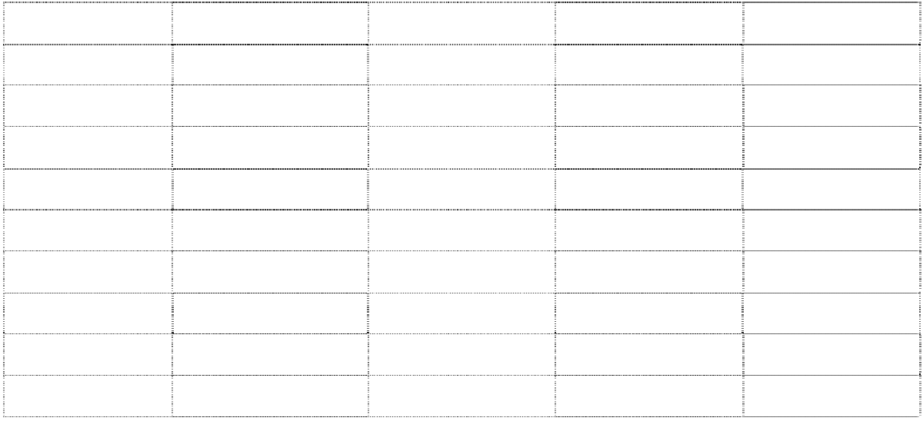

Phần 2. ĐÁP ÁN
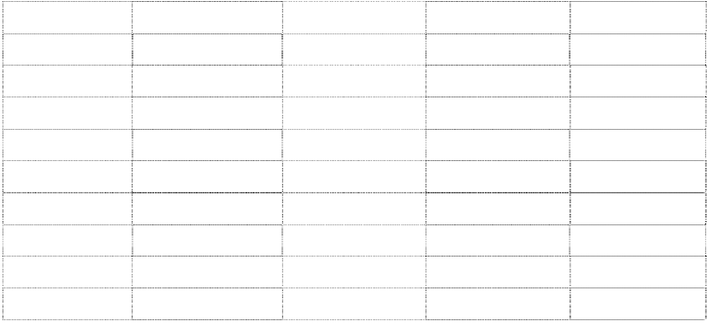

 |  | PRACTICE TEST 1
1. A | 11. B | 21. B | 31. B | 41. D
2. B | 12. D | 22. A | 32. B | 42. A
3. A | 13. A | 23. B | 33. B | 43. A
4. A | 14. B | 24. A | 34. D | 44. A
5. C | 15. B | 25. B | 35. C | 45. C
6. C | 16. D | 26. D | 36. B | 46. A
7. B | 17. C | 27. A | 37. B | 47. A
8. D | 18. B | 28. D | 38. B | 48. A
9. C | 19. A | 29. A | 39. C | 49. D
10. D | 20. B | 30. C | 40. A | 50. C
 |  | PRACTICE TEST 2
1. A | 11. A | 21. A | 31. C | 41. D
2. D | 12. B | 22. C | 32. A | 42. B
3. C | 13. D | 23. C | 33. B | 43. A
4. A | 14. C | 24. A | 34. C | 44. B
5. D | 15. A | 25. A | 35. B | 45. D
6. C | 16. A | 26. B | 36. B | 46. A
7. B | 17. B | 27. A | 37. D | 47. B
8. B | 18. B | 28. D | 38. A | 48. A
9. A | 19. D | 29. B | 39. B | 49. A
10. B | 20. C | 30. C | 40. C | 50. B


PRACTICE TEST 3
A
A
B
D
D
C
B
D
A
C
A
D
A
A
B
A
B
A
A
B
C
D
B
B
B
C
A
C
D
A
B
A
A
C
B
B
A
B
A
B
D
A
A
A
C
A
B
B
A
B


PRACTICE TEST 4
C
A
C
C
D
C
C
D
A
A
C
D
A
D
B
D
B
C
A
C
B
A
C
D
D
D
A
C
B
D
C
B
A
B
A
A
C
A
A
C
D
B
A
B
C
A
A
A
A
C

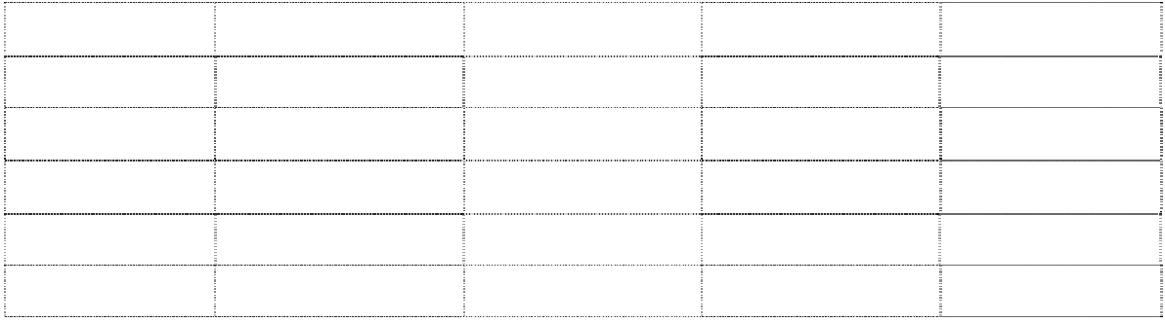
PRACTICE TEST 5
C
B
B
D
C
B
B
A
A
A
B
D
C
A
C
D
C
D
A
B
C
B
B
A
B
A
B
C
C
B

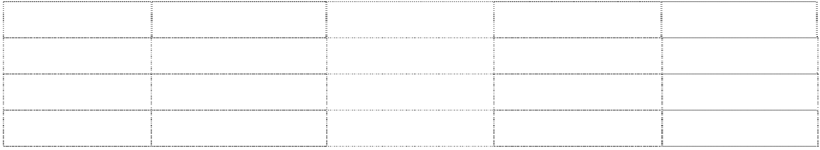
B
A
C
D
A
D
B
B
A
D
C
B
D
A
C
D
A
A
A
D

PRACTICE TEST 6
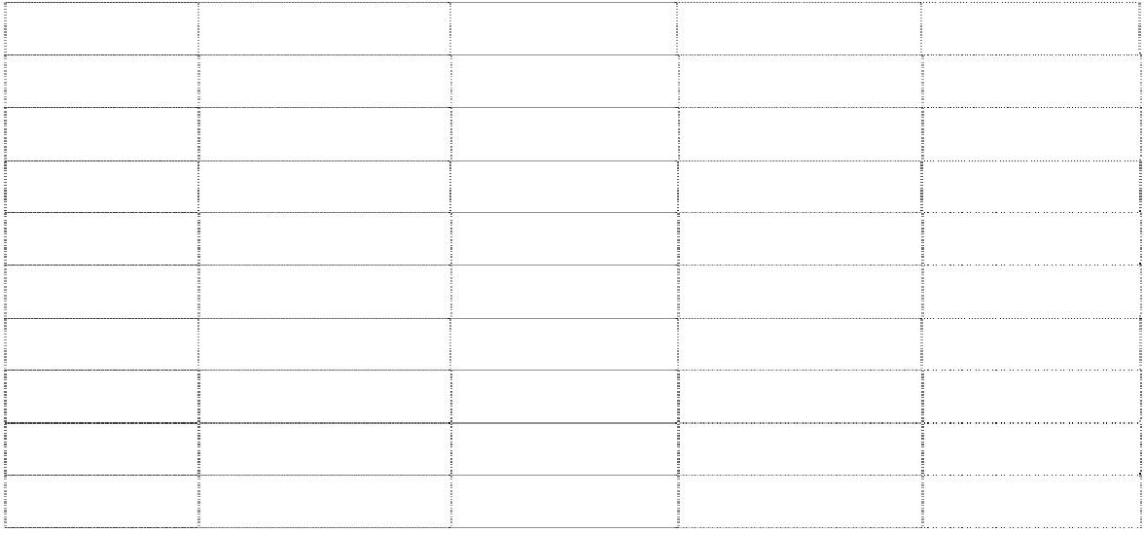
B
C
D
A
D
A
C
D
A
C
A
A
B
A
C
B
D
B
A
C
A
A
A
D
B
B
C
B
A
B
B
A
A
B
C
B
C
A
B
C
A
A
A
C
B
B
A
A
B
B

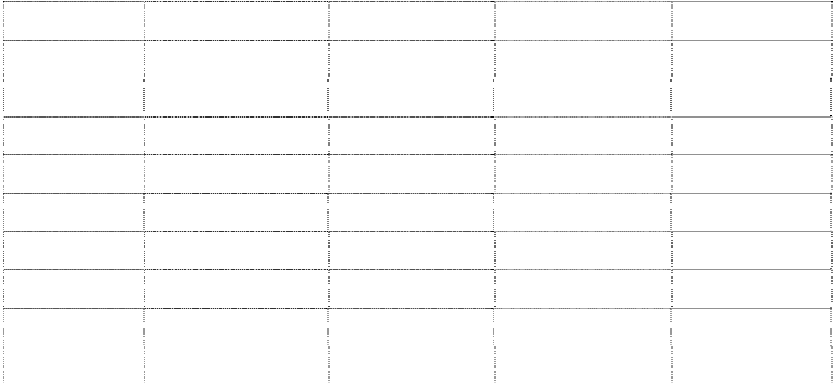
PRACTICE TEST 7
D
A
C
B
D
D
D
C
A
C
D
B
C
C
B
A
D
B
D
C
D
B
A
C
B
C
B
A
B
C
B
D
A
B
B
C
B
A
C
D
B
C
B
D
D
D
A
B
C
D

PRACTICE TEST 8


1. C | 11. A | 21. A | 31. B | 41. A
2. D | 12. A | 22. C | 32. A | 42. B
3. A | 13. B | 23. B | 33. A | 43. C
4. B | 14. B | 24. A | 34. A | 44. C
5. D | 15. A | 25. A | 35. B | 45. B
6. A | 16. A | 26. D | 36. B | 46. B
7. C | 17. A | 27. A | 37. D | 47. A
8. B | 18. C | 28. B | 38. A | 48. C
9. B | 19. C | 29. B | 39. B | 49. D
10. D | 20. A | 30. A | 40. C | 50. A

PRACTICE TEST 9
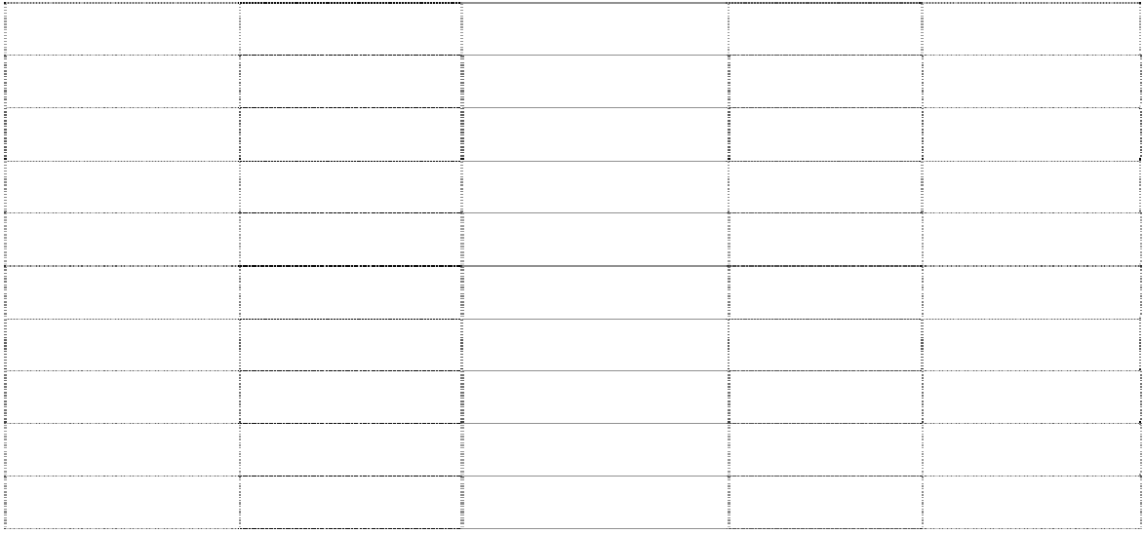

1. D | 11. A | 21. D | 31. A | 41. C
2. C | 12. A | 22. A | 32. C | 42. A
3. D | 13. A | 23. D | 33. A | 43. D
4. C | 14. B | 24. A | 34. D | 44. D
5. A | 15. A | 25. B | 35. B | 45. A
6. B | 16. B | 26. A | 36. A | 46. B
7. C | 17. D | 27. B | 37. B | 47. B
8. A | 18. B | 28. A | 38. B | 48. B
9. D | 19. A  Giaoandethitienganh.info | 29. C | 39. C | 49. C
10. B | 20. C | 30. B | 40. B | 50. A

PRACTICE TEST 10
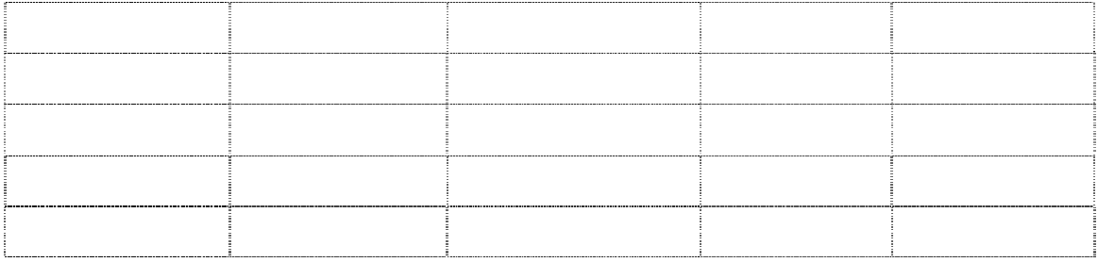

1. A | 11. A | 21. C | 31. B | 41. A
2. D | 12. B | 22. A | 32. A | 42. D
3. A | 13. C | 23. A | 33. A | 43. D
4. B | 14. D | 24. B | 34. B | 44. D
5. C | 15. B | 25. D | 35. A | 45. B

6. C | 16. B | 26. C | 36. B | 46. B
7. B | 17. C | 27. D | 37. C | 47. A
8. D | 18. B | 28. B | 38. B | 48. B
9. C | 19. A | 29. B | 39. A | 49. C
10. B | 20. B | 30. A | 40. C | 50. C

PRACTICE TEST 11
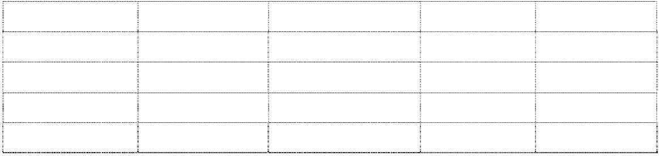

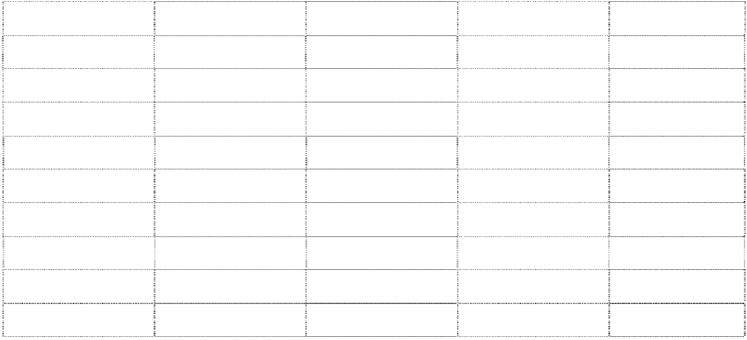

1. B | 11. C | 21. D | 31. A | 41. A
2. D | 12. C | 22. B | 32. A | 42. D
3. D | 13. A | 23. D | 33. A | 43. B
4. A | 14. B | 24. A | 34. C | 44. D
5. C | 15. D | 25. A | 35. B | 45. A
6. D | 16. B | 26. D | 36. A | 46. C
7. A | 17. D | 27. B | 37. B | 47. B
8. B | 18. B | 28. A | 38. B | 48. B
9. D | 19. B | 29. A | 39. A | 49. B
10. C | 20. C | 30. C | 40. C | 50. A  Giaoandethitienganh.info

PRACTICE TEST 12
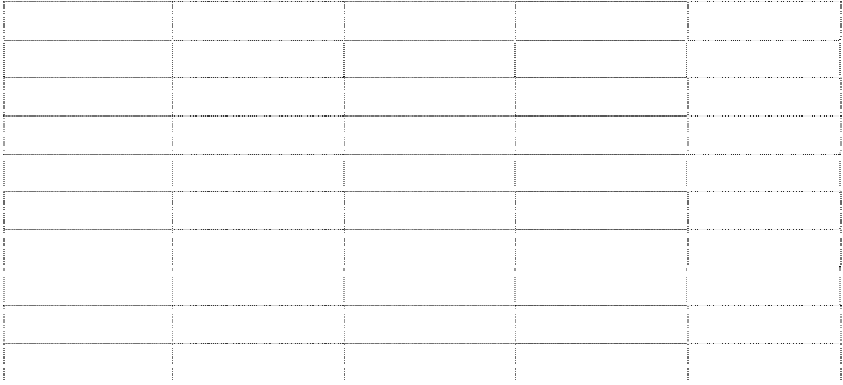

1. A | 11. D | 21. D | 31. A | 41. A
2. B | 12. B | 22. C | 32. B | 42. D
3. B | 13. B | 23. B | 33. A | 43. B
4. A | 14. C | 24. A | 34. C | 44. B
5. D | 15. A | 25. C | 35. A | 45. C
6. C | 16. B | 26. B | 36. D | 46. B
7. D | 17. C | 27. D | 37. C | 47. B
8. C | 18. D | 28. A | 38. A | 48. D
9. A | 19. C | 29. B | 39. B | 49. A
10. C | 20. A | 30. D | 40. D | 50. A

PRACTICE TEST 13
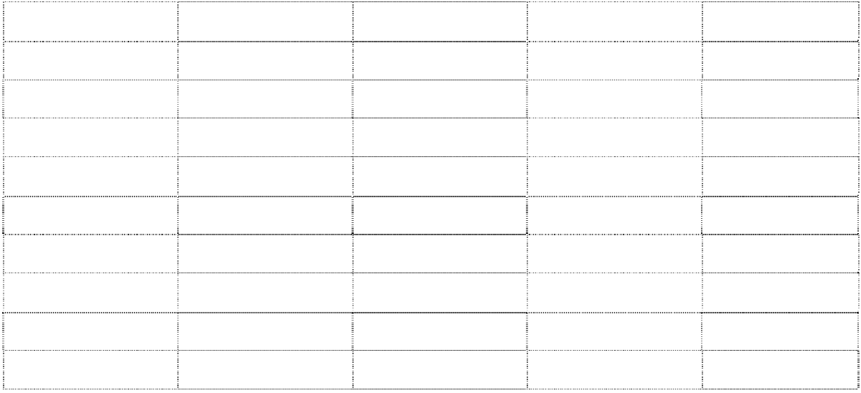

1. D | 11. C | 21. B | 31. C | 41. A
2. B | 12. D | 22. D | 32. A | 42. D
3. C | 13. A | 23. B | 33. C | 43. C
4. A | 14. D | 24. B | 34. D | 44. B
5. D | 15. D | 25. A | 35. A | 45. A
6. B | 16. C | 26. C | 36. B | 46. A
7. C | 17. D | 27. D | 37. C | 47. B
8. D | 18. C | 28. B | 38. A | 48. C
9. A | 19. B | 29. C | 39. A | 49. D
10. B | 20. A | 30. A | 40. D | 50. B

PRACTICE TEST 14


1. C | 11. D | 21. D | 31. D | 41. C
2. B | 12. A | 22. A | 32. B | 42. C
3. B | 13. D | 23. B | 33. B | 43. C
4. D | 14. C | 24. D | 34. C | 44. A
5. A | 15. A | 25. A | 35. C | 45. D
6. C | 16. C | 26. C | 36. D | 46. D
7. D | 17. B | 27. C | 37. A | 47. A
8. A | 18. D | 28. A | 38. D | 48. D
9. B | 19. A | 29. B | 39. B | 49. C
10. C | 20. C | 30. D | 40. A | 50. A

PRACTICE TEST 15
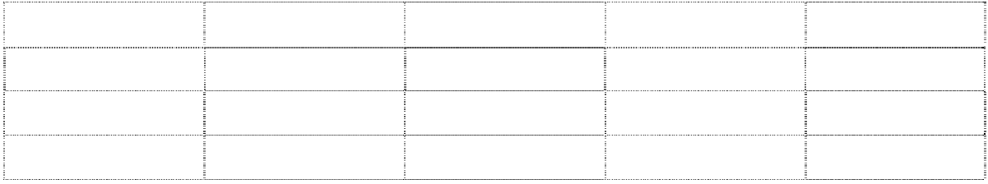

1. A | 11. B | 21. B | 31. A | 41. D
2. C | 12. D | 22. D | 32. A | 42. A
3. D | 13. A | 23. C | 33. C | 43. C
4. D | 14. A | 24. A | 34. B | 44. A



5. B | 15. B | 25. C | 35. A | 45. B
6. A | 16. A | 26. A | 36. D | 46. B
7. B | 17. C | 27. B | 37. B | 47. D
8. C | 18. B | 28. D | 38. C | 48. A
9. C | 19. D | 29. C | 39. A | 49. B
10. A | 20. A | 30. A | 40. B | 50. C

PRACTICE TEST 16
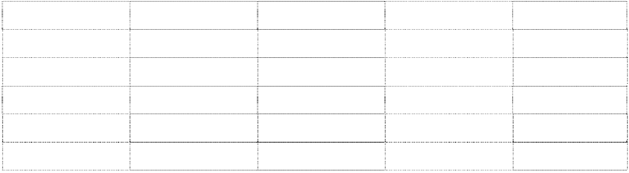



1. B | 11. A 21. B | 31. C | 41. A
2. A | 12. C 22. B | 32. B | 42. A
3. C | 13. B 23. A | 33. C | 43. B
4. D | 14. A 24. A | 34. B | 44. A
5. B | 15. C 25. D | 35. D | 45. B
6. A | 16. B 26. D | 36. A | 46. A
7. A | 17. A 27. A | 37. C | 47. D
8. A | 18. C 28. B | 38. C | 48. A
9. D | 19. D 29. A | 39. A | 49. B
10. A | 20. C 30. C | 40. C | 50. A
 | PRACTICE TEST 17
1. B | 11. B 21. C | 31. C | 41. C
2. D | 12. C 22. B | 32. A | 42. C
3. C | 13. A 23. A | 33. C | 43. B
4. B | 14. A 24. A | 34. A | 44. C
5. D | 15. A 25. B | 35. C | 45. B
6. A | 16. B 26. B | 36. C | 46. D
7. A | 17. A 27. A | 37. B | 47. D
8. A | 18. C 28. A | 38. B | 48. C
9. D | 19. A 29. D | 39. D | 49. A
10. A | 20. D 30. C | 40. A | 50. C


PRACTICE TEST 18
B
B
A
B
A
A
C
A
D
A
A
C
A
B
A
B
A
D
A
B
D
C
A
B
B
A
C
A
C
C
C
A
C
A
C
A
B
A
B
D
A
D
B
A
B
C
A
C
A
B

PRACTICE TEST 19

A
C
A
B
C
B
A
C
D
D
A
A
A
C
A
B
A
C
D
B
A
C
D
B
A
A
B
A
B
A
D
D
B
A
C
D
C
A
B
D
C
A
B
C
C
A
A
A
B
A

PRACTICE TEST 20
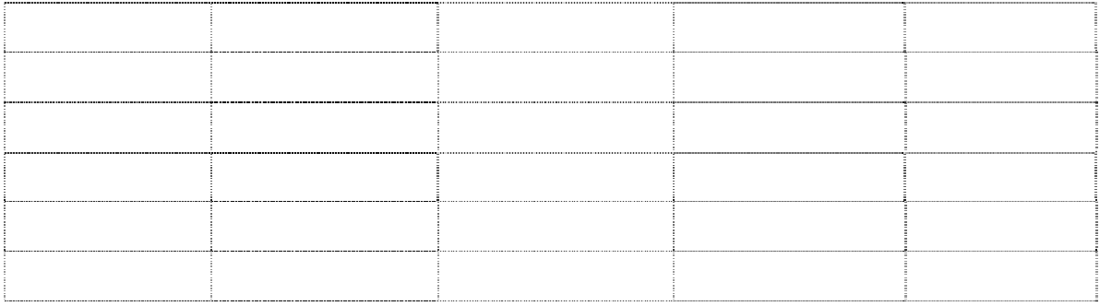
A
A
D
C
B
A
B
A
B
C
B
B
A
C
D
A
A
A
B
B
A
C
D
B
D
A
B
B
C
C
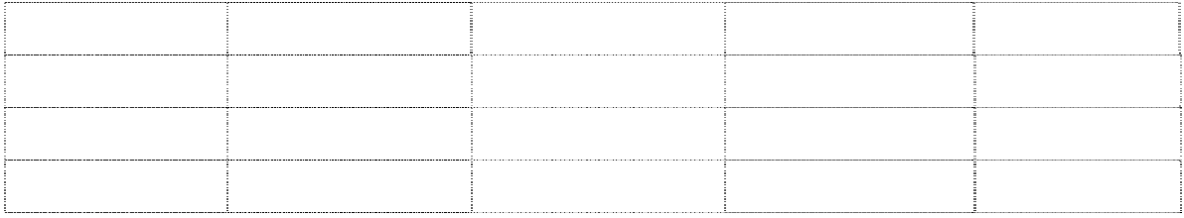

7. A | 17. C 27. B | 37. D | 47. C
8. B | 18. A 28. A | 38. A | 48. A
9. C | 19. D 29. D | 39. B | 49. B
10. A | 20. C 30. A | 40. C | 50. B
 | PRACTICE TEST 21
1. C | 11. C 21. B | 31. A | 41. D
2. D | 12. B 22. B | 32. D | 42. C
3. C | 13. C 23. B | 33. A | 43. B
4. B | 14. C 24. B | 34. A | 44. D
5. C | 15. B 25. B | 35. A | 45. A
6. D | 16. B 26. C | 36. D | 46. C
7. B | 17. A 27. D | 37. B | 47. D
8. B | 18. D 28. C | 38. B | 48. A
9. A | 19. A 29. A | 39. A | 49. A
10. D | 20. C 30. C | 40. C | 50. A

PRACTICE TEST 22
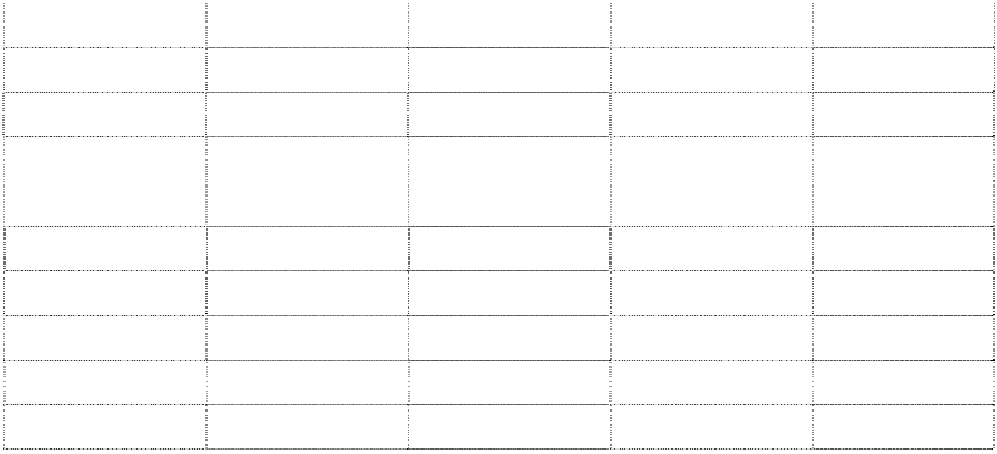

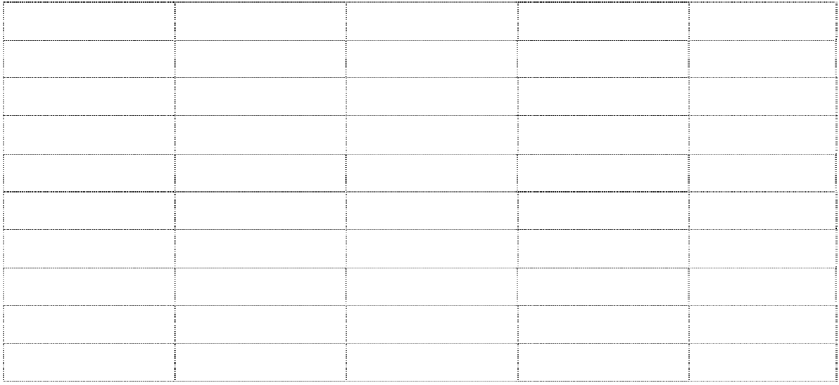

1. D | 11. C | 21. D | 31. A | 41. D
2. C | 12. C | 22. A | 32. D | 42. A
3. C | 13. A | 23. C | 33. A | 43. C
4. A | 14. C | 24. D | 34. A | 44. B
5. A | 15. D | 25. B | 35. A | 45. C
6. A | 16. D | 26. A | 36. B | 46. B
7. B | 17. C | 27. B | 37. C | 47. A
8. A | 18. B | 28. A | 38. A | 48. A
9. D | 19. C | 29. A | 39. C | 49. B
10. C | 20. C | 30. A | 40. B | 50. C

PRACTICE TEST 23


1. A | 11. B | 21. B | 31. C | 41. C
2. D | 12. D | 22. B | 32. C | 42. C
3. D | 13. D | 23. B | 33. B | 43. A
4. C | 14. A | 24. C | 34. B | 44. C
5. B | 15. C | 25. C | 35. C | 45. C
6. C | 16. A | 26. C | 36. C | 46. B
7. A | 17. A | 27. B | 37. A | 47. A
8. B | 18. A | 28. C | 38. A | 48. C
9. C | 19. A | 29. B | 39. B | 49. C
10. A | 20. A | 30. B | 40. A | 50. A

PRACTICE TEST 24
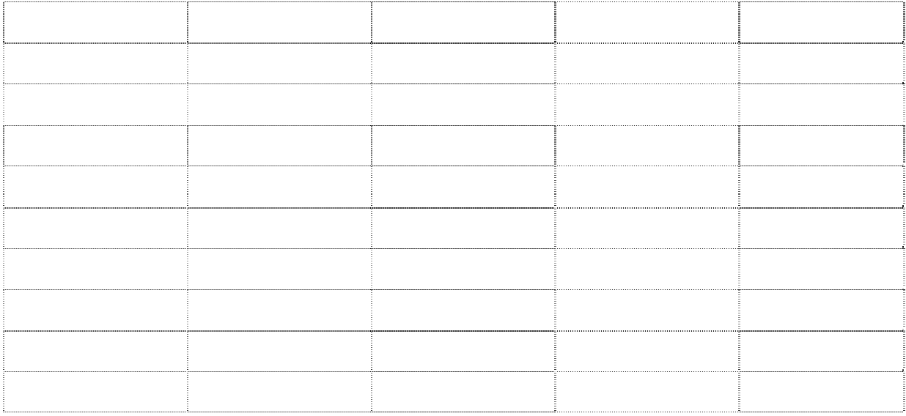

1. A | 11. D | 21. B | 31. D | 41. B
2. B | 12. A | 22. D | 32. A | 42. D
3. B | 13. A | 23. A | 33. C | 43. A
4. B | 14. B | 24. D | 34. B | 44. B
5. A | 15. B | 25. B | 35. C | 45. C
6. C | 16. B | 26. A | 36. A | 46. A
7. A | 17. B | 27. A | 37. B | 47. A
8. B | 18. C | 28. D | 38. C | 48. C
9. B | 19. B | 29. A | 39. D | 49. A
10. B | 20. B | 30. D | 40. A | 50. A

PRACTICE TEST 25
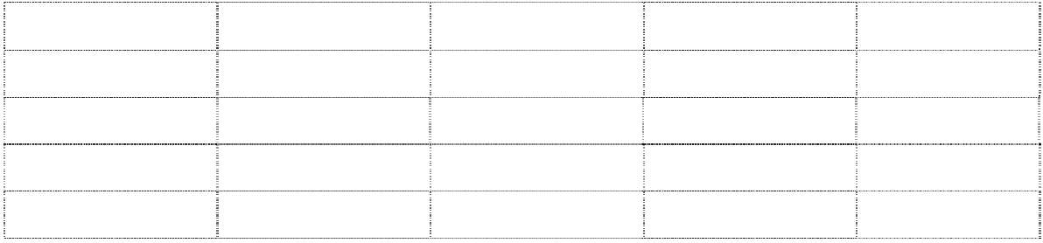

1. A | 11. C | 21. B | 31. A | 41. A
2. B | 12. C | 22. D | 32. C | 42. C
3. A | 13. A | 23. C | 33. B | 43. A
4. B | 14. B | 24. D | 34. A | 44. A
5. B | 15. B | 25. C | 35. C | 45. A

6. A | 16. C | 26. A | 36. D | 46. A
7. B | 17. C | 27. B | 37. B | 47. B
8. D | 18. A | 28. A | 38. D | 48. A
9. B | 19. A | 29. B | 39. A | 49. D
10. A | 20. A | 30. B | 40. A | 50. A

PRACTICE TEST 26
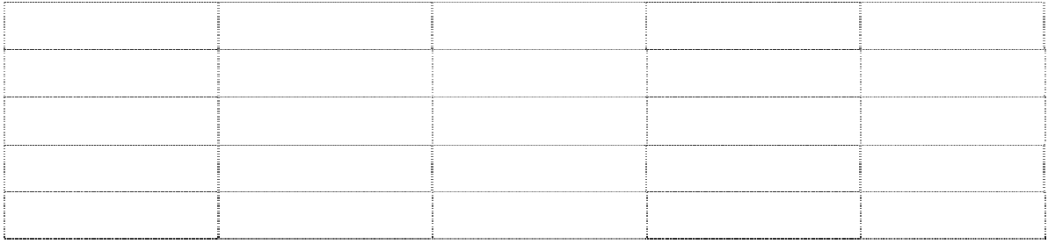

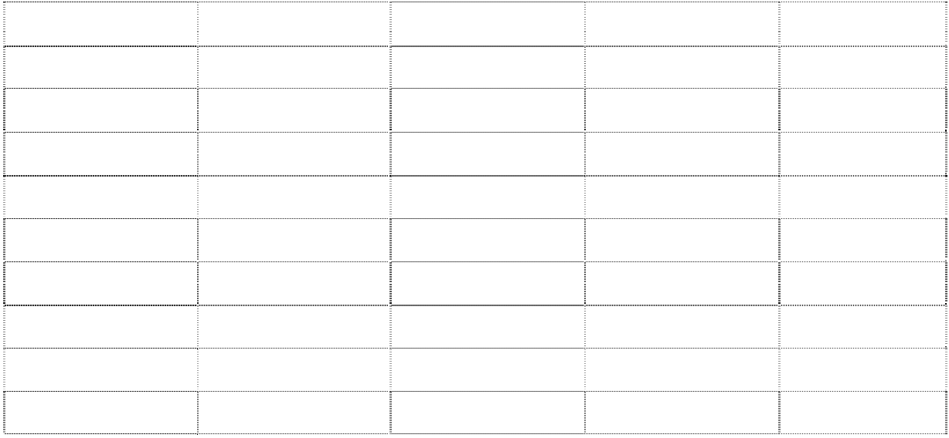

1. C | 11. B | 21. C | 31. B | 41. D
2. A | 12. A | 22. B | 32. B | 42. A
3. B | 13. B | 23. B | 33. A | 43. B
4. D | 14. C | 24. C | 34. B | 44. D
5. A | 15. C | 25. C | 35. D | 45. C
6. B | 16. B | 26. D | 36. C | 46. D
7. C | 17. D | 27. A | 37. B | 47. C
8. B | 18. C | 28. D | 38. D | 48. A
9. A | 19. C | 29. C | 39. D | 49. B
10. C | 20. D | 30. D | 40. B | 50. A

PRACTICE TEST 27


1. B | 11. D | 21. C | 31. A | 41. C
2. C | 12. B | 22. A | 32. B | 42. B
3. D | 13. C | 23. B | 33. A | 43. A
4. C | 14. C | 24. D | 34. A | 44. B
5. B | 15. D | 25. C | 35. D | 45. C
6. A | 16. D | 26. D | 36. B | 46. D
7. C | 17. B | 27. A | 37. A | 47. B
8. D | 18. D | 28. B | 38. A | 48. B
9. C | 19. A | 29. A | 39. A | 49. D
10. B | 20. B | 30. A | 40. D | 50. B

PRACTICE TEST 28
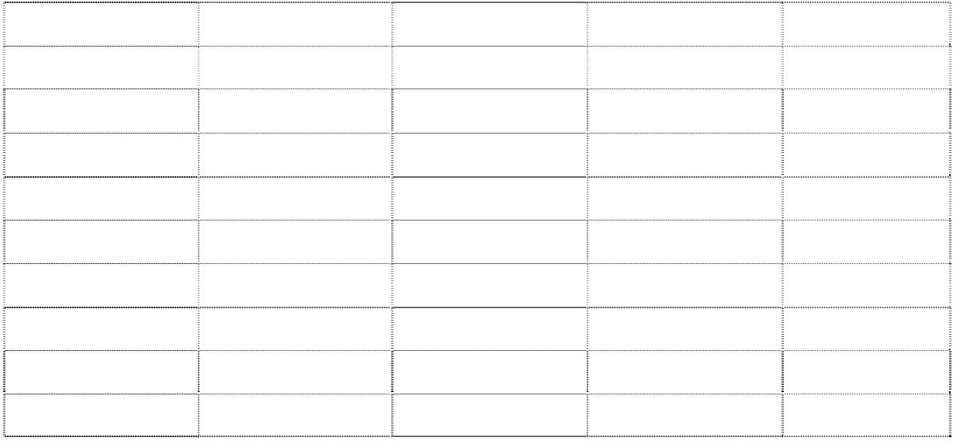

1. A | 11. C | 21. C | 31. C | 41. A
2. A | 12. B | 22. C | 32. A | 42. B
3. D | 13. A | 23. A | 33. A | 43. A
4. A | 14. A | 24. D | 34. A | 44. A
5. A  Giaoandethitienganh.info | 15. A | 25. C | 35. B | 45. B
6. D | 16. D | 26. A | 36. B | 46. A
7. C | 17. C | 27. D | 37. C | 47. D
8. B | 18. B | 28. B | 38. A | 48. D
9. A | 19. B | 29. B | 39. D | 49. C
10. C | 20. C | 30. A | 40. D | 50. A

PRACTICE TEST 29
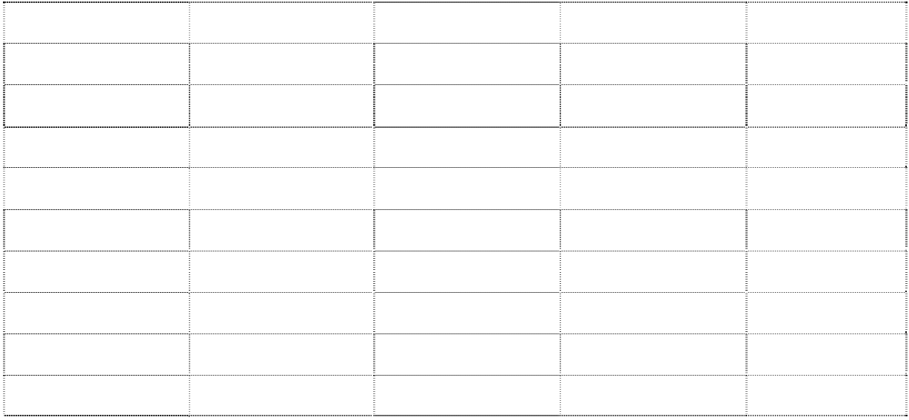

1. D | 11. D | 21. D | 31. A | 41. D
2. A | 12. C | 22. D | 32. C | 42. B
3. A | 13. C | 23. B | 33. D | 43. A
4. A | 14. B | 24. C | 34. C | 44. C
5. C | 15. D | 25. C | 35. C | 45. C
6. B | 16. B | 26. D | 36. A | 46. C
7. A | 17. B | 27. B | 37. B | 47. B
8. A | 18. A | 28. C | 38. C | 48. C
9. D | 19. B | 29. A | 39. A | 49. A
10. A | 20. C | 30. A | 40. C | 50. A

PRACTICE TEST 30


1. D | 11. B | 21. C | 31. D | 41. A
2. C | 12. C | 22. A | 32. B | 42. C
3. B | 13. A | 23. C | 33. A | 43. B
4. B | 14. B | 24. A | 34. A | 44. A
5. D | 15. D | 25. D | 35. C | 45. D
6. D | 16. D | 26. C | 36. A | 46. C
7. B | 17. A | 27. C | 37. C | 47. C
8. A | 18. D | 28. A | 38. A | 48. D
9. B | 19. B | 29. D | 39. B | 49. D
10. D | 20. A | 30. B | 40. D | 50. A

MỤC LỤC

Trang

Lời nói đầu 3
Phần 1. Đề ôn luyện 5
PRACTICE TEST 1 5
PRACTICE TEST 2 11
PRACTICE TEST 3 17
PRACTICE TEST 4 23
PRACTICE TEST 5 29
PRACTICE TEST 6 35
PRACTICE TEST 7 41
PRACTICE TEST 8 47
PRACTICE TEST 9 53
PRACTICE TEST 10 59
PRACTICE TEST 11 66
PRACTICE TEST 12 72
PRACTICE TEST 13 78
PRACTICE TEST 14 84
PRACTICE TEST 15 90
PRACTICE TEST 16 96
PRACTICE TEST 17 102
PRACTICE TEST 18 108
PRACTICE TEST 19 114
PRACTICE TEST 20 120
PRACTICE TEST 21 126
PRACTICE TEST 22 132
PRACTICE TEST 23 138
PRACTICE TEST 24 144
PRACTICE TEST 25 150
PRACTICE TEST 26 156
PRACTICE TEST 27 162
PRACTICE TEST 28 168
PRACTICE TEST 29 174
PRACTICE TEST 30 180
Phần 2. Đáp án 186

NHÀ XUẤT BẢN ĐẠI HỌC QUỐC GIA HÀ NỘI
16 Hàng Chuối – Hai Bà Trưng – Hà Nội
Điện thoại: Biên tập (024) 39714896
Quản lí xuất bản: (024) 39728806; Tổng biên tập: (024) 39715011
Fax: (024) 39729436

ChÞu tr¸ch nhiÖm xuÊt b¶n:
Gi¸m ®èc - Tæng biªn tËp ph¹m thÞ tr©m

Biªn tËp chuyªn m«n: lý tuyÕt nhung
Biªn tËp xuÊt b¶n: …………….. Söa bµi: ………………………. ChÕ b¶n: ...................................
Tr×nh bµy b×a: l−u chÝ ®ång

S¸ch liªn kÕt

H−íng dÉn «n tËp thi tuyÓn sinh vµo líp 10 THPT m«n tiÕng anh N¨m häc 2021 - 2022
(Dμnh cho häc sinh tØnh Th¸i B×nh)
Mã số: 2L-0000PT2021
In 3.000 bản, khổ 17 x 24cm tại Công ty CP In & Thương mại Trường An
Địa chỉ: Lô A2, CN1 cụm CN vừa và nhỏ Từ Liêm, P. Minh Khai, Q. Bắc Từ Liêm, Hà Nội Số xác nhận ĐKXB: 000-2021/CXBIPH/00-77/ ĐHQGHN, ngày 00/00/2021
Quyết định xuất bản số: 000 LK-XH/QĐ-NXB ĐHQGHN, ngày 00/00/2021 In xong và nộp lưu chiểu năm 2021.

