Unit 8 Test/Review
PART I. LISTENING (1.25 pts)
Listen to a talk about online shopping and decide if the following statements are True (T) or False (F).
STT | Statements | True (T) | False (F)
1 | You can buy both products and services when you shop online.
2 | Online shopping is a great way to save your time and money.
3 | When you return a product, the seller will pay for the shipping.
4 | Shopping online too much can make you become a shopaholic.
5 | There are exactly two ways to pay when you buy things online.

PART II. PRONUNCIATION (1.0 pt)
Task 1. Choose the word whose bold part is pronounced differently from the others.
6. A. space B. speciality C. staff D. spend
7. A. outstand B. waste C. respect D. honest
Task 2. Choose the word whose stress pattern is different from the others.
8. A. customer B. bargain C. market D. attract
9. A. convenience B. assistant C. specialty D. performance
PART III. LANGUAGE USE (2.5 pts)
10. In an open-air market, buyers can often __________ with the sellers to get a lower price.
A. bargain B. browse C. purchase D. complain
11. My mother loves this salad because it is made of __________ vegetables from our garden.
A. home-made B. home-grown C. on sale D. expensive
12. I cannot see the __________ on this T-shirt. How much does it cost?
A. specialty B. convenience C. price tag D. bargain
13. The supermarket in my neighbourhood __________ at 8 a.m. and closes at 10 p.m. every day.
A. open B. opens C. will open D. is opening
14. Look at the schedule! The bus for our field trip __________ at 9:00 tomorrow morning.
A. leaves B. leave C. will leave D. is leaving
15. My sister is a __________. She spends too much time and money shopping for clothes.
A. shop assistant B. shopaholic C. seller D. customer
16. I __________ buy things online, just once or twice a year. I prefer shopping at the mall.
A. always B. often C. rarely D. usually
17. Choose the best response to complete the following dialogue:
Customer: "I'm calling to make a complaint about the backpack I ordered last week."
Shop Assistant: "________________________"
Customer: "It's smaller than the one you advertised online, and the color is wrong."
Shop Assistant: "I'm sorry about that. We will send you another one right away."
A. What's the matter with it, sir?
B. I'm glad you like it.
C. How much is the backpack?
D. You should go to the convenience store.
Task 2. Choose the sentence (A, B, C or D) that is closest in meaning to the original one.
18. The art lesson starts at one o'clock this afternoon.
A. The art lesson is scheduled to start at one o'clock this afternoon.
B. The art lesson might start at one o'clock this afternoon.
C. We will start the art lesson at one o'clock this afternoon.
D. The art lesson started at one o'clock.
19. My mother never shops anywhere else but the supermarket.
A. My mother always shops at the supermarket.
B. My mother sometimes goes to the supermarket.
C. My mother rarely shops at the supermarket.
D. The supermarket is where my mother rarely goes.

PART IV. PRACTICAL SKILLS (1.0 pt)
20. What does this sign mean?
A. All items are half-price.
B. You can buy one and get one free.
C. The shop is closed for the holidays.
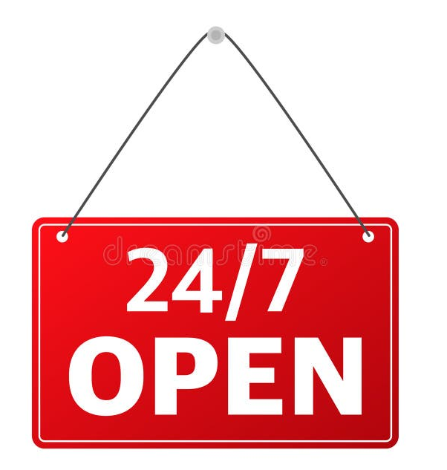
D. You need to pay double for the items.
21. What does this notice tell you about the shop?
A. The shop is open 24 hours a day, 7 days a week.
B. The shop is only open on weekends.
C. The shop closes at 7 p.m. every day.
D. The shop is open for 24 days in July.
Task 2. Read the announcement and choose the best answers.
NORTHWOOD SHOPPING CENTRE
Opening next month: 24 March
Location: 8 kilometres from city centre.
Facilities: More than 60 shops, 4 restaurants, 2 cafes, a cinema, and a playground for children.
Opening hours: 9:00 – 21:00 daily.
22. When will the Northwood Shopping Centre open?
A. Next month, on 24 March.
B. Every day from 9:00 to 21:00.
C. 8 kilometres from the city centre.
D. Today.
23. Which facility is NOT mentioned in the announcement?
A. Restaurants B. Cinema C. Swimming pool D. Playground
PART V. READING (2.25 pts)
Read the notice and choose the correct option A, B, C, or D to fill in each blank.
SUMMER BIG SALE!
Our annual summer sale starts this Friday! We offer a (24) ________ range of products from clothes to electronics. You can find many (25) ________ at our discount shops with prices up to 50% off. The sale only (26) ________ for three days, so don't miss it! Our friendly (27) ________ are always ready to help you find what you need.
24. A. wide B. small C. tall D. long
25. A. price tags B. bargains C. complaints D. schedules
26. A. goes B. stays C. lasts D. opens
27. A. shopaholics B. customers C. assistants D. viewers

Read the text and choose the correct answer A, B, or C.
Shopping centres attract a lot of customers, especially at the weekend. People go there for many reasons. Shopping centres offer a wide range of products to choose from. Customers can touch the products and try on clothes. This makes them feel more comfortable when they decide to buy something. However, people also go to shopping centres for entertainment. These centres often offer year-round free entertainment like live music and special performances. It is also a good way to relax because shopping centres offer free air conditioning and heating.
28. Why do people go to shopping centres?
A. Only for shopping. B. Only for entertainment. C. For many reasons.
29. What can customers do at a shopping centre before buying?
A. Bargain to get lower prices. B. Touch the products. C. Pay to watch live music.
30. Which kind of entertainment is NOT mentioned?
A. Fashion contests. B. Live music. C. Special performances.
31. The word "year-round" in the text is similar in meaning to _______.
A. always B. sometimes C. rarely
32. Why is a shopping centre a good place to relax?
A. Because it is always crowded. B. Because it is outdoors.
C. Because of the air conditioning and heating.
PART VI. ORDERING (0.5 pt)
Arrange the sentences to make a complete dialogue.
33. a. I'm sorry about that. I'll send you another one right away.
b. I'm calling to make a complaint about the backpack I ordered.
c. Well, it's smaller than the one you advertised online.
d. Can you tell me what is wrong with it, please?
A. b - d - c - a B. b - c - d - a C. c - b - d - a D. d - b - c - a
34. a. It leaves at 10:05 from the main bus station.
b. I want to go to Aeon Mall by bus tomorrow.
c. Great! I'll be there on time.
d. What time does the bus leave?
A. b - a - d - c B. d - a - b - c C. b - d - a - c D. a - b - d - c
PART VI. WRITING (1.5 pt)
35. My mother never misses an episode of the Junior Master Chef programme.
-> My mother always watches _______________________________________________.
36. The shuttle bus leaves every 15 minutes to take customers to the parking lot.
-> The shuttle bus schedule says that ___________________________________________.
37. I don't often buy things at the dollar store. (rarely)
-> I _____________________________________________________________________. 38. The big sale starts next Friday, according to the advertisement.
-> The advertisement says that the big sale ______________________________________.
Write a paragraph (100 - 150 words) about the advantages and disadvantages of online shopping.
________________________________________________________________________
________________________________________________________________________
________________________________________________________________________
________________________________________________________________________
________________________________________________________________________
________________________________________________________________________
________________________________________________________________________
________________________________________________________________________
________________________________________________________________________
________________________________________________________________________
________________________________________________________________________
________________________________________________________________________
________________________________________________________________________
________________________________________________________________________
________________________________________________________________________

DÀNH CHO GIÁO VIÊN (TRANSCRIPT & KEY)
Audio Script
"Online shopping is becoming very popular. You can buy a product or a service on a website. It helps you save time and money because you can compare prices easily. However, it has some disadvantages. If you return a product, you still must pay for the shipping. Also, it can make you become a shopaholic. When you shop online, you can pay in three ways: by cash, by credit card, or by using an e-wallet."
Answer Key:
- Listening: 1. T (buy a product or a service) 2. T (save time and money) 3. F (you still must pay for the shipping) 4. T (can make you become a shopaholic) 5. F (three ways: cash, credit card, e-wallet)
- Phonetics: 6. C (Âm /st/, các từ còn lại là /sp/) 7. C (Âm /sp/, các từ còn lại là /st/) 8. D (Trọng âm 2, các từ còn lại trọng âm 1) 9. C (Trọng âm 1, các từ còn lại trọng âm 2)
• Part III: 10.A | 11.B | 12.C | 13.B | 14.A | 15.B | 16.C | 17.A | 18.A | 19.A
• Part IV: 20.A | 21.A | 22.A | 23.C
• Reading: 24.A | 25.B | 26.C | 27.C | 28.C | 29.B | 30.A | 31.A | 32.C
• Ordering: 33.A | 34.C
35. My mother always watches every episode of the Junior Master Chef programme.
  - The shuttle bus schedule says that it leaves every 15 minutes...
  - I rarely buy things at the dollar store.
  - The advertisement says that the big sale starts next Friday.

MA TRẬN ĐỀ KIỂM TRA UNIT TEST (FORM 40 CÂU - 10 ĐIỂM)
Thời gian: 45 phút | Hệ số: 0.25 điểm/câu
Phần | Dạng bài cụ thể | Số câu | Câu số | Điểm số
I. LISTENING | Trắc nghiệm chọn đáp án đúng (A, B, C) | 5 | 1 - 5 | 1.25
II. PHONETICS | Phát âm (2) & Trọng âm (2) | 4 | 6 - 9 | 1.0
III. LANGUAGE USE | Từ vựng & Ngữ pháp (7) + Hội thoại khuyết (1) + Closest Meaning (2) | 10 | 10 - 19 | 2.5
IV. PRACTICAL SKILLS | Biển báo hình ảnh (2) + Thông báo/Quảng cáo ngắn (2) | 4 | 20 - 23 | 1.0
V. READING | Announcement Cloze (4) + Comprehension (5) | 9 | 24 - 32 | 2.25
VI. ORDERING | Sắp xếp câu thành hội thoại (Dialogue) | 2 | 33 - 34 | 0.5
VII. WRITING | Sentence Transformation (Viết lại câu tự luận) | 4 | 35 - 38 | 1.0
 | Paragraph Writing (Viết đoạn văn 100-150 từ) | 2 | 39 - 40 | 0.5
TỔNG CỘNG |  | 40 |  | 10.0

