**Video lesson: How languages evolve?**

**Task 1. Look at the photos from a TV programme about languages and discuss the questions.**

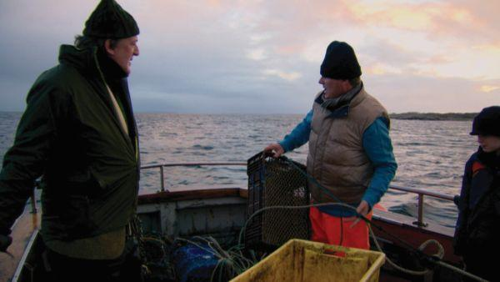 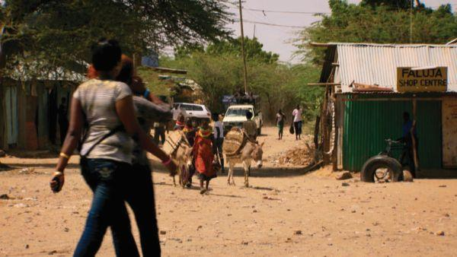

1. What countries could the photos be from?

2. What languages do you think are spoken there?

3. Are any small regional languages spoken in your country? If so, what are they?

4. Do you think it is important to keep them alive? Why?/Why not?

**Task 2. Watch the TV programme and give short answers to the questions.**

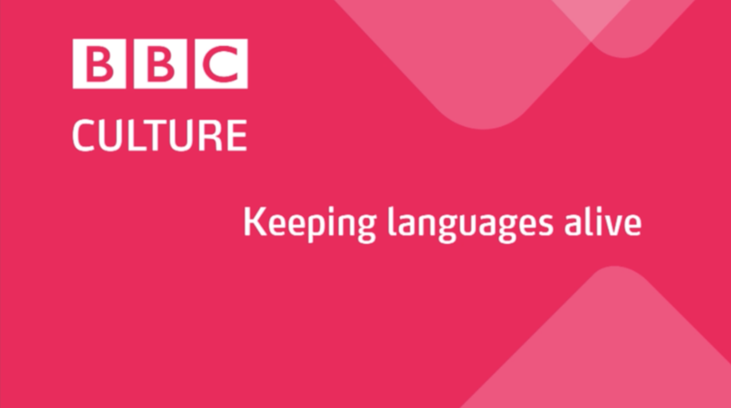

1. What languages are spoken in Ireland?

__________________________________________________________________________

2. How many local languages are spoken in Kenya?

__________________________________________________________________________

3. What is English used for in our global world?

__________________________________________________________________________

4. Do you think it is important to keep them alive? Why?/Why not?

__________________________________________________________________________

**Task 3. Watch the video again and complete each blank with one word and/or a number.**

1. There are ______________ of different languages in the world today.
2. English is spoken by ______________ of people.
3. English is studied as a second language by 1.5 ______________ learners.
4. ______________ people speak Irish.
5. The Irish language has ______________ words than English.
6. 35,000 children in Ireland go to ______________ primary schools.
7. The Turkana people use ______________ different languages.
8. In their own community, ______________ is their first choice.

**ANSWER KEY**

**Task 1.**

*Students’ own answers.*

**Task 2.**

1. What languages are spoken in Ireland?

*English and Irish*

2. How many local languages are spoken in Kenya?

*three: Turkana, English, Swahili*

3. What is English used for in our global world?

*education, communication, work*

4. Do you think it is important to keep them alive? Why?/Why not?

*Yes, so that local communities and traditions can survive too*

**Task 3.**

1. thousands  2. millions 3. billion

4. 80,000/ 80 thousand 5. fewer 6. Irish

7. three 8. Turkana

***AUDIO SCRIPT (Video 29)***

**Keeping languages alive**

There are thousands of different languages in the world today. Some, like English, are spoken by millions of people. English is now studied as a second language by around one and a half billion learners. It is often seen as a kind of ‘world language’, but there’re lots of smaller, regional languages around the world too. Can they continue to exist now that English is so popular?

This is the west coast of Ireland. English is the most common language in Ireland, but in this part of the country people use the ancient Irish language, too.

Stephen Fry has come on this fishing boat to meet some Irish speakers.

‘About 80,000 people still speak this language. It’s taught in school, and they have very proud Irish speakers all around us. I mean in Donegal and in Cork. But it’s here in Connemara Galway that we find probably the majority of Irish speakers.’

‘Irish speaking is a very old language. Yah. It doesn’t have as many words as the English language, but its descriptions are very, very good.’

[teacher speaking Irish in the classroom]

Thirty-five thousand children in Ireland go to Irish-language primary schools. There are also some secondary schools where all the subjects are taught in Irish. These children can all speak and use English too, but the Irish language is part of their culture and their identity. People feel connected to their local languages. They use them to pass on traditions from generation to generation.

In other countries, many languages are used every day. In Kenya, for example, English and Swahili are the official languages, but there are over 60 local languages, too.

The Turkana people use three different languages in their daily lives: their own Turkana language …,

English for the older children at school and … Swahili in the towns. But in their own community, the Turkana language is their first choice.

In our globalised world, English is becoming more and more important for education, communication and work. But keeping local languages alive is important if we want local communities and their traditions to survive too.