|  |  |
| --- | --- |
| **PHÒNG GD&ĐT NAM SÁCH**  **TRƯỜNG TH&THCS PHÚ ĐIỀN**    **ĐỀ CHÍNH THỨC**  *(Đề thi gồm 04 trang)* | **ĐỀ KIỂM TRA CUỐI HỌC KỲ II**  **NĂM HỌC 2024-2025**  **MÔN:** **Tiếng Anh – LỚP 9**  **Mã đề: 101**  *Thời gian làm bài: 60’(Không kể thời gian giao đề)* |

**Họ và tên: Nguyễn Thị Tám Tên Zalo: Tám Nguyễn**

**Sdt Zalo: 0989788195 Email: coicodon2412948@gmail.com**

**I. LISTENING**

**Listen to 5 short conversations TWICE then choose the correct answer for each question. (1 point )**

**Question 1**. What is the man going to take to the repair shop?

1. CD player B. TV C. lamp

**Question 2.** How will Nancy and Joe get to the sports center?

1. by bus B. walk C. by car

**Question** **3.** How much is the prize for the competition?

1. 100 pounds B. 200 pounds C. 300 pounds

**Question 4.** What will the weather be like tomorrow lunchtime?

1. rainy B. foggy C. windy

**Listen to** **a conversation** twice **then decide whether the statements are True (T) or False (F). (1 point)**

|  |  |
| --- | --- |
| **Statements** | **T/F** |
| **Question 5**. The woman can get on boat at the bridge. |  |
| **Question 6**. There is only a boat trip per day at 2 p.m. |  |
| **Question 7**. The boat goes to Aldford. |  |
| **Question 8**. On boat, the woman can buy drinks and ice cream. |  |

**II. PRONUNCIATION**

**Find the word which has a different sound in the part underlined. (0.5 points)**

**Question** **9**. A. affect B. habitat C. climate D. vitual

**Question** **10**. A. estimate B. exchange C. essential D. ecological

**Choose the word which has a different stress pattern from the others. (0.5 points)**

**Question** **11**. A. reserve B. glassland C. landform D. flora

**Question 12**. A. protect B. presuade C. cover D. observe

**III. GRAMMAR AND VOCABULARY**

**Choose the best option to complete each sentence. (1.75 points)**

**Question 13.** Our teacher suggests that we _____ waste paper for the school’s recycling scheme.

|  |  |  |  |
| --- | --- | --- | --- |
| A. collected | B. collecting | C. should collect | D. to collect |

**Question 14**.The book _____ I read yesterday was written by Jack London.

|  |  |  |  |
| --- | --- | --- | --- |
| A. what | B. who | C. when | D. which |

**Question 15.** Pu Luong is a _____ in Viet Nam. It has beautiful limestone mountains with

high biodiversity.

|  |  |  |  |
| --- | --- | --- | --- |
| A. grassland area | B. natural habitat | C. disaster area | D. nature reserve |

**Question 16**. You can carry your _____ laptop with you from class to class because it's small and light.

|  |  |  |  |
| --- | --- | --- | --- |
| A. virtual | B. portable | C. aluminium | D. wireless |

**Question 17**. My father advised not _____ digital devices before bedtime

|  |  |  |  |
| --- | --- | --- | --- |
| A. to using | B. to use | C. used | D. using |

**Question 18.** Nobody could hear her _____ she spoke too quietly.

|  |  |  |  |
| --- | --- | --- | --- |
| A. although | B. because | C. because of | D. in spite of |

**Question 19**. I always wanted a _____ job because I think I would get bored if it wasn't.

|  |  |  |  |
| --- | --- | --- | --- |
| A. challenging | B. worrying | C. boring | D. tiring |

**Read the following advertisement/ announcement and mark the letter A, B, C, or D on your answer sheet to indicate the correct option that best fits each of the numbered blanks from 20 to 22. (0.75 points)**

|  |
| --- |
| **DREAM OF BECOMING A CHEF?**  Join our prestigious Culinary Institute and start your journey today! Our programs are designed for aspiring chefs of all levels. Discover the art **(20)** _____ cooking with expert chefs. Hands-on experience in a professional kitchen. Flexible schedules for **(21)** _____ busy learners. In addition, **(22)** _____ aid available for eligible students.  *For more information or to apply, contact us:*  Phone: 555-012  Email: info@culinaryinstitute.edu  Visit: 45 Gourmet Avenue, Flavor Town |

|  |  |  |  |  |  |
| --- | --- | --- | --- | --- | --- |
| **Question 20.** | A. of | B. on | C. in | | D. by |
| **Question 21.** | A. a | B. an | C. the | D.Ø (no article) | |
| **Question 22.** | A. Financial | B. Finance | C. [Financing](https://www.ldoceonline.com/dictionary/finance#finance__4) | | D. [Financially](https://www.ldoceonline.com/dictionary/financial) |

**IV. READING**

**Read the following passage and choose the letter A, B, C, or D to indicate the correct option that best fits each of the numbered blanks from 23 to 27. (1.25 points)**

Television is an invention of the 20th century. It has been so popular that now we can’t imagine what life (23)______ like if there were no television. Television is a major (24)______ of communication and entertainment. It brings pictures and sounds from around the world into millions of homes. Television viewers can see and learn about people, places and things in far away lands. Television widens our knowledge by introducing us to new ideas (25)______ may lead us to new hobbies and recreations. In addition to the news, television provides us with a variety of programs that can satisfy every taste. Most people now seem to like (26)______ their evenings watching television. It is more convenient for them to stay at home watching television (27)______ to go out for amusement elsewhere.

**Question 23. A.** would be **B.** will be **C.** is **D.** was

**Question 24. A.** way **B.** kind **C.** mean **D.** sort

**Question 25. A.** whom **B.** which **C.** who **D.** what

**Question 26. A.** spent **B.** spending **C.** spend **D.**to spend

**Question 27. A.** than **B.** to **C.** as **D.** and

**Read the following passage and choose the letter A, B, C, or D to indicate the correct answer to each of the questions from 28 to 32. (1.25 points)**

The two main advantages of developed tourism industry are boost in country’s economy and a large number of new job openings for the local people. Firstly, tourists spend money on a wide range of services, including hotels, amusements, transportation, food and medical services. This way, tourism yields an additional income, greatly supporting the country’s economy. Secondly, tourism increases the level of employment by bringing new jobs. For instance, the influx of tourists results in a larger demand in restaurant workers, tour guides, hotel staff and employees of retail services, exhorting business owners to hire more people for these positions.

But tourism also has some major disadvantages like destruction of popular tourist destinations and development of illegal economic activities. Ancient buildings, temples and monuments struggle to **cope with** a vast amount of visitor’s traffic and get damaged. Also, the large number of tourists can cause environmental problems. For instance, when places of interest are overcrowded, natural resources often become overexploited. What’s more, the presence of a considerable number of tourists with a lot of money to spend, and often carrying valuables such as cameras and jewelry, increases the attraction for criminals and brings with it activities like robbery and drug dealing. However, proper hospitality management and correct usage of tourism revenue by the local government can eliminate these disadvantages.

**Question** **28**. What is the passage about?

A. The advantages of tourism.

B. The disadvantages of tourism.

C. The advantages and disadvantages of tourism.

D. Environmental problems.

**Question** **29**. How many main advantages does the writer mention?

A. three B. two C. five D. four

**Question** **30.** Which following word has the closest meaning to “**cope with**”?

A. put off B. turn down C. deal with D. take off

**Question** **31**. Which following information in the passage is **not true**?

A. Tourism provides a large number of new jobs for the local people.

B. Tourism can increase the attraction for criminals.

C. Tourists spend money on a wide range of services, including hotels, amusements, transportation, food and medical services.

D. The local government can never eliminate these disadvantages of tourism.

**Question** **32**. Based on the passage, which of the following is a way tourism can negatively impact popular tourist destinations?

A. Increased job opportunities for local people

B. Boost in the country’s economy

C. Development of illegal economic activities

D. Additional income from tourists spending money

**V. WRITING**

**Choose the best sentence that can be combined from the two given.** ***(0.5 points)***

**Question** **33**. People live in Scotland. They are called Scots.

A. People live in Scotland who are called Scots.

B. People live in Scotland whom are called Scots.

C. People whom are called Scots, live in Scotland.

D. People who are called Scots, live in Scotland.

**Question** **34**. “You should take better care of your health,” said Tom’s mother.

A. Tom’s mother promised to take better care of his health.

B. Tom’s mother suggested he take better care of his health.

C. Tom’s mother required him to take better care of his health.

D. Tom’s mother advised him to take better care of his health.

***Finish each of the following sentences in such a way that it means the same as the sentence printed before it. (0.5 point)***

Question 35. “ Are you interested in the natural wonders of your country?” David asked me.

* David asked me ...................................................................................................

Question 36. Although he makes great efforts, he still failed to control his violent temper.

* Despite ................................................................................................................

***Read the following sign or notice and mark the letter A, B, C or D on your answer sheet to indicate the correct answer to each of the following questions.***

**Question 37:** What does the sign say?

***Read the following sign or notice and mark the letter A, B, C or D on your answer sheet to indicate the correct answer to each of the following questions.***

**Question 29:** What does the sign say?

|  |  |
| --- | --- |
|  | 1. Anyone, including visitors and staff, can park here without restrictions. 2. Only employees or staff members are allowed to park in these spaces 3. Parking is not allowed in this area under any circumstances 4. The parking area is open to all people, without any specific rules |

**Question 30:** What does the notice say?



1. You must have permission to use the phone in this area
2. You may not turn off your phone if you are not using it
3. Cell phones are only for emergency use here
4. Cell phones must be turned off or silenced in this area.

***Mark the letter A, B, C or D on your answer sheet to indicate the correct answer to each of the following questions 17.***

1. Finally, I would buy a motorcycle for my sister. She has had to ride her old bicycle since she was 15.
2. Do you think winning the lottery would make you happy? If I won it, I could do something easily.
3. Secondly, I would have our old house rebuilt. My parents, my sister and I have been living in there fore more than 40 years and it is downgraded
4. First of all, I would donate half of the money to the orphanages in my little hometown.
5. b-c-a-d B. b-d-c-a C. b-c-d-a D. b-d-a-c

***Question 18. Choose the sentence that most appropriately ends the text (in question 17)***

1. To sum up, I would use the money to help my family with the satisfaction of basic needs
2. To sum up, I think that money can not buy basic things for my family
3. To sum up, people shouldn’t look forward to lottery
4. To sum up, we should win lottery as it brings lots of money for us.

**------ THE END -----**

|  |
| --- |
| **HƯỚNG DẪN CHẤM ĐỀ KIỂM TRA CUỐI HỌC KÌ II**  **NĂM HỌC: 2024-2025**  **MÔN: TIẾNG ANH- LỚP 9** |

**I. LISTENING**

**Listen to the recording and choose the letter A, B, C, or D to indicate the correct answer to each of the following questions. (You will hear the recording TWICE.) (1.0 point)**

1C 2B 3B 4C

**Listen to the recording and state whether the statements below are true (T) or false (F). (You will hear the recording TWICE.) (1.0 point)**

5. T 6. F 7. T 8. T

**II. PRONUNCIATION (3.5 points)**

**Choose the letter A, B, C, or D to indicate the word whose underlined part differs from the other three in pronunciation in each of the following questions. (0.5 point)**

9B 10A

**Choose the letter A, B, C, or D to indicate the word that differs from the other three in the** **position of the primary stress in each of the following questions. (0.5 point)**

11A 12C

**III. GRAMMAR AND VOCABULARY**

13C 14D 15D

16B 17D 18B 19 A

Read the following advertisement / school announcement and choose the letter A, B, C, or D to indicate the correct option that best fits each of the numbered blanks from 20 to 22. (0.75 point)

20C 21D 22A

**IV. READING**

Read the following passage and choose the letter A, B, C, or D to indicate the correct option that best fits each of the numbered blanks from 23 to 27. (1.25 points)

23. A 24. C 25. B 26. B 27. A

Read the following passage and choose the letter A, B, C, or D to indicate the correct answer to each of the questions from 28 to 32. (1.25 points)

28. C 29. B 30. C 31. D 32. C

**V. WRITING**

***Finish each of the following sentences in such a way that it means the same as the sentence printed before it. (1.5 points)***

Question 35. “ Are you interested in the natural wonders of your country?” David asked me.

* David asked me **if I was interested in the natural wonders of my country.**

Question 36. Although he makes great efforts, he still failed to control his violent temper.

* Despite **making great efforts, he still failed to control his violent temper.**

***Read the following sign or notice and mark the letter A, B, C or D on your answer sheet to indicate the correct answer to each of the following questions.***

**Question 37:** What does the sign say?

|  |  |
| --- | --- |
|  | 1. Anyone, including visitors and staff, can park here without restrictions.  1. Only employees or staff members are allowed to park in these spaces 2. Parking is not allowed in this area under any circumstances 3. The parking area is open to all people, without any specific rules |

**Question 38:** What does the notice say?

1. You must have permission to use the phone in this area
2. You may not turn off your phone if you are not using it
3. Cell phones are only for emergency use here
4. Cell phones must be turned off or silenced in this area.

### 39. Mark the letter A, B, C or D on your answer sheet to indicate the correct answer to each of the following questions 17.

1. Finally, I would buy a motorcylce for my sister. She has had to ride her old bicyle since she was 15.
2. Do you think winning the lottery would make you happy? If I won it, I could do something easily.
3. Secondly, I would have our old house rebuilt. My parents, my sister and I have been living in there fore more than 40 years and it is downgraded
4. First of all, I would donate half of the money to the orphanages in my little hometown.

A. b-c-a-d B. b-d-c-a C. b-c-d-a D. b-d-a-c

### Question 40. Choose the sentence that most appropriately ends the text (in question 39)

* 1. To sum up, I would use the money to help my family with the satifastion of basic needs
  2. To sum up, I think that money can not buy basic things for my family
  3. To sum up, people shouldn’t look forward to lottery
  4. To sum up, we should win lottery as it brings lots of money for us.

**(Audio source: KET 6 – TEST 4 – PART 1 )**

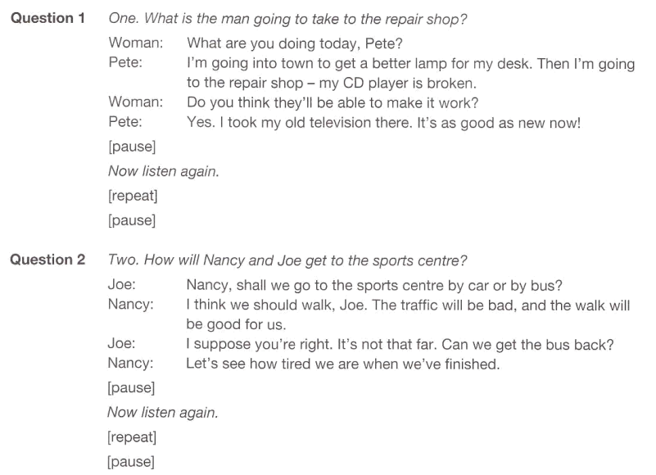

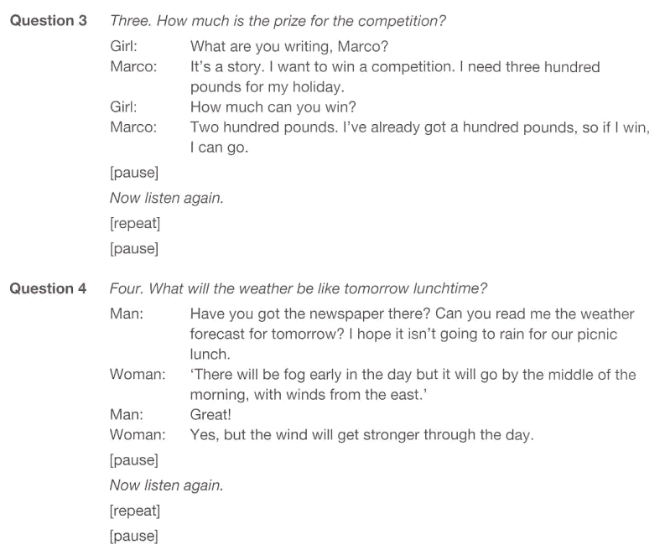

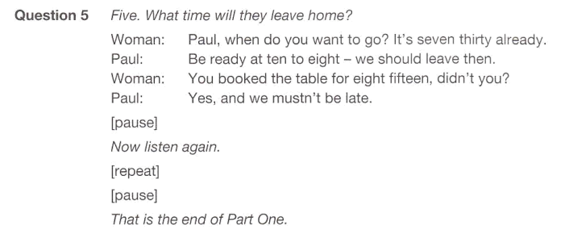

**(Audio source: KET 6 – TEST 4 – PART 4 )**