Date of preparing: ………………………………….
Date of teaching: ………………………………….

Period……
UNIT 9: HOUSES IN THE FUTURE
Lesson 2 - Part 1 (Page 73) - Vocabulary and Reading

I. OBJECTIVES
By the end of the lesson, Ss will be able to…
1. Knowledge
- describe similarities and differences between homes now and in the future
- discuss and choose smart devices for homes in the future
- get someone’s attention into reading passage and answer the answers
2. Ability
- improve their English skills
- develop the ability to communicate and cooperate with their partners, to self - study, to solve problems and other skills
- distinguish the differences and similarities between homes now and in the future
3. Quality
- have a positive attitude in English language learning so that they actively participate in all classroom activities
- express the reasons for their homes in the future
II. TEACHING AIDS AND LEARNING MATERIALS.
Lesson plan, PPT slides, student’s book, workbook, notebook, personal computer (if any), projector/TV, speakers, DCR & DHA on EDUHOME, handouts…
III. PROCEDURES
A. Warm up: (5’)
a) Objective: To set the scene for the new lesson
b) Content: Introduction of new words about the topic
c) Product: to understand and have general ideas about the topic
d) Competence: Collaboration, communication, critical thinking and creativity
e) Organization of the activity:
Teacher’s activities | Students’ activities
- Give Ss some pictures of smart devices such as smartphone, drone, robot, …  - Ask Ss to work in groups of 4 to choose the devices they have and would like to have in their homes.  - Ask Ss to find others having the same pictures, and discuss the reasons.  - Lead to new topic - Unit 9: Houses in the future. – Lesson 2. | - Look at the pictures.  - Work in groups.  - Find others having the same pictures and discuss the reasons. (Ss can give any reasons they think are reasonable)

B. New lesson (35’)
- Activities 1: New words (8’)
a) Objective: to learn new vocabulary
b) Content: New words (page 73).
c) Products: Ss can learn the new words and know how to pronounce them correctly
d) Competence: Communication, collaboration, analytical & synthesizing skills
e) Organization of the activity:
Teacher’s activities | Ss’ activities
a. Number the pictures using the definitions. Listen and repeat.  - Show the Powerpoint slides/ DCR with the pictures on them to elicit Ss to the new words.  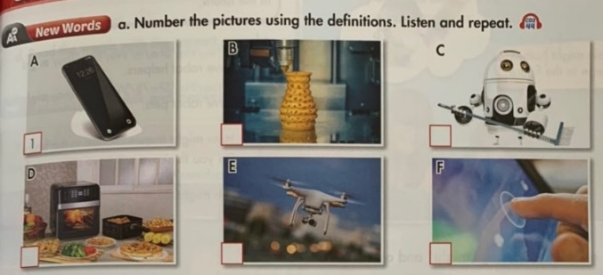  - Ask Ss to guess the names and uses of these things.  - Demonstrate the activity using the example.  + A smart device, like a TV or a mobile phone, is a machine with a computer inside it.  - Have Ss number the pictures.  - Divide the class into pairs and has them check their answers with their partners.  - Check answers as a whole.  - Play audio and have Ss listen and repeat.  - Give feedback | - Observe the pictures and guess the names and uses of smart devices.  + a smartphone (n)  + robots (n)  + …  - Listen to audio and number the pictures.  - Work in pairs to check the answers.  Expected answers:  A.1; B.4; C.6; D.5; E.2; F.3  - Practice new words  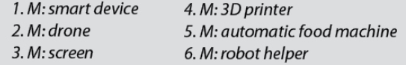  - Listen and repeat.

- Activity 2: Speaking Skill (7’)
a) Objective: to practice the vocabulary presented
b) Content: Working in pairs to say what smart devices they have at their home
c) Products: Ss can practice what they have learned in communication
d) Competence: Collaboration, communication, presentation, creativity
e) Organization of the activity:
Teacher's activities | Ss' activities
- Say what smart devices you have in your home.  + Option 1:  - Set the scene and gives some examples for Ss to talk about smart devices you have in my home.  Example: T presents a smart phone and says  + I have a smart phone.  - Divide the class into pairs.  - Have pairs say what smart devices they have in their homes.  - Check some pairs, gives comments.  + Option 2:  - Have pairs say what smart devices they would like to have in their homes.  - Encourage Ss to give more ideas/reasons.  - Set a mode: “I’d like to have an automatic food machine because we don’t have to spend much time preparing meals. And you?”  - Have some pairs share their ideas with the class.  - Checks some pairs, give comments and corrects. | - Listen to the T carefully  - Work in pairs, say what smart devices they have in their homes.  - Listen to the T.  - Share their ideas with the class.  - Works in pairs (discuss and give advice)  - Present in front of the class

- Activity 4: Reading Skill (15’)
a) Objective: to improve the reading comprehension, to see how target language is used in the reading context
b) Content: A reading text about homes in the future.
c) Products: Ss can practice reading for main ideas and for details.
d) Competence: Collaboration, communication, analytical and synthesizing skills
e) Organization of the activity:
Teacher's activities | Ss' activities
Reading:  a. Read the article about homes in the future. Is Professor Rendall excited about the future?  - YES / NO  - Ask Ss to read the text individually.  - Have the whole class read the text.  - Have Ss answer the question by circle “Yes” or “No”  - Check answer as a whole class.  - Ask Ss to present the reasons why their answer is Yes.  - Give feedback  b. Read the text again and answer the questions.  - Have Ss look at the questions  - Help Ss with some vocabularies (if necessary)  - Ask Ss to read the article and answer the questions.  - Check answer as a whole class.  - Give feedback. | - Ss read the text individually.  - Read the text as a whole class.  - Share their answers with the partner.  - Check answers as a whole class.  Expected answer: Yes  - Present their answers.  - Look at the questions carefully.  - Get some new words.  + be ready in seconds: (V phr)  + delivery (n)  - Read the article and answer the questions.  - Do the task and share their answers with partners/ check answers as a whole class.  Expected answers:  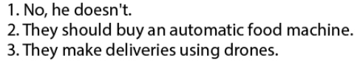
C. Consolidation (2’)
- Vocabulary about technology devices
D. Homework (3’)
- Write four sentences about your favorite smart devices you would like to have in your home.
- Do exercises in the workbook (Page 52)
a. Match the pictures with the words
b. Listen and tick
- Prepare for the new lesson – Grammar (page 74 – SB)

