SỞ GD&ĐT VĨNH PHÚC
TRƯỜNG THPT TRẦN NGUYÊN HÃN ĐỀ THI CHỌN HSG LỚP 10 CẤP TRƯỜNG
NĂM HỌC 2023-2024
MÔN: TIẾNG ANH
(Đề thi có 7 trang) Thời gian: 90 phút(không kể thời gian giao đề

A. LISTENING (YL2)
Part 1:
Complete the form below. Write NO MORE THAN TWO WORDS AND/OR A NUMBER for each answer.

REGISTRATION FORM
Type of crime reported: robbery
Name: Anna 1. ________
Date of Birth (dd/mm/yyyy): 2. ________
Address: 3. ________ St.
Post code: 4. ________
Nationality: Grenadian
Number of previous burglaries: 5. ________
Time of apartment tenancy: 6. ________
Number of occupants: 7. ________
Entry point of burglar: 8. ________
Details of lost property:
Serial number of lost computer: 9. ________
Material of stolen purse: 10. ________ cloth

Part 2:
Question 11 to 14: Choose the correct letter, A, B or C.

Local council report on traffic and highways
11 A survey found people’s main concern about traffic in the area was
A cuts to public transport.
B poor maintenance of roads.
C changes in the type of traffic.
12 Which change will shortly be made to the cycle path next to the river?
A It will be widened.
B It will be extended.
C It will be resurfaced.
13 Plans for a pedestrian crossing have been postponed because
A the Post Office has moved.
B the proposed location is unsafe.
C funding is not available at present.
14 On Station Road, notices have been erected
A telling cyclists not to leave their bikes outside the station ticket office.
B asking motorists to switch off engines when waiting at the level crossing.
C warning pedestrians to leave enough time when crossing the railway line.

Questions 15-20
Label the map below.
Write the correct letter, A-I, next to Questions 15-20.

Recreation ground after proposed changes

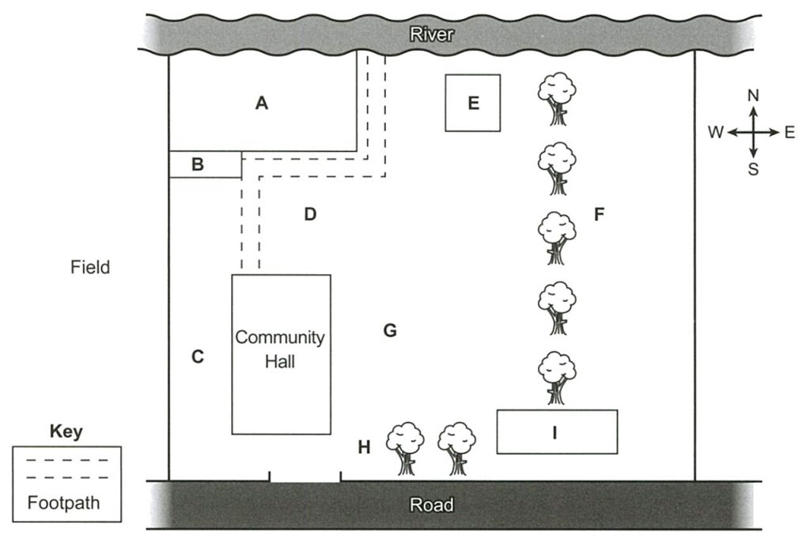

15 New car park ……………
16 New cricket pitch ……………
17 Children’s playground ……………
18 Skateboard ramp ……………
19 Pavilion ……………
20 Notice board ……………
B. LEXICO-GRAMMAR
21. One of my relatives is _____________ to garlic.
A. stimulating B. stressful C. sensitive D. allergic
22. Not only___________ to speak to him, but she also vowed never to see him again.
A. she refused B. did she refuse C. She did refuse D. does she refuse
23. We must________ our pounds for dollars before going to New York.
A. change B. convert C.turn D. exchange
24. Many people were injured when the building _________.
A. collapsed B. destroyed C. struck D. erupted
25. He was so ____________ in the book that he did not hear her footsteps.
A. distracted B. engrossed C. gripped D. attracted
26. This young tree could not have been damaged by accident. I believe it was done ____________
A. in fact B. on purpose C. by appointment D. by plan
27. Mark painted his bedroom black. It looks dark and dreary. He _______ a different color.
A. must have been choosing B. must have chosen
C. should have chosen D. can’t have chosen
28. ________the barrier on the road, we could arrive at the airport in time.
A. But for B. Unless C. Apart from D. Except for
29. Peter: “I think self-learning is facilitated by e-learning platforms”
Mark : “___________”
A. You can say that again B. Don’t worry, I disagree
C. I can agree with you more D. It was a very good thing
30. Can I ________ your brain for a moment? I can’t do this crossword by myself.
A. have B. pick C. mind D. use
31. It is essential that we________informed as soon as there is any change in the schedule.
A. informed B. inform C. be it informed D. be informed
32. Luckily, the rain ________ so we were able to play the match
A. gave out B. got away C. went away D. held off
33. The party was already ________ by the time we arrived. Everyone was singing and dancing.
A. in full swing B. up in the air C. over the moon D. under the cloud.
34. _______to the United States House of Representatives in 1791, Nathaniel Marco remained in office until 1815
A. Election B. Why he was elected C. Elected D. Who was elected
35. ______________you have watched, which film impresses you most ?
A. Between many films B. All of the films
C. Of films all D. Of all the films

C. READING COMPREHENSION
Part 1. Choose the correct answer to complete the following passage by writing the corresponding letter A, B, C or D on your answer sheet.
WIND - The untamable weather machine
On 15 October 1987, the southern counties of Britain were struck by the strongest winds they had experienced in 200 years. Gusts of over 130 kilometers per hour slammed across the region and £1.5- billion-worth of damage was (36)__________ in just a few hours.
Extreme weather events like this are dramatic (37)__________ of the power of the wind. It’s one part of the weather we generally don't give a second thought to in Britain but it plays a vital role in people’s lives across the world. Without the formation and circulation of winds there would quite (38)__________ be no climate.
Some parts of the world seem to suffer more than others from the effects of ‘ill winds’, and links between particular winds and psychological problems (39)__________ back centuries. The Föhn, the hot dry wind that slides off the slopes of the Alps, is capable of boosting temperatures quite suddenly by 10°C or more. It affects as many as one in three people in its (40)__________, making them feel anxious, irritable and generally ill. In California, many people (41)__________ the arrival of the Santa Ana, which rushes down from the high Mojave desert. Lyall Watson, in his book Heaven’s Breath, claims that when the Santa Ana blows, murder rates soar.
The wind may get into the headlines when it comes in the form of tornadoes and hurricanes, but for the (42)__________ part it goes about its job of shifting huge masses of air around the planet. Plants take (43)__________ of this free ride to send their pollen grains far and wide. Trees (44)__________ on it to remove old leaves and make way for new growth. Spiders have been caught (45)__________ a lift at altitudes of almost 4.5 kilometers.
36. A. made B. caused C. destroyed D. completed
37. A. reminders B. recollections C. mementos D. memorial
38. A. easily B. rightly C. surely D. simply
39. A. last B. originate C. pass D. date
40. A. line B. road C. path D. bypass
41. A. despair B. respect C. dread D. warn
42. A. most B. maximum C. majority D. general
43. A. benefit B. chance C. occasion D. advantage
44. A. need B. trust C. hope D. rely
45. A. traveling B. hitching C. borrowing D. making
Part 2. Read the passage and fill in each numbered gap with ONE suitable word.
The British are widely (46) _____ to be a very polite nation, and in (47)______ respects this is true. An Italian journalist once commented of the British that they need (48) _____ fewer than four “thank you” merely to buy a bus ticket. The first, from the bus conductor means, “I’m here.” The second accompanies the handing over of the money. The third, again from the conductor, (49) ____ “Here is your ticket.”, and then the passenger utters a final one as he accepts the tickets. Such transactions in most (50) ____ parts of the world are usually conducted in total silence. In sharp contrast (51)____ this excessive politeness with strangers, the British are strangely lacking in ritual phrases for social interaction. The exhortation “Good appetite”, uttered in so (52) ______ other languages to fellow-diners before a meal, does not exist in English. The nearest equivalent – Enjoy your dinner! – is said only by people who will not be partaking of the meal in question. What’s more, the British (53) ____ happiness to their friends or acquaintances only at the start of a new year and at (54)_____ such as birthdays, (55) _____ the Greeks routinely wish all and sundry a “good week” or a “good month”.
Part 3. Read the following passage and choose the correct answer by writing the corresponding letter A, B, C or D on your answer sheet.
The symptoms of hay fever include watery and itchy eyes and a runny, congested nose. People suffering from hay fever may experience occasional wheezing and repeated bouts of sneezing and may even lose their sense of smell. Some victims of hay fever may also have stopped-up ears. About 30 percent of those who suffer from hay fever may develop the symptoms associated with periodic asthma or a sinus infection. The allergen-antibody theory does not fully explain allergic reactions because the membranes and glands in eyes and ears are controlled by the independent nervous system, which keeps these organs in balance. But the independent nervous system itself is part of the emotional- response center and may cause the feelings of anger, fear, resentment, and lack of self-confidence in reaction to allergy-causing substances.
The most common cause of hay fever is the pollen of ragweed, which blossoms during the summer and autumn. When airborne pollen particles, as well as mold, come into contact with the victim’s membranes, they can cause allergic reactions that release histamine and result in virtual blockage of air passages. To prevent hay fever or to decrease the severity of its symptoms, contact with the ragweed pollen should be reduced. Although some communities have attempted to eliminate the plants that cause the reactions, elimination programs have not been successful because airborne pollen can travel considerable distances. Antihistamine can help with short but severe attacks. Over extended periods of time, however, patients are prescribed a series of injections of the substance to which they are sensitive in order to increase immunity and thus be relieved of the seasonal allergy.
(Resource: Toefl test strategies by Eli Hinkel, Ph.D)
56. It can be inferred from the passage that the phrase “hay fever” refers to________.
A. fodder for cattle B. a seasonal discomfort
C. viral bacteria D. a lung disease
57. According to the passage, the symptoms of the allergy are predominantly________.
A. abdominal B. intestinal C. respiratory D. chronic
58. What can be inferred from the first paragraph?
A. Hay fever may cause severe allergic reactions and even death.
B. The cause of allergic reactions has not been determined.
C. The nervous system balances allergic reactions.
D. People should not have an emotional response to allergic reactions.
59. According to the passage, patients suffering from hay fever may also experience________.
A. hunger pains B. mood swings
C. nervous blockages D. sensory perceptions
60. The word “resentment” is closest in meaning to________.
A. reprieve B. reprisal C. irritation D. grief
61. According to the passage, the irritants are transported by________.
A. wind B. food C. travelers D. air passages
62. The word “blockage” in the passage is closest in meaning to________.
A. obstruction B. bleeding C. enlargement D. dryness
63. According to the passage, to avoid incidents of hay fever, patients need to________.
A. avoid interactions with other patients B. avoid exposure to pollen
C. increase their self-confidence D. take doses of prescribed medicine.
64. Which of the following is NOT mentioned in the passage as a cause of allergies?
A. pollen B. mold C. flowers D. injections
65. A paragraph following this passage would most probably discuss________.
A. how the nervous system alerts patients.
B. how the immune system reacts to allergens.
C. what other diseases can be relieved by vaccines.
D. what flowers are harmless to hay fever patients.
D. WRITING
Section 1. Rewrite each of the following sentences in such a way that it has a similar meaning to the original one.

- She’s sorry that I didn’t complete my project last night.

  - She wishes________________________________________________________.

- When he got to the office, everyone was discussing something.

  - On ______________________________________________________________.

- I realized how important health was until I got sick.

  - Not until________________________________________________________.

- Although Mike is patient with his students, he still gets angry sometimes.

  - Patient ________________________________________________________.

- It is fairly unlikely that he will be convicted of the offence.

  - There ____________________________________________________________.
Section 2. Complete each second sentence using the word given, so that it has a similar meaning to the first sentence. Write between TWO and SIX words in each gap.
71. I never thought that we would have legal problems. CROSSED
  - It never ______________________________ that we’d have legal problems.
- I’ve decided that teaching is not the right profession. CONCLUSION
  - I ‘ve _________________________________ that teaching is not the right profession for me.
73. It would be so hard for them to finish the essay by the weekend. DIFFICULTY
- They _______________________ the essay by the weekend.
74. When the minister was asked about the strike, he declined to comment. ON
- On_________________________, the minister declined to comment.
75. I’ve considered the advantages and disadvantages and decided not to go. (WEIGHED)
- I’ve _________________________________ and decided not to go.

…………………………………….THE END…………………………………….

(Thí sinh không được phép sử dụng tài liệu. Cán bộ coi thi không giải thích gì thêm)

