School: ……………………………………….. | Date: ……………………………..
Class: ……………………………..................... | Period: ………………………......

UNIT 10: ENERGY SOURCES
Lesson 1.1 – New words and Listening (Page 76)

I. OBJECTIVES
By the end of the lesson, Ss will be able to:
1.1. Language knowledge and skills
- know more vocabularies about types and sources of energy (wind power, solar power, oil, coal, natural gas, hydropower, renewable energy, non-renewable energy).
- talk about renewable energy sources that could be useful in their places.
- listen to and understand a conversation of two people talking to experts at an energy convention (for general and specific details).
- know how to ask for clarification.
1.2. Competences
- improve communication, collaboration, and critical thinking skills.
1.3. Attributes
- save energy.
- choose suitable and economical types of energy for everyday use.

II. TEACHING AIDS AND LEARNING MATERIALS
1. Teacher’s aids: Student book and Teacher’s book, class CDs, Digital Book (DCR phần mềm tương tác SB, DHA (từ vựng/ cấu trúc) phần mềm trò chơi tương tác), projector/interactive whiteboard / TV (if any), PowerPoint slides.
2. Students’ aids: Student’s book, workbook, notebook.

III. ASSESSMENT EVIDENCE
Performance Tasks | Performance Products | Assessment Tools
- Fill in the table. | - Ss’ answers. | - T’s feedback/Peers’ feedback.
- Listen and repeat. | - Ss’ presentation. | - T’s feedback/Peers’ feedback.
- Discuss which renewable energy source could be useful where you live. | - Ss’ answers. | - T’s feedback/Peers’ feedback.
- Listen to Emma and James talking to experts at an energy convention. What do they want to learn about? | - Ss’ answers. | - T’s feedback/Peers’ feedback.
- Listen and circle True or False | - Ss’ answers. | - T’s feedback/Peers’ feedback.
- Speak: What sources of energy does your country use? Do you think it uses more non-renewable or renewable energy? | - Ss’ answers/ presentation. | - T’s observation and feedback.

IV. PROCEDURES
A. Warm up: (5’)
a) Objective: Introduce the new lesson and set the scene for Ss to acquire new language; get students' attention at the beginning of the class by enjoyable and short activities as well as to engage them in the steps that followed.
b) Content: Introduce types and sources of energy.
c) Expected outcomes: Ss get to know some new words / structures they are going to study in the lesson.
d) Organization of the activity:
TEACHER’S ACTIVITIES | STUDENTS’ ACTIVITIES
- Option 1: Fill in the table. Listen and repeat.  - Use the “New words” part a.– page 76 for the warm-up activity.  - Show words and pictures, have Ss look and fill in the blanks (in pairs).  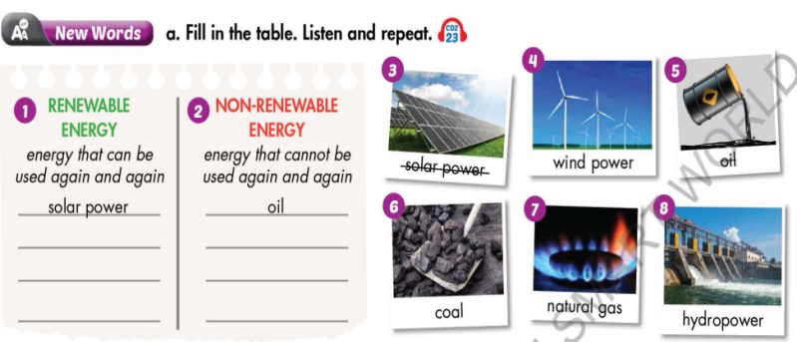  - Call Ss to give answers.  - Give feedback and show correct answers.  - Lead to the new lesson.  - Play the audio (CD2 – Track 23), have Ss listen and repeat.  - Correct Ss’ pronunciation if necessary.  - Option 2: Song: Energy  - Let Ss watch a video clip of a song about energy.  - Have Ss watch, sing together and try to remember how many types of energy and names of some energy sources mentioned in the song.  - Call Ss to give answers.  - Check Ss’s answers and give feedback.  - Lead to the new lesson.  *Illustration:  Link: https://www.youtube.com/watch?v=WgYxQE7aOXY  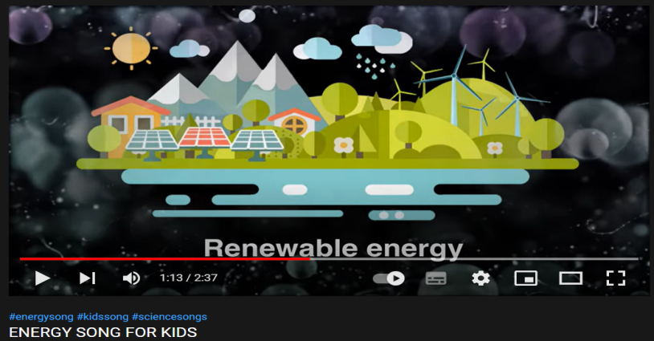 | - Work in pairs to fill in the blanks.  - Give answers.  - Listen.  - Listen and repeat.  Answer keys  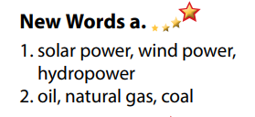  - Watch, remember.  - Read answers.  - Listen.  Answers keys  There are 2 types of energy: Renewable (from the sun and the wind) and non-renewable (from petroleum, coal and natural gas)

B. New lesson (35’)
- Activity 1: Pre-Listening (Vocabulary) (12’)
a) Objective: Ss get to know words about types and sources of energy.
b) Content:
- Vocabulary study (wind power, solar power, oil, coal, natural gas, hydropower, renewable energy, non-renewable energy).
- Speaking: Discuss which renewable energy source could be useful where you live.
c) Expected outcomes: Ss know how to pronounce the new words correctly and use them when they do some listening tasks.
d) Organization of the activity:
TEACHER’S ACTIVITIES | STUDENTS’ ACTIVITIES
Task a. Fill in the table. Listen and repeat.  - Option 1 (If the teacher hasn’t used this part for the Warm-up activity)  - Demonstrate the activity on DCR, using the example.  - Have Ss fill in the table.  - Divide class into pairs and have them check their answers with their partners.  - Call Ss to give answers.  - Check answers as a whole class using DCR.  - Play audio (CD2 – Track 23). Have Ss listen and repeat.  - Correct Ss’ pronunciation.  - Option 2: (If the teacher has used part a for the Warm-up activity): Fill in the blanks  - Have Ss look at the pictures and fill in the blanks by the words they have known in Task a (from Warm up activity. (T uses different pictures from those in the textbook.)  - Have Ss give answers and tell the meaning of words / phrases again.  - Check answers as a whole class.  - Call some Ss to read the words again.  - Correct Ss’ pronunciation if necessary.  *Illustration:  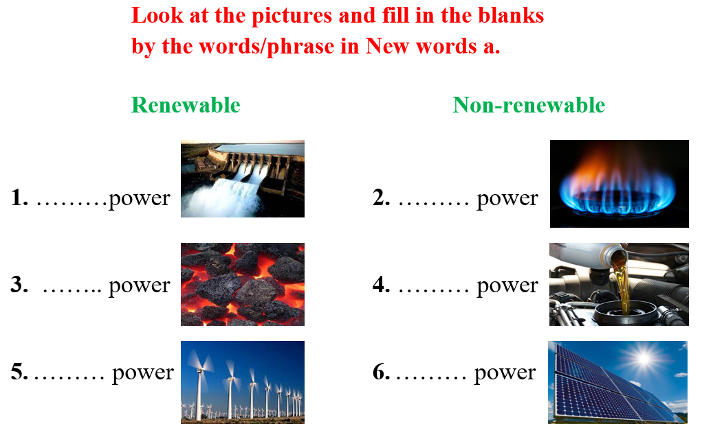  Task b. In pairs: Discuss which renewable energy source could be useful where you live.  - Have Ss work in pairs to discuss which renewable energy source could be useful where they live.  - Go round and give help if necessary.  - Have some pairs share their ideas in front of the class.  - Give feedback and evaluation. | - Look and listen.  - Work individually.  - Work in pairs.  - Give answers.  - Listen and repeat.  Answer keys  - Work in pairs.  - Give answers, meaning.  - Read.  Answer keys  1 hydro  2 natural gas  3 coal  4 oil  5 wind  6 solar  - Work in pairs to discuss.  - Present.  Sample answers  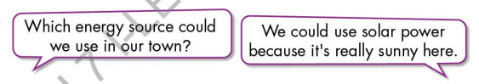
- Activity 2: While - Listening (17’)
a) Objective: Students can develop their listening skill.
b) Content:
- Listen to Emma and James talking to experts at an energy convention. What do they want to learn about?
- Listen and circle True or False.
c) Expected outcomes: Ss can listen to and understand a conversation of two people talking to experts at an energy convention.(for general and specific details).
d) Organization of the activity:
TEACHER’S ACTIVITIES | STUDENTS’ ACTIVITIES
Task a. Listen to Emma and James talking to experts at an energy convention. What do they want to learn about?  - Have Ss read the question, guess the answer.  - Play audio (CD2 - Track 24).  - Have Ss listen and give answers.  - Check answer as a whole class using DCR.  Task b. Now, listen and circle True or False.  - Have Ss read the through the content of Task b, underline the key words.  - Play the audio again (CD2 - Track 24).  - Have Ss listen and circle True or False.  - Have Ss check answers with their partners.  - Call Ss to give answers.  - Give feedback and show correct answers. | -Work individually.  - Listen.  - Give the correct answers.  Answer keys  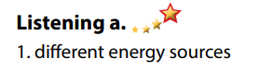  - Read, underline the key words.  - Do the task.  - Exchange answers.  Answer keys  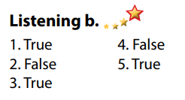

- Activity 3: Post - Listening (6’)
a) Objective: Students can use the vocabulary and the content in listening part to develop their speaking skill.
b) Content: Speaking: What sources of energy does your country use? Do you think it uses more non-renewable or renewable energy?
c) Expected outcomes: Students can talk about sources of energy in Vietnam.
d) Organization of the activity:
TEACHER’S ACTIVITIES | STUDENTS’ ACTIVITIES
Conversation skill  - Have Ss look at the Conversation skill box and read  - Play audio (CD 2 - Track 25), have Ss listen and repeat  - Ask Ss to find more ways to ask for clarification.  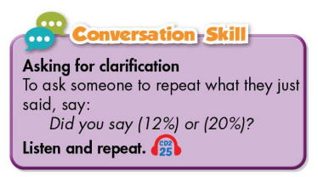  Task c. In pairs: What sources of energy does your country use? Do you think it uses more non-renewable or renewable energy?  - Have Ss work in pairs to discuss the question.  - Observe and give help if necessary.  - Call some pairs to share their ideas with the class.  - Give feedback and evaluation. | - Look and read.  - Listen and repeat.  - Give answers.  - Work in pairs.  - Present.

C. Consolidation and homework assignments (5’)
* Consolidation:
- Words about types and sources of energy (wind power, solar power, oil, coal, natural gas, hydropower, renewable energy, non-renewable energy).
- Language for asking for clarification:
- Did you say…?
- Is that …?
* Homework
- Learn the new words by heart.
- Do the exercises in WB: New words and Listening (page 56).
- Do the vocabulary exercise in Tiếng Anh 7 i-Learn Smart World Notebook (page 60).
- Play consolation games in Tiếng Anh 7 i-Learn Smart World DHA App on www.eduhome.com.vn
- Prepare: Lesson 1.2 – Grammar (page 77 – SB).

D. Reflection
a. What I liked most about this lesson today:
…………………………………………………………………………………………
- What I learned from this lesson today:
…………………………………………………………………………………………
c. What I should improve for this lesson next time:
…………………………………………………………………………………………

