Unit 9: Natural Disaster

A. VOCABULARY
No. | Word/ Phrase | Type | IPA | Meaning
1 | authority | (n) | /ɔːˈθɒrəti/ | chính quyền
2 | damage | (n/v) | /ˈdæmɪdʒ/ | thiệt hại, gây tổn hại
3 | destroy | (v) | /di'strɔi/ | phá hủy
4 | disaster | (n) | /dɪˈzɑːstə(r)/ | thảm họa
5 | earthquake | (n) | /ˈɜːθkweɪk/ | trận động đất
6 | emergency kit | (np) | /ɪˈmɜː.dʒən.si kɪt/ | bộ dụng cụ dùng trong trường hợp khẩn cấp
7 | erupt | (v) | /ɪˈrʌpt/ | phun trào
8 | fahrenheit | (n) | /ˈfær.ən.haɪt/ | độ F (đo nhiệt độ)
9 | funnel | (n) | /ˈfʌn.əl/ | cái phễu
10 | landslide | (n) | /ˈlænd.slaɪd/ | vụ sạt lở
11 | liquid | (n) | /ˈlɪk.wɪd/ | chất lỏng
12 | predict | (v) | /prɪˈdɪkt/ | dự đoán
13 | pretty | (adv) | /ˈprɪti/ | khá là
14 | property | (n) | /ˈprɒpəti/ | của cải, nhà cửa
15 | pull up | (phr.v) | /pʊl ʌp/ | kéo lên, nhổ lên, lôi lên
16 | rescue worker | (np) | /ˈres.kjuː ˈwɜː.kər/ | nhân viên cứu hộ
17 | richter scale | (n) | /ˈrɪk.tə skeɪl/ | độ Richter (đo độ mạnh của động đất)
18 | shake | (v) | /ʃeɪk/ | rung, lắc
19 | storm | (n) | /stɔːm/ | bão
20 | suddenly | (adv) | /ˈsʌdənli/ | đột nhiên, bỗng nhiên
21 | tornado | (n) | /tɔːˈneɪdəʊ/ | lốc xoáy
22 | tremble | (v) | /ˈtrem.bəl/ | rung lắc
23 | tsunami | (n) | /tsuːˈnɑːmi/ | trận sóng thần
24 | victim | (n) | /ˈvɪktɪm/ | nạn nhân
25 | volcanic | (adj) | /vɒlˈkænɪk/ | thuộc / gây ra bởi núi lửa
26 | warn | (v) | /wɔːn/ | cảnh báo
27 | affect | (v) | /əˈfekt/ | ảnh hưởng
28 | flood | (n) | /flʌd/ | lụt
29 | natural disaster | (np) | /'næt∫rəl di'zɑ:stə/ | thảm họa thiên nhiên
30 | look out | (phr.v) | /lʊk aʊt/ | nhìn ra
31 | whistle | (n/v) | /ˈwɪs.əl/ | tiếng còi, huýt sáo
32 | bookcase | (n) | /ˈbʊkkeɪs/ | tủ sách
33 | numerous | (adj) | /ˈnjuːmərəs/ | to lớn, mênh mông
34 | tropical | (adj) | /ˈtrɒpɪkl/ | thuộc về nhiệt đới
35 | poisonous | (adj) | /ˈpɔɪzənəs/ | ngộ độc, có độc
36 | camp | (v) | /kæmp/ | cắm trại
37 | donate | (v) | /dəʊˈneɪt/ | quyên góp
38 | awful | (adj) | /ˈɔːfl/ | tồi tệ, khủng khiếp
39 | share | (v) | /ʃeə(r)/ | chia sẻ
40 | rock | (n) | /rɒks/ | đá
41 | mud | (n) | /mʌd/ | bùn
42 | questionnaire | (n) | /ˌkwestʃəˈneə(r)/ | bảng câu hỏi
43 | celsius | (adj) | /ˈsel.si.əs/ | độ C
44 | thunderstorm | (n) | /ˈθʌndəstɔːm/ | sấm sét
45 | run out of | (phr.v) | /rʌn aʊt ɒv/ | chạy khỏi, cạn kiệt
46 | luckily | (adv) | /ˈlʌkɪli/ | may mắn
47 | instruction | (n) | /ɪnˈstrʌk·ʃənz/ | hướng dẫn
48 | keep away | (phr.v) | /kiːp əˈweɪ/ | tránh xa
49 | flowerpot | (n) | /ˈflaʊ.ə.pɒt/ | chậu hoa
50 | heavy rain | (np) | /ˈhev.i reɪn/ | mưa nặng hạt
51 | during | (adv) | /ˈdjʊərɪŋ/ | trong
52 | strong wind | (np) | /strɒŋ wɪnd/ | gió to
53 | system | (n) | /ˈsɪstəm/ | hệ thống
54 | come down | (phr.v) | /kʌm daʊn/ | rơi xuống
55 | hill | (n) | /hɪl/ | đồi
56 | while | (conjunction) | /waɪl/ | trong khi
57 | involve | (v) | /ɪnˈvɒlv/ | liên quan
58 | cause | (v) | /kɔːz/ | dẫn tới, gây ra
59 | snowy | (adj) | /ˈsnəʊi/ | trời tuyết
60 | rain | (n) | /reɪn/ | mưa

B. WORD FORM
1. authority (n): quyền lực, thẩm quyền, nhà chức trách  => authorities (n-plural): các nhà chức trách, chính quyền  => authoritative (adj): có thẩm quyền, đáng tin cậy  => authoritatively (adv): một cách có thẩm quyền  => authorize (v): cho phép, ủy quyền  => authorization (n): sự cho phép, sự ủy quyền | 6. warn (v): cảnh báo, báo trước  => warning (n): lời cảnh báo, sự cảnh báo  => warned (adj): được cảnh báo  => unwarned (adj): không được cảnh báo
2. destroy (v): phá hủy, tiêu diệt  => destruction (n): sự phá hủy, sự tàn phá  => destructive (adj): có tính phá hoại, gây hại  => destructively (adv): một cách phá hoại  => destroyer (n): người/vật phá hủy  => destroyed (adj): bị phá hủy | 7. involve (v): liên quan, dính líu, bao gồm  => involvement (n): sự tham gia, sự dính líu  => involved (adj): có liên quan, phức tạp  => uninvolved (adj): không liên quan  => involving (adj): liên quan đến
3. disaster (n): thảm họa, tai họa  => disastrous (adj): thảm khốc, tai hại  => disastrously (adv): một cách thảm hại | 8. system (n): hệ thống  => systematic (adj): có hệ thống, có phương pháp  => systematically (adv): một cách có hệ thống  => systematize (v): hệ thống hóa  => systemic (adj): thuộc về hệ thống, toàn diện
4. predict (v): dự đoán, tiên đoán  => prediction (n): lời dự đoán, sự dự báo  => predictable (adj): có thể dự đoán được  => unpredictable (adj): không thể dự đoán  => predictably (adv): một cách có thể dự đoán  => predictor (n): người/yếu tố dự đoán | 9. cause (v/n): gây ra / nguyên nhân  => causation (n): quan hệ nhân quả  => causal (adj): thuộc về nguyên nhân  => causally (adv): về mặt nhân quả  => caused (adj): được gây ra
5. donate (v): quyên góp, tặng  => donation (n): sự quyên góp, món quà tặng  => donor (n): người quyên góp, nhà tài trợ  => donated (adj): được quyên góp | 10. rescue (v/n): cứu hộ, giải cứu / sự giải cứu  => rescuer (n): người cứu hộ  => rescued (adj): được giải cứu  => rescuing (n/adj): việc cứu hộ / đang cứu hộ

C. GRAMMAR THE PAST CONTINUOUS (Thì quá khứ tiếp diễn)
Mục | Nội dung (Quá khứ tiếp diễn – Past Continuous) | Ví dụ
Cấu trúc | (+) S + was/were + V-ing  (-) S + wasn’t/weren’t + V-ing  (?) Was/Were + S + V-ing?  Wh-? Wh + was/were + S + V-ing? | (+) I was studying.  (-) They weren’t sleeping.  (?) Were you watching TV?  Wh-? What were you doing?
Cách dùng | 1) Đang diễn ra tại 1 thời điểm quá khứ  2) 2 hành động song song (while)  3) Hành động đang diễn ra thì có việc khác xen vào (when + QKĐ) 4) Miêu tả bối cảnh | 1) At 7 a.m. yesterday, I was having breakfast.  2) While I was cooking, she was studying.  3) I was taking a shower when the phone rang.  4) It was raining.
Dấu hiệu | at + giờ + quá khứ; at this time yesterday; while; when (+ QKĐ); as; all day/night…; from…to… (quá khứ) | At this time yesterday, we were traveling.
-ing | Thường: +ing | -e: bỏ e +ing | -ie: ie→y+ing | CVC: gấp đôi âm cuối +ing | -c: +k+ing | make→making; lie→lying; run→running; panic→panicking
Lỗi hay gặp | 1) Nhầm was/were  2) Dùng QKTD cho hành động xen vào (đúng là QKĐ)  3) Quên V-ing  4) Nhầm when/while | I was sleeping when the alarm rang (không phải was ringing)

D. EXERCISES
❖ PHONETIC
Exercise 1: Choose the word (A, B, C, or D) whose underlined part is pronounced differently from the others.
1. A. flood B. blood C. food D. wood
2. A. cyclone B. crisis C. cave D. cold
3. A. storm B. torn C. form D. world
4. A. quick B. quit C. quilt D. quiet
5. A. measure B. treasure C. pleasure D. house
6. A. hurricane B. heavy C. help D. hour
7. A. wave B. safe C. damage D. gate
8. A. danger B. nature C. earthquake D. damage
9. A. emergency B. danger C. gentle D. gather
10. A. typhoon B. flood C. soon D. book

Exercise 2: Choose the word (A, B, C, or D) whose main stress is different from the others in the group.
1. A. victim B. survive C. destroy D. protect
2. A. rescue B. shelter C. warning D. collapse
3. A. damage B. safety C. disaster D. homeless
4. A. evacuate B. emergency C. temperature D. preparation
5. A. tsunami B. blizzard C. landslide D. forest
6. A. predict B. climate C. severe D. destroy
7. A. earthquake B. avalanche C. volcano D. hurricane
8. A. donate B. supply C. support D. shelter
9. A. forecast B. extreme C. rebuild D. weather
10. A. powerful B. dangerous C. survivor D. terrible

❖ VOCABULARY AND GRAMMAR
Exercise 1: Choose the word/ phrase/ sentence (A, B, C, or D) that best fits the space in each sentences or best answers the question.
1. The local ________ have ordered residents to evacuate before the hurricane arrives.
A. authorities B. citizens C. residents D. witnesses
2. Flooding can completely ________ roads and bridges in just a few hours.
A. protect B. destroy C. repair D. maintain
3. Scientists believe the volcano could ________ without warning at any moment.
A. freeze B. melt C. erupt D. collapse
4. Weather experts use satellites to ________ the path of tropical storms.
A. predict B. prevent C. produce D. prepare
5. Buildings may ________ violently when an earthquake strikes the area.
A. shake B. break C. crack D. fall
6. The massive ________ swept away coastal villages after the undersea earthquake.
A. avalanche B. tsunami C. blizzard D. drought
7. Insurance companies estimate that people lost millions in ________ during the wildfire.
A. income B. salary C. property D. profit
8. The earthquake registered 7.5 on the magnitude ________.
A. meter B. scale C. gauge D. level
9. The storm struck ________ while most people were sleeping peacefully.
A. gradually B. slowly C. suddenly D. gently
10. Emergency services must ________ residents to evacuate immediately.
A. warn B. force C. teach D. help
11. A team of ________ searched through rubble for survivors all night.
A. rescue workers B. volunteers C. firefighters D. police officers
12. Every household should prepare an ________ containing essential supplies.
A. first aid box B. emergency kit C. supply bag D. safety pack
13. The typhoon caused extensive physical ________ to crops and livestock.
A. harm B. injury C. damage D. loss
14. A powerful ________ touched down near the airport, destroying several planes.
A. hurricane B. tornado C. cyclone D. typhoon
15. Climate change will seriously ________ weather patterns around the world.
A. admire B. affect C. avoid D. accept
16. Relief organizations are providing food and water to disaster ________.
A. victims B. patients C. refugees D. survivors
17. Southeast Asia experiences many ________ storms during monsoon season.
A. arctic B. tropical C. desert D. mountain
18. If rain continues, the river will ________ the nearby villages by tomorrow.
A. flood B. reach C. touch D. cover
19. Emergency teams face ________ challenges in reaching isolated communities.
A. few B. several C. numerous D. various
20. Carry a ________ to signal for help if you become trapped.
A. flashlight B. whistle C. radio D. phone
21. The ________ eruption covered everything in a thick layer of ash.
A. volcanic B. explosive C. massive D. violent
22. Many organizations are asking people to ________ money to help flood victims.
A. provide B. donate C. spend D. save
23. A ________ can strike with little warning and cause devastating damage.
A. natural disaster B. weather event C. climate crisis D. storm system
24. Floodwater may contain ________ chemicals that can make people very ill if swallowed.
A. harmful B. dangerous C. dirty D. poisonous
25. Heavy rainfall triggered a ________ that blocked the mountain road.
A. mudflow B. landslide C. rockfall D. avalanche
26. Evacuated families are staying at an emergency ________ until it's safe to return.
A. shelter B. hotel C. building D. house
27. Weather conditions remained ________ throughout the entire rescue operation.
A. pleasant B. steady C. severe D. mild
28. Community members should ________ resources during emergency situations.
A. divide B. distribute C. share D. split
29. Temperatures exceeded 45 degrees ________ during the record-breaking heat wave.
A. Celsius B. Fahrenheit C. centimeter D. kilometer
30. A moderate ________ measuring 5.2 shook the region but caused minimal damage.
A. earthquake B. tremor C. movement D. vibration
31. The violent ________ with rain and lightning brought down power lines across the city.
A. wind B. storm C. gale D. breeze
32. Rescue teams struggled through thick ________ to reach stranded vehicles.
A. sand B. dust C. mud D. soil
33. ________, no one was seriously injured during the entire evacuation.
A. Sadly B. Luckily C. Surprisingly D. Clearly
34. Falling ________ from the cliff injured several hikers during the earthquake.
A. stones B. rocks C. sand D. dirt
35. A severe ________ with lightning strikes caused several house fires.
A. rainstorm B. windstorm C. thunderstorm D. hailstorm
36. Please complete this ________ about your emergency preparedness plans.
A. survey B. form C. questionnaire D. document
37. Rising sea temperatures may ________ more frequent hurricanes.
A. create B. produce C. cause D. make
38. Follow the safety ________ in the manual carefully when assembling emergency equipment.
A. guidelines B. instructions C. directions D. steps
39. The new warning ________ can alert millions of people within seconds.
A. network B. system C. program D. service
40. The recent ________ has highlighted the need for better emergency planning.
A. incident B. disaster C. accident D. crisis
41. At 3 a.m. last night, emergency teams ________ through the rubble looking for survivors.
A. searched B. were searching C. are searching D. have searched
42. While the firefighters ________ the blaze, paramedics treated injured residents.
A. fought B. fight C. were fighting D. are fighting
43. The earthquake struck when most people ________ peacefully in their beds.
A. slept B. were sleeping C. are sleeping D. sleep
44. I ________ the emergency broadcast when the power suddenly went out.
A. watched B. was watching C. am watching D. watch
45. What ________ when you heard the tsunami warning siren?
A. were you doing B. did you do C. are you doing D. do you do
46. The rescue helicopter ________ overhead while we waited for help below.
A. circled B. circles C. was circling D. is circling
47. At this time yesterday, thousands of people ________ to emergency shelters.
A. evacuated B. were evacuating C. evacuate D. are evacuating
48. Strong winds ________ trees down all night during the hurricane.
A. knocked B. were knocking C. knock D. are knocking
49. While some volunteers ________ food, others distributed blankets to victims.
A. prepared B. prepare C. were preparing D. are preparing
50. The children ________ scared when the ground started shaking violently.
A. were B. was C. were being D. was being
51. Emergency sirens ________ continuously from midnight until dawn.
A. sounded B. were sounding C. sound D. are sounding
52. I ________ my emergency kit when the evacuation order came through.
A. packed B. pack C. was packing D. am packing
53. While the storm ________, nobody dared to go outside.
A. raged B. was raging C. rages D. is raging
54. The meteorologists ________ the hurricane's path when it suddenly changed direction.
A. tracked B. track C. were tracking D. are tracking
55. At 6 p.m. yesterday, rescue boats ________ stranded families from rooftops.
A. collected B. were collecting C. collect D. are collecting
56. We ________ to the radio for updates when the first aftershock hit.
A. listened B. listen C. were listening D. are listening
57. The volcano ________ warning signs for weeks before it finally erupted.
A. showed B. was showing C. shows D. is showing
58. While emergency teams ________ the area, they discovered more damage than expected.
A. assessed B. assess C. were assessing D. are assessing
59. Heavy rain ________ continuously when the mudslide occurred yesterday afternoon.
A. fell B. was falling C. falls D. is falling
60. From 10 p.m. to 2 a.m., volunteers ________ sandbags to protect homes from flooding.
A. filled B. were filling C. fill D. are filling
Exercise 2: Fill in the blank with THE PAST CONTINUOUS.
1. At 11 p.m. last night, emergency helicopters ______________ (fly) over the disaster area searching for survivors.
2. While the firefighters ______________ (battle) the wildfire, strong winds made their job even more dangerous.
3. I ______________ (prepare) my emergency kit when the earthquake warning came through my phone.
4. The children ______________ (not/play) outside when the tornado touched down near their school.
5. What ______________ you ______________ (do) at this time yesterday when the flood warning was issued?
6. Heavy rain ______________ (fall) continuously while rescue teams tried to reach the trapped families.
7. From 6 a.m. to noon yesterday, volunteers ______________ (distribute)food and water when another aftershock hit.
8. The ground ______________ (shake) violently when we ran out of the building.
9. ______________ the emergency sirens ______________ (sound) when you left your house?
10. While some residents ______________ (evacuate), others ______________ (refuse) to leave their homes despite the danger.

Exercise 3: Circle the correct option in brackets.
1. At midnight last night, strong winds (was blowing / were blowing) debris through the streets.
2. The earthquake struck while most people (slept / were sleeping) peacefully in their homes.
3. Emergency teams (was working / were working) around the clock to clear the blocked roads.
4. I (watched / was watching) the weather forecast when the power suddenly went out.
5. While the storm (raged / was raging), a massive tree fell and blocked the main evacuation route.
6. At this time yesterday, thousands of residents (evacuated / were evacuating) the danger zone.
7. The volcano (erupted / was erupting) continuously when the scientists arrived at the observation point.
8. What (did you do / were you doing) when you felt the first earthquake tremor?
9. The rescue helicopter (wasn't flying / weren't flying) because of the severe weather conditions.
10. While volunteers (distributed / were distributing) supplies, a truck suddenly (arrived / was arriving) with more donations.

Exercise 4: Choose the letter A, B, C, or D to indicate the word(s) OPPOSITE in meaning to the underlined word(s) in each of the following sentences
1. The 2004 tsunami completely destroyed thousands of coastal homes in Southeast Asia.
A. demolished B. ruined C. rebuilt D. devastated
2. Climate change continues to affect weather patterns around the globe, causing more extreme events.
A. influence B. have no effect on C. impact D. alter
3. The meteorological department failed to predict the sudden change in the hurricane's path.
A. forecast B. anticipate C. misjudge D. foresee
4. The earthquake severely damaged the city's infrastructure and transportation system.
A. repaired B. harmed C. injured D. impaired
5. Emergency sirens warned residents about the approaching tornado last night.
A. alerted B. notified C. reassured D. informed

Exercise 5: Choose the letter A, B, C, or D to indicate the word(s) CLOSEST in meaning to the underlined word(s) in each of the following sentences
1. The authorities warned coastal residents to evacuate before the typhoon made landfall.
A. encouraged B. requested C. commanded D. alerted
2. The volcanic eruption destroyed entire villages within a 10-kilometer radius.
A. devastated B. preserved C. abandoned D. relocated
3. Rising sea temperatures affect the formation and intensity of tropical storms.
A. prevent B. influence C. observe D. reduce
4. Scientists can now predict earthquakes with greater accuracy using advanced technology.
A. measure B. prevent C. forecast D. analyze
5. The flood damaged crops and agricultural land across three provinces.
A. improved B. harmed C. protected D. replaced

Exercise 6: Fill in each blank with the appropriate form of the word in brackets.
1. The local _______ issued an evacuation order before the typhoon arrived. (AUTHORITY)
2. The earthquake caused massive _______ to buildings in the city center. (DESTROY)
3. The flood was the most _______ event in the region's recent history. (DISASTER)
4. Weather experts made accurate _______ about the storm's path. (PREDICT)
5. Many people made generous _______ to help the flood victims. (DONATE)
6. The weather service issued a _______ about the approaching hurricane. (WARN)
7. The rescue operation _______ hundreds of volunteers from nearby towns. (INVOLVE)
8. The emergency teams worked _______ according to a detailed plan to evacuate all residents before the storm. (SYSTEM)
9. Heavy rainfall _______ severe flooding in coastal areas last week. (CAUSE)
10. The brave _______ saved many lives during the earthquake. (RESCUE)

❖ COMMUNICATION
Exercise 1: Choose the word or phrase (A, B, C, or D) that best completes each of the following exchanges.
1. Reporter: "What were you doing when the earthquake struck?"
Witness: "_________"
A. I was sleeping in my bedroom.
B. I sleep every night.
C. Yes, I did.
D. The earthquake was strong.
2. Friend: "Were you watching TV when the storm warning came?"
You: "_________"
A. No, I watch TV now.
B. Yes, I was watching the news.
C. The TV is broken.
D. I don't like storms.
3. Rescue worker: "Was anyone injured while you were evacuating?"
Resident: "_________"
A. We evacuate every year.
B. No, everyone was safe during the evacuation.
C. The evacuation is important.
D. I injured yesterday.
4. Neighbor: "I heard you were volunteering at the shelter yesterday."
You: "_________"
A. Yes, I was helping distribute food and water.
B. I volunteer tomorrow.
C. The shelter is big.
D. No, I don't like helping.
5. Police officer: "What were people doing when the flood started?"
Local resident: "_________"
A. People like water.
B. The flood was terrible.
C. Most people were sleeping because it happened at night.
D. People do many things.
6. Teacher: "Were you listening to the emergency broadcast?"
Student: "_________"
A. The broadcast is on TV.
B. I listen to music.
C. No, I was doing my homework at that time.
D. Emergency is dangerous.
7. Mother: "What were you doing when the power went out?"
Child: "_________"
A. The power is important.
B. I was playing video games with my friends.
C. I play every day.
D. Power went out is bad.
8. News anchor: "Can you describe what was happening during the evacuation?"
Eyewitness: "_________"
A. Evacuation happens sometimes.
B. People were rushing to leave, carrying their belongings.
C. I describe things well.
D. The evacuation finished.
9. Friend: "Were your parents working when the typhoon warning was issued?"
You: "_________"
A. My parents work hard.
B. Typhoons are scary.
C. Yes, they were both at the office.
D. The warning issued yesterday.
10. Volunteer coordinator: "What were the rescue teams doing at 6 AM?"
Assistant: "_________"
A. They were searching for survivors in the collapsed buildings.
B. Rescue teams are brave.
C. 6 AM is early.
D. The teams do rescue.

Exercise 2: Choose the correct answer (A, B, C, or D) to arrange the following sentences into a meaningful conversation.
1.
a. Anna: I was watching TV when I heard the warning on the news.
b. Mike: What were you doing when the typhoon warning was announced?
c. Mike: Did you prepare emergency supplies?
d. Anna: Yes, my family was storing water and food immediately after that.
A. a-b-c-d B. b-a-c-d C. c-d-a-b D. b-c-a-d
2.
a. Rescuer: We need volunteers to help at the evacuation center.
b. Tom: I was helping injured people while my sister was giving out blankets.
c. Rescuer: Thank you! What were you doing during yesterday's operation?
d. Tom: I can help. I was volunteering during the last flood too.
e. Tom: We were working there from 6 AM to midnight.
A. a-d-c-b-e B. d-a-c-b-e C. a-c-d-b-e D. c-a-d-b-e
3.
a. Reporter: Were people following the evacuation orders?
b. Officer: I was directing traffic while my team was guiding residents to safety.
c. Reporter: Officer, what were you doing when the flood started?
d. Officer: Most were leaving quickly, but some were still packing their belongings.
e. Reporter: How long were you working in the affected area?
f. Officer: We were working non-stop for about 15 hours.
A. c-b-a-d-e-f B. a-b-c-d-e-f C. c-a-b-d-e-f D. b-c-a-d-e-f

❖ READING
Exercise 1: Look at the sign or the notice. Choose the best answer (A, B, C or D) for these questions.
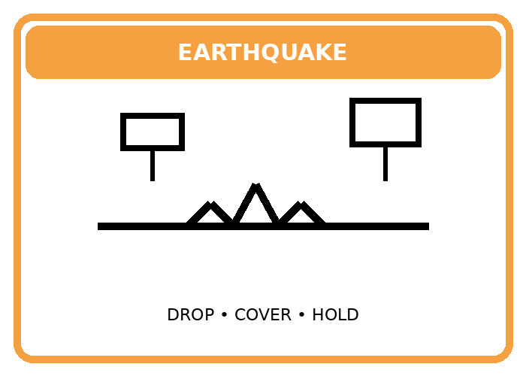 | 1. What does the sign tell people?  A. Stay near windows to watch.  B. Drop, cover, and hold on.  C. Go swimming.  D. Light a fire for warmth.
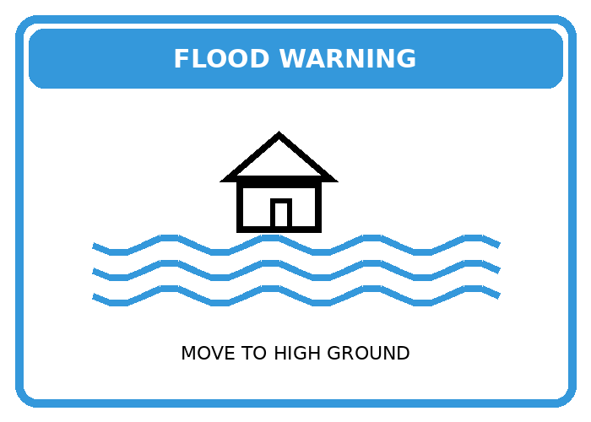 | 2. What does the sign tell people?  A. Move to higher ground.  B. Drive through flooded roads.  C. Go to the beach.  D. Turn on all electrical devices.
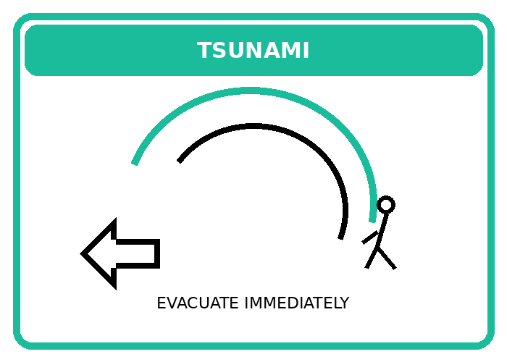 | 3. What does the sign tell people?  A. Wait by the shoreline.  B. Evacuate immediately because of a tsunami.  C. Go fishing now.  D. Stay in the basement for snow.
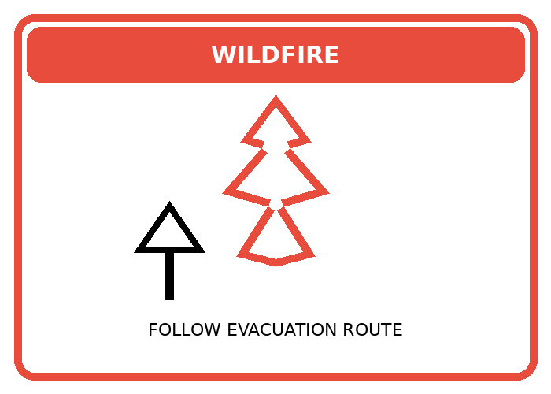 | 4. What does the sign tell people?  A. Start a campfire here.  B. Follow the evacuation route due to wildfire.  C. Plant more trees now.  D. Close the road for a parade.
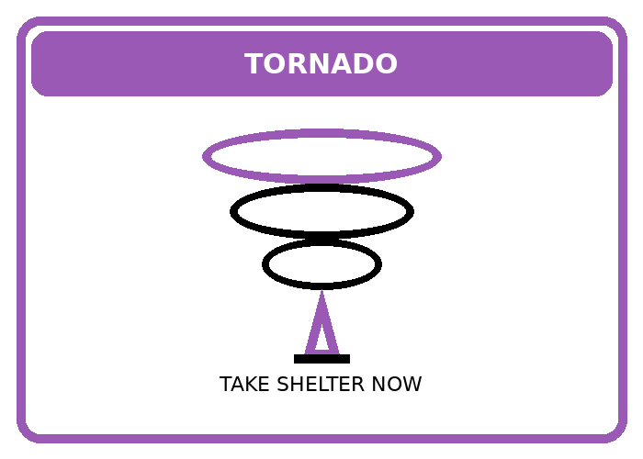 | 5. What does the sign tell people?  A. Take shelter now because of a tornado.  B. Stand outside to take photos.  C. Open all windows.  D. Go hiking on a hill.

Exercise 2: Read the following advertisement/ notice/ flyer/ announcement and mark the letter A, B, C or D to indicate the correct option that best fits each of the numbered blanks
1.
EMERGENCY PREPAREDNESS ANNOUNCEMENT
Be Ready for Natural Disasters!
Dear residents,
Last month, while people (1)_____ their daily activities, a sudden flood hit our town. Many families lost their homes because they were not prepared.
We want to (2)_____ everyone to get ready for future emergencies. Natural disasters can happen at any time, so preparation is very (3)_____.
Essential Emergency Supplies:
Store enough water and food for 3 days
Keep flashlights and batteries ready
Have a first aid kit at home
Prepare important documents in waterproof bags
During the last typhoon, rescue teams were (4)_____ hard to save people, but some areas were difficult to reach. That's why every family should have (5)_____ emergency plan.
Join our free disaster preparedness training this Saturday at the Community Center. Experts will teach you what to do before, during, and after natural disasters.
Remember: When authorities issue warnings, follow them (6)_____!
Registration: Call 024-888-9999
Time: 9:00 AM - 12:00 PM
Location: Community Center, District 5
Stay safe and be prepared!
1. A. were doing B. are doing C. do D. did
2. A. to remind B. remind C. reminding D. reminded
3. A. importance B. importantly C. important D. unimportant
4. A. work B. working C. worked D. works
5. A. a B. an C. the D. Ø
6. A. immediate B. immediately C. immediacy D. mediate

2.
COMMUNITY NOTICE - EARTHQUAKE SAFETY
Learn from Yesterday's Experience
Dear neighbors,
Yesterday's earthquake taught us an important lesson. When the earthquake struck at 2 PM, many people were (1)_____ lunch at home. Some children were playing outside while their parents were cooking.
We need (2)_____ better prepared for future earthquakes. Here are some safety tips:
During an earthquake:
Drop, cover, and hold on
Stay away from windows and heavy furniture
Don't run outside while the ground is shaking
Find (3)_____ safe spot under a strong table
After yesterday's event, our (4)_____ response team checked all buildings. Fortunately, there was only minor damage. However, we were lucky this time.
Please join our earthquake drill next Monday. We will practice what to do when an earthquake happens. Your (5)_____ in this drill is very important for community safety.
Date: Monday, January 8
Time: 10:00 AM
Meeting point: Central Park
Together, we can stay safe!
Community Safety Committee
Questions:
1. A. having B. have C. had D. to have
2. A. be B. to be C. being D. been
3. A. a B. an C. the D. Ø
4. A. emerge B. emergency C. emergent D. emerging
5. A. participate B. participating C. participation D. participant

Exercise 3: Read the following passage and mark the letter A, B, C, or D to indicate the correct word that best fits each of the numbered blanks.
1.
Living with Natural Disasters in Vietnam
Vietnam faces many natural disasters every year. People must learn (1)_____ safely when typhoons, floods, or earthquakes happen. Preparation and knowledge can save many lives during these dangerous times.
Last year, while a strong typhoon was approaching the central coast, families were preparing their homes. They were storing food and water (2)_____ they knew shops would close for several days. Children were helping parents cover windows with tape. Everyone was working together to stay safe.
(3), not all disasters can be predicted. Earthquakes happen suddenly without warning. When the ground starts shaking, people should immediately drop, cover, and hold on. They must stay away from windows and heavy (4) that might fall.
After disasters strike, communities become very (5)_____ with rescue teams, volunteers, and aid workers. People were sharing food and shelter with neighbors who lost their homes. The government sends emergency supplies to affected areas quickly.
Schools now teach disaster preparedness to students. Children practice evacuation drills and learn emergency phone numbers. They understand what to do when warning signals sound. Being prepared helps everyone feel less (6)_____ when disasters occur. Together, we can reduce the damage from natural disasters.
1. A. to act B. acting C. act D. acted
2. A. although B. because C. but D. despite
3. A. Therefore B. Besides C. However D. Moreover
4. A. furnitures B. furniture C. furnish D. furnished
5. A. busy B. busily C. business D. busier
6. A. scare B. scary C. scared D. scaring

2.
Technology Helps During Natural Disasters
Modern technology plays (1)_____ important role in protecting people from natural disasters. Today, scientists can predict storms and floods better than before. This helps save thousands of lives each year.
When Hurricane Maria hit the Philippines last month, warning systems (2)_____ already working three days before. People received alerts on their phones about the coming danger. The government used social media to share safety information with everyone.
During floods, rescue (3)_____ use drones to find people trapped in their homes. These flying cameras help them see dangerous areas from above. Volunteers were using apps (4)_____ emergency supply lists and share them with affected families. Technology made rescue work faster and safer.
After the earthquake in Japan, robots helped search for survivors under collapsed buildings. They moved through small spaces where humans couldn't go. The robots worked (5)_____ for many days, finding people who were still alive.
Weather apps now send warnings (6)_____ to people's phones when disasters are coming. Families can prepare better with more time. Students learn to use these apps at school. Everyone should download emergency apps and keep their phones charged. Technology cannot stop disasters, but it helps us respond better.
1. A. a B. an C. the D. some
2. A. are B. were C. had been D. having been
3. A. team B. team's C. teams D. teaming
4. A. make B. making C. to make D. made
5. A. continue B. continuous C. continuously D. continuation
6. A. direct B. directer C. directly D. directness

Exercise 4: Read the following passage and mark the letter A, B, C, or D to indicate the correct answer to each of the questions.
Flood Heroes in Central Vietnam
Last month, terrible floods hit central Vietnam. The water rose quickly and destroyed many homes. In Quang Nam province, a group of young volunteers called "Rescue Team 24" worked day and night to help flood victims.
The team had fifteen members, all university students. When the flood warning came, they immediately prepared boats, life jackets, and emergency supplies. They knew many families were trapped in their homes without food or clean water. The volunteers divided into small groups to reach more people.
During three dangerous days, they rescued over 200 people, including elderly residents and small children. They brought them to safe shelters at local schools. The team also delivered food packages and medicine to families who stayed in their flooded homes. Everything was wet and dirty, but the volunteers kept working.
The biggest problem was reaching highland villages. Roads were completely underwater and very dangerous. The team used local fishing boats to navigate through strong currents. They marked safe routes with red flags for other rescue teams.
After the flood, the volunteers helped clean damaged homes and schools. They raised money online and collected 50 million dong for rebuilding houses. Their brave actions inspired many young people to join volunteer groups. Natural disasters are scary, but communities become stronger when people help each other.
1. Which of the following is the best title for the text?
A. How to Prepare for Floods
B. Young Volunteers Save Flood Victims
C. University Life in Vietnam
D. Problems with Highland Villages
2. What did the rescue team do first when the flood warning came?
A. They ran away to safe places
B. They called the government for help
C. They prepared boats and emergency supplies
D. They stayed at home
3. What was the most difficult challenge for the rescue team?
A. Getting to highland villages
B. Finding enough volunteers
C. Raising money online
D. Cleaning the schools
4. The word "them" in paragraph 2 refers to ______.
A. the volunteers
B. the rescued people
C. the boats
D. the supplies
5. Why did communities become stronger after the disaster?
A. Because the government gave money
B. Because people helped each other
C. Because floods stopped coming
D. Because volunteers left the area

My Family's Typhoon Experience
My name is Minh, and I live in Da Nang city. Every year, typhoons visit our coastal city between September and November. Last October, Typhoon Noru hit our area, and it was the strongest storm I had ever experienced.
Two days before the typhoon arrived, my father started preparing our house. He bought extra food, water, candles, and batteries from the supermarket. My mother cooked rice and boiled eggs because we might lose electricity. She filled all containers with clean water. My sister and I helped tape the windows and moved our bicycles inside.
When the typhoon came, the wind was extremely loud and scary. Trees fell down on our street, and the electricity went out at 8 PM. We stayed together in the living room, away from windows. My little brother was crying because of the terrible noise. We played card games by candlelight to stay calm.
The storm lasted eight hours. In the morning, our neighborhood looked completely different. Many roofs were damaged, and garbage was everywhere. Luckily, our house was safe, but our neighbor's kitchen roof flew away. Everyone came outside to help clean up and check on each other.
This experience taught me that preparation is very important. We were fortunate because we listened to weather warnings and prepared well. Now I keep an emergency bag ready with flashlights, first-aid supplies, and important documents. Natural disasters can happen anytime, so we must always be ready.
1. When do typhoons usually come to Da Nang?
A. From January to March
B. From April to June
C. From September to November
D. All year round
2. What did Minh's mother do to prepare for the typhoon?
A. She went to visit relatives
B. She cooked food and stored water
C. She bought new windows
D. She called the police
3. How long did the typhoon last?
A. Two days
B. One day
C. Eight hours
D. Thirty minutes
4. The word "it" in paragraph 1 refers to ______.
A. Da Nang city
B. Typhoon Noru
C. October
D. the coastal area
5. What lesson did Minh learn from this experience?
A. Typhoons never cause damage
B. Preparation is very important
C. Games are fun during storms
D. Neighbors don't help each other

❖ WRITING
Exercise 1: Reorder the words to make correct sentences.
1. raining / was / heavily / It / arrived. / the / when / typhoon
→ ___________________________________________________________________
2. were / People / shelters / running / storm. / to / during / the
→ ___________________________________________________________________
3. blowing / The / was / trees / down. / strongly / wind / and / knocking
→ ___________________________________________________________________
4. family / My / basement / was / the / hiding / earthquake / in / the / during
→ ___________________________________________________________________
5. rescuers / for / were / The / survivors / looking / morning. / all
→ ___________________________________________________________________
6. preparing / Were / you / flood? / emergency / bags / before / the
→ ___________________________________________________________________
7. grandmother / My / crying / was / storm. / loudly / the / during
→ ___________________________________________________________________
8. helping / Volunteers / were / after / people / typhoon. / homeless / the
→ ___________________________________________________________________
9. watching / We / were / news / the / happened. / when / earthquake / the
→ ___________________________________________________________________
10. rising / The / was / quickly / water / night. / last / very
→ ___________________________________________________________________
11. wasn't / The / warning / government / people / time. / in
→ ___________________________________________________________________
12. neighbors / Were / your / houses? / cleaning / their / damaged
→ ___________________________________________________________________
13. carrying / Rescue / were / teams / victims / hospital. / to / injured / the
→ ___________________________________________________________________
14. listening / Everyone / to / was / warnings. / the / weather / radio / for
→ ___________________________________________________________________
15. children / The / were / because / not / dangerous. / outside / playing / was / it
→ ___________________________________________________________________

Exercise 2: Write in full sentences using the given words.
1. shaking / was / The / minutes. / ground / five / for
→ ___________________________________________________________________
2. Were / windows / they / storm? / closing / the / before / the
→ ___________________________________________________________________
3. moving / People / were / places. / higher / to / flood / during / the
→ ___________________________________________________________________
4. wasn't / phone / My / the / working / after / disaster.
→ ___________________________________________________________________
5. falling / Trees / were / road. / the / on / yesterday / afternoon.
→ ___________________________________________________________________
6. waiting / We / were / arrive. / rescue / for / to / boats / the
→ ___________________________________________________________________
7. sirens / The / warning / were / night. / sounding / all
→ ___________________________________________________________________
8. was / What / doing / your / father / earthquake? / during / the
→ ___________________________________________________________________
9. staying / Families / were / centers. / together / evacuation / in
→ ___________________________________________________________________
10. destroying / The / was / houses / tornado / many / morning. / yesterday
→ ___________________________________________________________________

Exercise 3: Choose the letter A, B, C or D on your answer sheet to indicate the sentence that is closet in meaning to the original sentence in each of following questions
1. When the earthquake started, I was sleeping in my room.
A. I was sleeping in my room when the earthquake started.
B. I slept in my room after the earthquake started.
C. The earthquake started because I was sleeping.
D. I went to sleep when the earthquake started.
2. The storm was getting stronger, so people were leaving the area.
A. People left because the storm got strong.
B. People were leaving the area because the storm was getting stronger.
C. The storm got strong after people left.
D. People stayed although the storm was getting stronger.
3. My parents weren't at home during the flood.
A. My parents were at home when the flood came.
B. My parents stayed home during the flood.
C. My parents were not at home when the flood happened.
D. The flood happened at my parents' home.
4. Were the rescue teams working all night?
A. The rescue teams didn't work at night.
B. Did the rescue teams work throughout the night?
C. The rescue teams worked only at night.
D. The rescue teams stopped working at night.
5. While we were waiting for help, the water was rising quickly.
A. We waited after the water rose.
B. The water rose before we waited for help.
C. The water was rising quickly as we were waiting for help.
D. We didn't wait because the water was rising.
6. The children were crying because the thunder was very loud.
A. The thunder was loud, so the children were crying.
B. The children cried before the thunder.
C. The thunder stopped when the children cried.
D. The children weren't afraid of the thunder.
7. What were you doing when the typhoon hit the city?
A. What did you do after the typhoon?
B. Were you sleeping during the typhoon?
C. When the typhoon hit the city, what were you doing?
D. Did you know about the typhoon?
8. The government was warning people, but many weren't listening.
A. Everyone listened to the government's warning.
B. Many people weren't listening although the government was warning them.
C. The government didn't warn people.
D. People listened after the government warned them.
9. It wasn't raining when we left the evacuation center.
A. It was raining when we left the evacuation center.
B. We left the evacuation center, and it wasn't raining.
C. It was raining before we left the evacuation center.
D. We stayed because it was raining.
10. During the earthquake, everyone was running outside for safety.
A. Everyone ran outside before the earthquake.
B. People stayed inside during the earthquake.
C. Everyone was running outside to be safe during the earthquake.
D. The earthquake happened after everyone went outside.

Exercise 4: Choose (A, B, C, or D) to indicate the correct arrangement of the sentences to make a meaningful paragraph/letter in each of the following questions.
1.
Dear Mark,
a. The wind was blowing very hard, and trees were falling everywhere.
b. I hope you and your family are safe. We had a terrible storm last night.
c. My parents were watching the news while I was doing my homework.
d. Suddenly, all the lights went out at about 8 PM.
e. We were staying in the basement for three hours until it was safe.
f. Thankfully, our house wasn't damaged, but many neighbors lost their roofs.
Best wishes,
Tom
A. b-c-d-a-e-f B. c-b-d-a-e-f C. b-d-c-a-e-f D. b-a-c-d-e-f
2.
a. First, the sky was getting very dark at 3 PM yesterday.
b. The earthquake happened while everyone was having lunch.
c. Then, people were running outside to open areas.
d. Many buildings were shaking for about 30 seconds.
e. After that, rescue teams were arriving to help injured people.
f. Finally, families were gathering at evacuation centers for safety.
A. b-d-c-e-f-a B. a-b-d-c-e-f C. b-a-d-c-e-f D. b-d-a-c-e-f
3.
a. The water was rising quickly in the streets.
b. Last week, our city experienced the worst flood in 10 years.
c. People were moving their belongings to higher floors.
d. It was raining heavily for two days without stopping.
e. Rescue boats were helping families leave dangerous areas.
f. The government was providing food and water at emergency shelters.
A. b-d-a-c-e-f B. d-b-a-c-e-f C. b-a-d-c-e-f D. b-d-c-a-e-f

Exercise 5: Choose (A, B, C, or D) to indicate the correct answer to each of the following questions.
1.
Put the sentences (a-c) in the correct order, then fill in the blank to make a logical text.
Yesterday's typhoon was one of the strongest this year. ___________. By midnight, the storm had passed, and people were starting to clean up the damage.
a. Strong winds were breaking windows and damaging roofs all over the city.
b. At 6 PM, families were moving to evacuation centers for safety.
c. The weather service was warning people to stay indoors since morning.
A. c - a - b B. a - b - c C. b - c - a D. c - b - a
Choose the sentence that can COMPLETE the blank most appropriately.
A. Many people enjoy watching storms from their windows.
B. During the typhoon, rescue teams were working hard to help trapped families.
C. Typhoons usually happen in summer months.
D. The weather is usually nice after a storm.

2.
(1) ______. The flood affected thousands of families and caused serious damage to our community. (2) ______. Thanks to these efforts, many lives were saved during the disaster.
Choose the TOPIC SENTENCE that can BEGIN the text most appropriately.
A. Floods happen every year in our country.
B. Last week's flood was the worst natural disaster in our city's history.
C. Many people don't prepare for floods.
D. Our city has many rivers and lakes.
Put the sentences (a-c) in the correct order, then fill in the blank (2) to make a logical text.
a. Meanwhile, volunteers were distributing food and clean water at emergency shelters.
b. Rescue teams were working day and night to evacuate people from flooded areas.
c. Local authorities were also providing medical care to injured victims.
A. b - a - c B. a - c - b C. b - c - a D. c - b - a

❖ LISTENING
Exercise 1: Listen to the audio about the flood and choose the best answer (A, B, C, or D) for each question.
1. When did the flood happen in the village?
A. In December last year
B. In October last year
C. In September this year
D. In November last year
2. What was the father doing when the water entered their street?
A. He was packing clothes
B. He was moving furniture
C. He was calling neighbors to warn them
D. He was helping grandmother
3. How high was the flood water by noon?
A. Half a meter
B. One meter
C. Two meters
D. Three meters
4. How long did the family stay on the second floor?
A. One day
B. Two days
C. Three days
D. Four days
5. What happened after the flood ended?
A. The family moved to a new house
B. The village had a big celebration
C. Everyone left the village immediately
D. The whole village cleaned together for many weeks

Exercise 2: Listen to the audio about the earthquake. Decide if the following statements are TRUE or FALSE.
1. The earthquake happened on a Tuesday evening.
2. When the earthquake started, the speaker's sister was watching TV in the living room.
3. The earthquake lasted for about 3 minutes.
4. The earthquake had a magnitude of 6.2.
5. After the earthquake, the family slept in the garden because they were afraid of aftershocks.

