SỞ GIÁO DỤC VÀ ĐÀO TẠO KỲ THI TUYỂN SINH VÀO LỚP 10 THPT
HÀ NỘI THEO CHƯƠNG TRÌNH GDPT 2018
Môn thi: TIẾNG ANH
ĐỀ MINH HỌA
Thời gian làm bài: 60 phút, không kể thời gian phát đề
(Đề thi gồm 04 trang) Mã đề: 16
Mark the letter A, B, C, or D on your answer sheet to indicate the word whose underlined part differs from the other three in pronunciation in each of the following questions.
Question 1: A. spread B. cream C. bread D. head
Question 2. A. chair B. cheap C. chemist D. child
Mark the letter A, B, C, or D on your answer sheet to indicate the word that differs from the other three in the position of primary stress in following questions.
Question 3: A. personal B. digital C. electric D. excellent
Question 4. A. environment B. activity C. limitation D. emotional
Mark the letter A, B, C, or D on your answer sheet to indicate the correct answer to each of the following questions.
Question 5. Many people use the __________ to get around the city quickly.
A. train B. restaurant C. beach D. airport
Question 6. By the time she moved to the city, she ___________ a simple rural lifestyle for many years.
A. experiences B. was experiencing C. experienced D. had experienced
The more she practices, ____________ she becomes.
A. the more confident B. the most confident
C. the greater confidence D. the more confidently
Question 8. Sophia has started a new hobby in painting.
Sophia: "I’ve started painting as a new hobby!"
Tom: “_______________”
A. That’s wonderful! What have you painted? B. I’m not into painting.
C. Painting is too messy. D. Hobbies are just a waste of time.
Question 9. If the children ___________ their homework this afternoon, they ___________ time to play outside before dinner.
A. finish/will have B. finishes/having C. finishing/will has D. will finish/have
Question 10. The factory in ______ my brother works is the biggest in the city.
A. that B. whom C. where D. which
Question 11. The Internet is also __________ in the countryside, so even farmers can get access to it.
A. impossible B. believable C. available D. comparable
Question 12. ____________ exercise is important for maintaining a healthy lifestyle, especially if you have a sedentary job.
A. Regular B. A few C. Many D. Some
Read the following announcement and mark the letter A, B, C, or D on your answer sheet to indicate the correct option that best fits each of the numbered blanks from 13 to 16.
Announcement: Social Community Clean-Up
The Local Volunteer Group invites:
- All community members to participate (13) __________ a clean-up day on September 10 starting at 8:00 AM.
- Each participant is to (14) __________ gloves and trash bags for the clean-up.
- If you haveany issues during the event, please (15) __________ a volunteer leader know.
The clean-up will take place (16) __________ the town center.
Question 13: A. an B. a C. the D. no article
Question 14: A. bring B. bringing C. brought D. brings
Question 15: A. agree B. let C. allow D. say
Question 16: A. in B. at C. on D. with
Mark the letter A, B, C, or D on your answer sheet to indicate the correct answer to each of the following questions from 17 to 18.
Question 17: Put the sentences (a-c) in the correct order, then fill in the blank to make a logical text.
Vietnamese soldiers play a key role in protecting the country. __________.
a. After the mission, the soldiers felt proud to have helped keep the country safe.
b. The problems started when it became clear that more help was needed for the mission.
c. At first, the mission seemed simple, but soon it was clear that there were many challenges to face.
A. c-b-a B. a-c-b C. b-c-a D. c-a-b
Question 18: Choose the sentence that best fits as the opening sentence for the text (in Question 17).
A. Many people respect the bravery of Vietnamese soldiers.
B. The mission had some problems but was finished successfully.
C. Vietnamese soldiers play a key role in protecting the country.
D. Soldiers received awards for their hard work and bravery.
Mark the letter A, B, C, or D on your answer sheet to indicate the correct option that best fits each of the numbered blanks from 19 to 24.
A narrow rock that stands taller than the Empire State Building does not look like the most Welcoming place to set up home. But that did not stop an insect which was (19) _____________ to be extinct for 80 years from building its last known colony on the 562-meter tall Ball's Pyramid in the South Pacific Ocean. Scientists have discovered 24 of the creatures (20) _____________ on the rock. The “tree lobster” insect, which is as large as a human hand, had somehow made its camp (21) _____________ the lack of food. Despite the harsh conditions, the insect colony managed to thrive on the rock with (22) _____________ small plants providing sustenance.
In 2001, Australian scientists (23) _____________ claims by climbers who tackled Ball's Pyramid that they had seen fresh droppings here. They too saw the droppings and upon returning after dark with flashlights were stunned to discover the insect colony around the only plant on the rock. Mr. Carlie said: “It felt like (24) _____________ back into the Jurassic age, when insects ruled the world.”
Question 19: A. donated B. supposing C. supposed D. donating
Question 20: A. living a plant around B. living around C. living a plant D. living around a plant
Question 21: A. because B. and C. despite D. even
Question 22: A. a little small plants B. a few small plants C. a lot of small plants D. little small plants
Question 23: A. decided for investigating B. decided to investigating
C. to decided investigating D. to decided investigate
Question 24: A. stepped B. steps C. step D. stepping
Mark the letter A, B, C, or D on your answer sheet to indicate the sentence that is closest in meaning to the original sentence in each of the following questions.
Question 25: She speaks English well, but she still finds it hard to communicate with native speakers.
A. Although she is good at English, she still has difficulty communicating with native speakers.
B. She speaks English well, so she has no difficulty communicating with native speakers.
C. She finds it hard to communicate with native speakers despite being fluent in English.
D. Even though she speaks English well, she is able to communicate effectively with native speakers.
She passed the exam because she studied very hard.
A. If she hadn't studied hard, she wouldn't have passed the exam.
B. If she studies hard, she will pass the exam.
C. She could have passed the exam if she studied.
D. If she hadn’t studied hard, she would still pass the exam.
Mark the letter A, B, C, or D on your answer sheet to indicate the sentence that is made from the given cues in each of the following questions.
Question 26: Mai’s parents / always / expect / her / get / good / grades / and / go / top / university / study / medicine /.
A. Mai’s parents always expect her to get good grades and go to a top university to study medicine.
B. Mai’s parents always expect her getting good grades and go to a top university study medicine.
C. Mai’s parents always expects her to get good grades and goes to a top university to study medicine.
D. Mai’s parents always expect her get good grades and go to a top university study medicine.
Question 26: In / past / most / girls / like / knit / scarves / sweaters / themselves /.
A. In the past, most of the girls had liked knitting and scarves and sweaters themselves.
B. In the past, most of the girls like knitting and scarves and sweaters themselves.
C. In the past, most of the girls liked knitting scarves and sweaters themselves.
D. In the past, most of the girls liked knitting and the scarves and the sweaters themselves.
Read the following sign or notice and mark the letter A, B, C, or D on your answer sheet to indicate the correct answer to each of the following questions.
Question 29: What does the sign say?
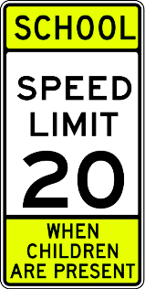
A. You drive as fast as you can.
B. You stop right now.
C. You drive slowly to a speed at no greater than 25km/h when children are present
D. You drive to a speed at over 25 km/h when children are present.
Question 30: What does the notice say?
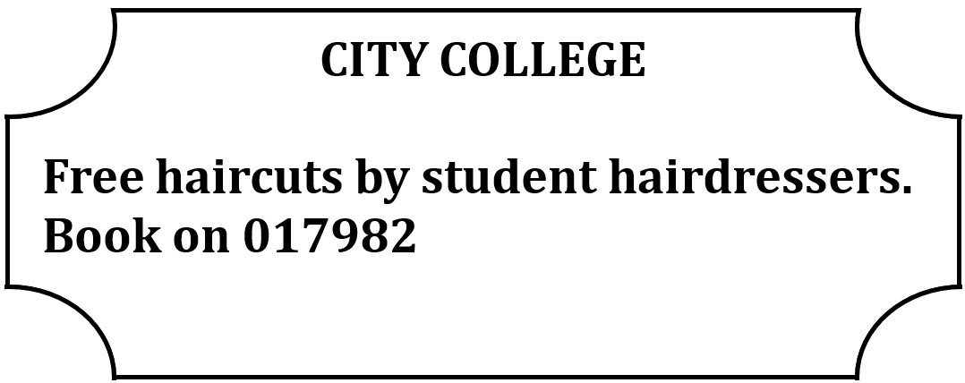
A. You can book a free haircut with City College students.
B. The haircuts at City College are only free for students.
C. You need to pay to book a haircut here.
D. The haircuts are given by professional hairdressers.
Read the following passage and mark the letter A, B, C, or D on your answer sheet to indicate the correct answer to each of the following questions from 31 to 36.
The environment is the natural world dial surrounds US, consisting of the air we breathe, the water we drink, the land we live on, and the ecosystems dial support life. It is essential for the well-being of all living beings on Earth.
One of the issues concerning the environment is climate change. Human activities, such as burning fossil fuels and deforestation, contribute to the release of greenhouse gases, leading to global warming and the change of ecosystems. Climate change has serious consequences, including extreme weather events, sea-level rise, and the loss of biodiversity. Another important aspect of die environment is pollution. Industrial activities, and the use of harmful chemicals contaminate die air, waler, and soil. Pollution has negative effects on human health, wildlife, and the overall balance of ecosystems.
Preserving and protecting the environment requires collective actions. Conservation efforts, such as sustainable resource management and afforestation, play a crucial role in reducing environmental damage. Besides, individual actions, such as reducing waste, and adopting eco-friendly practices, contribute to a more sustainable future. It is essential to raise awareness and educate the public about environmental issues. By this way. individuals can make informed choices and lake steps to minimize their ecological footprint.
Question 31. Which of the following can be the best title for the passage?
A. The Importance of Environmental Preservation B. Pollution and Its Impact on the Environment
C. Climate Change: A Global Crisis D. Raising Awareness for a Sustainable Future
Question 32. The word "ecosystems" in paragraph 1 is CLOSEST in meaning to ____________.
A. habitats B. species C. climates D. environments
Question 33. According to paragraph 2, which of the following is NOT mentioned as the consequences of climate change?
A. sea-level rise B. extreme weather events
C. the loss of biodiversity D. reducing temperature
Question 34. The word “contaminate” is closest in meaning to _____________.
A. pollute B. protect C. improve D. destroy
Question 35. According to the passage, pollution _____________.
A. contaminates the environment B. does not affect the air
C. has no effect on human health D. does not change ecosystems
Question 36. According to the passage, what is one important thing individuals can do to help protect the environment?
A. Use more energy and fossil fuels
B. Reduce waste and use eco-friendly practices
C. Depend only on factories for environmental care
D. Ignore environmental problems and think only about personal gain
Four phrases/sentences have been removed from the text below. For each question, mark the letter A, B, C, or D on your answer sheet to indicate the correct option that best fits each of the numbered blanks from 37 to 40.
Education has transformed significantly over the years. The advent of online learning (37) ____________. Students can now access courses from anywhere and learn at their own pace. Technology has also changed teaching methods, (38) ____________. Interactive tools and digital resources help educators engage students more effectively. However, this shift has brought about challenges, as (39) ____________. It is essential for schools to adapt to these changes and ensure that all students benefit. In conclusion, education has improved dramatically, and (40) ____________.
A. has made learning more accessible B. not all students have equal access to technology
C. allowing for personalized learning experiences D. it will continue to improve in the future
Question 37. ____________. Question 38. ____________. Question 39. ____________. Question 40. ____________.

