|  |  |
| --- | --- |
| **Mã đề 9.1.16**  **-------------------------------** | **ĐỀ KIỂM TRA GIỮA HỌC KÌ I**  **NĂM HỌC 2022-2023**  **MÔN: TIẾNG ANH – LỚP 9 (THÍ ĐIỂM)**  Thời gian làm bài: 60 phút |

**A.LISTENING: ( 2 points)**

**Part 1: You will hear five short conversations. Listen and choose the right answer. (1.0p)**

1. What will they eat for dinner this evening?

|  |  |  |
| --- | --- | --- |
| 112 | 114 | 115 |

A B C

2. What time is it?

|  |  |  |
| --- | --- | --- |
| **2:10** | **2:20** | **2:30** |

A B C

3. What’s Michelle going to read?

|  |  |  |
| --- | --- | --- |
| 116 | 118 | 119 |

A B C

4. How much did the ticket cost?

|  |  |  |
| --- | --- | --- |
| **$19** | **$90** | **$99** |

A B C

5. Where is chemist’s?

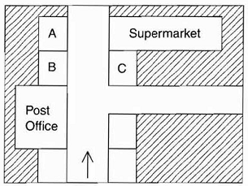

A B C

**Part 2: Listen and complete. (1.0 p)**

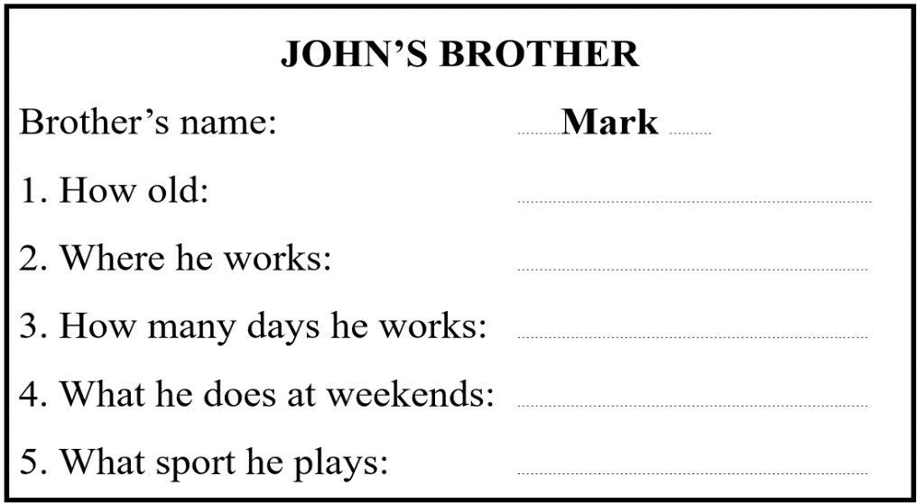

**B. Language:( 3 points)**

**1. Choose the word whose underlined part is pronounced differently from that of the others.**

1.1.   A. impress**ed**  B. disappoint**ed**  C. wish**ed**      D. stopp**ed**  NB

1.2. A**.** ch**i**ldren                 B**.** inv**i**te                 C**.** m**i**nute D**.** vis**i**t TH

**2. Choose the word whose stress pattern is different from that of the others.**

2.1. A. famous B. workshop C. village D. bamboo NB

2.2. A. tradition B. mention C. pollution D. attraction NB

**3. Choose the correct option A,B,C or D to complete the sentences.**

3.1. I have no idea what ……………….. the traditional drums. NB

|  |  |  |  |
| --- | --- | --- | --- |
| A. to buy | B. buy | C. bought | D. buys |

3.2…………………………a majority of Vietnamese small and medium enterprises do not have in-house designers or specialized design staff, they have to hire freelance designers. VD

|  |  |  |  |
| --- | --- | --- | --- |
| A. While | B. Since | C. Despite the fact | D. Due to |

3.3. The amusement centre is so small that they cannot ................... the demand of the local residents. VD

|  |  |  |  |
| --- | --- | --- | --- |
| A. keep up with | B. face up to | C. deal about | D. set up |

3.4. Karachi is ...................... city in the world population. TH

|  |  |  |  |
| --- | --- | --- | --- |
| A. the two largest | B. the two larger | C. The second largest | D. the second larger |

3.5. Mary and Tom are talking about a famous artisan.

Mary: “Have you ever heard that Dan is a famous artisan?” Daisy: “ ” VD

|  |  |
| --- | --- |
| A. No, I don’t mind. | B. Really? So surprising to hear that. |
| C. Dan is working at a workshop. | D. Just keep it a secret. |

3.6.My mother is a caring woman and always **thoughtful** of others. The word "**thoughtful**" is closest in meaning to…………………………………… VD

|  |  |  |  |
| --- | --- | --- | --- |
| A.  considerate | B.      rude | C. inconsiderable | D. critical |

**C. READING:( 2 points)**

**Part 1. Circle the correct answer A, B or C for each gap in the passage. (1,0 p)**

For many people, traveling by plane is an exciting experience. Others, however, find the whole ideas quite terrifying, (1) __________ flying is no more dangerous than any other form of travel and some experts say it is considerably safer. It is known, however, that most accidents occur during take-off and landing when a  (2) ________ decisions are vitally important. The people whose job is to look after the passengers - the stewards and stewardesses (3) ___________  an important part in helping passengers to feel safe and comfortable. Indeed, for many passengers being(4) _______ such care of is all part of the total experience. No other form of travel involves waiting on people in quite the same (5) _________ , with food, drink, newspapers, magazines and even video films

1. A. too B. and C. although D. because

2. A. driver’s B. leader’s C. chief’s D. pilot’s

3. A. play B. make C. experience D. get

4. A. shown B. taken C. kept D. given

5. A. kind B. way C. sort D. part

**Part 2. Circle the correct answer A,B,C and D that best fit the question below.( 1.0 p)**

Recently, my grandparents often recall how difficult their lives were when they were young, claiming that my generation has much easier lives than they had. I agree with them. In fact, life today is much more comfortable and easier than it was in my grandparents’ youth for some reasons.

First, technology has made modern-day life much more comfortable than in the past. During my grandparents’ time, life was rough and hard because all the work was done without any modern tools, so they had to do their laundry by hand, walked from one place to another. Furthermore, there was limited in entertainment choices in the past. They could at best listen to the radio or perhaps watch a black-and-white movie for pleasure.

In addition, people today have more leisure time than they did before. People no longer have to work very long hours like my grandparents did. Since my grandparents were farmers, they had to work in the rice field all day long even without resting on weekends. In contrast, many people today, including my parents, simply work from nine to five on weekdays and take weekends off. They therefore have much free time than my grandparents did, so they can spend more time on leisure activities. They go to the movies, go to the gym, or take trips. All these activities have positive affect on their quality of living.

In conclusion, people today have more comfortable and easier lives than in the past.

1. Life in the past was …….. than it is now.

1. more boring B. happier C. more comfortable

2.People used to move from one place to another ……….

1. by bike B. by motorbike C. on foot

3.There are …….. kinds of entertainment now than before.

1. more B. less C. much

4.People in the past …………. have weekends off.

1. used to B. didn’t use to C. needed

5.What do people today do to relax? – They ………..

1. go camping B. go to the gym or take trips C. both A and B

**D.WRITING (30 pts)**

**Part 1. Choose the underlined word or phrase in each sentence below that needs correcting (1.0 p).**

1. When he came, I watched a football match on TV.

A B C D

2. When Andrew saw the question, he was knowing the answer immediately.

A B C D

3. Mai has stayed on her uncle's farm for last week.

A B C D

4. I'm looking forward to hear from you.

A B C D

5. They asked me don’t talk during the discussion

A B C D

**Part 2 . Rewrite the following sentences in such a way that they stay the same meanings. (1.0 p)**

1. “Why do you like playing the piano?” asked Minh.

→ Minh asked me

2. It’s a pity that I don’t bring my umbrella.

→ I wish

3. The weather is not nice today, so we will not go on a picnic.

→ If the weather

4. “ Why don’t you get up earlier, Ba?” Hoa said

→ Nga suggested

5. We last met our cousins six months ago.

→ We haven’t

**Part 3. Write a passage (about 100 – 120 words) about a wonder of Viet Nam (1.0 p)**

**Your passage may include:**

* What is the name of wonder?
* Where is it?
* What is it famous for?
* What can you do when you visit it?
* How do you feel about it?

.................................................................................................................................................................................................................................................................................................................................................................................................................................................................................................................................................................................................................................................................................................................................

**The end.**

**ANSWER KEY ( 9 Thí điểm )**

1. **LISTENING ( 20 points)**

**Part 1*.* 5 x 2 = 10 pts**

1. B 2. C 3. B 4. B 5. C

**Part 2*.* 5 x 2 = 10 pts**

1. 17/ seventeen (years old) 2. (in a) library/ He works in a library

3. 4/ He works 4 days a week 4. He goes to the cinema/ go to the cinema

5. table tennis/ He plays table tennis

**B. Language (10 x 3 = 30 pts)**

1. 1.B 1.2. B 2.1. D 2.2. B 3.1. A 3.2. B

3.3. A 3.4. C 3.5. B 3.6. A

**C READING: ( 20 points)**

**Part 1. 5 x 02 = 10pts**

1. C 2. D 3. A 4. B 5. B

**Part 2. 5 x 2 = 10 pts**

**1.A 2.C 3. A 4. B 5. B**

**D. WRITING: ( 30 points)**

**Part 1: (5 x 2= 10 pt).**

1. B 2. C 3. D 4. D 5. D

**Part 2. 5 x 2 = 10 pt**

1. Minh asked me why I liked playing the piano.

2. I wish I brought my umbrella.

3. If the weather were nice today, we would go on a picnic.

4. Nga sueggested (that) Ba should get up earlier/ **or Nga suggested that Ba get up earlier**

5. We haven’t met our cousins for six months

**Part 3. (10pt)**

**1. Form:**

* *Correct form of a paragrpah (1 point)*

**2. Task fulfillment:**

* *Task complete with relevant information (4 points)*
* *Well- organized (3 points)*

**3. Language:**

* *Accurate grammar (3 points )*
* *Appropriate vocabulary (2 points )*
* *Correct spelling and punctuation (2 points )*