Họ và tên: ....................................................  Lớp: ............................................................. | PHIẾU GHI BÀI HÓA HỌC 11 CÁNH DIỀU  Bài 14: ARENE (HYDROCARBON THƠM)
MỞ ĐẦU
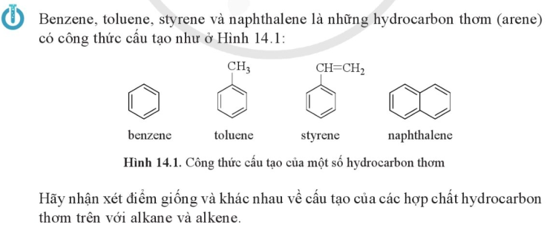
..........................................................................................................................................................................
..........................................................................................................................................................................
I. KHÁI NIỆM VÀ DANH PHÁP
1) Vòng benzene và hydrocarbon thơm  ....................................................................................................................  ....................................................................................................................  ....................................................................................................................  ....................................................................................................................  ....................................................................................................................  ....................................................................................................................  ....................................................................................................................  ....................................................................................................................  ....................................................................................................................  2) Danh pháp  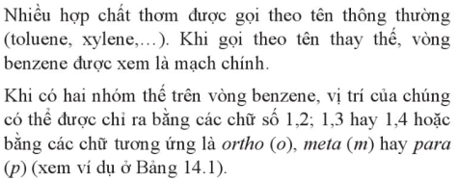 |  | 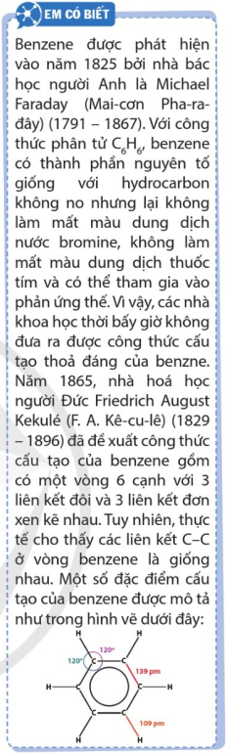
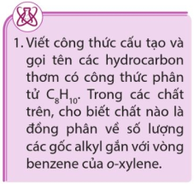 | .......................................................................................................................  .......................................................................................................................  .......................................................................................................................  .......................................................................................................................  .......................................................................................................................  .......................................................................................................................
II. TÍNH CHẤT VẬT LÍ
Trạng thái: ............................ Mùi: .......................... Tính tan: ......................................................................
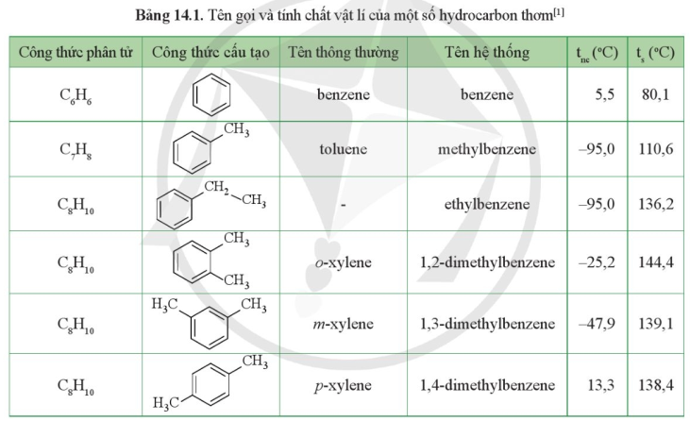
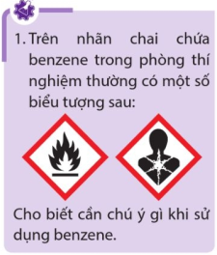 | ....................................................................................................................  ....................................................................................................................  ....................................................................................................................  ....................................................................................................................  ....................................................................................................................  ....................................................................................................................  ....................................................................................................................
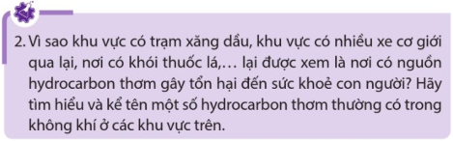 |  | ..................................................................  ..................................................................  ..................................................................  ..................................................................  ..................................................................

II. TÍNH CHẤT HÓA HỌC
1) Các phản ứng ở vòng benzene  a) Phản ứng thế  ■ Phản ứng thế halide  .........................................................................................................................  .........................................................................................................................  .........................................................................................................................  .........................................................................................................................  .........................................................................................................................  .........................................................................................................................  .........................................................................................................................  .........................................................................................................................  ......................................................................................................................... | 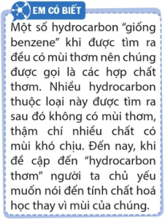
■ Phản ứng nitro hóa  .........................................................................................................................  .........................................................................................................................  .........................................................................................................................  .........................................................................................................................  .........................................................................................................................  .........................................................................................................................  .........................................................................................................................  .........................................................................................................................  .........................................................................................................................  .........................................................................................................................  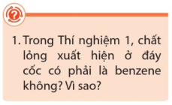  .........................................................................................................................  .........................................................................................................................  .........................................................................................................................  .........................................................................................................................  ......................................................................................................................... | 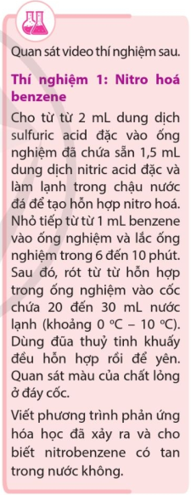

b) Phản ứng cộng
■ Cộng hydrogen
..........................................................................................................................................................................
..........................................................................................................................................................................
..........................................................................................................................................................................
..........................................................................................................................................................................
■ Cộng chlorine
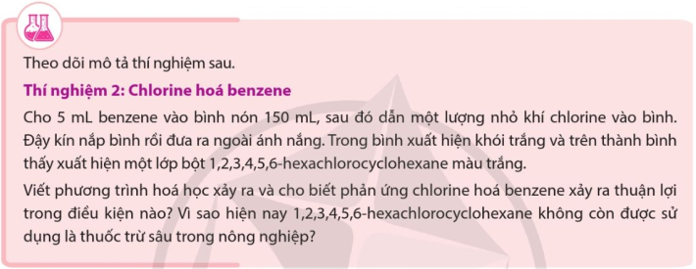
..........................................................................................................................................................................
..........................................................................................................................................................................
..........................................................................................................................................................................
..........................................................................................................................................................................
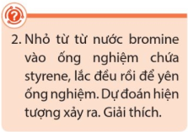 | ....................................................................................................................  ....................................................................................................................  ....................................................................................................................  ....................................................................................................................
2) Các phản ứng khác
a) Phản ứng oxi hóa mạch nhánh alkyl
..........................................................................................................................................................................
..........................................................................................................................................................................
..........................................................................................................................................................................
..........................................................................................................................................................................
..........................................................................................................................................................................
..........................................................................................................................................................................
..........................................................................................................................................................................
..........................................................................................................................................................................
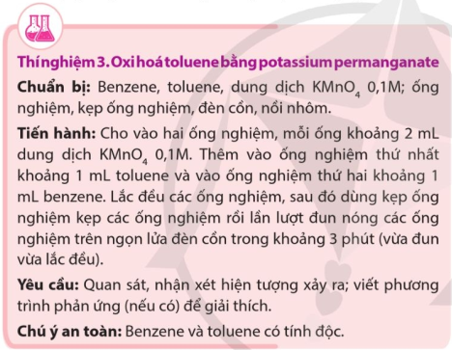  ....................................................................................................  ....................................................................................................  ....................................................................................................  ....................................................................................................  ....................................................................................................  .................................................................................................... | 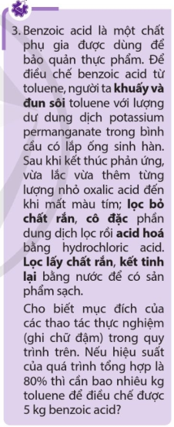
..........................................................................................................................................................................
..........................................................................................................................................................................
..........................................................................................................................................................................
..........................................................................................................................................................................
..........................................................................................................................................................................
..........................................................................................................................................................................
b) Phản ứng cháy
..........................................................................................................................................................................
..........................................................................................................................................................................
..........................................................................................................................................................................

IV. ĐIỀU CHẾ VÀ ỨNG DỤNG
1) Điều chế  .........................................................................................................................  .........................................................................................................................  .........................................................................................................................  .........................................................................................................................  2) Ứng dụng  .........................................................................................................................  .........................................................................................................................  .........................................................................................................................  .........................................................................................................................  .........................................................................................................................  ......................................................................................................................... | 