READING
PART 1
Look at the picture. Read the words. Which words go with the picture? Fill in the correct circles on your answer sheet.
1.

(A) The boy is drawing a picture. | (B) The boy is taking a photo. | (C) The boy is talking on the phone
The answer is “B”. Fill in “B” on your answer sheet.
2.
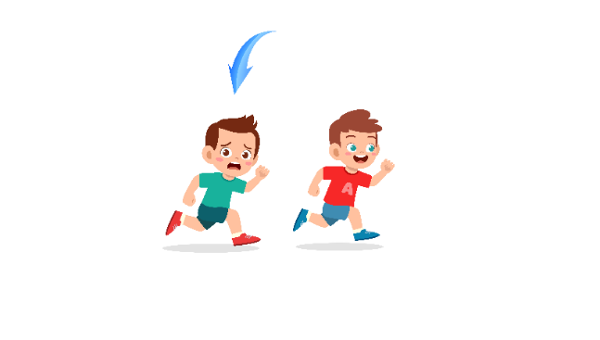
What does the arrow show?
The boy with the arrow is ahead of the other boy.
(A) Ahead | (B) Beside | (C) Under
The answer is “A”. Fill in “A” on your answer sheet.

3.

(A) Computer | (B) Calculator | (C) Keyboard
4.

(A) Blanket | (B) Bed | (C) Pillow
5.
 | 
(A) Butterfly | (B) Ant | (C) Snail
6.

(A) Longan | (B) Papaya | (C) Peach
7.
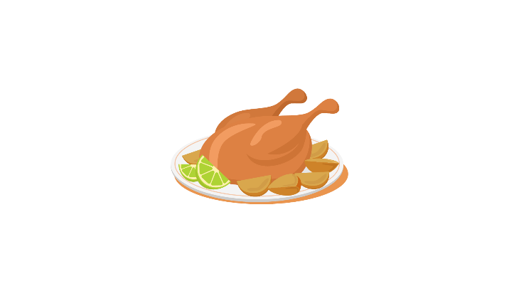

(A) Beef | (B) Chicken | (C) Pork
8.

(A) beard | (B) mustache | (C) hair
9.
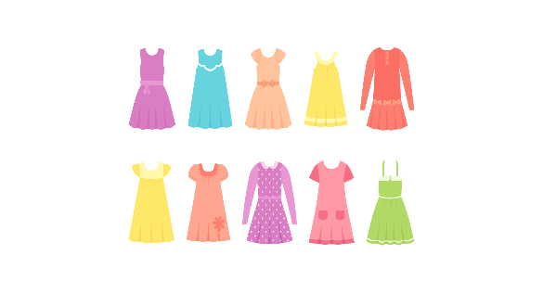
(A) Shirt | (B) Jacket | (C) Dress
10.
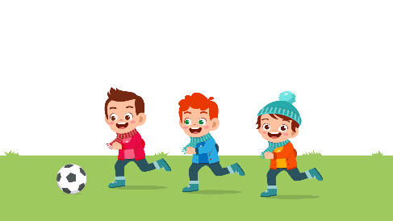
(A) They are playing soccer. | (B) They are playing table tennis. | (C) They are playing basketball.
11.
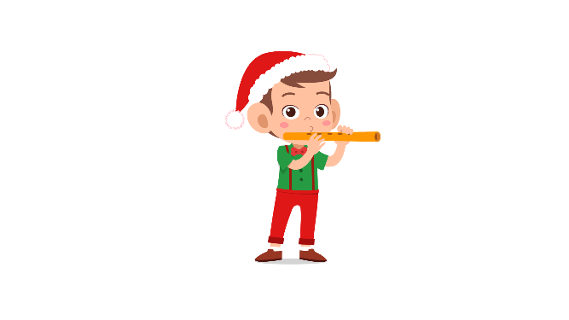
(A) The boy is playing the flute. | (B) The boy is playing the violin. | (C) The boy is playing the guitar.
12.
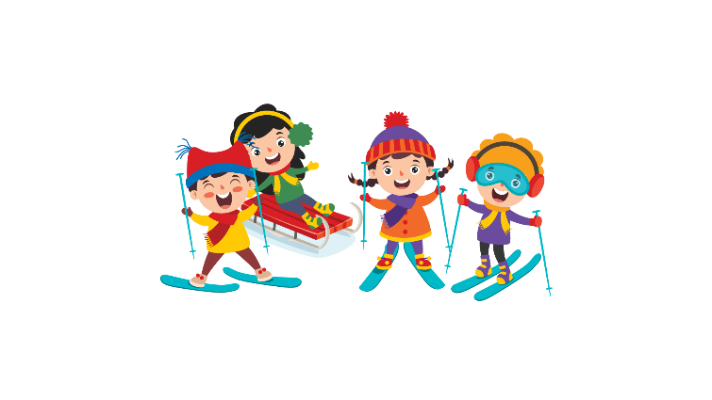
(A) They are going swimming. | (B) They are going skiing. | (C) They are going skateboarding.
13.
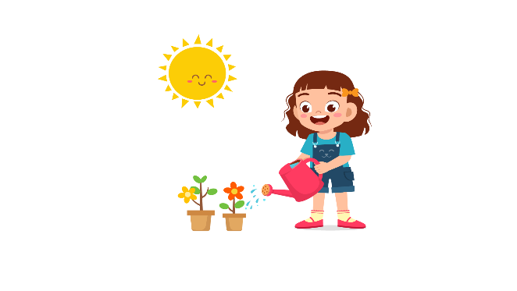
(A) She is cleaning the sofa. | (B) She is watering the flowers. | (C) She is washing dishes.
14.
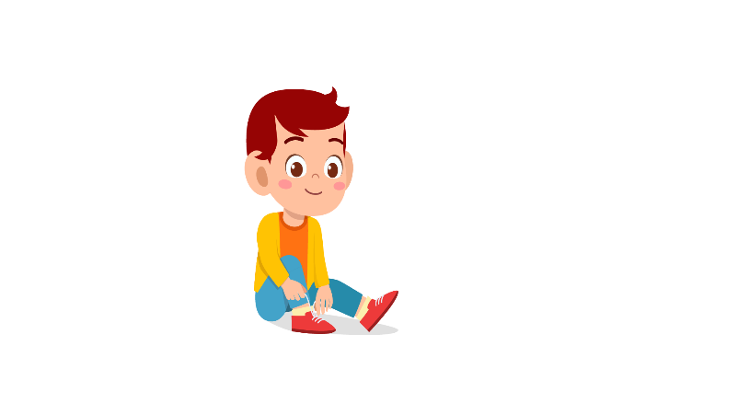
(A) The boy is wearing shoes. | (B) The boy is wearing sandals. | (C) The boy is wearing boots.
15.

(A) She is eating candies. | (B) She is eating a cake. | (C) She is eating fries.
16.

(A) The cat is chasing a mouse. | (B) The cat is climbing tree. | (C) The cat is eating fish.
17.


(A) The hospital is larger than the post office. | (B) The post office is larger than the hospital. | (C) The hospital is smaller than the post office.

PART 2
Read and find the answer.
Fill in the correct circles on your answer sheet.
Let’s do an example.
- Students go to class here. Teachers work here. It has many desks. What is it?
  - (A) A house
  - (B) A school
  - (C) A bank
The correct answer is a school. Fill in "B" on your answer sheet.

- It is a place. People go there to buy books. Where is it?
(A) A laboratory
(B) A library
(C) A bookstore

- This is a school object. It is on the wall. Teachers use chalk to write on it. What is it?
(A) A blackboard
(B) A book
(C) A paper

- Peter wants to take care of patients. He wants to be ________________ in the future.
(A) a doctor
(B) an engineer
(C) a teacher

- Today Lan is going to see a dentist. She has a _________.
(A) headache
(B) toothache
(C) stomachache

- A cat uses its legs to go up the top of the tree. It is ________ the tree.
(A) moving
(B) climbing
(C) running

- Musa is going out. She wears a big hat. It is ______________ outside.
(A) sunny
(B) rainy
(C) windy

- The class is _____________ because the teacher asks students not to talk.
(A) noisy
(B) crowded
(C) quiet

PART 3
Read the sign. Answer questions 26 to 29.
Fill in the correct circles on your answer sheet.
Jay, Alex, Janice, Kelly and Ana go to the insect museum. They read this sign at the museum

Guide to the insect museum

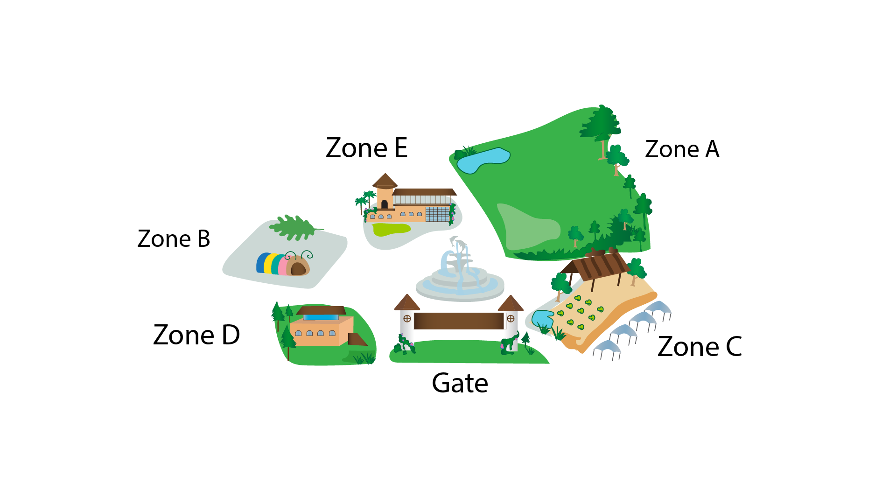

- Janice wants to read about insects. She goes to ____________.
(A) zone D
(B) zone E
(C) the gate
- Ana needs to see the butterflies. She goes to ____________.
(A) zone A
(B) zone C
(C) zone E
- Jay wants to watch videos about insects. He goes to ____________.
(A) zone A
(B) zone B
(C) zone C
29. Kelly wants to buy some gifts. She goes to ____________.
(A) the gate
(B) zone E
(C) zone D

Read about how family members help with the housework. Answer questions 30 to 33.
 | Karina | Mura | Jessie
Collect materials | From library | From Internet | From textbooks
Write the essay | Introduction | Conclusion | Body
Make presentation | Designing slides | Presenting | Writing scripts
30. Who will search for online materials?
(A) Karina
(B) Mura
(C) Jessie
31. Which part of the essay will Jessie write?
(A) Introduction
(B) Body
(C) Conclusion
32. Who will present the ideas in front of class?
(A) Karina
(B) Mura
(C) Jessie
33. Which source will Karina get information from?
(A) Library
(B) Internet
(C) Textbooks

Read the letter. Answer questions 34 to 35.

To: luckysira100@webmail.com
Subject: Invitation

Hi Lisa,

I'm having a birthday party next Friday at my house. Would you like to come? It’ll be fun! Lots of people from my school are coming. You know some of them – Petra, Karl, Marco and Rob. Can you bring some lemonade and crisps?

My house is behind our school, 6 GreenField Avenue. It’s right next to the park and it’s got a blue front door.

Hope you can come and see you soon,
Edu.

34. Why does Edu write to Lisa?
(A) To ask her to bring some food
(B) To introduce some of her friends
(C) To invite her to a party
35. What is true about the birthday party?
(A) There will be a lot of participants from other schools.
(B) It is held behind the school.
(C) It has a lot of fast food.

Read the email. Answer questions 36 to 37.
36. Why does Lili Song write to Ms Black?
(A) To show her interest in English courses
(B) To ask questions about the courses
(C) To apply for the English courses

37. What information does Lili NOT need to know?
(A) the price of the courses
(B) names of students who will live with her
(C) whether social programme has sports activities

Read the letter. Answer questions 38 to 39.
To: tim147@mail4me.uk
Subject: Hi :)

Hi Tim,

Nice to meet you! My name's Sara and I'm fifteen. I live in London with my mum, my little brother and my dog. We live in a small house in Greenwich. It's got three bedrooms and a small garden.

My teacher Mrs Jenkins is nice, but sometimes she gives us lots of homework. After school I often go to a cafe with my friends. Then usually we go home to do our homework.

At the weekend I sometimes play in hockey matches and I often go running in the park. I can run very fast and sometimes I run when I take my dog for a walk!

Write soon and tell me all about yourself, your friends and your family.
Best wishes
Sara
38. Why does Sara write to Tim?
(A) To share about her school life
(B) To talk about her life
(C) To tell about sports
39. What is NOT true about Sara?
(A) She can run fast.
(B) She and her friends enjoy doing homework at the café.
(C) She takes part in the school hockey team.

You finished the reading test.
LISTENING
PART 1
Listen to the words. Look at the pictures.
Fill in the correct circles on your answer sheet.
1.
 | 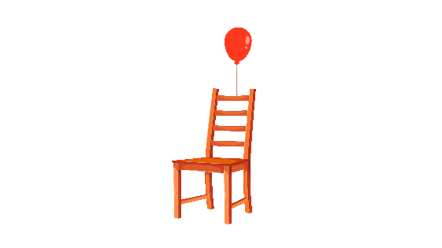 | 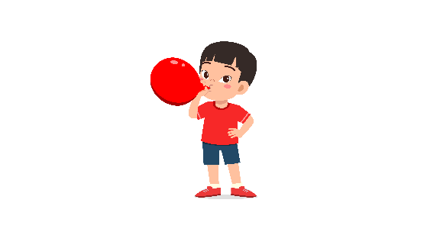
(A) | (B) | (C)
2.
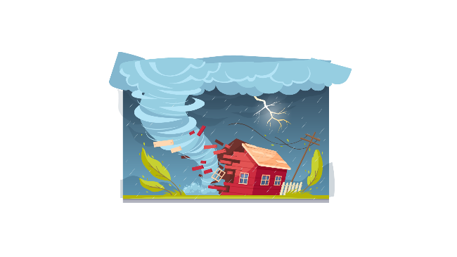 |  | 
(A) | (B) | (C)
3.
 | 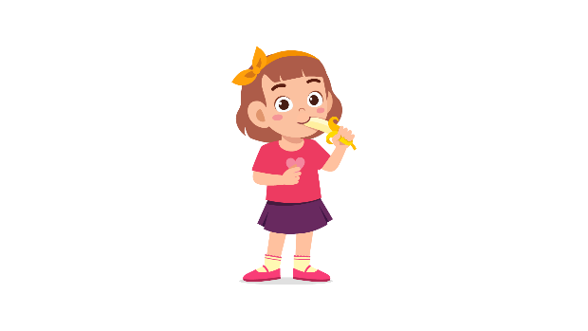 | 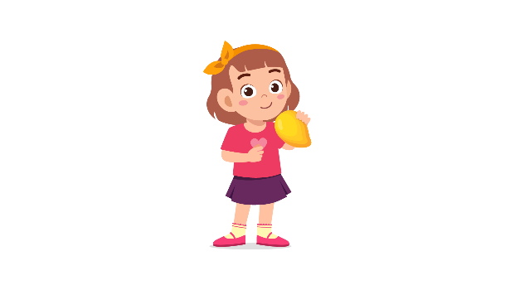
(A) | (B) | (C)
4.
 | 
(A) | (B) | (C)
5.
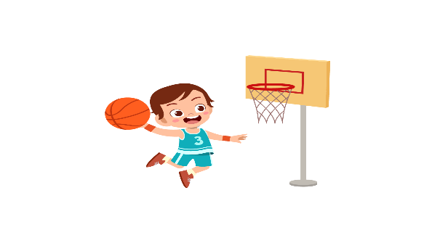 | 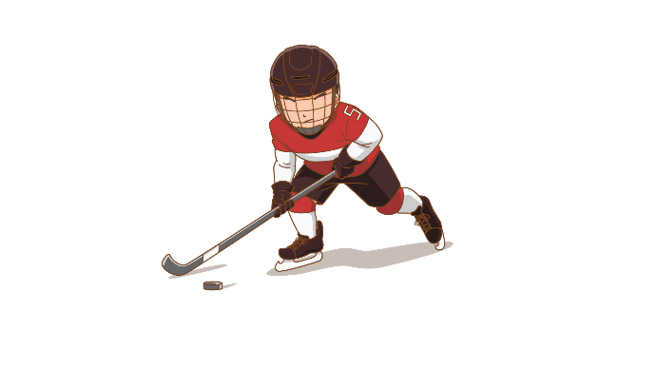 | 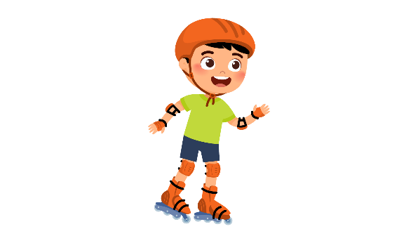
(A) | (B) | (C)
6.
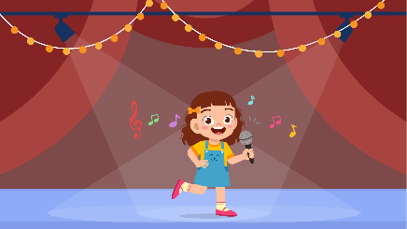 | 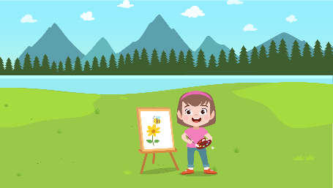 | 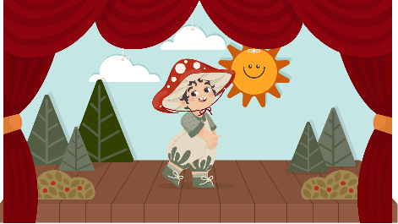
(A) | (B) | (C)
7.
 |  | 
(A) | (B) | (C)
8.
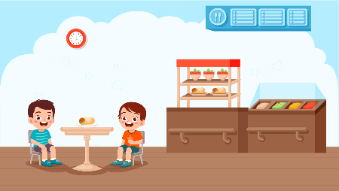 |  | 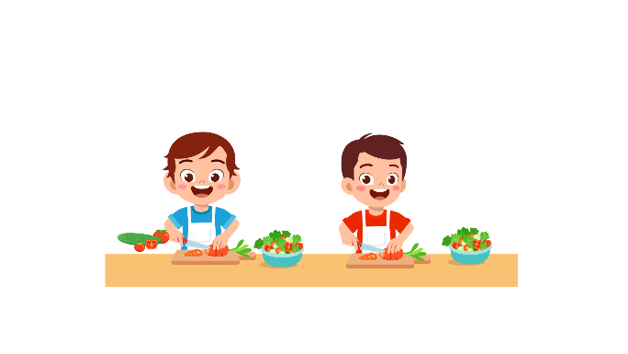
(A) | (B) | (C)

PART 2
Fill in the correct circles on your answer sheet.

9.
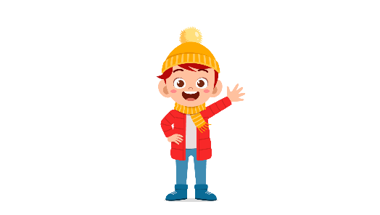 | 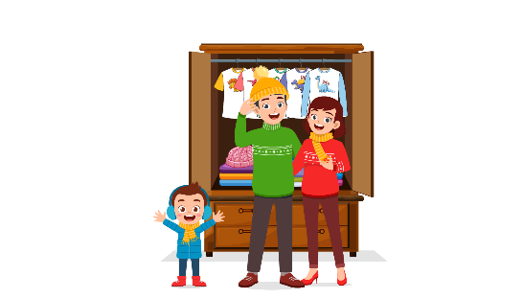 | 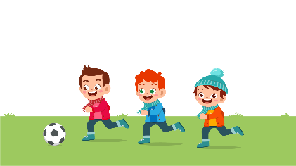
(A) | (B) | (C)
10.
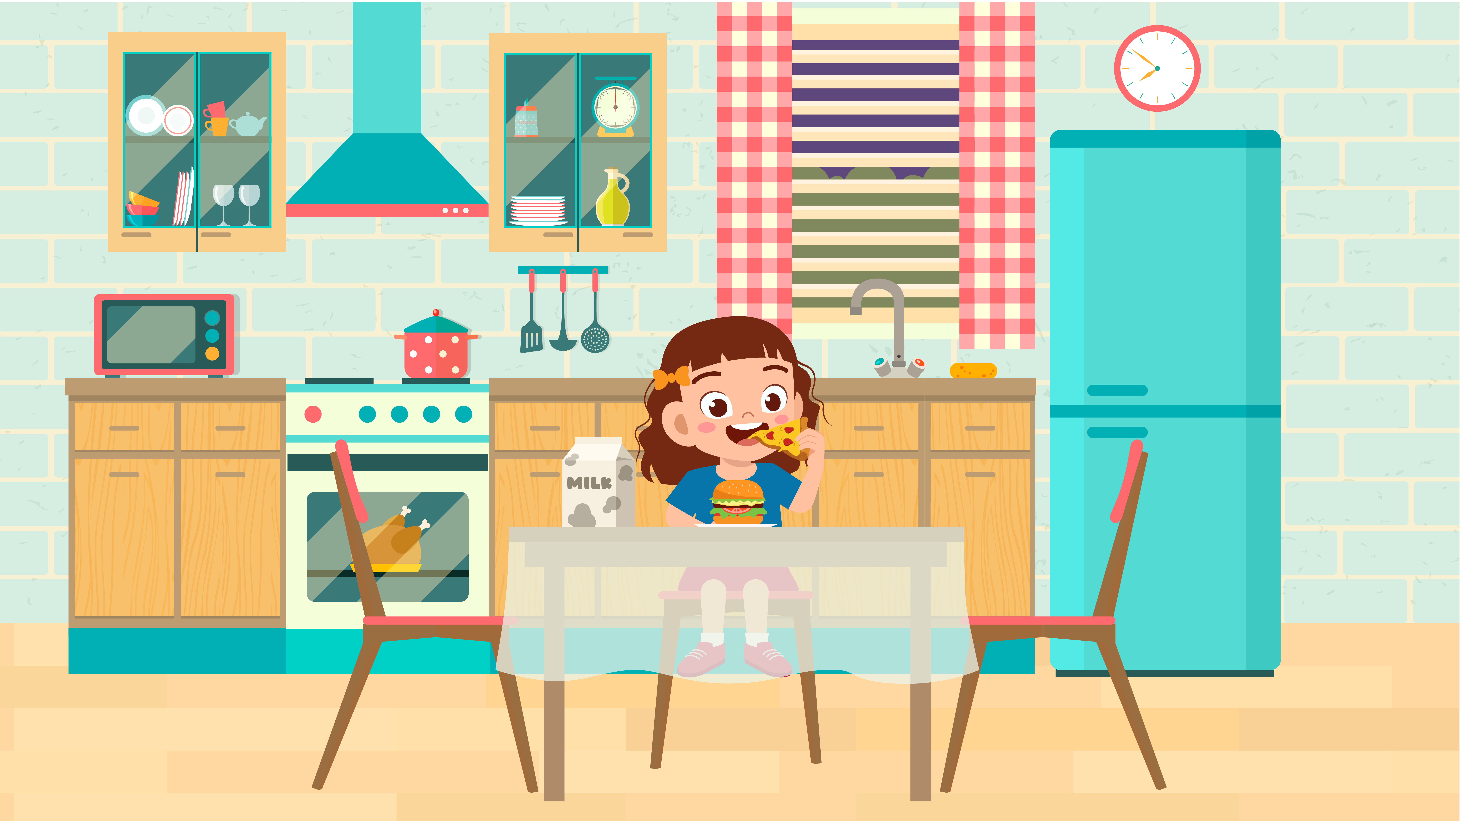 | 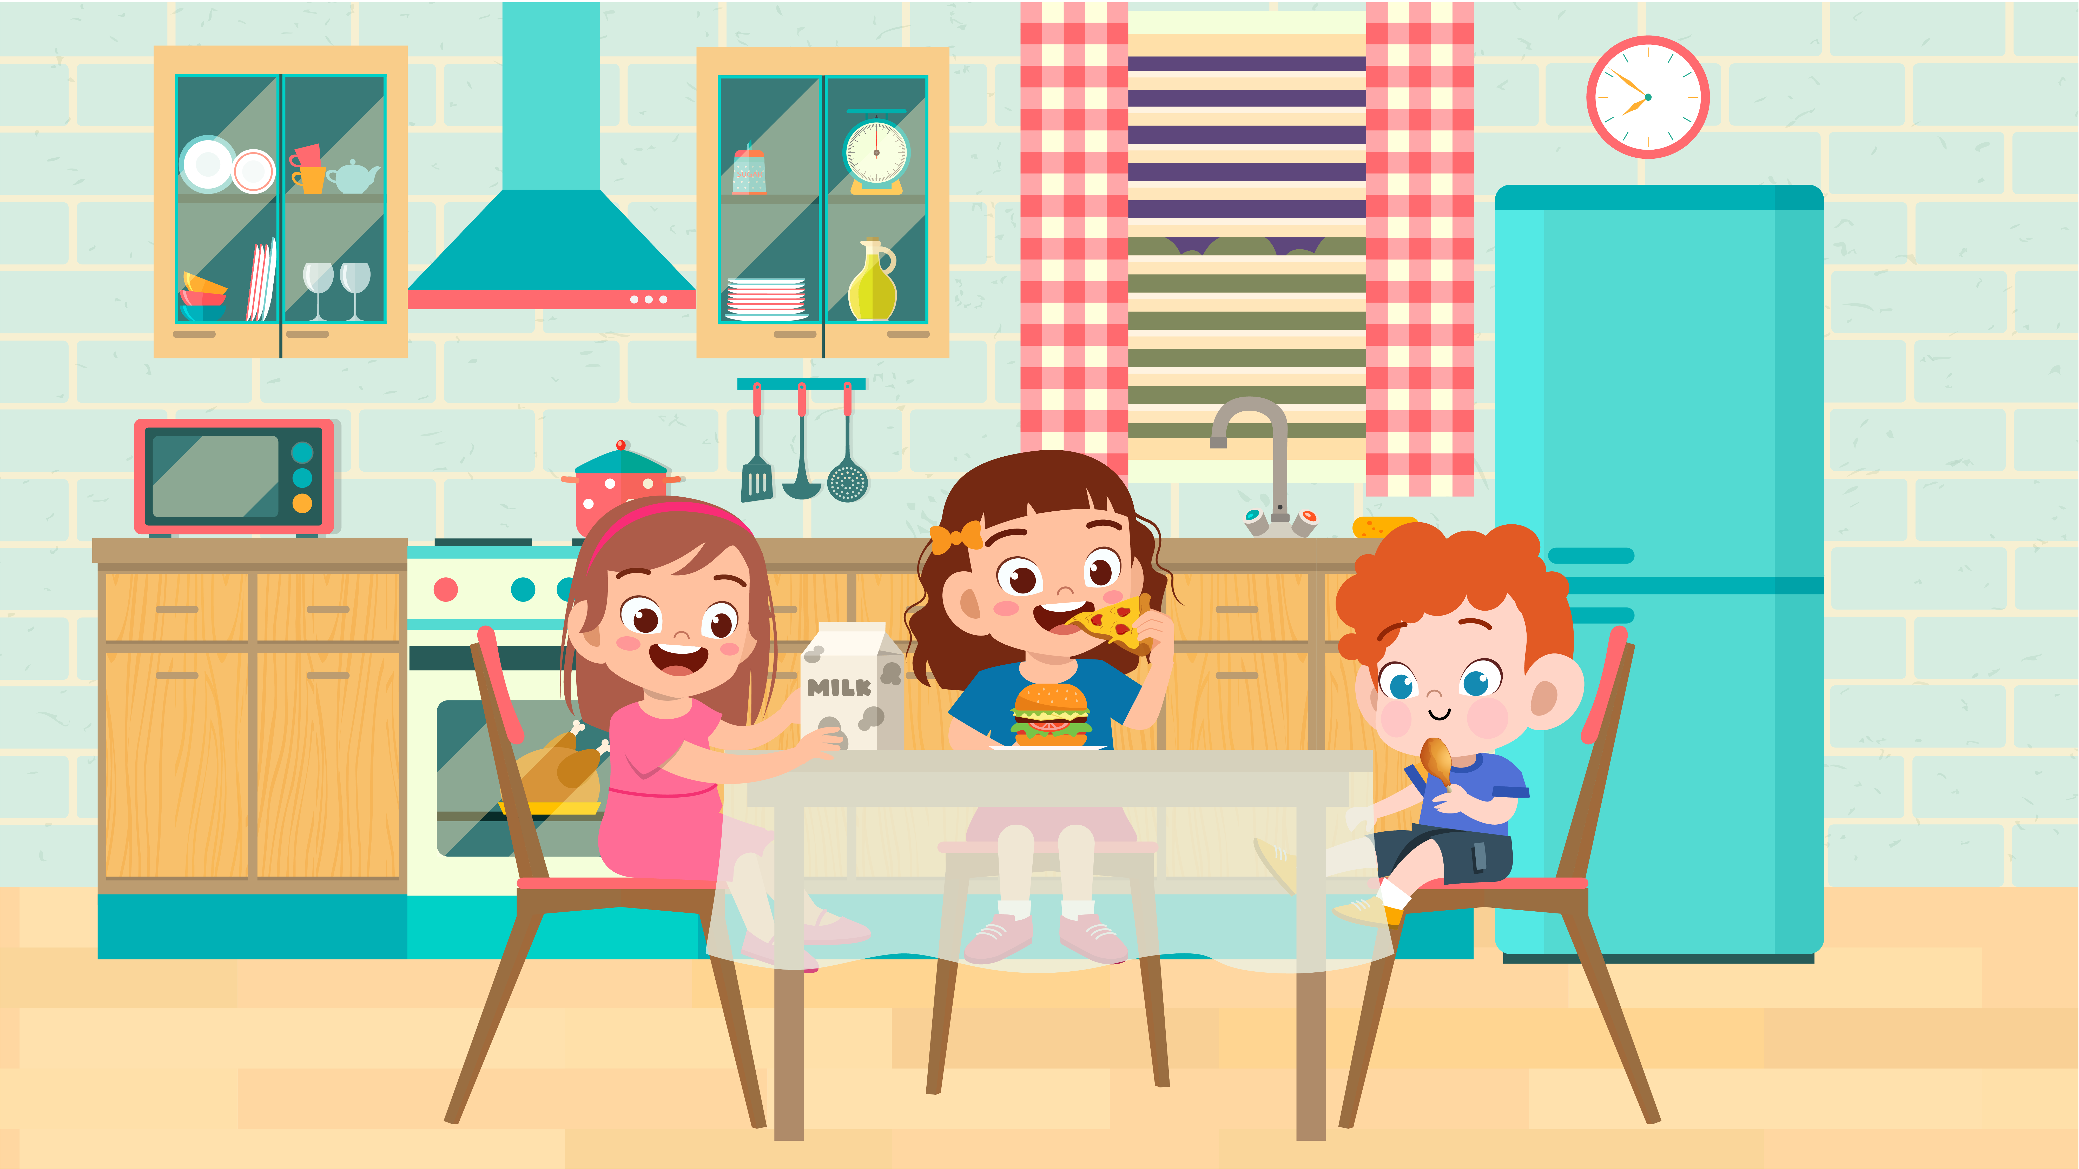 | 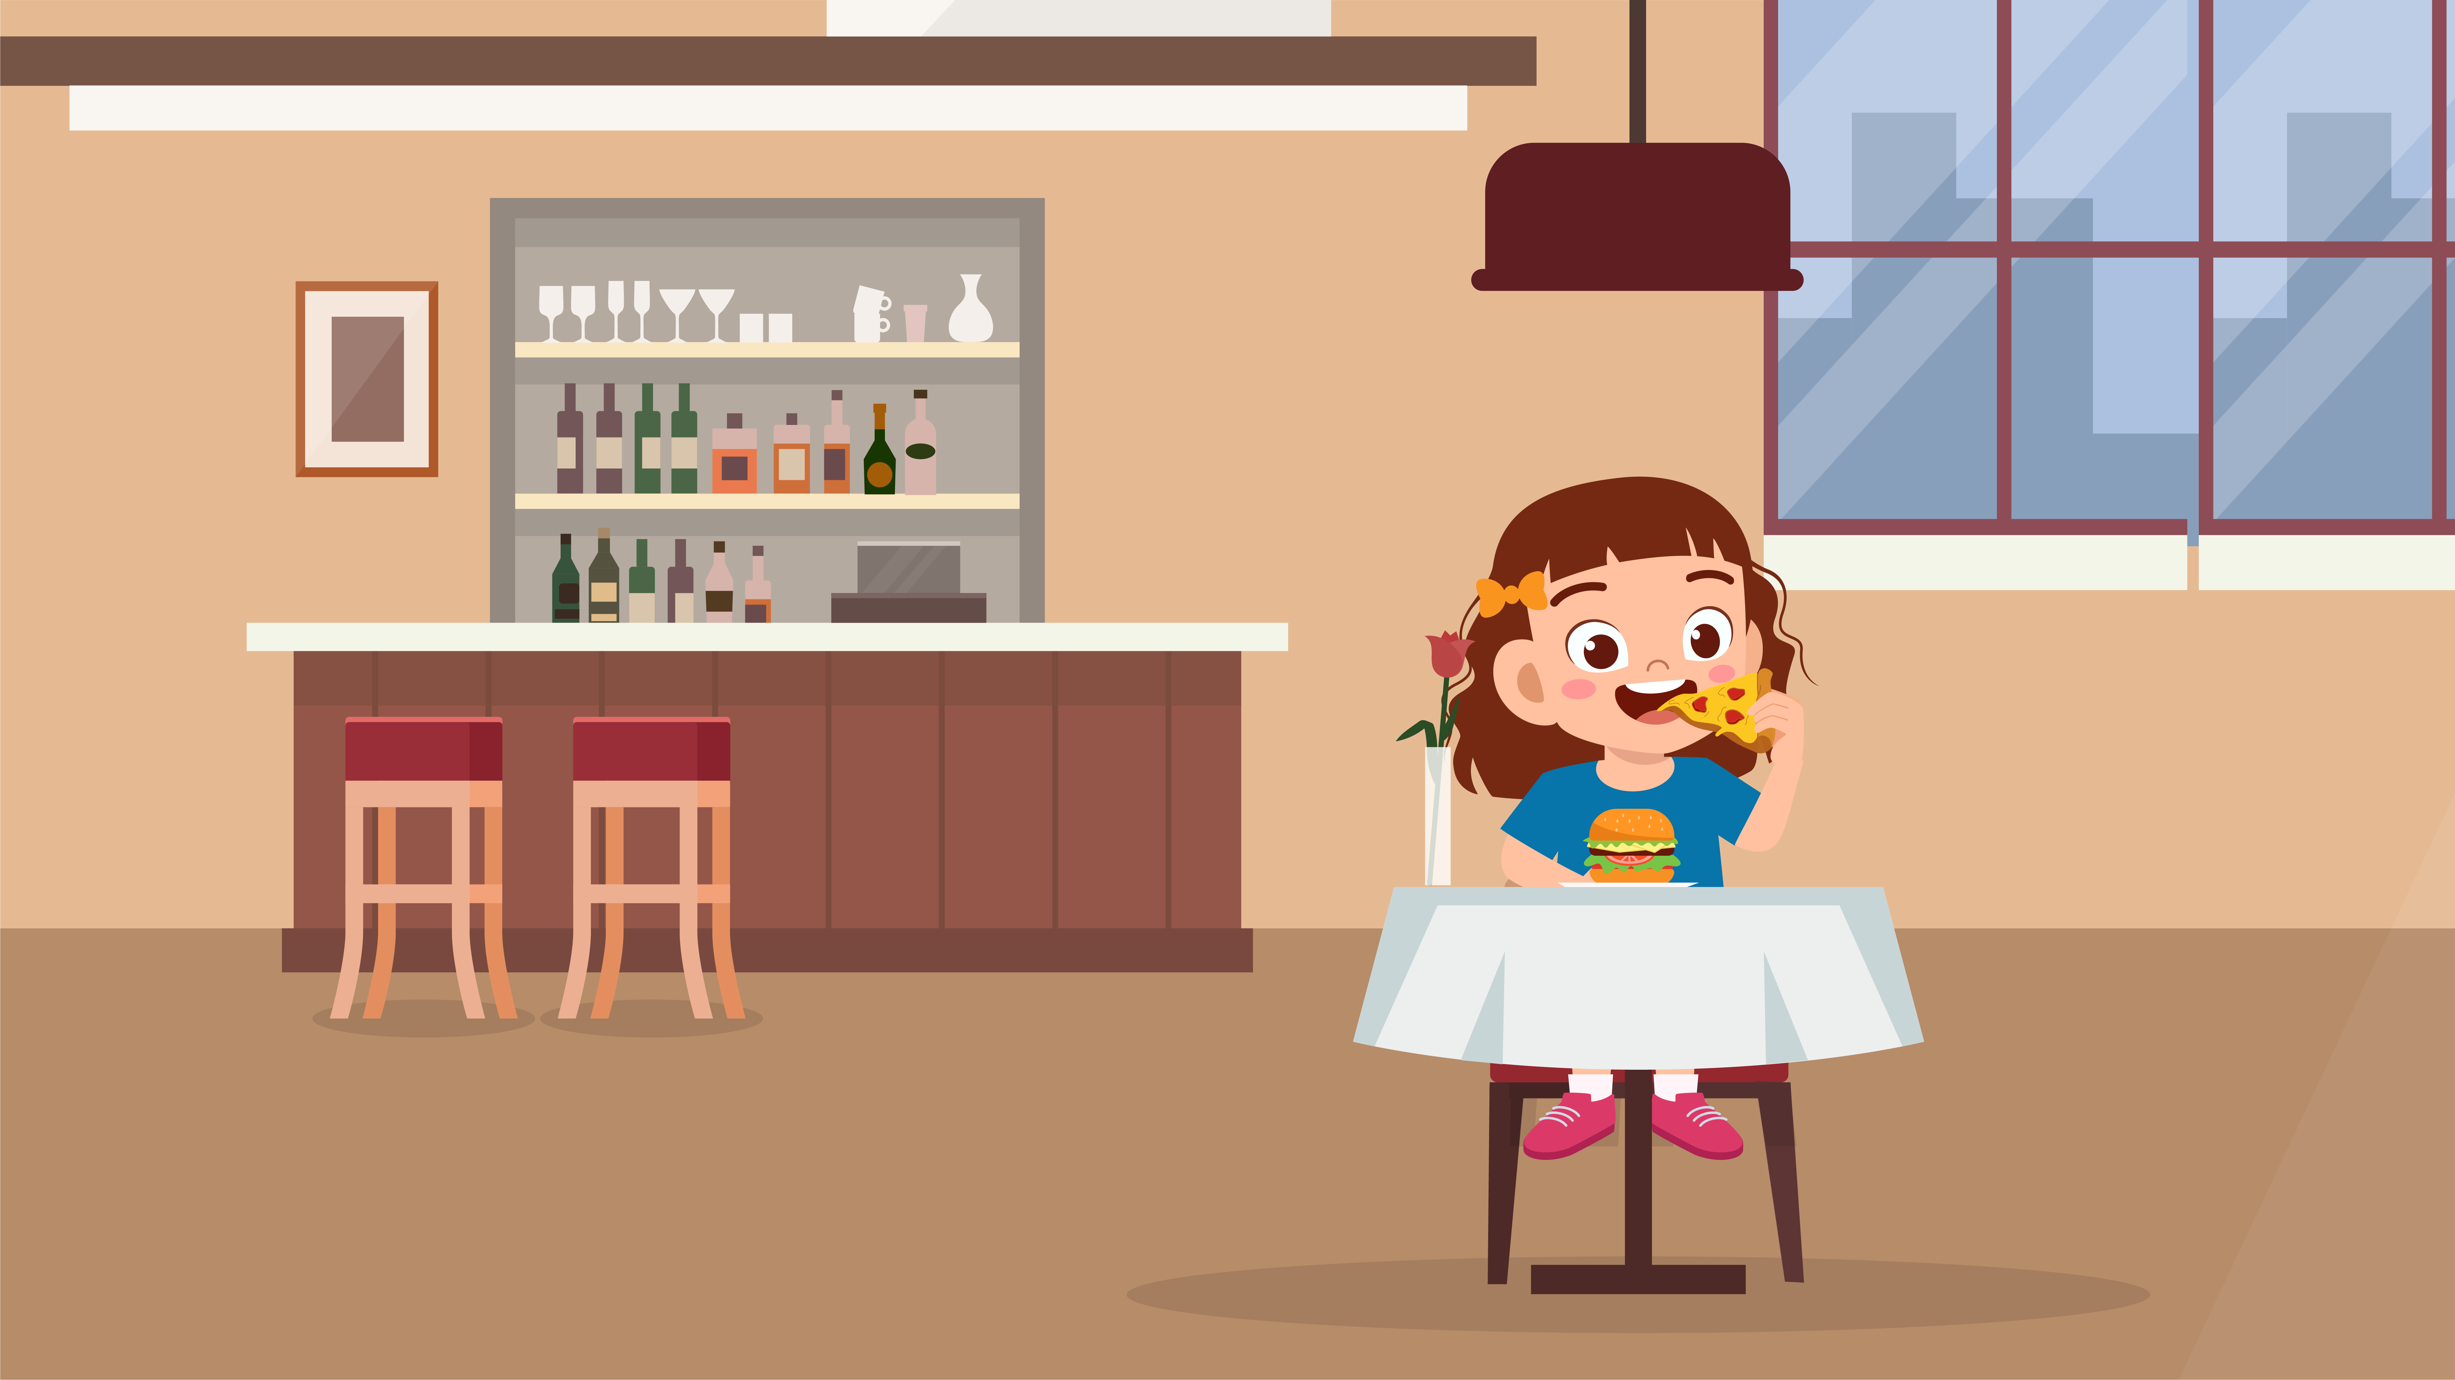
(A) | (B) | (C)
11.
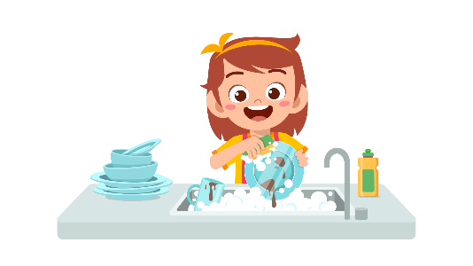 | 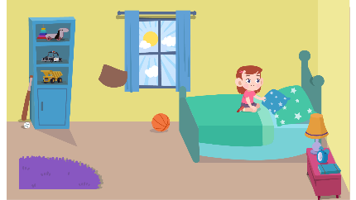 | 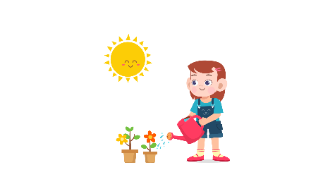
(A) | (B) | (C)
12.
 |  | 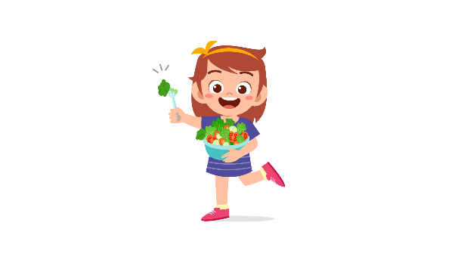
(A) | (B) | (C)
13.
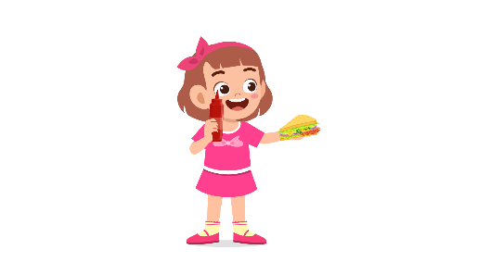 | 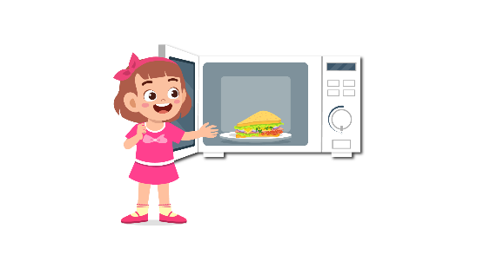 | 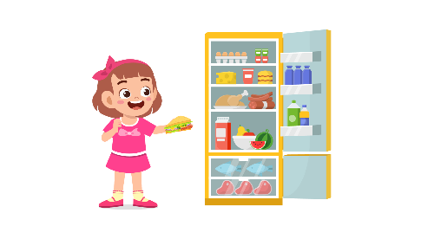
(A) | (B) | (C)
14.
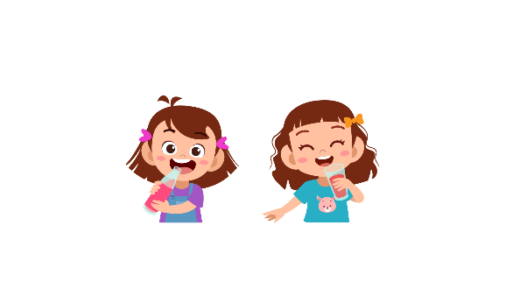 |  | 
(A) | (B) | (C)
15.
 |  | 
(A) | (B) | (C)
16.
 |  | 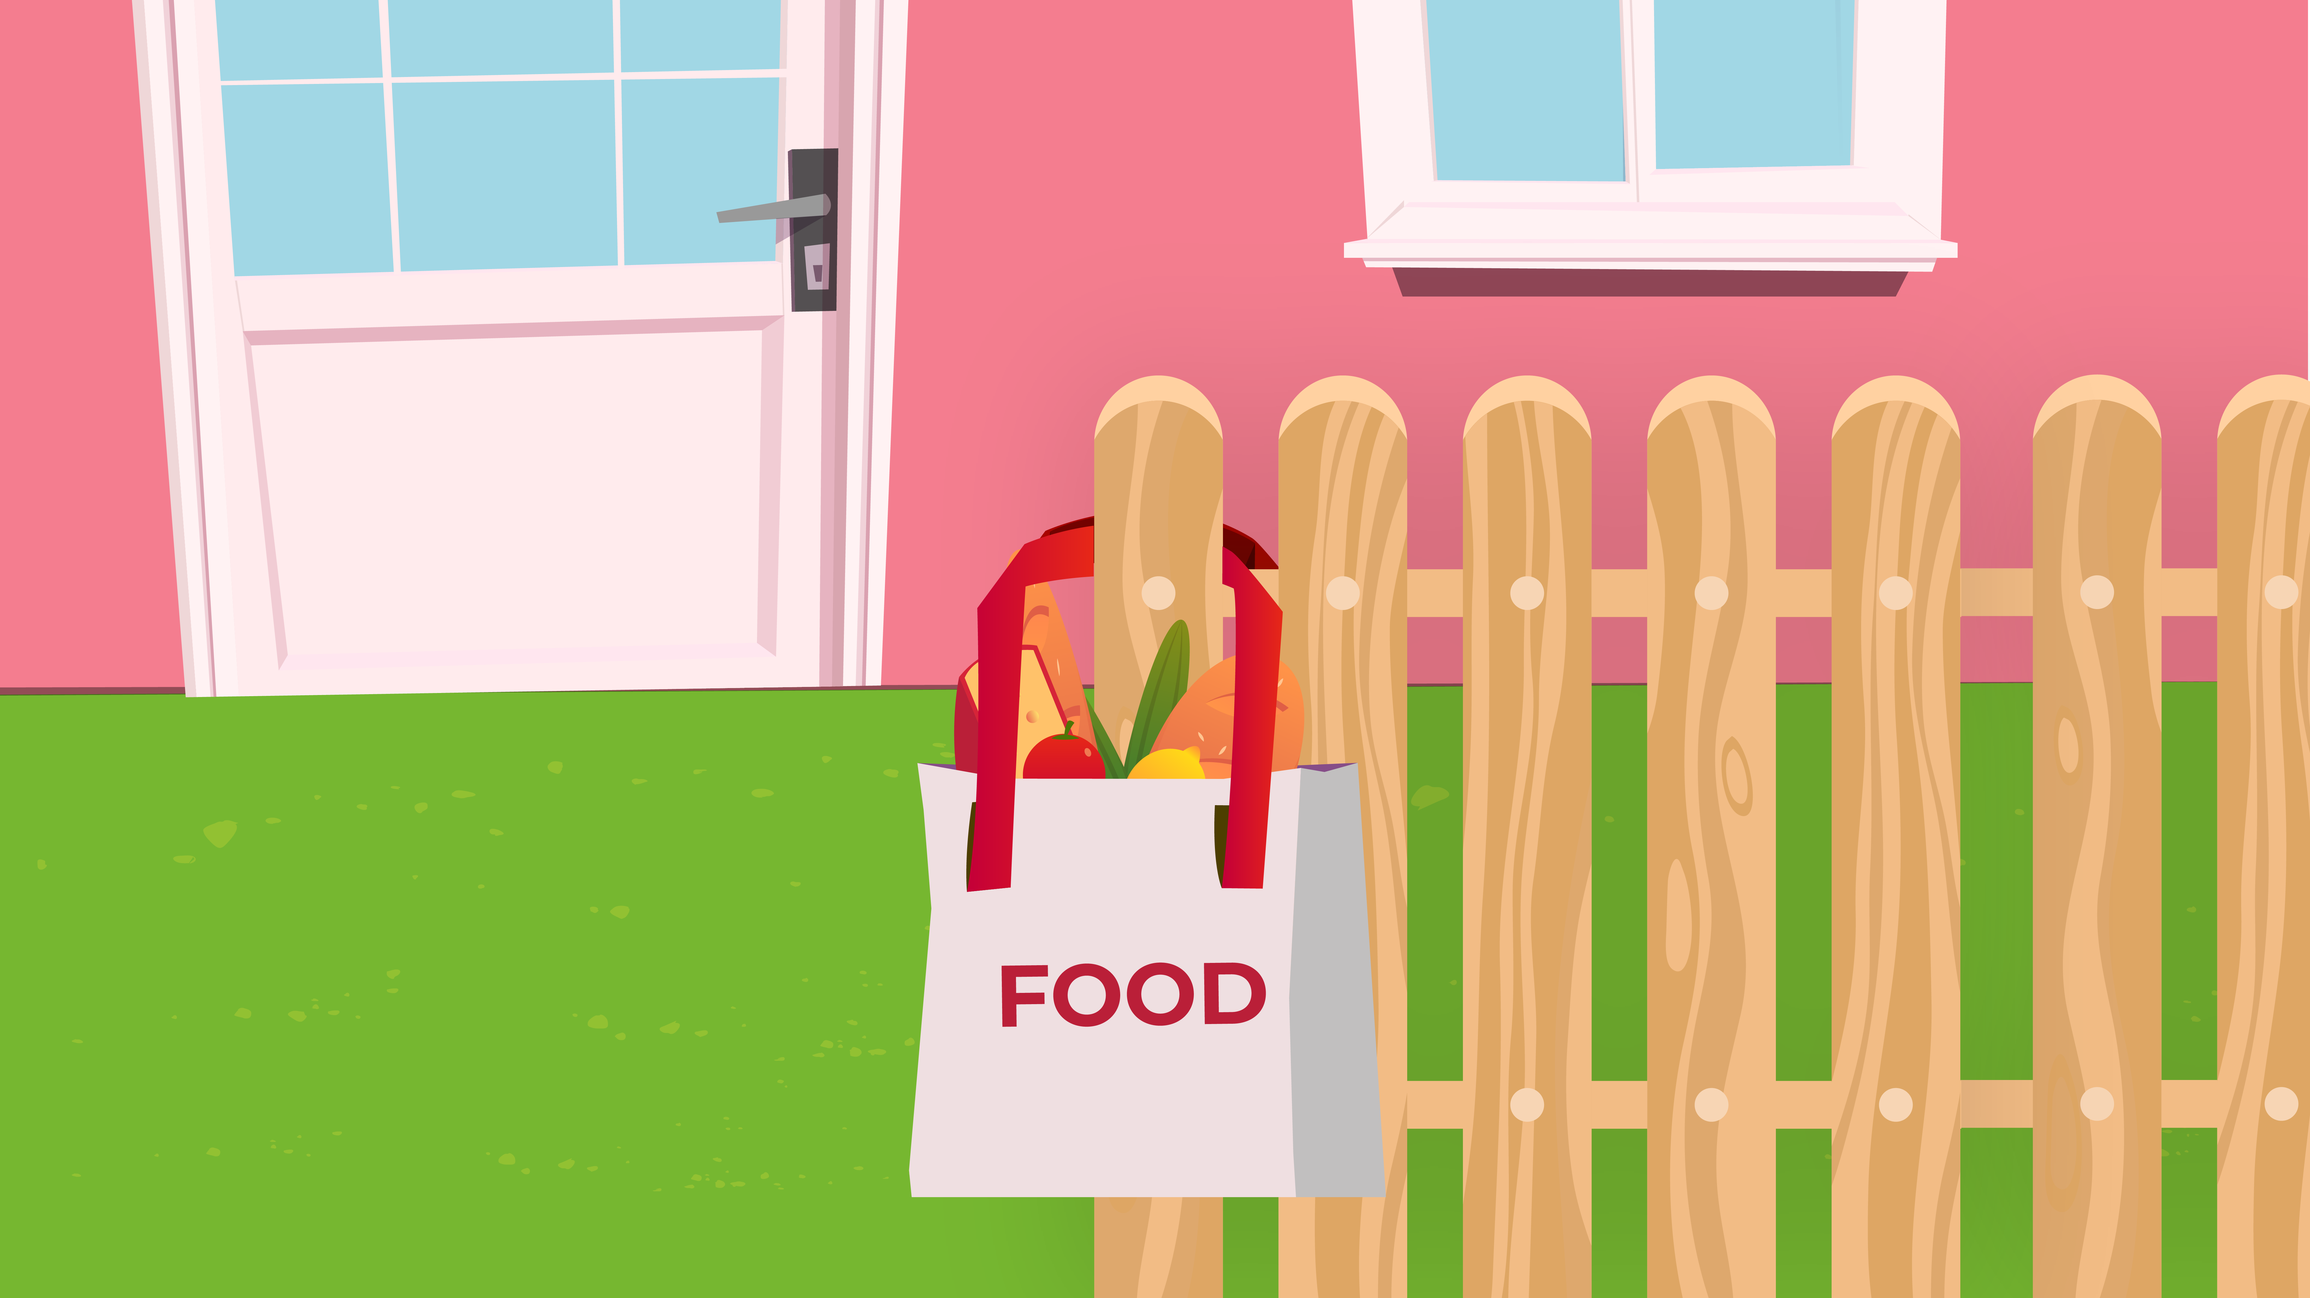
(A) | (B) | (C)
17.
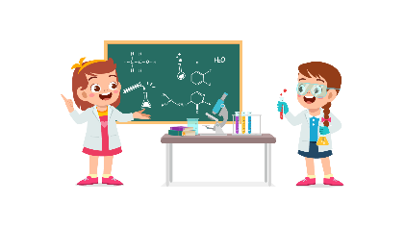 | 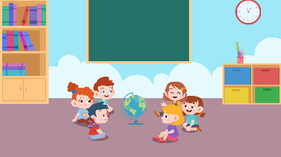 | 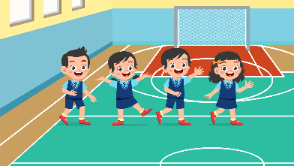
(A) | (B) | (C)
PART 3
Fill in the correct circles on your answer sheet.
Look at your answer sheet. Listen to a conversation. Which conversation sounds correct?
Let’s do an example.
(Narrator): A
(Boy): Hello. What’s your name?
(Girl): I’m fine, thanks.
(Narrator): B
(Boy): How are you today?
(Girl): I’m six years old.
(Narrator): C
(Boy): Nice to meet you!
(Girl): Nice to meet you, too!
The answer is "C." Fill in "C" on your answer sheet. Now, you do it.
18.
(A) | (B) | (C)
19.
(A) | (B) | (C)
20.
(A) | (B) | (C)
21.
(A) | (B) | (C)
22.
(A) | (B) | (C)
23.
(A) | (B) | (C)
24.
(A) | (B) | (C)
25.
(A) | (B) | (C)
26.
(A) | (B) | (C)
27.
(A) | (B) | (C)

PART 4
Listen to a conversation and answer the question. Fill in the correct circle on your answer sheet.
Let’s do an example.
28. When is the girl's party?
(A) Tonight
(B) Next week
(C) This weekend
The answer is "C." Fill in "C" on your answer sheet. Now, you do it.
29. What did the girl do last weekend?
(A) Stay at home
(B) Visit another country
(C) Go camping
30. What does the customer buy?
(A) A shirt
(B) A skirt
(C) A T-shirt
31. What will the girl do this summer holiday?
(A) go to the beach
(B) climb a mountain
(C) go camping
32. What does the teacher tell the boy to do?
(A) write an essay
(B) go to the library
(C) read books
33. What does the girl need to do?
(A) design the party
(B) wash the dishes
(C) prepare food for friends
34. What do the friends want to do?
(A) go to the park
(B) go to the museum
(C) go to the zoo

PART 5
Listen and answer the question.
Fill in the correct circle on your answer sheet.
Let’s do an example.
- What did Mike call about?
(A) Homework
(B) A movie
(C) A library book
The answer is "B." Fill in "B" on your answer sheet. Now, you do it.

36. Why did Lisa’s mother call?
(A) To ask her to make a list
(B) To ask her to check the table
(C) To tell her to buy something
37. Why did Santra call?
(A) To remind about the homework’s deadline
(B) To suggest essay checking
(C) To change a date
38. Why did Camilla call?
(A) To confirm one previous decision
(B) To tell about her piano class
(C) To change the plan
39. Why did the teacher call?
(A) To invite Lucy to the gallery
(B) To borrow her pictures
(C) To ask Lucy to draw a picture
40. Why did the shop assistant call?
(A) To notify Maria of new products
(B) To tell about lower price of products
(C) To ask about favorite products
41. Why did Ariel call?
(A) To get further information on the topic
(B) To ask about the deadline
(C) To ask for related materials

