School: ……………………………………….. | Date: ………………………………..
Class: ……………………………..................... | Period: ………………………..........

UNIT 7: TRANSPORTATION
Lesson 4 – Review (pages 102, 103)

I. OBJECTIVES
By the end of the lesson, Ss will be able to:
1.1. Language knowledge and skills
- review words about personal belongings and means of transportation (customs, passport, suitcase, baggage claim, boarding pass, frequent, sunglasses, subway, …) and talk about them.
- review grammar: possessive pronouns, order of adjectives, equal comparison.
- review: describe and identify personal belongings, compare different types of transportation.
- pronoun the ending sounds correctly: “s” endings.
- put stress on nouns and adjectives with two and three syllables.
1.2. Competences
- improve speaking, listening, reading and writing skills.
- improve the use of English.
1.3. Attributes
- have positive attitude in English language learning so that they actively participate in all classroom activities.
- review the old lesson and have good preparation for the second mid-term test.

II. TEACHING AIDS AND LEARNING MATERIALS
1. Teacher’s aids: Student book and Teacher’s book, class CDs, Digital Book (DCR phần mềm tương tác SB, DHA (từ vựng/ cấu trúc) phần mềm trò chơi tương tác), projector/interactive whiteboard / TV (if any), PowerPoint slides, handouts.
2. Students’ aids: Student’s book, workbook, notebook.

III. ASSESSMENT EVIDENCE
Performance Tasks | Performance Products | Assessment Tools
- Listening: You will hear a man talking about transportation in London. Listen and fill in the blanks. You will hear the information twice. | - Ss’ answers. | - T’s feedback/Peers’ feedback.
- Reading: Read the email about a trip to an amusement park. Write one word for each blank. | - Ss’ answers. | - T’s feedback/Peers’ feedback.
- Vocabulary: Match the words with the descriptions. | - Ss’ answers. | - T’s feedback/Peers’ feedback.
- Grammar: Circle the correct words.  - Write sentences using the prompts. | - Ss’ answers. | - T’s feedback/Peers’ feedback.
-Pronunciation: Circle the word that has the underlined part pronounced differently from the others.  + Circle the word that differs from the other three in the position of primary stress in each of the following questions. | - Ss’ answers/ presentation. | - T’s observation, T’s feedback/Peers’ feedback.

IV. PROCEDURES
A. Warm up: (5’)
a) Objective: Introduce the new lesson and set the scene for Ss to acquire new language; get students' attention at the beginning of the class by enjoyable and short activities as well as to engage them in the follow-up steps.
b) Content: Review: Means of transport.
c) Expected outcomes: Ss are ready for the new lesson.
d) Organization of the activity:
TEACHER’S ACTIVITIES | STUDENTS’ ACTIVITIES
- Option 1: Find the differences  - Have Ss look at 2 pictures and find the differences between them (in 2 minutes).  - Call Ss to give answers.  - Correct Ss’ pronunciation if necessary.  - Lead to the new lesson.  *Illustration:  Picture 1:  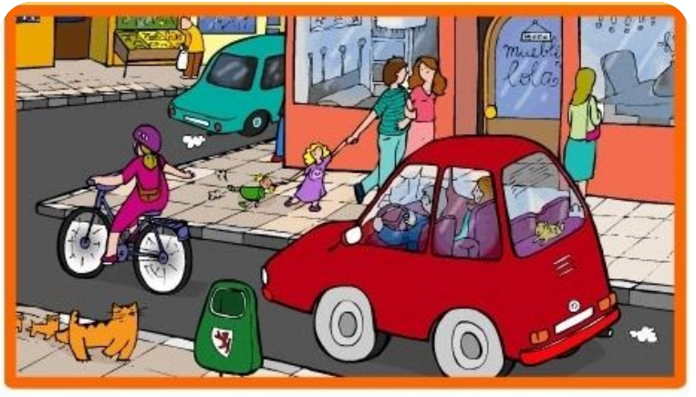  Picture 2  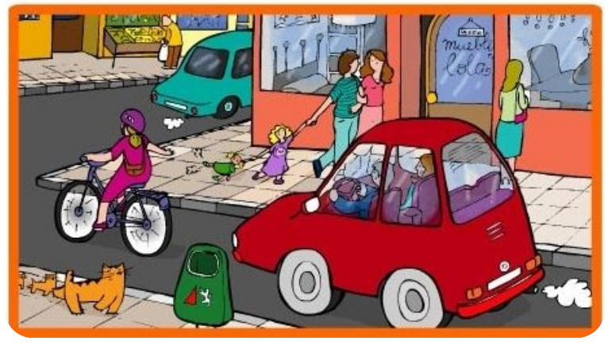  - Option 2: Review: Means of Transport  - Have Ss work in groups to list means of transport as many as possible.  - Call Ss to give answers, then pronounce the words and give meaning.  - Correct Ss’ pronunciation if necessary.  - Lead to the new lesson. | - Look at the pictures and find the differences.  - Give answers.  - Listen.  Suggested answer  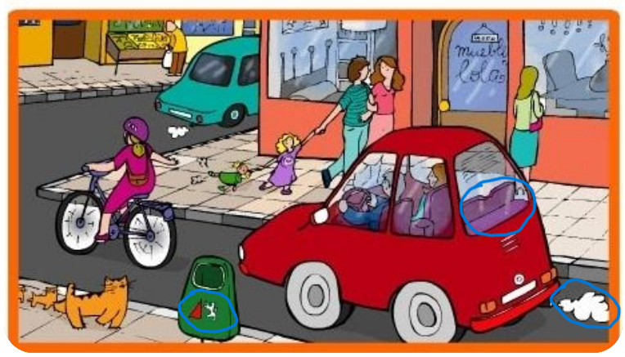  - Work in groups, list means of transport.  - Give answers, pronounce the words.  - Listen.  Some suggested answers  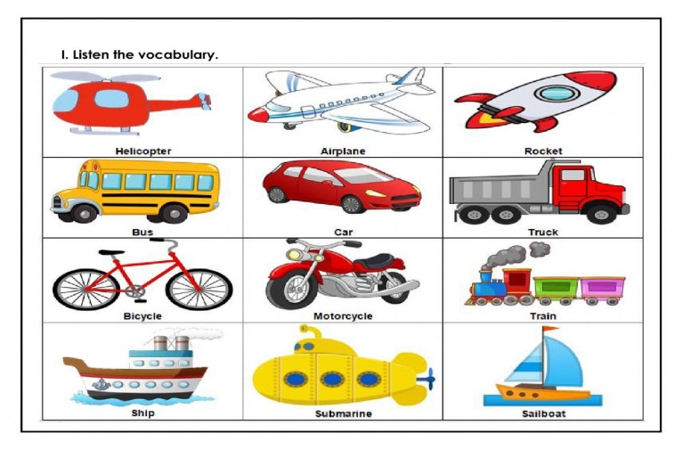

B. New lesson (35’)
- Activity 1: Listening (7’)
a) Objective: Help Ss improve their listening skill.
b) Content:
- You will hear a man talking about transportation in London. Listen and fill in the blanks. You will hear the information twice.
c) Expected outcomes: Ss listen in details and get familiar with the listening test format.
d) Organization of the activity:
TEACHER’S ACTIVITIES | STUDENTS’ ACTIVITIES
You will hear a man talking about transportation in London. Listen and fill in the blanks. You will hear the information twice.  - Have Ss read through the listening part.  - Demonstrate the activity on DCR by using the example.  - Play the audio (CD 2 – Track 41). Have Ss listen and choose the correct answer.  - Have Ss check answers with pairs, then read answers  - Check answers as a whole class using DCR. | - Read in silence.  - Listen and read answers.  Answer keys  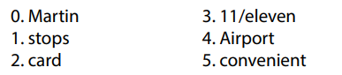
- Activity 2: Reading (7’)
a) Objective: Students can improve their reading skill.
b) Content:
- Read the email about a trip to an amusement park. Write one word for each blank.
c) Expected outcomes: Ss read for comprehension and get familiar with the reading test format.
d) Organization of the activity:
TEACHER’S ACTIVITIES | STUDENTS’ ACTIVITIES
Read the email about a trip to an amusement park. Write one word for each blank.  - Demonstrate the activity on DCR by using the example.  - Have Ss look and read, then choose the correct answer, underline the supporting ideas for their answers.  - Call Ss to give answers, explain.  - Give feedback and evaluation. | - Observe and listen.  - Work individually.  - Give answers, explain.  Answer keys  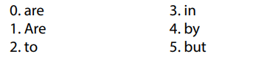

- Activity 3: Vocabulary (7’)
a) Objective: Ss can review vocabulary about personal belongings.
b) Content: Match the words with the descriptions.
c) Expected outcomes: Ss produce the new language successfully, and they can use these words in speaking and writing.
d) Organization of the activity:
TEACHER’S ACTIVITIES | STUDENTS’ ACTIVITIES
Match the words with the descriptions.  - Have Ss read the sentences.  - Ask Ss to work in pairs match the words with the descriptions.  - Have Ss give answers, tell the meaning of the words /phrase again.  - Check answers as a whole class using DCR. | - Read the sentences.  - Work in pairs to match.  - Give answers.  Answer keys  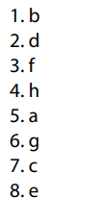
- Activity 4: Grammar (10’)
a) Objective: Ss can review the use of English: possessive pronouns, order of adjectives, equal comparison.
b) Content:
- Circle the correct words.
- Write sentences using the prompts.
c) Expected outcomes: Ss produce the new language successfully, and they can use the grammar points in speaking and writing.
d) Organization of the activity:
TEACHER’S ACTIVITIES | STUDENTS’ ACTIVITIES
Task a. Circle the correct words.  - Ask Ss to work individually to circle the correct words.  - Have Ss work in pairs to check each other’s work.  - Call Ss to give answers, explain for their choice.  - Check answers as a whole class using DCR.  Task b. Write sentences using the prompts  - Ask Ss to read the prompts.  - Have Ss write sentences using the prompts.  - Have Ss work in pairs to check each other’s work.  - Call Ss to give answers.  - Check answers as a whole class using DCR. | - Work individually.  - Work in pairs.  - Give answers.  Answer keys  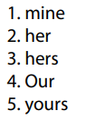  - Work individually.  - Work in pairs.  - Give answers.  Answer keys  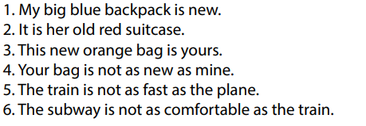
- Activity 5: Pronunciation (4’)
a) Objective: Ss can review the stress of nouns and adjectives with 2 and 3 syllables, last consonant of “s” endings.
b) Content:
- Circle the word that has the underlined part pronounces differently from the others.
- Circle the word that differs from the other three in the position of primary stress in each of the following questions.
c) Expected outcomes: Ss produce the new language successfully.
d) Organization of the activity:
TEACHER’S ACTIVITIES | STUDENTS’ ACTIVITIES
Task a. Circle the word that has the underlined part pronounced differently from the others.  - Have Ss distinguish 3 ways to pronoun “s” endings (review).  - Ask Ss to work individually to circle the answer.  - Have Ss work in pairs to check each other’s work.  - Call Ss to give answers, pronounce the words again.  - Give feedback, correct Ss’ pronunciation if necessary.  Task b. Circle the word that differs from the other three in the position of primary stress in each of the following questions.  - Remind Ss some basic rules of putting stress on nouns and adjectives with 2 or 3 syllables.  - Ask Ss to work individually.  - Have Ss work in pairs to check each other’s work.  - Call Ss to give answers, pronounce the words again.  - Give feedback, correct Ss’ pronunciation if necessary. | - Review.  - Work individually.  - Work in pairs.  - Give answers.  Answer keys  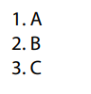  - Listen.  - Work individually.  - Work in pairs.  - Give answers.  Answer keys  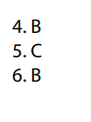

C. Consolidation and homework assignments (5’)
* Consolidation:
* Grammar of Unit 7: Possessive pronouns, order of adjectives, equal comparison.
* Vocabulary of Unit 7: Words about personal belongings and means of transportation (customs, passport, suitcase, baggage claim, boarding pass, frequent, sunglasses, subway, …).
* Homework:
- Review vocabulary, grammar of unit 7.
- Do the exercises in WB: Review of Unit 7 (page 68).
- Prepare: Unit 8 – New words and Reading (page 60 – SB).

D. Reflection
a. What I liked most about this lesson today:
…………………………………………………………………………………………
- What I learned from this lesson today:
…………………………………………………………………………………………
c. What I should improve for this lesson next time:
…………………………………………………………………………………………

