|  |  |
| --- | --- |
|  |  |

**Họ tên thí sinh: .................................................................**

**Số báo danh: ......................................................................**

**Mã Đề: 023.**

**Câu 1.** What discount does Adventure Park offer for groups?

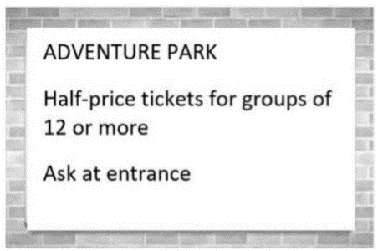

**A.** 25% off tickets  **B.** 10% off for groups of 10 or more

**C.** Free tickets for every 12th person  **D.** 50% off tickets

**Câu 2.** What is the purpose of the event mentioned in the notice?

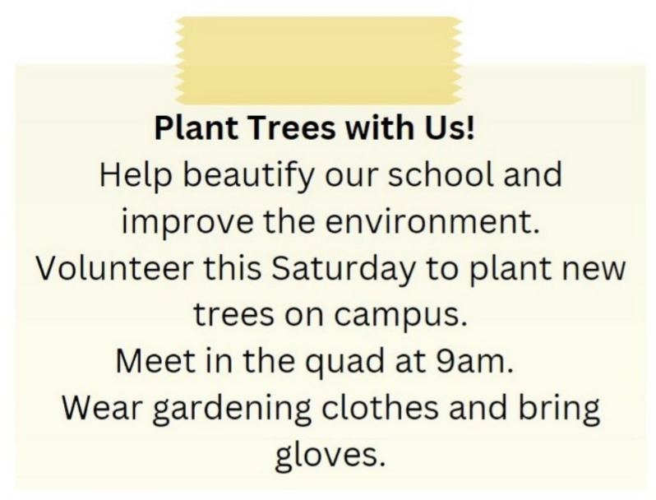

**A.** To collect donations for charity  **B.** To plant new trees on campus

**C.** To paint the school building  **D.** To clean the school

**Câu 3.** What is true about this notice?

Charity Kitchen Notice:

Calling all kind-hearted souls! Our charity kitchen is now open to feed the homeless. Come join us in our mission to spread love and warmth to those in need. Every day from 11 AM to 2 PM, we will be serving hot meals at the corner of Main and 2nd Street. Donations are welcome and appreciated. Let's make a difference together!

**A.** The charity kitchen is located at the corner of Main and 3rd Street.

**B.** The charity kitchen is open from 11 PM to 2 AM.

**C.** The charity kitchen is open to feed the homeless.

**D.** Donations are not accepted.

**Câu 4.** What does this sign mean?



**A.** They are wearing traditional clothing.

**B.** There are two old people here.

**C.** Be careless as elderly people may be crossing the road.

**D.** Be cautious as elderly people may be crossing the road.

**Câu 5.** What is the offer at the Tennis Club?

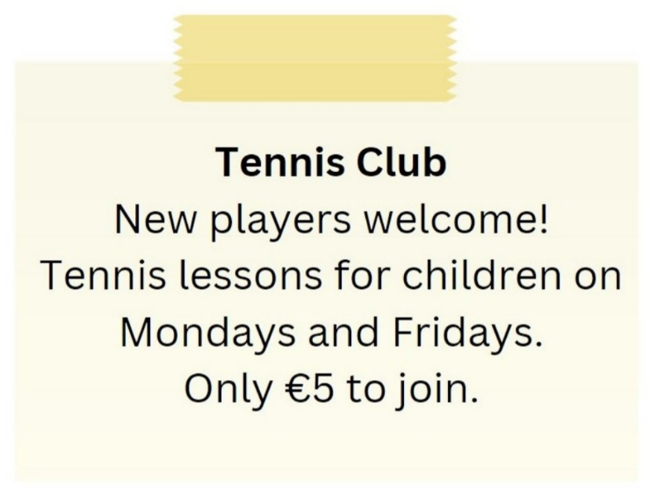

**A.** Tennis lessons for children on Mondays and Fridays for €5 to join

**B.** Tennis lessons for children on Tuesdays and Thursdays

**C.** Tennis lessons for adults on Mondays and Fridays

**D.** €10 to join the club

**Câu 6.** Which of the following statements is true?

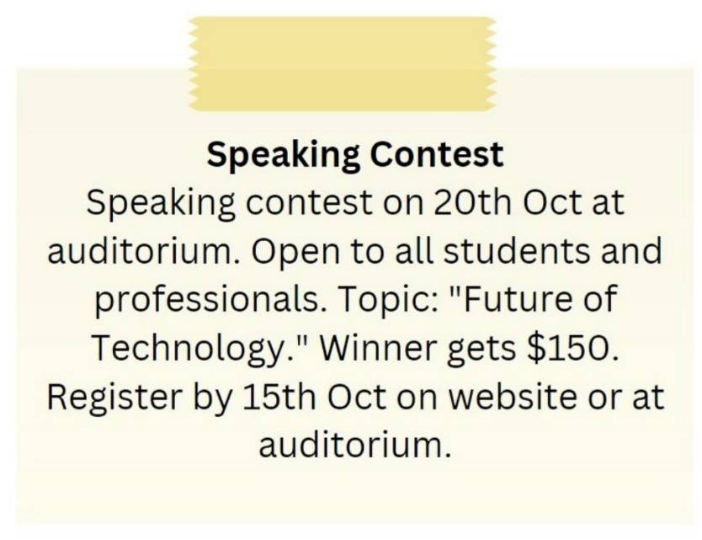

**A.** The speaking contest is only open to students.

**B.** The speaking contest is on 15th October.

**C.** The topic of the speaking contest is "Future of Technology."

**D.** The winner of the speaking contest gets $100.

**Câu 7.** **Look at the signs. Choose the best answer for the question.**



**A.** Be careful when eating and drinking outside this place.

**B.** Do not bring food or drink from outside into this place.

**C.** Do not eat or drink anything outside this place.

**D.** Food and drink are not allowed in this place.

**Câu 8.** How long does the reading competition last?

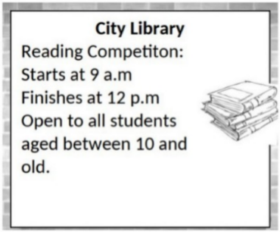

**A.** 5 hours  **B.** 2 hours  **C.** 3 hours  **D.** 4 hours

**Câu 9.** **Look at the signs. Choose the best answer for the question.**



**A.** You should slow your speed and pay attention to pedestrians.

**B.** You should drive carefully because of slow pedestrians.

**C.** Pedestrians will slow down the traffic.

**D.** Pedestrians should walk slowly.

**Câu 10.** How much discount do students get on the smartphone?

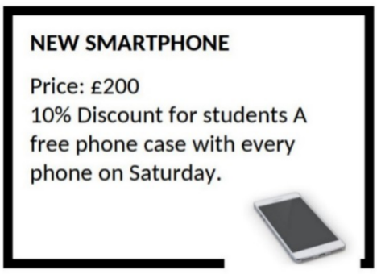

**A.** 10%  **B.** 5%  **C.** 20%  **D.** 15%

**----HẾT---**