UNITS | VOCABULARY | GRAMMAR
Unit 5  FOOD AND DRINKS | - Food and drink  - Containers and Quantities of food and drinks | - Quantities and amounts  - Indefinite and definite articles
Tiếng Anh 7 – i-LEARN SMART WORLD

UNIT 5 TEST
Note: Each correct answer earns 0.2 points.

I. PRONUNCIATION (0.8 points)
A. Choose the word whose underlined part is pronounced differently.
1. A. bunch B. butter C. sugar D. cupboard
2. A. cans B. eggs C. bags D. sticks
B. Choose the word that has a different stressed syllable from the rest.
3. A. garlic B. dessert C. lemon D. carton
4. A. spaghetti B. grocery C. vegetable D. tablespoon

II. VOCABULARY AND GRAMMAR (2.4 points)
Choose the best option (A, B, C or D) to complete each of the following questions.
5. The chef __________ the potatoes in oil in a pan.
A. fries B. grills C. chops D. roasts
6. There’s __________ apple and ________ honey on the table.
A. an / a B. some / some C. an / some D. an / the
7. She was thirsty, so she bought a __________ of soda.
A. jar B. can C. bag D. stick
8. I gave Chloe a __________ of chocolates to say thank you. She helped me a lot with my assignment.
A. bottle B. bag C. parcel D. box
9. Steve puts only a __________ of sugar on his coffee. He says too much sugar is not good for his health.
A. teaspoon B. gram C. tablespoon D. liter
10. My mum bought __________ bunch of bananas this morning. She used half of ________ bananas to make banana muffins.
A. the / the B. some / some C. a / the D. the / some
11. I like mixing ______ fruit with yoghurt to have a nice, healthy dessert.
A. a B. some C. many D. much
12. I always bring a __________ of water when I go to the gym.
A. glass B. box C. stick D. bottle
13. I don’t like __________ food because it has a strong hot taste.
A. crunchy B. spicy C. sweet D. sour
14. Student A: How much butter do we need?
Student B: _________
A. Maybe one or two.
B. About 100 g.
C. Not many.
D. A bunch.

15. Read the notice and choose the correct statement.
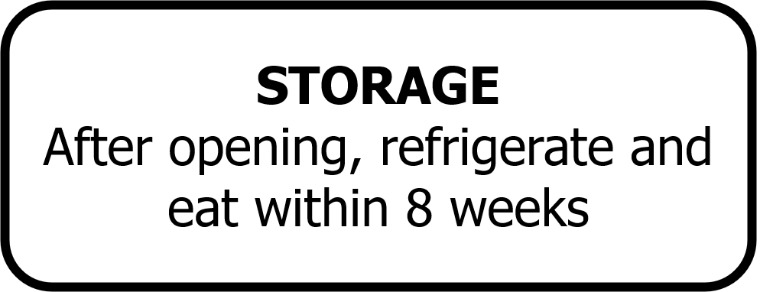 | A. You have to put it in the fridge after you open it.  B. It is enough to eat in 8 weeks.  C. You have to keep it cold in 8 weeks.  D. You need to open the refrigerator in 8 weeks.

16. What does this sign mean?
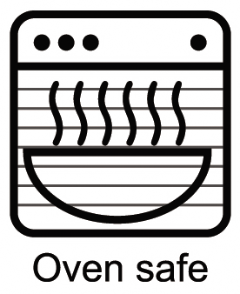 | A. It’s safe to buy a microwave oven.  B. You need to use the microwave oven safely.  C. You can heat up this container in the microwave oven.  D. There is a container for this microwave oven.

III. WORD FORMATION (1.2 points)
Write the correct form of the words in brackets.

My sister, Sonya, is a food lover. She often eats (17) __healthy________ food, such as rice, vegetables, fruit, and fish. She hardly ever eats (18) _fried_________ food because it is high in fat, calories and salt. She likes trying (19) ___unusual_______ dishes when she travels. She thinks it’s (21) _interesting_________ to eat local food and learn more about the cultures. Last year, she ate tarantula in Cambodia. Tarantulas are spiders living underground. They deep-fry tarantulas in oil until they are crispy. Sonya thought tarantula was a (20) ___tasty_______ snack. Two years ago in Germany, she tried Limburger cheese – one of the world’s stinkiest cheese. She said it was delicious but really (22) _smelly_________. | (HEALTH)  (FRY)  (USUALLY)  (INTEREST)  (TASTE)  (SMELL)

IV. LISTENING (2 points)
A. You will listen to a tour guide talking about a traditional dish. For questions 23-27, listen and decide whether the statements are True (T) or False (F).

23. Bamboo worms is a famous dish in Hà Giang. True
24 The best time to eat it is between September and October
because the worms are crunchy. False
25. The chef adds some sugar to the worms. False
26. People can fry worms with herbs or steam them. True
27. The worms taste like corn or butter. False

B. You will listen to a cookery show. For each question from 28 to 32, listen and complete the recipe. Write NO MORE THAN TWO WORDS AND/OR A NUMBER.
FRUIT PANCAKES
Ingredients:

- Some fruit (bananas or strawberries)
- (28) ___200 g/grams_______ of flour
- 400 ml of milk
- 40 g of (29) ___butter_______
- 2 eggs
- (30) __4/four tablespoons____ of sugar
- One teaspoon of salt
- Some oil

Instructions:
- Chop the fruit
- Melt the butter
- (31) __Mix________ the flour, milk, eggs and salt together
- Put some oil into a pan
- Put some of the mixture into the pan, make a pancake and (32) _fry___ it on both sides
- Take out the pancake
- Put fruit on top of the pancake

V. READING (2 points)
A. Read the following passage. For each statement from 33 to 37, write SP for silkworm pupae and ST for stinky tofu.

Many people consider Asia as a food heaven with attractive and delicious dishes. However, there is also some really strange food that not everyone is brave enough to try.
Silkworm pupae (con nhộng) in Vietnam
Many villages in the north of Vietnam are famous for raising silkworms (con tằm) and harvest cocoons to make silk. Therefore, silkworm pupae are very popular in the local markets. First, people wash the pupae, dry and mix them with salt. Then, they fry pupae with oil and fish sauce. They also cut lemon leaves into tiny strips and mix them with fried pupae to add more taste to the dish. The pupae’s outer shell is crunchy while the inside is soft and juicy. It also contains lots of protein.
Stinky tofu in China
Stinky tofu is a kind of fermented tofu. It has a strong unpleasant smell. Some people say it smells like garbage or wet socks. It’s a popular street food in China, Taiwan or Hongkong. People usually buy it at night markets or roadside stalls, rather than in restaurants. Traditionally, it is made from fermented milk, vegetables, meat and Chinese herbs. People can cook stinky tofu in different ways. The most common way is to deep-fry it and then add garlic, soy sauce and chili sauce. It’s crispy on the outside, but still hot and smooth on the inside. People serve it with cucumber and pickled cabbage.

33. People rarely sell it in restaurants. ST
34. It is served with lemon leaves. SW
35. Its ingredients include meat and herbs. ST
36. There is a variety of ways to cook this dish. ST
37. It is high in protein. SW

B. Read the online post. For questions from 38 to 42, choose the correct option A, B, C or D that best suits each blank.

Hi Julie,
Jack fell off the ladder while he was fixing the roof this afternoon. He hurt his head, so I need (38) __________ in the hospital with him tonight. Can you take care of the children? They love spending time with their auntie. I’ll be home tomorrow. There’s enough food for you all. I bought some chicken and a lettuce this morning. I put (39) __________ in the fridge. There are some onions, potatoes, gingers and a (40) __________ of rice in the bottom cupboard next to the fridge. You can use them to make chicken curry if you like. There are two cans of tuna in the cupboard above the oven, in case you want to make tuna salad. I also bought a tub of vanilla ice cream. You can have (41) __________ of the ice cream for dessert after dinner. Don’t let the children eat too much, or they may have a stomachache. Unfortunately, there is (42) __________ milk left. Can you buy two bottles of milk on your way here? Call me if you have any problems or questions.
See you soon,
Susan

38. A. stay B. staying C. to stay D. to staying
39. A. it B. them C. some D. many
40. A. bag B. can C. jar D. carton
41. A. little B. a lot C. much D. some
42. A. some B. much C. not D. no
VI. WRITING (1.6 points)
A. Put the words in the correct order to make correct sentences.
43. Emma / breakfast / a carton / had / for / a / milk / of / sandwich / and
→ Emma had a sandwich and a carton of milk for breakfast.
→ Emma had a carton of milk and a sandwich for breakfast.
44. There / pasta / some / tuna / top cupboard / are / cans / a box / of / in / of / the / and
→ There are some cans of tuna and a box of spaghetti in the top cupboard.
B. Rewrite the following sentences without changing their meaning. Use the given word(s) if any.
45. We don’t have many eggs in the fridge. (FEW)
→ There are (a) few eggs in the fridge.
46. I have a little money, just enough to buy a cup of coffee.
→ I don’t have much money, just enough to buy a cup of coffee.
C. Use the given words or phrases to make complete sentences.
47. How / glasses / milk / you / drink / day?
→ How many glasses of milk do you drink a day?
48. We / need / buy / carton / eggs / and / a kilogram / meat.
→ We need to buy a carton of eggs and a kilogram of meat.
49. There / big bag / rice / bottom cupboard / next / the sink.
→ There is a big bag of rice in the bottom cupboard next to the sink.
50. Please put / butter / the fridge / and / cooking oil / top cupboard.
→ Please put the butter in the fridge and the cooking oil in the top cupboard.

***End – Of – Test***

Audio scripts:
Listening 1:
M: Okay, here we are, it’s lunch time. Let’s try some tasty local food! I’d like to tell you about one of Hà Giang’s famous dishes, sâu tre, which is Vietnamese for “bamboo worms”. People usually eat this dish between September and October, when the worms are really juicy. The chef washes the worms and puts salt on them. Then, he fries them with herbs in hot oil, or steams them. Some people say they taste like grilled corn, and other people say they taste like cheese. Yeah, I know, they look a little bit strange to you, but really, they taste delicious. I think you should all try one! Who wants to go first? Nobody? Okay, I’ll eat one to show you … yum!

Listening 2:
Melisa: Good evening, everyone. My name is Melisa and welcome to the show “Chef at home”. Our guest today is Kate Williams.
Kate: Good evening, Melisa. Today, I have a very easy recipe for fruit pancakes to introduce to you.
Melisa: Cool! What do you need?
Kate: For 8 pancakes, we need some fruit, for example some bananas or strawberries. Then you need 200 grams of flour, 400 ml of milk, 40 gram of butter, two eggs, four tablespoons of brown sugar, and a teaspoon of salt. And some oil.
Melisa: Now, let’s get started. What do you do first?
Kate: First, you chop the fruit, melt the butter and then you make the pancakes.
Melisa: OK, and how do you make the pancakes?
Kate: You mix the flour, salt, melted butter and egg together. Keep stirring the mixture and gradually adding milk. Then you put some oil into a pan. When the pan is hot, you put some of the mixture into the pan and make a pancake. You fry it on both sides for about 2-3 minutes. Take it out of the pan and put the fruit on top.
Melisa: And that’s it?
Kate: Yes, it’s really quick to make and it’s healthy. You can have it for breakfast, lunch or dessert. Try it with some ice cream, honey or chocolate sauce. It’s yummy.
Melisa: That’s great, Kate! Thanks a lot.

