**TIẾNG ANH 8 – FRIENDS PLUS**

**UNIT 8 – TEST 1**

**I. PRONUNCIATION**

**Câu 1.** Which word has the underlined part pronounced differently from that of the others?

**A.** crime **B.** thrill **C.** pitch **D.** film

**Đáp án đúng:** A

A. crime /kraɪm/

B. thrill /θrɪl/

C. pitch /pɪtʃ/

D. film /fɪlm/

**Câu 2.** Which word has the underlined part pronounced differently from that of the others?

**A.** man**g**a **B.** **g**enre **C.** **g**uess **D.** **g**ossip

**Đáp án đúng:** B

A. man**g**a /ˈmæŋɡə/

B. **g**enre /ˈʒɒnrə/

C. **g**uess /ɡes/

D. **g**ossip /ˈɡɒsɪp/

**Câu 3.** Which word has a different stress pattern from that of the others?

**A.** award **B.** fancy **C.** novel **D.** delta

**Đáp án đúng:** A

A. award /əˈwɔːd/

B. fancy /ˈfænsi/

C. novel /ˈnɒvl/

D. delta /ˈdeltə/

**Câu 4.** Which word has a different stress pattern from that of the others?

**A.** mystery **B.** adventure **C.** trilogy **D.** advertise

**Đáp án đúng:** B

A. mystery /ˈmɪstri/

B. adventure /ədˈventʃə/

C. trilogy /ˈtrɪlədʒi/

D. advertise /ˈædvətaɪz/

**II. Choose the answer (A, B, C or D) that best fits the space in each question.**

**Câu 5.** This is the biggest film poster I have ever seen. It’s more than half the size of a professional football ______.

**A.** pitch **B.** course **C.** ring **D.** court

**Đáp án đúng:** A

**Câu 6.** *“______ search ______ my Father*”, which is an episode in the series BBC eye documentary, is about children grown up in single parent families.

**A.** To – for **B.** In – for **C.** In – of **D.** To – of

**Đáp án đúng:** A

**Câu 7.** Before “*Star War*”, “*Mad Max*” (1979) was considered the best ______ science fiction movie in the 1970s.

**A.** classical **B.** classics **C.** classic **D.** classically

**Đáp án đúng:** C

**Câu 8*.*** *“Mùa len trâu”* – Buffalo Boy is a Vietnamese successful film which was ______ in 2004.

**A.** reminded **B.** recalled **C.** remade **D.** released

**Đáp án đúng:** D

**Câu 9.** Ke Quan Huy, an American actor, won the Oscar for Best Actor in a ______ role.

**A.** minor **B.** assistant **C.** supporting **D.** leading

**Đáp án đúng:** C

**Câu 10.** Steven Spielberg______ the movie “*E.T”*.

**A.** directs **B.** is directed **C.** directed **D.** was directed

**Đáp án đúng:** C

**Câu 11.** Which one below has the same meaning as this given sentence: “*You mustn’t use your smartphone during the film*”?

**A.** It’s likely that you can use your smartphone during the film. **B.** If I were you, I would use the smartphone during the film. **C.** You aren’t going to use your smartphone during the film. **D.** Youaren’t allowed to use your smartphone during the film.

**Đáp án đúng:** D

**Câu 12.** The cinema floor is littered ______ popcorn.

**A.** by **B.** for **C.** in **D.** with

**Đáp án đúng:** D

**Câu 13.** Jennifer Lawrence has won ______ Oscar for her performance in “*Silver Lining Playbook*”.

**A.** a **B.** an **C.** the **D.** X

**Đáp án đúng:** B

**Câu 14.** Jackson: “You might prefer *The Little Mermaid*” – Katie: “______”

**A.** Yeah, I saw it last week. **B.** All right. **C.** Was the book adapted for film? **D.** I like watching film in my free time.

**Đáp án đúng:** A

**III. Look at each sign or notice. Choose the best answer (A, B, C or D) that matches its meaning.**

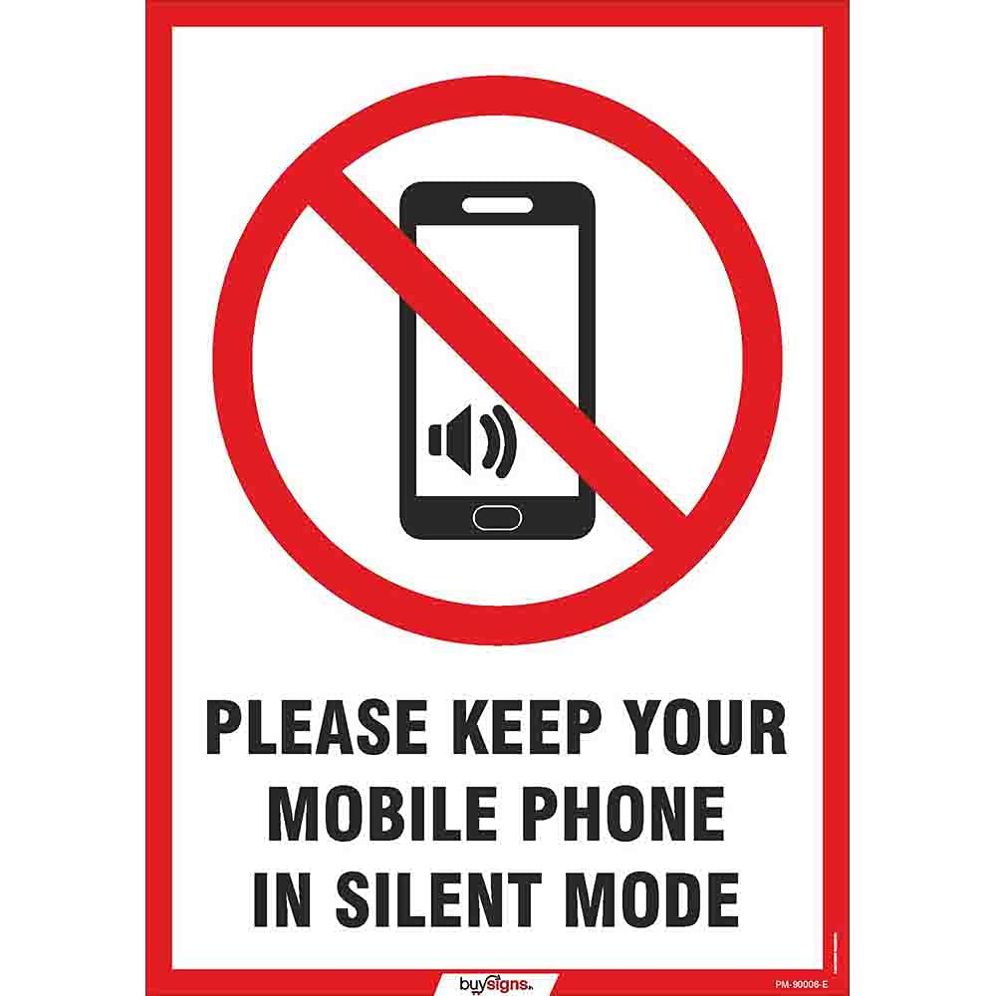**Câu 15.** What does the sign mean?

**A.** Sit in your allocated seat. **B.** Leave the chatter until the end of the movie.

**C.** Have awareness of personal space. **D.** Keep your mobile phone in silent mode.

**Đáp án đúng:** D

**Câu 16.** What does the notice say?

**A.** There are films for students during weekdays.

**B.** Students can watch movies free of charge.

**C.** Adult tickets are less expensive than student ones.

**D.** The audience can eat and drink at the café.

**Đáp án đúng:** D

**IV. Read the following and do as directed.**

For film buffs, the Cannes Film Festival is now the world’s most widely publicized film gathering that is too good to miss. Held annually in France, it not only offers filmmakers of all genres a rendezvous to showcase their new artistic works, but also does great honour to cinematographic achievements.

The origins of the Cannes Film Festival date back to 1938 when the French government decided to set up an international cinematic festival with support from the American and British counterparts. At that time, the Venice Film Festival was the only platform for filmmakers on a global scale, but its jury’s decisions were heavily influenced by fascist groups. This marked bias caused outrage among a vast audience in other European countries and the U.S. One year later, the city of Cannes was selected as the location for the new festival. However, in the middle of screenings, the festival was called off due to the outbreak of the Second World War. Not until 1947 was the festival relaunched with 21 countries presenting their films at the first edition. Today, the festival has remained faithful to its founding purpose and ushered emerging directors into the film industry at an international level.

**True/False Questions:**

**Câu 17.** France plays host to the Cannes Film Festival every two years.

**A.** True **B.** False

**Đáp án đúng:** B

**Câu 18.** By 1939, there was no international cinematographic event apart from the Venice Film Festival.

**A.** True **B.** False

**Đáp án đúng:** A

**Câu 19.** The first Cannes Film Festival officially took place in 1947.

**A.** True **B.** False

**Đáp án đúng:** A

**Câu 20.** The Cannes Film Festival has undergone a shift in its purpose.

**A.** True **B.** False

**Đáp án đúng:** B

**Choose the correct answer to each question:**

**Câu 21.** What serves as the best title for the passage?

**A.** The History of the Cannes Film Festival **B.** The Origin of the Cannes Film Festival

**C.** The New Era of the Cannes Film Festival **D.** The Purpose of the Cannes Film Festival

**Đáp án đúng:** B

**Câu 22.** What is NOT mentioned as the purpose of the Cannes Film Festival?

**A.** It gives a golden opportunity for filmmakers to introduce their new films.

**B.** It pays tribute to outstanding filmmakers.

**C.** It introduces potential directors to the international film’s spotlight.

**D.** It portrays painful experiences during the Second World War.

**Đáp án đúng:** D

**V. Choose the word (A, B, C or D) that best fits each blank space in the following passage.**

As a (23) ______, I enjoy going to the cinema on a regular basis to watch the latest work of my favourite studio. Last week, I felt excited to see Disney’s (24) ______ “The Little Mermaid”. Based on Anderson’s fairy tale of the same name, the film gives us an account of the journey of King Triton’s youngest daughter, Ariel, who is willing to (25) ______ up her voice to gain a human soul.

Disney’s products never let me down with their melodious music, and this movie is no exception. All the (26) ______ are so wonderful that I couldn’t resist singing along. Specifically, Ariel’s two songs with Halle Bailey’s (27) ______ superb voice drove me into a miraculous undersea world. Another reason why “The Little Mermaid” is a must-see is its moral. For years now, Disney has been atoning (28) ______ racial discrimination. In this version, featuring the African American Halle Bailey doesn’t mean a Black adaptation. It’s still a Disney blockbuster whose heroic figure happens to be Black.

**Câu 23.** Choose the correct answer.

**A.** cinephile **B.** theatregoer **C.** filmmaker **D.** movie theatre

**Đáp án đúng:** A

**Câu 24.** Choose the correct answer.

**A.** broadway **B.** soap opera **C.** live-action **D.** musical

**Đáp án đúng:** C

**Câu 25.** Choose the correct answer.

**A.** take **B.** bring **C.** make **D.** give

**Đáp án đúng:** D

**Câu 26.** Choose the correct answer.

**A.** sound cards **B.** sound effects **C.** soundstages **D.** soundtracks

**Đáp án đúng:** D

**Câu 27.** Choose the correct answer.

**A.** extremely **B.** incredibly **C.** absolutely **D.** completely

**Đáp án đúng:** C

**Câu 28.** Choose the correct answer.

**A.** for **B.** against **C.** with **D.** by

**Đáp án đúng:** A

**VI. Supply the correct form of the word given in each sentence.**

**Câu 29.** The book “Chicken Soup for the Soul” was written by two ______ speakers, Jack Canfield and Mark Victor Hansen. **(MOTIVATE)**

**Đáp án đúng:** motivational

**Câu 30.** Sir Arthur Conon Doyle drew his ______ from Edgar Allen Poe’s works to develop his fictional character Sherlock Holmes. **(INSPIRE)**

**Đáp án đúng:** inspiration

**Câu 31.** After his performance as a literally grown-up kid in “Big”, Tom Hanks rose to ______ as a box office name. **(STAR)**

**Đáp án đúng:** stardom

**Câu 32.** In the movie, the woman ______ her heart after her husband had remarried her best friend. **(HARD)**

**Đáp án đúng:** hardened

**Câu 33.** I take a deep breath and prepare to act surprised when she tells me she’s ______ me for the title “*Best Supporting Actress*”. **(NOMINATION)**

**Đáp án đúng:** nominating

**Câu 34.** Steven Spielberg is a(n) ______ good director who has won three Academy Awards. **(BELIEVE)**

**Đáp án đúng:** unbelievably

**VII. Rearrange the groups of words in a correct order to make complete sentences.**

**Câu 35.** as the books. / really good, / quite as good / Screen adaptations are / but they’re not

**Đáp án đúng:** Screen adaptations are really good, but they’re not quite as good as the books.

**Câu 36.** held the record / tickets sold. / cinema / *Gone with the Wind* has / for the most

**Đáp án đúng:** *Gone with the Wind* has held the record for the most cinema tickets sold.

**VIII. Rewrite each of the following sentences in another way so that it means almost the same as the sentence printed before it.**

**Câu 37.** I’d prefer you not to smoke in the cinema.

🡪 I’d rather you

**Đáp án đúng:** I’d rather you didn’t smoke in the cinema.

**Câu 38.** My sister is very interested in Agatha Christie’s detective novels. (**FAN**)

🡪 My sister is a

**Đáp án đúng:** My sister is a huge/big/great fan of Agatha Christie’s detective novels.

**Câu 39.** There were five nominees for the Oscars for Best Actress in a Leading Role.

🡪 Four people were

**Đáp án đúng:** Five people were nominated for the Oscars for Best Actress in a Leading Role.

**Câu 40.** India makes the most number of films as compared to any other country. (**IN**)

🡪 More films

**Đáp án đúng:** More films are made in India than in any other country.

**------ HẾT ------**