Unit 12 Test/Review
PART I. LISTENING (1.25 pts)
Listen to a student talking about an imaginary planet and choose the best option A, B, or C.
1. Where is Planet Hope located?
A. In the Andromeda Galaxy. B. In the Milky Way Galaxy. C. Close to the Sun.
2. What do the creatures on Planet Hope (Hopeans) look like?
A. They have one eye and four arms.
B. They have two eyes and two arms.
C. They have a small head and no legs.
3. Hopeans only attack people who ________.
A. visit their planet. B. try to talk to them. C. try to attack them.
4. What do Hopeans drink for energy?
A. Liquid water from the sea.
B. Petrol from under the ground.
C. Milk and fruit juice.
5. How do Hopeans travel on their planet?
A. By walking on two legs.
B. By using high-speed rockets.
C. By flying at very high speeds.
PART II. PRONUNCIATION (1.0 pt)
Task 1. Choose the word whose bold part is pronounced differently from the others.
6. A. galaxy B. crater C. planet D. cancel
7. A. rocket B. solar C. robot D. close
Task 2. Choose the word whose stress pattern is different from the others.
8. A. Jupiter B. Mercury C. Telescope D. Possibility
9. A. Creature B. Alien C. Commander D. Galaxy
PART III. LANGUAGE USE (2.5 pts)
Task 1. Choose the best option A, B, C or D to complete each sentence.
10. __________ is the second planet from the sun and is almost as big as Earth.
A. Mars B. Venus C. Jupiter D. Mercury
11. Scientists use a powerful __________ to see distant stars and galaxies in outer space.
A. rocket B. crater C. telescope D. UFO
12. My little brother asked me how many moons Jupiter __________.
A. has B. having C. had D. has had
13. The student asked his professor __________ forms of life could exist on Mars.
A. if B. what C. that D. who
14. There are many __________ on the surface of the moon, which look like large holes.
A. galaxies B. rockets C. planets D. craters
15. He wanted to know how many planets __________ in our solar system.
A. there were B. were there C. are there D. there are
16. Nick: "Do you think Mars may support life?"
Mark: "__________ . Scientists are still looking for traces of water there."
A. I'm not sure about it. B. I'm absolutely sure. C. No doubt. D. Yes, I do.
17. Choose the best response to complete the following dialogue:
Ann: "Why can't humans ever stand on the surface of Jupiter like we do on Earth?"
Mark: "________. Earth has a solid surface, but Jupiter is a gas giant."
A. It’s because of its composition
B. Because it's an inner planet
C. It is the same as Earth
D. I don't think so
Task 2. Choose the sentence (A, B, C or D) that is closest in meaning to the original one.
18. "Who will be the first to step on Mars?" Mary asked the scientist.
A. Mary asked the scientist who would be the first to step on Mars.
B. Mary asked the scientist who will be the first to step on Mars.
C. Mary asked the scientist who would he be the first to step on Mars.
D. Mary asked the scientist if who would be the first to step on Mars.
19. Mercury is similar in size to Earth's moon.
A. Mercury is almost as big as Earth's moon.
B. Mercury is much larger than Earth's moon.
C. Earth's moon is bigger than Mercury.
D. Mercury and Earth's moon have different sizes.
PART IV. PRACTICAL SKILLS (1.0 pt)
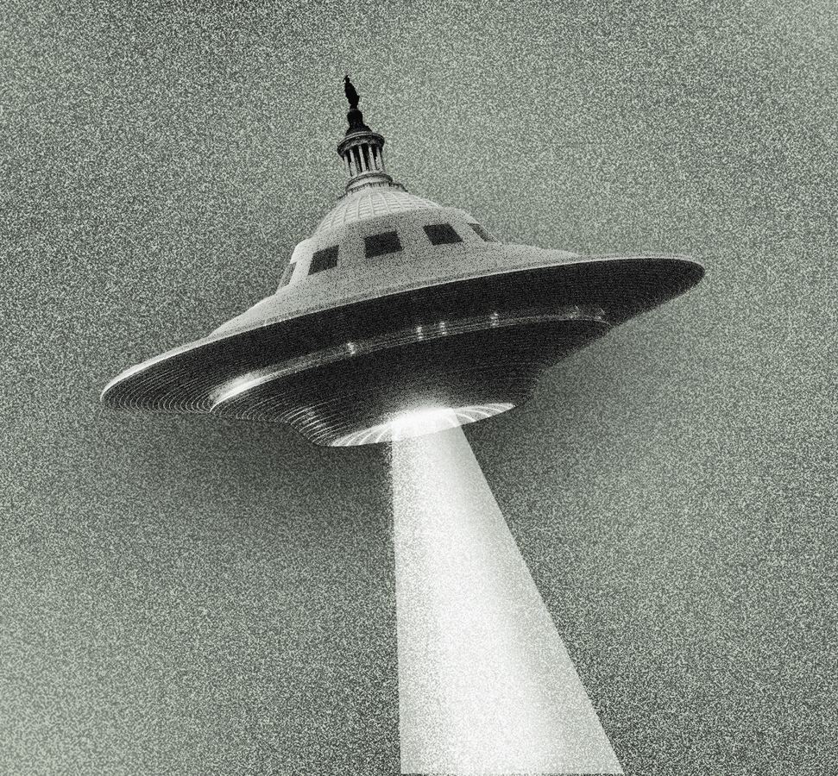
20. What is this object?
A. A natural planet.
B. A telescope.
C. A UFO.
D. A galaxy.
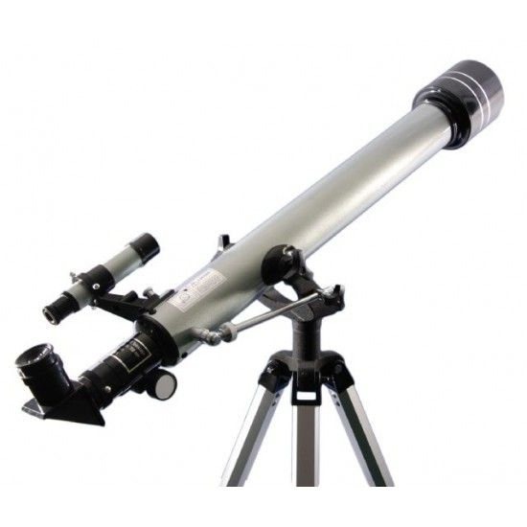
21. What do people use this device for?
A. To travel to other planets.
B. To explore the surface of the sun.
C. To see distant objects in space more clearly.
D. To take photos of aliens.
22. Read the information and choose the correct answers.
PLANET FACT SHEET: MERCURY
- Position: Smallest and closest planet to the sun.
- Temperature: Very hot in the daytime (up to 430°C) but very cold at night (-180°C).
- Atmosphere: No atmosphere => no wind or weather on it.
22. Which of the following is TRUE about Mercury?
A. It is the largest planet in our solar system.
B. It is the farthest planet from the sun.
C. It is the smallest planet in our solar system.
D. It has a very thick atmosphere.
23. Why is there no wind or weather on Mercury?
A. Because it is too close to the sun.
B. Because it has no atmosphere.
C. Because it is very cold at night.
D. Because it is a small planet.
PART V. READING (2.25 pts)
Read the notice and choose the correct option A, B, C, or D to fill in each blank.
BOOK REVIEW: A JOURNEY BACK TO SODUKA
If you love science fiction, you should read this novel. It is about four (24) ________ named Titu, Kaku, Hub, and Barb. They are travelling back to Soduka, a planet like Earth. Along the way, their spaceship (25) ________ down, so they have to land on Earth. They meet a boy named Tommy and manage to (26) ________ their commander who wants to destroy Earth. The story has a happy (27) ________ and makes us think about the possibility of aliens.
24. A. humans B. creatures C. teachers D. doctors
25. A. breaks B. stops C. goes D. flies
26. A. help B. oppose C. support D. follow
27. A. ending B. starting C. middle D. part

Read the text and choose the correct answer A, B, or C.
Scientists are still wondering what planets in outer space might support life. To support human life, a planet needs to meet three main conditions. Firstly, it must have liquid water. Secondly, the temperature must not be too high or too low. Finally, the planet needs to have a suitable size so that its gravity is strong enough to hold an atmosphere around it.
According to scientists, Mars is one of the most promising planets for life in our solar system. Its days last for 24.5 hours, which is similar to Earth's. However, the climate on Mars is unsuitable for humans because it is too cold and lacks oxygen. Although scientists have found some traces of water on its surface, humans still cannot live there without special equipment.
28. What is the first condition for a planet to support life?
A. It must have a lot of gold.
B. It must have liquid water.
C. It must be very far from the sun.
29. Why is gravity important for a habitable planet?
A. It helps the planet move faster.
B. It holds an atmosphere around the planet.
C. It makes the planet look bigger.
30. How long does a day last on Mars?
A. 24.5 hours B. 12 hours C. 48 hours
31. Why can't humans live on Mars now?
A. Because it's too hot.
B. Because it's too cold and lacks oxygen.
C. Because there are too many aliens.
32. The word "traces" in the text is closest in meaning to ________.
A. big oceans B. marks or signs C. bottles of water

PART VI. ORDERING (0.5 pt)
Arrange the sentences to make a complete dialogue.
33. a. Nick: Yes, it is. It's about four creatures from another planet.
b. Mai: That’s a science fiction book, isn’t it? What's it about?
c. Mai: What book are you reading, Nick?
d. Nick: A journey back to Soduka. I’m on the last page.
A. c - d - b - a B. c - a - b - d C. b - a - c - d D. d - b - c - a
34. a. Nick: Do you think humans will find a way to live on Mars soon?
b. Mark: I’m not sure about it. It’s still too cold and lacks oxygen.
c. Nick: So we will need special equipment to survive there, right?
d. Mark: Exactly. Scientists are still working on that.
A. a - b - c - d B. a - c - b - d C. b - a - d - c D. d - b - a - c
PART VII. WRITING (1.5 pt)
Task 1. Rewrite the sentences using Reported Speech.
35. "Who will be the first to step on Mars?" Mary asked the scientist.
-> Mary asked ___________________________________________________________.
36. "How fast can a UFO travel?" I asked my father.
-> I asked _______________________________________________________________.
37. "Which planet is the closest to the sun?" She wanted to know.
-> She wanted to know _____________________________________________________.
38. "Can we find information about the solar system on the Internet?" The pupils asked.
-> The pupils asked ________________________________________________________.
Task 2. Write a paragraph (100 - 150 words) to describe imaginary creatures living on another planet.
________________________________________________________________________
________________________________________________________________________
________________________________________________________________________
________________________________________________________________________
________________________________________________________________________
________________________________________________________________________
________________________________________________________________________
________________________________________________________________________
________________________________________________________________________
________________________________________________________________________
________________________________________________________________________
________________________________________________________________________
________________________________________________________________________

DÀNH CHO GIÁO VIÊN (TRANSCRIPT & KEY)
Audio Script (Dựa trên nội dung Skills 2 - Trang 131):
"Today, I will tell you about an imaginary planet called Planet Hope. It is located in the Milky Way Galaxy. The creatures living there are called Hopeans. They look very strange: they have a big head, one eye, and four arms. Hopeans are usually friendly and only attack people who try to attack them first. Interestingly, they don't drink water; they drink petrol from under the ground. They can also travel at very high speeds to explore their planet."
Answer Key:
- Listening:
  - B (In the Milky Way Galaxy)
  - A (One eye and four arms)
  - C (Try to attack them)
  - B (Petrol from under the ground)
  - C (Travel at very high speeds)
- Phonetics: 6. B (Âm /eɪ/, các từ còn lại là /æ/) 7. A (Âm /ɒ/, các từ còn lại là /əʊ/) 8. D (Trọng âm 3: /ˌpɒs.əˈbɪl.ə.ti/, các từ còn lại trọng âm 1) 9. C (Trọng âm 2, các từ còn lại trọng âm 1)
• 10. B | 11. C | 12. C | 13. A | 14. D | 15. A
•16. A | 17. A | 18. A | 19. A | 20. C | 21. C | 22. C | 23. B
Reading: 24.B | 25.A | 26.B | 27.A | 28.B | 29.B | 30.A | 31.B | 32.B
Ordering: 33.A | 34.A
35. "Who will be the first to step on Mars?" Mary asked the scientist.
-> Mary asked the scientist who would be the first to step on Mars.
36. "How fast can a UFO travel?" I asked my father.
-> I asked my father how fast a UFO could travel.
37. "Which planet is the closest to the sun?" She wanted to know.
-> She wanted to know which planet was the closest to the sun.
38. "Can we find information about the solar system on the Internet?" The pupils asked.
-> The pupils asked if/whether they could find information about the solar system on the Internet.

MA TRẬN ĐỀ KIỂM TRA UNIT TEST (FORM 40 CÂU - 10 ĐIỂM)
Thời gian: 45 phút | Hệ số: 0.25 điểm/câu
Phần | Dạng bài cụ thể | Số câu | Câu số | Điểm số
I. LISTENING | Trắc nghiệm chọn đáp án đúng (A, B, C) | 5 | 1 - 5 | 1.25
II. PHONETICS | Phát âm (2) & Trọng âm (2) | 4 | 6 - 9 | 1.0
III. LANGUAGE USE | Từ vựng & Ngữ pháp (7) + Hội thoại khuyết (1) + Closest Meaning (2) | 10 | 10 - 19 | 2.5
IV. PRACTICAL SKILLS | Biển báo hình ảnh (2) + Thông báo/Quảng cáo ngắn (2) | 4 | 20 - 23 | 1.0
V. READING | Announcement Cloze (4) + Comprehension (5) | 9 | 24 - 32 | 2.25
VI. ORDERING | Sắp xếp câu thành hội thoại (Dialogue) | 2 | 33 - 34 | 0.5
VII. WRITING | Sentence Transformation (Viết lại câu tự luận) | 4 | 35 - 38 | 1.0
 | Paragraph Writing (Viết đoạn văn 100-150 từ) | 2 | 39 - 40 | 0.5
TỔNG CỘNG |  | 40 |  | 10.0

