**LỚP HỌC THẦY (CÔ) ___________________________** **ĐỀ ÔN TẬP: READING SIGNS/ NOTICES – A2**

**Test 20**

*Thời gian làm bài: [Time]*

Họ và tên: ________________________________________________ Lớp: 9/___

**Question 1:** What does this sign indicate?

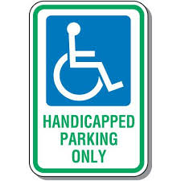

**A.** Anyone can park here.

**B.** Only vehicles with a handicap permit can park here.

**C.** Parking is free in this spot.

**D.** This spot is reserved for electric vehicles.

**Question 2:** Go upstairs if you want to

**Now on first floor:**  
Women's sports clothes  
Toys for 0-12 year olds  
Half-price books

**A.** Buy a dress for a party.  
**B.** Pay less for something to read**.**  
**C.** Find a game for a teenager.  
**D.** Look at women's sports clothes.

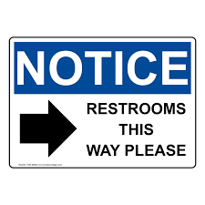**Question 3:** What does this sign indicate?

**A.** The restrooms are in the opposite direction.

**B.** Follow the sign to find the restrooms.

**C.** Restrooms are closed**.**

**D.** The restrooms are located outside.

**Question 4:** Which of the following is true?



**A.** Adults can take children to the museum in the morning.  
**B.** Adults with children over 12 will enjoy the museum.  
**C.** Children can visit the museum alone if they are over 12.  
**D.** Children can visit the museum if they are with an adult.

**Question 5:** What does this sign indicate?

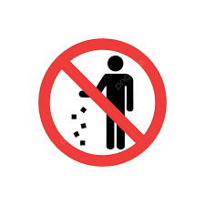**A.** You are allowed to litter anywhere.

**B.** You cannot litter anywhere, put it in the trash.

**C.** You can only throw trash in the trash.

**D.** If you can't put trash in the bin, leave it where you want.

**Question 6:** Which of the following is true?

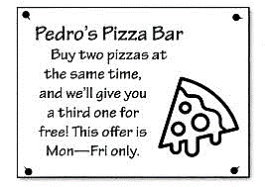

**A.** Pedro's Pizza Bar isn't open at weekends.  
**B.** The third time you visit, you get a free pizza**.**  
**C.** Three pizzas cost the same as two.  
**D.** You get a free pizza if you buy two pizzas at the same time.

**Question 7:** What does this sign indicate?

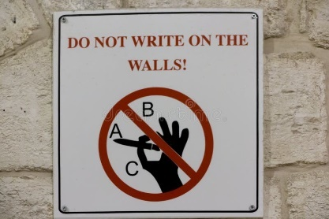**A.** You are allowed to write on the wall.

**B.** You can only write on certain parts of the wall.

**C.** You cannot write or draw on the walls here.

**D.** Do not write or draw if you are not an artist.

**Question 8:** Which of the following is true?

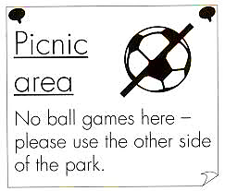

**A.** You can buy food somewhere else in the park.  
**B.** Please don't eat while you are playing sport here.  
**C.** You can play ball games on this side of the park.

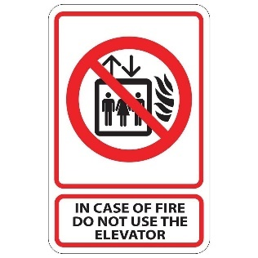**D.** This is a place for eating and you can't play football here.  
**Question 9:** What does the sign / picture say?

**A.** You mustn’t use the elevator in case of fire.

**B.** You should stay inside the elevator in case of fire.

**C.** You mustn’t use the elevator alone in case of fire.

**D.** The elevator was out of order due to the fire.

**Question 10:** Which of the following is true?

Museum trip

Students who have not booked this trip should come to school as normal.

**A.** Students who do not want to join the trip can stay home.  
**B.** Students must come to school before going on the trip.  
**C.** Students can decide to join the trip after today.  
**D.** Students who have booked the trip do not need to come to school.

**[HẾT]**