School: ……………………………………….. | Date: …………………………………..
Class: ……………………………..................... | Period: ………………………….........

UNIT 9: ENGLISH IN THE WORLD
Lesson 2.3 – Pronunciation and Speaking (page 73)

I. OBJECTIVES
By the end of the lesson, Ss will be able to:
1.1. Language knowledge and skills
- distinguish and pronounce the /ə/ sound correctly.
- talk about holiday.
1.2. Competences
- improve listening and speaking skills.
1.3. Attributes
- love studying English, love travelling.
- have good preparation for any trip.

II. TEACHING AIDS AND LEARNING MATERIALS
1. Teacher’s aids: Student book and Teacher’s book, class CDs, Digital Book (DCR phần mềm tương tác SB, DHA (từ vựng/ cấu trúc) phần mềm trò chơi tương tác), projector/interactive whiteboard / TV (if any), PowerPoint slides, handouts.
2. Students’ aids: Student’s book, workbook, notebook.

III. ASSESSMENT EVIDENCE
Performance Tasks | Performance Products | Assessment Tools
- Listen to the words and focus on the underlined letters. | - Ss’ performance and answers. | - T’s observation.
- Listen to the /ə/ sound. Cross out the word that doesn’t follow the note in “a”. | - Ss’ answers. | - T’s feedback/Peers’ feedback.
- Read the words with the sound noted in “a” to a partner | - Ss’ performance. | - T’s feedback/Peers’ feedback.
- Practice the conversation. Swap roles and repeat. | - Ss’ performance. | - T’s feedback/Peers’ feedback.
- Make two more conversations using the ideas on the right. | - Ss’ performance /  Presentation. | - T’s observation, T’s feedback/Peers’ feedback.
- You just returned home from a holiday. In pairs: Student B, turn to page 122, File 10. Student A, answer Student B's questions about your trip. Then, swap roles. Ask questions and complete the table about Student B's holiday | - Ss’ performance /  Presentation. | - T’s observation, T’s feedback/Peers’ feedback.
- Discuss which city you would like to visit and why. | - Ss’ performance /  Presentation. | - T’s observation, T’s feedback/Peers’ feedback.

IV. PROCEDURES
A. Warm up: (5’)
a) Objective: Introduce the new lesson and set the scene for Ss to acquire new language; get students' attention at the beginning of the class by enjoyable and short activities as well as to engage them in the follow-up steps.
b) Content: Introduce the /ə/ sound.
c) Expected outcomes: Ss get to know what they are going to study in the new lesson and use them in other speaking activities.
d) Organization of the activity:
TEACHER’S ACTIVITIES | STUDENTS’ ACTIVITIES
- Option 1: Introduce the /ə/ sound.  - Play a video clip to introduce the /ə/ sound.  - Have Ss watch the video clip and repeat/sing together.  - Lead to the new lesson: how to pronounce the /ə/ sound.  *Illustration:  Link: https://www.youtube.com/watch?v=yjD940asufE  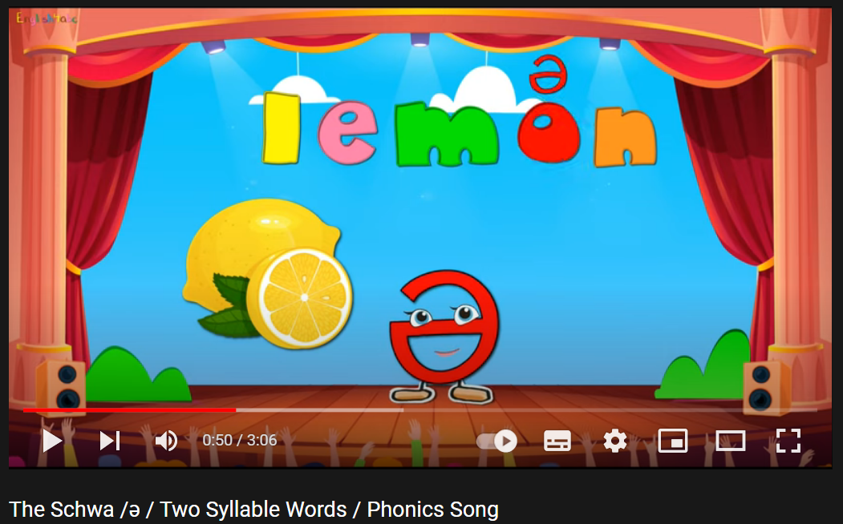  - Option 2: Let Me In  - Give Ss some words with a missing letter.  - Have Ss find the missing letters to make these words meaningful.  - Ask Ss to give answers.  - Have Ss make comments on the sound of letters they have just added.  - Give feedback.  - Lead to the new lesson.  *Illustration:  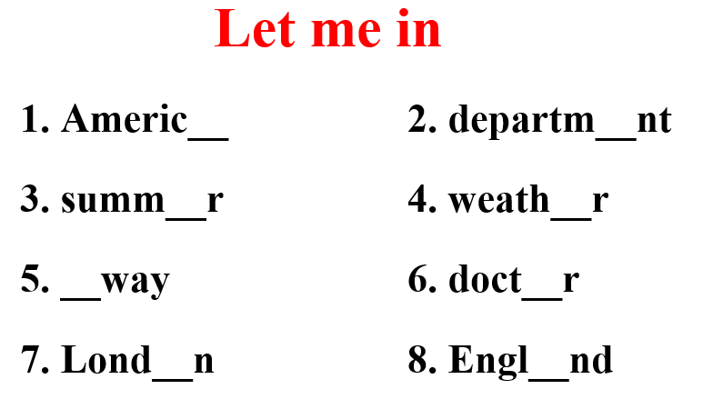 | - Watch and sing together.  - Find the missing letters.  - Give answers.  Suggested comment: They have the same sound: /ə/  Answer keys  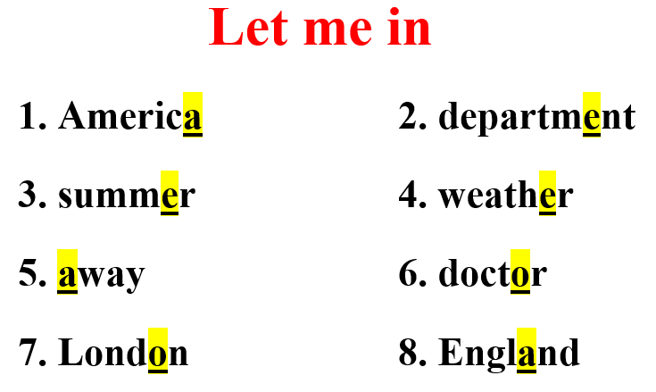

B. New lesson (35’)
- Activity 1: Pre-Speaking: Pronunciation (7’)
a) Objective: Introduce the /ə/ sound.
b) Content:
- recognize: the /ə/ sound.
- listen to the /ə/ sound. Cross out the word that doesn’t follow the note in “a”.
- practice.
c) Expected outcomes: Ss distinguish and pronounce the /ə/ sound correctly in their speaking.
d) Organization of the activity:
TEACHER’S ACTIVITIES | STUDENTS’ ACTIVITIES
Task a + b. Listen to the words and focus on the underlined letters.  - Play the recording (CD2, track 20) using DCR.  - Ask Ss to listen and focus on the underlined letters.  - Play the recording again, have Ss listen and repeat with a focus on the sound feature.  - Explain more about how to pronounce the /ə/ sound:  The mouth position for /ə/ is neutral – the lips are relaxed, not rounded, the jaw is roughly half way open, and the tongue is flat, not forward or back. It is very similar to the long thinking vowel sound /ɜː/ as in BIRD, but it is always weak, so it’s short and soft.    Task c + d. Listen to the /ə/ sound. Cross out the word that doesn’t follow the note in “a”.  - Play the recording (CD 2 – Track 21), have Ss listen to the /ə / sound, then cross out the word that doesn’t follow the note in “a”.  - Call Ss to give answers.  - Play the recording again and check answers as a whole class using DCR.  - Give feedback and evaluation. | - Listen.  - Listen again and repeat.  - Listen.  - Listen and give answers.  Answers keys  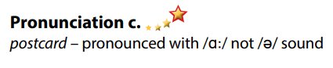
- Activity 2: While-speaking (23’)
a) Objective: Students can talk about their holidays.
b) Content:
- Practice the conversation. Swap roles and repeat.
- Make two more conversations using the ideas on the right.
- You just returned home from a holiday. In pairs: Student B, turn to page 122, File 10. Student A, answer Student B's questions about your trip. Then, swap roles. Ask questions and complete the table about Student B's holiday.
c) Expected outcomes: Ss produce the new language successfully.
d) Organization of the activity:
TEACHER’S ACTIVITIES | STUDENTS’ ACTIVITIES
PRACTICE  Task a. Practice the conversation. Swap roles and repeat.  - Demonstrate the activity by practicing the role-play with a student.  - Divide the class into pairs.  - Have pairs practice the conversation.  - Swap roles and repeat.  - Have some pairs demonstrate the activity in front of the class.  - Give feedback and evaluation.  Task b. Make two more conversations using the ideas on the right.  - Have pairs make two more conversations using the ideas on the right.  - Have some pairs demonstrate the activity in front of the class.  SPEAKING: How Was Your Holiday?  * Task a. You just returned home from a holiday. In pairs: Student B, turn to page 122, File 10. Student A, answer Student B's questions about your trip. Then, swap roles. Ask questions and complete the table about Student B's holiday.  - Demonstrate the activity by practicing the activity with a student.  - Divide the class into pairs.  - Have Student B turn to page 122, File 10.  - Have Student B ask and Student A answer to complete the table.  - Have students swap roles and repeat.  - Observe, give help if necessary.  - Have some students demonstrate the activity in front of the class.  - Give feedback and evaluation. | - Observe, listen.  - Work in pairs.  - Present.  - Work in pairs.  - Present.  - Observe, listen.  - Work in pairs.  - Present.

- Activity 3: Production (5’)
a) Objective: Students can share their ideas about the city they would like to visit.
b) Content: Discuss which city you would like to visit and why.
c) Expected outcomes: Ss produce the new language successfully in everyday speaking and writing.
d) Organization of the activity:
TEACHER’S ACTIVITIES | STUDENTS’ ACTIVITIES
SPEAKING: How Was Your Holiday?  Task b. Discuss which city you would like to visit and why.  - Have students discuss which city they would like to visit and give reasons.  - Have some students share their ideas with the class.  - Give feedback and evaluation. | - Discuss in pairs / groups.  - Present.

C. Consolidation and homework assignments (5’)
* Consolidation: Some words with the /ə/ sound: America, apartment, away, paper, vacation, London, England, summer.
* Homework:
- Practice: reading words with the /ə / sound.
- Find more words containing the /ə / sound.
- Prepare: Unit 9 - Lesson 3 –Listening and Reading (page 74 – SB).
- Review the vocabulary and grammar notes in Tiếng Anh 7 i-Learn Smart World Notebook
(pages 56 & 57).
- Play consolation games in Tiếng Anh 7 i-Learn Smart World DHA App on www.eduhome.com.vn

D. Reflection
a. What I liked most about this lesson today:
…………………………………………………………………………………………
- What I learned from this lesson today:
…………………………………………………………………………………………
c. What I should improve for this lesson next time:
…………………………………………………………………………………………

