School: ……………………………………….. | Date:…………………………………..
Class: ……………………………..................... | Period: …………………………..........

UNIT 3: PROTECTING THE ENVIRONMENT
Lesson 4.2 – Review (Page 91)

I. OBJECTIVES
By the end of the lesson, Ss will be able to:
1.1. Language knowledge and skills
- review vocabulary about protecting the environment (clean up, electricity, health, land, waste, reduce, save, recycle, wildlife, diseases, …).
- review grammar: First conditional sentences, compound and complex sentences.
- pronoun /t/ sounds correctly and second-syllable word stress.
1.2. Competences
- improve communication, collaboration, analytical and critical thinking skills.
1.3. Attributes
- have positive attitude in English language learning so that they actively participate in all classroom activities.
- review the old lesson and have good preparation for next unit.
II. TEACHING AIDS AND LEARNING MATERIALS
1. Teacher’s aids: Student book and Teacher’s book, class CDs, Digital Book (DCR phần mềm tương tác SB, DHA (từ vựng/ cấu trúc) phần mềm trò chơi tương tác), projector/interactive whiteboard / TV (if any), PowerPoint slides, handouts.
2. Students’ aids: Student’s book, workbook, notebook.
III. ASSESSMENT EVIDENCE
Performance Tasks | Performance Products | Assessment Tools
- Vocabulary: Read the clues and complete the crossword puzzle.  - Grammar:  * Write First Conditional sentences using the prompts.  * Combine two sentences into one using and or so (that). Add a comma when necessary.  -Pronunciation: sound and stress.  - Writing: Write about how we should help the environment, and why | - Ss’ answers.  - Ss’ answers.  - Ss’ answers.  - Ss’ answers/ presentation.  - Ss’ answers. | - T’s feedback/Peers’ feedback.  - T’s feedback/Peers’ feedback.  - T’s feedback/Peers’ feedback.  - T’s feedback/Peers’ feedback.  - T’s feedback/Peers’ feedback.

IV. PROCEDURES
A. Warm up: (5’)
a) Objective: Review the lesson and set the scene for Ss to recap previous knowledge; get students' attention at the beginning of the class by enjoyable and short activities as well as to engage them in the follow-up steps.
b) Content: Review vocabulary, grammar, pronunciation and writing.
c) Expected outcomes: Ss are ready for the revision of unit 3.
d) Organization of the activity:
TEACHER’S ACTIVITIES | STUDENTS’ ACTIVITIES
- Option 1: Hot seat  - Choose 8 words from Vocabulary tasks: clean up, electricity, health, land, waste, reduce, save, recycle, wildlife, diseases.  - Divide class into 2 group.  - Have s sit on the chair, the others read the word and try to describe so that their partner can figure out the word and say aloud.  - Check and correct Ss’ answers.  - Have Ss make sentences with the words they say.  - Give feedback and evaluation.  → Lead to the new lesson.  - Option 2: Sound - choice game  - Play audio of some word of voiced and unvoiced /t/ sound.  - Have ss stand up for voiced /t/ sound and sit down for unvoiced /t/ sound.  - Give feedback and evaluation.  * Suggested words: time, listen, rest, guitar, castle, night, doctor, whistle, often (can be pronounced in 2 ways with /t/ or /silent t/  →Lead to the new lesson. | - Listen and say the words you can hear.  - Make sentences.  - Listen and do action (stand up or sit down)  - Listen to teacher’s explanation about “often”.

B. New lesson (35’)
- Activity 1: Vocabulary (5’)
a) Objective: Help Ss review vocabulary they have learnt.
b) Content:
- Read the clues and complete the crossword puzzle.
c) Expected outcomes: Ss can recall all previous vocabulary they have learnt and write the words correctly. They are able to get familiar with the test format.
d) Organization of the activity:
TEACHER’S ACTIVITIES | STUDENTS’ ACTIVITIES
Read the clues and complete the crossword puzzle.  - Use DCR to show the task.  - Have Ss read the clues and write the correct word in pairs.  - Have Ss check answers with pairs and then give answers.  - Check answers as a whole class. | - Do the crossword.  - Give answers.  Answer keys  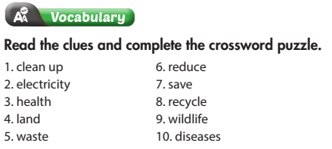
- Activity 2: Grammar (10’)
a) Objective: Students can use First Conditional sentences in speaking and writing skills.
b) Content:
- Write First Conditional sentences using the prompts.
- Combine two sentences into one using and or so (that).
c) Expected outcomes: Ss are able to use First Conditional sentences with if or unless correctly and get familiar with the test format.
d) Organization of the activity:

TEACHER’S ACTIVITIES | STUDENTS’ ACTIVITIES
Task a. Write First Conditional sentences using the prompts  - Use DCR to show the task.  - Demonstrate the activity by using the example.  - Have Ss read and write the sentences.  - Call Ss to give answers, explain.  - Give feedback and evaluation.  Task b: Combine two sentences into one using and or so (that). Add a comma when necessary.  - Use DCR to show the task.  - Demonstrate the activity by using the example.  - Have Ss read and write the sentences.  - Call Ss to give answers, explain.  - Give feedback and evaluation. | - Observe and listen.  - Work individually.  - Give answers.  Answer keys  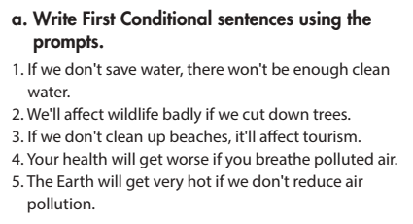  - Observe and listen.  - Work individually.  - Give answers.  Answer keys  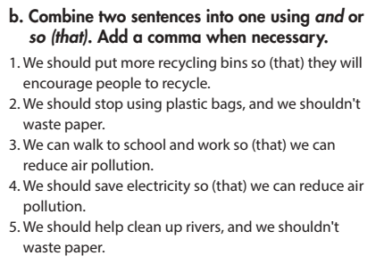

- Activity 3: Pronunciation (7’)
a) Objective: Ss can review the /t/ sounds and word stress.
b) Content:
- Circle the word that differs from the other three in the position of primary stress in each of questions.
c) Expected outcomes: Ss distinguish the word stress correctly.
d) Organization of the activity:
TEACHER’S ACTIVITIES | STUDENTS’ ACTIVITIES
Circle the word that differs from the other three in the position of primary stress in each of the following questions.  Use DCR to show the task.  - Ask Ss to work individually to circle the answer.  - Have Ss work in pairs to check each other’s work.  - Call Ss to give answers, pronounce the words again.  - Give feedback, correct Ss’ pronunciation if necessary. | - Work individually.  - Work in pairs  - Give answers.  Answer keys  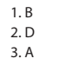
- Activity 4: Writing (12’)
a) Objective: Ss can write a passage about how to help the environment and why.
b) Content:
- Write about how and why we should help the environment.
c) Expected outcomes: Ss produce the new language successfully, and they can use the vocabulary as well as the grammar points in writing.
d) Organization of the activity:
TEACHER’S ACTIVITIES | STUDENTS’ ACTIVITIES
Write about how we should help the environment, and why.  - Have ss brainstorm the ideas with helping the environment. They can get the ideas from task a and b in grammar task.  - Instruct them to write the layout of passage: main idea, supported ideas.  - Give feedback, correct Ss’ mistakes.  - Use the feedback form to give evaluation. Focus on:  + the format, the structures.  + the understandability.  + the coherence and cohesion. | - Work individually.  - Work individually.  - Give answers.

C. Consolidation and homework assignments (5’)
* Consolidation:
* Vocabulary of Unit 3: Vocabulary about protecting environment.
* Grammar of Unit 3: the First Conditional sentences, compound and complex sentences.

* Homework:
- Review vocabulary, grammar of unit 3.
- Do the exercises in WB: Review of Unit 3 – part 2 (page 52).
- Prepare: Unit 4 (page 34 – SB).

V. Reflection
a. What I liked most about this lesson today:
…………………………………………………………………………………………
- What I learned from this lesson today:
…………………………………………………………………………………………
c. What I should improve for this lesson next time:
…………………………………………………………………………………………

