Week :  Period: | Date of planning: / /2023  Date of teaching: / / 2023
UNIT 6: LIFESTYLES
Lesson 2: A closer look 1
I. OBJECTIVES
By the end of this lesson, Ss will be able to:
- Learn and use the words related to the different aspects of lifestyles in sentences.
- Pronounce the sounds / br/ and / pr/ in words correctly.
1. Knowledge
- Vocabulary: To help ss practice more with vocabularies related to the topic “Lifestyles”
- Pronunciation: Correctly pronounce words that contain the sounds: /br/ and /pr/ in words and sentencces.
2. Competences
- Develop communication skills and creativity
- Be collaborative and supportive in pair work and teamwork
- Actively join in class activities
3. Personal qualities
- Love and respect the lifestyles of Viet Nam and other countries around the world
II. MATERIALS
- Grade 8 textbook, Unit 6, Skills 1.
- Computer connected to the Internet
- Projector / TV
- hoclieu.vn
III. PROCEDURES
1. WARM-UP (5’)
a. Objectives:
- To create an active atmosphere in the class before the lesson.
- To lead into the new lesson.
b. Content:
- Chatting: Use pictures related to different lifestypes in Viet Nam and other countries and talk about them.
c. Expected outcomes:
- Students remember and describe what they see in the pictures.
d. Organisation:
TEACHER’S AND STUDENTS’ ACTIVITIES | CONTENTS
T gives Ss some pictures related to different lifestypes in Viet Nam and other countries.  - Ask Ss to name these things and talk about them  - T elicits answers from Ss. | Name and talk about the pictures
2. ACTIVITY 1: PRESENTATION. (22’)
VOCA BULARY
a. Objectives:
- To revise / teach some words and collections related to the different aspects of lifestypes.
b. Content:
Task 1:Match the words and phrases with the pictures
c. Expected outcomes:
- Students know how to use the target vocabulary.
d. Organisation:
TEACHER’S AND STUDENTS’ ACTIVITIES | CONTENTS
Task 1: Vocabulary teaching (5’)
- Teacher teaches new words.  - Check : Rub out and remember  - Ask Ss to look at the pictures and the words and phrases  - Ask Ss to work in pairs to match the words with the correct pictures.  T elicits answers from Ss. | New words:  1. dogsled (n) ( picture)  2. make crafts (picture)  3. native (adj) ( explaination)  4. tribal (adj) ( picture)  Match the words with the correct pictures  Answer key:  1. dogsled (n)  2. make crafts (v)  3. native art (n)  4. weave (v)  5. tribal dance (n)
3.ACTIVITY 2. PRACTICE.(17’)
a. Objectives:
- To give Ss practice on how to use words and phrases related to the topice Lifestyles in context and sentences.
b. Content:
Task 2: ﻿Complete the sentences with the words and phrases from the box.
Task 3: ﻿Choose the correct answer A, B, or C to complete each sentence.
c. Expected outcomes:
- Know how to use words and phrases in context and sentences.
d. Organisation:
TEACHER’S AND STUDENTS’  ACTIVITIES | CONTENTS
Task 2: ﻿Complete the sentences with the words and phrases from the box. (10’)  - T has Ss read the sentences and choose the correct word given to fill each blank in the sentences.  ﻿- T tells Ss to read the sentences carefully and look for clues so that they can choose the correct words.  - T asks Ss to check their answers with their partners. Ask for translation of some of the words to check their understanding.  - T confirms the correct answers. | Answer key:  ﻿1. weaving  2. tribal dances  3. native art  4. making crafts  5. dogsled
Task 3: ﻿Choose the correct answer A, B, or C to complete each sentence. (7’)
- Have Ss read the sentences and choose the correct options to complete the sentences.  - Go around and give assistance if necessary and check their answers.  - Confirm the correct answers as a class.  - Teacher checks students’ pronunciation and gives feedback. | Answer key:  1. A 2. B  3. A 4. C  5. B

4. ACTIVITY 3: PRODUCTION
PRONUNCIATION (15’)
a. Objectives:
- To teach Ss how to pronounce the sounds /br/ and /pr/ and practise pronouncing these sounds in words correctly.
-Ss differentiate the sounds /br/ and /pr/
b. Content:
- Task 4: Listen and repeat the words. Pay attention to the sounds /br/ and /pr/.
- Task 5: Listen and practise the sentences. Underline the words with the sound /br/ and circle the words with /pr/.
c. Expected outcomes:
- Students can pronounce the /br/ and /pr/ sounds in words in sentences correctly.
d. Organisation:
TEACHER’S AND STUDENTS’ ACTIVITIES | CONTENTS
Task 4: Listen and repeat the words. Pay attention to the sounds /br/ and /pr/. (7’)
T gives examples of the sounds /br/ and /pr/  - Teacher asks some Ss to read out the words .  T plays the recording and asks Ss to listen and repeat the words they hear.  - Explain to Ss the difference between the two sounds if needed:  - Correct their pronunciation. | 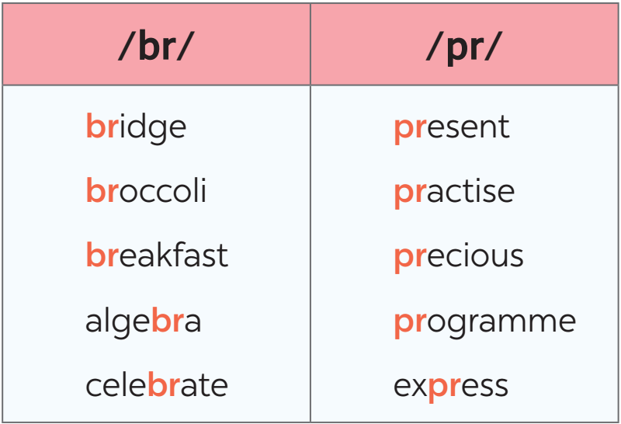
Task 5: Listen and practise the sentences. Underline the words with the sound /br/ and circle the words with /pr/. (8’)
- Teacher aks Ss to quickly read the sentences and underline the words having the sounds /br/, and circle the words having the sound /pr/.  T plays the recording for Ss to listen and check.  - T asks Ss to work in pairs to compare their answers  - Teacher gives corrections and feedback to students’ pronunciation. | Answer key:  ﻿1. My brother says online learning improves our IT skills.  2. Santa Claus brings a lot of presents to children.  3. She briefly introduced the new programme.  4. He spent a lot of time preparing for his algebra test.  5. My mum prays at the temple before breakfast on Sundays.
5. CONSOLIDATION (3’)
a. Wrap-up
- Ask one or two Ss to tell the class what they have learnt.
- Ask Ss to say make some sentences with words and phrases they remember from the lesson
b. Homework
- Learnt by heart all the new words. and the sounds /br/ and /pr/.
- Do Ex A1,2 P44 (Workbook)
- Prepare next lesson : A closer look 2
+ Review: The future simple and give some examples

