School: ……………………………………….. | Date: …………………………………..
Class: ……………………………..................... | Period: ………………………….........

UNIT 7: TRANSPORTATION
Lesson 2.3 – Pronunciation and Speaking (page 57)

I. OBJECTIVES
By the end of the lesson, Ss will be able to:
1.1. Language knowledge and skills
- distinguish and pronounce the cluster /st/ correctly.
- talk about means of transport and compare them.
- compare different ways to travel.
1.2. Competences
- improve listening and speaking skills.
1.3. Attributes
- be careful and safe road users.
- choose suitable means of transport for travelling.

II. TEACHING AIDS AND LEARNING MATERIALS
1. Teacher’s aids: Student book and Teacher’s book, class CDs, Digital Book (DCR phần mềm tương tác SB, DHA (từ vựng/ cấu trúc) phần mềm trò chơi tương tác), projector/interactive whiteboard / TV (if any), PowerPoint slides, handouts.
2. Students’ aids: Student’s book, workbook, notebook, pens, pencils, crayons.

III. ASSESSMENT EVIDENCE
Performance Tasks | Performance Products | Assessment Tools
- Listen to the words and focus on the underlined letters. | - Ss’ performance and answers. | - T’s observation.
- Listen to the /st/ sound. Find and note down three more words with the same sound. | - Ss’ answers. | - T’s feedback/Peers’ feedback.
- Read the words in “c” with the sound noted in “a” to a partner. | - Ss’ performance. | - T’s feedback/Peers’ feedback.
- Practice the conversation. Swap roles and repeat. | - Ss’ performance. | - T’s feedback/Peers’ feedback.
- Practice with your own ideas. | - Ss’ performance /  Presentation. | - T’s feedback/Peers’ feedback.
- You are deciding how to get to Richmond Park. In pairs: Student B, turn to page 121, File 8. Student A, ask your partner about the bus and answer their questions about the train. Then, compare the different ways to travel and decide how you will get to the park. | - Ss’ performance /  Presentation. | - T’s observation, T’s feedback/Peers’ feedback.
- Join another pair. Will they use the same type of transportation? Why (not)? | - Ss’ performance /  Presentation. | - T’s observation, T’s feedback/Peers’ feedback.

IV. PROCEDURES
A. Warm up: (5’)
a) Objective: Introduce the new lesson and set the scene for Ss to acquire new language; get students' attention at the beginning of the class by enjoyable and short activities as well as to engage them in the follow-up steps.
b) Content: Introduce the cluster /st/.
c) Expected outcomes: Ss get to know what they are going to study in the new lesson and use them in other speaking activities.
d) Organization of the activity:
TEACHER’S ACTIVITIES | STUDENTS’ ACTIVITIES
- Option 1: Introduce the cluster /st/  - Play a video clip to introduce the cluster /st/.  - Have Ss watch the video clip and sing.  - Lead to the new lesson:  *Illustration:  Link: https://www.youtube.com/watch?v=lJb-iI-Rc9s  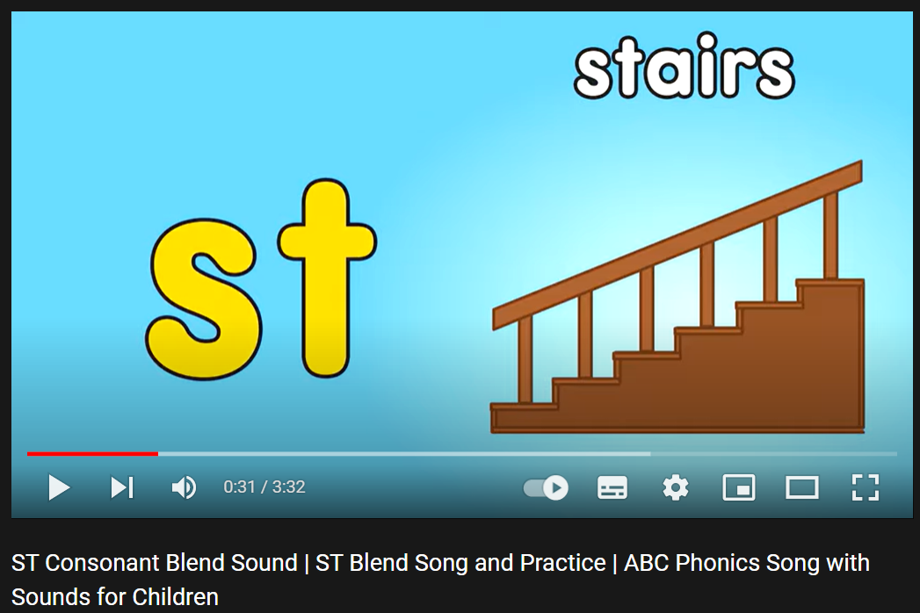  - Option 2: Brainstorming  - Have Ss close all books.  - Divide class into 4 groups.  - Ask Ss to think of words in English containing the letters “st”.  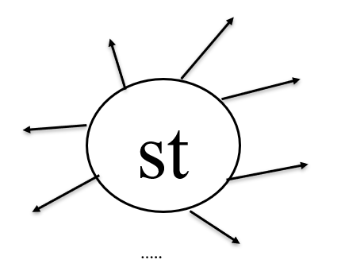  - Call Ss to write answers on the board.  - The group with the most correct answers will be the winner.  - Check Ss’ answers, give feedback, announce the winner.  - Lead to the new lesson. | - Watch and sing together.  - Close books.  - Work in groups to write words with letters “st” inside.  Suggested answers  Stay, step, first, last, steal, style, stole, stolen, stairs, station, fast, tourist, festival, stamp, stew, stone, stele, astounding, …

B. New lesson (35’)
- Activity 1: Pre-Speaking: Pronunciation (7’)
a) Objective: Introduce the cluster /st/.
b) Content:
- recognize: cluster /st/.
- listen to the /st/ sound. Find and note down three more words with the same sound.
- practice.
c) Expected outcomes: Ss distinguish and use the cluster /st/ correctly in their speaking.
d) Organization of the activity:
TEACHER’S ACTIVITIES | STUDENTS’ ACTIVITIES
Task a + b. Listen to the words and focus on the underlined letters.  - Play the recording (CD1, track 77).  - Ask Ss to listen and focus on the underlined letters.  - Play the recording again, have Ss listen and repeat with a focus on the sound feature.  Task c + d. Listen to the /st/ sound. Find and note down three more words with the same sound; then read them  - Play the recording (CD 1 – Track 78), have Ss listen to the /st/ sound. Find and note down three more words with the same sound; then read them.  - Remind Ss to remember words in the warm up activity.  - Call Ss to give answers.  - Play the recording again and check answers as a whole class using DCR.  - Give feedback and evaluation. | - Listen.  - Listen again and repeat.  - Listen and give answers.  Suggested answers  Stay, step, first, last, steal, style, stole, stolen, stairs, station, fast, tourist, festival, stamp, stew, stone, stele, astounding, …
- Activity 2: While-speaking (23’)
a) Objective: Students can talk about means of transport and compare them.
b) Content:
- Practice the conversation. Swap roles and repeat.
- You are deciding how to get to Richmond Park. In pairs: Student B, turn to page 121, File 8. Student A, ask your partner about the bus and answer their questions about the train. Then, compare the different ways to travel and decide how you will get to the park.
c) Expected outcomes: Ss produce the new language successfully.
d) Organization of the activity:

TEACHER’S ACTIVITIES | STUDENTS’ ACTIVITIES
PRACTICE  * Task a. Practice the conversation. Swap roles and repeat.  - Demonstrate the activity by practicing the role-play with a student.  - Divide the class into pairs.  - Have pairs practice the conversation.  - Swap roles and repeat using the ideas on the right.  - Have some pairs demonstrate the activity in front of the class.  - Give feedback and evaluation.  * Task b. Practice with your own ideas.  - Have students practice the conversation with their own ideas. Swap roles.  - Have some pairs demonstrate the activity in front of the class.  - Give feedback and evaluation.  SPEAKING: How Do We Get To The Park?  Task a. You are deciding how to get to Richmond Park. In pairs: Student B, turn to page 121, File 8. Student A, ask your partner about the bus and answer their questions about the train. Then, compare the different ways to travel and decide how you will get to the park.  - Demonstrate the activity by practicing the activity with a student.  - Divide the class into pairs.  - Have Student B turn to page 121, File 8.  - Have students ask and answer to complete the table. - Have students compare the information and choose how they will get to the park.  - Call some pairs to answers.  - Observe, give help if necessary. | - Observe, listen.  - Work in pairs.  - Swap the roles and repeat.  - Present.  - Work in pairs.  - Present.  - Observe and listen.  - Work in pairs.  - Do the task.  - Give answers.  Suggested conversation

- Activity 3: Production (5’)
a) Objective: Students can have a free talk about means of transport and choose a suitable one for their travelling.
b) Content: Join another pair. Will they use the same type of transportation? Why (not)?
c) Expected outcomes: Ss produce the new language successfully in everyday speaking and writing.
d) Organization of the activity:
TEACHER’S ACTIVITIES | STUDENTS’ ACTIVITIES
SPEAKING: How Do We Get To The Park?  Task b. Join another pair. Will they use the same type of transportation? Why (not)?  - Have students join another pair.  - Have students check if they will use the same or different type of transportation and why.  - Have some students share their decisions with the class.  - Give feedback and evaluation. | - Join another pair and continue acting out the situation.  - Present.

C. Consolidation and homework assignments (5’)
* Consolidation: Some words with /st/ sound: stamp, stapler, star, starfish, statue, steak, steam, stem, stick, stingray, stone, stool, stop, stork, strawberry, and stump, …
* Homework:
- Practice: reading words with /st/ sound.
- Prepare: Unit 7 - Lesson 3 –Listening and Reading (page 58 – SB).
- Review the vocabulary and grammar notes in Tiếng Anh 7 i-Learn Smart World Notebook
(pages 44 & 45).
- Play consolation games in Tiếng Anh 7 i-Learn Smart World DHA App on www.eduhome.com.vn

D. Reflection
a. What I liked most about this lesson today:
…………………………………………………………………………………………
- What I learned from this lesson today:
…………………………………………………………………………………………
c. What I should improve for this lesson next time:
…………………………………………………………………………………………

