|  |  |
| --- | --- |
| **Chương I** | **ĐỌC HIỂU BIỂN BÁO:**  **CẤM, CHỈ DẪN, THÔNG TIN** |

I. HƯỚNG DẪN LÀM BÀI [5501]

Đề bài sẽ có 2 dạng:

- Dạng 1 đưa ra các loại biển báo, biển chỉ dẫn và yêu cầu bạn khoanh tròn vào câu mô tả đúng nhất thông tin mà biển báo truyền tải.

What does the sign say?

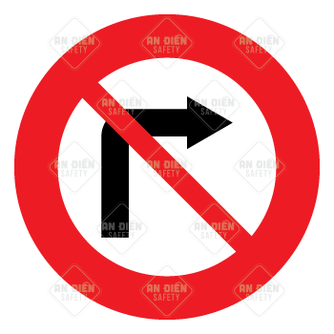

A. You should turn right. *(Bạn nên rẽ phải.)*

B. You should be careful on the right. *(Bạn nên cẩn thận bên phải.)*

**C. You should go straight on or turn left. *(Bạn nên đi thẳng hoặc rẽ trái.)***

D.You should give way to vehicles on the right. *(Bạn nên nhường đường cho phương tiện đi bên phải.)*

Khi làm dạng bài này, chúng ta có một số lưu ý như sau:

• Xác định loại biển báo (biển cấm, biển cảnh báo, biển chỉ dẫn,...) dựa vào hình ảnh và chữ trên biển báo (gạch chéo, chữ CAUTION, dấu chấm than,...)

• Lưu ý các động từ khuyết thiếu, dạng bị động của từ (be + P2) và các từ vựng thường hay xuất hiện được liệt kê trong bảng dưới đây:

|  |  |  |
| --- | --- | --- |
| **Từ** | **Loại từ** | **Nghĩa** |
| accept | v | *chấp nhận* |
| allow  = permit  permission | v  v  n | *cho phép*  *sự cho phép* |
| avoid | v | *tránh* |
| ban = forbid | v | *cấm* |
| be aware of | phr | *lưu ý* |
| careful  carefully | adj  adv | *cẩn thận*  *một cách cẩn thận* |
| caution | n | *thận trọng, chủ ý* |
| harmful | adj | *có hại* |
| notice | n | *thông báo* |
| obligation  compulsory  = mandatory | n  adj  adj | *nghĩa vụ*  *bắt buộc* |
| optional | adj | *không bắt buộc* |
| require | v | *yêu cầu* |
| risk | n | *nguy cơ* |
| warning | n | *cảnh báo* |

- Dạng 2 cho bạn một mẩu thông tin ngắn (7 - 20 từ), có thể kèm hình hoặc không và yêu cầu khoanh vào đáp án mô tả đúng.

What does the notice sat?

**Please do not feed the animal**

**A. Do not give food to the animals. *(Không đưa đồ ăn cho động vật.)***

B. You may feed the animal with staff supervision. *(Bạn có thể cho động vật ăn với sự giám sát của nhân viên.)*

C. Feeding the animal is allowed in certain areas. *(Cho động vật ăn được cho phép ở những khu vực nhất định.)*

D. Animals can be fed at specific times. *(Động vật được cho ăn ở những giờ cụ thể.)*

Khi làm dạng bài này, chúng ta có một số lưu ý như sau:

• Xác định các từ khóa, lưu ý tính phủ định (nếu có)

• Đoán nghĩa của các từ mới (nếu có) để hiểu nội dung mẩu tin

Dưới đây là một số từ vựng thường xuất hiện trong dạng bài này:

|  |  |  |
| --- | --- | --- |
| **Từ** | **Loại từ** | **Nghĩa** |
| appointment | n | *cuộc hẹn* |
| available | adj | *có sẵn, rảnh* |
| book (in advance)  reserve  reservation | V  V  n | *đặt trước*  *đặt trước/ dành cho*  *sự đặt trước* |
| charge  fee  fare  fine | n | *phí dịch vụ (mua bán)*  *phí dịch vụ (cố định)*  *phí đi lại*  *tiền phạt* |
| emergency | n | *khẩn cẩp* |
| encourage | v | *khuyển khích* |
| facility  equipment | n  n | *cơ sở vật chất*  *thiết bị* |
| fix  maintenance | v  n | *sửa chữa*  *sự bảo trì, bảo dưỡng* |
| keep sth adj | phr | *giữ cái gì như thế nào* |
| only  for sb/sth only | adj  phr | *chỉ có 1, duy nhất*  *chỉ dành cho ai, cái gì* |
| out of order  out of service | Idiom  idiom | *không hoạt động*  *không hoạt động* |
| possible | adj | *có thể* |
| receipt  bill | n  n | *biên nhận*  *hóa đơn* |
| reception  receptionist | n  n | *lễ tân*  *người lễ tân* |
| take place | phr | *diễn ra* |
| temporary | adj | *tạm thời* |
| unattended | adj | *bỏ mặc* |

II. BÀI TẬP VẬN DỤNG

**Read the following sign or notice and mark the letter A, B, C or D on your answer sheet to indicate the correct answer to each of the following questions.**

DẠNG 1: WHAT DOES THE SIGN SAY?

**Tra ID Đề [5502] - Tra ID Video [5503]**

**Question 1** [683932]:

|  |  |
| --- | --- |
| Caution Watch your step Sign | A. You can step fast here.  B. You cannot go this way.  C. You should step carefully.  D. You should step while watching something. |

**Question 2** [683933]:

|  |  |
| --- | --- |
| Premium Vector | Isolated sign of pets not allow no pet allowed animal do not enter sign with pictogram | A. Don't bring pets with you.  B. Pets are dangerous.  C. Bring a cat, don't bring a dog.  D. Pets are allowed. |

**Question 3** [683934]:

|  |  |
| --- | --- |
| Gas Traffic Sign | A. Gas station is closed.  B. You can get gasoline here.  C. You cannot get the fuel here.  D. Gas station is yellow. |

**Question 4** [683935]:

|  |  |
| --- | --- |
| 6: The definition of the height of the sign in ISO 3864-1:2002. | Download  Scientific Diagram | A. Pay attention when being on fire here.  B. Extinguish fire inside.  C. Don’t play with fire here.  D. Exit in the event of a fire. |

**Question 5** [683936]:

|  |  |
| --- | --- |
| Biển Báo Đường Được Sử Dụng Ở Quốc Gia Botswana Châu Phi Người Bán Hàng Rong Bị Cấm Hình minh họa Sẵn có - Tải xuống Hình ảnh Ngay bây giờ - iStock | A. Honk your horn.  B. No horn allowed.  C. No sound allowed.  D. Horn whenever you want. |

**Question 6** [683937]:

|  |  |
| --- | --- |
| 600Mm Road Works Ahead Sign Plate | A. Road work ahead.  B. There are workers ahead.  C. Look out for working children.  D. Workers are not allowed. |

**Question 7** [683938]:

|  |  |
| --- | --- |
| 4,000+ Parking Zone Stock Illustrations, Royalty-Free Vector Graphics &  Clip Art - iStock | Parking zone icon, No parking zone | A. Don’t play on the street.  B. Parking is free.  C. Parking lot is here.  D. No pedestrian traffic. |

**Question 8** [683939]:

|  |  |
| --- | --- |
| Slippery road ahead Road Sign | UK Delivery | Hirst Signs | A. You can drive as fast as you can.  B. Be aware of careless drivers.  C. Slippery road is ahead.  D. You cannot drive on this road. |

**Question 9** [683940]:

|  |  |
| --- | --- |
|  | A. No car allowed.  B. No overtaking allowed.  C. Go behind all cars.  D. Go faster than other cars. |

**Question 10** [683941]:

|  |  |
| --- | --- |
| Cutting Trees Prohibited Sign Forbidden Signs Stock Vector (Royalty Free) 2233165513 | Shutterstock | A. Using a hammer is harmful here.  B. Cutting down a tree is allowed.  C. Cutting down the wood is prohibited.  D. Having trees here is luxurious. |

**Question 11** [683942]:

|  |  |
| --- | --- |
| Premium Vector | Hard Hat Area Floor Sign On White Background | A. You don’t need to wear a hard hat in this area.  B. There is a hard hat in this area.  C. This area provides hard hat.  D. You must wear a hard hat here. |

**Question 12** [683943]:

|  |  |
| --- | --- |
| Danger Toxic complainy Hazard Sign | A. Animal bones are stored.  B. Toxic or poisonous chemicals.  C. This is the burial ground.  D. You should wash your head. |

**Question 13** [683944]:

|  |  |
| --- | --- |
| High Voltage Signs, High Voltage Warning Sign, Voltage Sign | Emedco | A. Electricity is in higher place.  B. Be careful! High-tech devices!  C. Serious injury or death may occur.  D. Voltage is not high enough. |

**Question 14** [683945]:

|  |  |
| --- | --- |
| Dấu Hiệu Bệnh Viện Hình ảnh PNG | Vector Và Các Tập Tin PSD | Tải Về Miễn Phí Trên Pngtree | A. There is a nearby medical center.  B. We should take patients to the hospital.  C. Hospitals are permitted to build here.  D. The Red Cross is available. |

**Question 15** [683946]:

|  |  |
| --- | --- |
| Biển báo đeo bảo vệ tai - HVT Safety | A. Low noise area.  B. Personal headphones are prohibited.  C. Hearing protection must be worn.  D. Making noise can be accepted. |

**Question 16** [683947]:

|  |  |
| --- | --- |
| Biển Cấm Uống Rượu Hình minh họa Sẵn có - Tải xuống Hình ảnh Ngay bây giờ - Thức uống không cồn, Biểu tượng - Ký hiệu chữ viết, Ấn Độ - iStock | A. Alcohol is allowed.  B. There is not good wine here.  C. Alcohol is not on the list.  D. You can’t drink beer here. |

**Question 17** [683948]:

|  |  |
| --- | --- |
| Advisory speed limit Traffic sign 30 km/h zone Vehicle, Traffic Signs,  text, trademark png | PNGEgg | A. Maximum 60 vehicles are allowed on this road.  B. You shouldn’t move below this speed.  C. You shouldn’t exceed this speed.  D. The road is 60 meter wide. |

**Question 18** [683949]:

|  |  |
| --- | --- |
| Signs - Regulatory - U.S. Municipal | A. You cannot turn left.  B. Only vehicles on the left can move.  C. Vehicles on the left should be careful.  D. You cannot go straight on. |

**Question 19** [683950]:

|  |  |
| --- | --- |
| Wheelchair Flat Icon PNG & SVG Design For T-Shirts | A. This area sells wheelchair.  B. For the handicapped only.  C. You must sit down.  D. Hospital ahead. |

**Question 20** [683951]:

|  |  |
| --- | --- |
| Sigo Signs Ring Bell for Service Sign, 10x7 Inches, Rust Free .040  Aluminum, Fade Resistant, Made in USA: Amazon.com: Industrial & Scientific | A. You must ring the bell to ask for help.  B. The bell will ring when you come in.  C. The bell will ring when you go out.  D. The staff will ring the bell for you. |

**Question 21** [683952]:

|  |  |
| --- | --- |
| Imperatives: Road Safety | Baamboozle - Baamboozle | The Most Fun Classroom Games! | A. Please keep noise at minimum.  B. People are allowed to make noise.  C. Please keep noise at maximum.  D. Muted people allowed. |

**Question 22** [683953]:

|  |  |
| --- | --- |
| 1PC welcome please knock sign Practical Do Not Disturb Sign For Office Door | A. You can enter the room.  B. You can come another time.  C. There is no one on the room.  D. Knock hard on the door. |

**Question 23** [683954]:

|  |  |
| --- | --- |
| Minh Họa Biểu Tượng Thùng Rác | Công cụ đồ họa AI Tải xuống miễn phí - Pikbest | A. Littering is permitted here.  B. We must not use recycle bins.  C. We must put waste paper into the bin.  D. Dust bins can be found everywhere. |

**Question 24** [683955]:

|  |  |
| --- | --- |
| No Driving and Phone Using Vector Sign Isolated on White Background Stock Illustration - Illustration of steering, notification: 273408481 | A. not to start the engine with a cell phone.  B. not to stop and buy a cell phone on the way.  C. not to use cell phones when driving.  D. not to talk with friends when driving. |

**Question 25** [683956]:

|  |  |
| --- | --- |
| Baggage Claim With Down Arrow Yellow Landscape - Wall Sign | A. Leave your suitcase here and go this way.  B. Go this way to get your suitcase.  C. Luggage is not allowed here.  D. Check your luggage before going downstairs. |

**Question 26** [683957]:

|  |  |
| --- | --- |
| 977 Departure Indicator Stock Vectors and Vector Art | Shutterstock | A. This gate is for buying tickets.  B. You wait for the flight here.  C. Passengers flights come out.  D. This area where passengers will leave. |

**Question 27** [683958]:

|  |  |
| --- | --- |
| Người Đi Bộ Qua Đường Cho - Miễn Phí vector hình ảnh trên Pixabay | A. The zebra is crossing the road.  B. Pedestrians running ahead.  C. Pedestrians crossing the roads.  D. Stop the car and take a walk. |

**Question 28** [683959]:

|  |  |
| --- | --- |
| Biểu Tượng Biển Báo Bùng Binh Minh Họa Vector Biển Báo Giao Thông Hình minh họa Sẵn có - Tải xuống Hình ảnh Ngay bây giờ - iStock | A. Go around the road.  B. Follow the roundabout.  C. Vehicles arranged in a circle.  D. Return to the roundabout. |

**Question 29** [683960]:

|  |  |
| --- | --- |
| Recycling icon. An arrow that revolves endlessly Reuse concept Recycled.  2756870 Vector Art at Vecteezy | A. You should put plastic bags here.  B. This area provides recyclable waste.  C. This bin is for unused cardboard.  D. Bring back the waste to your bin. |

**Question 30** [683961]:

|  |  |
| --- | --- |
| Cảnh Báo Biển Báo Dốc Xuống Dốc Hình minh họa Sẵn có - Tải xuống Hình ảnh Ngay bây giờ - Di chuyển xuống - Hoạt động thể chất, Ô tô - Xe động cơ trên đường bộ, Dốc - Mô tả vật lý - iStock | A. Steep incline ahead for vehicles.  B. Vehicles must stop immediately.  C. Steep downhill road ahead.  D. The road ends ahead soon. |

**Question 31** [683962]:

|  |  |
| --- | --- |
| Động Vật Hoang Dã Lai Ở Ba Lan Hình ảnh Sẵn có - Tải xuống Hình ảnh Ngay bây giờ - 2000-2009, 2015, Ba Lan - iStock | A. Animal crossing zone ahead.  B. Deer are prohibited from crossing.  C. Watch out for wildlife crossing.  D. Hunting allowed in this area. |

**Question 32** [683963]:

|  |  |
| --- | --- |
| Safety Shoes Required Sign | A. Safety boots are mandatory here.  B. Foot protection is optional today.  C. Workers should remove footwear.  D. Foot protection is not required. |

**Question 33** [683964]:

|  |  |
| --- | --- |
| Eye Protection | Safety Signage Gobos | Projected Image | A. Goggles must be worn in this area.  B. Eye protection is not needed here.  C. Eye protection is optional during work.  D. Regular glasses are allowed as protection. |

**Question 34** [683965]:

|  |  |
| --- | --- |
| Parking Sign Board at ₹ 200/square feet in Pune | ID: 20183477488 | A. This is a reserved parking space only.  B. Parking is prohibited in this area.  C. Parking is available in the direction.  D. No parking beyond this point. |

**Question 35** [683966]:

|  |  |
| --- | --- |
| fall trong Tiếng Việt, dịch, Tiếng Anh - Từ điển Tiếng Việt | Glosbe | A. Slow down and be cautious.  B. Increase speed to avoid the danger.  C. Turn around, the road is closed.  D. Continue driving without stopping. |

**Question 36** [683967]:

|  |  |
| --- | --- |
| 360+ Priority Seat Sign Stock Photos, Pictures & Royalty-Free Images -  iStock | A. The elderly can sit in front of the disabled.  B. Please offer the seat for these individuals.  C. Only pregnant woman can sit here.  D. These seats are available for every passenger. |

**Question 37** [683968]:

|  |  |
| --- | --- |
| No loud music sign, circular. Stock Vector | Adobe Stock | A. No loud music or noise allowed in this area.  B. Headphones are required when listening to music.  C. Music is encouraged in this area.  D. Use of speakers is allowed at low volume only. |

**Question 38** [683969]:

|  |  |
| --- | --- |
| Restricted Area: No Trespassing with Icon Landscape - Wall Sign | A. Anyone can enter if they look official.  B. Only those with permission can enter.  C. It’s okay to enter if you’re in a hurry.  D. Entry is allowed during office hours. |

**Question 39** [683970]:

|  |  |
| --- | --- |
| Warning You Will Be Fined Sign - Shop Now, Save 10% | A. Littering is acceptable if no one is watching.  B. You may litter as long as you pay the fine.  C. Dispose of trash properly to avoid fines.  D. Fines are imposed for large amounts of litter. |

**Question 40** [683971]:

|  |  |
| --- | --- |
| Please Don't Waste Water Sign - Get 10% Off Now | A. You can use as much water as you wish.  B. You should save water for future generations.  C. You should turn off the tap to protect children.  D. You shouldn’t use water for any purposes. |

**Question 41** [683972]:

|  |  |
| --- | --- |
| Caution: Hot Surface Do Not Touch Warning - Wall Sign | A. Touch lightly to check the temperature.  B. Wait until it cools down before touching.  C. Avoid touching only if you have sensitive skin.  D. It’s safe to touch if you’re wearing gloves. |

**Question 42** [683973]:

|  |  |
| --- | --- |
| Caution Uneven Ground Sign – New Signs | A. Be careful only if it’s dark outside.  B. Proceed carefully as the ground may be uneven.  C. It’s safe to ignore if you’re familiar with the area.  D. You can walk normally unless you trip. |

**Question 43** [683974]:

|  |  |
| --- | --- |
| No swimming allowed do not swim banned prohibited deep water posters for  the wall • posters white, water, warning | myloview.com | A. Swimming is allowed only in deep areas.  B. Deep water is unsafe if you can swim.  C. Do not swim here for safety reasons.  D. You can swim in the deepest part. |

**Question 44** [683975]:

|  |  |
| --- | --- |
| This Area Is Under 24 Hour Video Surveillance OSHA Notice Safety Sign | A. You can do anything since it's just a warning.  B. Your actions may be monitored for security.  C. Cameras only record in emergencies.  D. It’s safe to behave dangerously without concern. |

**Question 45** [683976]:

|  |  |
| --- | --- |
| Notice "Babies Sleeping, Please Be Quiet" Durable Matte Laminated Vinyl  Floor Sign- Various Sizes Available | A. It’s okay to be loud as long as babies have fun.  B. Keep noise to a minimum so the baby won’t wake up.  C. Babies can sleep despite the noise.  D. You can talk quietly with the baby. |

**Question 46** [683977]:

|  |  |
| --- | --- |
| Không Thích Hợp Cho Trẻ Em Dưới 3 Tuổi Ký Hình minh họa Sẵn có - Tải xuống Hình ảnh Ngay bây giờ - Biểu tượng - Đồ thủ công, Hình minh họa, Hình vuông - iStock | A. Two-year-old babies can play this toy.  B. Kids should play with this toy for 3 hours.  C. Kids over 3 years old can play with this toy.  D. This toy is for toddlers under three years old. |

**Question 47** [683978]:

|  |  |
| --- | --- |
| Notice - No Cell Phones During Work Hours Sign With Symbol | LABEL DECAL  STICKER Retail Store Sign Sticks to Any Surface 8" | A. Use your phone secretly.  B. Silence your phone but keep using it.  C. Avoid using phones to focus on your work.  D. Only put your phone away during meetings. |

**Question 48** [683979]:

|  |  |
| --- | --- |
| Please keep your distance – COVID-19 floor vinyl - Stocksigns | A. You can stand closer if you know the person.  B. Maintain a distance of at least 2 meters from others.  C. Standing less than 2 meters away is enough.  D. You can ignore this sign if it’s not crowded. |

**Question 49** [683980]:

|  |  |
| --- | --- |
| Earth Hour Campaign Poster Or Banner Turn Off Your Lights For Our Planet 60  Minutes Illustration Royalty Free SVG, Cliparts, Vectors, and Stock  Illustration. Image 162599307. | A. You can leave the lights on if you're home.  B. Turn off all lights and electrical devices for 60 minutes.  C. Switch off only if you want to save energy.  D. It’s duty to participate in Earth Hour. |

**Question 50** [683981]:

|  |  |
| --- | --- |
| Please Flush After Use Sign Board - 15cm X 21cm | Daraz.lk | A. Flushing is optional if no one is around.  B. Always flush after using the toilet.  C. Flush only if someone else is waiting.  D. You can skip flushing if it looks clean. |

**Question 51** [683982]:

|  |  |
| --- | --- |
| Opportunities To Advocate for Anti-Bullying | A. Ignore bullying unless it's serious.  B. Stand up against bullying and speak out.  C. Stop bullying only if you're directly involved.  D. Speak about bullying to students. |

**Question 52** [683983]:

|  |  |
| --- | --- |
| Pick-Up and Drop-Off Only No Parking | A. Parking is okay if you're quick.  B. Only stop briefly without parking.  C. You can park but not leave the car.  D. Parking is allowed when no one is around. |

**Question 53** [683984]:

|  |  |
| --- | --- |
| &quot;Please Fasten Your Seatbelts&quot;: Why Cybersecurity Is the Safety  Harness Your Business Needs | Venkata Satish Guttula | A. Seatbelts are suggested but not necessary.  B. You should fasten your seatbelt for safety.  C. It's fine to leave your seatbelt unfastened.  D. Fastening your seatbelt is only important for the driver. |

**Question 54** [683985]:

|  |  |
| --- | --- |
| Flammable icon SVG Vector & PNG Free Download | UXWing | A. Be careful, it’s easy to catch fire.  B. Burning something is not allowed.  C. No picnicking allowed.  D. Keep away from the fire. |

**Question 55** [683986]:

|  |  |
| --- | --- |
|  | A. We should stop and park 2.5-ton trucks here.  B. We should be careful with trucks crossing the road.  C. We should look for another way to travel if your truck is over 2.5 tons.  D. We should ask for help from a bigger truck. |

**Question 56** [683987]:

|  |  |
| --- | --- |
| Keep Site Entrance Clear Sign | A. Only use this entrance in an emergency.  B. Do not park in front of this entrance.  C. Always keep this door open.  D. Permission is needed to park here. |

**Question 57** [683988]:

|  |  |
| --- | --- |
| What does this sign mean? A. We should stop driving cars. B. Cars must not  be turned left. C. Cars must be turned right. D. Cars must be parked here.  What does | A. We should stop driving cars.  B. Cars must not be turned left.  C. Cars must be turned right.  D. Cars must be parked here. |

**Question 58** [683989]:

|  |  |
| --- | --- |
| Nhãn dán vận chuyển Homelyworld Fragile, Tự dính, 1 cuộn | A. The package is waterproof.  B. The item inside is easily broken and should be handled with care.  C. The item should be exposed to sunlight.  D. The package is heavy and needs special equipment for lifting. |

**Question 59** [683990]:

|  |  |
| --- | --- |
| Warning: Fall Protection Required In This Area - Most ship within 48 hours! | A. The area has a high risk of falling objects.  B. Fall protection is optional in this area.  C. Wear protection to avoid falling from heights.  D. Only trained personnel are allowed to use protection. |

**Question 60** [683991]:

|  |  |
| --- | --- |
| Premium Vector | Round blue safety sign parent hold kids hand on escalator for indoor safety sign | A. Only children are allowed in this area without supervision.  B. Adults must supervise and hold the hands of children in this area.  C. Children are prohibited from entering this area.  D. This is a pedestrian zone where running is encouraged. |

**Question 61** [683992]:

|  |  |
| --- | --- |
| No Pushing Symbol Sign ,Vector Illustration, Isolate on White Background Label. EPS10 Stock Vector - Illustration of defense, diet: 302807953 | A. You must push someone into the pool.  B. Watch your steps when pushing people.  C. Pushing people is dangerous here.  D. It’s unsafe to play in the pool. |

**Question 62** [683993]:

|  |  |
| --- | --- |
| Fragile Labels - Do Not Stack | A. Only heavy materials can be placed here.  B. No stacking blocks allowed.  C. Blocks must be stacked neatly.  D. Using these blocks is prohibited. |

**Question 63** [683994]:

|  |  |
| --- | --- |
| Do Not Pluck Flowers Sign Royalty-Free Images, Stock Photos & Pictures |  Shutterstock | A. You may pick up some small flowers.  B. Don’t bring flowers along.  C. There are flowers around here.  D. Do not damage the flowers. |

**Question 64** [683995]:

|  |  |
| --- | --- |
| Elevator Advisory, Max 3 Passengers Sign | A. Only three people or less are allowed in the elevator at a time.  B. Three passengers must stay apart in the elevator.  C. Three passengers can use the elevator.  D. Standing closer is required in the elevator. |

**Question 65** [683996]:

|  |  |
| --- | --- |
| Railway level crossing without gate or barrier ahead Road Sign | UK  Delivery | Hirst Signs | A. You should watch and stop the train.  B. Railway ahead; proceed with caution.  C. Train station is near here.  D. You can cross the railways. |

DẠNG 2: WHAT DOES THE NOTICE SAY? / WHAT DOES THE NOTICE TELL US ABOUT?

Tra ID Đề [5504] - Tra ID Video [5505]

**Question 1** [685846]:

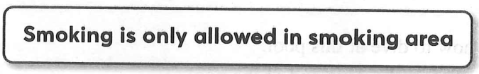

A. You are not allowed to smoke anywhere in the building.

B. There are certain places where you can smoke.

C. You must smoke if you are in one of the building’s smoking areas.

D. Smoking is encouraged in the building.

**Question 2** [685847]:

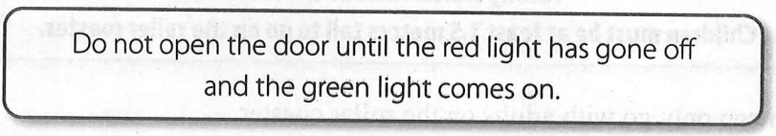

A. Turn off the red light when you open the door.

B. Do not open the door when the green light is on.

C. Wait for the green light before opening the door.

D. Until the green light is on, keep the door open.

**Question 3** [685848]:

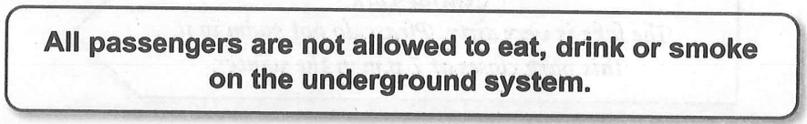

A. You cannot bring your food on the underground.

You can eat and drink at special areas on the underground.

C. You can smoke on the platform before going on the underground.

D. Drinking water at the station is forbidden.

**Question 4** [685849]:



A. Buy a gold watch with $50 and you can return it.

B. You will get some money if you can bring the watch over.

C. If the watch is not returned safely, you will receive $50.

D. Bring $50 and you will be given a gold watch.

**Question 5** [685850]:

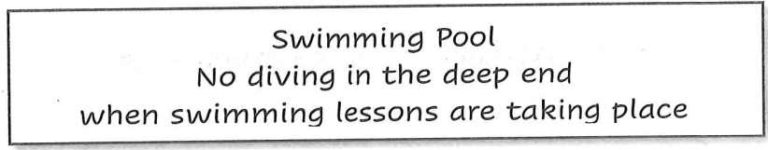

A. You can learn how to dive at this pool.

B. Swimmers can dive in the deep end of the pool.

C. You cannot dive and swim when there’s a swimming class.

D. It’s dangerous to dive in this area of the pool.

**Question 6** [685851]:

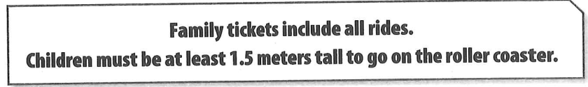

A. Children can only go with adults on the roller coaster.

B. It costs extra if children under 1.5 meters want to go on roller coaster.

C. Smaller children cannot go on the roller coaster.

D. You cannot go on the roller coaster without family ticket.

**Question 7** [685852]:

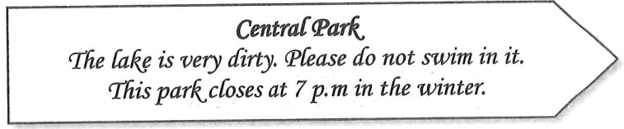

A. The park is closed during the winter.

B. You can swim in the park in the summer.

C. Swimming in it is safe after 7 p.m.

D. You cannot get into the lake.

**Question 8** [685853]:

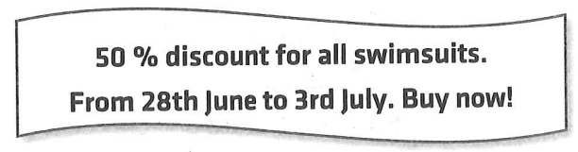

A. Everything is on sale in the next two months.

B. All the swimsuits are half-price only in June.

C. The special offer is only for a few days.

D. You can get the discount on the last day of July.

**Question 9** [685854]:

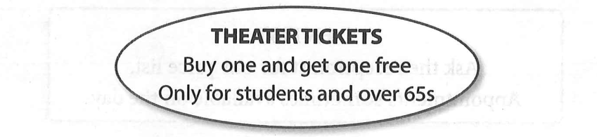

A. People over 65 pay more to buy a ticket.

B. Two students only need to pay for one ticket.

C. There are free tickets for 65 students.

D. You have to pay double for a ticket if you are under 65s.

**Question 10** [685855]:

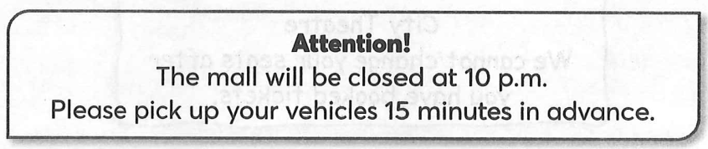

A. You have 15 minutes to get your car.

B. You can pick up your car after 10 p.m.

C. You can stay in the mall until 10 p.m if you walk home.

D. You have to spend 15 minutes to get your car.

**Question 11** [685856]:

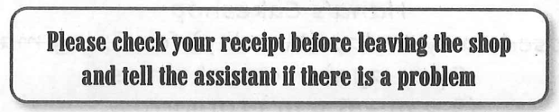

A. Let the assistant know if you think there’s a mistake on your receipt.

B. Keep your receipt because you might need to change something you bought.

C. Tell the assistant if you’ve lost the receipt for something you bought.

D. After leaving the shop, you can call the assistant for help.

**Question 12** [685857]:

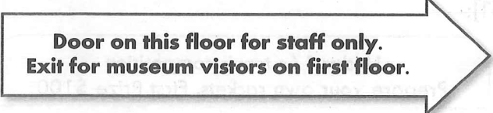

A. The way out of the museum is on this floor.

B. Enter the room and ask a staff about the exit.

C. Visitors should use a different door to leave the museum.

D. Only staff can leave the museum.

**Question 13** [685858]:

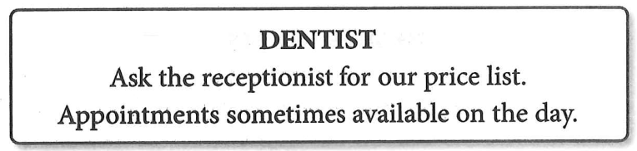

A. There are maybe some appointments available you can book for today.

B. The dentist may see you if you haven’t booked an appointment.

C. When you book an appointment, we can’t tell you how much it will cost.

D. Check the price before you book an appointment.

**Question 14** [685859]:

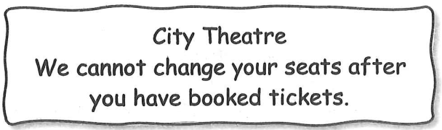

A. Customers should choose their seats carefully when they are in the theatre.

B. Customers can get their money back on tickets.

C. Customers can ask for different seats after they’ve paid.

D. Customers should choose where they sit before they book.

**Question 15** [685860]:

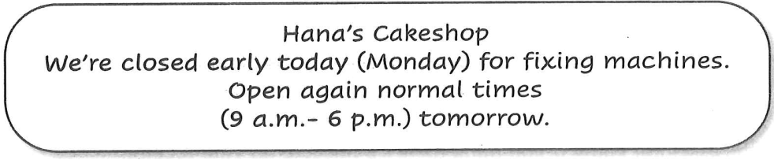

A. The shop plans to change its usual opening times.

B. The shop closes earlier on Mondays.

The shop will serve as usual from Tuesday.

The shop will spend 2 days fixing the machines.

**Question 16** [685861]:

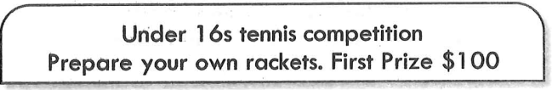

A. You may earn some money by selling your rackets.

B. You have to pay $100 to participate in the competition.

C. You must have at least a racket to get $100.

D. There is no prize for 15-year-old kids if they win.

**Question 17** [685862]:

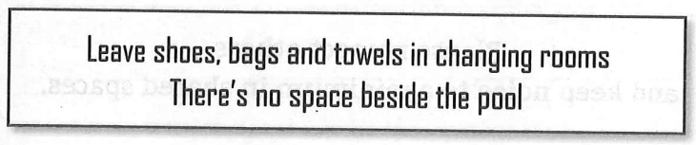

A. The changing rooms are now in a different place.

B. Swimmers can’t take their stuff into the pool area.

C. Don’t forget your shoes, bags and towels before you go.

D. There is no space in changing rooms.

**Question 18** [685863]:

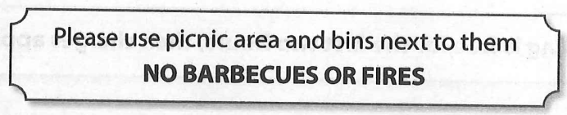

A. You can’t bring your food into the picnic area.

B. You can’t leave your rubbish in the bins.

C. The picnic area is open for camp fire.

D. You can’t bum wood in picnic area.

**Question 19** [685864]:

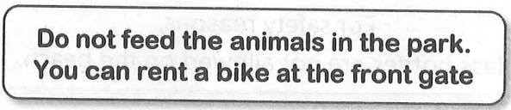

A. Even if you have the right food, you can’t feed the animals.

B. Renting a bike and feeding the animals are not allowed.

C. You must feed the animals after renting a bike.

D. You can only feed certain animals when riding a bike.

**Question 20** [685865]:

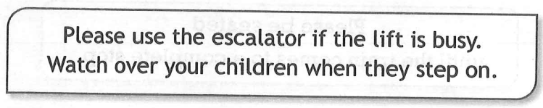

A. The lift is always out of order so please use the escalator instead.

B. You cannot use the escalator without your children.

C. If the lift is full, the escalator will work.

D. Keep an eye on your kids on the escalator in case the lift is full.

**Question 21** [685866]:

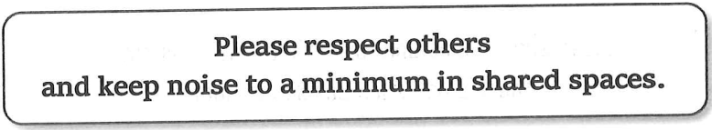

A. You can make as much noise as you want in shared spaces.

B. It's okay to be loud if other people aren’t nearby.

C. You should try to be quiet when in shared spaces.

D. Noise is only a problem in private spaces.

**Question 22** [685867]:

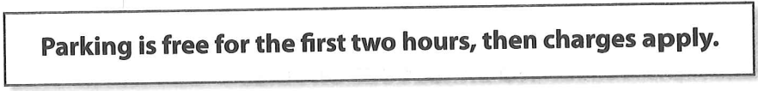

A. You must always pay for parking.

B. You can park for free for two hours but must pay after that.

C. Parking is free after two hours.

D. Parking is always free, no matter how long you stay.

**Question 23** [685868]:

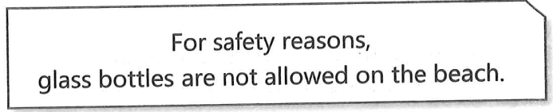

A. You can bring plastic bottles, but not glass ones.

B. Glass bottles are allowed if you don’t break them.

C. You can bring glass bottles to the beach but keep them hidden.

D. Glass bottles are only allowed if they are empty.

**Question 24** [685869]:

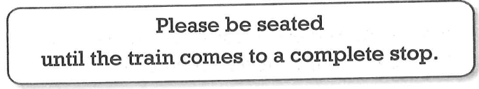

A. You can stand up when the train slows down.

B. It’s okay to leave your seat once the train starts moving.

C. Stay seated until the train fully stops.

D. You must get off the train while it is still moving.

**Question 25** [685870]:

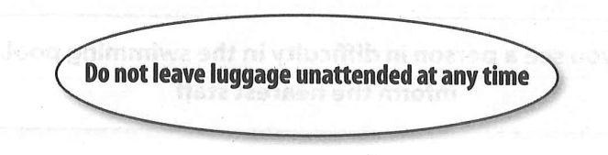

A. Remember to take your bags with you when you leave the train

B. Leave your bags here

C. Always stay with your bags

D. Bags must be left at any time

**Question 26** [685871]:

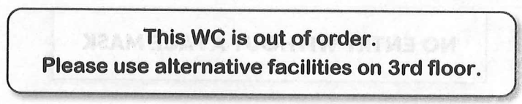

A. You can use this toilet or the one on 3rd floor.

B. You can’t use this toilet and there aren’t any others in the building.

C. You can’t use this toilet and there is another on 3rd floor.

D. You can’t use either this toilet or the one on 3rd floor.

**Question 27** [685872]:

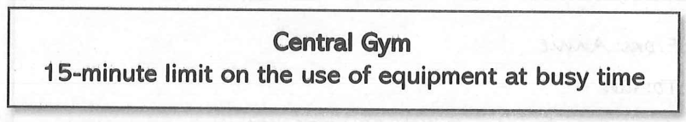

A. Equipment is available for a maximum of 15 minutes at any time.

B. When the gym is crowded, there is a time limit for using equipment.

C. At busy time, you may have to queue to use the equipment.

D. When there is a lot of people in the gym, avoid using the equipment.

**Question 28** [685873]:

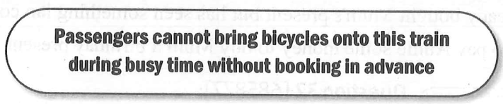

A. All passengers must book before boarding with a bicycle.

B. There is no room for bicycle on this train when it is busy time.

C. Passengers must book after boarding with a bicycle.

D. Bicycles are not allowed during busy time.

**Question 29** [685874]:

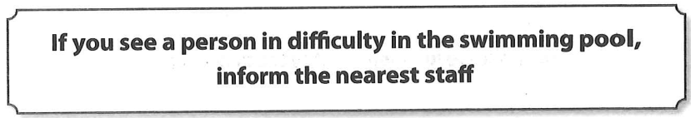

A. This pool is for good swimmers only.

B. Call a staff if you are in danger.

C. The nearest staff informs the difficulty in the pool.

D. Tell a staff member if there is an accident with someone.

**Question 30** [685875]:

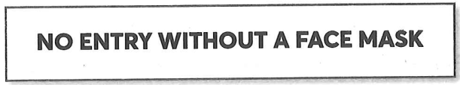

A. Using facemask is required here.

B. Using facemask is prohibited here.

C. Using facemask is optional here.

D. Using facemask is decorated here.

**Question 31** [685876]:

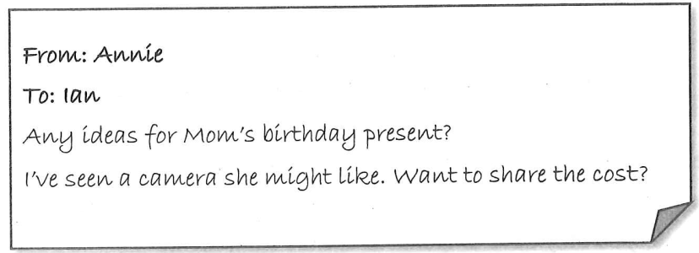

A. Annie suggests that she and Ian give Mum one birthday present together.

B. The present Annie saw for Mum was too expensive, so she needs other ideas.

C. Annie has already bought Mum’s present but has seen something Ian could buy.

D. Ian suggests paying Annie some money to buy Mum a birthday present.

**Question 32** [685877]:

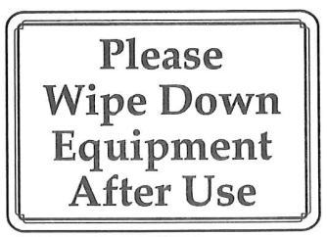

A. Wiping down the equipment is only required if it’s dirty.

B. Always wipe down the equipment after you’ve used it.

C. You can skip wiping if someone else is waiting to use it.

D. After wiping down the equipment, use it please.

**Question 33** [685878]:

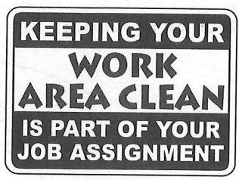

A. Cleaning is different from your assignment.

B. Your job responsibility includes keeping the area clean.

C. You only need to clean after finishing the task.

D. Cleaning is optional unless mentioned.

**Question 34** [685879]:

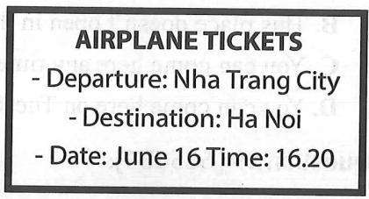

A. The plane to Nha Trang City leaves at 4.20 p.m.

B. The plane to Ha Noi leaves at 16.20.

C. The plane to Nha Trang City leaves on June 6.

D. The plane to Nha Trang City leaves on 6th of July.

**Question 35** [685880]:

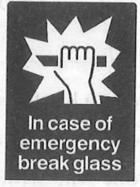

A. This glass will break in the fire.

B. Break this glass if there is a fire.

C. Anyone who breaks the glass will be fired.

D. Don’t break the glass in case of fire.

**Question 36** [685881]:

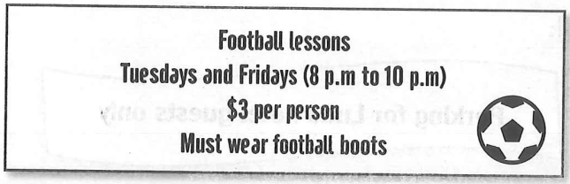

A. The football lessons are free.

B. Each lesson lasts for 3 hours.

C. You will have two lessons every week.

D. The football lessons are in the morning.

**Question 37** [685882]:

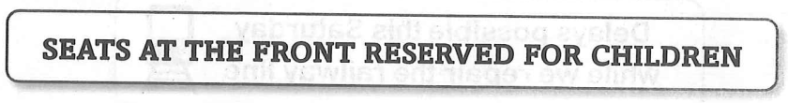

A. You should wait here before you sit down.

B. There’s no more seats for adults.

C. Children cannot sit at front seats.

D. Front seats are only for children.

**Question 38** [685883]:

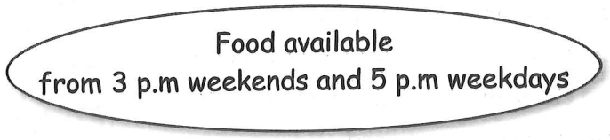

A. It is impossible to come here after 5 p.m.

B. This place doesn’t open in the morning.

C. You can come here any time.

D. You can come here on Tuesday at 4 p.m.

**Question 39** [685884]:

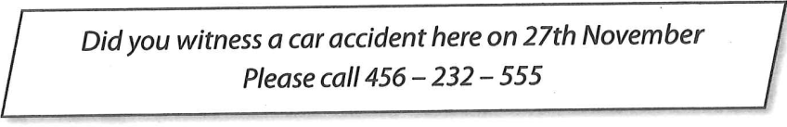

A. Anyone who drove a car into another call this number.

B. Anyone who saw a car cash must report via this number.

C. Anyone who witness a car crash must keep calm.

D. Anyone who cause the accident has been recorded.

**Question 40** [685885]:

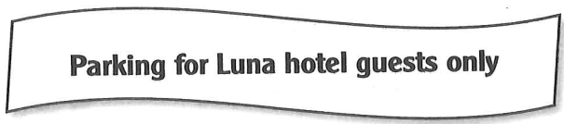

A. Only hotel staff can park here.

B. Guests must pay for parking at Luna Hotel.

C. Anyone using hotel service is allowed to park here.

D. Parking is available for anyone near Luna Hotel.

**Question 41** [685886]:

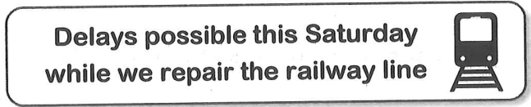

A. Repairs on the railway might cause delays on Saturday.

B. Delays will happen every Saturday due to repairs.

C. There will be no delays during the railway repairs on Saturday.

D. The railway will not be repaired on Saturday to avoid delays.

**Question 42** [685887]:

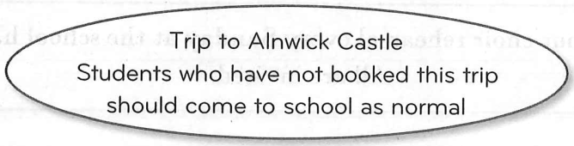

A. Students not going on the trip cannot have a day off at school.

B. Students have to decide today if they would like to join the trip.

C. Students going on the trip must come to school first.

D. Students should go to school first to book the trip.

**Question 43** [685888]:

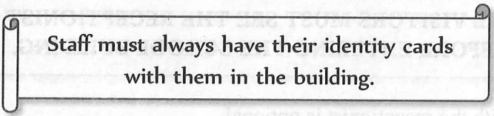

A. Staff can leave their identity cards at home while in the building.

B. All staff members must carry their identity cards while in the building.

C. Only new staff need to bring their identity cards to the building.

D. Identity cards are required to enter the building but can be left in the office.

**Question 44** [685889]:

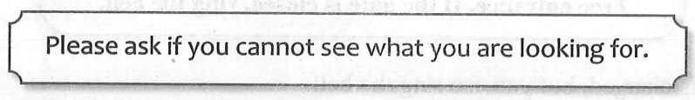

A. Ask only if you do not know what you are looking for.

B. You must look for what you need without asking.

C. You can only ask after finding what you need.

D. Ask for help if you cannot find what you need.

**Question 45** [685890]:

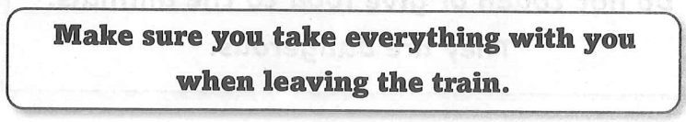

A. You can return to the train if you forget your belongings.

B. You should leave your bags on the train after you exit.

C. Check that you don’t leave any belongings behind when you exit the train.

D. Take only important items with you when leaving the train.

**Question 46** [685891]:

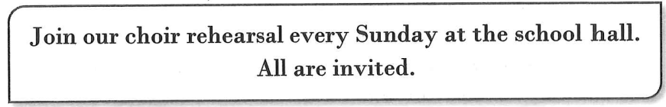

A. Everyone is welcome to attend choir practice on Sundays.

B. Only students are allowed to join the choir rehearsals.

C. Choir rehearsals take place at different locations each week.

D. You must sign up in advance to attend the choir rehearsal.

**Question 47** [685892]:

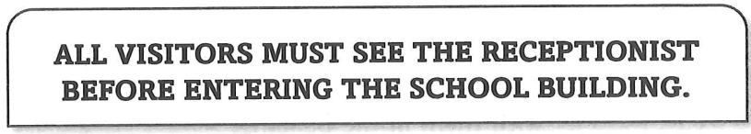

A. Checking in with the receptionist is optional.

B. Everyone needs to check in prior to entering.

C. Visitors can proceed without any restrictions.

D. Only authorized personnel can enter the building.

**Question 48** [685893]:

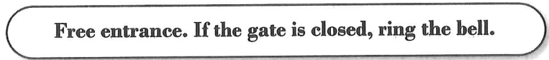

A. Entrance is charged, but you can ring the bell.

B. You may enter freely unless the bell is ringing.

C. Entrance is free; ring the bell if you can’t come in.

D. The bell must be rung to enter at all times.

**Question 49** [685894]:

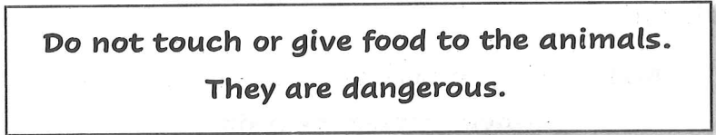

A. Feeding the animals is encouraged for safety.

B. Touching the animals can be harmful to you.

C. Animals are safe to pet if you have food.

D. Avoid contact and feeding as they may be dangerous.

**Question 50** [685895]:

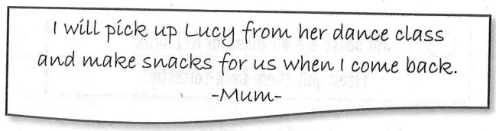

A. Mum will prepare snacks before picking up Lucy.

B. Lucy will make snacks for everyone when she returns.

C. Lucy will be picked up and then have some snacks.

D. Snacks will be made before picking up Lucy from class.

**Question 51** [685896]:

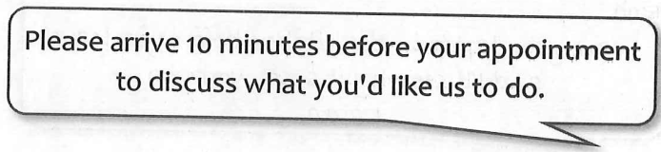

A. Arriving late is acceptable as long as you inform us.

B. It’s best to come early to talk about your needs.

C. You should arrive exactly at your appointment time.

D. Discussions will only happen after your appointment begins.

**Question 52** [685897]:

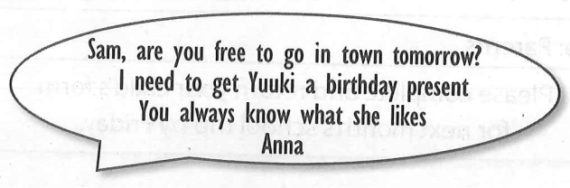

A. Anna is asking Sam to come to Yuuki’s birthday party.

B. Anna is asking Sam to go into town with Yuuki.

C. Anna is asking Sam to choose a gift for Yuuki.

D. Anna is asking Sam if Sam bought Yuuki a gift or not.

**Question 53** [685898]:

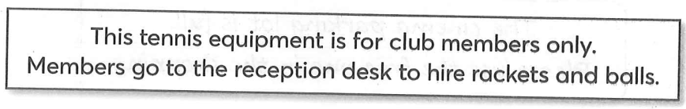

A. Non-members can borrow equipment from the club.

B. Only members can rent rackets and balls at reception.

C. Equipment is available to everyone without restrictions.

D. You can buy rackets and balls at the reception desk.

**Question 54** [685899]:

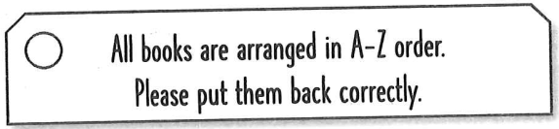

A. Books should be returned in any random order.

B. Arrange books by their authors’ last names.

C. Ensure books are placed back in alphabetical order.

D. Only fiction books need to be organized alphabetically.

**Question 55** [685900]:

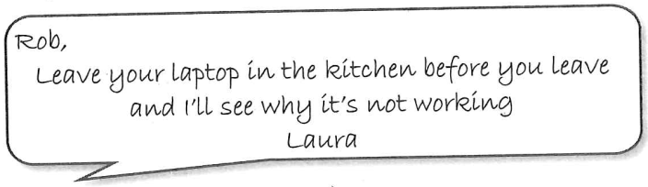

A. Laura will check the laptop later.

B. Rob should take his laptop with him.

C. Laura is fixing the laptop immediately.

D. Rob must leave the kitchen before checking the laptop.

**Question 56** [685901]:

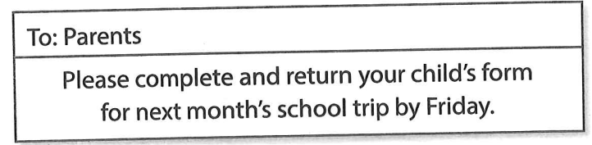

A. Forms should be submitted by next month.

B. Parents can return forms in the next month’s trip.

C. All forms must be returned by this Friday.

D. Only some parents need to fill out the form.

**Question 57** [685902]:

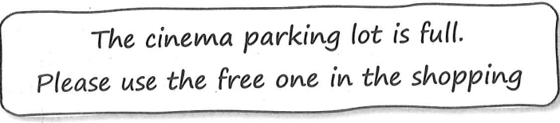

A. Parking is available for people going to the cinema only.

B. The shopping center offers paid parking.

C. The cinema parking lot has no available spaces; use the free lot nearby.

D. You must find another parking space outside the shopping center.

**Question 58** [685903]:

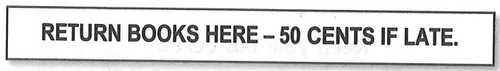

A. You must pay 50 cents to return any book.

B. Books returned late will charge you a 50-cent fee.

C. You can return books here only if they are late.

D. Only some books are subject to a late fee.

**Question 59** [685904]:

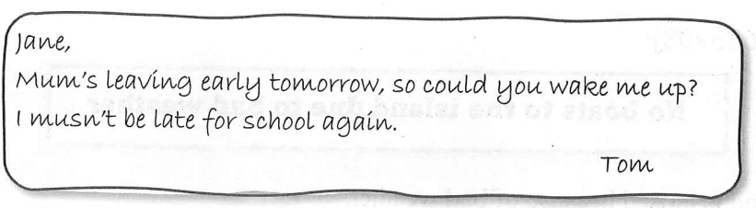

A. Tom wants Jane to take him to school tomorrow.

B. Tom reminds Jane that they have to wake up early tomorrow.

C. Tom would like Jane to do him a favor tomorrow.

D. Tom regrets for not getting up early this morning.

**Question 60** [685905]:

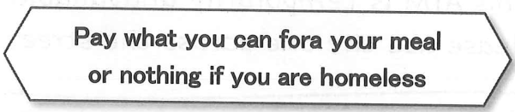

A. Homeless individuals are allowed to eat for free.

B. Everyone must pay the same amount.

C. You are required to pay something, even if you are homeless.

D. Only people who can afford to pay are allowed to eat here.

**Question 61** [685906]:

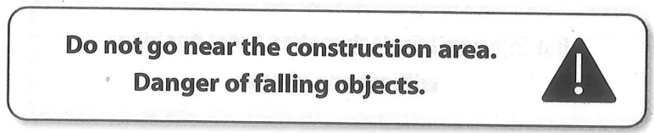

A. Stay away from the construction area.

B. Enter the construction area carefully.

C. The construction area provides falling objects.

D. It’s safe to visit the construction area later.

**Question 62** [685907]:

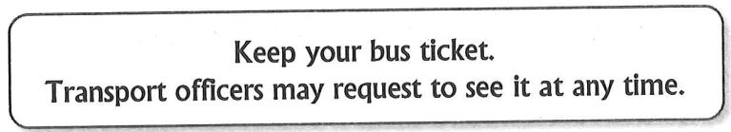

A. There may be ticket checks during your bus journey.

B. Transport officers request you to buy a bus ticket.

C. Transport officers have to keep your bus ticket.

D. You can get your bus tickets from transport officers.

**Question 63** [685908]:

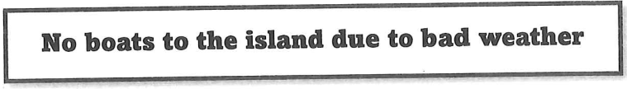

A. The island is closed because of bad weather.

B. Only some boats will go to the island.

C. Boats are running late due to bad weather.

D. Boat trips are cancelled because of the weather.

**Question 64** [685909]:

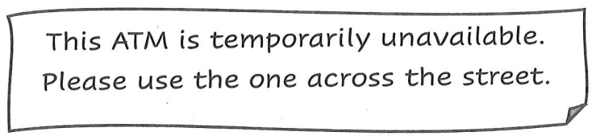

A. You can use this ATM for limited services.

B. The ATM is out of service.

C. The ATM will be fixed later today.

D. You may wait here until the ATM is working again.

**Question 65** [685910]:

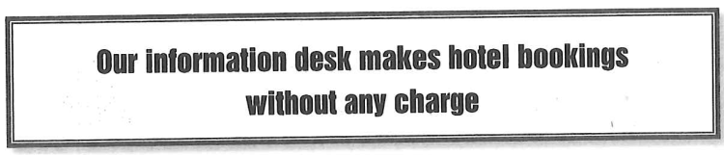

A. You must pay a service fee to book a hotel here.

B. The information desk charges a fee for hotel bookings.

C. You can book a hotel through the information desk for free.

D. The information desk only provides information, not bookings.

**Question 66** [685911]:

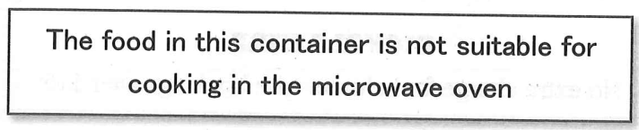

A. This food cannot be microwaved in its container.

B. Microwave the food in this container on low heat.

C. The container is safe for microwave use.

D. You must remove the food before microwaving.

**Question 67** [685912]:

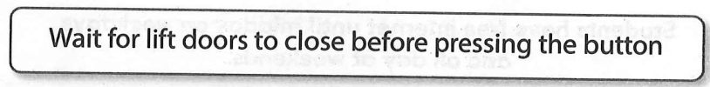

A. The button can be pressed at any time.

B. Press the button before the lift doors close.

C. The lift doors will close automatically after pressing the button.

D. Press the button after the lift doors close.

**Question 68** [685913]:

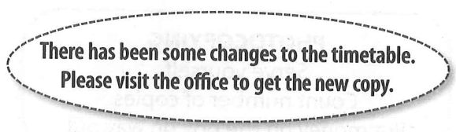

A. The timetable is the same as it was before.

B. You need to tell the office about any changes to your timetable.

C. You can go to the office collect the updated timetable.

D. The office will send you the new time table.

**Question 69** [685914]:

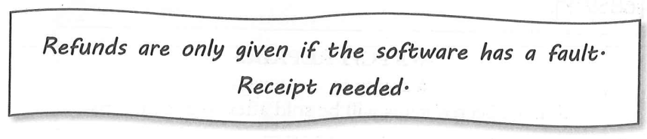

A. Refunds are available for any reason if you have the receipt.

B. Refunds are available for faulty software with a receipt.

C. A refund can be given without a receipt for faulty software.

D. You can return the software at any time for a refund.

**Question 70** [685915]:

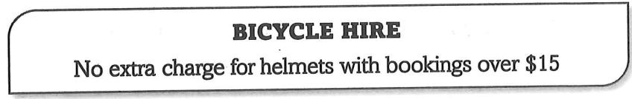

A. Helmets are free if you pay $20.

B. Helmets are always free with any booking.

C. You must pay extra for helmets, even with rentals over $15.

D. Helmets are free for bikers who have their own bike.

**Question 71** [685916]:

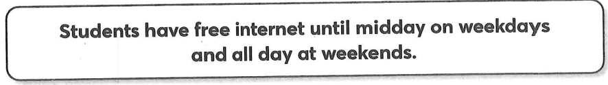

A. There is a charge for internet access at weekends.

B. Students must always pay to use the internet in the afternoons.

C. It doesn’t cost anything to use the internet on weekdays.

D. Internet is free at all times.

**Question 72** [685917]:

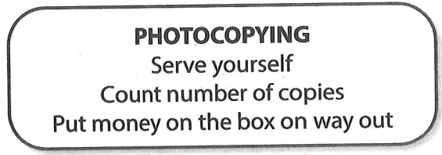

A. Put your money in the photocopier before you leave.

B. Put your money in the photocopier before you start to use it.

C. Put your photocopies in the box on the way out.

D. Do your photocopying and pay for it when you leave.

**Question 73** [685918]:

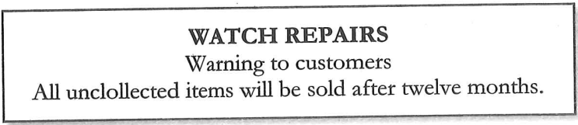

A. This shop will sell customers’ watches within twelve months.

B. This shop will keep customers’ watches for up to twelve months.

C. This shop will look after customers’ watches more than twelve months.

D. This shop will repair customers’ watches in twelve months.

**Question 74** [685919]:

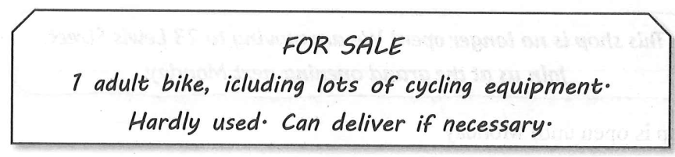

A. Equipment costs extra when you buy the bike.

B. The owner can bring the bike to you if buy it.

C. The bike is very hard to ride

D. You have to go to pick up the bike.

**Question 75** [685920]:

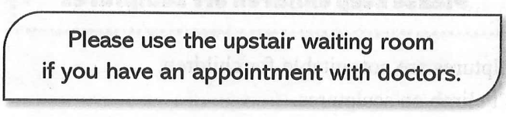

A. You can go upstairs to make appointment with doctors.

B. Doctors can only see patients with appointments.

C. You can wait upstairs to see the doctors.

D. Doctors wait for patients with no appointments upstairs.

**Question 76** [685921]:

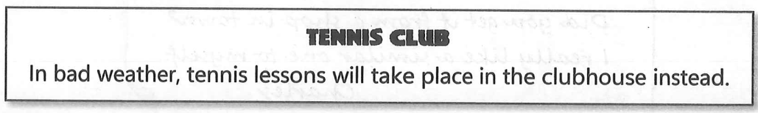

A. If it rains, a different activity will be available.

B. The place that tennis lessons take place depends on weather.

C. The next tennis lesson will be cancelled due to the bad weather.

D. Tennis lessons may take place in both indoors and outdoors when it rains.

**Question 77** [685922]:

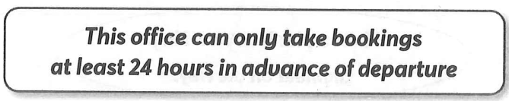

A. This office doesn’t take booking on the same day you travel.

B. If you book tickets here, you will see them a day later.

C. You can book tickets from this office 24 hours a day.

D. You can travel 24 hours with the tickets from this office.

**Question 78** [685923]:

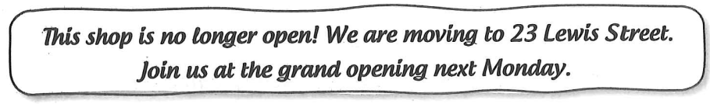

A. The shop is open until Monday.

B. The shop will not be at number 23 anymore.

C. The shop is opening in a different place.

D. The shop at 23 Lewis will be closed.

**Question 79** [685924]:

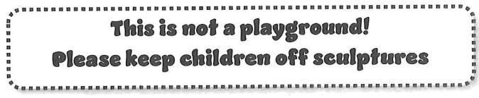

A. Some of the sculptures are not suitable for children.

B. Children mustn’t climb on sculptures.

C. You can play with sculptures as long as you want.

D. Families can only play in the playground.

**Question 80** [685925]:

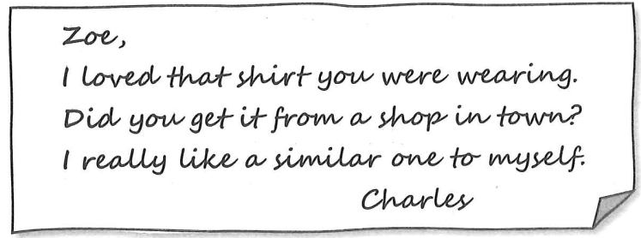

A. Charles wants to know which shirt Zoe bought yesterday.

B. Charles wants to know when Zoe had his shirt.

C. Charles wants to know how much Zoe liked his shirt.

D. Charles wants to know where Zoe got his shirt.

**Question 81** [688559]:

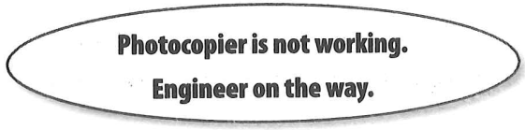

A. The photocopier will be fixed soon.

B. You need to call an engineer for repairs.

C. The photocopier is available for use.

D. Only the engineer can use the photocopier.

**Question 82** [688560]:

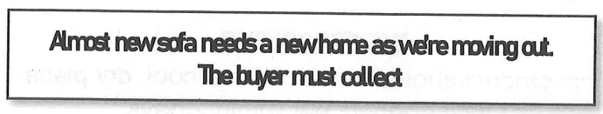

A. The sofa is perfect for small apartment.

B. The buyer must arrange to transport the sofa.

C. The sofa is brand new.

D. The seller will deliver the sofa to you.

**Question 83** [688561]:

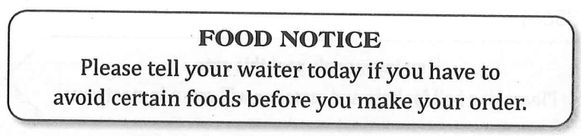

A. The waiter will explain our special meals of the day.

B. Inform us of any issues with your diet.

C. Orders must be paid for before you eat.

D. You must avoid ordering certain foods today.

**Question 84** [688562]:

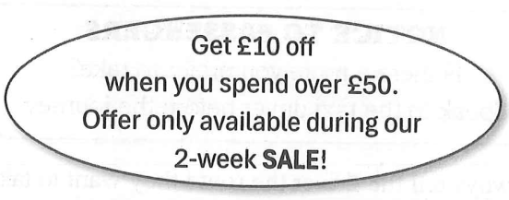

A. Get £10 off all sales.

B. Offer lasts two weeks.

C. Spend up to £50 and save £10.

D. All items are £10 off during the sale.

**Question 85** [688563]:

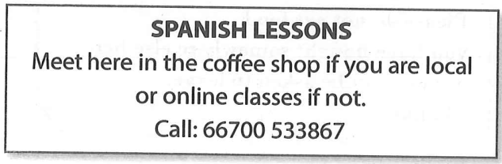

A. Only local students can take Spanish lessons.

B. Call this number to book coffee shop reservations.

C. Spanish lessons are held only in the coffee shop.

D. Online classes are available for students who live far away.

**Question 86** [688564]:

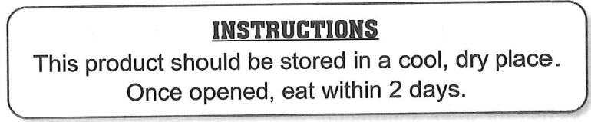

A. The product must be eaten by a certain time after it has been opened.

B. The product will only last two days.

C. This product is best eaten when it is cool.

D. Eat this product immediately after buying it.

**Question 87** [688565]:

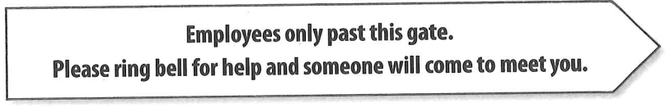

A. Everyone must ring the bell for entry.

B. Employees should meet at the gate if the bell rings.

C. Ring the bell unless you work for the company.

D. You can go past the gate without assistance.

**Question 88** [688566]:

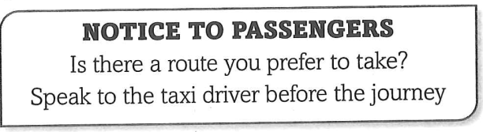

A. Passengers must always tell the driver the route they want to take.

B. The driver is willing to discuss the way to go.

C. Once the journey has started, do not speak to the driver.

D. Passengers cannot change their route once the journey has started.

**Question 89** [688567]:

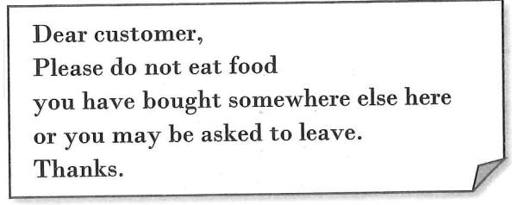

A. Please do not leave food on the table.

B. You may be asked to leave if you don't order food.

C. Customers are encouraged to bring their own food.

D. Only food bought here should be eaten in our café.

**Question 90** [688568]:

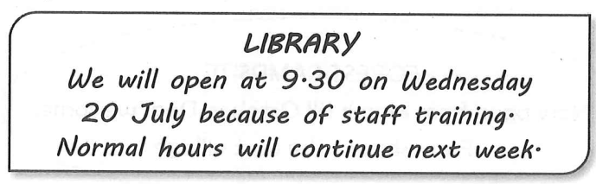

A. Staff training starts at 9.30.

B. Opening hours are different on 20 July.

C. The library will open at a different time after 20 July.

D. The library will have extended hours next week.

**Question 91** [688569]:

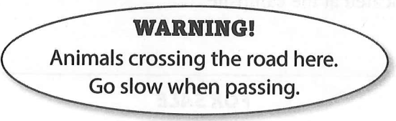

A. Animals are allowed to cross the road anywhere.

B. Animals will stop traffic on this road.

C. Drivers should reduce speed in this area.

D. It is safe to drive fast in this area.

**Question 92** [688570]:

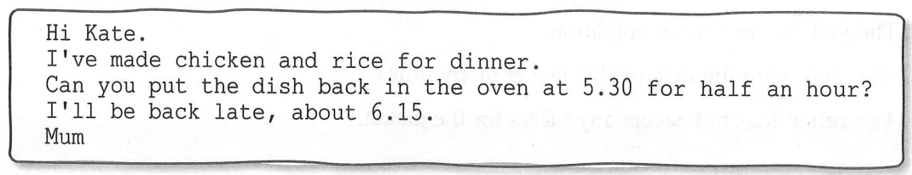

A. Kate should cook a new meal for dinner.

B. Kate needs to heat the dishes for 30 minutes.

C. Mum will be home in time for dinner

D. Kate is responsible for setting the table for dinner.

**Question 93** [688571]:

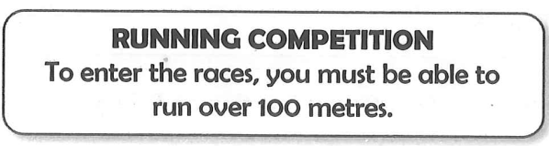

A. Runners at all levels can enter this competition.

B. The races are for people who cannot run very far.

C. The races in this competition will be 100 metres long.

D. This competition is for people who can run more than 100 metres.

**Question 94** [688572]:

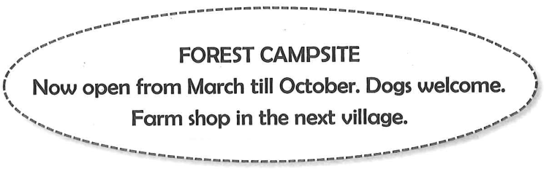

A. This is a new campsite on a farm.

B. You can stay in this campsite all year round.

C. You can take your pet to this campsite.

D. The farm shop is located at the campsite.

**Question 95** [688573]:

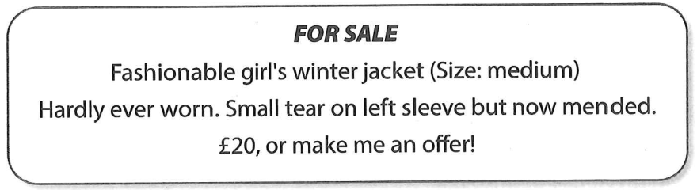

A. The seller may accept a lower price.

B. The jacket is in perfect condition.

C. Alex has worn the fashionable jacket many times.

D. The seller does not accept any offers for the jacket.

**Question 96** [688574]:

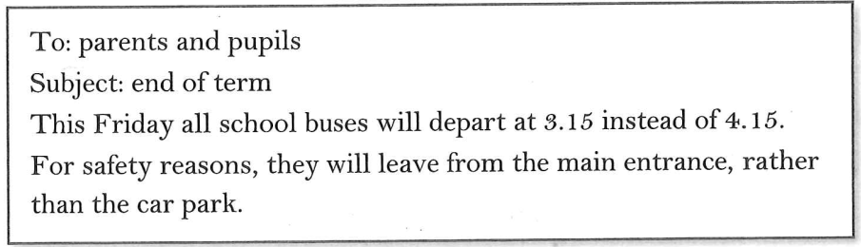

A. Students must get the bus at a different location on Friday.

B. Parents should collect their children by car on Friday.

C. Buses will leave the school later than usual on Friday.

D. All school buses will leave at 4:15 this Friday.

**Question 97** [688575]:

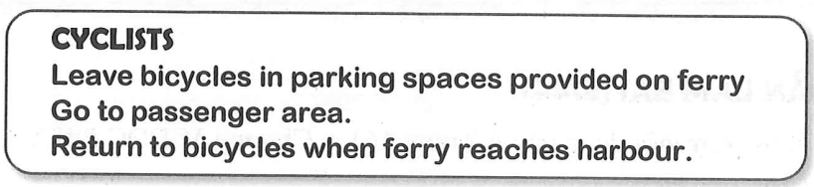

A. Cyclists should take their bicycles with them to the passenger area.

B. Bicycles must be left in designated parking spaces on the ferry.

C. Cyclists can return to their bicycles at any time during the journey.

D. Bicycles are not allowed on the ferry.

**Question 98** [688576]:

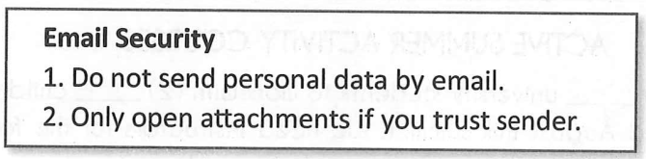

A. You should send personal data by email.

B. Open any attachment to check it.

C. Open trusted attachments only.

D. It's safe to open attachments from unknown senders.

**Question 99** [688577]:

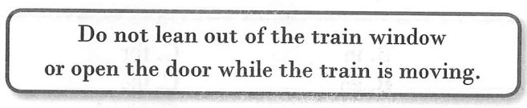

A. Passengers are informed that they are not allowed to open train windows.

B. Train windows are to open only when the train has entered a station.

C. Passengers are prohibited from putting their head out of the window when the train has left the station.

D. Open doors only when you are leaning out of the train window.

**Question 100** [688578]:

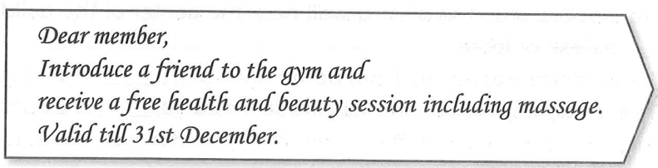

A. This is an offer for people who already belong to the gym.

B. This is a special package for people joining the gym before the end of the year.

C. If you and a friend join the gym now, your friend will get a free massage.

D. Free health sessions are available only for new members.