Date of preparing: ………………………………….
Date of teaching: ………………………………….

Period……
UNIT 3: FRIENDS
Lesson 3 - Part 2 (Page 29) – Reading, Speaking and Writing

I. OBJECTIVES
By the end of the lesson, Ss will be able to…
1. Knowledge
- read an article about 2 sisters from a Vietnamese folklore.
- describe personal characters.
- write an email about their best friend.
2. Ability
- improve the reading, speaking and writing skills.
3. Quality
- have positive attitude in English language learning so that they actively participate in all classroom activities.
- love reading books (Vietnamese and foreign books).

II. TEACHING AIDS AND LEARNING MATERIALS
Lesson plan, PPT slides, student’s book, workbook, notebook, personal computer (if any), projector/TV, speakers, DCR & DHA on Eduhome, handouts
III. PROCEDURES
A. Warm up: (5’)
a) Objective: Introduce the new lesson and set the scene for Ss to acquire new language; get students' attention at the beginning of the class by means of enjoyable and short activities as well as to engage them in the steps that followed.
b) Content: Introducing the film / the book “Harry Porter” or introducing the story “Tấm Cám”
c) Product: Ss can be provided with general idea about the story/characters mentioned in the lesson.
d) Competence: Collaboration, guessing.
e) Organization of the activity:
Teacher’s Activities | Students’ Activities
- Give greetings  - Check attendance  - Option 1:  - Show the trailer of the film “Harry Porter”, then introduce something about the characters in the film: Hermione, Ron, Hagrid.  - Introduce more: The film “Harry Porter” was based on the novel with the same name by J. K. Rowling. Teenagers around the world like this work very much.  Link:  https://www.youtube.com/watch?v=VyHV0BRtdxo  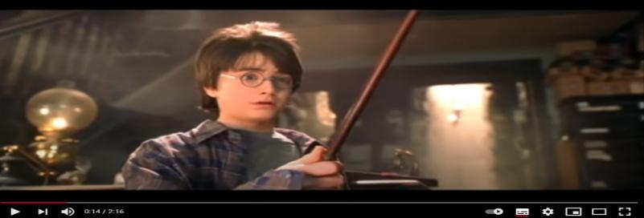  → Lead to the new lesson.  - Option 2: Matching  - Show pictures of some Vietnamese folklores and their names on the screen (or give handouts)  - Have Ss close books and do the matching  - Have Ss give answers  - Introduce “Tam Cam” – the story that is mentioned in this lesson  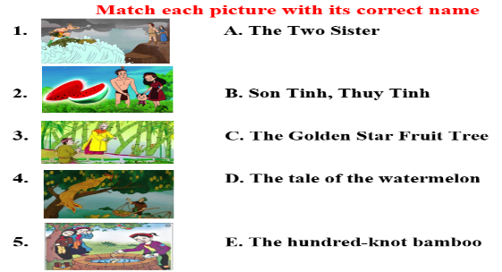  → Lead to the new lesson | - Greet T  - Watch  - Listen  - Look and match  - Give answers  Answer keys  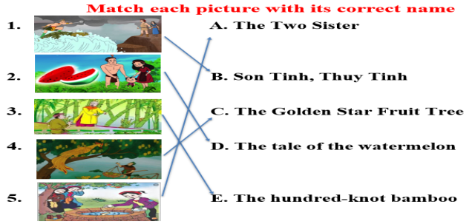

B. New lesson (35’)
- Activities 1: Reading (10’)
a) Objective: Ss improve their reading skill (scanning, skimming)
b) Content:
- Reading the article and circle the best headline.
- Reading and finding detailed information.
c) Products: Ss can practice skimming and scanning in reading comprehension.
d) Competence: Collaboration, analytical and synthesizing skills, communication.
e) Organization of the activity:
Teacher’s Activities | Students’ Activities
a. Read the article and circle the best headline  - Have Ss read the article individually  - Have some Ss read the article aloud  - Have Ss circle the best headline  - Check answers as a whole class.  b. Read and find things that show Tấm and Cám’s personalities. Write an example next to each adjective  - Option 1:  - Have Ss read the article again  - Have Ss work in pairs to write an example next to each adjective  - Call Ss to give answers  - Check answers as a whole class.  - Option 2: Matching (for class with low-level students)  - Have Ss read the article again and work in pairs to match  - Have Ss underline the phrases that show Tam and Cam’s personalities in the article  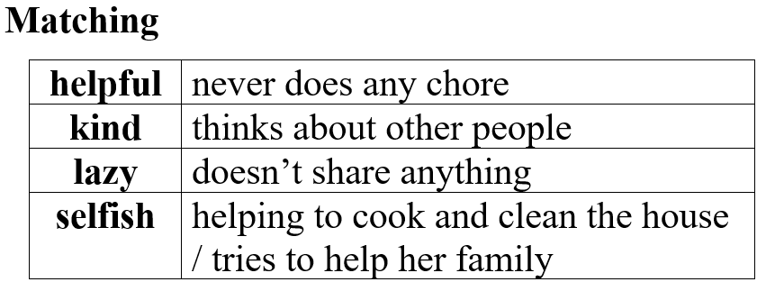  - Call Ss to give answers,  - Check answers as a whole class.  - Have Ss write an example next to each adjective | - Read in silence  - Read in front of the class  - Do the task  - Check and correct mistakes  Answer key  1. Good Sister, Bad Sister  - Work individually  - Read  - Work in pairs  - Give answers, explain  Answer keys  2. kind: thinks about other people  3. lazy: never does any chores  4. selfish: doesn’t share anything  - Read, work in pairs to match  - Underline  - Give answers  -Write
- Activity 2: Speaking: Describing characters (10’)
a) Objective: Ss can describe characters.
b) Content: Talking about the characters in the Harry Porter book.
c) Products: Ss can apply what they have learnt in communication.
d) Competence: Collaboration, communication, creativity, public speaking.
e) Organization of the activity:

Teacher’s Activities | Students’ Activities
You’re in a book club meeting. Work in pairs. Take turns talking about the characters from the Harry Porter books.  - Option 1:  - Demonstrate the activity by practicing the role play with a student  - Have Ss practice the conversation in pairs  - Have Ss take turns talking about the characters from the Harry Porter books, remind Ss to use the structures to ask about personal appearance and personalities  - Have some pairs act out the conversation in front of the class.  - Give feedback and evaluation  - Option 2:  - Follow the same steps as option 1  - Give an extra activity: Have Ss talk about the characters in the “Tấm Cám” tale, using the information from the “Reading” task  - Call some pairs to demonstrate the activity in front of the class.  - Give feedback and evaluation | - Observe and listen  - Work in pairs  - Work in pairs  - Present  - Work in pairs  - Present  Suggested conversation  A: I like Tấm.  B: What’s she like?  A: She’s very kind and helpful.  B: What does she look like?  A: She’s tall and pretty.  B: What does she do?  A: She thinks about other people and tries to help her family.
- Activity 3: Writing (15’)
a) Objective: Ss can write an email about their best friend.
b) Content: writing an email about their best friend, 40 to 50 words
c) Products: Ss can use what they have learnt in producing an informal email writing.
d) Competence: Collaboration, communication, critical thinking and creativity.
e) Organization of the activity:

Teacher’s Activities | Students’ Activities
Write an email about your best friend.  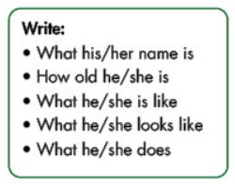  - Focus on the Writing Tip box, remind Ss to follow the outline:  - Explain the format of an e-mail  - Have Ss write an email about their best friend  - Have some Ss write their email on the board (If Ss write in the extra board, have them hang the extra board on the big board)  - Check Ss’ writings, correct Ss’ writings if necessary.  - Give evaluation | - Look and read  - Listen  - Work individually  - Write  Suggested writing  Dear Peter,  Thanks for your email. Your best friend seems really nice.  Let me tell you about my best friend.  My best friend is Lan. She’s 12 years old. She’s a student. She’s my classmate at school. She’s very friendly ad funny. She likes making new friends and telling jokes. She’s tall and thin. She has brown eyes and short hair.  Write back soon,  Britney

C. Consolidation (3’)
* Asking about personal appearance: What does he / she look like?
* Asking about personal character: How is he / she like?
* Writing an email about your best friend: Name, age, characteristics, appearance and activities of your best friend

D. Homework (2’)
- Finish the writing part.
- Read more books for children.
- Do exercises in Workbook: Reading and Writing (page 19).
- Prepare: Unit 3 - Review (page 90 – SB).

