Week: Date of planning:
Period: Date of teaching:
UNIT 6: LIFESTYLES
Lesson 3: A closer look 2

I. OBJECTIVES
By the end of this lesson, Ss will be able to:
1. Knowledge
- use the future simple and first conditional
2. Competences
- Develop communication skills and creativity
- Be collaborative and supportive in pair work and teamwork
- Actively join in class activities
3. Personal qualities
- Love talking about future possibilities and conditions

II. MATERIALS
- Grade 8 textbook, Unit 6, A closer look 2
- Computer connected to the Internet
- Projector / TV

III. PROCEDURES
1. WARM-UP (4 mins)
a. Objectives:
- To create an active atmosphere in the class before the lesson.
- To lead into the new lesson.
b. Content:
- Asking questions to lead in the lesson.
c. Expected outcomes:
- Students’ answers.
d. Organisation

TEACHER’S AND STUDENTS’ ACTIVITIES | CONTENTS
Asking questions:  - Teacher asks Ss “What will you buy if you have 1,000,000 VND?”  - Ss answer the question individually.  - Teacher leads in the introduction of the target grammar point.  - Teacher sets the context for the lesson. | Question:  What will you buy if you have 1.000.000 VND?

2. ACTIVITY 1: PRESENTATION (8 mins)
a. Objectives:
- To revise Ss forms of future simple and first conditional
b. Content:
- Teacher asks Ss to do the exercise individually and then check their answer in pairs.
- Invite some Ss to share their answers. Confirm the correct answers.
c. Expected outcomes:
- Students know how to use the target grammar.
d. Organisation

TEACHER’S AND STUDENTS’ ACTIVITIES | CONTENTS
Grammar teaching  - Teacher reminds students that they have already learnt The future simple and First conditional.  - Tell them to read the Remember! box in pairs (p. 63, 64)  - Teacher explains again the form and use of future simple and first conditional. | 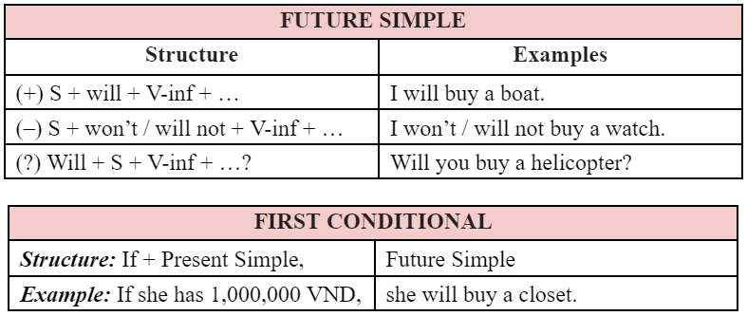

3. ACTIVITY 2: PRACTICE (20 mins)
a. Objectives:
- Task 1: To help Ss revise the future simple to complete the given dialogues.
- Task 2: + To help Ss revise and further study the future simple
+ To help Ss use the future simple to build sentences.
- Task 3: To help Ss review the form and use the first conditional.
- Task 4: + To help Ss revise if and practise the use of unless
+ To help Ss distinguish if and unless in conditional sentences.
b. Content:
- Task 1: Use the verbs from the box with will or won’t to complete these dialogues.
- Task 2: Arrange these words and phrases in the correct order to form meaningful sentences.
- Task 3: Give the correct tense of the verbs in brackets, using the first conditional.
- Task 4: ﻿Fill in each blank with IF or UNLESS.
c. Expected outcomes:
- Students understand how to use the target grammar.
d. Organisation

TEACHER’S AND STUDENTS’ ACTIVITIES | CONTENTS
Task 1: ﻿Use the verbs from the box with will or won’t to complete these dialogues. (5 mins)
- Give Ss some time to work by themselves and write down the answers. Observe and help when and where necessary.  - Ask some Ss to read their sentences. Call on some Ss to write their answers on the board. Confirm the correct answers.  - Explain to Ss another use of the future simple (to describe future possibilities or conditions), and give one or two examples before moving into 2. | Answer key:  ﻿1. will tell  2. will attend – won’t join  3. won’t have – will do
Task 2: Arrange these words and phrases in the correct order to form meaningful sentences. (5 mins)
﻿- Have Ss work individually. Tell them to put the words in the correct order to build meaningful sentences. Tell them to pay attention to the form of the future simple.  - T lets Ss work in pairs to compare their answers before sharing their answers.  - T checks and confirms the correct answers. | Answer key:  ﻿1. We will take our first-term exams very soon.  2. Will they stay in an igloo when they visit Alaska?  3. She will work with the tribal groups to help them revive their culture.  4. I won’t choose online learning in the second semester.  5. I’ll come to see you if I go to London this summer.
Task 3: Give the correct tense of the verbs in brackets, using the first conditional. (5 mins)
﻿- Draw Ss’ attention to the form and use of the first conditional: main clause (future simple) and if-clause (present simple).  - Have Ss look at the sentences and write down their answers.  - T asks Ss to check their answers with their partners. Ask for translation of some of the words to check their understanding.  - T confirms the correct answers. | Answer key:  ﻿1. eat  2. goes  3. will have  4. don’t do  5. Will she be
Task 4: ﻿Fill in each blank with IF or UNLESS. (5 mins)
﻿- Have Ss do the exercise individually and then exchange their answers with a partner.  - Call on some Ss to read the sentences aloud. Other Ss comment.  - T confirms the correct answers. | Answer key:  ﻿1. unless  2. if  3. unless  4. If  5. unless
4. ACTIVITY 3: PRODUCTION (8 mins)
a. Objectives:
- To help Ss ﻿apply the uses of the first conditional with if and unless in real contexts by completing sentences about themselves with if-clauses given.
b. Content:
- Task 5: ﻿Complete the following sentences to make them true for you. Then share your answers with a partner.
c. Expected outcomes:
- Students can make sentences using the learned grammar points.
d. Organisation

TEACHER’S AND STUDENTS’ ACTIVITIES | CONTENTS
Task 5: ﻿Complete the following sentences to make them true for you. Then share your answers with a partner. (8 mins)
- Give them some time to work independently and write down their sentences.  - Then let them work in pairs to exchange their sentences.  - T goes around giving help when and where necessary.  - Some Ss may write their answers on the board. Other Ss comment and T makes corrections. | Suggested answers:  ﻿1. If it rains tomorrow, I will stay at home.  2. Unless I get good marks, I will be upset.  3. If I have free time this weekend, I will visit my grandparents  4. If I study harder, I will get good marks.  5. Unless I go to bed early, I will be tired tomorrow.

5. CONSOLIDATION (5 mins)
a. Wrap-up
- Summarise the main points of the lesson.
- Ask Ss to make sentences about themselves, using the first conditional.
b. Homework
- Ask Ss to revise the future simple and the first conditional and make 5 sentences using the future simple and 5 sentences using the first conditional.
- Do exercise pages 45-46 on Student’s workbook.
- Prepare for lesson 4: Communication.

