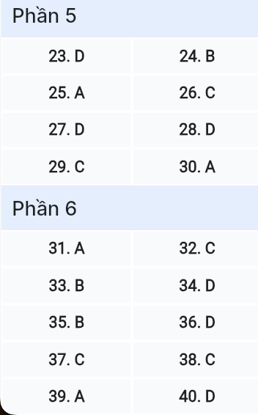
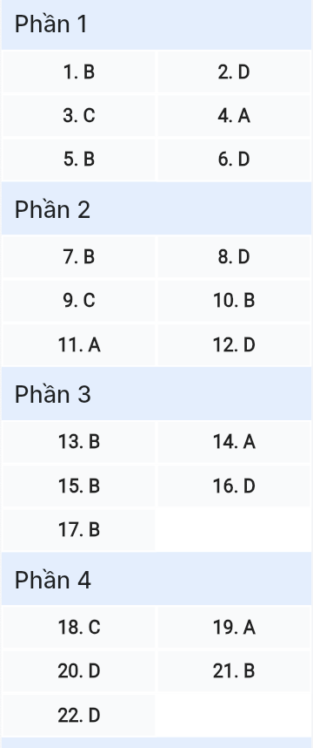
ĐỀ MINH HỌA SỐ 22
KỲ THI TỐT NGHIỆP TRUNG HỌC PHỔ THÔNG NĂM 2025
(Đề thi có 08 trang)
Môn thi: TIẾNG ANH
Thời gian làm bài: 50 phút, không kể thời gian phát đề

Read the following advertisement and mark the letter A, B, C or D on your answer sheet to indicate the option that best fits each of the numbered blanks from 1 to 6.

ART COMPETITION FOR TEACHER’S DAY CELEBRATION
To celebrate Teacher’s Day on November 20th, the school will be hosting a(n) (1) ______ with the theme "Our Beloved Teachers and School." The competition will take place (2) ______ November 15th to 19th in the Art Room. Students (3) ______ to participate must submit their artwork by 4:00 PM on November 19th. All (4) ______ will be displayed in the school hall, and the winners will be announced during the Teacher’s Day ceremony. We encourage everyone (5) ______ part and showcase their creativity. For more information or any questions, please feel free to (6) ______ in touch with your art teacher directly.
Question 1 [698669]: A. art exciting competition B. exciting art competition
C. competition art exciting D. exciting competition art
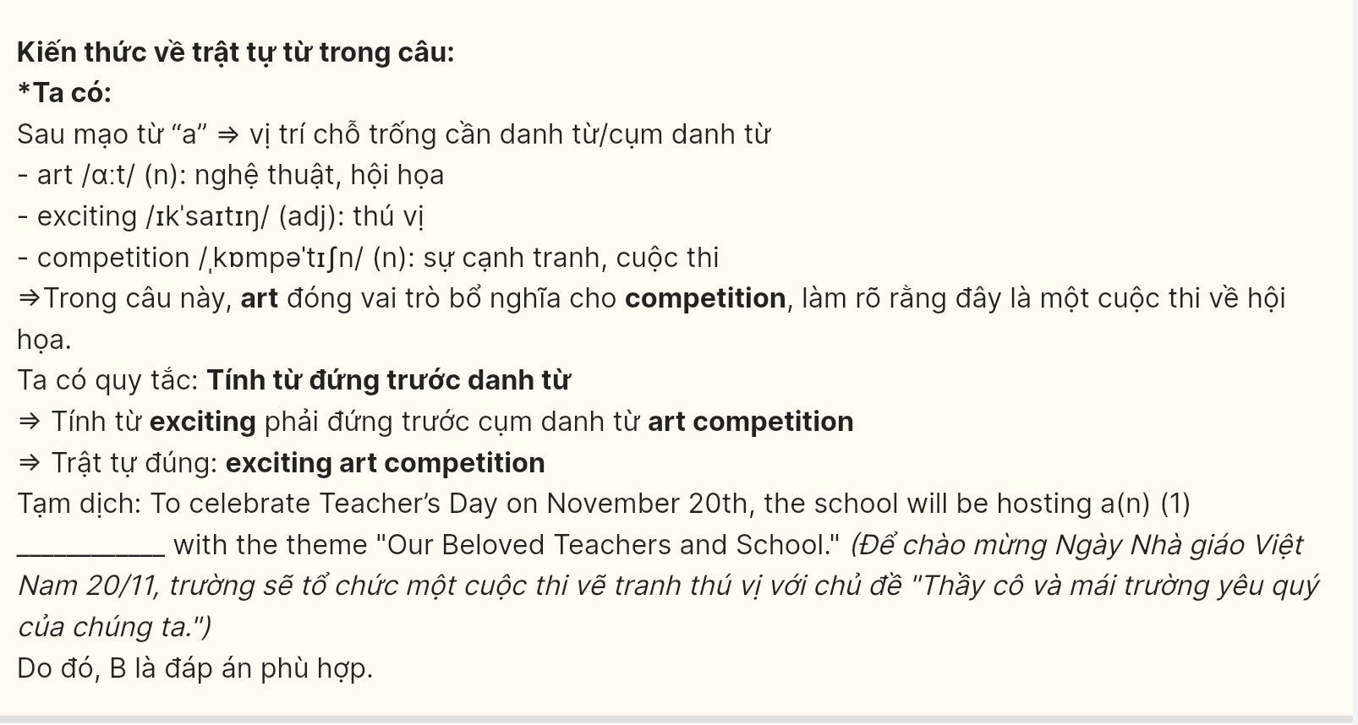
Question 2 [698670]: A. between B. in C. on D. from
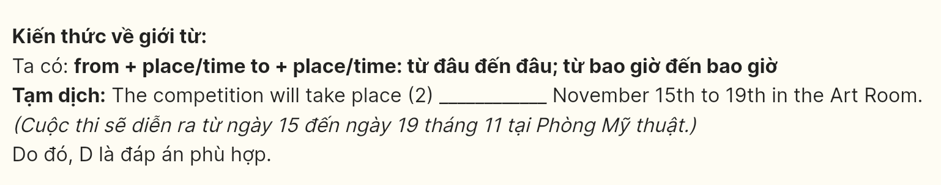
Question 3 [698671]: A. wish B. who wishes C. wishing D. wished
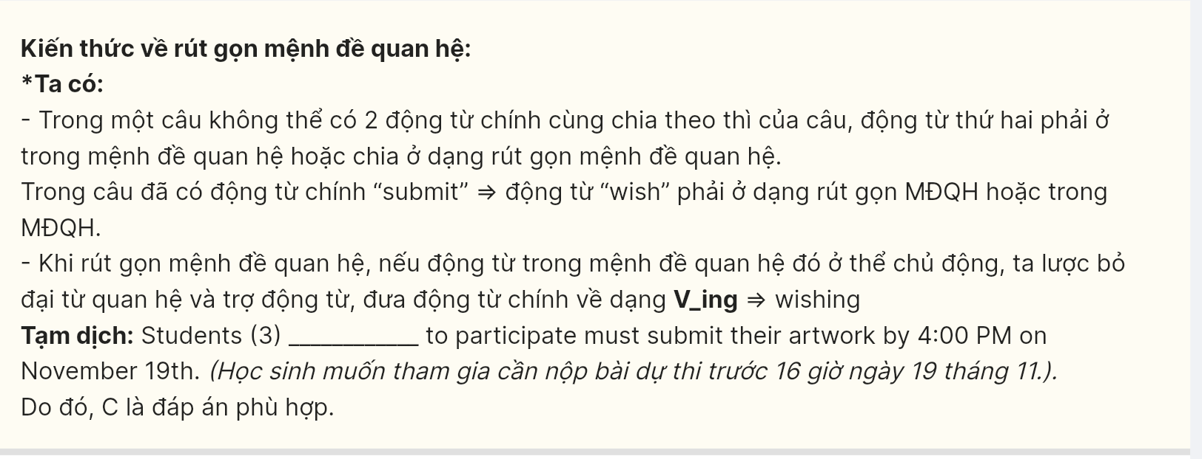
Question 4 [698672]: A. submissions B. submit C. submissive D. submitted
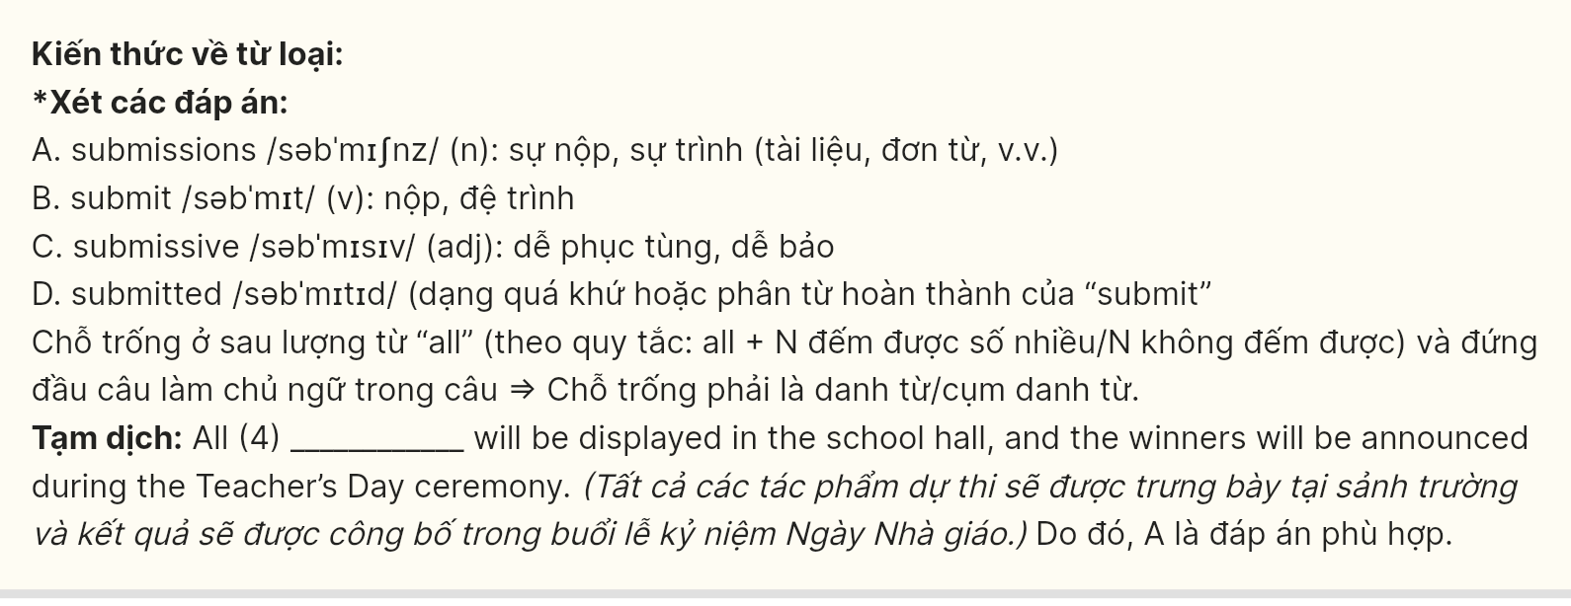
Question 5 [698673]: A. taking B. to take C. to taking D. take
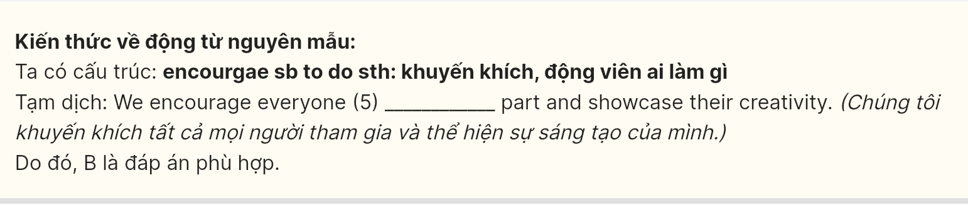
Question 6 [698674]: A. make B. go C. take D. get
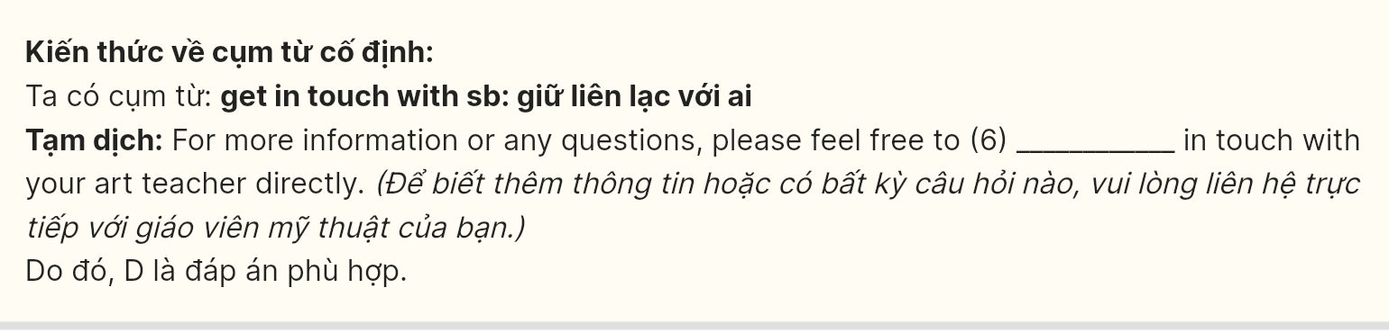
Read the following leaflet and mark the letter A, B, C or D on your answer sheet to indicate the option that best fits each of the numbered blanks from 7 to 12.

- Keeping Kids Safe on Social Media: A Parent’s Guide 🟢
Let’s work together to create a safer online environment for our children.
- The Issue
Social media offers a great way for kids to connect and learn from (7) ______, but it also comes with risks. Many children can run into inappropriate content, cyberbullying, or online predators without knowing how to protect themselves. It’s crucial for parents to understand these dangers and (8) ______ for potential issues to ensure a safe online experience for their kids.
- Tips for Keeping Your Kids Safe
- Set Up Strong Privacy Settings: Make sure all social media (9) ______ have privacy settings enabled. This helps control who can see your child’s posts and limits contact from strangers.
• Have Open Conversations: Talk regularly with them about their online activities
(10) ______ their safety. Encourage them to share their experiences, and (11) ______ them that they can always come to you if they ever feel uncomfortable.
Monitor Their Usage: Keep an eye on how much time your kids spend online and what platforms they use. Use (12) ______ control apps if needed and check their friend lists to ensure they’re interacting with people they know.
Question 7 [698675]: A. another B. others C. the other D. other
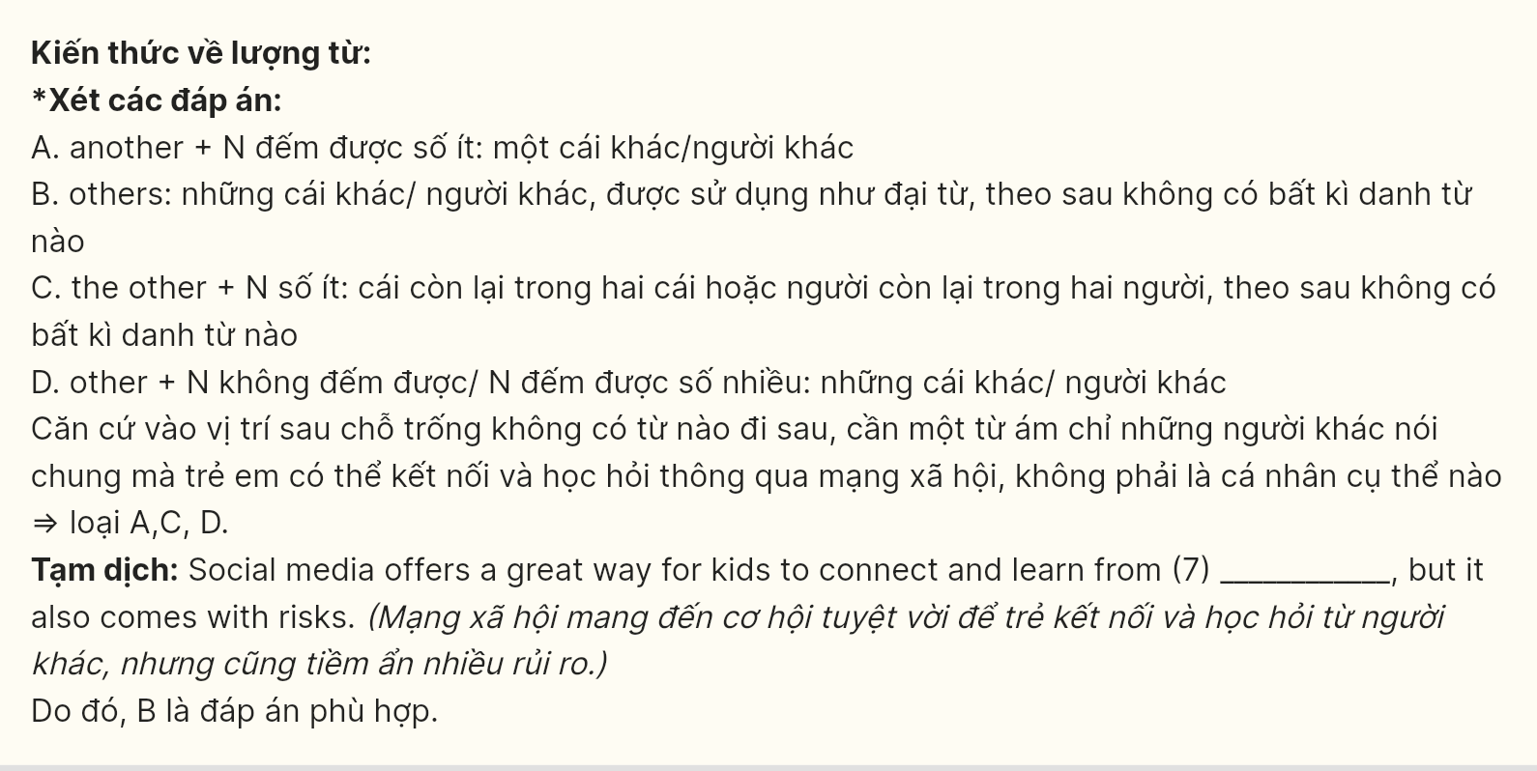
Question 8 [698676]: A. make out B. take out C. turn out D. watch out
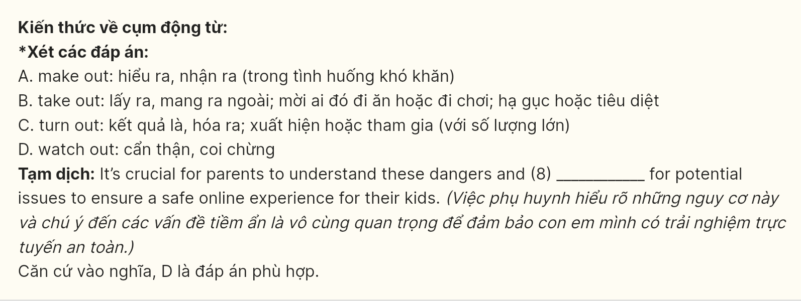
Question 9 [698677]: A. channels B. hashtags C. accounts D. comments
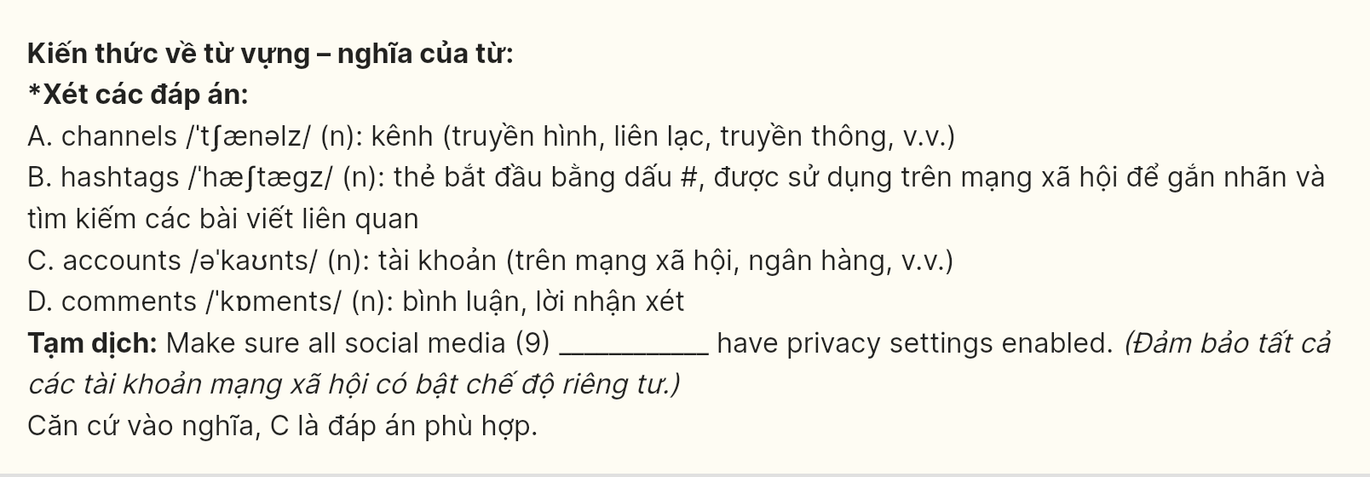
Question 10 [698678]: A. in place of B. for the sake of C. for fear of D. regardless of
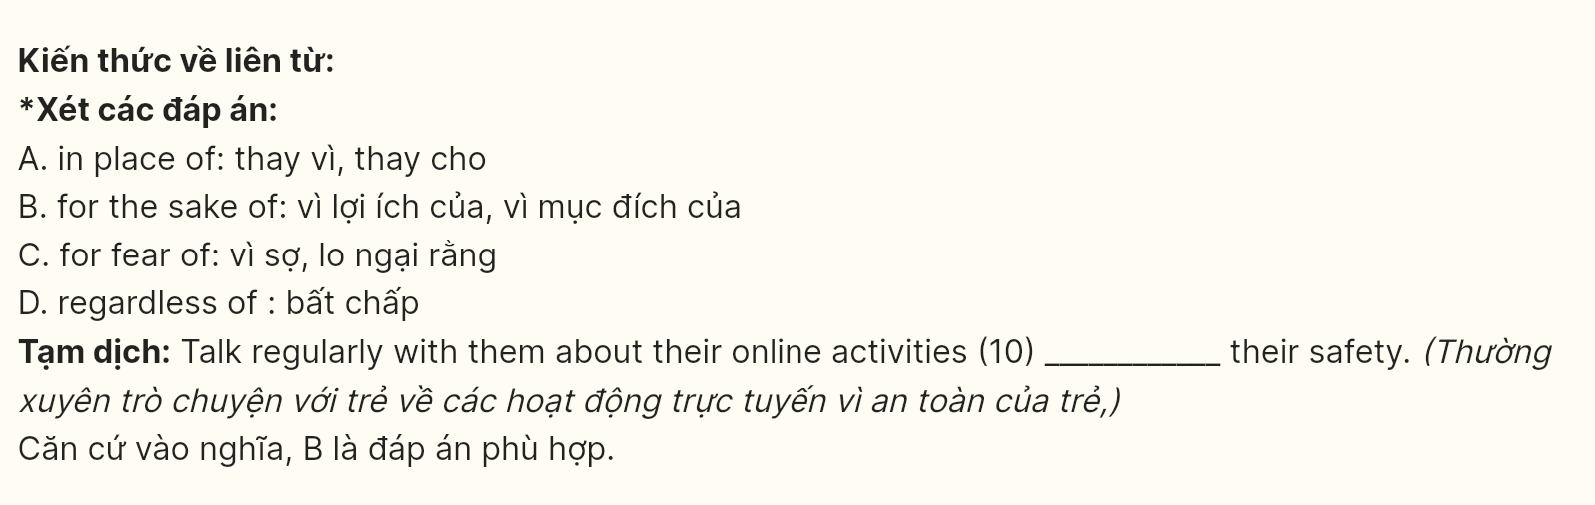
Question 11 [698679]: A. reassure B. rehearse C. remember D. reconcile
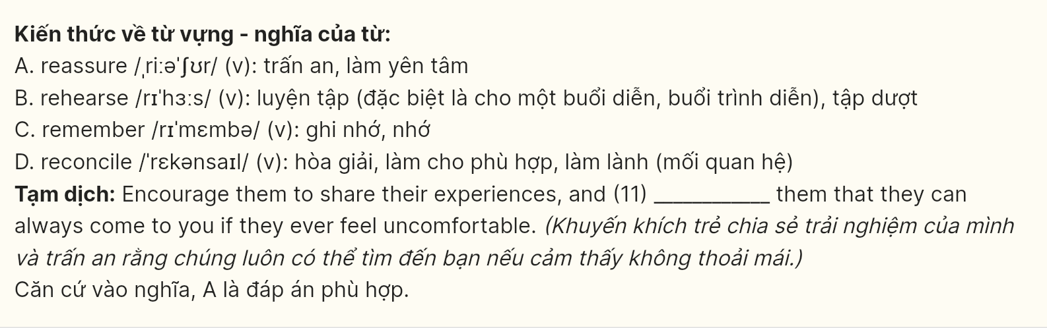
Question 12 [698680]: A. medical B. cultural C. illegal D. parental

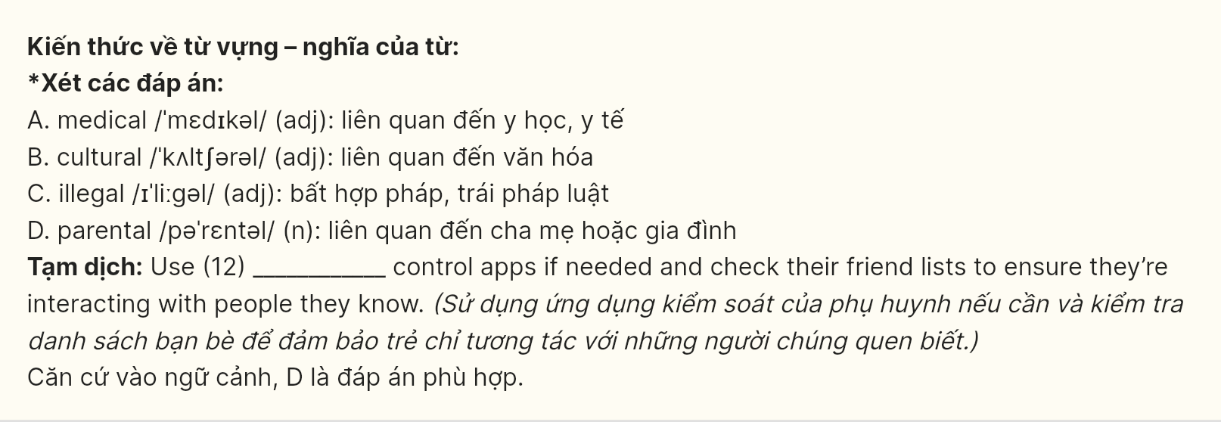Mark the letter A, B, C or D on your answer sheet to indicate the best arrangement of utterances or sentences to make a meaningful exchange or text in each of the following questions from 13 to 17.
Question 13 [698681]:
a. Alex: Hi, Mia! Long time no see. How’s everything going with your new job?
b. Alex: That’s awesome! I heard your company is a great place to work. Congratulations!
c. Mia: Hi, Alex! Thanks for asking. It’s going really well, actually. I’m learning a lot.
A. b - c – a B. a - c - b C. c - a - b D. c - b - a

Question 14 [698682]:
a. Zara: Japan? That’s amazing! What made you choose it?
b. Oliver: I’ve always wanted to experience the cherry blossom season and visit the temples.
c. Oliver: I’ve been thinking about going to Japan next summer.
d. Oliver: Oh, I can’t wait to try the sushi and ramen there!
e. Zara: It’s a great choice! I went there last year, and the food was incredible too.
A. c - a - b - e - d B. b - e - d - a - c C. b - a - c - e - d D. c - e - d - a - b
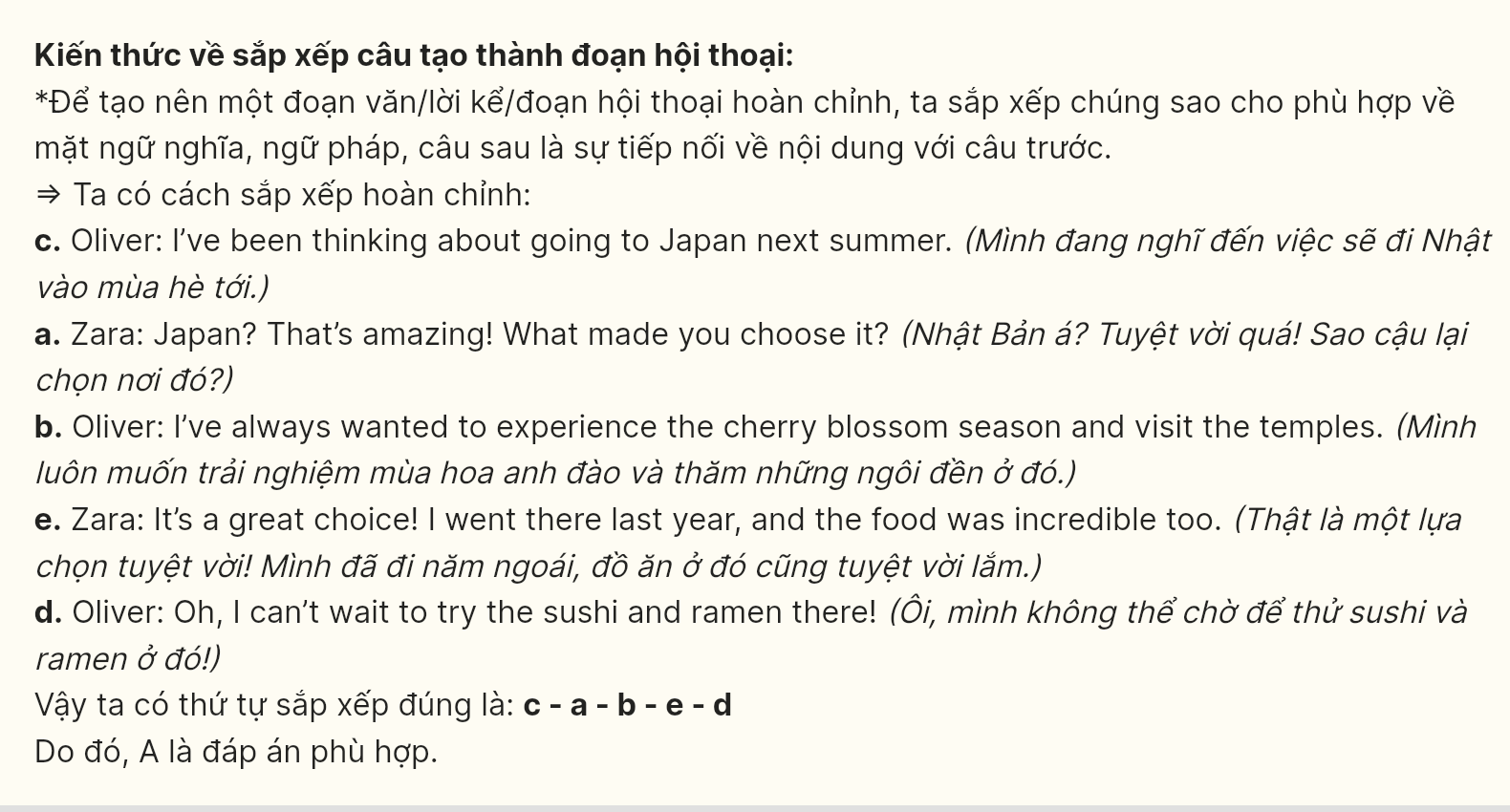
Question 15 [698683]:
Hi Oliver,
a. I’m sure it was a magical moment, knowing how thoughtful you are.
b. Let me know when we can meet up to celebrate this exciting milestone together.
c. I can’t wait to hear all the details about the proposal.
d. I just heard the fantastic news about your engagement – congratulations!
e. You and Sarah make such a wonderful couple, and I couldn’t be happier for you both.
Best wishes,
Sophie
A. e - a - c - b - d B. d - e - c - a - b C. a - e - b - d - c D. b - a - d - c - e
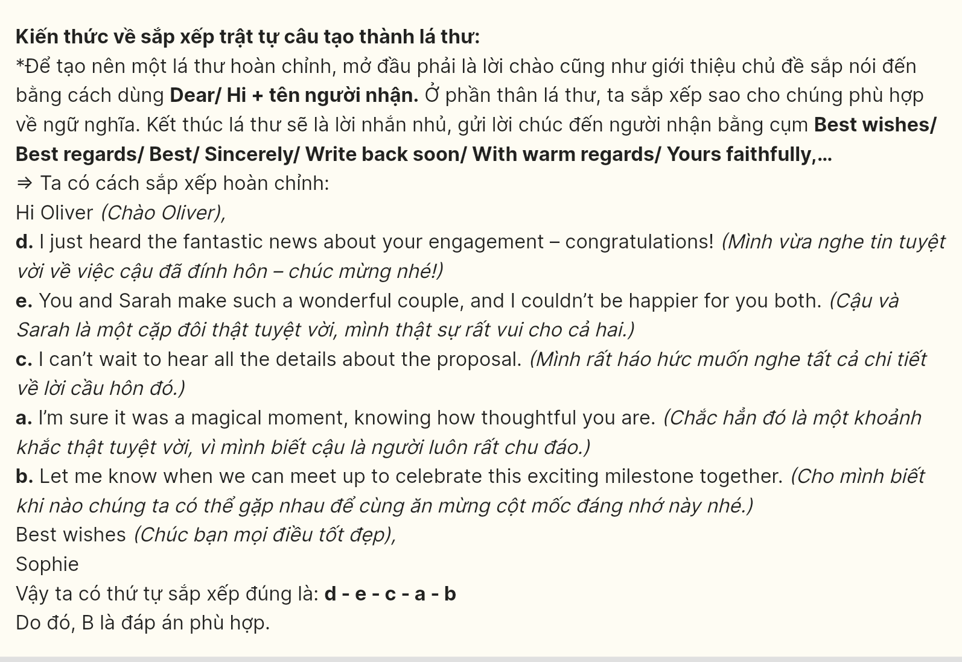
Question 16 [698684]:
a. Just 30 minutes of physical activity a day, whether it’s brisk walking, yoga, or weightlifting, can lead to significant improvements in fitness.
b. With many types of exercise to choose from, it’s easy to find something enjoyable that suits your lifestyle.
c. Regular exercise is one of the best habits for enhancing overall health, benefiting both your body and mind.
d. In conclusion, staying active regularly is vital for achieving lasting physical and mental well-being.
e. It boosts your mood, improves cardiovascular health, and aids in maintaining a healthy weight, reducing the risk of diseases.
A. a - e - c - b – d B. e - a - b - c – d C. b - a - c - e – d D. c - e - a - b - d
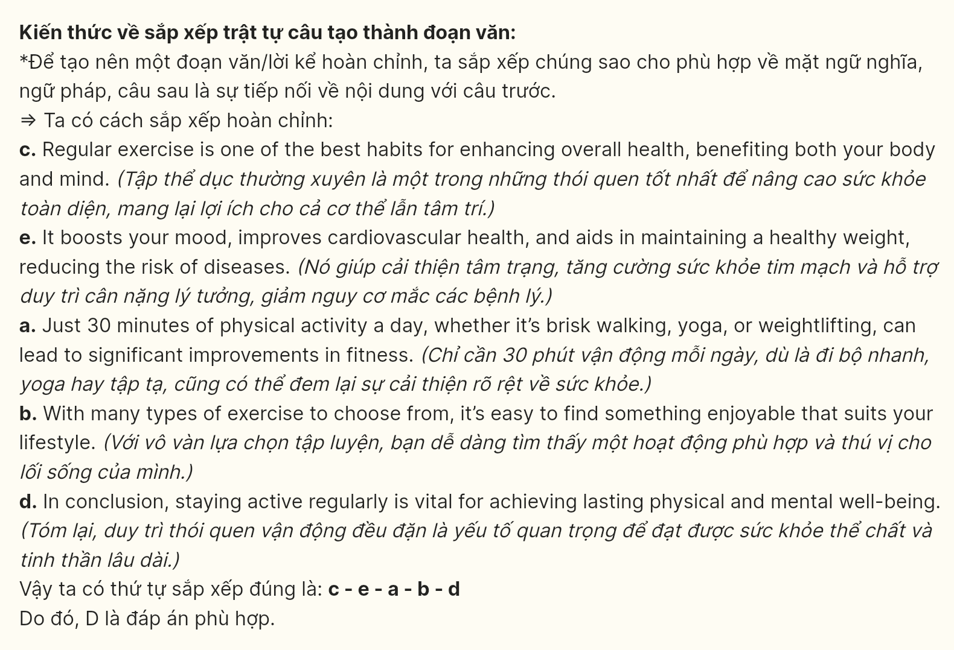
Question 17 [698685]:
a. In the past, people used phones only for calling and texting, but now smartphones have become multifunctional devices that allow us to access the internet, work, and entertain ourselves.
b. Although these advancements bring many conveniences, they also increase our dependence on technology, making it easier for people to get distracted.
c. Technology has changed significantly over the years.
d. Overall, this transformation has not only influenced the way we live but also had a profound impact on how we work and communicate daily.
e. Additionally, household appliances like washing machines and microwaves are becoming smarter, as they can be connected and controlled via mobile apps.
A. c - b - e - d – a B. c - a - e - b – d C. c - e - d - a – b D. c - d - b - e - a
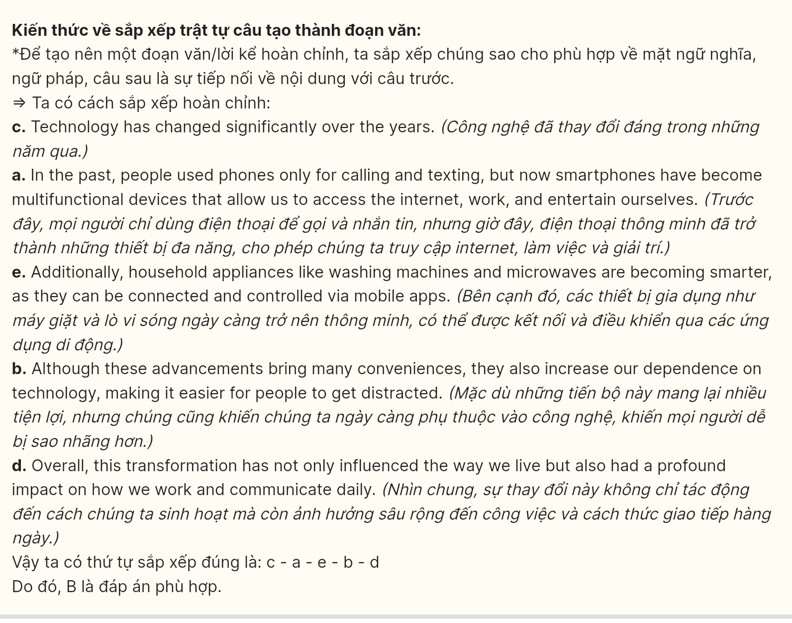
Read the following passage and mark the letter A, B, C or D on your answer sheet to indicate the option that best fits each of the numbered blanks from 18 to 22.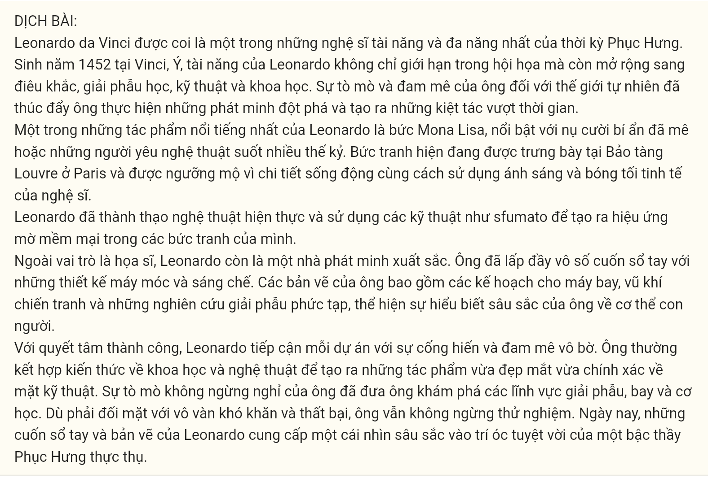
Leonardo da Vinci is widely regarded as one of the most talented and versatile artists of the Renaissance. Born in 1452 in Vinci, Italy, Leonardo’s talents extended beyond painting to include sculpture, anatomy, engineering, and science. His curiosity and fascination with the natural world (18) ______.
One of Leonardo’s most famous works is the Mona Lisa (19) ______. The painting hangs in the Louvre Museum in Paris and is admired for its lifelike detail and the artist’s subtle use of light and shadow. Leonardo mastered realism and used techniques like sfumato to create a soft, blurred effect in his paintings.
In addition to his work as a painter, Leonardo was also a brilliant inventor. (20) ______. His drawings include plans for flying machines, war devices, and intricate anatomical studies that showed his deep understanding of the human body. GIA SƯ TẠI HUẾ (0793833272)
Determined to succeed, (21) ______. He often combined his knowledge of science and art to create works that were both visually stunning and technically precise. His endless curiosity led him to explore anatomy, flight, and mechanics. (22) ______. Today, Leonardo’s notebooks and sketches offer a glimpse into the brilliant mind of a true Renaissance master.

Question 18 [698686]:
A. which drove him to make groundbreaking discoveries and create timeless masterpieces
B. from which he made groundbreaking discoveries and created timeless masterpieces
C. drove him to make groundbreaking discoveries and create timeless masterpieces
D. driving him to make groundbreaking discoveries and create timeless masterpieces
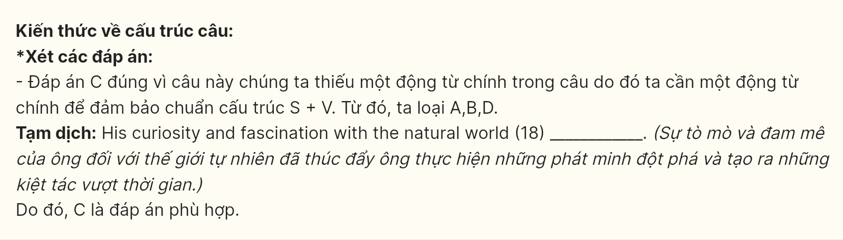
Question 19 [698687]:
A. featuring a mysterious smile that has fascinated art lovers for centuries
B. features a mysterious smile that has fascinated art lovers for centuries
C. in which a mysterious smile that has fascinated art lovers for centuries
D. has captivated art lovers for centuries with a mysterious smile in the painting
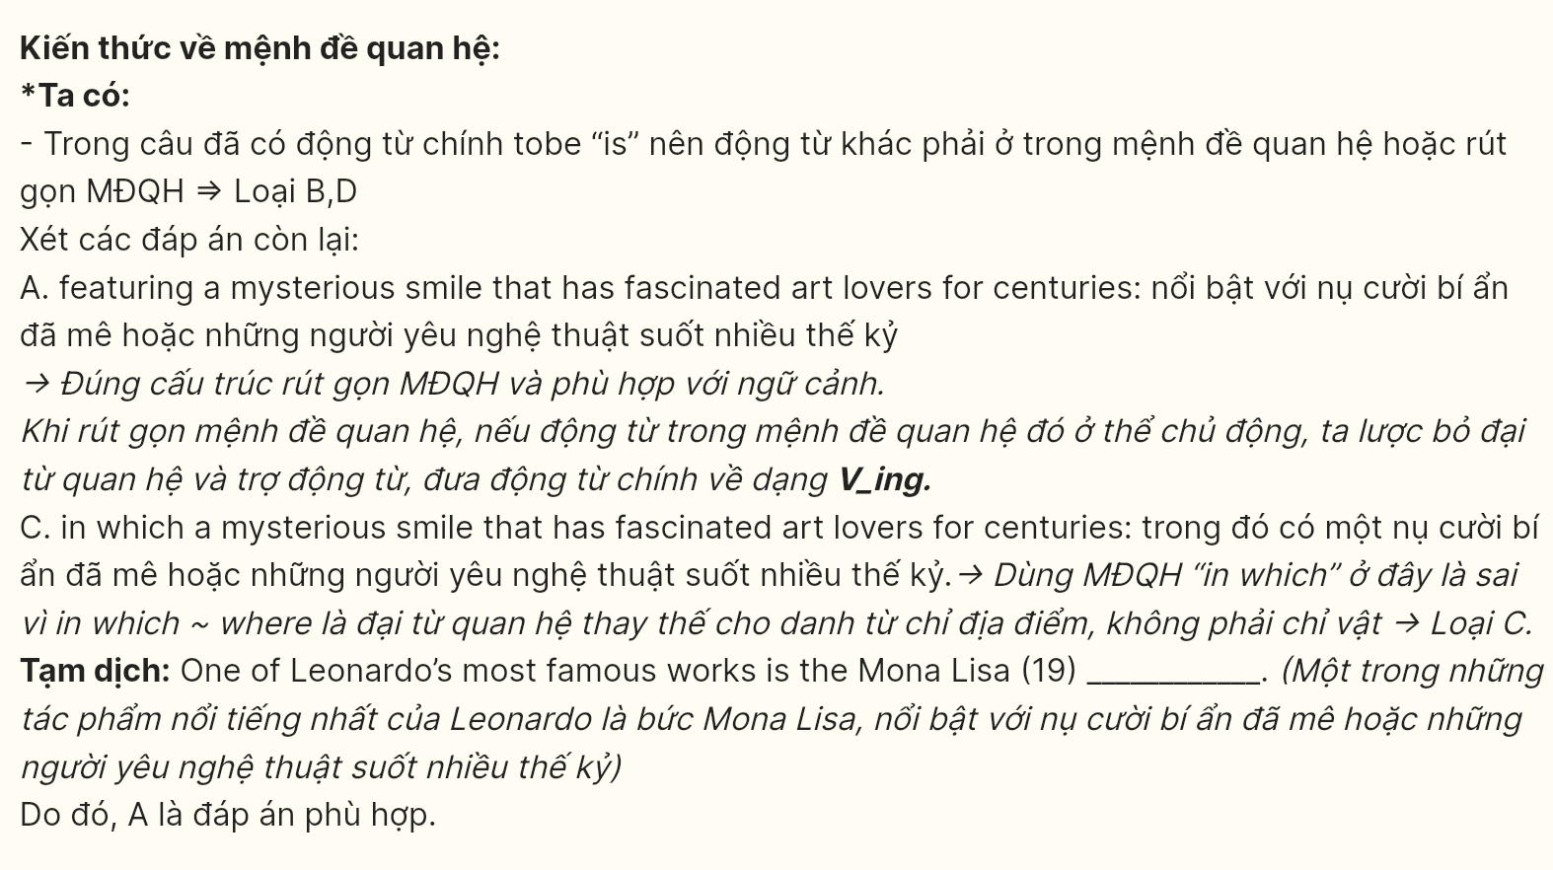
Question 20 [698688]:
A. Filling countless sketchbooks with designs, machines, and innovations were developed
B. Machines and innovations motivate him to come up with designs for countless sketchbooks
C. Countless sketchbooks are direct results of his machines and innovations
D. He filled countless sketchbooks with designs for machines and innovations
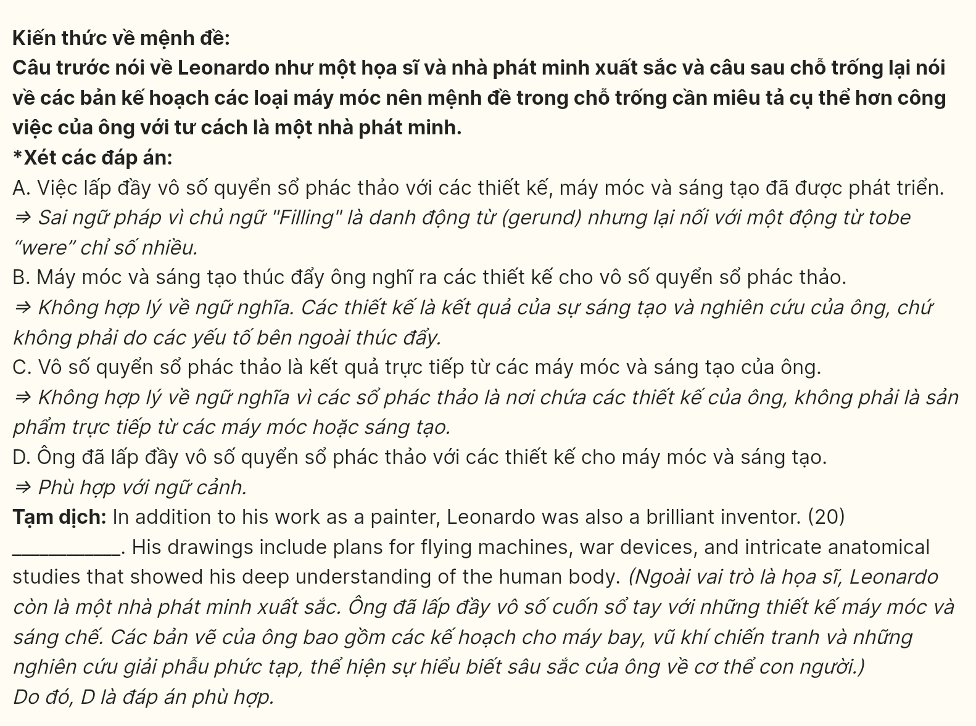
Question 21 [698689]:
A. Every project was approached with unmatched dedication and passion
B. Leonardo approached every project with unmatched dedication and passion
C. Unmatched dedication and passion were shown in every Leonardo’s project
D. His dedication and passion were unmatched in the approach to every project
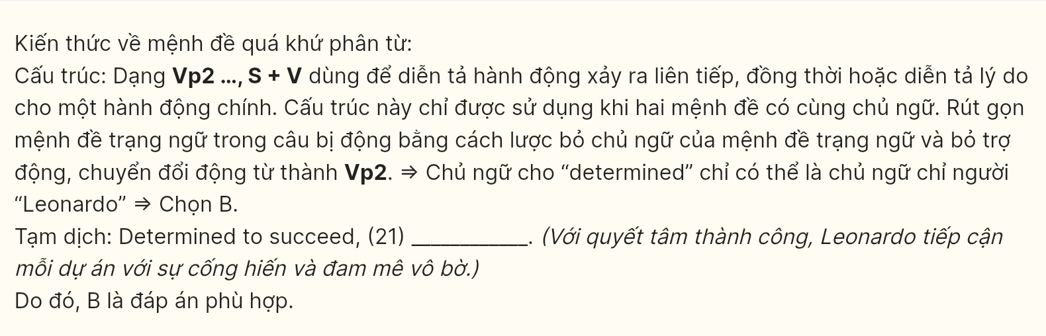
Question 22 [698690]:
A. Facing numerous setbacks and challenges, doing experiments is important to him
B. He never stopped experimenting so that he could face numerous setbacks and challenges
C. He faced numerous setbacks and challenges until he stopped experimenting
D. Despite facing numerous setbacks and challenges, he never stopped experimenting

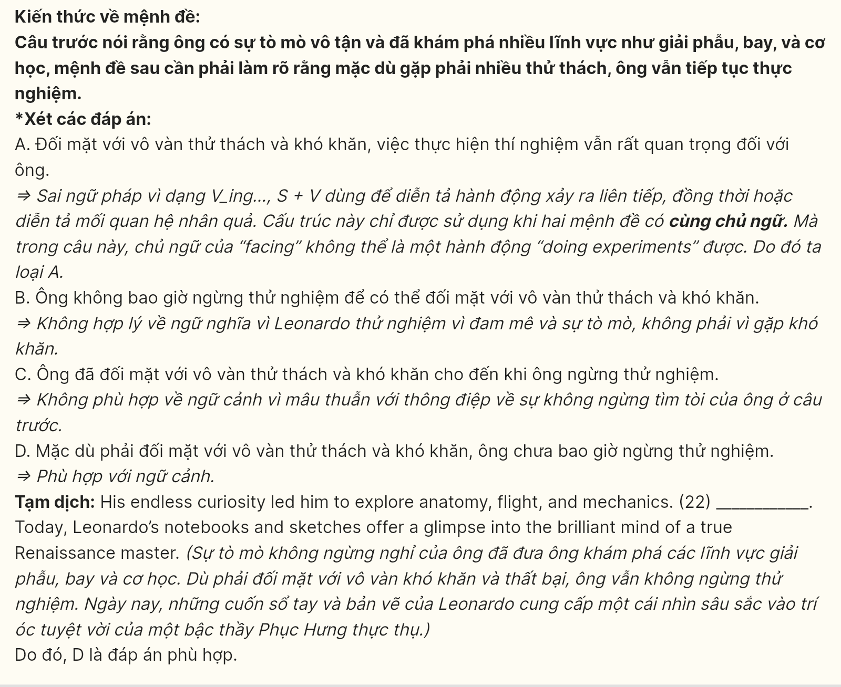Read the following passage and mark the letter A, B, C or D on your answer sheet to indicate the best answer to each of the following questions from 23 to 30.
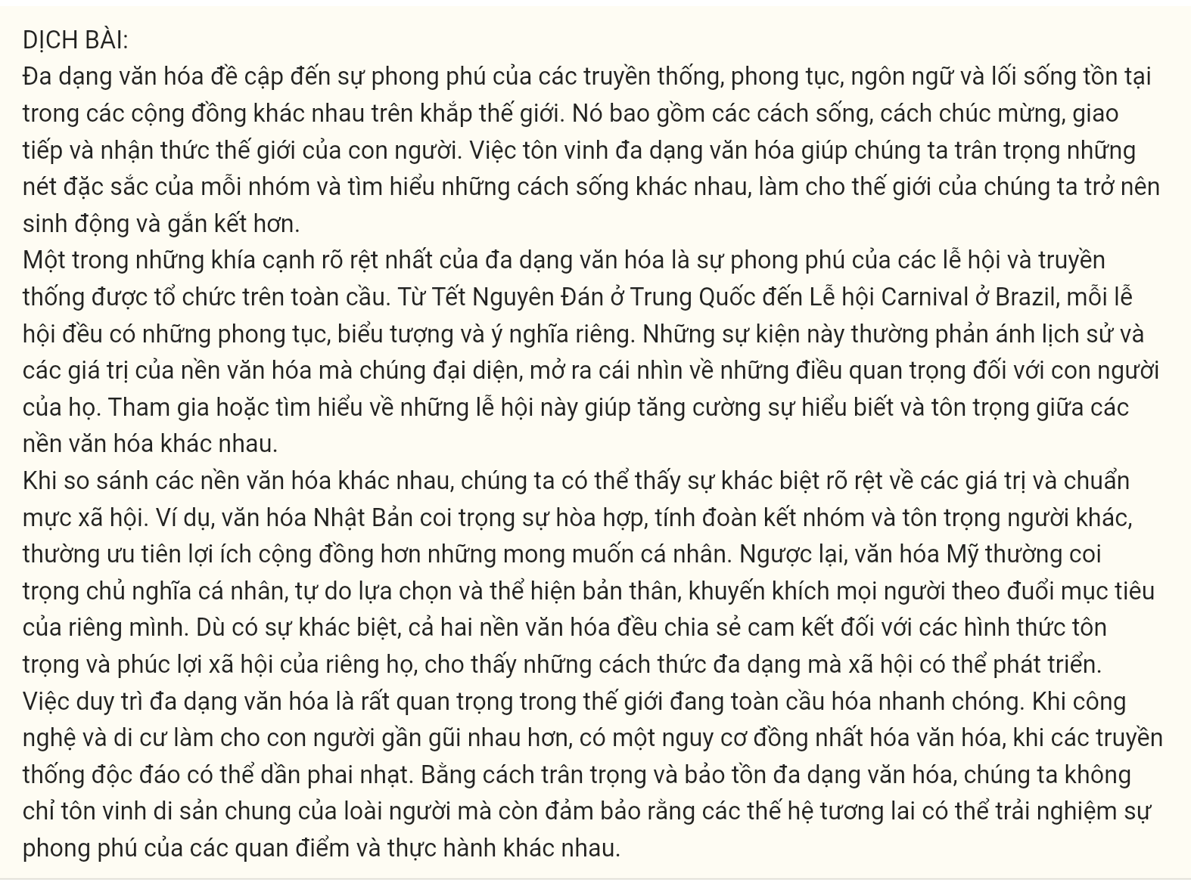
Cultural diversity refers to the variety of traditions, customs, languages, and lifestyles that exist within different communities around the world. It encompasses the different ways people live, celebrate, communicate, and perceive the world. Embracing cultural diversity allows us to appreciate the unique qualities of each group and learn about different ways of life, making our world more colorful and interconnected.
One of the most visible aspects of cultural diversity is the range of festivals and traditions celebrated globally. From the Lunar New Year in China to Carnival in Brazil, each festival has its own unique customs, symbols, and meanings. These events often reflect the history and values of their respective cultures, offering a glimpse into what is important to their people. Participating in or learning about these celebrations helps to foster understanding and respect among different cultures.
When comparing different cultures, we can see notable differences in values and social norms. For example, Japanese culture emphasizes harmony, group cohesion, and respect for others, often prioritizing the needs of the community over individual desires. On the other hand, American culture tends to value individualism, freedom of choice, and self-expression, often encouraging people to pursue their own goals. Despite these differences, both cultures share a commitment to their own forms of respect and societal well-being, showcasing the diverse ways societies can thrive.
Maintaining cultural diversity is crucial in our rapidly globalizing world. As technology and migration bring people closer together, there is a risk of cultural homogenization, where unique traditions may fade away. By valuing and preserving cultural diversity, we not only honor our shared human heritage but also ensure that future generations can experience the richness of different perspectives and practices.
Question 23 [698691]: Which of the following is NOT mentioned as one of the aspects of cultural diversity?
A. traditions B. customs C. languages D. life skills
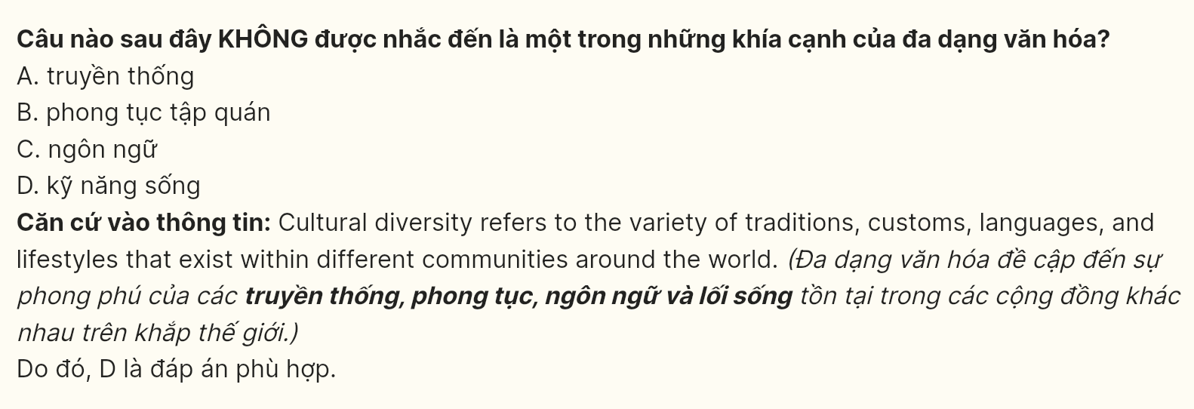
Question 24 [698692]: The word appreciate in paragraph 1 is OPPOSITE in meaning to?
A. respect B. disregard C. accept D. acknowledge
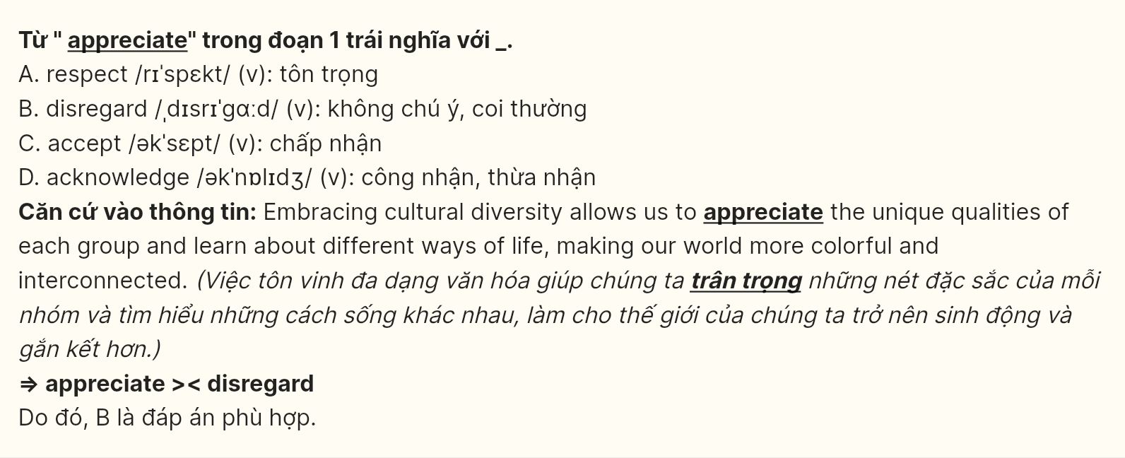
Question 25 [698693]: The word their in paragraph 2 refers to ______.
A. events B. values C. cultures D. people
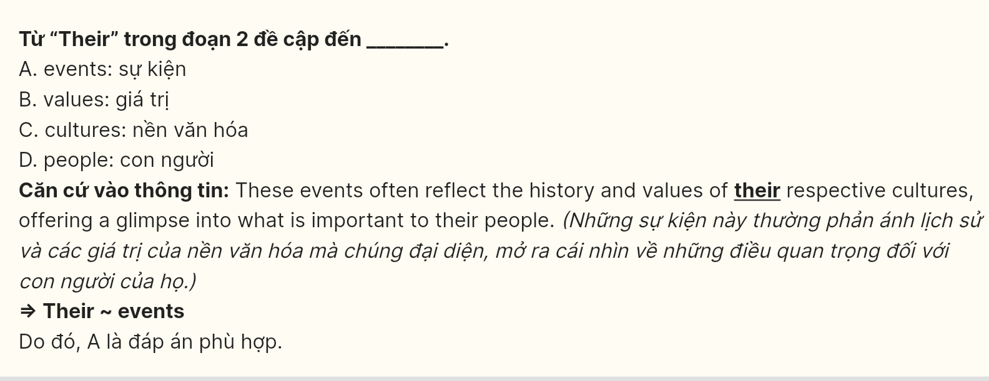
Question 26 [698694]: The phrase fade away in paragraph 4 could be best replaced by ______.
A. preserve B. foster C. disappear D. emerge
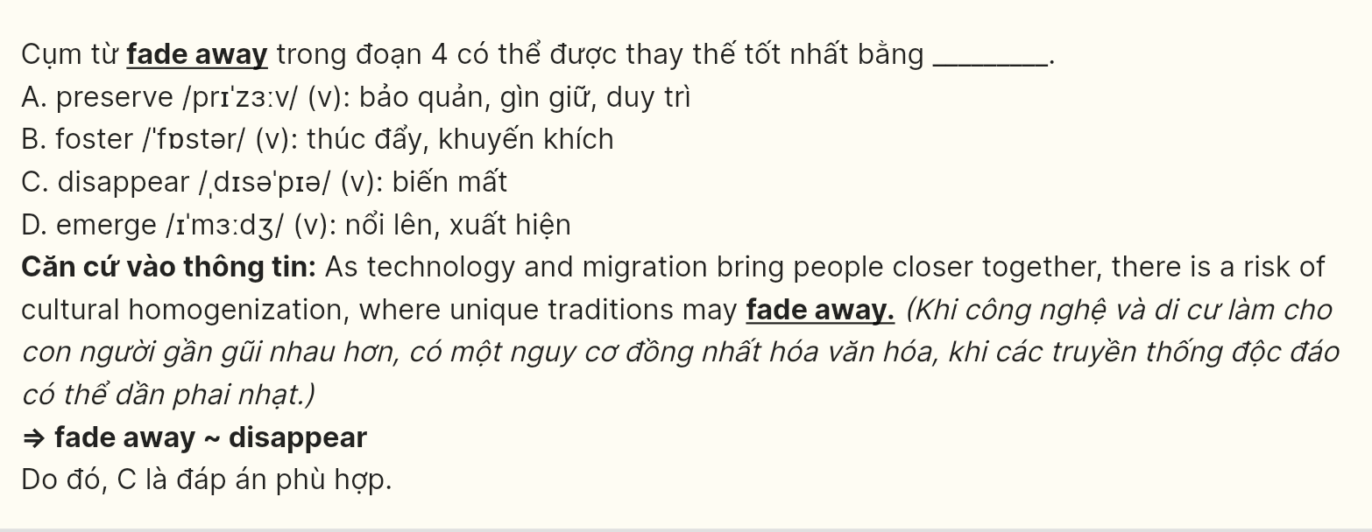
Question 27 [698695]: Which of the following best paraphrases the underlined sentence in paragraph 3?
A. Examining cultures reveals that there are often no major differences in their values and norms.
B. When comparing different cultures, we find that their values and social norms are quite similar.
C. When we compare different cultures, slight differences in values and social norms become obvious.
D. When we compare different cultures, distinct differences in values and social norms become apparent.
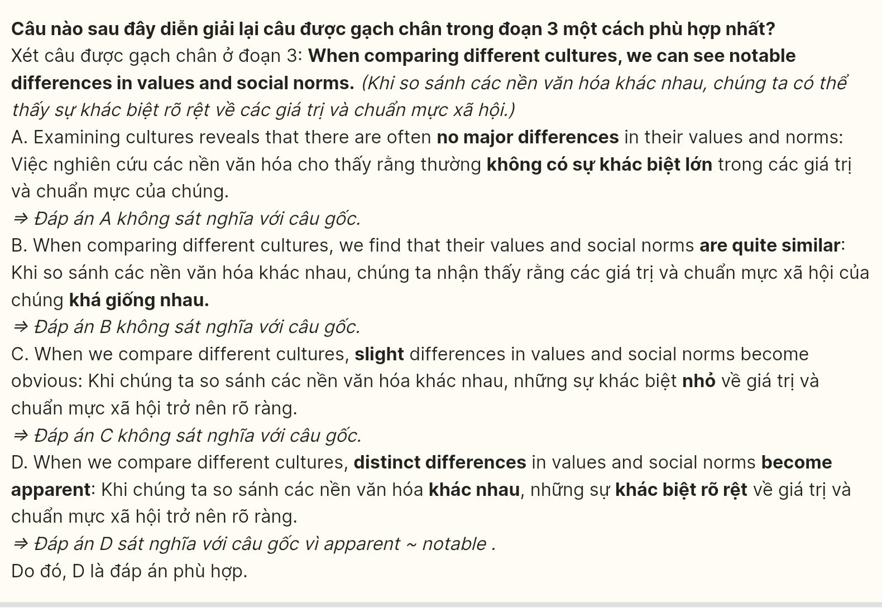
Question 28 [698696]: Which of the following is TRUE according to the passage?
A. Cultural diversity mainly focuses on shared values and common traditions across societies.
B. Celebrations like the Lunar New Year and Carnival have identical customs and symbols worldwide.
C. Both Japanese and American cultures prioritize individual freedom and self-expression above all.
D. Cultural diversity is at risk due to globalization, which may cause unique traditions to disappear.
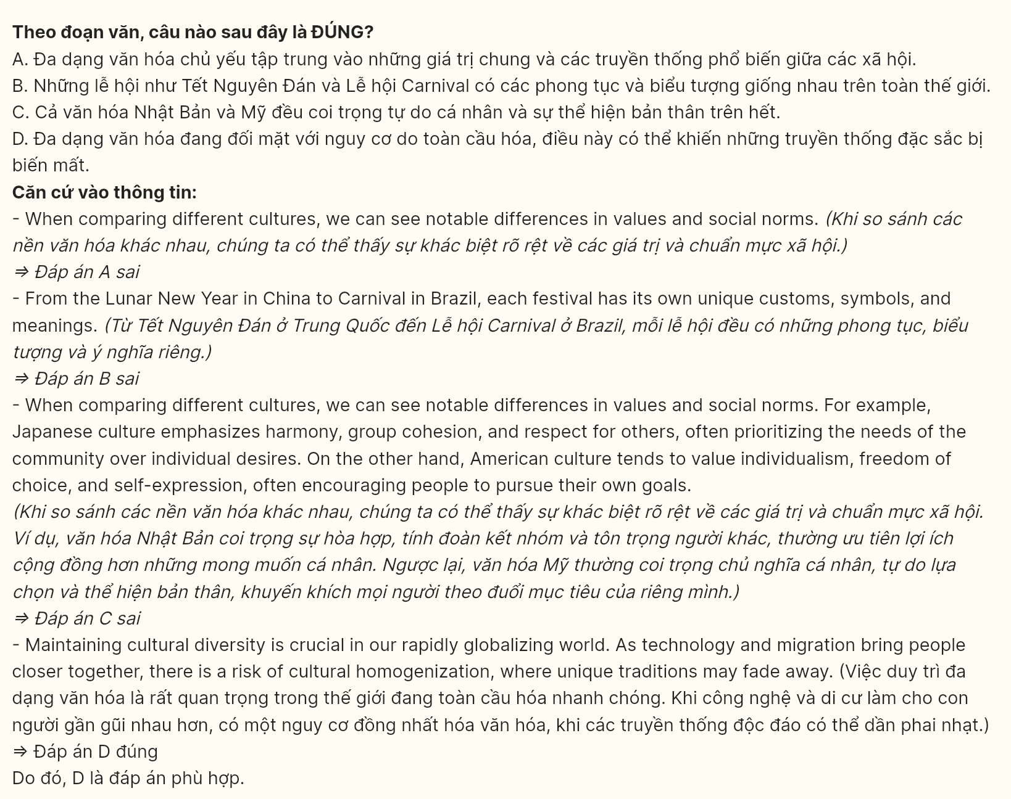
Question 29 [698697]: In which paragraph does the writer mention a contrastive relationship
A. Paragraph 1 B. Paragraph 2 C. Paragraph 3 D. Paragraph 4
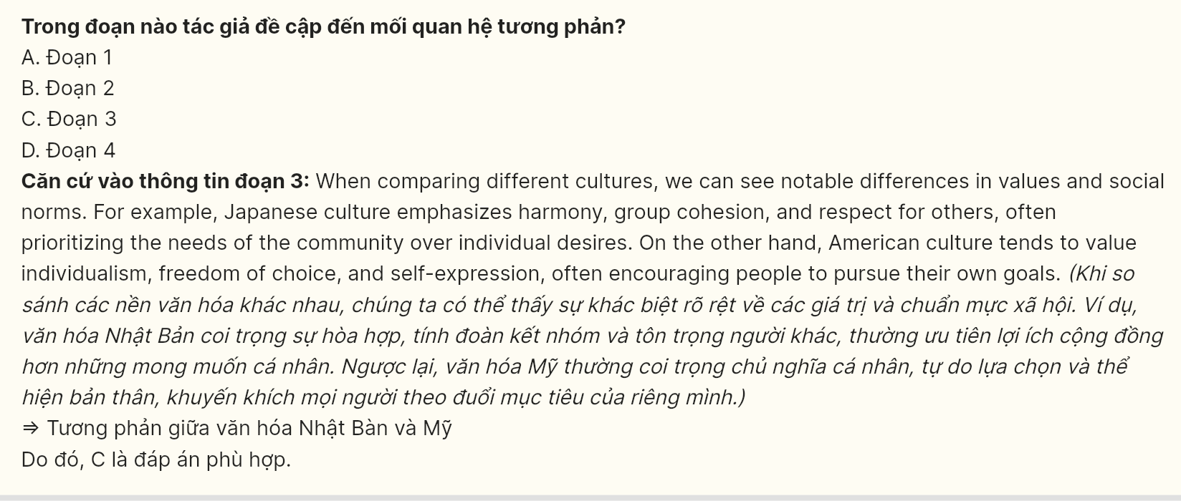
Question 30 [698698]: In which paragraph does the writer provide a definition related to culture?
A. Paragraph 1 B. Paragraph 2 C. Paragraph 3 D. Paragraph 4
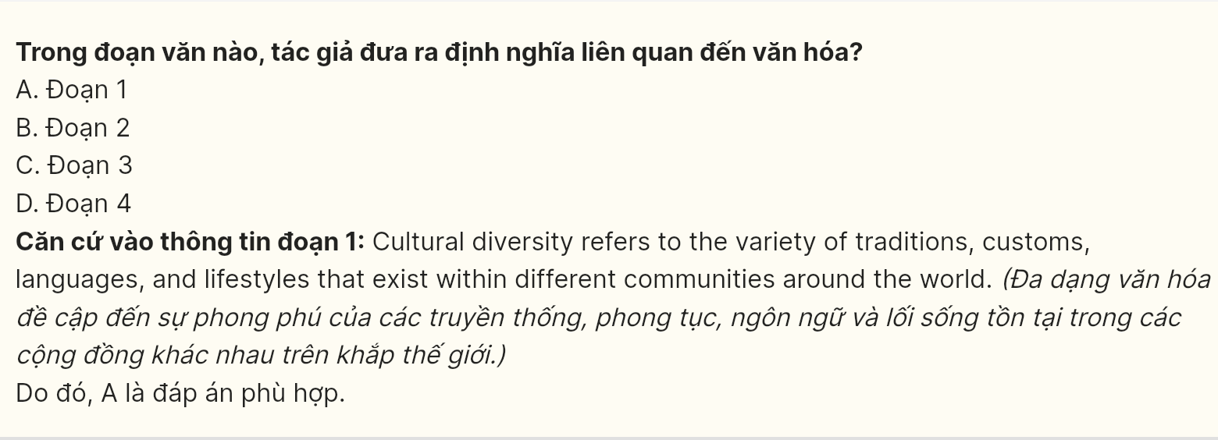
Read the following passage and mark the letter A, B, C or D on your answer sheet to indicate the best answer to each of the following questions from 31 to 40.
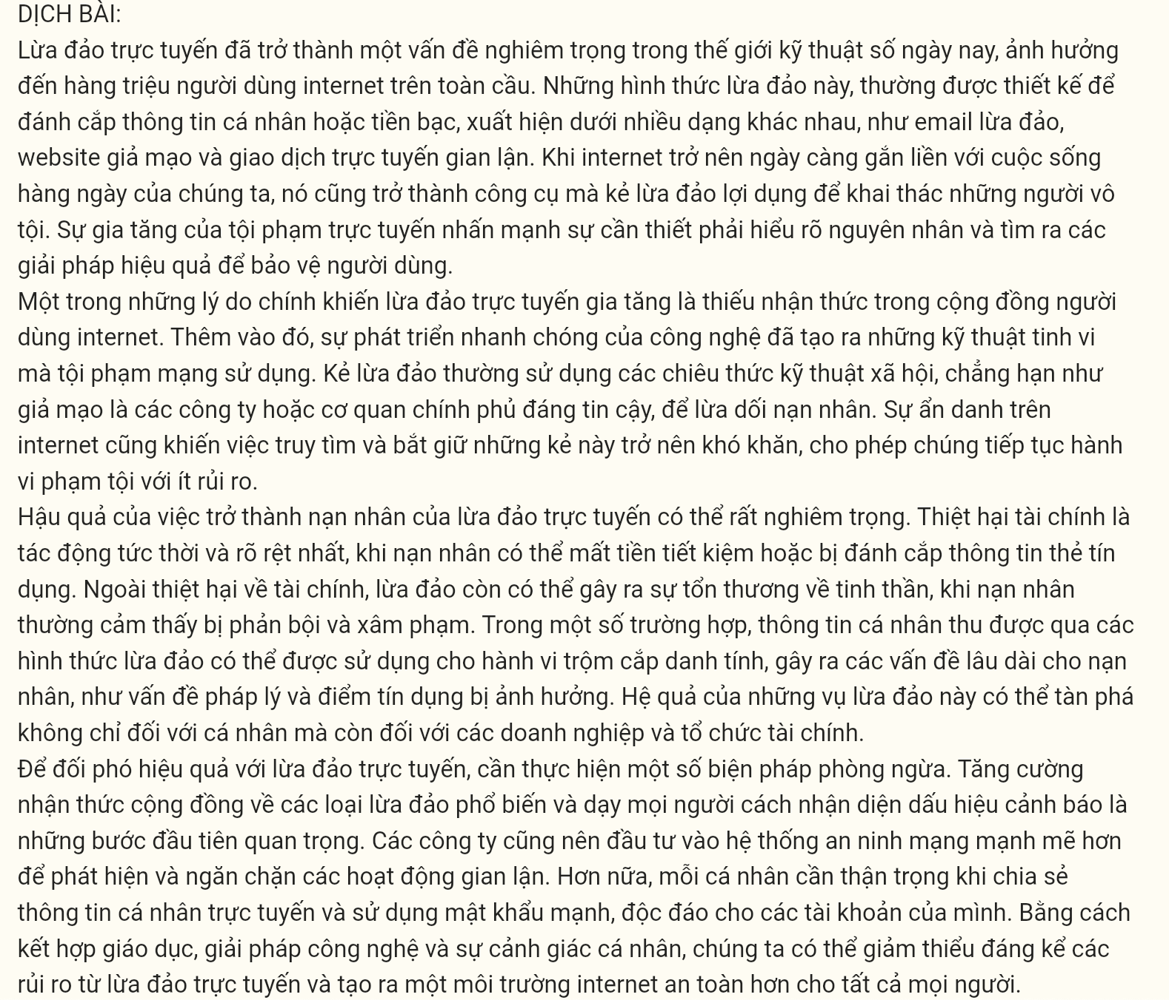
Online scams have become a serious issue in today’s digital world, affecting millions of internet users worldwide. These scams, often designed to steal personal information or money, come in many forms, such as phishing emails, fake websites, and fraudulent online transactions. As the internet becomes more integrated into our daily lives, it also becomes a tool for scammers to exploit unsuspecting individuals. The increase in online fraud highlights the urgent need to understand the causes and find effective solutions to protect users.
One major reason for the rise of online scams is the lack of awareness among internet users. [I] Additionally, the rapid development of technology has given rise to sophisticated techniques used by cybercriminals. [II] Scammers often use social engineering tactics, such as pretending to be trusted companies or government agencies, to deceive victims. [III] The anonymity of the internet also makes it difficult to trace and catch these criminals, allowing them to continue their activities with minimal risk. [IV]
The consequences of falling victim to online scams can be severe. Financial losses are the most immediate and obvious impact, as victims may lose their savings or have their credit card details stolen. Beyond financial damage, scams can also lead to emotional distress, as victims often feel betrayed and violated. In some cases, personal information obtained through scams is used for identity theft, causing long-term problems for the victim, such as legal issues and damaged credit scores. The ripple effects of these scams can be devastating, not only for individuals but also for businesses and financial institutions.
240
To combat online scams effectively, several preventive measures need to be implemented. Raising public awareness about common types of scams and teaching people how to recognize warning signs are crucial first steps. Companies should also invest in stronger cybersecurity systems to detect and prevent fraudulent activities. Moreover, individuals should be cautious about sharing personal information online and use strong, unique passwords for their accounts. By combining education, technological solutions, and personal vigilance, we can significantly reduce the risks posed by online scams and create a safer internet environment for everyone.
Question 31 [698699]: Where in paragraph 2 does the following sentence best fit?
Many people do not realize the risks associated with sharing their personal information online, making them easy targets for scammers.
A. [I] B. [II] C. [III] D. [IV]
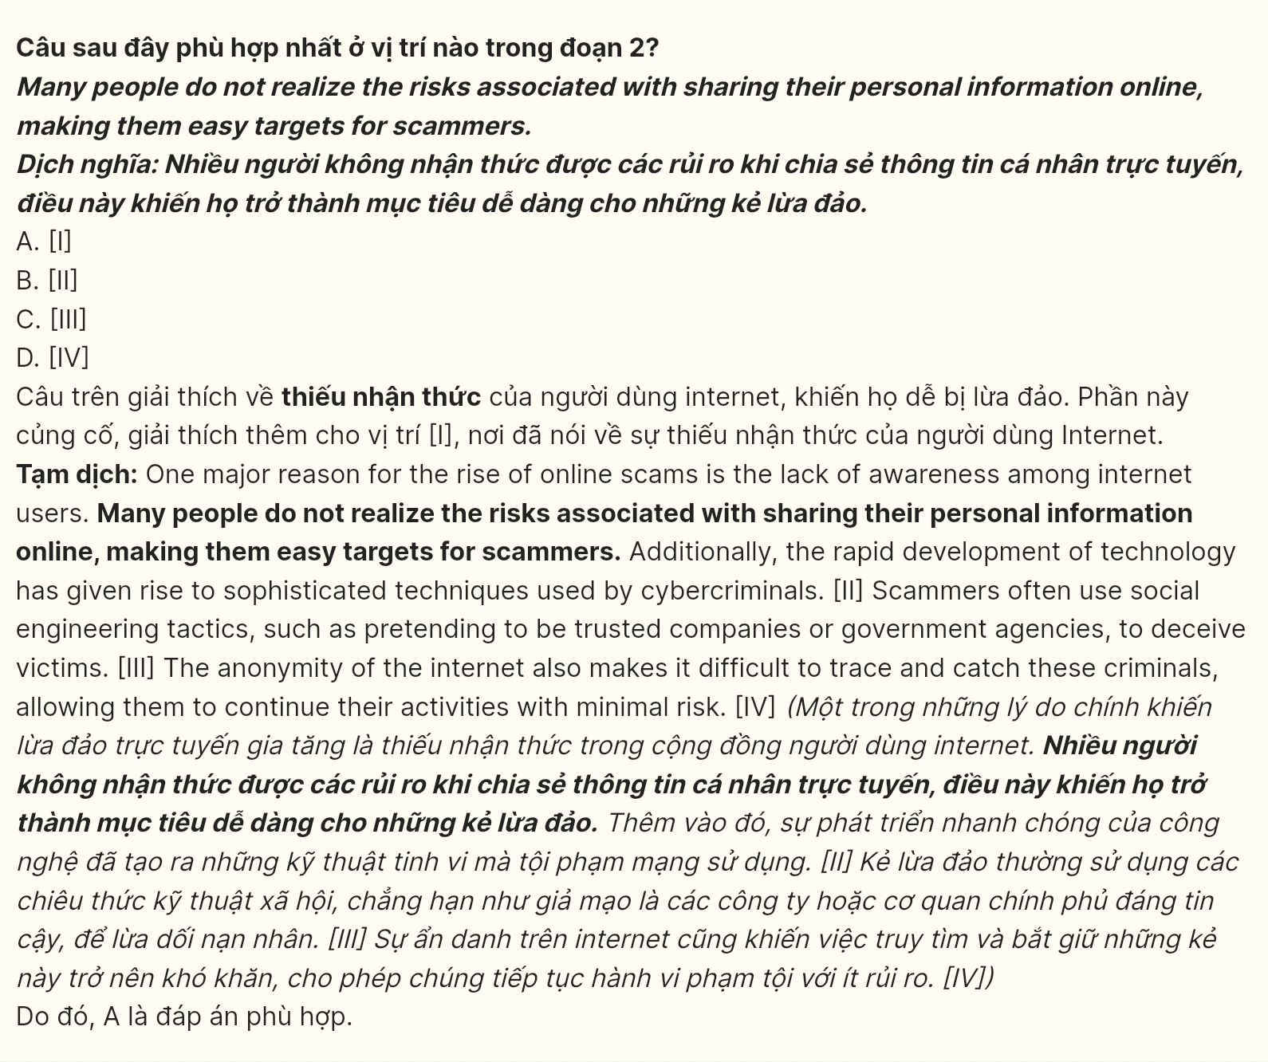
Question 32 [698700]: The word unsuspecting in paragraph 1 could be best replaced by ______.
A. attentive B. conscious C. unaware D. uncertain
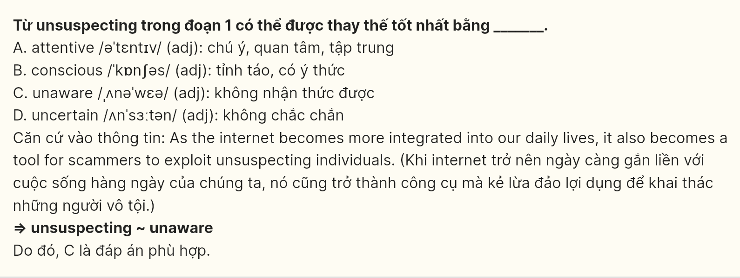
Question 33 [698701]: The word their in paragraph 3 refer to?
A. consequences B. victims C. online scams D. details
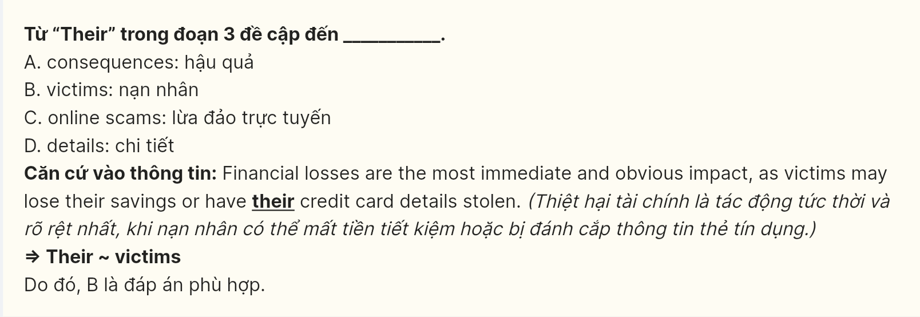
Question 34 [698702]: According to paragraph 1, which of the following is NOT mentioned as a form of online scam?
A. phishing emails B. fake websites C. fraudulent online transactions D. investment fraud schemes

Question 35 [698703]: Which of the following best summarises paragraph 3?
A. Online scams can lead to minor financial losses but have no lasting legal impacts.
B. The effects of online scams can be severe, including financial, emotional, and legal issues.
C. Victims of online scams often face financial problems, but emotional harm is less common.
D. Online scams are mostly harmful, affecting only those with weak online security practices.
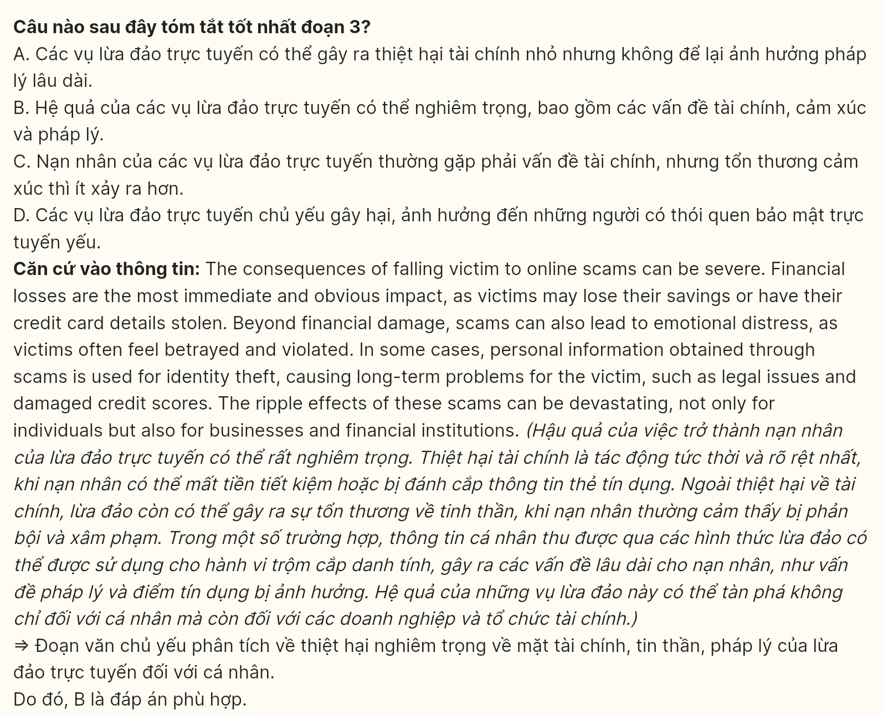
Question 36 [698704]: The word implemented in paragraph 4 is OPPOSITE in meaning to ______.
A. introduced B. executed C. enforced D. abandoned
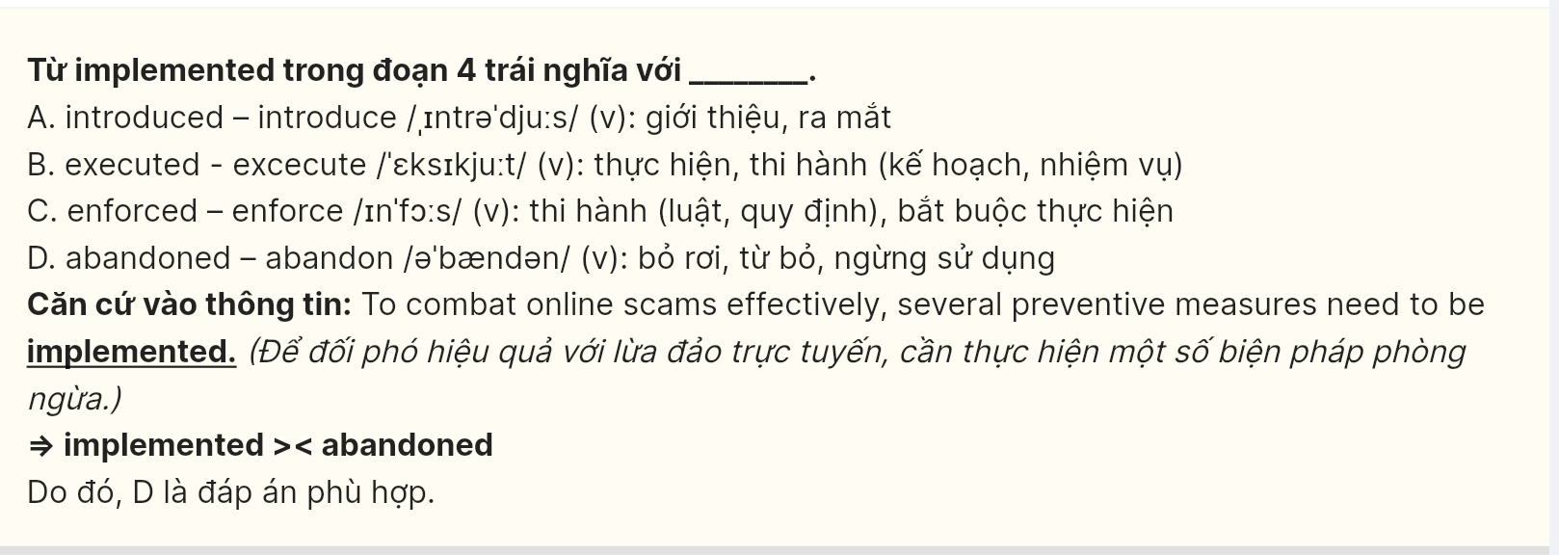
Question 37 (698705): Which of the following is TRUE according to the passage?
A. Online scams are becoming less common as users learn to protect their data.
B. Scammers mainly focus on businesses rather than individual internet users.
C. Technological advances have helped scammers use more sophisticated methods.
D. Raising public awareness is enough to completely stop online fraud attempts.
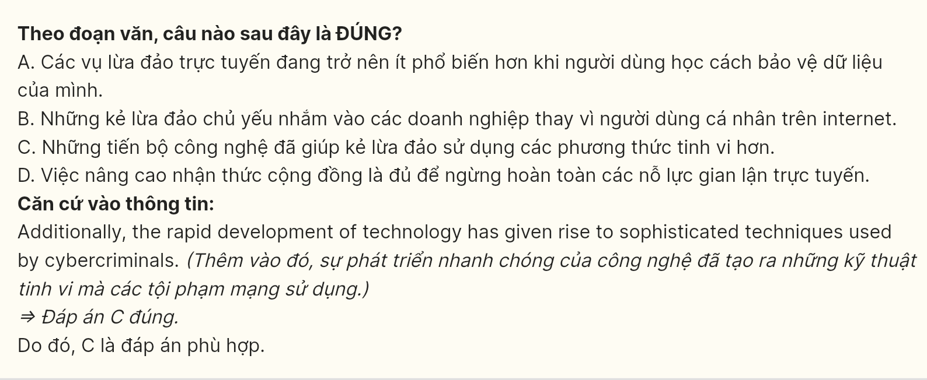
Question 38 (698706): Which of the following best paraphrases the underlined sentence in paragraph 3?
A. The consequences of these scams are often severe, mainly affecting financial institutions and large companies.
B. These scams typically cause serious harm to financial institutions while leaving individuals mostly unaffected.
C. The impact of these scams can be far-reaching, affecting not just individuals but also businesses and financial institutions.
D. The ripple effects of these scams are limited, mostly influencing individual victims without impacting financial institutions.
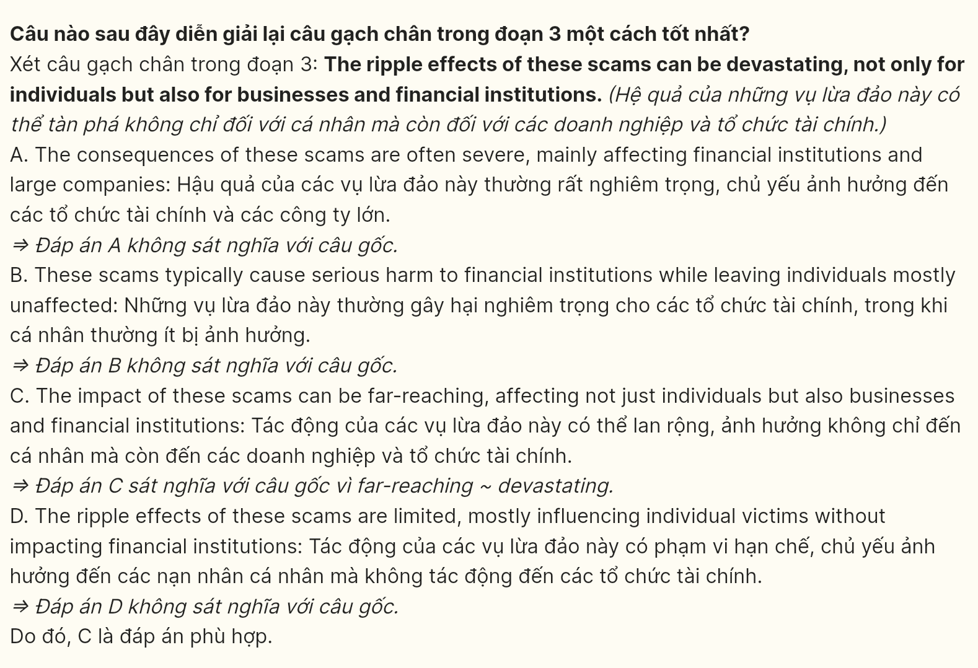
Question 39 (698707): Which of the following can be inferred from the passage?
A. A combination of awareness, technology, and caution is essential to minimize online scam risks.
B. Personal vigilance is unnecessary if companies implement strong cybersecurity measures.
C. Online scams have become less common because users are now more cautious with their data.
D. Most online scams are easy to detect, but users still fall victim because of poor internet skills.
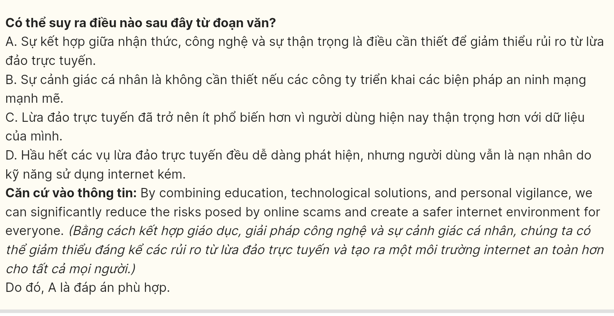
Question 40 (698708): Which of the following best summarises the passage?
A. Online scams are rare occurrences but often happen because careless users share personal information online without considering the potential risks involved.
B. Online scams mainly target businesses and individuals, but advanced technology and better security can help prevent them effectively in the long term.
C. The primary cause of online scams is weak internet security, and only stricter regulations and better enforcement can truly reduce their harmful effects.
D. Online scams are increasing due to user unawareness and evolving techniques, causing serious impacts, but can be mitigated with combined preventive measures.
