School: ……………………………………….. | Date:……………………………………..
Class: ……………………………..................... | Period: 85

UNIT 5: TRAVEL AND TRANSPORTATION
Right on (Page 91)

1. Objectives
By the end of this lesson, students will be able to…
1.1. Language knowledge/ skills
- practise presenting about wonders in their country.
- create a brochure.
- develop ICT skills.
- improve public speaking skills.
1.2. Competences
- improve Ss’ communication, collaboration, analytical, critical thinking skills.
1.3. Attributes
- become knowledgeable people.
- develop value of responsibility to the sites.
2. Teaching aids and materials
- Teacher’s aids: Student’s book and Teacher’s book, class CDs, IWB – Phần mềm tương tác trực quan, projector/interactive whiteboard /TV (if any), PowerPoint slides.
- Students’ aids: Student’s book, Workbook, Notebook.
3. Assessment evidence
Performance Tasks | Performance Products | Assessment Tools
- List the wonders in Vietnam.  - Make a brochure and present it.  - Do a quiz.  - Make a poster and present it. | - Ss’ answers.  - Ss’ brochure/ presentation.  - Ss’ answers  - Ss’ poster/ presentation. | - Observation.  - Observation & rubric.  - Observation.  - Observation.

4. Procedures
A. Warm up: 5 minutes
a. Objectives: to help Ss brainstorm the topic.
b. Content: some wonders in Vietnam.
c. Expected outcomes: Ss can think about the topic.
d. Organization

Teacher’s activities | Students’ activities
Answer the question  Can you tell me some wonders in our country?  - Ask Ss to answer the questions.  - Give feedbacks and lead to new lesson. | - Answer the question.  Suggested answers:  Ho Chi Minh Mausoleum, Thien Mu Pagoda, One pillar pagoda, Ba Chua Xu Temple,…  - Listen to the teacher and take notes.

B. Presentation : 10 minutes
a. Objectives: to help Ss develop research skills to find out some more wonders in Vietnam and create a brochure.
b. Content: task 1.
c. Expected outcomes: Ss can know some more wonders in Vietnam and create a brochure.
d. Organization
Teacher’s activities | Students’ activities
Task 1: Collect information about wonders in your country. Create a brochure.  - Ask Ss to work in small groups and give them time to research online and collect information about wonders in their country.  - Give Ss time to prepare a brochure. Remind Ss they have to use a main heading, then present the wonder. | - Work in group to collect information about wonders in Vietnam.  - Prepare a brochure.  Suggested answers  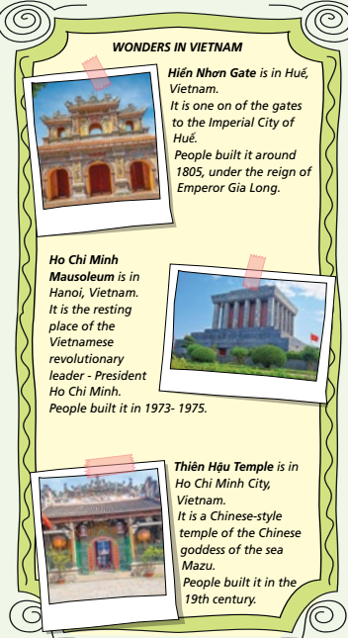

C. Practice: 15 minutes
a. Objectives: to help Ss practise presentation skills, develop value of responsibility to the sites.
b. Content: task 2 and task 3.
c. Expected outcomes: Ss can make a presentation about wonders in Vietnam, be responsible for these sites.
d. Organization:
Teacher’s activities | Students’ activities
Task 2: Use your research in Exercise 1 to prepare and give a presentation about wonders in your country to a group of exchange students visiting your school.  - Give Ss time to use their answers in Exercise 1 to prepare a presentation.  - Ask various Ss to give their presentations to the class. | - Present the answers in Exercise 1 to the class.  Suggested Answer  Hello everyone.  Welcome to Vietnam’! Today, I’m going to  talk to you about some wonders in Vietnam  which you might want to visit.  First of all, there is the Hiển Nhơn Gate in Huế.  It is one on of the gates to the Imperial City of  Huế. They built the gate around 1805, under  the reign of Emperor Gia Long. You should go and see it.  Another place you should see is Ho Chi Minh  Mausoleum in Hanoi. It is the resting place of  the Vietnamese revolutionary leader –President Ho Chi Minh. People built it in 1973- 1975.  Finally, the Thiên Hậu Temple in Ho Chi Minh City. It is a Chinese-style temple of the Chinese goddess of the sea Mazu. People built it in the 19th century. You should see it because it is an amazing building.  Those are three famous wonders you should  visit while you’re here in Vietnam.  I hope you enjoy your visit!  Thank you for listening
Task 3: Do you visit places with respect? Do the quiz to find out. Use A (Always), B (Sometimes) or C (Never).  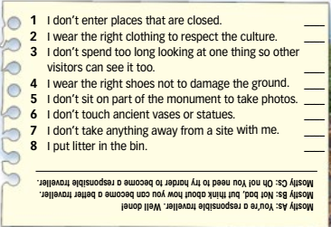  - Give Ss time to read the statements and do the quiz and then check their results.  - Then ask various Ss to share their results with the class. | - Read the statements and do the quiz.  - Share results to the class.  Suggested Answer  Ss’ own answers.

D. Production: 10 minutes
a. Objectives: to help Ss to use the language and information in the real situation; develop ICT skills.
b. Content: task 4.
c. Expected outcomes: Ss can make a poster about showing their respects when they visit places and present it to the class.
d. Organization

Teacher’s activities | Students’ activities
Task 4: Prepare a poster about showing  your respect when you visit places. Use the  ideas in the quiz as well as your own.  Present the poster to the class.  - Ask Ss to work in groups.  - Give Ss time to prepare their poster using  the ideas in the quiz and their own ideas.  - Ask Ss to present their poster to the class. | - Work in groups to make a poster.  - Present their poster to the class  Suggested Answer:  Ss’ own answers

E. Consolidation and homework assignments: 5 minutes
- Do the exercises in workbook on page 74.
- Prepare the next lesson: Progress Check (page 92).
5. Reflection

a. What I liked most about this lesson today:
…………………………………………………………………………………………
b. What I learned from this lesson today:
…………………………………………………………………………………………
c. What I should improve for this lesson next time:
…………………………………………………………………………………………

