Chỉ 100k/12 tháng, bạn tải rất nhiều tài liệu tiếng anh file word hay tại: ***Giaoandethitienganh.info***  Mong bạn ghé ủng hộ !

**ĐỀ VIP 9+ - ĐỀ SỐ 3**

## Read the following advertisement and mark the letter A, B, C, or D to indicate the correct option that best fits each of the numbered blanks from 1 to 6.

Are you a teen eager to master a foreign language but feeling disappointed by traditional learning methods? Meet LangBot, an AI-powered app **(1)** just for you! With LangBot, you’ll **(2)**

control of your language journey through interactive games and **(3)**  . This innovative app offers real-time feedback and daily challenges to help you succeed **(4)** building fluency, vocabulary, and confidence. Fancy **(5)** your speaking skills with virtual tutors? Or perhaps you’d love to brush up on grammar without the boring drills? LangBot has it all! Plus, you’ll never get stuck with its easy-to-use support features. Whether you’re studying solo or with friends, this app will keep you **(6)** every step of the way. Ready to kick off your language adventure? Download LangBot now and start seeing results!

|  |  |  |  |  |
| --- | --- | --- | --- | --- |
| **Question 1.** | **A.** is designed | **B.** designing | **C.** which designs | **D.** designed |
| **Question 2.** | **A.** make | **B.** put | **C.** take | **D.** raise |
| **Question 3.** | **A.** practice personalised sessions | | **B.** sessions personalised practice | |
|  | **C.** personalised practice sessions | | **D.** personalised sessions practice | |
| **Question 4.** | **A.** for | **B.** at | **C.** on | **D.** in |
| **Question 5.** | **A.** improving | **B.** to improve | **C.** to improving | **D.** improve |
| **Question 6.** | **A.** engaging | **B.** engaged | **C.** engagement | **D.** engage |

## GIẢI CÂU 1:

## 

## GIẢI CÂU 2:

## 

## GIẢI CÂU 3:

## 

## GIẢI CÂU 4:

## 

## GIẢI CÂU 5:

## 

## GIẢI CÂU 6:

## 

## 

## Read the following cover of a brochure and mark the letter A, B, C, or D to indicate the correct option that best fits each of the numbered blanks from 7 to 12.

Step into a world where imagination meets innovation! Join us at the Cities of the Future exhibit, where you'll discover how urban spaces are being reimagined to **(7)** to changing times. **(8)**

today’s challenges, architects, scientists, and engineers are working hard to shape environments that are sustainable, efficient, and accessible to all. This immersive experience offers a great **(9)** of insight into groundbreaking designs and technologies that could transform our cities. Explore **(10)** interactive displays, from eco-friendly transportation systems to smart buildings and urban green spaces, that show how cities will look in the coming decades. Don’t miss this opportunity to get a **(11)** of what’s ahead. Cities of the Future - where innovation **(12)**

!

|  |  |  |  |  |
| --- | --- | --- | --- | --- |
| **Question 7.** | **A.** apply | **B.** adapt | **C.** suit | **D.** comply |
| **Question 8.** | **A.** Irrespective of | **B.** In contrast to | **C.** Except for | **D.** By means of |
| **Question 9.** | **A.** number | **B.** handful | **C.** range | **D.** deal |
| **Question 10.** | **A.** several | **B.** another | **C.** every | **D.** a little |
| **Question 11.** | **A.** glance | **B.** sight | **C.** glimpse | **D.** impression |
| **Question 12.** | **A.** pulls down | **B.** gets on | **C.** takes over | **D.** turns off |

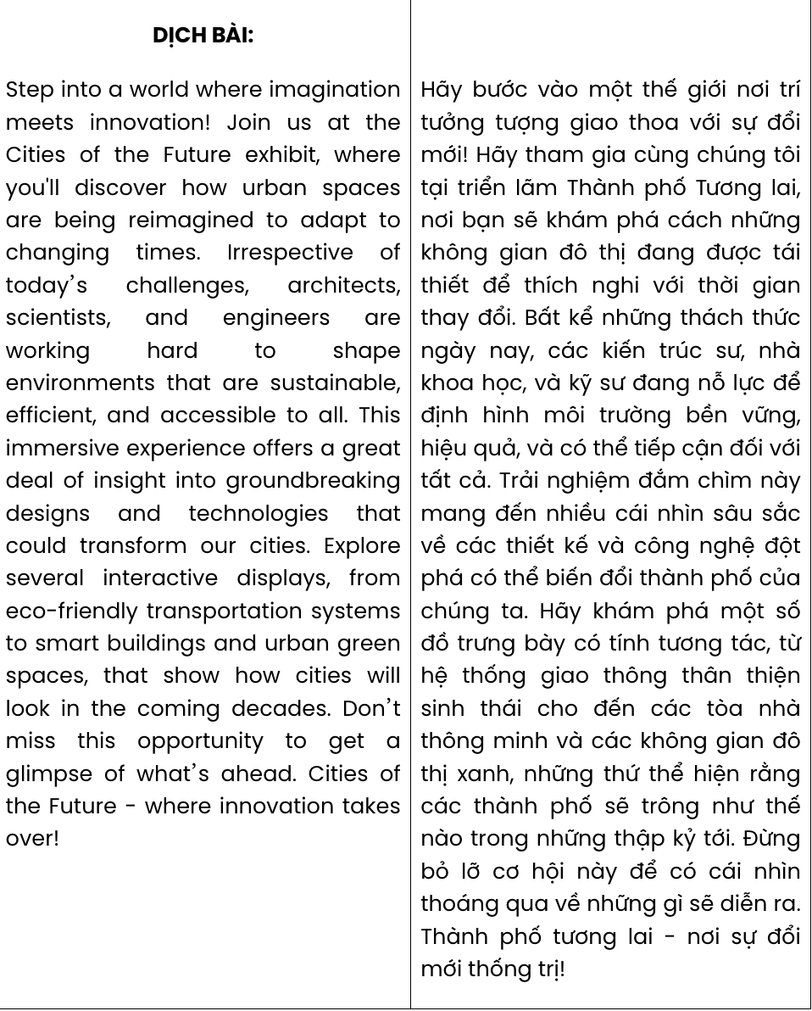

## GIẢI CÂU 7:

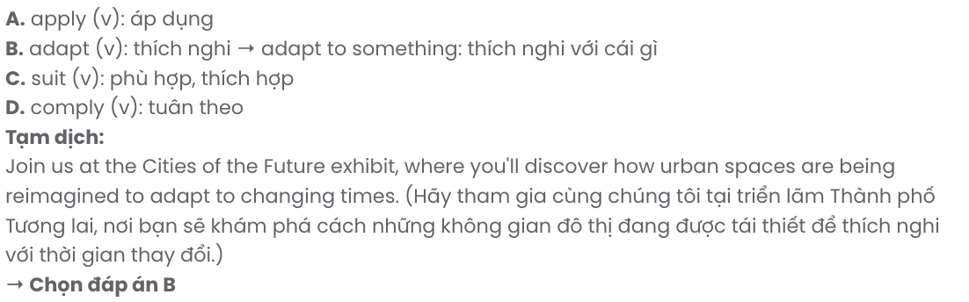

## GIẢI CÂU 8:

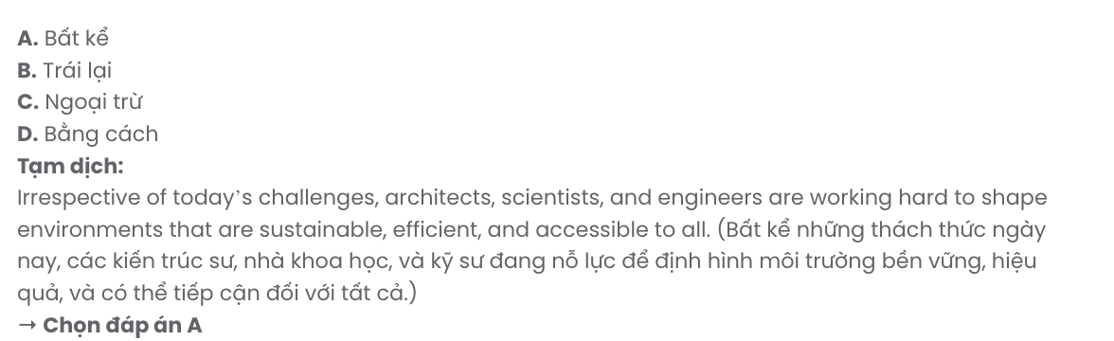

## GIẢI CÂU 9:

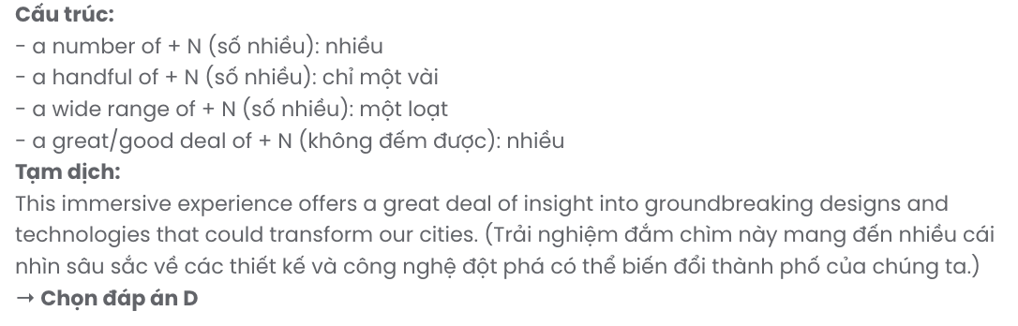

## GIẢI CÂU 10:

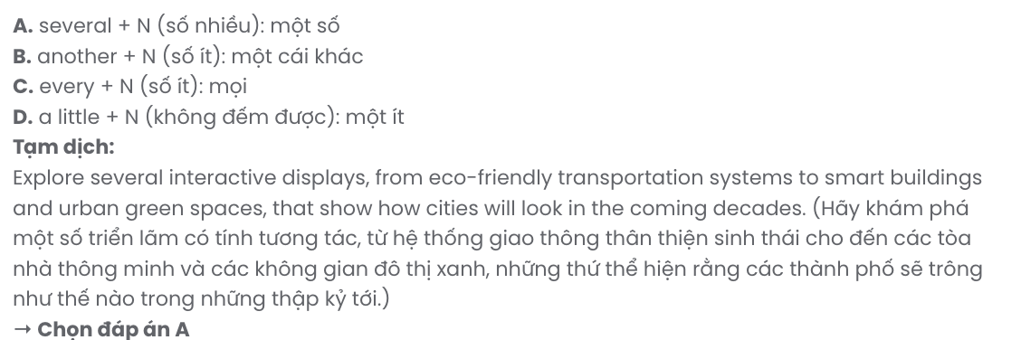

## GIẢI CÂU 11:

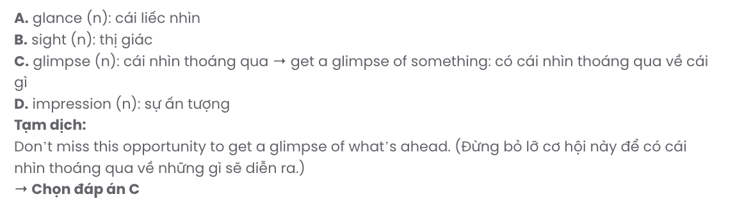

## GIẢI CÂU 12:

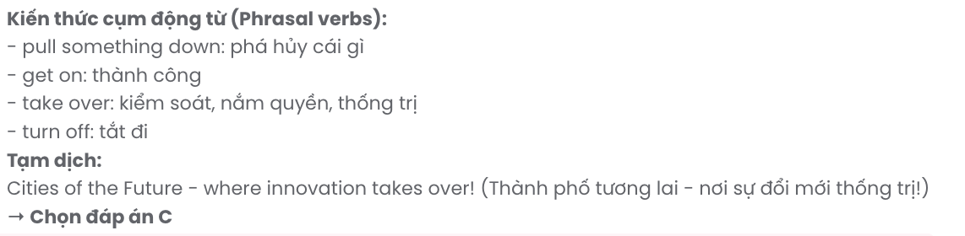

***Mark the letter A, B, C or D on your answer sheet to indicate the best arrangement of utterances or sentences to make a meaningful exchange or text in each of the following questions from 13 to 17.***

# Question 13.

1. Nam: Hi, Mark. I'm reading a really good book in English called *The Diary of Dang Thuy Tram*.
2. Mark: Hi, Nam. Your book must be very interesting. What are you reading?
3. Mark: Could you tell me more about it?

**A.** a – c – b **B.** c – a – b **C.** b – c – a **D.** b – a – c

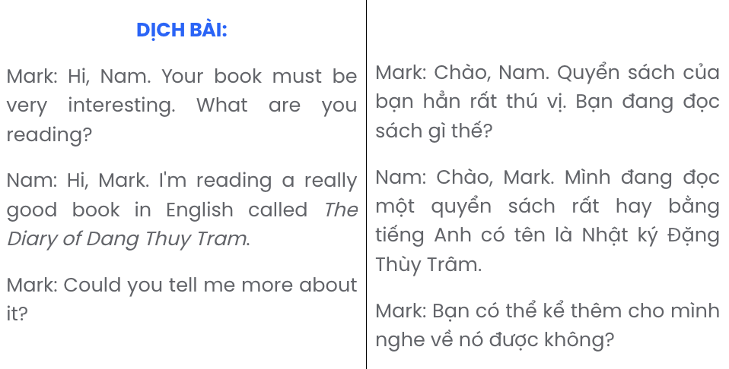

# Question 14.

1. Lan: There are three criteria, including: raising environmental awareness, reducing our carbon footprint, and using resources efficiently.
2. Linda: How exciting! But how will the classrooms be judged?
3. Lan: Yes, this is the easiest thing to do, but we also need to change our classmates' behaviour so that we can develop eco-friendly habits in our class.
4. Lan: Our school is holding a Green Classroom Competition. The greenest classroom will win an ecotour!
5. Linda: I think we should start by cleaning up our classroom more frequently and having more plants in it.

**A.** e – a – d – b – c **B.** e – c – d – b – a **C.** d – e – a – b – c **D.** d – b – a – e – c

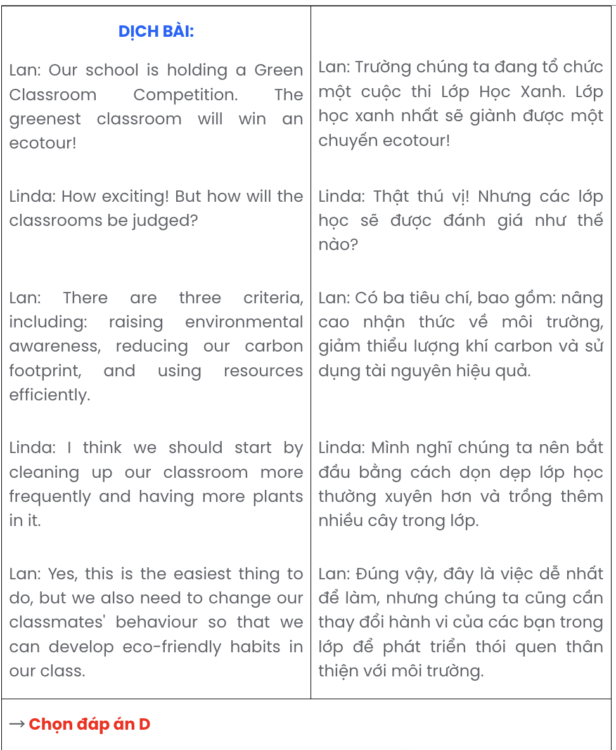

# Question 15.

Hi Julia,

1. Staying safe online is so important, especially with how common cyberbullying is these days.
2. Thanks for the tips you sent on protecting myself online - they were really helpful!
3. I’ve already started using stronger passwords and adjusting my privacy settings on social media.
4. Also, I checked out that website you recommended for reporting harmful content. It's good to know how to handle situations like that.
5. I think everyone should know these steps to stay safe from cyberbullying, and I’ll definitely share them with my friends.

Write back soon. Alex

**A.** a – e – b – d – c **B.** e – c – b – d – a **C.** b – c – d – e – a **D.** d – a – b – e – c

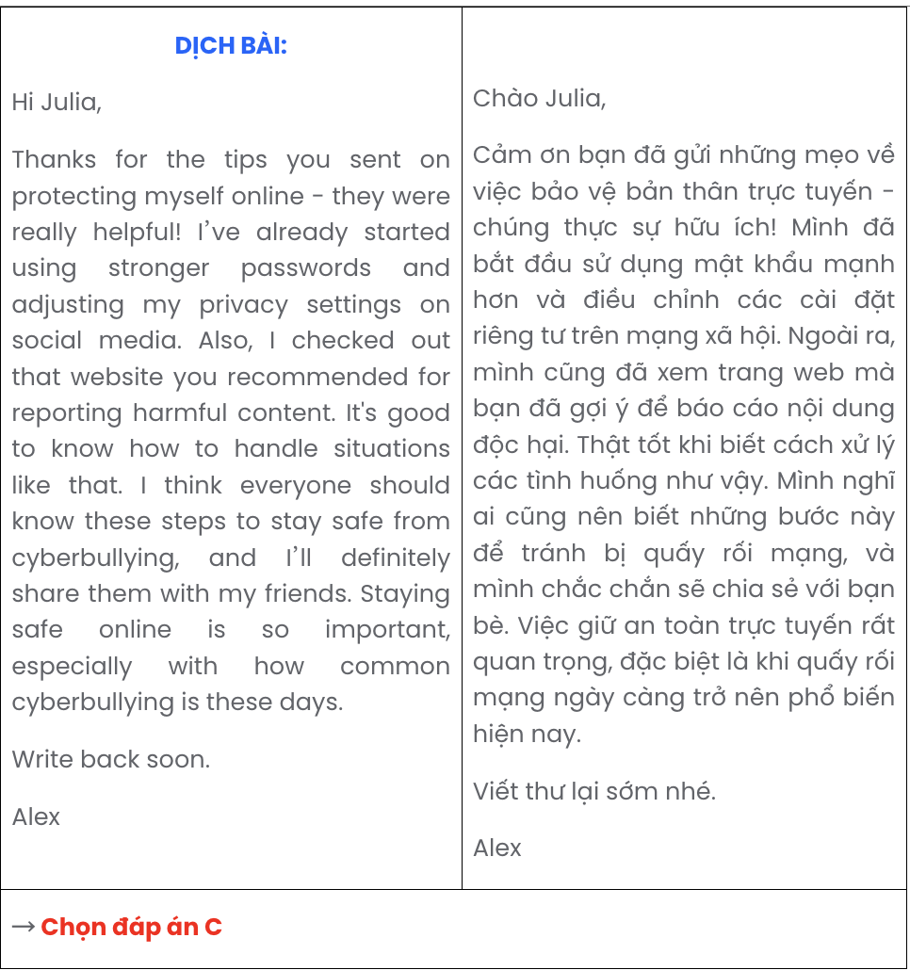

# Question 16.

1. While tasks like cleaning enclosures and preparing food are quite repetitive, the reward of seeing the animals thrive makes it all worthwhile.
2. My long-standing passion for animal welfare has led me to volunteer at the shelter, where I find immense fulfilment.
3. Beyond daily care, I assist in coordinating adoption events to help match animals with loving, permanent homes.
4. Over the past year, I have cherished every opportunity at this place, where I contribute to creating a safe and nurturing environment for each animal.
5. Altogether, this experience has instilled in me patience, a strong sense of responsibility, and a deeper appreciation for the welfare of animals.

**A.** d – c – a – b – e **B.** a – c – d – b – e **C.** c – d – a – b – e **D.** b – d – a – c – e

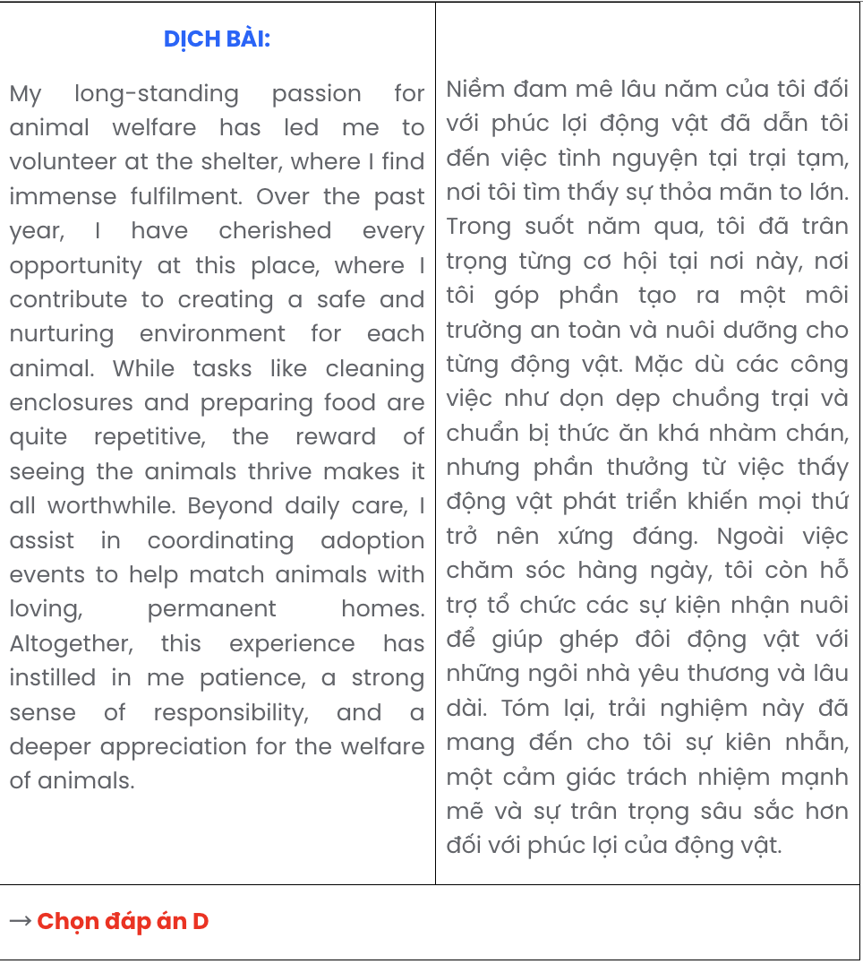

# Question 17.

1. The expansion of agriculture and cattle ranching has encroached on vast areas of forest, leading to significant deforestation.
2. Home to diverse species, the Amazon rainforest has undergone substantial changes in recent years.
3. In addition to forest loss, the development of new roads has fragmented wildlife habitats, affecting biodiversity and migration patterns.
4. This rapid deforestation has not only contributed to habitat destruction but also accelerated carbon emissions, impacting global climate.
5. Although conservation efforts have increased, the Amazon continues to face threats from illegal logging, mining, and land clearing.

**A.** b – e – d – a – c **B.** b – a – d – c – e **C.** b – d – c – a – e **D.** b – c – a – e – d

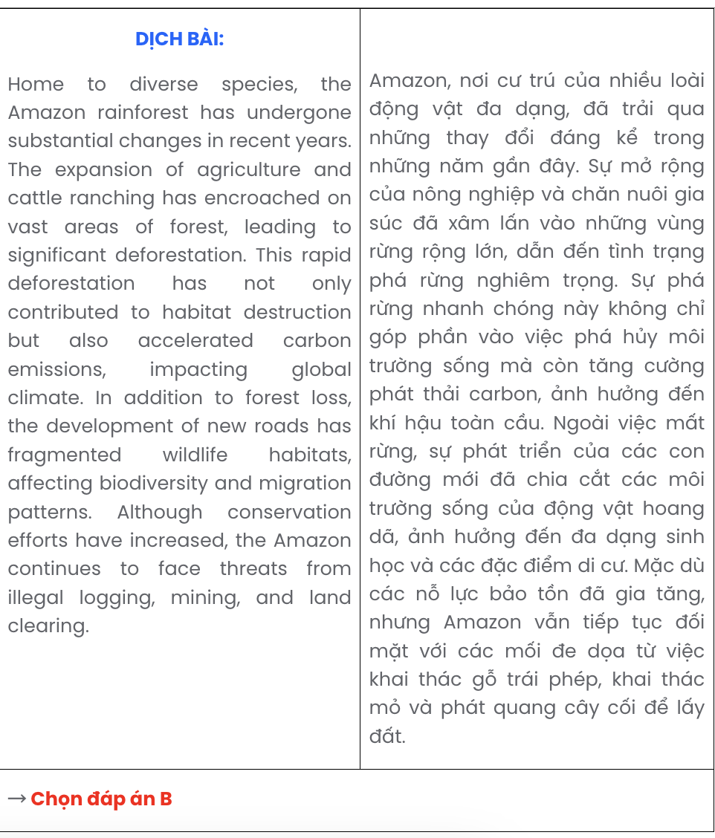

## Read the following passage about gender equality and mark the letter A, B, C, or D to indicate the correct option that best fits each of the numbered blanks from 18 to 22.

Gender equality, a fundamental human right, **(18)**  . Achieving this goal, which benefits everyone, requires collective effort and commitment from both individuals and institutions. Many organisations, inspired by the growing demand for equal opportunities, have implemented policies aimed at reducing gender bias in the workplace. **(19)**  .

Efforts toward gender equality often include promoting education, **(20)**  . Gender discrimination - present in multiple areas such as pay, career advancement, and political representation - continues to limit individuals’ potential irrespective of their abilities or qualifications. Recognised globally as a vital factor in social and economic development, **(21)**  .

Despite these efforts, persistent obstacles continue to hinder gender equality in various spheres.

**(22)** . Progress has been made, but achieving true equality, driven by policies and changing mindsets, remains an ongoing endeavour.

# Question 18.

1. having become a pressing issue across societies worldwide
2. which remains a burning issue across societies worldwide
3. remains a critical issue across societies worldwide
4. that becomes a major issue across societies worldwide

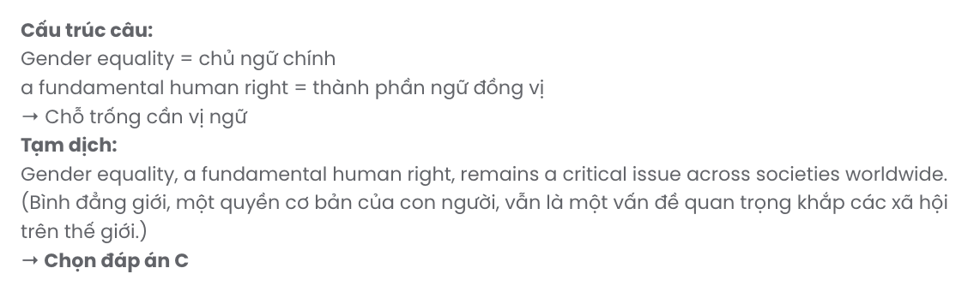

# Question 19.

1. Aiming to address historical societal inequalities, women are promoted in leadership
2. Promoting women in leadership helps address historical societal inequalities
3. Addressing historical societal inequalities assists in promoting women in leadership
4. Women in leadership helps promote and address historical societal inequalities

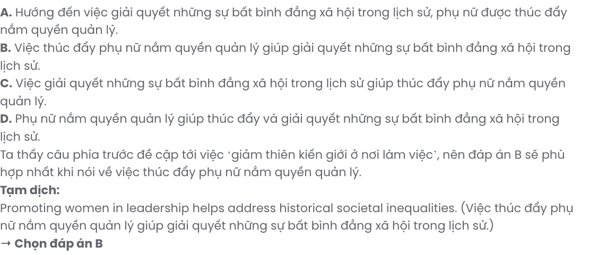

# Question 20.

1. of which offering women and men the same resources to succeed
2. brings about the same resources to succeed for women and men
3. created the same resources for women and men to succeed
4. which provides women and men with the same resources to succeed

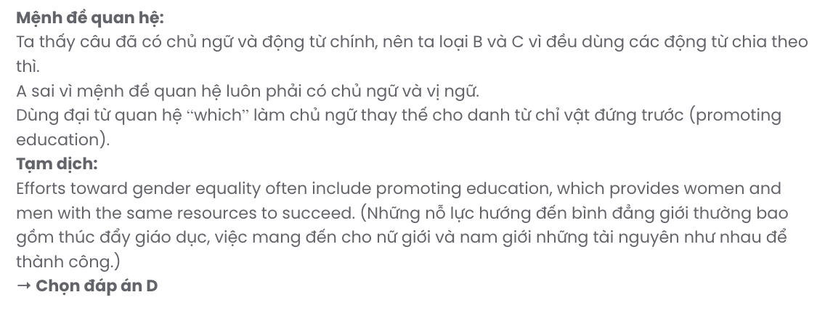

# Question 21.

1. gender equality helps communities thrive by unlocking the potential of all individuals
2. thriving communities helps unlock the potential of all individuals via gender equality
3. unlocking the potential all of all individuals by gender equality helps communities thrive
4. the potential of all individuals is unlocked by gender equality in thriving communities

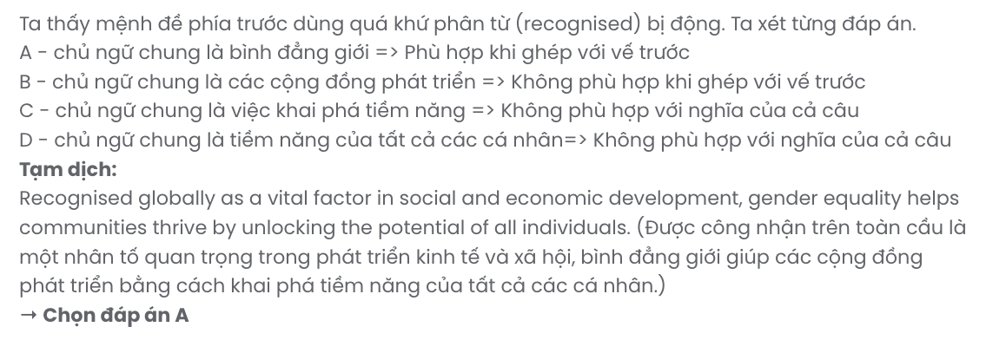

# Question 22.

1. Without inclusivity, it is required to address these challenges by reforms and awareness
2. These challenges are addressed by reforms and awareness so that they create inclusivity
3. Requiring reforms and awareness, these challenges are addressed by inclusivity
4. Addressing these challenges requires reforms and awareness, creating inclusivity

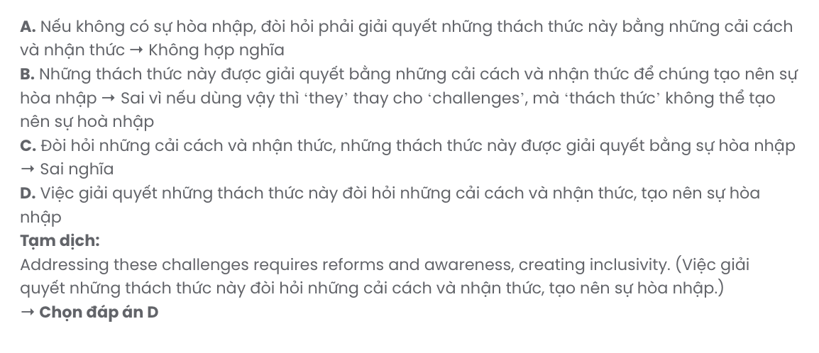

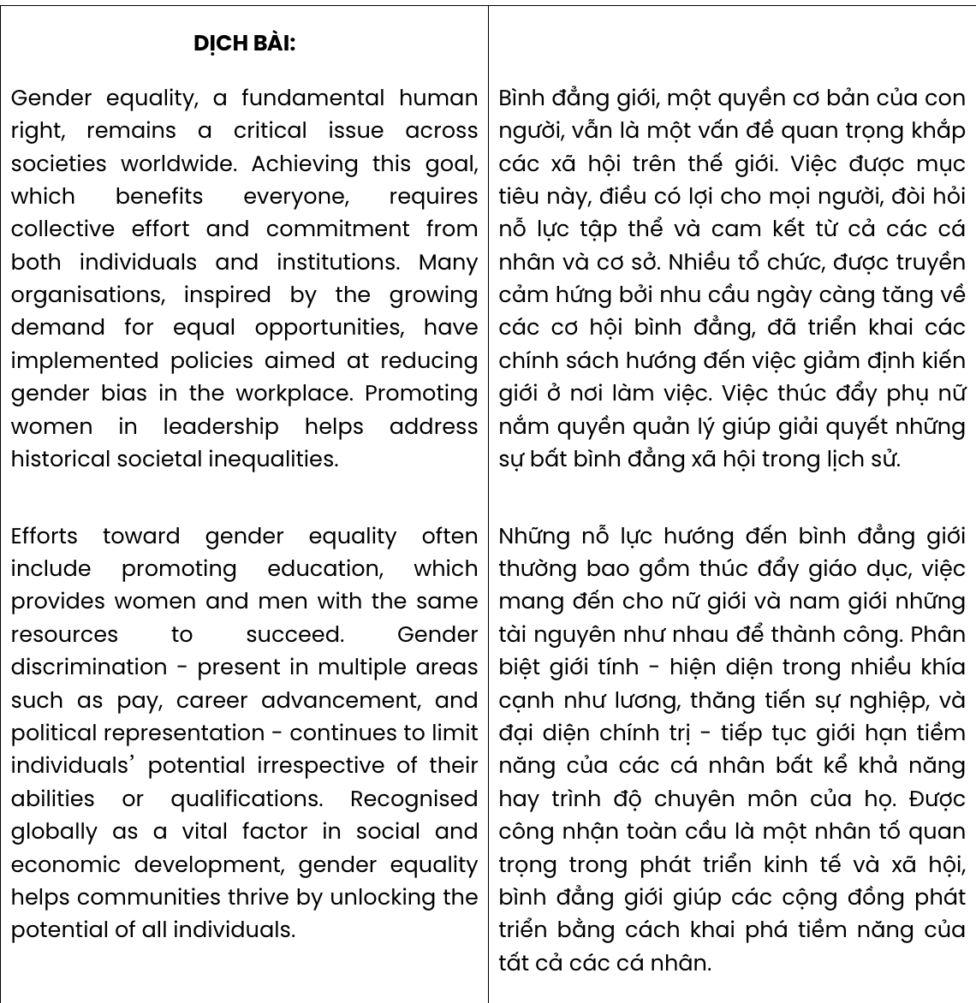

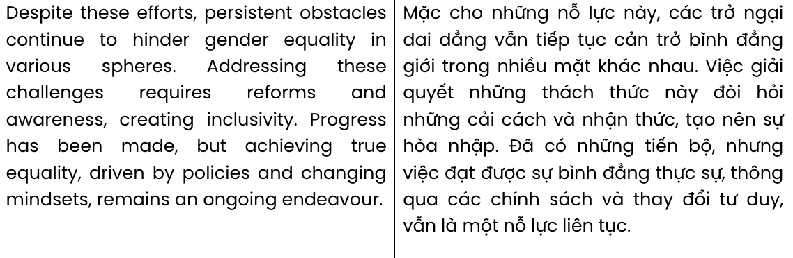

## Read the following passage about the history of the selfie and mark the letter A, B, C, or D to indicate the correct answer to each of the questions from 23 to 30.

When did the selfie mania begin? Most people would guess that it was around the beginning of this century or perhaps a bit later when smartphones became **mainstream**. But most people would be wrong, just as Britney Spears and Paris Hilton were wrong when they declared on Twitter in 2017 that they had invented the selfie eleven years previously. In fact, they were around 167 years too late to make that claim.

**The oldest existing selfie dates back to 1839 when photographer Robert Cornelius took a self- portrait photograph of himself**. To achieve this, he had to uncover the lens, run to his place and pose in the same position for up to fifteen minutes and then run back to cover the lens again. Cornelius couldn’t take a dozen shots and choose the best one – his selfie had to be just one photo. Half a century later, in 1914, thirteen-year-old Grand Duchess Anastasia Nikolaevna of Russia took a picture of herself in a mirror and became the first teenager to take a selfie.

And what about the origin of the word itself? It is thought to come from Australia where people have a habit of putting *-ie* on the end of words – barb*ie* for barbecue, post*ie* for postal worker and even Auss*ie* for Australian. In 2002, an Australian man took a photo of an injury to his lip and put it up on a public forum to ask for advice on how to treat **it**. He referred to the photo as a selfie, and the term was born. Selfie became Oxford Dictionaries’ word of the year in 2013.

So, why do we take so many photos of ourselves? A 2017 study into ‘selfitis’, as the obsessive taking of selfies has been called, found a range of motivations, from seeking to feel more part of a group to **shaking off** depressive thoughts and – of course – capturing a memorable moment. Since we live so much of our lives online, there is pressure to present good quality images, and so it is no surprise that airbrushing apps that enable people to retouch images and present an idealised version of themselves are gaining popularity.

(Adapted from *English Discovery*)

**Question 23.** The word **mainstream** in paragraph 1 is OPPOSITE in meaning to .

**A.** rare **B.** infamous **C.** normal **D.** acceptable

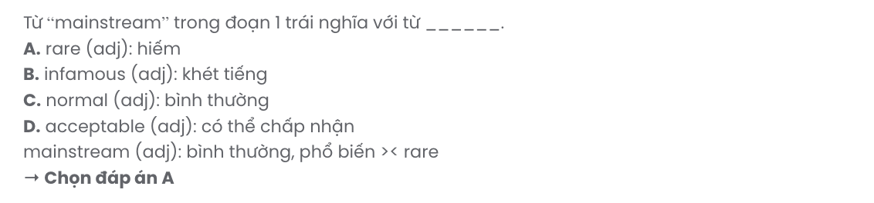

**Question 24.** According to paragraph 1, Britney Spears and Paris Hilton were wrong for .

1. making a claim about the origin of the first selfie
2. stating that they had coined the term ‘selfie’
3. declaring that the selfie mania began in 2017
4. making a guess about an invention in the past

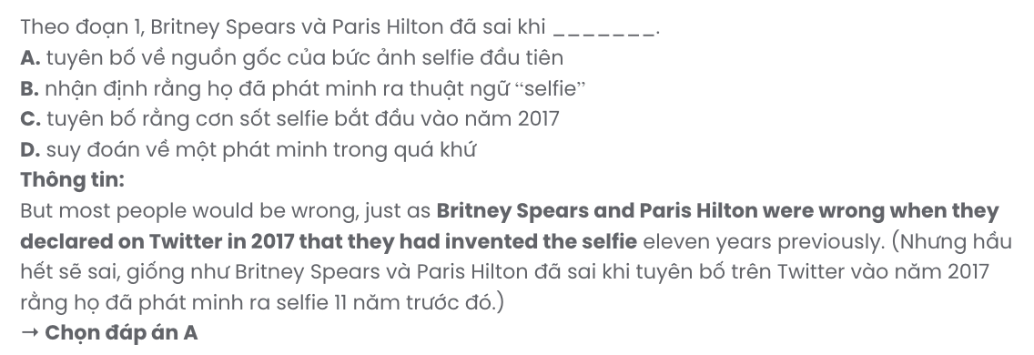

**Question 25.** Which of the following best paraphrases the underlined sentence in paragraph 2?

1. The earliest known selfie was taken in 1839 by photographer Robert Cornelius, who captured his own image.
2. The first selfie was taken in 1839 by Robert Cornelius, who succeeded in recording himself.
3. The oldest existing selfie was captured in 1839 by Robert Cornelius, who took a self-portrait.
4. The earliest selfie on record was taken in 1839 by Robert Cornelius, who created a painted image.

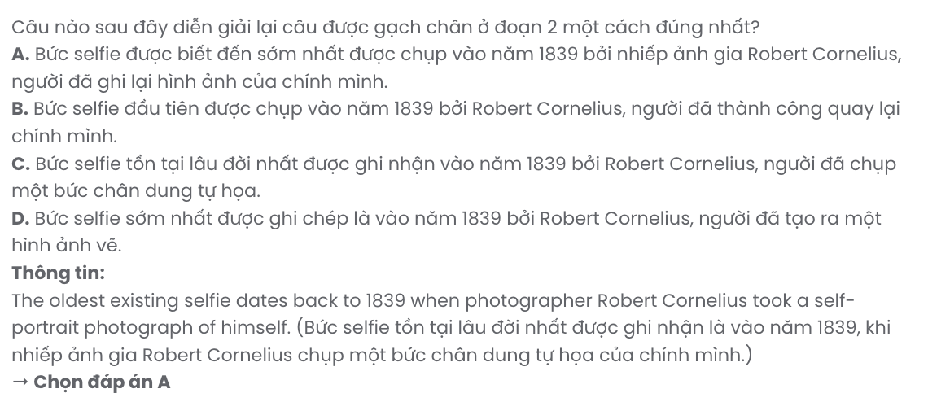

**Question 26.** The word **it** in paragraph 3 refers to .

**A.** a public form **B.** an injury to his lip **C.** a selfie **D.** a photo

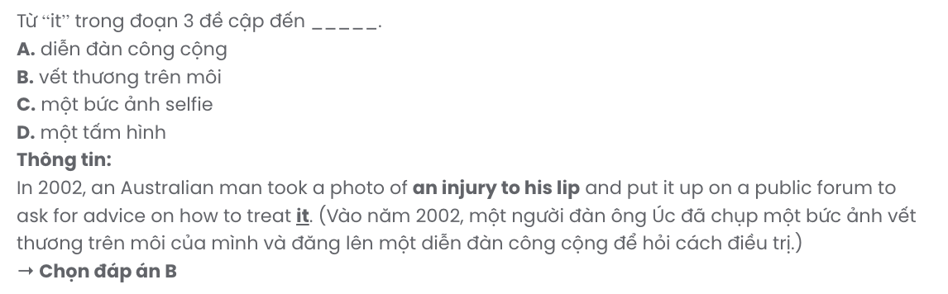

**Question 27.** The phrase **shaking off** in paragraph 4 can be best replaced by .

**A.** delaying **B.** containing **C.** tackling **D.** banishing

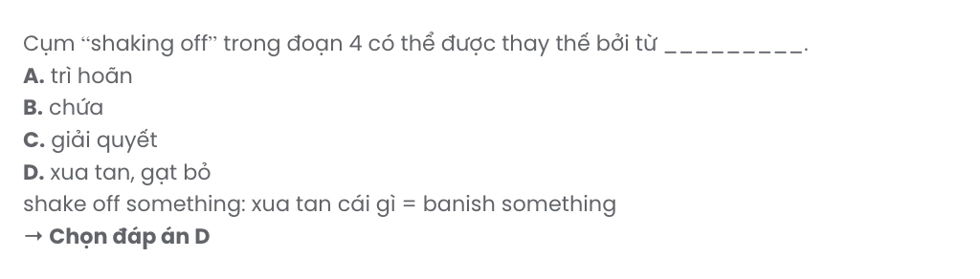

**Question 28.** Which of the following is NOT true according to the passage?

1. The first person to take a selfie was Grand Duchess Anastasia Nikolaevna of Russia.
2. There are a variety of reasons why people become so addicted to taking selfies.
3. Putting *-ie* at the end of the words is believed to give birth to the word ‘selfie’.
4. The demand to post impressive images is high due to our increasing online presence.

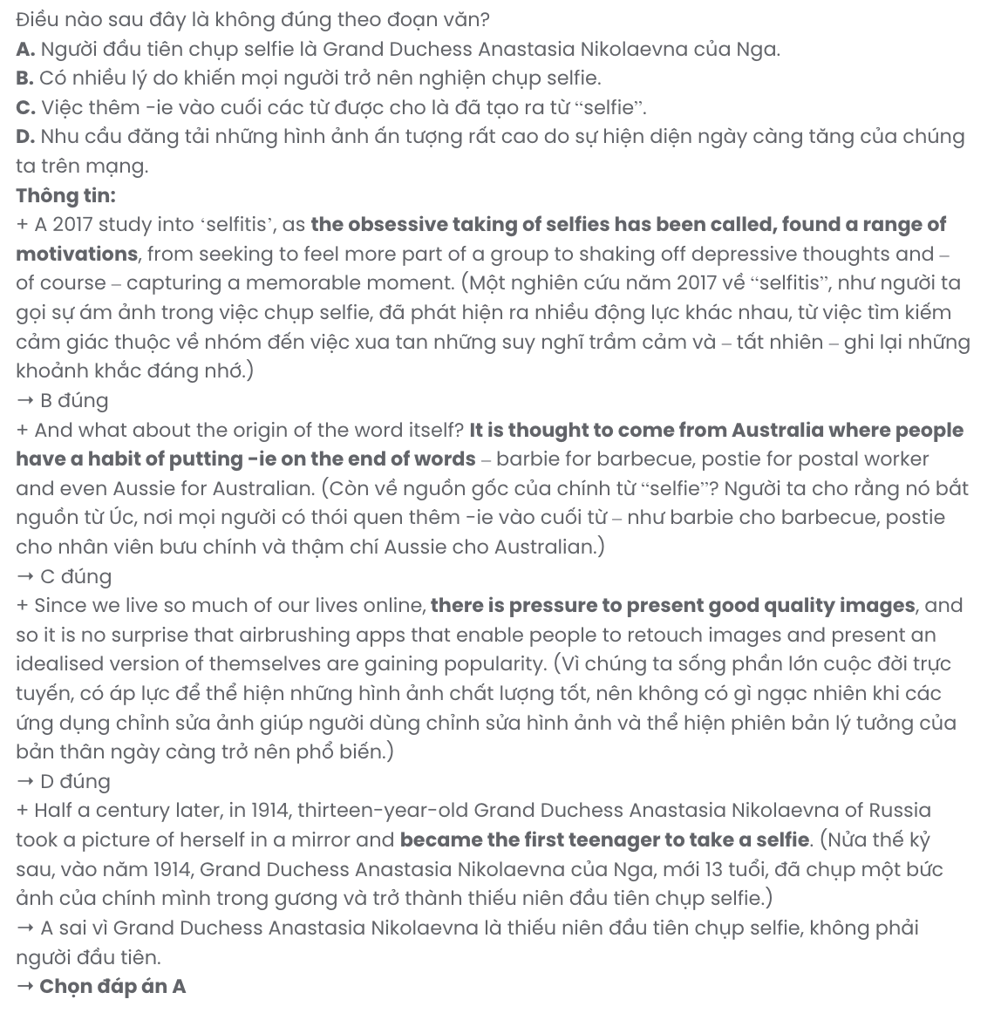

**Question 29.** In which paragraph does the author mention a contrast relationship?

**A.** Paragraph 1 **B.** Paragraph 2 **C.** Paragraph 3 **D.** Paragraph 4

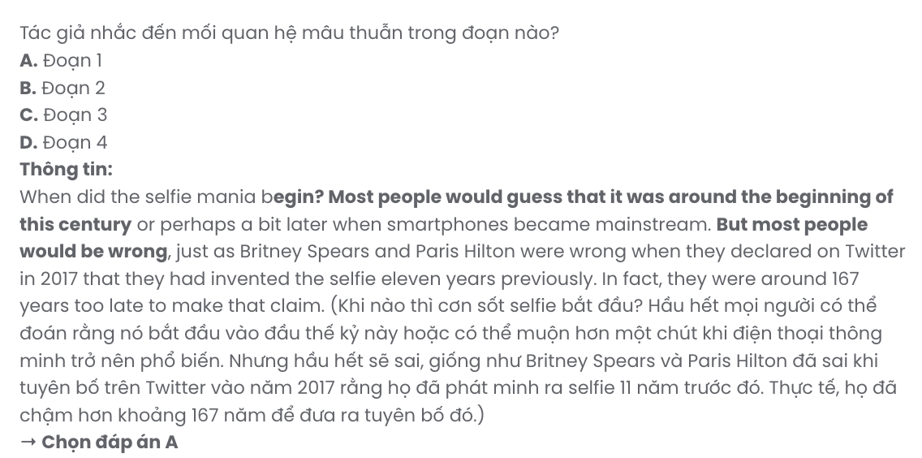

**Question 30.** In which paragraph does the author explore the influence of technology on how we present ourselves in digital spaces?

**A.** Paragraph 1 **B.** Paragraph 2 **C.** Paragraph 3 **D.** Paragraph 4

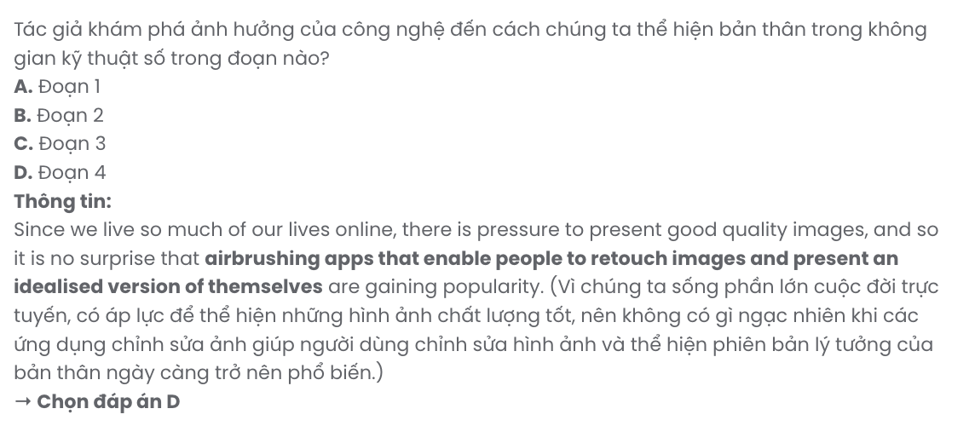

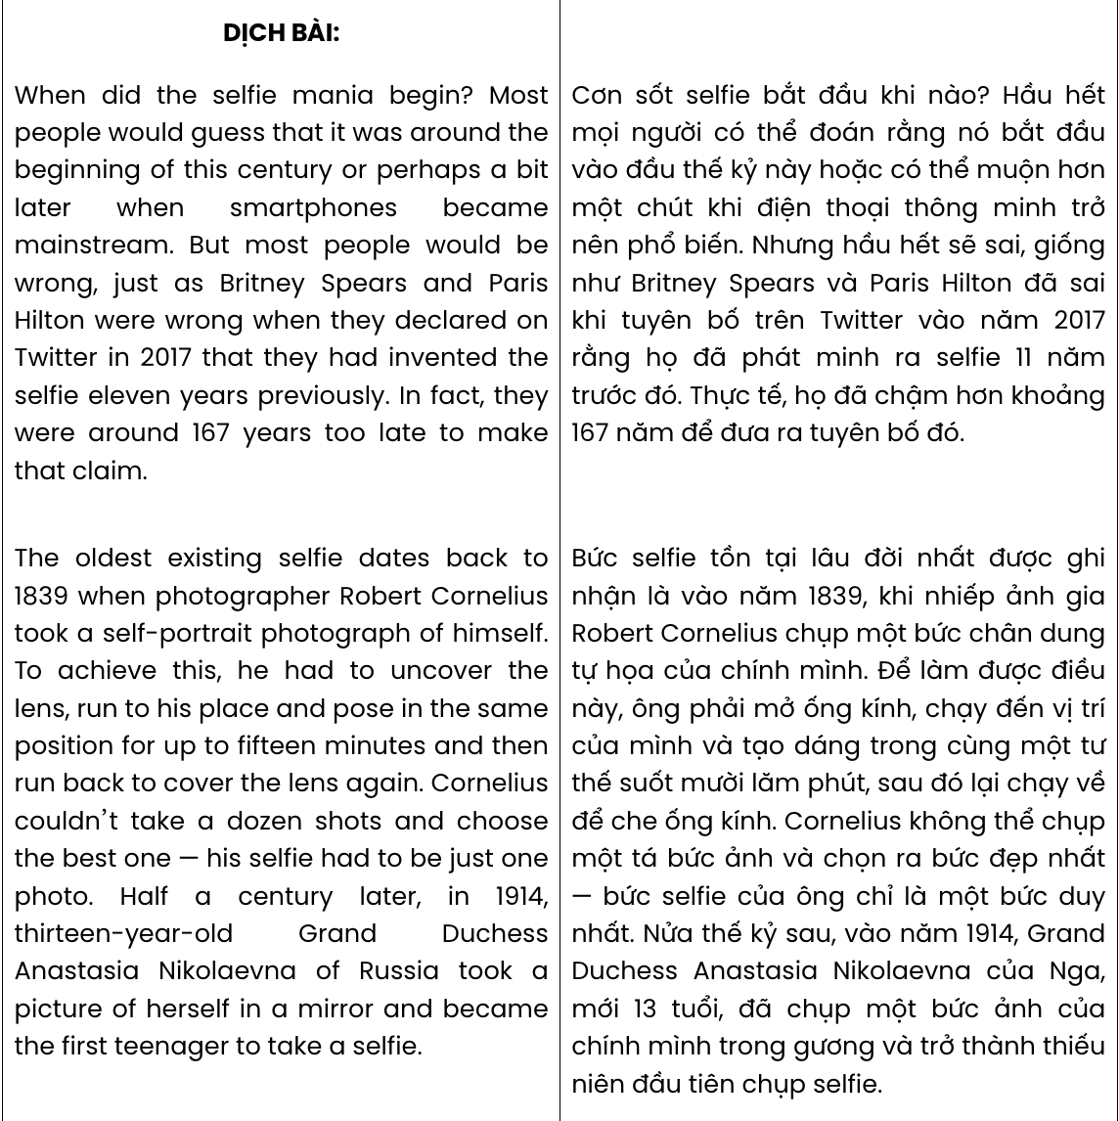

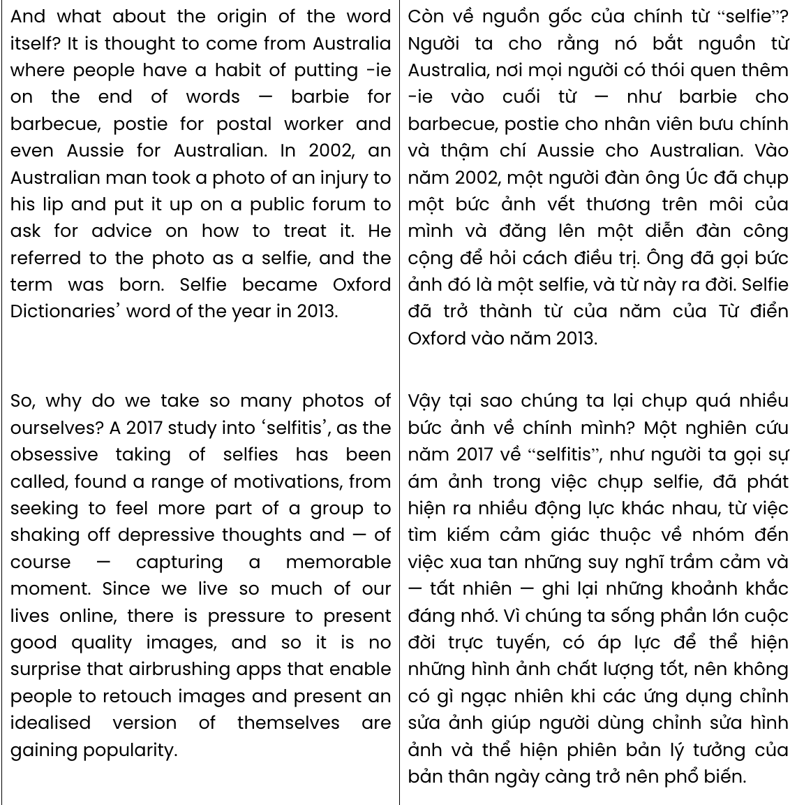

## Read the following passage about stars of the vlogsphere and mark the letter A, B, C, or D to indicate the correct answer to each of the questions from 31 to 40.

Helicopters circled the sky above Piccadilly Circus as the police officers below struggled to control the thousands of fans on the streets outside the bookstore. Who were the thousands of fans waiting for? That latest pop sensation? No, a 'vlogger' - a video blogger.

What makes vloggers so popular? Successful vloggers share some common characteristics. **[I]** They are outgoing, quick-witted and spontaneous in front of their webcams. There is also a lot of interaction with the audience and feedback on **their** videos. **[II]** This means vloggers can adapt the content of their videos to keep their viewers happy. **[III]** It is material that is made by young people for young people without any **intrusion** from media corporations. **[IV]** All these ingredients have created a two-way relationship between vloggers and their subscribers, based on shared interests and trust that cannot be found between the providers and users of other media.

**However, it appears that those shared interests and that trust might become negatively affected by money**. Some of the big-name vloggers can earn up to £20,000 for displaying an advertisement on their channel. They also earn a lot for mentioning or reviewing a product in a vlog. About 1,000 vloggers around the world earn at least £100,000 a year from their YouTube income. And profits are sometimes earned at the expense of **honesty**.

So, will vlogs go the way of many TV programmes and films? Not according to the vloggers, who emphasise their creative independence over making money. However, Zoella, one of the few vloggers in the public eye in Britain, caused a scandal after publishing a book and claiming that it had always been her dream to write a novel. Shortly later, she had to admit that she had not written it alone and her name was just being used to sell **it**. Many media experts saw it as a sign that vlogging had lost its innocence and that large media corporations were taking control.

(Adapted from *Friends Global*)

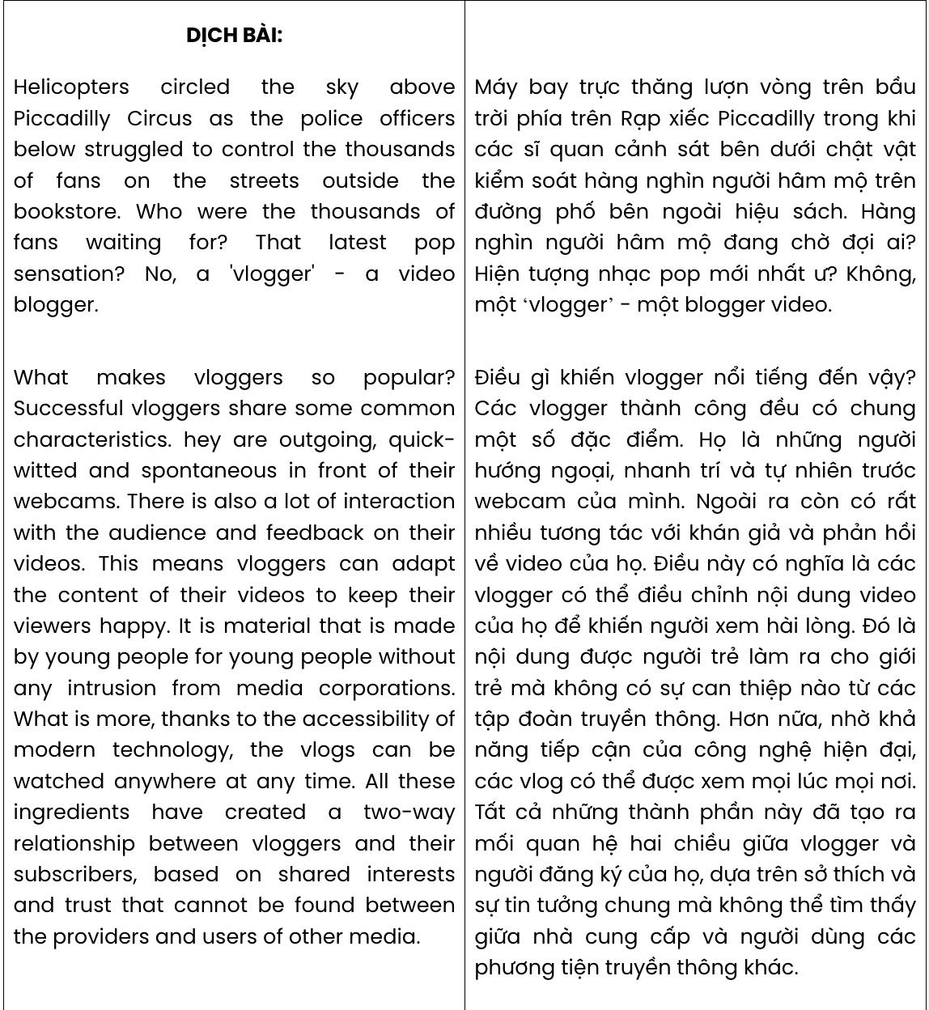

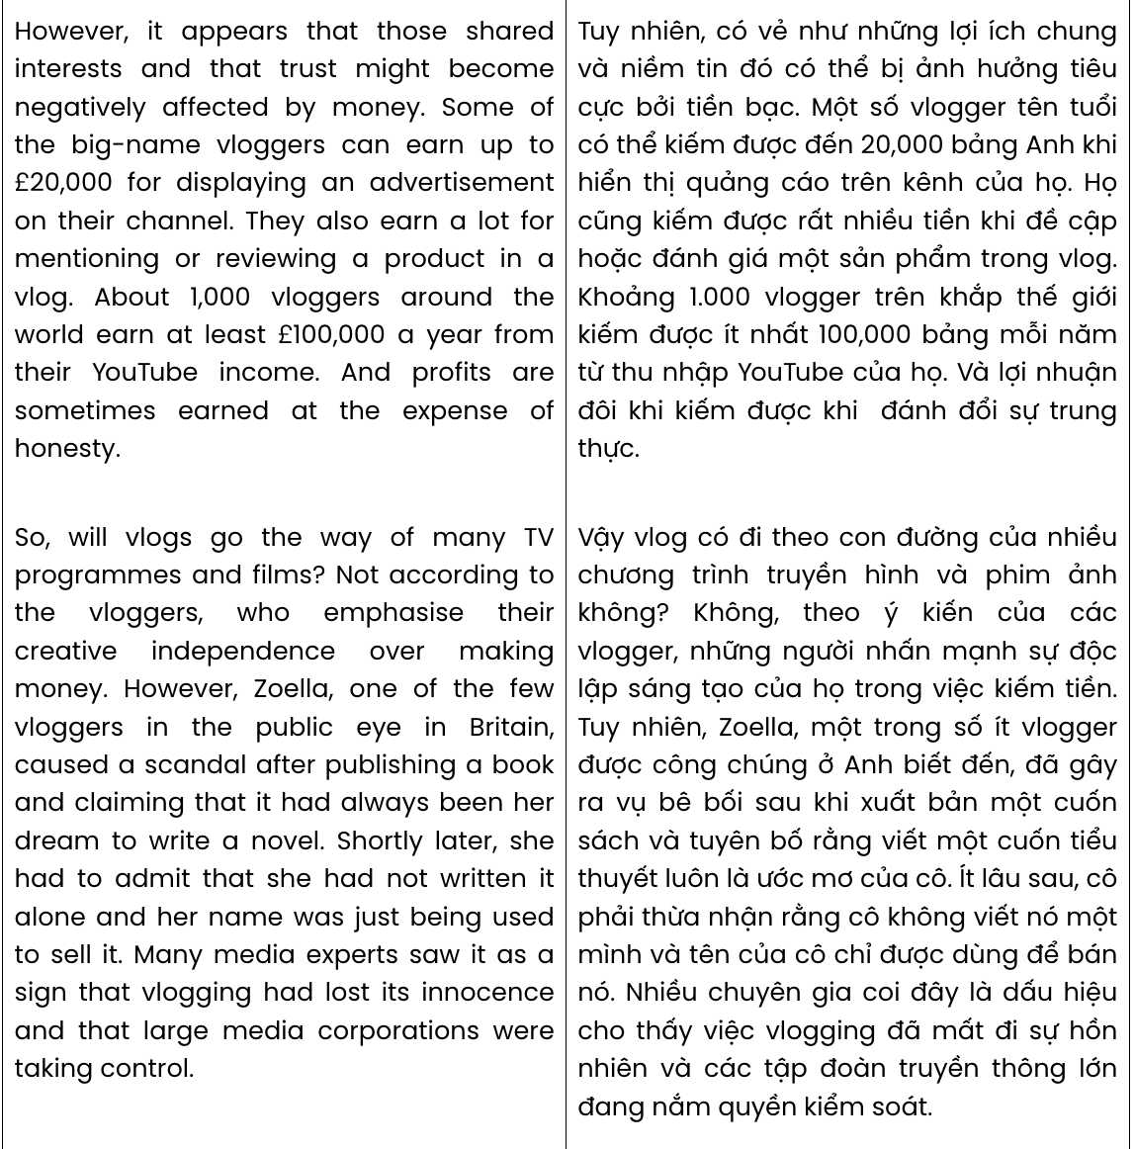

**Question 31.** Which of the following best summarises paragraph 1?

1. Thousands of fans gathered in Piccadilly Circus, eagerly awaiting the appearance of a popular vlogger.
2. Police and helicopters controlled crowds in Piccadilly Circus for the arrival of a recent pop sensation.
3. Police were unable to manage large crowds of fans gathered to meet an internet influencer.
4. Helicopters flew over Piccadilly Circus, where a popular blogger made their first public appearance.

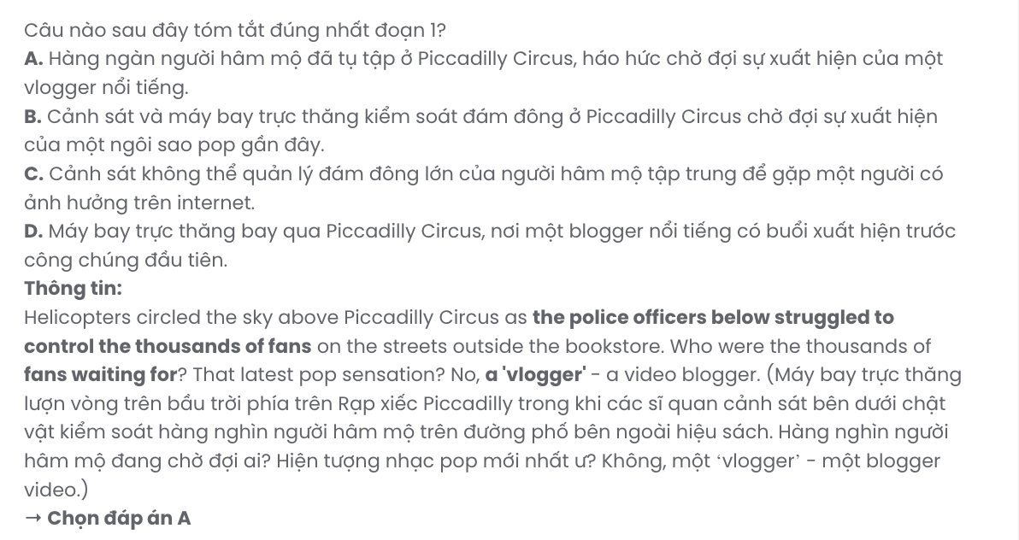

**Question 32.** According to paragraph 2, which of the following is NOT mentioned as a characteristic of a successful vlogger?

1. They are smart and able to think quickly.
2. They often do things without planning ahead.
3. They are friendly and enjoy meeting people.
4. They come from a very wealthy background.

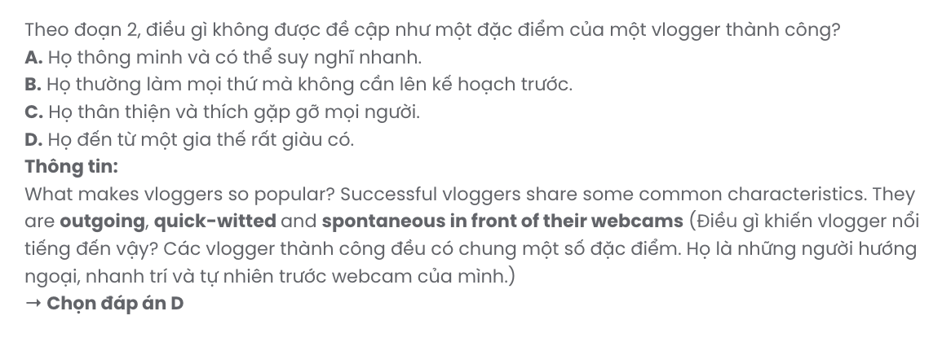

**Question 33.** The word **their** in paragraph 2 refers to .

**A.** the audience **B.** webcams **C.** vloggers **D.** characteristics

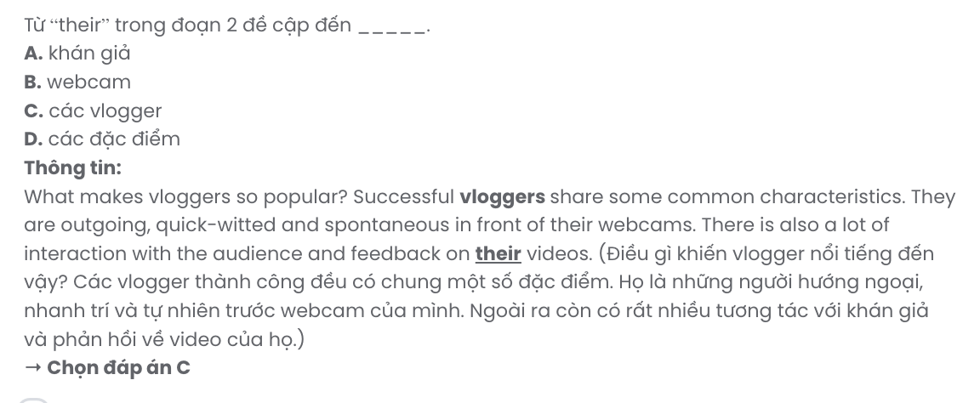

**Question 34.** The word **intrusion** in paragraph 2 is closest in meaning to .

**A.** opposition **B.** interference **C.** discrimination **D.** violation

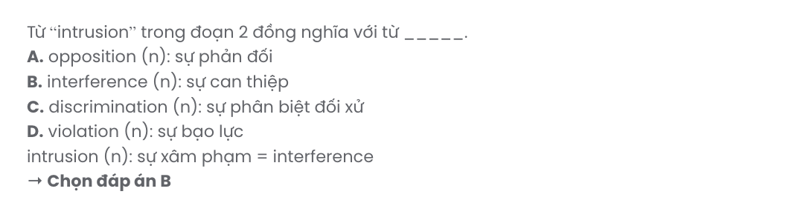

**Question 35.** Where in paragraph 2 does the following sentence best fit?

# What is more, thanks to the accessibility of modern technology, the vlogs can be watched anywhere at any time.

**A.** [I] **B.** [II] **C.** [III] **D.** [IV]

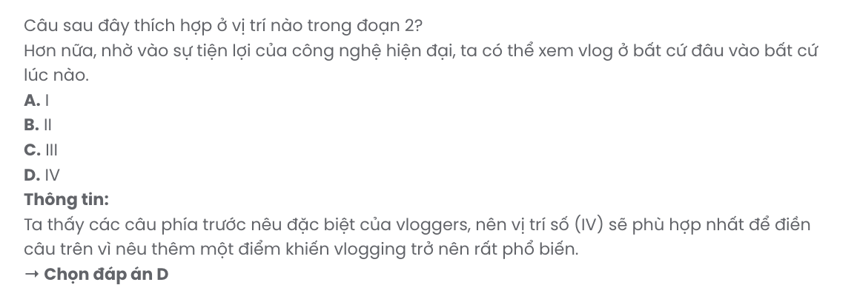

**Question 36.** The word **honesty** in paragraph 3 is OPPOSITE in meaning to .

**A.** truthfulness **B.** awareness **C.** dependence **D.** deception

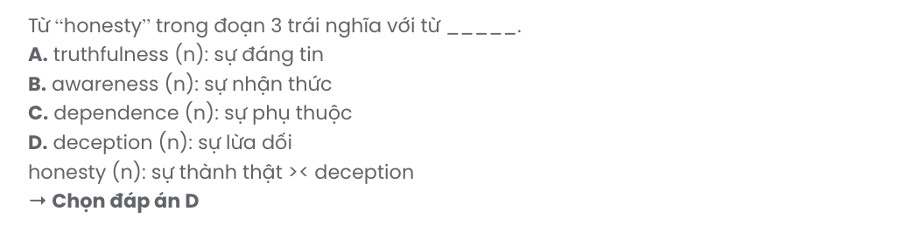

**Question 37.** Which of the following best paraphrases the underlined sentence in paragraph 3?

1. Shared interests and trust will definitely suffer if money becomes involved.
2. Common interests and trust seem to thrive when there’s no financial influence.
3. It seems that money could impact shared interests and trust in a negative way.
4. Trust and shared interests are strengthened when financial matters aren’t considered.

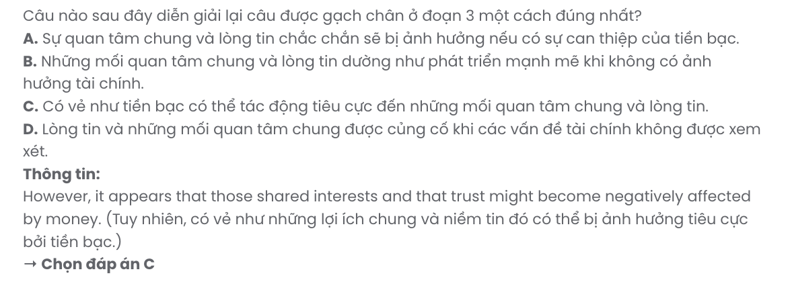

**Question 38.** Which of the following is TRUE according to the passage?

1. Vloggers can adjust the content of their videos based on their audience’s feedback.
2. Zoella was one of very few vloggers who gained attention through a scandal.
3. Every vlogger can make a good fortune by endorsing a product on their channel.
4. The relationship between vloggers and their subscribers is mainly based on profits.

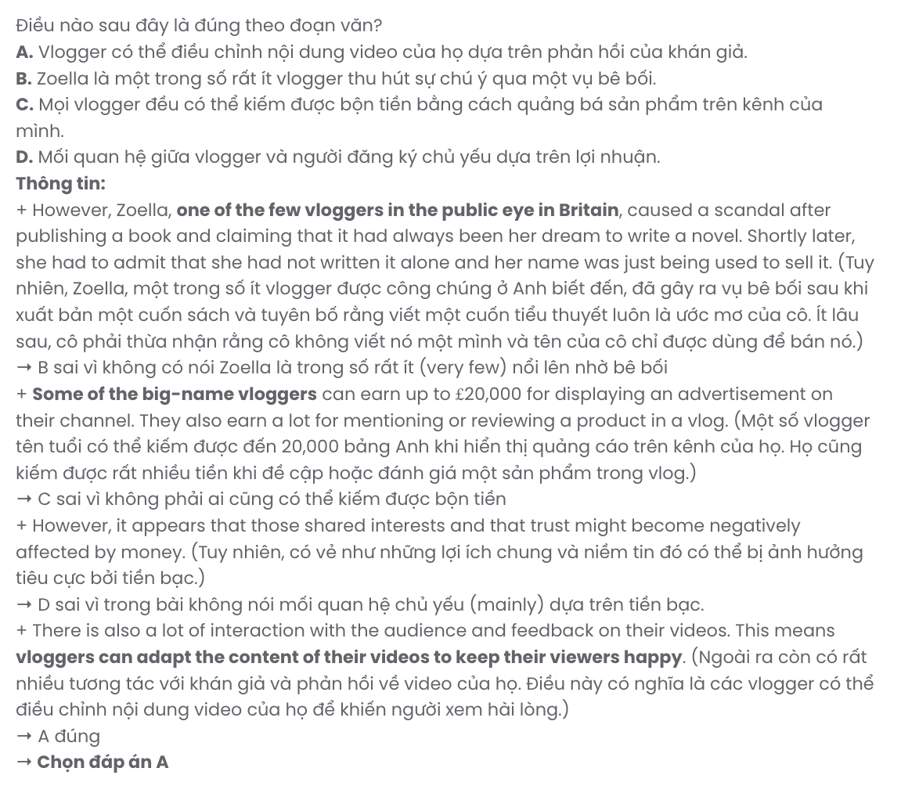

**Question 39.** It can be inferred from the passage that .

1. becoming a vlogger is a profit-making career that will become a trend in years to come
2. many TV shows and films may lose creative quality because of a focus on profit
3. vloggers like Zoella are examples of those trying to maintain their creative independence
4. it is only the matter of time before vlogging is dominated by large media corporations

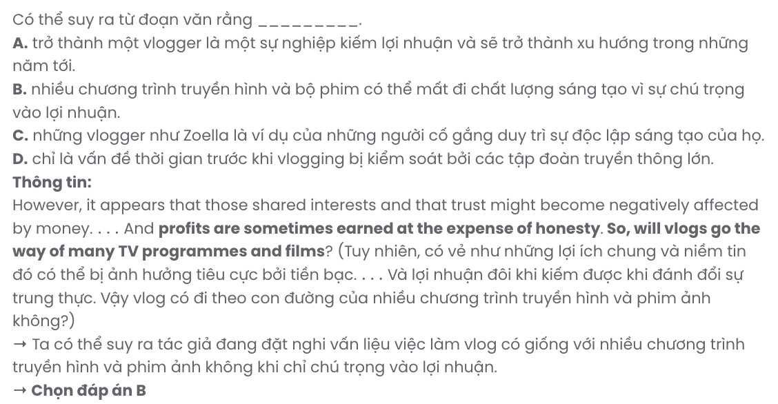

**Question 40.** Which of the following best summarises the passage?

1. Vloggers appeal to young audiences with independent, interactive content, largely affected by commercial pressures.
2. Vlogging’s popularity is built on a strong viewer connection, but is mainly determined by financial interests.
3. Young viewers favour vlogs over traditional media for their genuine, responsive style, free from corporate influence.
4. Vloggers’ popularity stems from engaging content and viewer interaction, but rising profits risk their authenticity.

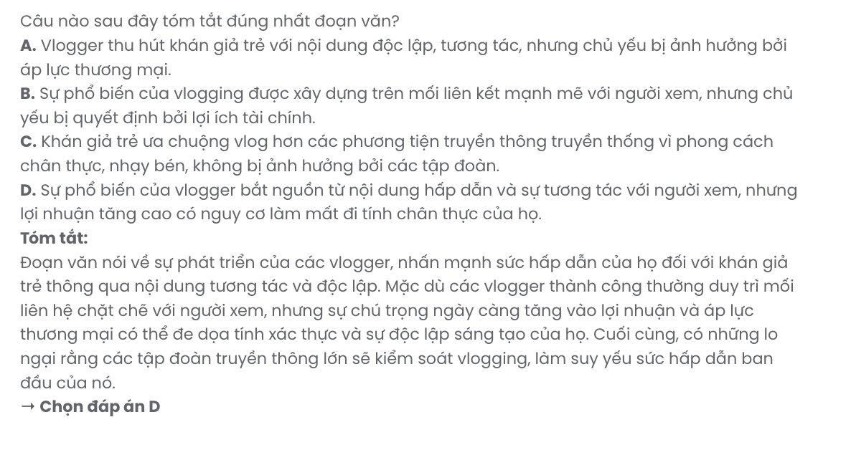

|  |  |  |  |  |
| --- | --- | --- | --- | --- |
| **BẢNG TỪ VỰNG** | | | | |
| **STT** | **Từ vựng** | **Từ loại** | **Phiên âm** | **Nghĩa** |
| **1** | eager | adj | /ˈiː.ɡər/ | háo hức, hăm hở |
| **2** | disappointed | adj | /ˌdɪs.əˈpɔɪn.tɪd/ | thất vọng |
| **3** | interactive | adj | /ˌɪn.təˈræk.tɪv/ | có tính tương tác |
| **4** | innovative | adj | /ˈɪn.ə.və.tɪv/ | có tính đổi mới |
| **5** | feedback | n | /ˈfiːd.bæk/ | phản hồi |
| **6** | virtual | adj | /ˈvɜː.tʃu.əl/ | ảo |
| **7** | tutor | n | /ˈtʃuː.tər/ | gia sư |
| **8** | fancy | v | /ˈfæn.si/ | thích |
| **9** | feature | n | /ˈfiː.tʃər/ | tính năng |
| **10** | adventure | n | /ədˈven.tʃər/ | chuyến phiêu lưu |
| **11** | download | v | /ˌdaʊnˈləʊd/  /ˈdaʊn.ləʊd/ | tải xuống |
| **12** | personalized/  personalised | adj | /ˈpɜː.sən.əl.aɪzd/ | được cá nhân hóa |
| **13** | session | n | /ˈseʃ.ən/ | phiên, buổi |
| **14** | engaging | adj | /ɪnˈɡeɪ.dʒɪŋ/ | hấp dẫn |
| **15** | engaged | adj | /ɪnˈɡeɪdʒd/ | chú tâm, tập trung |
| **16** | master | v | /ˈmɑː.stər/ | thông thạo |
| **17** | imagination | n | /ɪˌmædʒ.ɪˈneɪ.ʃən/ | trí tưởng tượng |
| **18** | exhibit | n | /ɪɡˈzɪb.ɪt/ | cuộc triển lãm |
| **19** | architect | n | /ˈɑː.kɪ.tekt/ | kiến trúc sư |
| **20** | sustainable | adj | /səˈsteɪ.nə.bəl/ | bền vững |
| **21** | accessible | adj | /əkˈses.ə.bəl/ | có thể tiếp cận |
| **22** | transform | v | /trænsˈfɔːm/ | biến đổi |
| **23** | groundbreaking | adj | /ˈɡraʊndˌbreɪ.kɪŋ/ | đột phá |
| **24** | comply | v | /kəmˈplaɪ/ | tuân theo |
| **25** | glimpse | n | /ɡlɪmps/ | cái nhìn thoáng qua |
| **26** | awareness | n | /əˈweə.nəs/ | nhận thức |
| **27** | criterion | n | /kraɪˈtɪə.ri.ən/ | tiêu chí |
| **28** | cyberbullying | n | /ˈsaɪ.bəˌbʊl.i.ɪŋ/ | sự bắt nạt qua mạng |
| **29** | privacy | n | /ˈprɪv.ə.si/ | sự riêng tư |
| **30** | repetitive | adj | /rɪˈpet.ə.tɪv/ | có tính lặp đi lặp lại |
| **31** | thrive | v | /θraɪv/ | phát triển mạnh mẽ |
| **32** | reward | n | /rɪˈwɔːd/ | phần thưởng |
| **33** | passion | n | /ˈpæʃ.ən/ | niềm đam mê |
| **34** | nurture | v | /ˈnɜː.tʃər/ | nuôi dưỡng |
| **35** | cherish | v | /ˈtʃer.ɪʃ/ | trân trọng, trân quý |
| **36** | logging | n | /ˈlɒɡ.ɪŋ/ | sự khai thác gỗ |
| **37** | accelerate | v | /əkˈsel.ə.reɪt/ | làm trầm trọng thêm |
| **38** | collective | adj | /kəˈlek.tɪv/ | có tính tập thể |

|  |  |  |  |  |
| --- | --- | --- | --- | --- |
| **39** | commitment | n | /kəˈmɪt.mənt/ | sự cam kết |
| **40** | bias | n | /ˈbaɪ.əs/ | định kiến |
| **41** | persistent | adj | /pəˈsɪs.tənt/ | dai dẳng |
| **42** | hinder | v | /ˈhɪn.dər/ | cản trở |
| **43** | endeavour/  endeavor | n | /ˈhɪn.dər/ | nỗ lực |
| **44** | inclusivity | n | /ˌɪn.kluːˈsɪv.ɪ.ti/ | sự hòa nhập |
| **45** | reform | n | /rɪˈfɔːm/ | cải cách |
| **46** | mania | n | /ˈmeɪ.ni.ə/ | cơn sốt |
| **47** | mainstream | adj | /ˈmeɪn.striːm/ | thịnh hành |
| **48** | origin | n | /ˈɒr.ɪ.dʒɪn/ | nguồn gốc |
| **49** | obsessive | adj | /əbˈses.ɪv/ | ám ảnh |
| **50** | depressive | adj | /dɪˈpres.ɪv/ | có tính phiền muộn |
| **51** | version | n | /ˈvɜː.ʃən/ | phiên bản |
| **52** | helicopter | n | /ˈhel.ɪˌkɒp.tər/ | máy bay trực thăng |
| **53** | characteristic | n | /ˌkær.ək.təˈrɪs.tɪk/ | đặc điểm |
| **54** | advertisement | n | /ədˈvɜː.tɪs.mənt/ | quảng cáo |
| **55** | honesty | n | /ˈɒn.ə.sti/ | sự thành thật |
| **56** | emphasise/  emphasize | v | /ˈem.fə.saɪz/ | nhấn mạnh |
| **57** | channel | n | /ˈtʃæn.əl/ | kênh |
| **58** | intrusion | n | /ɪnˈtruː.ʒən/ | sự xâm phạm |
| **59** | innocence | n | /ˈɪn.ə.səns/ | sự ngây thơ |

|  |  |  |
| --- | --- | --- |
| **BẢNG CẤU TRÚC** | | |
| **STT** | **Cấu trúc** | **Nghĩa** |
| **1** | take control of something | kiểm soát cái gì |
| **2** | succeed in something | thành công trong cái gì |
| **3** | fancy doing something | thích làm gì |
| **4** | adapt to something | thích nghi với cái gì |
| **5** | get a glimpse of something | có cái nhìn thoáng qua về cái gì |
| **6** | pull something down | phá hủy cái gì |
| **7** | get on | thành công |
| **8** | take over something | kiểm soát cái gì |
| **9** | turn up | xuất hiện |
| **10** | irrespective of something | bất kể cái gì |
| **11** | wait for somebody/something | đợi ai/cái gì |
| **12** | at the expense of something | với cái giá phải trả là cái gì |

Chỉ 100k/12 tháng, bạn tải rất nhiều tài liệu tiếng anh file word hay tại: ***Giaoandethitienganh.info***  Mong bạn ghé ủng hộ !