

A. VOCABULARY
No. | Word/ Phrase | Type | IPA | Meaning
1. | leisure | (n) | /ˈliːʒər/ | thời gian rảnh rỗi, sự nhàn rỗi
2. | leisure time | (n) | /ˈliːʒər taɪm/ | thời gian rảnh rỗi
3. | leisure activity | (n) | /ˈliːʒər ækˈtɪvəti/ | hoạt động giải trí
4. | knit | (v) | /nɪt/ | đan (áo, khăn...)
5. | knitting kit | (n) | /ˈnɪtɪŋ kɪt/ | bộ dụng cụ đan lát
6. | spend | (v) | /spend/ | dành (thời gian, tiền bạc)
7. | spend time on your own | (phr) | /spend taɪm ɒn jɔːr oʊn/ | dành thời gian một mình
8. | DIY (do-it-yourself) | (n, adj) | /ˌdiː aɪ ˈwaɪ/ | tự làm, tự chế
9. | puzzle | (n) | /ˈpʌzl/ | trò chơi xếp hình, câu đố
10. | do puzzle | (phr) | /duː ˈpʌzl/ | chơi xếp hình
11. | surf | (v) | /sɜːrf/ | lướt (mạng, sóng)
12. | surf the net | (phr) | /sɜːrf ðə net/ | lướt mạng
13. | message | (v) | /ˈmesɪdʒ/ | nhắn tin
14. | message friends | (phr) | /ˈmesɪdʒ frendz/ | nhắn tin cho bạn bè
15. | cooking | (n) | /ˈkʊkɪŋ/ | việc nấu ăn
16. | keen | (adj) | /kiːn/ | say mê, nhiệt tình
17. | fond | (adj) | /fɒnd/ | thích, yêu thích
18. | interested | (adj) | /ˈɪntrəstɪd/ | quan tâm, thích thú
19. | crazy | (adj) | /ˈkreɪzi/ | rất thích, phát cuồng
20. | like | (v) | /laɪk/ | thích
21. | love | (v) | /lʌv/ | yêu, rất thích
22. | enjoy | (v) | /ɪnˈdʒɔɪ/ | thích thú, tận hưởng
23. | fancy | (v) | /ˈfænsi/ | thích, muốn
24. | prefer | (v) | /prɪˈfɜːr/ | thích hơn
25. | hate | (v) | /heɪt/ | ghét
26. | detest | (v) | /dɪˈtest/ | ghét cay ghét đắng
27. | dislike | (v) | /dɪsˈlaɪk/ | không thích
28. | home-made | (adj) | /ˌhoʊm ˈmeɪd/ | tự làm tại nhà
29. | origami | (n) | /ˌɒrɪˈɡɑːmi/ | nghệ thuật gấp giấy origami
30. | fold | (v) | /foʊld/ | gấp
31. | paper folding | (n) | /ˈpeɪpər ˈfoʊldɪŋ/ | gấp giấy
32. | relax | (v) | /rɪˈlæks/ | thư giãn
33. | snowboarding | (n) | /ˈsnoʊbɔːrdɪŋ/ | trượt ván tuyết
34. | resort | (n) | /rɪˈzɔːrt/ | khu nghỉ dưỡng
35. | improve | (v) | /ɪmˈpruːv/ | cải thiện, nâng cao
36. | balance | (n) | /ˈbæləns/ | sự cân bằng
37. | muscle | (n) | /ˈmʌsl/ | cơ bắp
38. | muscle strength | (n) | /ˈmʌsl streŋθ/ | sức mạnh cơ bắp

B. WORD FORM
- activate (v): kích hoạt  - activation (n): sự kích hoạt  - active (adj): năng động, hoạt bát  - actively (adv): một cách năng động  - connect (v): kết nối  - connection (n): sự kết nối  - connected (adj): được kết nối, có liên quan  - connecting (adj): đang kết nối (ví dụ: chuyến bay nối chuyến)  - strengthen (v): củng cố, làm cho mạnh hơn  - strength (n): sức mạnh, điểm mạnh  - strong (adj): mạnh mẽ  - strongly (adv): một cách mạnh mẽ  - entertain (v): giải trí, chiêu đãi  - entertainment (n): sự giải trí, ngành giải trí  - entertaining (adj): mang tính giải trí, thú vị  - entertainer (n): người làm giải trí  - entertainingly (adv): một cách giải trí, thú vị  - create (v): tạo ra, sáng tạo  - creation (n): sự sáng tạo, tác phẩm  - creativity (n): sự sáng tạo (khả năng)  - creative (adj): sáng tạo  - creatively (adv): một cách sáng tạo | - comedy (n): hài kịch, sự hài hước  - comedian (n): diễn viên hài, người kể chuyện cười  - comic (adj): hài hước (cũng là danh từ: truyện tranh)  - comical (adj): khôi hài, buồn cười  - comically (adv): một cách khôi hài  - snowboard (v): trượt ván tuyết  - snowboarding (n): môn trượt ván tuyết  - snowboarder (n): người trượt ván tuyết  - popularize (v): phổ biến hóa  - popularity (n): sự phổ biến  - popular (adj): phổ biến  - popularly (adv): một cách phổ biến  - comfort (v): an ủi, làm cho thoải mái  - comfort (n): sự thoải mái  - comfortable (adj): thoải mái, dễ chịu  - comfortably (adv): một cách thoải mái  - uncomfortable (adj): không thoải mái  - uncomfortably (adv): một cách không thoải mái  - surprise (v): làm ngạc nhiên  - surprise (n): sự ngạc nhiên  - surprised (adj): ngạc nhiên (khi một người cảm thấy)  - surprising (adj): đáng ngạc nhiên (khi một điều gì đó gây ra)  - surprisingly (adv): một cách đáng ngạc nhiên

C. GRAMMAR
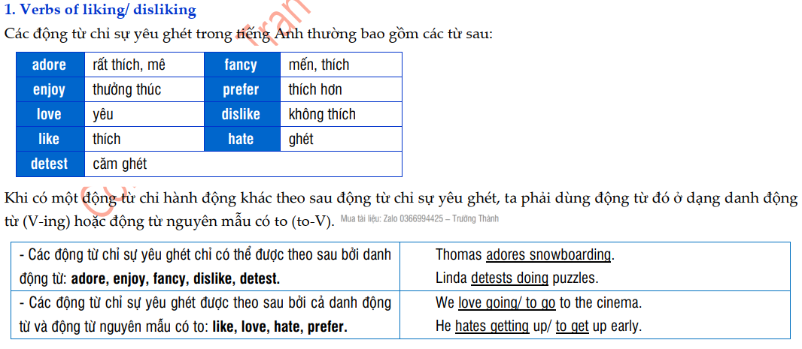

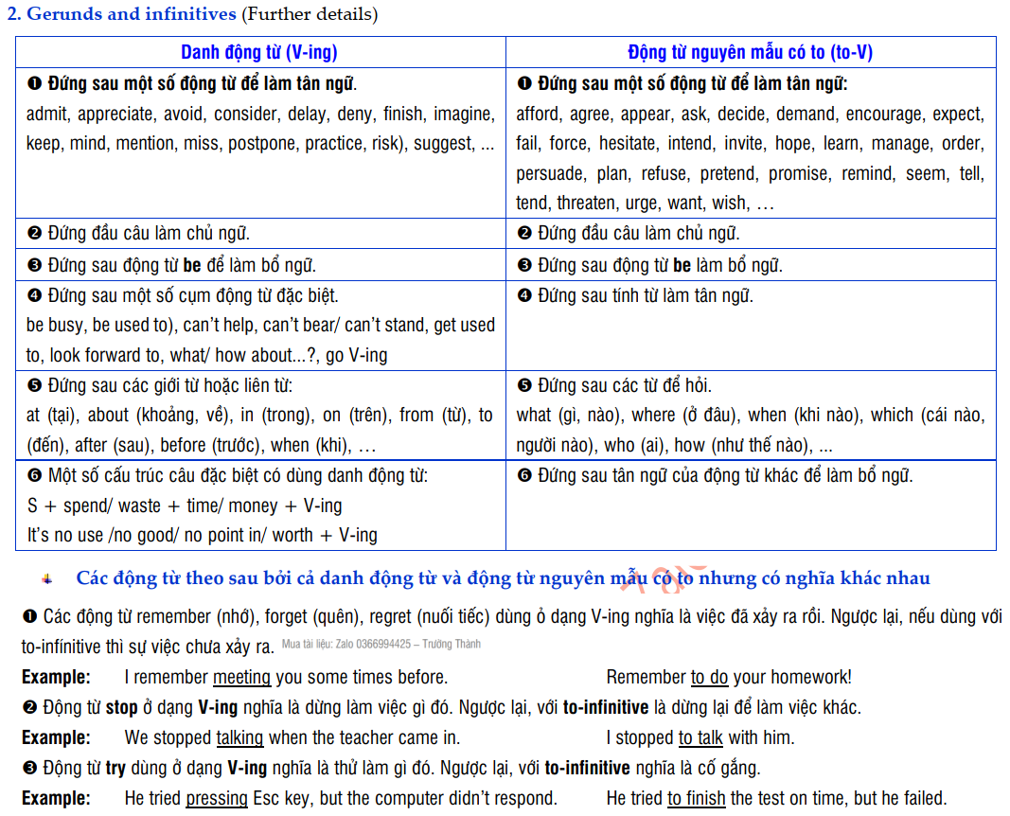

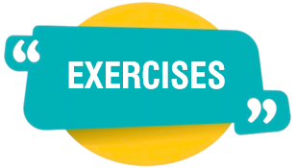
EXERCISES

- PHONETIC
Exercise 1: Choose the word (A, B, C, or D) whose underlined part is pronounced differently from the others.
1. A. mouse B. house C. would D. outdoors
2. A. ear B. clear C. hear D. bear
3. A. leisure B. eight C. celebrate D. penalty
4. A. worked B. watched C. needed D. walked
5. A. beat B. heat C. cheat D. break
6. A. pictures B. watches C. buses D. brushes
7. A. bracelet B. cake C. make D. hat
8. A. comedy B. letter C. princess D. cinema
9. A. sure B. sort C. soy D. soon
10. A. homework B. mother C. open D. judo

Exercise 2: Choose the word (A, B, C, or D) whose main stress is different from the others in the group.
1. A. relaxing B. traveling C. visiting D. listening
2. A. dislike B. detest C. fancy D. prefer
3. A. library B. museum C. melody D. favourite
4. A. protection B. addicted C. computer D. goldfish
5. A. volleyball B. weather C. winter D. vacation
6. A. climbing B. canoeing C. cricket D. cycling
7. A. computer B. protection C. volunteer D. museum
8. A. adore B. enjoy C. prefer D. listen
9. A. especially B. community C. activity D. absolutely
10. A. skateboard B. sticker C. adore D. leisure

- VOCABULARY AND GRAMMAR
Exercise 3: Choose the word/ phrase/ sentence (A, B, C, or D) that best fits the space in each sentences or best answers the question.
1. I like to _______ Tik Tok to watch short clips whenever I have free time.
A. knit B. surf C. message D. relax
2. I usually _______ my friends whenever I need your help.
A. message B. hit C. keep D. joke
3. In the beach _______, the apartments and villas have daily maid service.
A. conservation B. cooking C. resort D. competition
4. That dress looks so _______. I want to buy it. Do you think it is nice?
A. fancy B. funny C. crazy D. noisy
5. I bought a knitting _______ and asked my grandmother to teach me how to knit.
A. fold B. kit C. improve D. relax
6. Origami is the timeless Japanese art of _______.
A. paper folding B. car making C. train spotting D. bird watching
7. These exercises build _______ and increase stamina.
A. leisure B. muscle C. puzzle D. snowboarding
8. Most people now enjoy shorter working hours and more _______.
A. message friends B. paper folding C. leisure time D. muscle strength
9. Do you fancy ______ origami?
A. making B. looking C. doing D. seeing
10. Nam _______ the Internet a lot to find useful information for his studying.
A. surfs B. types C. checks D. looks
11. About favorite leisure activities, she and I share many things in _______.
A. similarity B. general C. common D. the same
12. Visiting _______ increases my knowledge about cultures in the past.
A. museums B. cinemas C. hometown D. city
13. My father advised me to do ________ every day because it is good for the brain.
A. messages B. puzzles C. sports D. cooking
14. Last school year, my students were very keen on ________. They decorated and repaired the classroom by themselves.
A. cooking B. doing origami C. doing DIY D. playing sports
15. ________ is an increasingly popular method of communicating over the internet. People often send short messages using a mobile phone or computer.
A. Messaging B. Volunteering C. Snowboarding D. Knitting
16. ________ helps to improve physical health and sometimes gives us a chance to make friends.
A. Messaging B. Playing computer games
C. Surfing the net D. Playing sports
17. Mark spends a lot of time ________ the internet. He visits one website after another just to watch short videos.
A. doing B. taking C. surfing D. knitting
18. Nowadays, most students only have a limited amount of ________ time. They have to do too much homework.
A. holiday B. quiet C. independent D. leisure
19. Alice spends a lot of time _______ her own; she always exercises regularly and does what she enjoys.
A. on B. in C. about D. for
20. He wasn't interested _______ growing flowers in the garden.
A. at B. for C. with D. in
21. Many people are fond _______ French cheese.
A. without B. of C. at D. in
22. Teenagers often prefer travelling with their friends _______ travelling with their parents.
A. from B. to C. on D. in
23. I like to watch TV _______ my free time.
A. up B. on C. of D. in
24. What do you think is the best leisure activity _______ teenagers?
A. for B. with C. between D. in
25. She loves going out _______ her friends.
A. for B. with C. between D. in
26. My younger brother used to detest ______ fish, but now he likes doing it.
A. eats B. ate C. eating D. eat
27. Tom loves ______ with his new pen friends in Vietnamese.
A. chat B. chatting C. both B and D D. to chat
28. Did you _______ listening to fairy tales when you were a child?
A. fancied B. adored C. fond of D. adore
29. My students don’t mind ______ English stories, some even adore doing it.
A. reading B. read C. to read D. listening
30. Minh ______ to play football, and so does his brother.
A. likes B. enjoys C. fancies D. detest.
31. Mai’s foreign friends fancy ______ museums when they are in Vietnam.
A. visits B. to visit C. of visiting D. visiting
32. My dad is hooked on news or football matches while my mum ______ watching fashion shows.
A. interested in B. fond of C. prefer to D. enjoys
33. Mai enjoys ______ to music, especially pop music in her free time.
A. hearing B. playing C. listening D. talking
34. My grandparents love ______ very much. There are a lot of beautiful flowers and fresh vegetables in their garden.
A. doing garden B. doing gardening C. do gardening D. to do garden
35. You should avoid ______ too much TV. It’s not good for your eyes. She feels relaxing.
A. seeing B. looking C. watching D. glancing
36. Nga likes ______ with her close friend on Saturday evenings.
A. window shop B. window to shop C. window shops D. window shopping
37. Lan used to love ______ front of the computer for hours but now she doesn’t. She takes part in a judo club.
A. using B. sitting C. doing D. having
38. Minh is very hard-working boy. He doesn’t mind ______ a lot of homework in the evenings.
A. making B. reading C. seeing D. doing
39. Do you fancy ______ around the West Lake with me this Sunday morning?
A. going B. having C. staying D. moving
40. I don’t like ______ up early in the winter days. I love ______ in bed late.
A. getting / stay B. get / stay C. getting / staying D. get / staying
Exercise 4: Choose the letter A, B, C, or D to indicate the word(s) CLOSEST in meaning to the underlined word(s) in each of the following sentences:
1. She hates talking with him about what he likes.
A. likes B. detests C. enjoys D. love
2. You do leisure activities in your free time and they make you feel satisfied.
A. pleased B. dissatisfied C. tired D. bored
3. You can enjoy great Vietnamese seafood in Ha Long Bay.
A. dislike B. like C. hate D. detest
4. Nam enjoys going to the cinema in his free time.
A. leisure time B. favorite activity C. summer holiday D. this weekend
5. I am certain that he will be satisfied with my DIY project.
A. uncertain B. sure C. unreliable D. unsure

Exercise 5: Choose the letter A, B, C, or D to indicate the word(s) OPPOSITE in meaning to the underlined word(s) in each of the following sentences:
1. My DIY project is to make some new bookshelves this summer.
A. old B. big C. small D. giant
2. Too much texting can be harmful to our health.
A. harmless B. dangerous C. unsafe D. poisonous
3. I fancy hanging out with my friends.
A. love B. hate C. like D. adore
4. I like hanging out with the girl next door.
A. dislike B. love C. adore D. enjoy
5. Playing soccer is good for your health.
A. excellent B. bad C. beneficial D. nice

Exercise 6: Circle the correct option in brackets.
1. Mary enjoys (to listen / listening) to classical music.
2. My sister adores (to make / making) paper flowers.
3. Does she fancy (messaging / to message) her friends?
4. My dad dislikes travelling. He always (stays / staying) at home on holidays.
5. Mrs. Nhung hates (to train / trains) dogs.
6. Most adults don’t like (watch / to watch) cartoons.
7. I’m into playing sport, especially table tennis. I (play / to play) table tennis almost every afternoon.
8. My sister loves origami. She often (folds / folding) paper into attractive shapes.
9. Linda prefers (visiting / to visit) the beautiful beaches in Vietnam.
10. Do your parents love (go / to go) to the theater in their free time?

Exercise 7: Put the verbs in brackets into the correct forms.
1. Do you fancy _________________ football matches? | (watch)
2. My parents enjoy _________________ meals together on weekends. | (prepare)
3. Lan and her sister love _________________ in their free time. | (shop)
4. He prefers _________________ the Internet after school. | (surf)
5. My mother detests _________________ out at that restaurant. | (eat)
6. I don’t mind _________________ early every day, even on Sundays. | (get up)
7. Do you prefer _________________ books in your free time? | (read)
8. My father loves _________________ golf with his friends. | (play)
9. I prefer _________________ up too late. | (not stay)
10. I used to prefer _________________ out with my friends at the weekend. | (hang out)
11. I think not many people like _________________ to her music. | (listen)
12. Teenagers love _________________ the web to while away their time. | (surf)
13. Do you enjoy _________________ DIY in your free time? | (do)
14. I detest _________________ a conversation with John. | (have)
15. Do you think Jane prefers _________________ with other students? | (not socialize)
16. I don’t mind _________________ the problem again. | (explain)
17. Ann fancies _________________ to the songs of her favorite singer. | (listen)
18. My friend adores _________________ time with her cats. | (spend)
19. I always love _________________ new things when I go traveling. | (try)
20. Mr. Smith hates _________________ his old car. | (drive)
21. My boyfriend dislikes _________________. | (wait)
22. My cat dislikes _________________ on the floor. | (sleep)
23. My cousin doesn’t like _________________ Math and Chemistry. | (study)
24. She didn’t want _________________ him about her plan. | (tell)
25. I think your brother won’t mind _________________ you a helping hand. | (lend)

Exercise 8: Supply the correct form of the words in brackets.
1. The most popular leisure _________________ in Britain is going for a walk. | (act)
2. To play video games, these computers must be used over a Wi-Fi internet _________________. | (connect)
3. I think badminton is an easy sport which helps to improve my muscle _________________. | (strong)
4. It is very _________________ to watch these movies. I think you should watch them. | (entertain)
5. I like doing DIY because it helps me to save money and increase my _________________ as well. | (create)
6. Little John is keen on acting at school shows, and he wants to be a _________________ in the future. | (comedy)
7. _________________ improves my overall health and balance, so I practice the sport every weekend. | (Snowboard)
8. Messaging has won _________________ among students nowadays. | (popular)
9. Having leisure activities is one of the best ways to make you feel _________________. | (comfort)
10. My dad was _________________ when I could repair my own bike. | (surprise)

- COMMUNICATION
Exercise 9: Choose the word or phrase (A, B, C, or D) that best completes each of the following exchanges.
1. Anna: Would you like to hang out with me?
Ben: “________”
A. Yes, I’d like B. No, I don’t like C. Yes, I’d love to D. Never mind
2. Chloe: Do you like going out?
David: “________”
A. Yes, I do B. No, I like going out C. Yes, I don’t like D. Yes, I like
3. Emily: Which leisure activity is more exciting, doing DIY or making crafts?
Frank: “________”
A. I think doing DIY is B. I don’t know. It may be doing DIY
C. Doing DIY is more exciting than making crafts D. All are correct.
4. Grace: “What do you usually do on Sundays?”
Harry: “________”
A. I used to drive to work B. I’m not doing anything
C. I usually sleep until noon D. I’d be sleeping all day.
5. Ivy: What do you think of a book?
Jack: “________”
A. That’s right B. No, it not C. It’s right D. Oh, excellent
Exercise 10: Choose the correct answer (A, B, C, or D) to arrange the following sentences into a meaningful conversation.
1. a. Brian: Origami? Like folding paper into shapes? I've never done it before.
b. Ally: Hey Brian, do you want to try making some origami later? It's really fun!
c. Ally: Yeah! I can show you. It's not too hard for beginners.
A. a-b-c B. b-a-c C. c-b-a D. a-c-b
2. a. Brian: I really like reading books, especially fantasy novels. What about you?
b. Ally: What do you usually do in your free time, Brian?
c. Ally: I enjoy going for walks in the park and listening to music.
A. a-b-c B. c-b-a C. b-a-c D. a-c-b
3. a. Ally: No, I don't, but it looks very relaxing.
b. Ally: Wow, that's really nice! Is it difficult to learn?
c. Brian: Yes, it is! I'm trying to knit a scarf for my mom.
d. Brian: A little at first, but it gets easier with practice. Do you ever knit?
e. Ally: What's that you're holding, Brian? Is it knitting?
A. e-c-b-d-a B. e-b-c-d-a C. c-e-b-d-a D. e-d-b-c-a

- READING
Exercise 11: Look at the sign or the notice. Choose the best answer (A, B, C or D) for these questions.
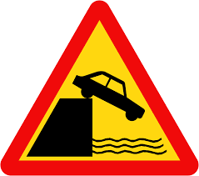 | 1. What does the sign say?  A. Dangerous dip  B. Slippery road  C. Quayside or riverbank ahead  D. Compulsory ahead only
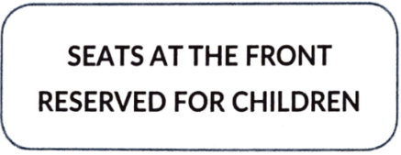 | 2. What does the notice say?  A. The front seats are only for children.  B. Children are not allowed to sit here.  C. Adults have to sit at the front.  D. There is no more seat for adults.
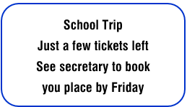 | 3. What does the sign say?  A. The trip has run out of tickets.  B. The secretary can book tickets after Friday.  C. This school trip starts on Friday.  D. The school trip has sold most of the tickets.
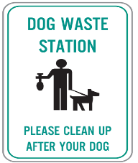 | 4. What does the notice say?  A. People should not bring their dogs waste here.  B. You don't need to clean up after your dog.  C. This area is where you put dog waste.  D. There is a dangerous dog in this area.
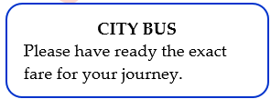 | 5. What does the sign say?  A. You need to have the correct money when you board the bus.  B. You need to keep your ticket ready for checking.  C. Tickets must be bought before boarding the bus.  D. You should not bring too much money on the bus.

Exercise 12: Read the following advertisement/ notice/ flyer/ announcement and mark the letter A, B, C or D to indicate the correct option that best fits each of the numbered blanks

Let's Build a Model!
Do you like (1) _____ things with your hands? Join our Model-Making Workshop! You will learn to make simple models like cars, houses, or robots using paper, plastic, and glue. It’s easy and fun! You don’t need (2) _______ experience. We will help you step by step. Bring your ideas and (3) ______. Make new friends and build something amazing together. (4) _______ the end, you can take your model home and show your family.
📅 Every Saturday
🕒 2 PM – 4 PM
📍 City Youth Center
Come and create something cool!
1. A. made B. making C. to make D. make
2. A. any B. some C. a lot of D. few
3. A. created B. creativity C. create D. creative
4. A. Of B. To C. At D. For

Let's Talk About Leisure Time!
Do you like watching movies, playing sports, or reading books? Everyone needs time to relax and enjoy life. Leisure time is important (1) ______ it helps us rest and feel happy. After work or school, you can go (2) _______ a walk, listen to music, or meet friends. These activities help your body and mind stay (3) _____. You don’t need much money—just a little free time and a fun idea. What do you like to do in your free time? Share your hobbies with us and let’s enjoy our leisure time together!
1. A. because B. but C. and D. so
2. A. in B. to C. for D. on
3. A. healthy B. unhealthily C. health D. unhealthy
4. A. sports B. puzzles C. hobbies D. messages

Exercise 13: Read the following passage and mark the letter A, B, C, or D to indicate the correct word that best fits each of the numbered blanks.
Quang is watering his garden and can't wait to pick the ripe fruit. He (1) _________ most of his spare time looking after the garden. Sounds great, doesn't it? But his garden is a (2) _________ one!
In today's world, teenagers rely on technology more than in the past. This can be a problem because using computers too much may have harmful effects (3) _________ both their minds and bodies. They prefer (4) _________ TV and playing computer games to reading books, perhaps because they don't have to think and imagine as much. They don't join clubs or have hobbies and they don't play sports. They sit in front of the computer all the time. They don't get out of the house, even for a walk. They are in a world that doesn't exist.
While Quang now knows the names of (5) _________ plants and his English seems to be improving as he chats with his "gaming friends" from all over the world, his parents are getting (6) _________. They want him to get out more. They are even thinking of banning him from using the computer.
1. A. spends B. takes C. does D. looks
2. A. real B. virtual C. different D. true
3. A. at B. with C. on D. with
4. A. watching B. watch C. to watching D. watched
5. A. much B. little C. many D. a few
6. A. happy B. cheerful C. physical D. worried

The British spend their free time in different ways. People generally use it to relax, but many people also do (1) _______ work, especially for charities.
A lot of free time is (2) _______ in the home, where the most popular leisure activity is watching television, the average viewing time being 25 hours a week. People often record programmes so that they can watch them later.
Reading is also a favorite way of spending leisure time. The British spend a lot of time reading newspapers and magazines.
In the summer, gardening is (3) _______, and in winter it is often replaced by "do-it- yourself", when people spend time improving or repairing their homes. Many people have pets to (4) _______. Taking the dog for a walk is a regular routine.
The extra time available at weekends means that some leisure activities, many of them to do with sport, normally take place only then. Traditional spectator sports include football, cricket, horse racing, motor racing and motor cycle racing. Popular forms of (5) _______ are swimming, tennis, ice-skating or roller-skating, cycling, climbing, and hill or country walking.
Families often have a "day out" at the weekend, especially in summer, with a visit to a local event such as a festival, fair or show. Young people especially go to clubs and discos, (6) _______ people of all ages go to the theatre, the cinema, art exhibitions and concerts.
1. A. voluntary B. paid C. willing D. social
2. A. played B. taken C. spent D. saved
3. A. popular B. different C. standard D. necessary
4. A. look after B. take off C. turn on D. get up
5. A. performance B. homework C. assignment D. exercise
6. A. or B. for C. so D. while

Exercise 14: Read the following passage and mark the letter A, B, C, or D to indicate the correct answer to each of the questions.
A favourite winter activity is skating. But before you go skating on a pond or lake, there are a few safety tips you should know. The ice should be at least 6 inches thick. Never skate alone. Never assume the ice is safe, and do not go out onto the ice after an animal or toy. Always be familiar with the area where you want to skate and be sure it is well-lit if you go skating at night. The safest place to go skating is on a skating rink. Some cities have outdoor skating rinks. And most cities have an indoor skating rink you can use for a small fee.
When you go skating for the first time, make sure you wear warm socks, a warm hat, and lots of layers of clothing. Most rinks have hot drinks and snacks, but you can also bring your own snacks. Weekends are usually the busiest time of the week to go skating. Weekday nights are usually less crowed. Evening skating can be a lot of fun for the whole family. Most rinks have floodlights. At night, the rink is lit up and bright.
1. What can be the best title for the passage?
A. Winter Fun B. Skating Safety Tips C. Best Skating Rinks D. How to Knit a Scarf
2. The word "assume" in line 2 is closest in meaning to __________.
A. believe B. doubt C. ignore D. confirm
3. The word "it" in line 3 refers to _______.
A. the area B. the ice C. the animal D. the toy
4. Which of the following is NOT true according to the passage?
A. You should never skate alone on a pond or lake.
B. Weekends are typically the busiest times for skating rinks.
C. It's recommended to wear warm clothing when you go skating for the first time.
D. It is always safe to skate on a lake if the ice is thick enough.
5. Which of the following can be inferred from the passage?
A. Outdoor skating rinks are always safer than indoor rinks.
B. It's possible to skate at night on well-lit rinks.
C. All cities have free indoor skating rinks.
D. You should never bring your own snacks to a skating rink.
One of the most obvious negative aspects of social networking is losing face- to-face contact with other people. Teens are sitting around with their phone in their hands all day long, tapping messages onto screens instead of communicating with real people. Many teenagers feel more comfortable with virtual friends than with real ones. The majority think that it is easier to chat on the Internet because they lack communication skills.
It is also true that parents often have no knowledge about what their kids do with their phones or computer. Crosby says that, "While kids are plugged in to social media, only about 40% of parents are involved themselves." And because parents don't know the full picture, they also don't know how to deal with a teenager's potential overuse of social media and might not even be aware that a problem exists. Therefore, social networking can be much more immediately engaging with the teenager's life than parents are, and this fact makes virtual communication feels more "real" than face-to-face communication.
(Source: Adapted from We have kids)
1. What is the main idea of the passage?
A. Social media helps teenagers improve their communication skills.
B. Parents should use social media more often.
C. Social networking can lead to less face-to-face contact and parental unawareness of its impact on teens.
D. Teenagers prefer virtual friends over real friends.
2. What does the word "tapping" in the passage mostly mean?
A. hitting B. typing C. drawing D. calling
3. The word "they" in line 4 refers to _______.
A. virtual friends B. real people C. many teenagers D. communication skills
4. According to the passage, which of the following sentences is TRUE?
A. Most parents are fully aware of their children's online activities.
B. Teenagers often feel more comfortable talking to virtual friends.
C. Face-to-face communication is becoming more popular among teenagers.
D. Social networking always helps improve family relationships.
5. Which of the following can be inferred from the passage?
A. Virtual communication is never as important as face-to-face communication.
B. Social media has no positive aspects for teenagers.
C. Teenagers who use social media always have poor communication skills.
D. Parents should try to be more involved in their children's online lives.

Exercise 15: Four phrases/sentences have been removed from the text below. Choose the correct answer to complete the text. Write only the letter A-D in each blank.
Leisure activities are very important to people. (1) ___C___. The most common type of leisure activities are those that are done just for fun. Often these activities do not need a special skill in order to do them. In many parts of the world, watching television is the number one leisure activity. (2) ___A___, eating out, playing sports, travelling, and playing electronic games.
More serious leisure activities include working on a hobby, (3) ___B___. People need to learn a special skill or have experience to do these types of leisure activities.
Leisure brings different rewards to different people. People usually feel happy and relaxed (4) ___D___. They can also feel a sense of adventure and pride in their accomplishment.
(Adapted from https://kids.britannica.com)
A. Other popular choices include talking with friends
B. such as building a model plane or working with pottery
C. There are a lot of activities they can do in their free time
D. when doing their leisure activities

A favourite pastime with children and adults alike (1) D. Children catch crickets and sell them for this purpose.
Horse racing held on weekends in a Saigon suburb draws large crowds as thousands of Vietnamese, young and old, turn out to cheer the pint-sized Asiatic horses and jockeys on to victory. Betting is heavy, with profits going into the national treasury of Southern Viet Nam. (2) C.
Other popular sporting events include soccer, basketball, volleyball, swimming, hiking, ping pong, and tennis. Viet Nam teams often compete with other countries in soccer, tennis, bicycling, basketball, and other sports.
There are few golf courses in Southern Viet Nam. (3) A. It may well be the only golf course in the world fortified by pillbox installations on its perimeter, (4) B. There is an excellent golf course in Da Lat. Caddies are usually women.
A. The one in Saigon is located near Tan Son Nhat airport
B. with soldiers and machine guns inside
C. It is not uncommon to see a horse run the wrong way around the track
D. is betting on cricket fights during the rainy season

- WRITING
Exercise 16: Put the words in the correct order to make meaningful sentences.
1. When/game/ be careful/ you/ online/, /when/ make friends/ strangers/ you/ with / .//

2. We/ that/ can/ Kim/ likes/ see/ the/ piano/ playing //.

3. Such as/ hobbies/ or/ making/ things/ crafts/ collecting/ interesting/ are / some / .//

4. health/ sitting/ problems/ all/ day/ in front of/ the/ can/ computer/ cause /. //

5. fancy/ you/ do/ children/ with/ working/ ?//

Exercise 17: Rewrite the following sentences without changing their original meanings.
1. I am interested in learning English.
I like
2. Lan likes using the computer best in her free time
Lan's favorite
3. I am interested in going camping with my close friends.
I fancy
4. Mr. Pike is a big fan of water polo.
Mr. Pike is fond
5. It is not a problem to me whether I have to pick her up to the cinema or not.
I don’t mind
6. John cannot bear listening to such kind of noisy music.
John dislikes
7. Watching historical films is very interesting to my younger brother.
My younger brother enjoys
8. She cannot bear talking with him about what he likes.
She hates
9. The thing that I hate most is motor racing, and I will never do it in my life.
I detest
10. It is really interesting for him to talk with his music teacher about jazz.
He fancies
11. He uses all his free time to look after his garden.
He spends
12. Making crafts or collecting things like stamps and coins are very interesting.
It’s very
13. We usually visit museums when we have leisure time.
We enjoy
14. I don’t like to get up early and prepare breakfast in the cold winter days.
I hate
15. It took us 30 minutes to rehearse the song.
We spent
16. It took Tom one hour to travel to his hometown last week.
Tom spent
17. It took him 30 minutes to watch the play.
He spent
18. He likes swimming and sunbathing.
He is interested
19. It took her nearly an hour to do the crossword.
She spent
20. My teacher enjoys listening to folk songs in her free time as this helps her to reduce stress.
My teacher likes
21. Jane likes skateboarding although this has hurt her leg and arm some times.
Jane fancies
22. My aunt really loves surfing the Internet. She can even do it all day without being tired at all.
My aunt adores
23. Ngoc dislikes doing any sports or exercises, so her health is not good enough to study.
Ngoc doesn’t like
24. Some of my friends fancy making crafts. They often save money for some craft kits.
Some of my friends enjoy
25. Cindy is extremely interested in taking care of her pets. She doesn’t mind doing it every day.
Cindy adores

Exercise 18: Choose (A, B, C, or D) to indicate the correct arrangement of the sentences to make a meaningful paragraph/letter in each of the following questions.
1.
Dear Mia,
a. We always have fun together!
b. How are you? I hope you are well.
c. Last Saturday, we went to the park. We rode our bikes and then played some games.
d. I love spending my free time with you.
e. It was a lovely day. Next week, maybe we can go to the cinema? There is a new film I want to see. Let me know what you think.
Best,
Ally
A. a-b-c-d-e B. b-d-a-c-e C. c-b-a-e-d D. d-a-c-e-b
2.
a. Some prefer to be active, like going for walks in the park or playing sports with friends.
b. Everyone has different favorite activities, and that's okay! Finding what you love to do helps you feel good.
c. Leisure activities are things we do for fun and relaxation in our free time.
d. It's important to have these activities because they help us relax, feel happy, and stay healthy.
e. Many people enjoy hobbies like reading books or watching movies. Learning new things, such as playing a musical instrument or drawing, can also be a great way to spend leisure time.
A. c-e-a-d-b B. c-a-e-b-d C. e-a-c-d- b D. a-e-c-b-d
Exercise 19: Choose (A, B, C, or D) to indicate the correct answer to each of the following questions.

Put the sentences (a-c) in the correct order, then fill in the blank to make a logical text.
Doing DIY, or "Do It Yourself" projects, can be a very rewarding activity. __________.
a. Lastly, it gives you a great sense of accomplishment when you finish a project. It feels good to see the results of your hard work.
b. Firstly, it allows you to be creative and make something unique with your own hands. You can personalize items for your home or create gifts for friends.
c. Secondly, doing DIY can save you money. Instead of buying new things or paying for repairs, you can often fix or build items yourself at a lower cost.
A. b - c – a B. a - c – b C. c - b – a D. b - a - c
Choose the sentence that can end the text most appropriately.
A. Then, you can start your next project.
B. It's a great way to save money and relax.
C. In conclusion, DIY is a fantastic way to express creativity, save money, and feel proud of what you've made.
D. Therefore, many people enjoy buying new things instead.

(1) _______. In my opinion, spending free time on hobbies is the best. (2) __________. In conclusion, using our leisure time wisely makes us happier and healthier.
Choose the TOPIC SENTENCE that can BEGIN the text most appropriately.
A. Leisure time is very important for everyone because it helps us relax and feel good.
B. Many people enjoy hobbies like reading books or watching movies.
C. Going for a walk outside is wonderful.
D. We need to forget about stress from work or school.
Put the sentences (a-c) in the correct order, then fill in the blank to make a logical text.
a. Going for a walk outside is also wonderful because you can enjoy nature and get some exercise. These activities help us forget about stress from work or school.
b. When we have good leisure time, we come back to our daily tasks feeling refreshed and ready to learn more.
c. For example, reading a book takes your mind to different worlds, and listening to music can make you feel calm or energized.
A. c-a-b B. a-c-b C. b-a-c D. c-b-a

- LISTENING
Exercise 20: Listen to the short talk twice and circle the correct answer to each of the following questions:
1. When Nam was a child, he liked playing with ______.
A. toys B. cars C. computers D. dolls
2. When did Nam prefer as a teenager?
A. volunteering B. socializing with friends
C. reading comics D. singing
3. What leisure activities did he do when he became a student at university?
A. volunteering B. socializing with friends C. reading comics D. singing
4. Now, he often ______.
A. reads books B. plays tennis C. plays with toys D. reads comics

Exercise 21: Listen to the conversation twice and decide whether the following sentences are True or False.
Statements | True/ False
1. Nowadays teenagers can be called a “technology” generation
2. Teenagers don't like surfing webs.
3. Teenagers cannot forget what time to do something.
4. Playing computer games makes teenagers concentrate less on their lessons in class.
--- THE END ---

