**SPEAKING TEST QUESTIONS**

**i-LEARN SMART WORLD 6**

**UNIT 1: HOME**

Target language:

• Talk about family members and housework

• Present Simple with Yes/No questions

• Present Simple with Wh-questions

1. Where do you live? Do you live in a house or in an apartment?
2. Does your house/apartment have a gym/pool/yard/balcony…?
3. How many people are there in your family? Who are they?
4. What housework do you do?
5. Who does the laundry/does the shopping/makes breakfast/makes dinner… in your family?
6. Who does the most housework in your family?
7. Where is your hometown? Do you like living there?
8. What do you like about your hometown?
9. What’s the weather like in your hometown?
10. What is your hometown famous for?

**UNIT 2: SCHOOL**

Target language:

• Talk about school subjects you like or don't like

• Talk about school activities

• "and" and "or" for positive and negative statements

• "like + verb-ing"

• Talk about different kinds of books

1. Do you like math/P.E./geography/music/…?
2. What subject do you like? What subject don’t you like?
3. What’s your favorite subject?
4. Do you like indoor/outdoor activities?
5. What indoor/outdoor activities do you like?
6. Do you like reading books/acting/dancing…?
7. What clubs do you want to join? Do you want to join a(n) art club/basketball club/band…?
8. What kind of books do you like reading?
9. Do you like reading fantasy novels/mystery stories/adventure stories?
10. Talk about your favorite book:

* What is your favorite book?
* What kind of book is it?
* Who is the author of the book?
* Why do you like the book?
* Do you think your friends should read it?

**UNIT 3: FRIENDS**

Target language:

• Describe someone's personal appearance

• Present Simple and Present Continuous

• Talk about character traits

1-2. What are you wearing? What is your friend wearing?

3-4. Who is your best friend? What does your friend look like?

5-6. What does your mother/father/brother… look like? What is he/she like?

7. What are you doing this weekend/tomorrow/tonight/on Wednesday…?

8. Are you making a cake/watching a movie/playing soccer on the weekend?

9. What is your favorite book? What is your favorite character in the book? What’s he/she like?

10. Choose one person (your mother, father, friend…) and describe him/her.

• What his/her name is

• How old he/she is

• What he/she is like

• What he/she looks like

• What he/she does

**UNIT 4: FESTIVALS AND FREE TIME**

Target language:

• Talk about how often you do activities in your free time

• Talk about future events

• Adverbs of frequency

• Present Simple for future use

1. What do you like to do in your free time?
2. How often do you go to the bookstore/play video games/ride your bike…?
3. How often does your family go shopping/cook dinner/watch movies… together?
4. Do you go swimming/play soccer/go running… after school?
5. What do you usually do in the afternoons?
6. What time do you go to school/eat breakfast/go to bed…?

7-8-9. Do you like watching TV? What is your favorite show? What time does the show start?

10. Talk about your favorite festival.

* What it is
* How people prepare for it
* What people usually do during the festival
* Why do you like it

**UNIT 5: AROUND TOWN**

Target language:

• Quantifiers

• Countable and uncountable nouns

• Talk about food from around the world

1. How often do you go to a clothing store? What do you usually buy?
2. What are you wearing?
3. Do you like to wear a dress/a T-shirt/trousers…? How often do you wear it/them?
4. What food do you often order in a restaurant?
5. What do you often have for dessert/breakfast/lunch/dinner?
6. What is the most popular dish in Vietnam?
7. What is your favorite Vietnamese dish?
8. Are there any dishes you would like to try in the future?
9. Do you like to try food from a different country?
10. Talk about your favorite food:

• The name and the kind of dish

• What people make it with

• When people eat it

• How it tastes

**UNIT 6: COMMUNITY SERVICES**

Target language:

• Talk about public services in your town

• Prepositions of place

• Give tips about how to save the environment

• Positive and negative imperatives

• Talk about environmental charities

1. Is there a hospital/police station/bus station… near here/your house?
2. Where is your house/school/shopping mall?
3. What can we do to protect the Earth?
4. What do you do to save the environment?
5. Do you recycle your notepaper/pick up trash on the street/reuse bottles…? How often do you do that?

6-7-8. Do you know any charities? What or who do they help? How can you help?

9. What can we do to help the town look better?

10. Does your family throw away glass bottles/use plastic bags/reuse old cans?

**UNIT 7: MOVIES**

Target language:

• Express opinions and exchange information about movies

• Past Simple and adjectives

• Talk about famous people from movies

1. Do you like watching movies?
2. What kind of movies do you like to watch?
3. Do you like to watch science fiction movies/comedies/animated movies…? Why?
4. Did you watch a movie last night/last weekend? What was it?
5. When was the last time you watched a movie? Was it good?
6. Do you like watching movies about people from history? Why?
7. How often do you go to the movie theater?
8. How often do you watch movies?
9. Are you watching a movie this weekend?
10. Talk about your favorite movie.

* What it is
* What kind of movie it is
* When you watched it
* Why you like it

**UNIT 8: THE WORLD AROUND US**

Target language:

• Talk about things you need for a trip

• Modals "should" and "can"

• Compound sentences with "so"

• Talk about visiting natural wonders

1. What outdoor activities do you like?

2. Do you like to go rafting/hiking/kayaking…?

3-4. Where do you want to go on your holiday? What can you do there?

5. Do you often go on a camping trip?

6. What should you bring for a camping trip? Why?

7. Should you bring a tent/pillow/camera…?

8. Do you like to visit a beach/bay/highland/forest…? Why?

9. Where should you visit for your next vacation?

10. Talk about a trip you would like to have with your class/family:

* Where you are going
* What you are going to do there
* How long you are going to stay
* Where you are going to stay
* Why you want to go on that trip

**UNIT 9: HOUSES IN THE FUTURE**

Target language:

• Describe similarities and differences between homes now and in the future

• Future Simple

• Indefinite quantifiers

• "might" for future possibilities

1. Where do you live?
2. Do you want to change to a new house in the future?
3. Where do you think people will live in the future?
4. Do you think lots of people will live in a(n) smart home/megacity/earthscraper/eco-friendly home?
5. What do you think homes will be like?
6. How might homes change in the future?
7. Do you think we will have automatic food machines/drones/robot helpers…?
8. Do you want to become an astronaut in the future? Why?
9. Would you like to visit a space station? Why?
10. What might it be like living on the Moon?

**UNIT 10: CITIES AROUND THE WORLD**

Target language:

• Compare features of cities around the world

• First Conditional sentences

• Comparative and superlative adjectives

1. What are some famous landmarks in your city? Do you often visit them?

2-3. What are you doing tomorrow? What will you do if the weather is bad?

4. What are you going to do for your vacation?

5. Is there any landmark in the world you would like to visit? What is it?

6. Is there any country in the world you would like to visit? What is it?

7. Is there any landmark in your city/country you would like to visit? What is it?

8. Which country in the world you would like to live in? Why?

9. Look at the table and answer the following questions: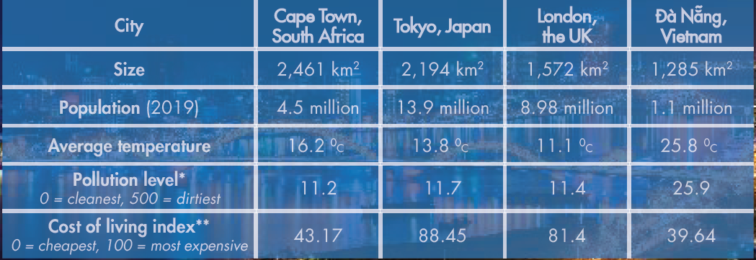

* Which city is the largest/most crowded/hottest/most expensive…?
* Which city is bigger, London or Tokyo?
* Which city is more crowded, Cape Town or Đà Nẵng?
* Which city is more polluted, Tokyo or Đà Nẵng?
* Which city is cheaper, London or Cape Town?

10. Talk about a beautiful landmark in your city/country:

* What it is
* Where it is
* What people usually do there
* Why you like it