REVIEW 1
Lesson 1: Language

I. OBJECTIVES
By the end of this lesson, students will be able to:
1. Knowledge
- Review words related to family life, humans and environment, and music;
- Review the pronunciation of the consonant blends /br/, /kr/, /tr/, /gr/, /pr/;
- Apply the knowledge of grammar points learnt in the previous units to do the tasks;
(to-infinitive, bare infinitive, the present simple, the present continuous, the future with will and be going to)
- Use the passive voice;
- Use the coordinating conjunctions (and, or, but, so).
2. Core competence
- Develop communication skills and cultural awareness;
- Be collaborative and supportive in pair work and teamwork;
- Actively join in class activities.
3. Personal qualities
- Develop self-study skills;

II. MATERIALS
- Grade 10 textbook, Review 1 - Language
- Computer connected to the internet
- Projector/ TV/ pictures and cards
- hoclieu.vn

Assumptions
Anticipated difficulties | Solutions
- Students may find the lesson boring due to a large number of language exercises. | - Encourage students to work in pairs, in groups so that they can help each other.  - Design as many exercises as games as possible.  - Provide feedback and help if necessary.
- Some students will excessively talk in the class. | - Define expectation in explicit detail.  - Have excessively talkative students practise.  - Continue to define expectations in small chunks (before every activity).

Board Plan
Date of teaching
REVIEW 1
Lesson 1: Language
* WARM-UP: Finding keywords
Pronunciation
Task 1: Listen and write the words in the correct columns.
Vocabulary
Task 1: Match the two parts to make complete sentences.
Task 2: Complete the sentences.
Grammar
Task 1: Complete the sentences.
Task 2: Complete the sentences.
Task 3: Match the two parts to make complete sentences.
* CONSOLIDATION

III. PROCEDURES
Notes:
In each activity, each step will be represented as following:
* Deliver the task
** Implement the task
*** Discuss
 Give comments or feedback

Stage | Stage aim | Procedure | Interaction | Time
WARM-UP | To lead in the lesson. | GAME: FINDING KEYWORDS  * Teacher shows 3 sets of pictures (taken from Project lessons of Unit 1-2-3) and asks students to find a keyword for each set of pictures.  ** Students raise hands to answer.  *** Teacher and students discuss the answers.   Teacher checks the answers as a class.  Set 1: Family life/family  Set 2: Humans and the environment/ go green/ green lifestyle/ living green  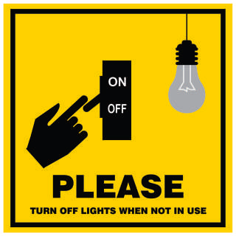  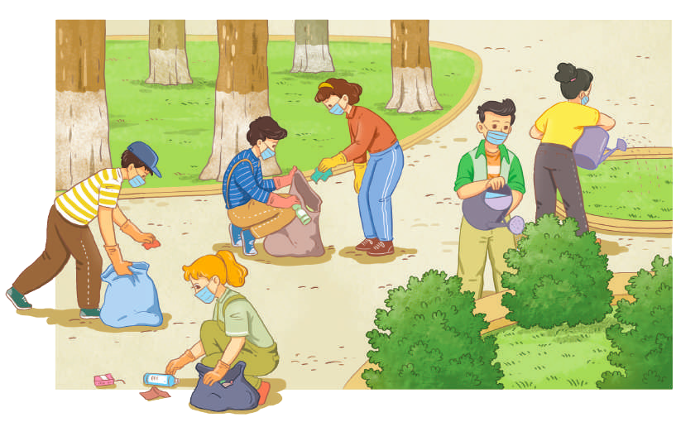  Set 3: Traditional music/music | T-S  S  T-S  T-S | 3 mins
PRONUNCIATION | To check if students can identify consonant blends and provide further pronunciation practice. | TASK 1: LISTEN AND WRITE THE WORDS IN THE CORRECT COLUMNS. THEN PRACTISE SAYING THE WORDS. (p. 38)  * Teacher writes /br/, /gr/, /kr/, /pr/ and /tr/ on the board.  - Teacher writes one word containing the consonant blend below each of them.  - Teacher asks students to listen and write down the words containing the sound blends.  ** Students do the task by writing the words in a suitable column.  *** Teacher can invite some pairs of students to read aloud.   Teacher checks students’ pronunciation and gives feedback.  Key:  /br/ /gr/ /kr/ /pr/ /tr/  brain green crash practise train  breakfast grow create protect treat  breadwinner great cream product tree | T-S  S  T-S  T-S | 5 mins
VOCABULARY | To check if students remember collocations they have learnt in the previous units. | TASK 1: MATCH THE TWO PARTS TO MAKE COMPLETE SENTENCES. (p. 38)  * Teacher tells students to read the given parts of the sentences carefully and make sure they understand their meanings.  ** Students do this exercise individually by matching the halves to complete the sentences  *** Teacher allows students to share their answers before discussing as a class and encourages them to pronounce the sentences correctly.   Teacher checks the answers as a class and gives feedback.  Key:  1. e  2. d  3. a  4. b  5. c | T-S  Ss  Pair work  T-S | 5 mins
 | To check if students can use words they have learnt in the previous units. | TASK 2: COMPLETE THE FOLLOWING SENTENCES USING THE WORDS FROM THE BOX. (p. 38)  * Teacher asks students to work individually to complete the sentences with the given words and phrases.  ** Students work individually to complete the task.  *** Teacher allows students to share answers before discussing as a class.   Teacher asks students to say the sentences aloud and makes sure they pronounce the words and phrases correctly. Teacher can ask for translation to check their understanding.  Key:  1. laundry  2. groceries  3. perform  4. audience  5. eco-friendly | T-S  S  T-S  T-S | 7 mins
GRAMMAR | To check if students can use the grammar points learnt in the previous units in  sentences. | TASK 1: COMPLETE THE SENTENCES WITH THE CORRECT FORMS OF THE VERBS IN BRACKETS. (p. 39)  * Teacher asks students to work independently to fill in the blanks with the correct forms of the verbs in brackets.  ** Students read the sentences first and underline the clues that help them decide the correct forms of the verbs in brackets.  *** Teacher reminds students to use the correct forms of the verbs as requested in each sentence then allows them to share answers before discussing as a class.   Teacher can ask students to read aloud the full sentences and correct their pronunciation if needed.  Key:  1. cleans – is helping  2. to improve – take  3. practise – are practising  4. am going to watch – will win | T-S  S  T-S  T-S | 7 mins
 | To check if Ss can use the passive voice. | Task 2: Complete the sentences. Make sure they mean the same as the sentences above them. (p.39)  * Teacher asks students to read the sentences first.  ** Students do the task individually.  *** Teacher reminds students to pay attention to the passive and active forms of the sentences then allows them to share answers before discussing as a class.   Teacher can ask students to read aloud the full sentences and correct their pronunciation if needed.  Key:  1. The rubbish in the neighbourhood is collected three times a week.  2. All the electrical devices in the house were turned off.  3. His music videos will be watched online (by millions of people). | T-S  S  T-S  T-S | 8 mins
 | To check if Ss can use coordinating conjunctions (and, or, but, so) to make compound sentences. | TASK 3: MATCH THE TWO PARTS TO MAKE COMPLETE SENTENCES. (p. 39)  * Teacher asks students to read the two halves given of the sentence.  ** Students do the task individually.  *** Teacher reminds students to pay attention to the coordinating conjunctions (and, or, but, so) then allows them to share answers before discussing as a class.   Teacher can ask students to read aloud the full sentences and correct their pronunciation if needed.  Key:  1. b  2. c  3. d  4. a | T-S  S  T-S | 5 mins
CONSOLIDATION | - To consolidate what students have learnt in the lesson  - To prepare vocabulary for the next lesson | WRAP-UP  Teacher asks students to talk about what they have learnt in the lesson.  - Review on how to pronounce consonant blends, grammar points (to-infinitive, bare infinitive, the present simple, the present continuous, the future with will and be going to) and vocabulary of Unit 1, 2, and 3.  HOMEWORK  Prepare for Review 1 – Skills 1: Listening and speaking. | T-S | 2 mins

REVIEW 1
Lesson 2: Skills (Listening & Speaking)
I. OBJECTIVES
By the end of this lesson, students will be able to:
1. Knowledge
- Practice listening for general and specific information about music;
- Practice talking about a favorite singer or musician.
2. Core competence
- Develop communication skills and cultural awareness;
- Be collaborative and supportive in pair work and teamwork;
- Actively join in class activities.
3. Personal qualities
- Develop self-study skills;

II. MATERIALS
- Grade 10 textbook, Review 1 – Skills 1 (Listening and speaking)
- Computer connected to the internet
- Projector/ TV/ pictures and cards
- hoclieu.vn

Assumptions
Anticipated difficulties | Solutions
Students may find the lesson boring due to a large number of language exercises. | - Encourage students to work in pairs, in groups so that they can help each other.  - Design as many exercises as games as possible.  - Provide feedback and help if necessary.
Some students will excessively talk in the class. | - Define expectation in explicit detail.  - Have excessively talkative students practise.  - Continue to define expectations in small chunks (before every activity).

Board Plan
Date of teaching
REVIEW 1
Lesson 2: Skills (Listening & Speaking)
* Warm-up
Name the pictures: Traditional music
Listening
Task 1: Listen and choose the best title for the talk.
Task 2: Listen and fill in the gaps.
Speaking
Talk about your favourite singer or musician.
* Consolidation

III. PROCEDURES
Notes:
In each activity, each step will be represented as following:
* Deliver the task
** Implement the task
*** Discuss
 Give comments or feedback

Stage | Stage aim | Procedure | Interaction | Time
WARM-UP | To lead in the lesson. | NAME THE PICTURES: TRADITIONAL MUSIC  * T shows pictures and asks Ss to name the traditional music in the pictures.  ** Ss raise hands to answer.  *** T and Ss discuss the answers more.   T checks the answers as a class.  Key:  Xoan singing Chau van singing  Quan ho singing | T-S  S  T-S  T-S | 5 mins
LISTENING | To help students practise listening for main ideas. | TASK 1: LISTEN AND CHOOSE THE BEST TITLE FOR THE TALK. (p. 40)  * T focuses Ss’ attention on the three options and asks ‘What do you think the listening text will be about?’ to elicit Elvis Presley and check what Ss know about him.  ** Ss look at three options, read and underline key words.  *** T plays the recording once for Ss to listen and choose the best answer.   T confirms the answers as a class.  Key: C | T-S  S  T-S  T-S | 10 mins
 | To help students practise listening for specific information. | TASK 2: LISTEN AGAIN AND FILL IN EACH GAP IN THE QUICK FACTS WITH A NUMBER. (p. 40)  * T asks Ss to read through the Quick facts first, and elicit what the missing numbers refer to, e.g. year, age, how many awards.  - T plays the recording and has Ss fill in each gap with a number.  ** Ss listen and do the task individually.  *** T calls on some Ss to report their answers for the class.   T checks the answers and add more information if necessary.  Key:  1. 1935  2. 21  3. 3  4. 42  Audio script:  Elvis Presley was an American singer, musician and actor born in 1935. His single Heartbreak Hotel, released when he was 21, became a number-one hit in the United States. Starting with the film Love Me Tender, Presley also made 31 films. His single of the same name sold more than a million 67 copies even before the film was released. During his life, he received many awards, including three Grammys. Presley died of a heart attack at the age of 42. Many years after his death, Presley is still one of the best-selling singers of all time. | T-S  S  T-S  T-S | 10 mins
SPEAKING | To help students practise speaking about a favourite singer or musician. | WORK IN PAIRS. TALK ABOUT YOUR FAVOURITE SINGER OR MUSICIAN. USE THE EXPRESSIONS BELOW TO HELP YOU. (p. 40)  * T asks Ss to read through the expressions in the box.  ** Ss work in pairs to exchange their ideas about their favorite singer or musician.  *** T calls on some Ss to report their answers for the class.   T checks the answers and add more information if necessary.  Useful expressions:  - My favourite singer / musician is ...  - His / Her (most famous) single / song / album / work is ...  - His / Her single became a (number 1) hit in ...  - (During his / her life), he / she has received (many / some …) awards, including ... | T-S  Pair work  T-S | 15 mins
CONSOLIDATION | To consolidate what students have learnt in the lesson. | WRAP-UP  T asks Ss to talk about what they have learnt in the lesson.  - Practice listening for general and specific information about music;  - Practice talking about a favourite singer or musician.  HOMEWORK  - Prepare for Review 1 – Skills 2 (Reading and Writing). | T-S | 5 mins

REVIEW 1
Lesson 2: Skills (Reading & Writing)

I. OBJECTIVES
By the end of this lesson, students will be able to:
1. Knowledge
- Practise reading for general and specific information about how to live a green life;
- Practise writing a short paragraph about ways of living green.
2. Core competence
- Develop communication skills and cultural awareness;
- Be collaborative and supportive in pair work and teamwork;
- Actively join in class activities.
3. Personal qualities
- Develop self-study skills.

II. MATERIALS
- Grade 10 textbook, Review 1 – Skills (Reading and Writing)
- Computer connected to the internet
- Projector/ TV/ pictures and cards
- hoclieu.vn

Assumptions
Anticipated difficulties | Solutions
Students may find the lesson boring due to a large number of language exercises. | - Encourage students to work in pairs, in groups so that they can help each other.  - Design as many exercises as games as possible.  - Provide feedback and help if necessary.
Some students will excessively talk in the class. | - Define expectation in explicit detail.  - Have excessively talkative students practise.  - Continue to define expectations in small chunks (before every activity).

Board Plan
Date of teaching
REVIEW 1
Lesson 2: Skills (Reading & Writing)
* Check-up
Talk about your favourite singer or musician
Reading
Task 1: Crossword.
Task 2: Read and answer the questions.
Writing
Complete the paragraph.
* Consolidation

III. PROCEDURES
Notes:
In each activity, each step will be represented as following:
* Deliver the task
** Implement the task
*** Discuss
 Give comments or feedback

Stage | Stage aim | Procedure | Interaction | Time
CHECK-UP | To check the knowledge in the previous lesson and give students more chance to practice speaking | TALK ABOUT YOUR FAVOURITE SINGER OR MUSICIAN  * T elicits the requirement of talking about Ss’ favourite singer or musician  ** Ss raise hands to answer.  *** T listens to Ss‘ answers and takes notes for comments.   T provides comments and feedback. | T-S  S  T-S  T-S | 5 mins
READING | To help students practise understanding word meanings in context. | TASK 1: READ THE TEXT BELOW. THEN WORK IN PAIRS TO COMPLETE THE CROSSWORD WITH FIVE WORDS FROM THE TEXT. (p. 40)  * T has Ss read through the text and the crossword clues. T focuses on the crossword grid and reminds them that the number of letters should match the number of squares.  ** Ss work individually to work out the words.  *** T puts them into pairs to compare their answers and asks individual Ss to write the words on the board.   T confirms the answers as a class.  Key:  1. environment  2. water  3. air  4. energy  5. green | T-S  S  T-S  T-S | 10 mins
 | To help students practise reading for specific information. | TASK 2: READ THE TEXT AGAIN AND GIVE SHORT ANSWERS TO THE FOLLOWING QUESTIONS. (p. 41)  * T asks Ss to read through the questions and check understanding of the vocabulary.  ** Ss read the text again and look for the answers to the questions.  *** T calls on some Ss to report their answers for the class.   T checks the answers and add more information if necessary.  Key:  1. The methods of collecting water (are).  2. Rainwater is collected from a roof and sent to a container.  3. Tiny drops of water in the air are turned into drinking water. | T-S  S  T-S  T-S | 10 mins
WRITING | To help students practise writing a short paragraph about ways of living green. | THINK ABOUT WAYS OF LIVING A GREEN LIFESTYLE. COMPLETE THE PARAGRAPH. USE WHAT YOU HAVE LEARNT AND THE IDEAS BELOW TO HELP YOU. (p. 41)  * T asks Ss to think about what they have learnt about different ways of living green.  ** Ss read through the ideas in the box, work in groups and brainstorm more ideas.  *** T gives Ss enough time to complete the paragraph. Set a time limit depending on the Ss’ ability level.   T asks individual Ss to read their paragraphs or collect them to check after class and provide written feedback.  Sample answer:  There are many ways you can make your life greener. First, make your area green by planting more trees and plants. Second, make your area clean by organising regular clean-up activities, collecting litter and setting up more recycling bins. Finally, turn off electrical devices when not in use and use energy from the sun, wind and water. Living a green lifestyle is not difficult, but these small changes will make a big difference. | T-S  S  Group work  T-S | 15 mins
CONSOLIDATION | To consolidate what students have learnt in the lesson. | WRAP-UP  T asks Ss to talk about what they have learnt in the lesson.  - Practise reading for general and specific information about how to live a green life.  - Practise writing a short paragraph about ways of living green.  HOMEWORK  Prepare for Unit 4 – Getting started. | T-S | 5 mins

