School: ……………………………………….. | Date:……………………………………..
Class: ……………………………..................... | Period: …………………………….........

UNIT 4: COMMUNITY SERVICES
Lesson 1.1 - Vocabulary and Reading (Page 28)

I. OBJECTIVES
By the end of the lesson, Ss will be able to:
1.1. Language knowledge and skills
- know some words about charity activities and volunteer work (car wash, bake sale, craft fair, talent show, fun run, volunteer, charity event, right).
- talk about planning a charity event.
- read an article about children’s right to understand general and specific information.
- use “should”, “Let’s” and “How about” to make suggestions.
1.2. Competences
- improve communication, collaboration, analytical and critical thinking skills.
1.3. Attributes
- be active to take part in social activities.
- help other people.

II. TEACHING AIDS AND LEARNING MATERIALS
1. Teacher’s aids: Student book and Teacher’s book, class CDs, Digital Book (DCR phần mềm tương tác SB, DHA (từ vựng/ cấu trúc) phần mềm trò chơi tương tác), projector/interactive whiteboard / TV (if any), PowerPoint slides.
2. Students’ aids: Student’s book, workbook, notebook.

III. ASSESSMENT EVIDENCE
Performance Tasks | Performance Products | Assessment Tools
- Number the pictures. | - Ss’ answers. | - T’s feedback/Peers’ feedback.
- Listen and repeat. | - Ss’ answers/ presentation. | - T’s observation / feedback.
- Circle the correct definitions for the underlined words. Listen and repeat. | - Ss’ answers. | - T’s feedback/Peers’ feedback.
- Discuss and add more events to the box. | - Ss’ answers/ presentation. | - T’s observation / feedback.
- Read the article and choose the best headline. | - Ss’ answers. | - T’s feedback/Peers’ feedback.
- Read again and write Yes, No or Doesn’t Say. | - Ss’ answers. | - T’s feedback/Peers’ feedback.

IV. PROCEDURES
A. Warm up: (5’)
a) Objective: Introduce the new lesson and set the scene for Ss to acquire new language; get students' attention at the beginning of the class by enjoyable and short activities as well as to engage them in the follow-up steps.
b) Content: Introduce some words about charity activities and volunteer work (car wash, bake sale, craft fair, talent show, fun run, volunteer, charity event, right).
c) Expected outcomes: Ss have general ideas about the topic of the new lesson: “Community services”.
d) Organization of the activity:
TEACHER’S ACTIVITIES | STUDENTS’ ACTIVITIES
- Option 1:  - Use the “New words” part a.– page 28 for the warm-up activity.  - Show pictures and words using DCR, have Ss number the pictures (in pairs).  - Call Ss to give answers.  - Give feedback and show correct answers.  - Lead to the new lesson.  - Play the audio (CD1 – Track 35), have Ss listen and repeat.  - Correct Ss’ pronunciation if necessary.  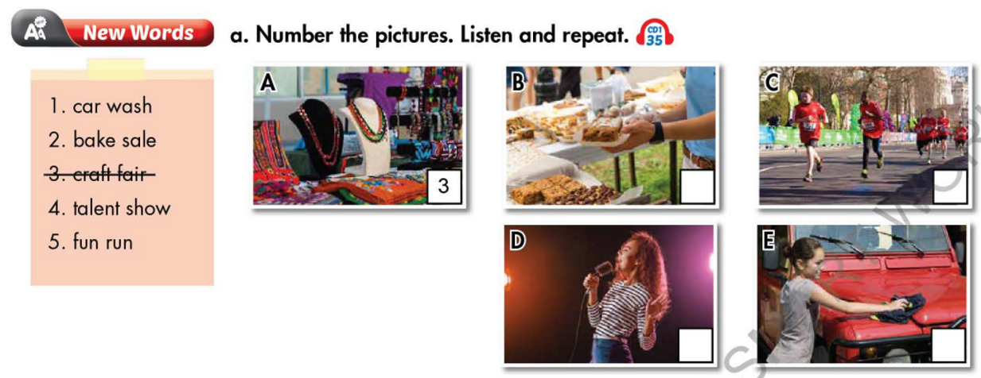  - Option 2:  - Divide class into 4 groups.  - Give questions: What can you do to help other people?  - Have Ss in each group list some activities they can do to help other people in 2 minutes.  - Have 4 representatives of 4 groups write answers on the board.  - Check Ss’ answers.  - Give feedback and announce the winner (The group with most correct answers and interesting ideas will be the winner).  - Lead to the new lesson: Community Services. | - Work in pairs to number the pictures.  - Give answers.  - Listen.  Answer keys  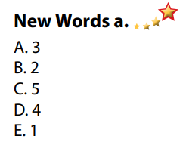  - Take part in the class’s activity in groups.  - Give answers.  Possible answers  Activities to help other people  - raise money for the poor  - provide classes / education for street children  - help old people / small children cross the street  - provide meals for homeless people  - clear up the streets / neighborhood / beach  - donate old clothes / books / school things to poor children,  - …

B. New lesson (35’)
- Activity 1: Pre-Reading (Vocabulary) (13’)
a) Objective: Ss know some words about charity activities and volunteer work.
b) Content:
- Vocabulary study: Number the picture: words about charity activities and volunteer work (car wash, bake sale, craft fair, talent show, fun run, volunteer, charity event, right).
- Circle the correct definitions for the underlined words. Listen and repeat.
- Speaking: Discuss and add more events to the box.
c) Expected outcomes: Ss know how to pronounce the new words correctly and use them in appropriate situations.
d) Organization of the activity:
TEACHER’S ACTIVITIES | STUDENTS’ ACTIVITIES
Task a. Match the words and phrases with the pictures. Listen and repeat.  - Option 1 (If the teacher hasn’t used this part for the Warm-up activity)  - Demonstrate the activity on DCR, using the example.  - Have Ss look at the pictures and phrases, then number the pictures.  - Divide class into pairs and have them check their answers with their partners.  - Call Ss to give answers (read or write).  - Check answers as a whole class.  - Play audio (CD1 – Track 35). Have Ss listen and repeat.  - Correct Ss’ pronunciation.  - Option 2: Matching (If the teacher has used part a. for the Warm-up activity)  - Have Ss review the words they have known in the warm-up activity by looking at the pictures and saying names of the phrases they have learnt. (T uses different pictures from those in the textbook.)  - Call Ss to give answers (read or write).  - Check answers as a whole class.  - Call some Ss to read the words again.  - Correct Ss’ pronunciation if necessary.  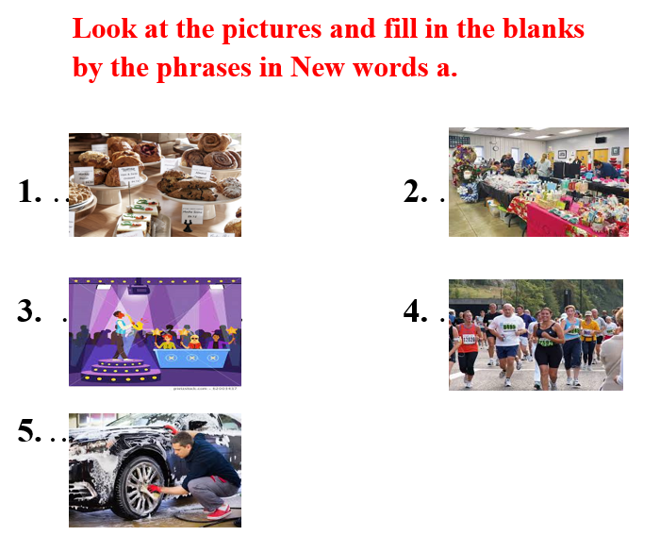  Task b. Circle the correct definitions for the underlined words. Listen and repeat.  - Have students read the sentences and circle the correct definitions.  - Divide the class into pairs and have them check their answers with their partners.  - Check answers as a whole class.  - Play audio (CD 1 – Track 36). Have students listen and repeat.  Task c. Discuss and add more events to the box  - Have Ss discuss in pairs and add more events to the box.  - Have Ss share their ideas in front of the class.  - Give feedback and evaluation. | - Look and listen.  - Work individually.  - Work in pairs.  - Give answers.  - Listen and repeat.  Answer keys  - Work in pairs.  - Give answers.  - Read.  Answer keys  1. bake sale  2. craft fair  3. talent show  4. fun run  5. car wash  - Read and do the task.  - Work in pairs.  - Listen and repeat.  Answer keys  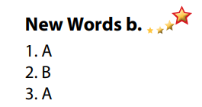  - Discuss in pairs.  - Present.
- Activity 2: While - Reading (16’)
a) Objective: Students can develop their reading skill.
b) Content: Read the article, then choose the best headline and write Yes, No or Doesn’t Say.
c) Expected outcomes: Students can read an article about children’s right and understand general and specific information.
d) Organization of the activity:

TEACHER’S ACTIVITIES | STUDENTS’ ACTIVITIES
Task a. Read the article and choose the best headline.  - Have Ss read 2 headlines and guess the answer.  - Ask Ss to scan the article, then choose the best headline.  - Remind Ss to underline or highlight the keywords or supporting ideas for their answers.  - Have some Ss share their answers with the class (read), explain for their answers.  - Give feedback.  - Give feedback and correct Ss’ answers if necessary.  Task b. Now, read and write Yes, No or Doesn’t Say.  - Have Ss read the sentences, underline key words.  - Have Ss read the article again and write Yes, No or Doesn’t Say, underline or highlight the supporting ideas.  - Have Ss check answers with their partners.  - Call Ss to give answers, explain.  - Give feedback and evaluation. | -Work individually.  - Read answers, explain.  - Check answers.  Answer keys  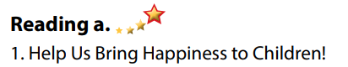  - Read and underline.  - Write answers.  - Check answers.  - Give answers.  Answer keys  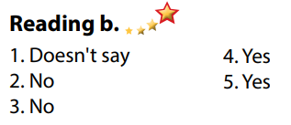

- Activity 3: Post - Reading (6’)
a) Objective: Students can use the vocabulary and ideas from the reading text to develop their speaking skill.
b) Content: Speaking: Which of the two events would you like to take part in?
c) Expected outcomes: Students can talk about their favorite charity event.
d) Organization of the activity:
TEACHER’S ACTIVITIES | STUDENTS’ ACTIVITIES
Task c. In pairs: Which of the two events would you like to take part in?  - Have Students work in pairs to talk about their favorite charity event.  - Go round and give help if necessary.  - Call some Ss to share their ideas with the whole class.  - Give feedback and evaluation. | - Discuss in pairs.  - Present.  - Listen.

C. Consolidation and homework assignments (5’)

* Consolidation:
- Words about charity activities and volunteer work (car wash, bake sale, craft fair, talent show, fun run, volunteer, charity event, right).

* Homework:
- Learn the new words by heart.
- Practice talking about charity activities.
- Do the exercises in WB: New words + Reading (page 20).
- Do the vocabulary exercise in Tiếng Anh 7 i-Learn Smart World Notebook (page 22).
- Play consolation games in Tiếng Anh 7 i-Learn Smart World DHA App on www.eduhome.com.vn
- Prepare: Unit 4 - Lesson 1.2 – Grammar (page 29 – SB).

D. Reflection
a. What I liked most about this lesson today:
…………………………………………………………………………………………
- What I learned from this lesson today:
…………………………………………………………………………………………
c. What I should improve for this lesson next time:
…………………………………………………………………………………………

