Date of preparing: ………………………………….
Date of teaching: ………………………………….

Period …
UNIT 4: FESTIVALS and FREE TIME
Lesson 4 - REVIEW (Page 92)

I. OBJECTIVES
By the end of the lesson, Ss will be able to…
1. Knowledge
- review free time activities.
- review making plans and giving opinions.
- review traditional festivals in Vietnam and around the world.
2. Ability
- improve the listening, reading, speaking and writing skills.
3. Quality
- have positive attitude in English language learning so that they actively participate in all classroom activities.
- review the old lesson and have good preparation for any assessment.
II. TEACHING AIDS AND LEARNING MATERIALS
Lesson plan, PPT slides, student’s book, workbook, notebook, personal computer (if any), projector/TV, speakers, DCR & DHA on Eduhome, handouts…
III. PROCEDURES
A. Warm up: (5’)
a) Objective: to introduce the new lesson and set the scene for Ss to review the language learnt; to get students' attention at the beginning of the class by means of enjoyable and short activities as well as to engage them in the steps that follow.
b) Content: Vocabulary revision.
c) Product: Being ready for the new lesson.
d) Competence: collaboration, communication, critical thinking.
e) Organization of the activity:
Teacher’s Activities | Students’ Activities
- Give greetings  - Check attendance  - Option 1: MATCHING  - Show on the screen or give out handouts  - Have Ss match festivals with the place where these festivals take place  - Have Ss give answers  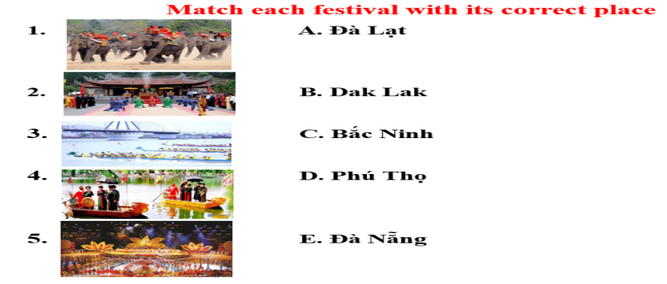  → Lead to the new lesson.  - Option 2: LETTER LINGO  - Show on the screen a secret word-containing 8 letters, from 1-8  - Have Ss choose number and answer the questions (pictures), the first letter of the answer will be the letter in the secret word.  - Have Ss guess the secret word through the letters in the answers  - The first student to give the right secret word will be the winner  - Give a small gift to the winner  → Lead to the new lesson  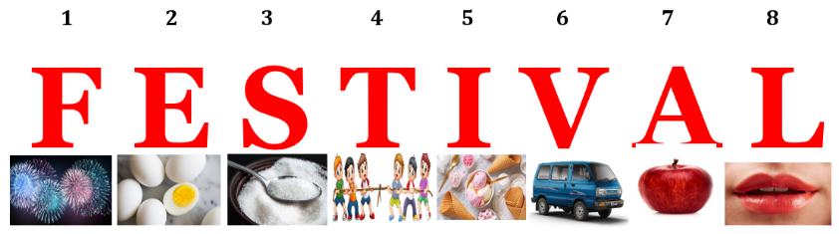 | - Greet T  - Match  - Look and give answers  Answer keys  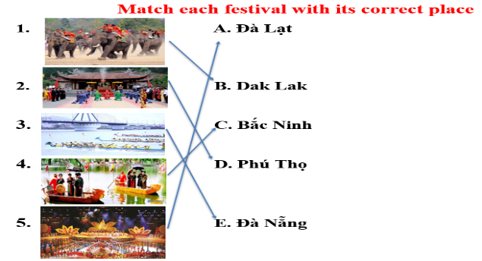  - Look  - Choose number and answer  Answer Keys  Secret word: FESTIVAL  1. fireworks → F  2. egg → E  3. sugar → S  4. tug of war → T  5. ice-cream → I  6. van → V  7. apple → A  8. lips → L

B. New lesson (36’)
- Activities 1: Listening (10’)
a) Objective: Ss improve their listening skill.
b) Content: listening and filling in the blanks.
c) Products: Ss listen for details and get familiar with the listening test format.
d) Competence: collaboration, analytical and synthesizing skills.
e) Organization of the activity:
Teacher’s Activities | Students’ Activities
You will hear two friends talking about festivals twice. Listen and fill in the blanks  - Have Ss read the table, guess answers  - Demonstrate the activity by using the example  - Play the audio (CD 2 – Track 66)  - Have Ss check answers with pairs and then give answers  - Check answers as a whole class | - Read in silence  - Listen and then give answers  - Check and correct mistakes  Answer keys  1. dresses 2. flowers 3. fun  4. music 5. talent
- Activity 2: Reading (7’)
a) Objective: Ss can improve reading skill
b) Content: reading messages, advertisements and choosing the correct answer.
c) Products: Ss read for comprehension and get familiar with the reading test format.
d) Competence: collaboration, analytical and synthesizing skills
e) Organization of the activity:

Teacher’s Activities | Students’ Activities
Look and read. Choose the correct answer (A, B or C)  - Demonstrate the activity by using the example  - Have Ss read the message, advertisements and choose the correct answer  - Call Ss to give answers, explain  - Give feedback | - Observe and listen  - Work individually  - Give answers  Answer keys  1.C 2.A 3. B
- Activity 3: Vocabulary (9’)
a) Objective: Ss can review vocabulary about festival activities.
b) Content: Filling in the blanks with the words from the box.
c) Products: Ss can use these vocabularies in producing the language for communication.
d) Competence: collaboration, analytical and synthesizing skills, communication.
e) Organization of the activity:

Teacher’s Activities | Students’ Activities
Fill in the blanks with the words from the box  - Have Ss read the sentences  - Ask Ss to work in pairs to write  - Have Ss give answers  - Check answers as a whole class | - Look  - Work in pairs  - Give answers  - Listen, correct mistakes  Answer keys  1. rarely  2. get lucky money  3. talent show  4. always  5. food stands  6. fireworks  7. never  8. eat traditional foods
- Activity 4: Grammar (5’)
a) Objective: Ss can review the use of English: The Present Simple tense for future use, How-questions, adverbs of frequency.
b) Content: Writing sentences using the words given.
c) Products: Ss can review and apply the grammar points learnt to producing the language successfully.
d) Competence: collaboration, communication, analytical and synthesizing skills.
e) Organization of the activity:

Teacher’s Activities | Students’ Activities
Write sentences, using the words given  - Ask Ss to work individually to write full sentences  - Have Ss work in pairs to check each other’s work  - Call Ss to write answers on the boards  - Check answers as a whole class | - Work individually  - Work in pairs  - Write answers  - Listen, correct mistakes  Answer keys  1. We decorate our houses for Halloween.  2. John sometimes plays video games with his friends after school.  3. The fashion show starts at 8 p.m.  4. How do people prepare for Christmas?  5. How often do you go shopping?  6. The bus leaves at 10 a.m.
- Activity 5: Pronunciation (5’)
a) Objective: Ss can review the word stress, vowels and consonants
b) Content: circling the word that has the underlined part pronounces differently from the others and circling the word that has different stress from the rest.
c) Products: Ss can review the sound and word stress and use them correctly in communication.
d) Competence: analytical and synthesizing skills, communication, collaboration.
e) Organization of the activity:
Teacher’s Activities | Students’ Activities
Circle the word that has the underlined part pronounced differently from the others.  - Have Ss distinguish the sound / ӕ/ - / eɪ/; / əʊ/ -/ aʊ/, and “s” endings  - Ask Ss to work individually  - Have Ss work in pairs to check each other’s work  - Call Ss to give answers, pronounce the words again  - Give feedback, correct Ss’ pronunciation if necessary  Circle the word that differs from the other three in the position of primary stress in each of the following questions.  - Remind Ss some basic rules of putting stress on words with 2 or 3 syllables  - Ask Ss to work individually  - Have Ss work in pairs to check each other’s work  - Call Ss to give answers, pronounce the words again  - Give feedback, correct Ss’ pronunciation if necessary | - Listen  - Work individually  - Work in pairs  - Give answers  - Listen, correct mistakes  Answer keys  1. D 2. A 3. B  - Listen  - Work individually  - Work in pairs  - Give answers  - Listen, correct mistakes  Answer keys  4. C 5. D 6. As

C. Consolidation (2’)
* Grammar of Unit 4: The Present Simple tense for future use, How-questions, adverbs of frequency
* Vocabulary of Unit 4: Vocabulary about festivals and festival activities

D. Homework (2’)
- Review vocabulary, grammar of unit 4.
- Do exercises in Workbook: Review of Unit 4 (page 65).
- Prepare: Unit 5 – Vocabulary and Listening (page 38 – SB).

