LỚP HỌC THẦY (CÔ) ___________________________ ĐỀ ÔN TẬP: READING SIGNS/ NOTICES – A2
Test 4
Thời gian làm bài: [Time]
Họ và tên: ________________________________________________ Lớp: 9/___
Nội dung:
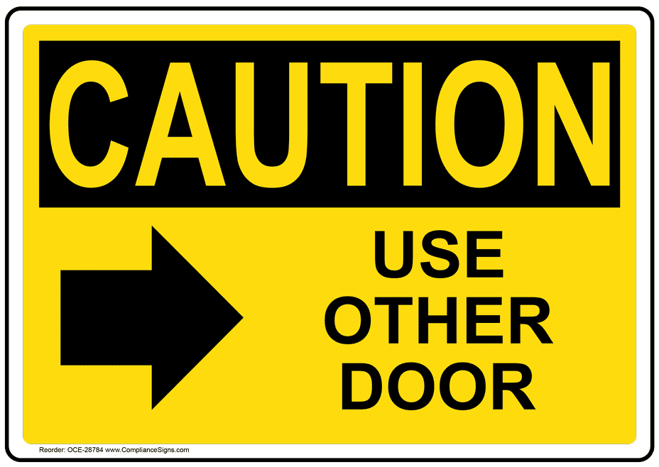
Question 1: What does the sign say?

A. You should use this door if you want to enter.
B. Please use a different door to go inside the building.
C. This door can only be used for emergencies and is not for general use.
D. This door cannot be opened because it is locked.

Question 2: What does the notice say?
"The parking lot will be full on Saturday due to a big event. Please park on the street."

A. Please don't park on Saturday, we have an event.
B. You can park in the parking lot on Saturday without any problems.
C. There will be more parking on Saturday.
D. There will be more cars in the parking lot on Saturday, park on the street.
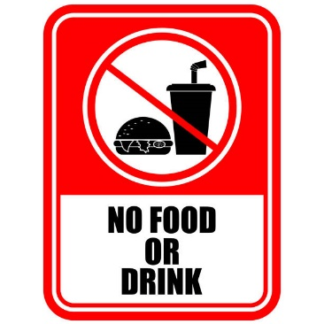
Question 3: What does the sign say?

A. You are allowed to eat and drink here without any restrictions.
B. Eating and drinking are not permitted in this area at all times.
C. You can bring drinks but not food into this area.
D. Food is permitted but drinks are not allowed in this area.

Question 4: What does the notice say?
"The library will be closed on Sunday for cleaning. It will open again on Monday morning."

A. The library will be open on Sunday for cleaning.
B. The library will be closed on Sunday and open again on Monday.
C. The library will close early on Sunday for cleaning.
D. The library will be closed all weekend.
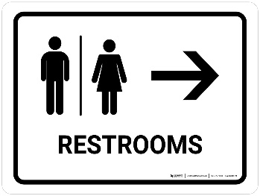
Question 5: What does the sign say?
A. Restrooms are in the direction shown by this sign.
B. The restroom is closed and you cannot use it now.
C. There are no restrooms here or nearby.
D. Restrooms are on the other side of this place.

Question 6: What does the notice say?
Notice:
Students will have Tet holiday from February 8, 2025. They will return to school on February 15, 2025 to prepare for mid-term exams.

A. Students will return to school after 8 days of holiday and prepare for exams.
B. Students' exams will come when they return to school.
C. Students will have to prepare for exams after the holiday.
D. Students will return to school after February 14 and prepare for exams.
Question 7: What does the sign say?
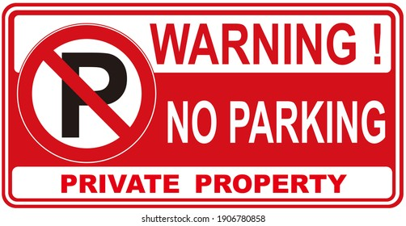
A. You can park your car in any place here without rules.
B. Do not park your car here; it is not allowed.
C. Only customers can park in this area.
D. You can park your car in any spot you like.

Question 8: What does the notice say?
Note: "The post office will be closed on holidays. Check the calendar for the specific days the post office will be closed."

A. The post office will be closed on public holidays.
B. Check the schedule to know the days the post office will be closed.
C. The post office will open later on public holidays.
D. The post office will close early on public holidays.
Question 9: What does the sign say?
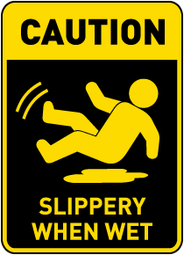
A. The floor is safe and dry; there is no need to be careful.
B. The floor becomes slippery when wet; you should be careful.
C. The floor is always slippery and may be dangerous.
D. The floor is clean and safe for walking at all times.

Question 10: What does the notice say?
"The local farmers market will be open every Saturday from 8 AM to 2 PM. Fresh produce and local goods will be sold."

A. The market will be open every Sunday from 8am to 2pm to sell local goods.
B. The farmers market will be open every Saturday from 8am to 2pm to sell fresh produce and local goods.
C. The market will only be open in the evening to sell local produce and local goods.
D. No local goods will be sold at the market.
[HẾT]

